Supplementary materials for “Molecular Circadian Disturbance in Human Blood Independently Predict Multi-Disease Risk and Maps to Hepatic metabolism Pathways”

Supplementary Tables

Table S1 Association between blood hematological metrics and blood collection time. Table and captions provided as separated .xlsx file.

Table S2 Association between blood biochemistry metrics and blood collection time. Table and captions provided as separated .xlsx file.

Table S3 Association between blood metabolomic molecules and blood collection time. Table and captions provided as separated .xlsx file.

Table S4 K-SHAPE clustering result of blood molecule trajectories. Table provided as separated .xlsx file.

Table S5 K-SHAPE clustering quality evaluations for k=2 to 7. Table provided as separated .xlsx file.

Molecule used | RMSE | R2 | MAE
all | 2.320499 | 0.37686 | 1.799713
early-peak | 2.510237 | 0.327025 | 2.049259
late-peak | 3.050072 | 0.302235 | 2.288389

Table S6 prediction accuracy of BART model. RMSE: Root mean square error. R2: coefficient of determination. MAE: Mean Absolute Error.

Table S7 Linear regression analysis of shift/disturbance on all covariates. Table provided as separated .xlsx file.

Table S8 Cox regression between shift, disturbance based on all molecules and future ICD-10 condition risk. Table and captions provided as separated .xlsx file.

Table S9 Cox regression between shift, disturbance based on early-peak molecules and future ICD-10 condition risk. Table and captions provided as separated .xlsx file.

Table S10 Cox regression between shift, disturbance based on late-peak molecules and future ICD-10 condition risk. Table and captions provided as separated .xlsx file.

Table S11 validation and sensitivity analysis for all molecule disturbance-disease risk association. Table and captions provided as separated .xlsx file.

Table S12 validation and sensitivity analysis for early-peak molecule disturbance-disease risk association. Table and captions provided as separated .xlsx file.

Table S13 validation and sensitivity analysis for late-peak molecule disturbance-disease risk association. Table and captions provided as separated .xlsx file.

Table S14 Linear regression between shift, disturbance based on all molecules and previous ICD-10 diagnosis. Table provided as separated .xlsx file.

Table S15 Linear regression between shift, disturbance based on early-peak molecules and previousICD-10 diagnosis. Table provided as separated .xlsx file.

Table S16 Linear regression between shift, disturbance based on late-peak molecules and previous ICD-10 diagnosis. Table provided as separated .xlsx file.

Table S17 Linear regression between shift, disturbance and previous ICD-10 diagnosis, with all molecules conditioned as covariates. Table provided as separated .xlsx file.

Table S18 Significant GWAS loci for shift. Table was summarized across three phenotypes (shift based on all/early-peak/late-peak molecules). Start and end position was determined based on the phenotype with the lowest p-value within the locus. Tagged gene: gene link to the rsid with the lowest p-value from dbSNP database. Table provided as separated .xlsx file.

Table S19 MAGMA result for shift. NSNPS, number of SNPs annotated to the gene after quality control; NPARAM, number of principal components retained as parameters in the gene-based test. Table provided as separated .xlsx file.

Table S20 Significant GWAS loci for disturbance. Table was summarized across three phenotypes (disturbance based on all/early-peak/late-peak molecules). Start and end position was determined based on the phenotype with the lowest p-value within the locus. Tagged gene: gene link to the rsid with the lowest p-value from dbSNP database. Table provided as separated .xlsx file.

Table S21 MAGMA result for disturbance. NSNPS, number of SNPs annotated to the gene after quality control; NPARAM, number of principal components retained as parameters in the gene-based test. Table provided as separated .xlsx file.

Table S22 Comparative pathway enrichment result for shift and disturbance based on all molecules. Obtained from “FINAL_GO” table from the output of metascape. Table provided as separated .xlsx file.

Table S23 Comparative TWAS result for shift and disturbance based on all molecules. Table provided as separated .xlsx file.

Table S24 PWAS result for shift and disturbance. Shown are linear regression statistics of each protein on each phenotype. Table provided as separated .xlsx file.

Table S25 Comparative pathway enrichment result for shift based on early-peak and late-peak molecules. Obtained from “FINAL_GO” table from the output of metascape. Table provided as separated .xlsx file.

Table S26 Comparative TWAS result for shift based on early-peak and late-peak molecules. Table provided as separated .xlsx file.

Supplementary Figures
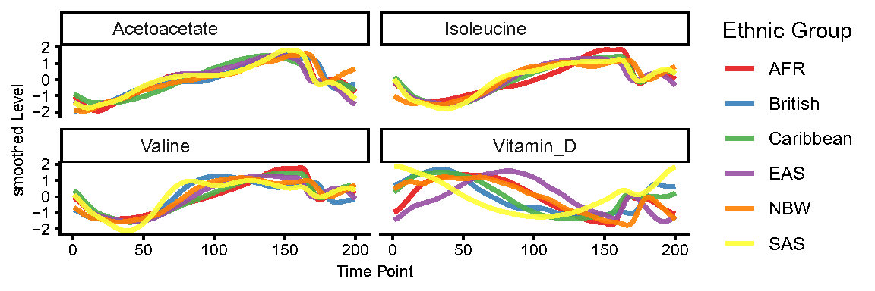
Figure S1 Ancestry-specific trajectory for molecules showing highest heterogeneity. Smoothed level: GAM prediction of each molecule over 200 grids. AFR: African participants. EAS: east Asian participants. NBW: non-British white people. SAS: south Asian participants.

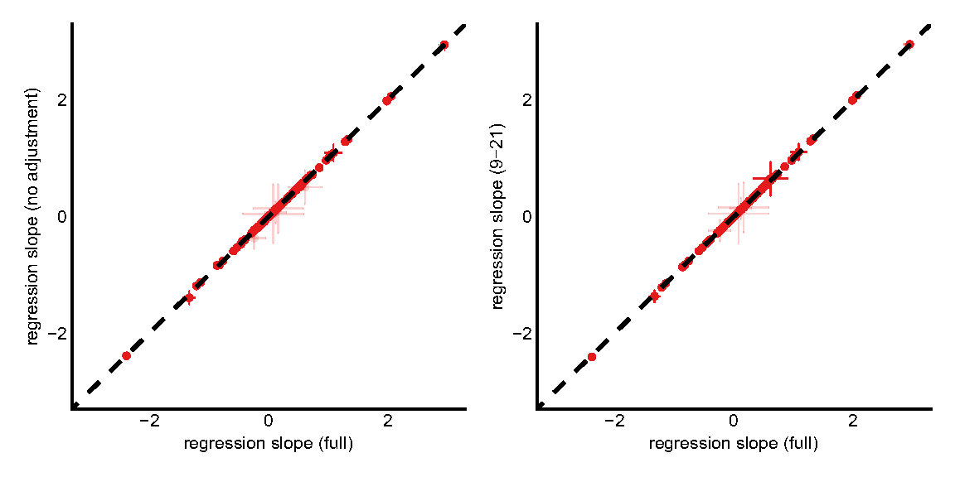
Figure S2 Robustness of circadian signals against covariates and time windows. Left: regression coefficient of molecule-time association with and without lifestyle and medical covariates controlled. Right: regression coefficient of molecule-time association with and without samples outside 9:00 - 21:00 time windows. Error bar denoted 95% confidence interval.

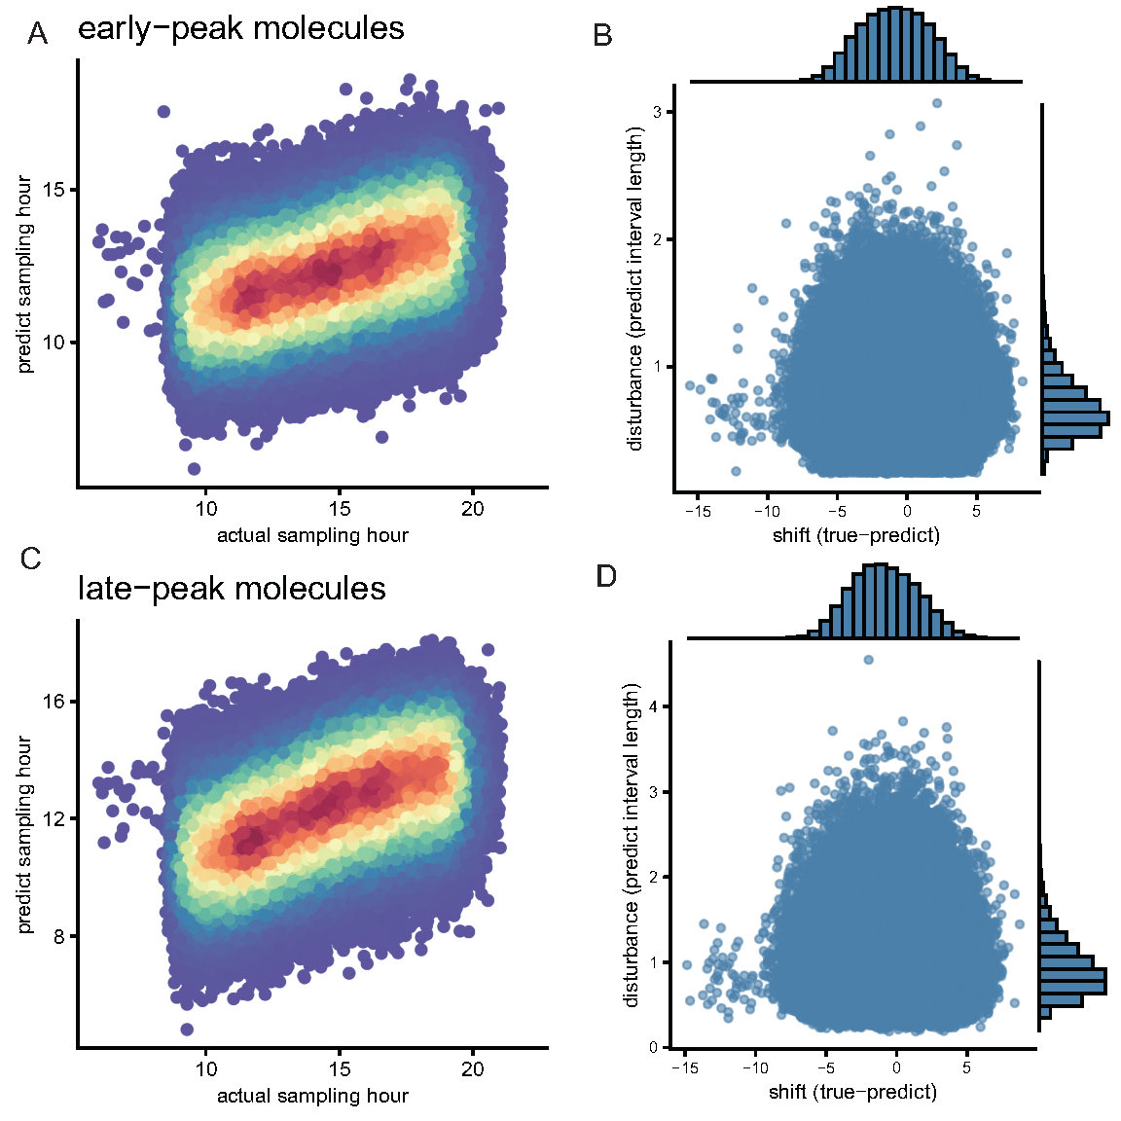
Figure S3 cluster-specific BART prediction and definition of shift and disturbance. A: Predicted vs. actual blood collection time based on early-peak molecules. B: distribution of shift and disturbance derived from early-peak molecule BART model. C: Predicted vs. actual blood collection time based on late-peak molecules. D: distribution of shift and disturbance derived from late-peak molecule BART model.
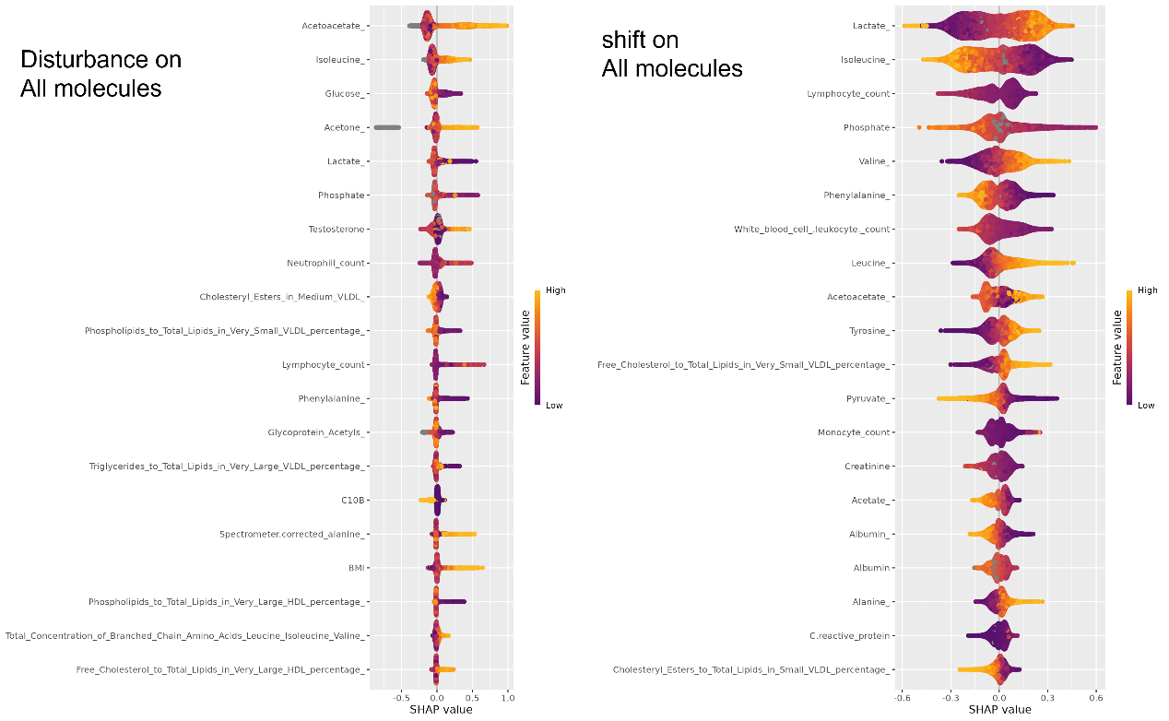
Figure S4 beeswarm plot for shift and disturbance based on all molecules. Each point represents a sample, point color corresponded to the molecule level, and x-axis denote the degree to which the given molecule increase or decrease the predicted time of the given sample.
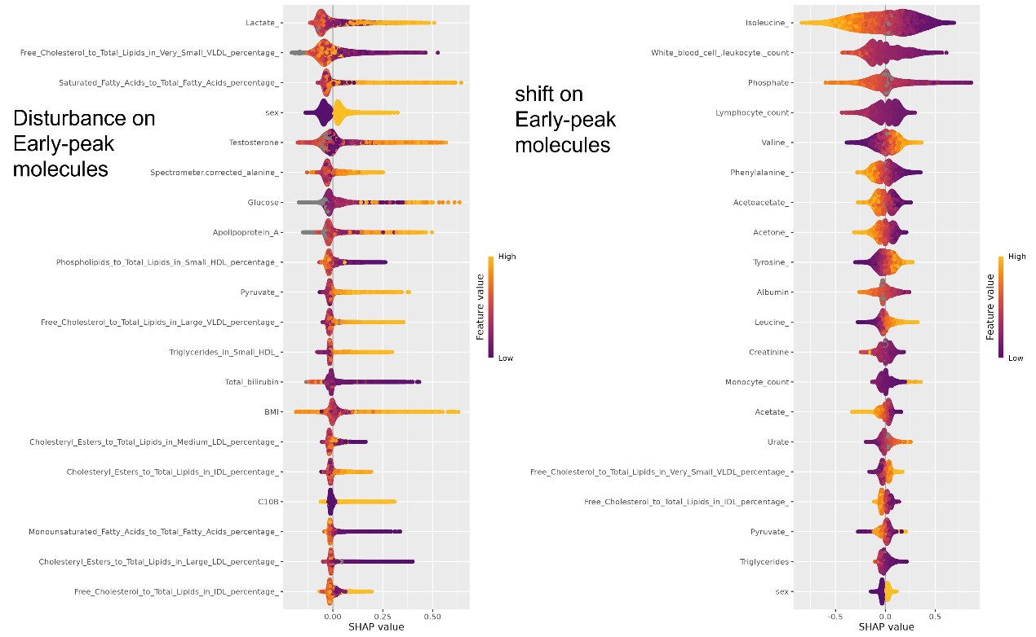
Figure S5 beeswarm plot for shift and disturbance based on early-peak molecules. Each point represents a sample, point color corresponded to the molecule level, and x-axis denote the degree to which the given molecule increase or decrease the predicted time of the given sample.
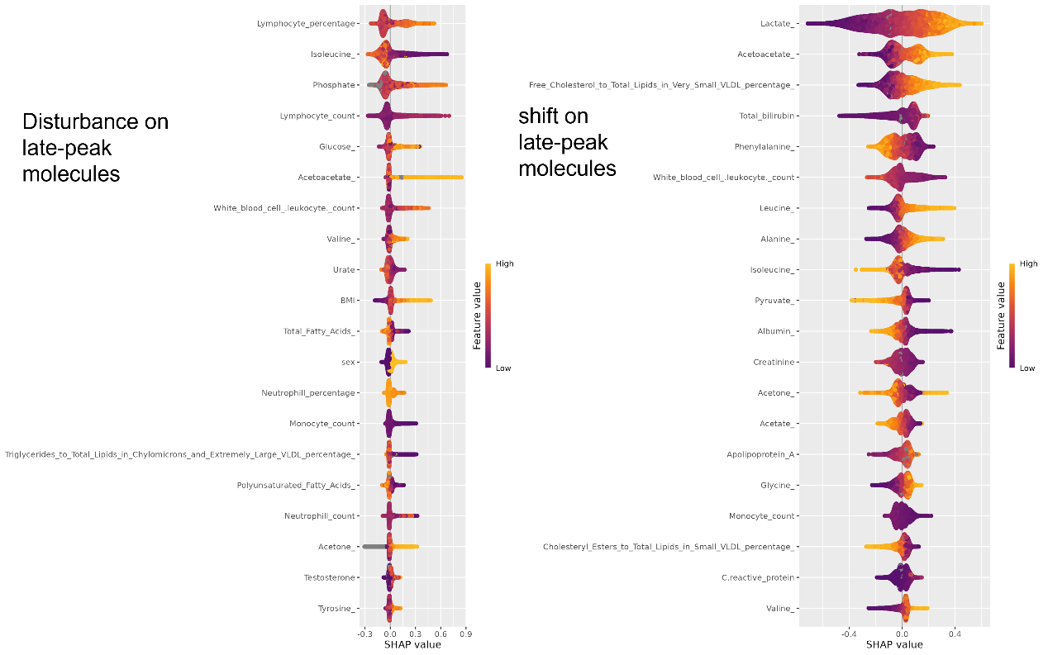
Figure S6 beeswarm plot for shift and disturbance based on late-peak molecules. Each point represents a sample, point color corresponded to the molecule level, and x-axis denote the degree to which the given molecule increase or decrease the predicted time of the given sample.

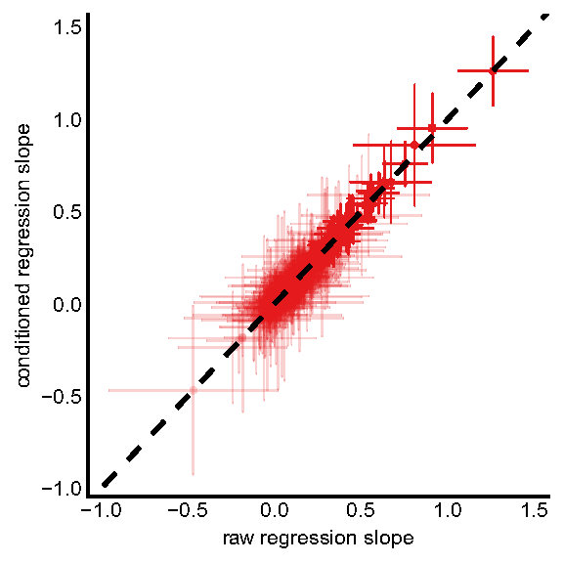
Figure S7 Comparison of linear regression between shift, disturbance and previous ICD-10 diagnosis with and without all molecules conditioned as covariates. Error bar denoted 95% confidence interval.
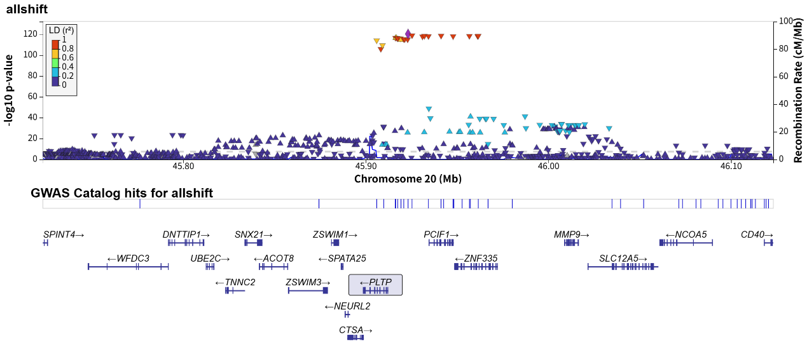
Figure S8 Locuszoom plot for the top 1 GWAS locus of shift based on all molecules.
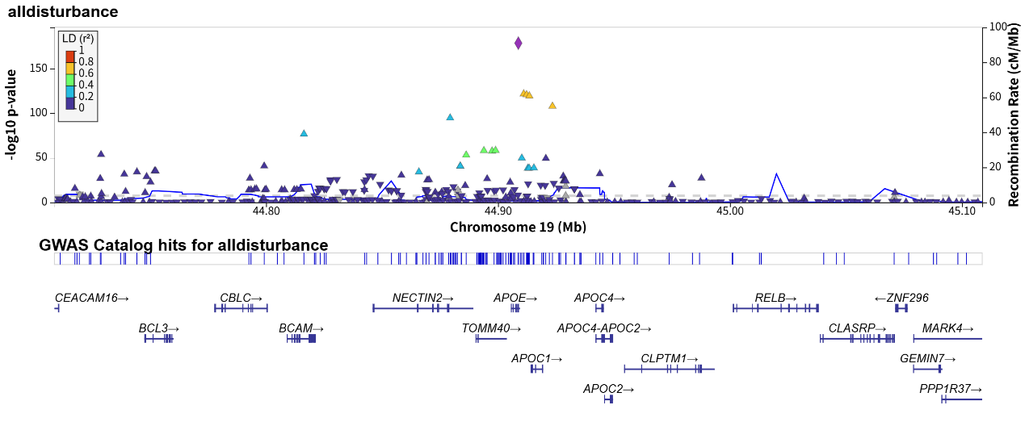
Figure S9 Locuszoom plot for the top 1 GWAS locus of disturbance based on all molecules.

