Additional file 1: Supplementary material
Association between body mass index and 90-day postoperative complications after insertional Achilles debridement and suture-anchor reattachment: a retrospective cohort study
Kyle Polanco, BS; Rohan Charles, BS; Daniel Ryssman, MD; Norman Turner III, MD; Alexander Vlasak, MD

Supplementary methods
The primary logistic-regression model used patient-clustered HC1 robust standard errors. BMI was represented with a three-knot restricted cubic spline at 25.882, 32.360, and 42.106 kg/m², corresponding to the 10th, 50th, and 90th percentiles. Global and nonlinear Wald tests used the patient-clustered covariance matrix. Marginal standardized probabilities were estimated by assigning each BMI value to every procedure while retaining each procedure’s observed age, diabetes, and preoperative smoking status, then averaging predicted probabilities. The main spline figure displays the central 90% of observed BMI values for readability; a full-range curve is provided as Supplementary Figure S4.
Observed absolute risks for the post hoc BMI ≥35 kg/m² comparison used a patient-level cluster bootstrap with 200,000 resamples and seed 20260907. All procedures from a sampled patient were retained together. Adjusted marginal probabilities and their difference were calculated from the binary logistic model with delta-method confidence intervals based on the patient-clustered HC1 covariance matrix.
The GEE sensitivity model used a binomial distribution, logit link, patient clustering, exchangeable working correlation, and robust sandwich standard errors. The first-procedure analysis retained the chronologically first eligible procedure for each patient. Firth models used penalized likelihood with profile penalized-likelihood confidence intervals [24]. The Firth models did not incorporate patient-level clustering and were used only as sparse-data sensitivity analyses; the GEE and first-procedure-only models addressed repeated procedures. The procedure-year sensitivity included calendar year as a continuous covariate. The surgeon analysis first excluded the sole procedure contributed by the fourth surgeon, then added surgeon as a categorical fixed effect among the three principal surgeons. The sex sensitivity added sex as documented in the medical record.
The return-to-activity Cox model used patient-clustered robust standard errors. Schoenfeld-residual testing showed no evidence of nonproportional hazards for BMI in the continuous-BMI model (p=0.728) or for that model globally (p=0.923). Results were similar for the post hoc BMI ≥35 kg/m² model (BMI term p=0.884; global p=0.929). Kaplan-Meier estimates were descriptive, and median confidence intervals were obtained by inversion of log-transformed survival confidence bands using survival::survfit.

Supplementary tables

Supplementary Table S1. Robustness of the linear BMI association
Analysis | N | Events | OR per 5 kg/m² | 95% CI | p value
Primary cluster-robust model | 217 | 32 | 1.43 | 1.11-1.85 | 0.006
GEE sensitivity | 217 | 32 | 1.43 | 1.11-1.84 | 0.005
First-procedure-only | 194 | 32 | 1.42 | 1.08-1.86 | 0.012
Procedure-year adjusted | 217 | 32 | 1.45 | 1.11-1.89 | 0.006
Sex adjusted | 217 | 32 | 1.43 | 1.11-1.86 | 0.006
Exclude single fourth-surgeon procedure | 216 | 32 | 1.43 | 1.10-1.84 | 0.007
Three-principal-surgeon adjusted | 216 | 32 | 1.51 | 1.12-2.02 | 0.007
Firth penalized model | 217 | 32 | 1.41 | 1.08-1.85 | 0.011
All models adjusted for age, diabetes, and smoking status at initial surgical evaluation unless the row indicates an additional covariate. BMI, body mass index; CI, confidence interval; GEE, generalized estimating equation; OR, odds ratio.

Supplementary Table S2. Complication rates by BMI category
BMI category | Events | Procedures | Rate | Wilson 95% CI
<25.0 kg/m² | 0 | 15 | 0.0% | 0.0%-20.4%
25.0-29.9 kg/m² | 4 | 62 | 6.5% | 2.5%-15.4%
30.0-34.9 kg/m² | 7 | 58 | 12.1% | 6.0%-22.9%
35.0-39.9 kg/m² | 13 | 45 | 28.9% | 17.7%-43.4%
40.0-44.9 kg/m² | 7 | 28 | 25.0% | 12.7%-43.4%
≥45.0 kg/m² | 1 | 9 | 11.1% | 2.0%-43.5%
Global Fisher-Freeman-Halton exact p=0.007. The small number of procedures at the distribution extremes limits precision. BMI, body mass index; CI, confidence interval.

Supplementary Table S3. Full primary linear logistic model
Term | Adjusted OR | 95% CI | p value
BMI, per 5 kg/m² | 1.43 | 1.11-1.85 | 0.006
Age, per 10 years | 1.05 | 0.74-1.50 | 0.769
Diabetes mellitus | 1.41 | 0.49-4.07 | 0.524
Active smoker at initial evaluation | 0.66 | 0.07-6.16 | 0.712
Patient-clustered robust standard errors were used. Adjustment-variable coefficients were not principal study findings. BMI, body mass index; CI, confidence interval; OR, odds ratio.

Supplementary Table S4A. Post hoc BMI ≥35 kg/m² absolute risks
Estimand | BMI <35 kg/m² | BMI ≥35 kg/m² | Difference | 95% CI | p value
Observed 90-day risk | 8.1% (11/135) | 25.6% (21/82) | 17.5 points | 6.9-28.6 points | Not applicable
Adjusted marginal probability | 8.2% | 25.5% | 17.4 points | 6.5-28.3 points | 0.002
Observed confidence intervals and the risk-difference interval used a patient-level cluster bootstrap with 200,000 resamples. Adjusted probabilities were standardized over the cohort’s observed age, diabetes, and preoperative smoking distributions. The cut point was selected post hoc.

Supplementary Table S4B. Post hoc BMI ≥35 kg/m² logistic model
Term | Adjusted OR | 95% CI | p value
BMI ≥35 vs <35 kg/m² | 3.89 | 1.71-8.85 | 0.001
Age, per 10 years | 1.04 | 0.72-1.51 | 0.819
Diabetes mellitus | 1.49 | 0.56-3.96 | 0.422
Active smoker at initial evaluation | 0.47 | 0.05-4.53 | 0.515
The BMI cut point was selected after review of the six category results and is exploratory. Patient-clustered robust standard errors were used.

Supplementary Table S5. Procedure-year-adjusted sensitivity model
Term | Adjusted OR | 95% CI | p value
BMI, per 5 kg/m² | 1.45 | 1.11-1.89 | 0.006
Age, per 10 years | 1.07 | 0.76-1.51 | 0.707
Diabetes mellitus | 1.25 | 0.39-4.01 | 0.705
Active smoker at initial evaluation | 0.76 | 0.08-7.00 | 0.809
Procedure year | 1.07 | 0.94-1.22 | 0.306
Procedure year was included as a secular-trend sensitivity covariate and was not a principal exposure.

Supplementary Table S6. Surgeon sensitivity analyses
Analysis | N | Patients | Events | BMI expression | OR | 95% CI | p value
Full cohort primary model | 217 | 194 | 32 | Per 5 kg/m² | 1.43 | 1.11-1.85 | 0.006
Exclude fourth-surgeon procedure | 216 | 193 | 32 | Per 5 kg/m² | 1.43 | 1.10-1.84 | 0.007
Adjust for three principal surgeons | 216 | 193 | 32 | Per 5 kg/m² | 1.51 | 1.12-2.02 | 0.007
Full cohort post hoc model | 217 | 194 | 32 | BMI ≥35 vs <35 | 3.89 | 1.71-8.85 | 0.001
Exclude fourth-surgeon procedure | 216 | 193 | 32 | BMI ≥35 vs <35 | 3.84 | 1.68-8.77 | 0.001
Adjust for three principal surgeons | 216 | 193 | 32 | BMI ≥35 vs <35 | 4.37 | 1.87-10.22 | <0.001
The fourth surgeon contributed one non-event procedure. Individual surgeon coefficients were not interpreted. BMI, body mass index; CI, confidence interval; OR, odds ratio.

Supplementary Table S7. Sex-adjusted sensitivity results
Analysis | BMI estimate | 95% CI | p value | Shape test
Linear BMI model, per 5 kg/m² | OR 1.43 | 1.11-1.86 | 0.006 | Not applicable
Post hoc BMI ≥35 vs <35 | OR 3.89 | 1.70-8.89 | 0.001 | Not applicable
Restricted cubic spline | Not applicable | Not applicable | Global 0.030 | Nonlinear 0.022
Sex was added as a sensitivity covariate. The BMI association was materially unchanged.

Supplementary Table S8. Exploratory Firth wound model
Term | OR | 95% profile CI | p value
BMI ≥35 vs <35 kg/m² | 3.36 | 1.25-9.85 | 0.016
Age, per 10 years | 0.81 | 0.54-1.25 | 0.331
Diabetes mellitus | 1.22 | 0.29-3.94 | 0.763
Active smoker at initial evaluation | 0.34 | 0.003-3.03 | 0.404
Only 17 wound events occurred. This model is exploratory and should not be interpreted as confirming an independent wound-specific threshold. CI, confidence interval; OR, odds ratio.

Supplementary Table S9. Adjusted Cox model for return to activity
Term | HR | 95% CI | p value
BMI, per 5 kg/m² | 0.91 | 0.74-1.11 | 0.355
Age, per 10 years | 0.97 | 0.83-1.14 | 0.738
Diabetes mellitus | 0.82 | 0.43-1.57 | 0.547
Active smoker at initial evaluation | 0.23 | 0.03-1.64 | 0.142
Patient-clustered robust standard errors were used. A hazard ratio below 1 indicates a lower instantaneous rate of documented return. Schoenfeld-residual testing showed no evidence of nonproportional hazards for BMI in the continuous-BMI model (p=0.728) or for that model globally (p=0.923); corresponding values for the post hoc BMI ≥35 kg/m² model were p=0.884 and p=0.929. BMI, body mass index; CI, confidence interval; HR, hazard ratio.

Supplementary Table S10. Kaplan-Meier estimates by BMI ≥35 kg/m² cut point
Group | Procedures | Return events | Censored | Median days | 95% CI | Log-rank p
BMI <35 kg/m² | 135 | 50 | 85 | 181 | 151-204 | 0.127
BMI ≥35 kg/m² | 82 | 29 | 53 | 203 | 183-not estimable | 0.127
The BMI cut point was post hoc. The adjusted continuous-BMI Cox model was the preferred return-to-activity inference. BMI, body mass index; CI, confidence interval.

Supplementary Table S11. Kaplan-Meier estimates by BMI category
BMI category | N | Events | Censored | Median days | 95% CI
<25.0 kg/m² | 15 | 7 | 8 | 140 | 97-not estimable
25.0-29.9 kg/m² | 62 | 18 | 44 | 188 | 168-not estimable
30.0-34.9 kg/m² | 58 | 25 | 33 | 168 | 146-not estimable
35.0-39.9 kg/m² | 45 | 17 | 28 | 186 | 184-not estimable
40.0-44.9 kg/m² | 28 | 8 | 20 | Not estimable | 156-not estimable
≥45.0 kg/m² | 9 | 4 | 5 | 103 | 65-not estimable
Global log-rank p=0.046. The category pattern was nonmonotonic, several estimates were unstable, and the adjusted continuous-BMI Cox model was not significant. These results are descriptive.

Supplementary Table S12. Operational definitions for postoperative events
Event category | Operational definition
Composite 90-day complication | At least one adjudicated qualifying event within 90 days; multiple subtypes counted once in the composite.
Minor wound complication | Abnormal delayed healing, drainage, superficial dehiscence, erythema, blistering, dry eschar, or wound concern requiring additional nonoperative care, including outpatient oral antibiotics.
Major wound complication | Deep infection, substantial dehiscence, hospitalization or intravenous antibiotics for wound infection, operative irrigation and debridement, washout, or surgical wound revision.
Venous thromboembolism | Imaging-confirmed or formally diagnosed and treated postoperative deep-vein thrombosis or pulmonary embolism. Negative diagnostic evaluation was not counted.
Neuritic symptoms | New clinically meaningful burning pain, dysesthesia, paresthesia, hypersensitivity, or nerve-distribution pain; nonspecific postoperative pain excluded.
Formal nerve injury | Clinician-diagnosed postoperative peripheral nerve injury rather than transient neuritic symptoms alone.
Abnormal edema/swelling | Swelling judged clinically abnormal and prompting additional evaluation, testing, treatment, or documented concern. Expected dependent swelling excluded.
Inflammatory/suture reaction | Clinically meaningful localized inflammatory response, sterile abscess, or symptomatic suture irritation prompting evaluation or treatment.
Reinjury/mechanical failure | Documented traumatic event, clinician-attributed reinjury, tendon failure or avulsion, or imaging or operative evidence of failure.
Revision surgery | Recorded separately. Elective or late revision for persistent or recurrent symptoms did not independently qualify; reoperation for an acute complication was recorded under the underlying event.
Outcome definitions and complication-classification criteria were established before medical-record abstraction and applied uniformly throughout data collection. The comprehensive re-audit verified their consistent application before dataset locking and final analysis. Uncertain cases were independently reviewed by two fellowship-trained foot-and-ankle surgeons blinded to BMI, with disagreements resolved by consensus.

Supplementary figures

Supplementary Figure S1. Robustness of the linear BMI estimate
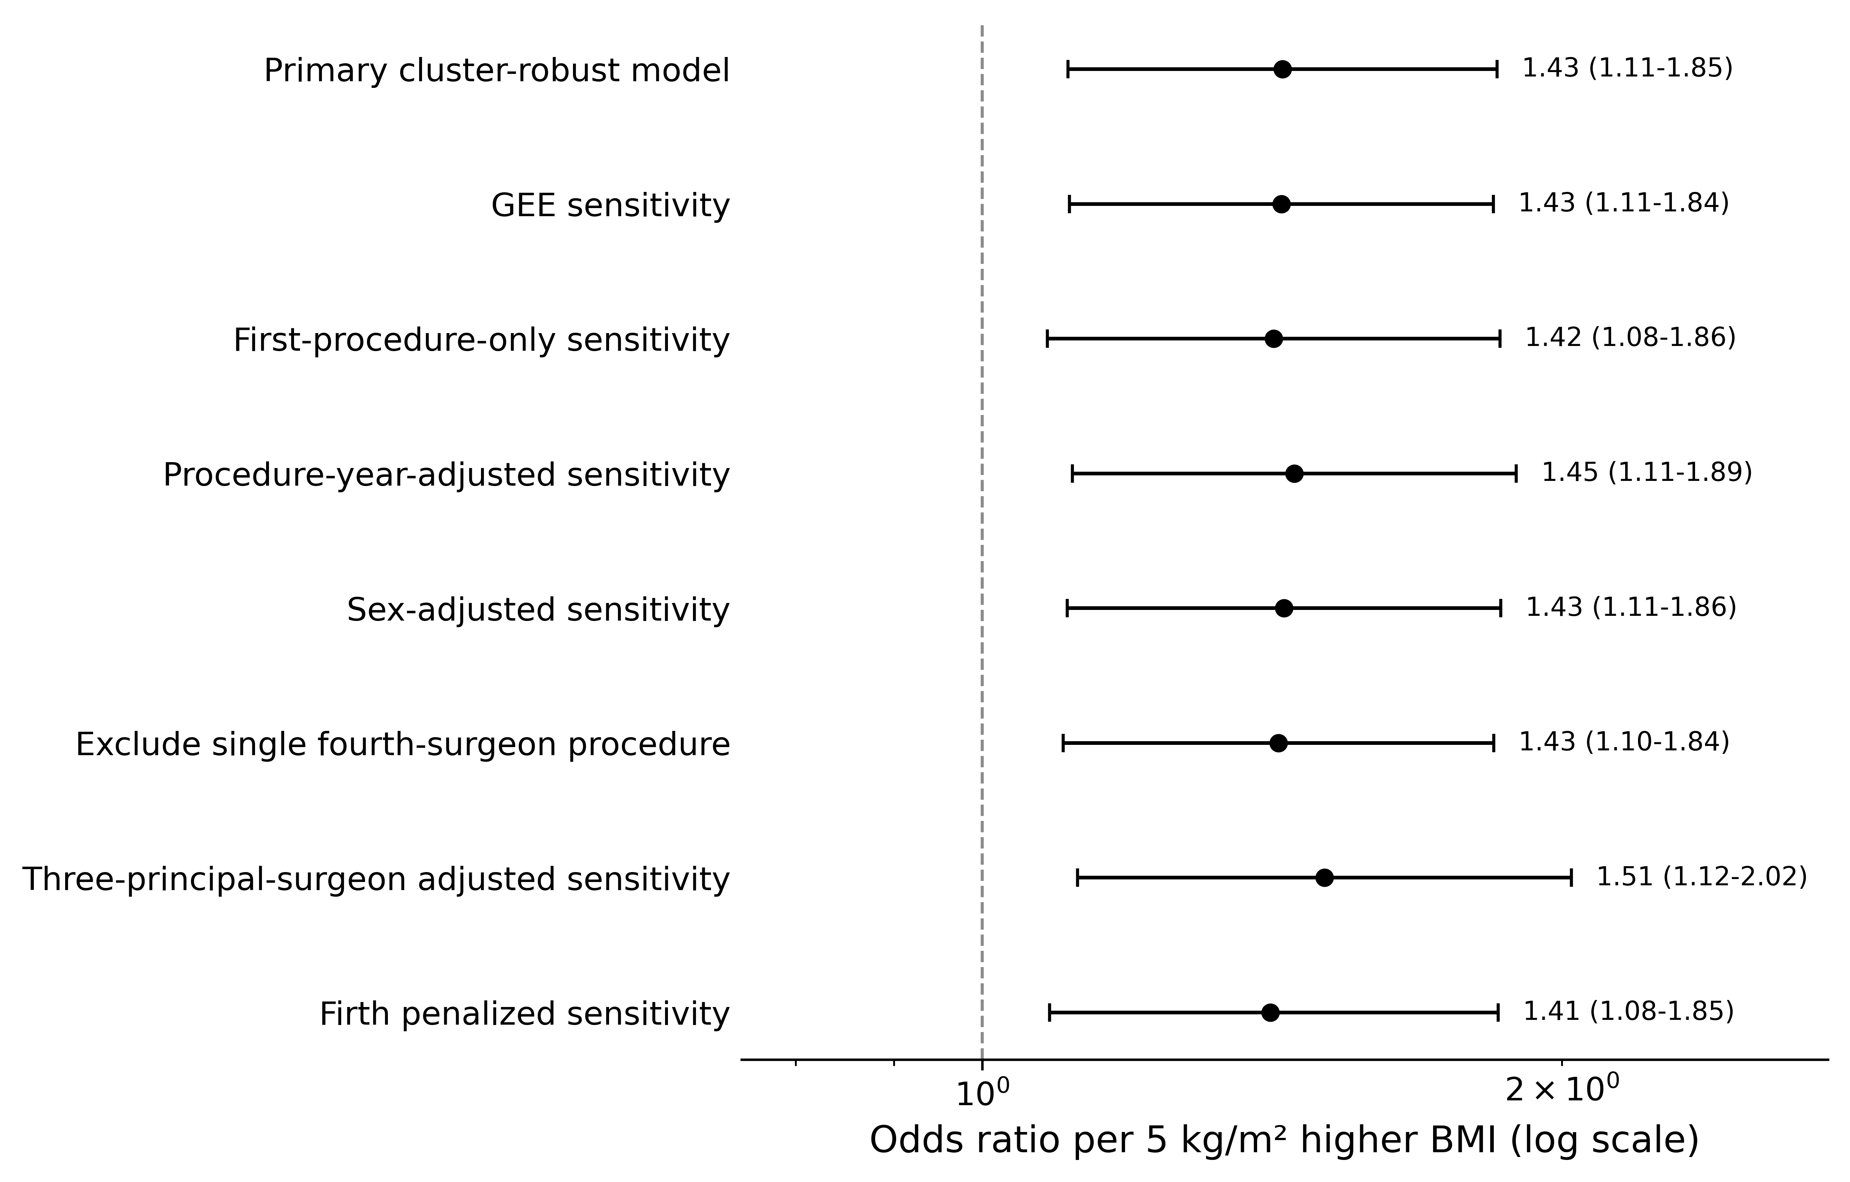
Forest plot of adjusted odds ratios per 5 kg/m² increase across the primary and sensitivity models. The linear odds ratio is an average summary; the restricted cubic spline identified nonlinearity.

Supplementary Figure S2. Return to usual activity by BMI group
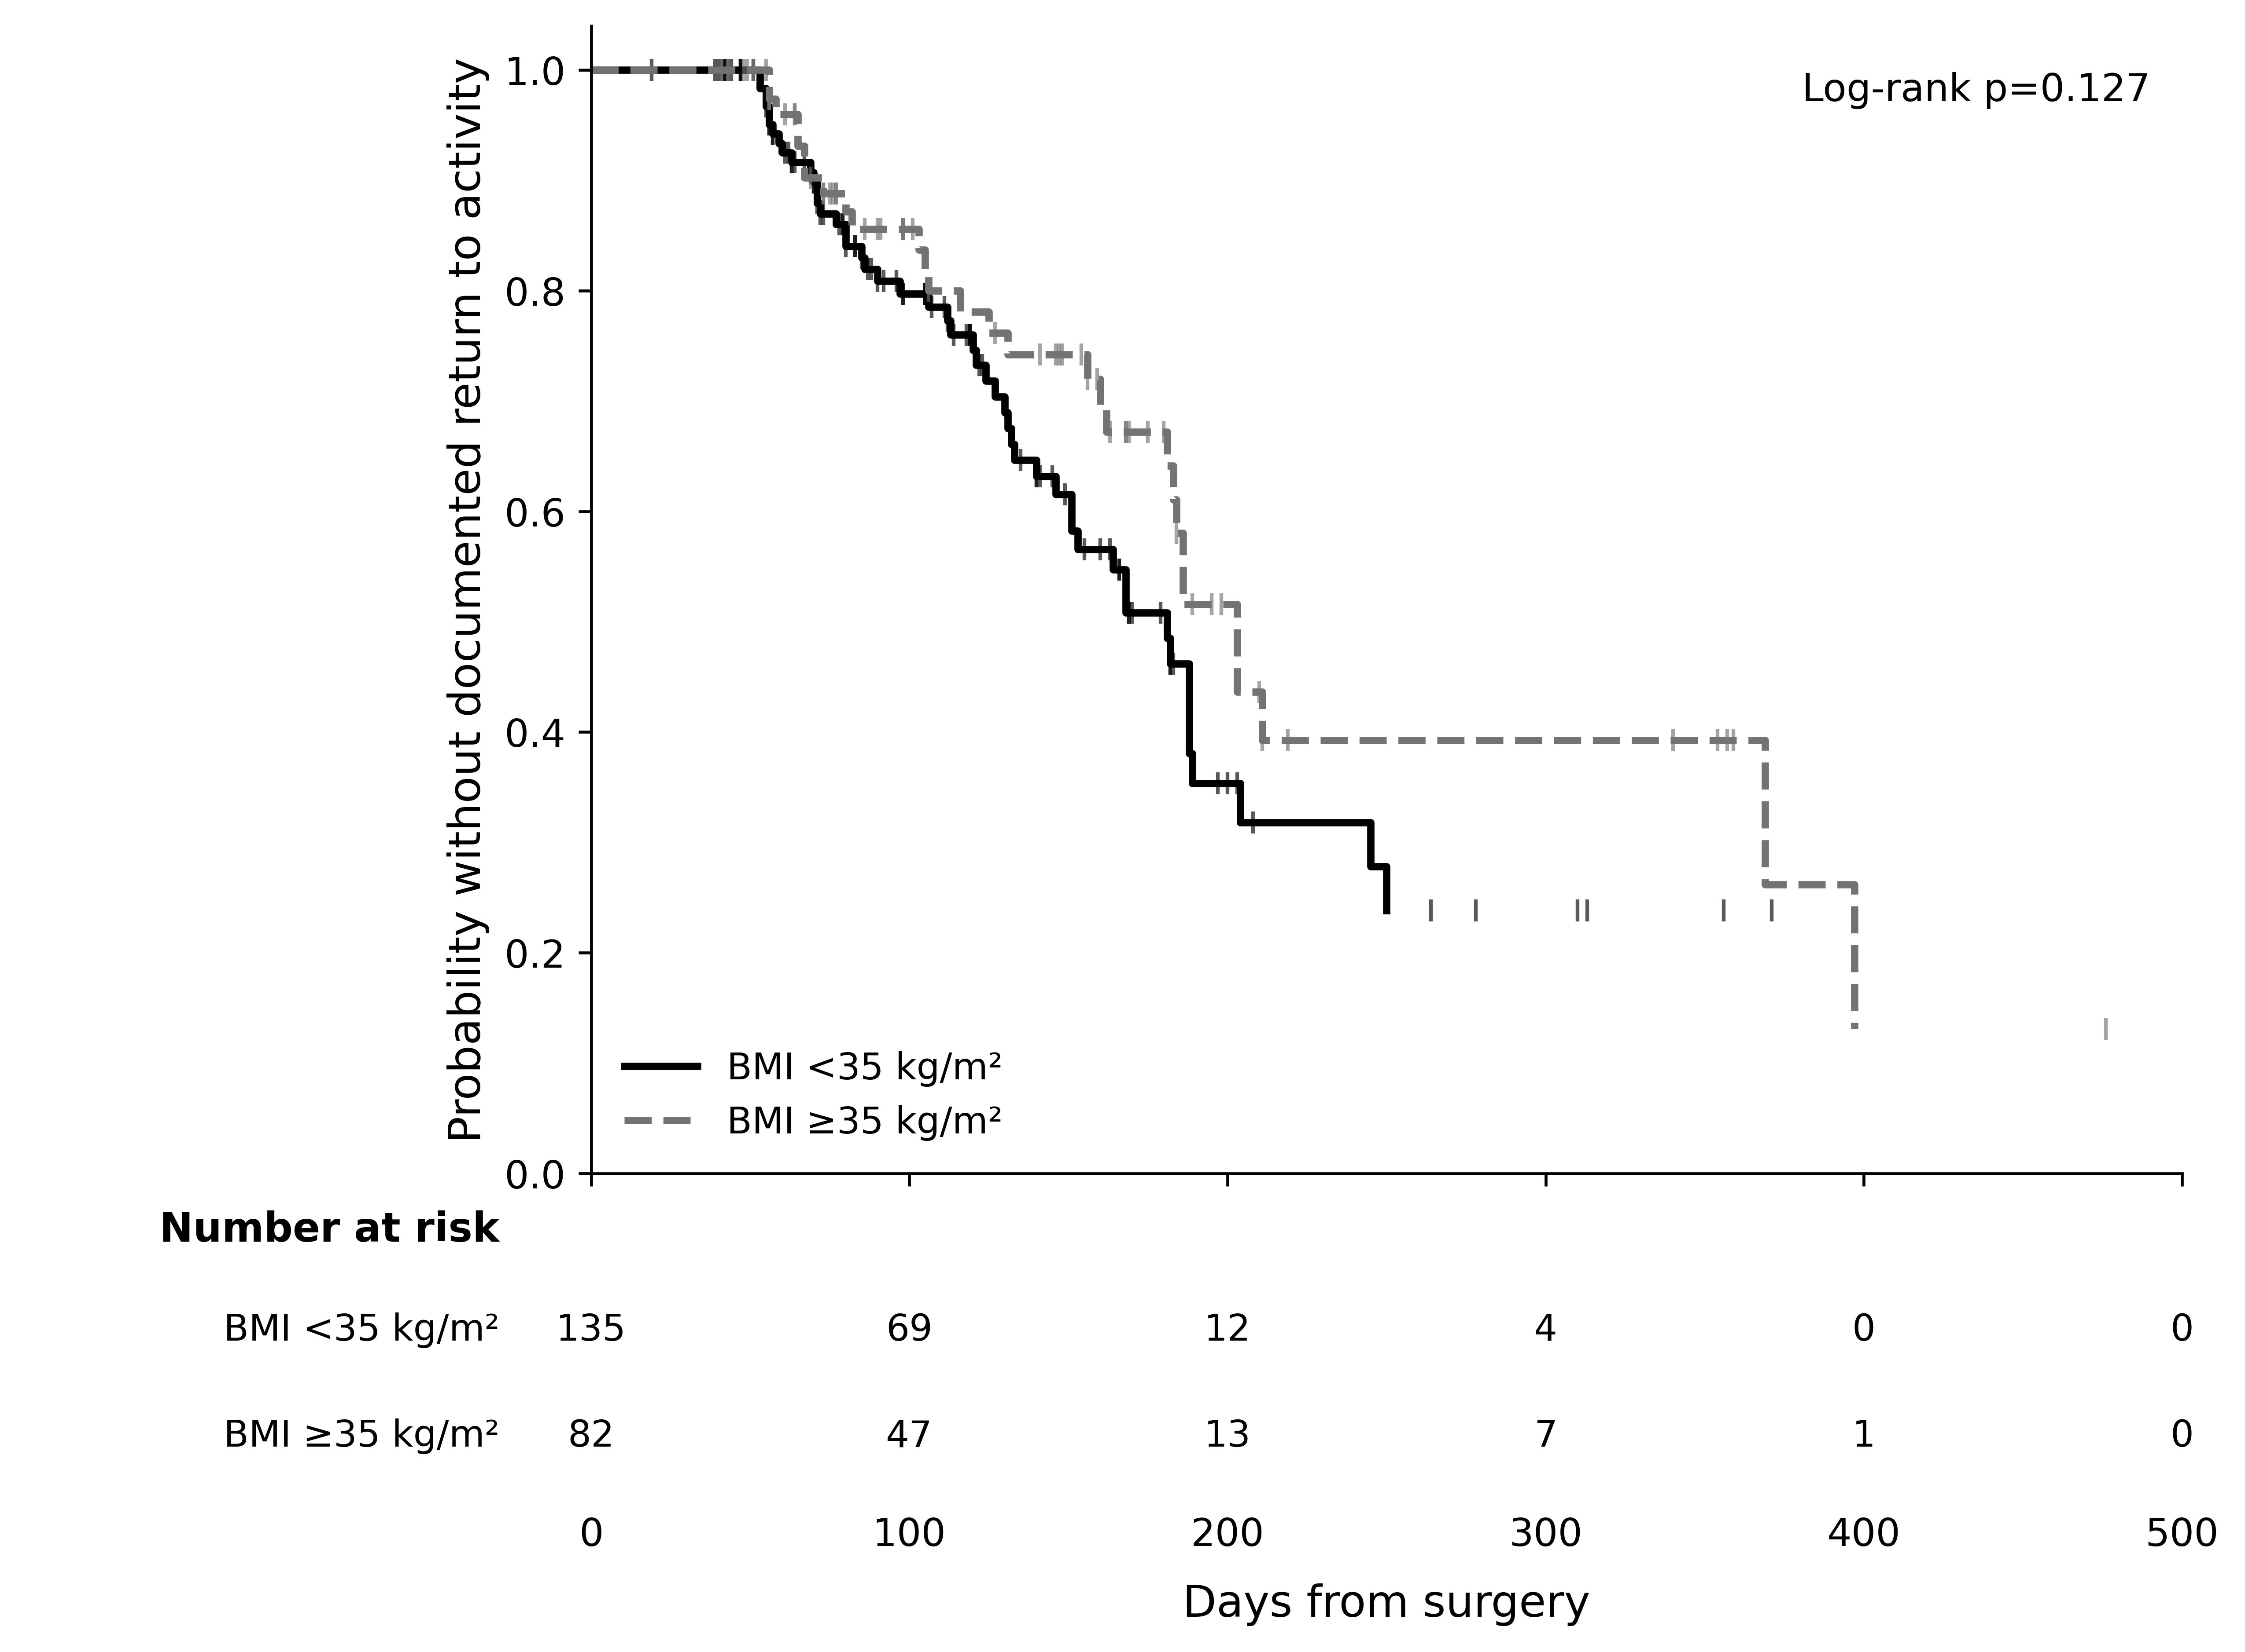
Kaplan-Meier curves for time to documented return to usual activity by the post hoc BMI 35 kg/m² cut point. Tick marks denote censoring, and numbers at risk are shown. The log-rank comparison was not significant, and the adjusted continuous-BMI Cox model was also negative.

Supplementary Figure S3. Cohort identification and exclusions
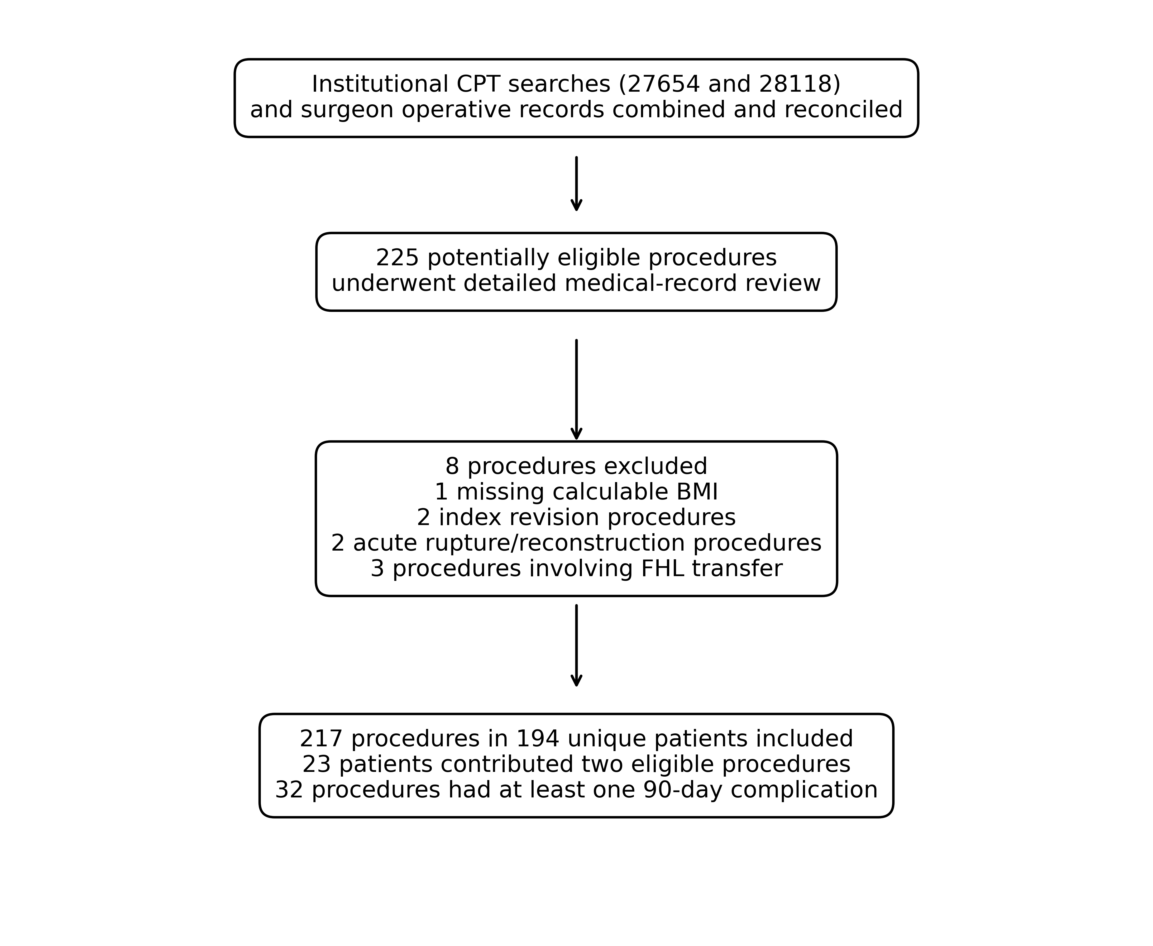
Flow diagram showing the 225 potentially eligible procedures that underwent full chart review, eight exclusions, and the final 217-procedure analytic cohort.

Supplementary Figure S4. Full-range BMI spline analysis
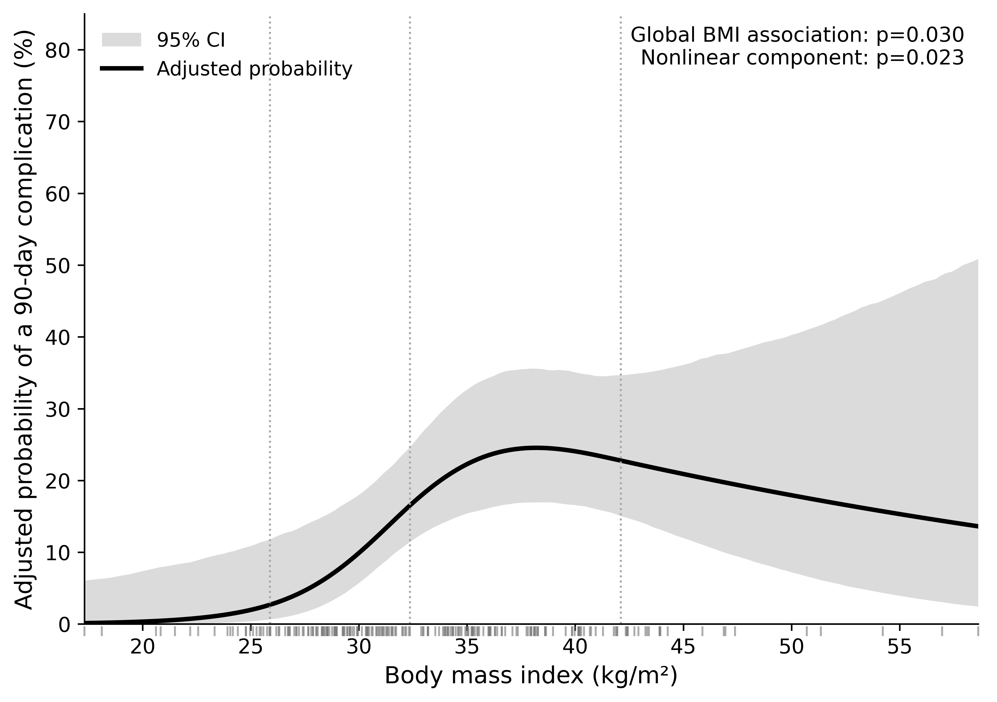
Adjusted marginal standardized probability of a 90-day postoperative complication across the full observed BMI range. Estimates at the extremes are imprecise because few procedures contributed data.

