Supplemental Materials
Contents

1. Supplementary Methods overview and scenario design 2
2. Projected active GLP-1 treatment prevalence. 4
3. Definition of Outcome Variables 7
4. Sensitivity Analysis Under Low and High Diffusion Pathways 8
5. GLP-1 induced dietary responses and food-demand pathways 17
6. Bayesian Estimation of the Generalized Bass Model 20
6.1. The standard Bass model and its closed-form solution 21
6.2. The Generalized Bass Model and the Cumulative Adoption Function 22
6.3. Construction of the market potential and market-effort variables 23
6.4. Likelihood, prior distributions, and posterior 38
6.5. Historical Data and Parameters of Innovation and Imitation 39
6.6. Markov chain Monte Carlo Estimation 41
6.7. Convergence Diagnostics and Posterior Summaries 42
6.8. Scenario Forecasting and Propagation of Parameter Uncertainty 42
6.9. Calibration of Discontinuation and Reinitiation 44
7. GTAP-RD model, database, baseline and counterfactual implementation 50
7.1. Model structure and database aggregation 50
7.2. SSP2 baseline construction 54
7.3. GLP-1 counterfactual demand pathways and model closure 55
7.4. Production-side environmental accounting 58

Supplementary Methods Overview and Scenario Design
The analysis uses a linked framework to trace how pharmaceutical diffusion and treatment persistence translate into population food-demand pathways and, subsequently, into economy-wide food-system outcomes. Pharmaceutical diffusion is modeled using a Bayesian Generalized Bass Model (GBM), which projects first-time GLP-1 adoption under alternative eligibility, access, affordability and awareness conditions. Treatment discontinuation and reinitiation then convert first-time adoption into annual active treatment prevalence. In parallel, clinical and food-demand evidence is used to construct per-user dietary responses. Randomized controlled trials provide the empirical anchor for changes in total energy intake, while complementary experimental, survey, purchase, and demand evidence informs differences across food categories. Active treatment prevalence and per-user dietary responses are combined to construct country-, year-, and food-category-specific population food-demand pathways. These pathways are introduced into GTAP-RD, a recursive-dynamic computable general equilibrium model calibrated to the 2017 GTAP Data Base, to evaluate economy-wide adjustment from 2026 to 2030. Detailed specification of the diffusion model, dietary calibration, and GTAP-RD implementation is provided in Sections 5–7.
The counterfactual design varies three dimensions. The first concerns treatment eligibility and access. Under current eligibility and access conditions, market potential is operationalized using the adult population with obesity, defined as BMI ≥30, combined with country- and year-specific practical access to treatment. Expanded weight-management access uses the larger population with overweight, defined as BMI ≥25 and including adults with obesity, together with a broader practical-access trajectory. Market potential therefore reflects both the population potentially eligible for treatment and the share that can realistically obtain it under the applicable regulatory, insurance, reimbursement, prescribing, and market conditions. In the diffusion model, major changes in eligibility and practical access affect the market-potential ceiling.
The second dimension concerns the speed of pharmaceutical diffusion. Within each eligibility and access condition, low, middle and high diffusion pathways represent alternative trajectories for affordability, accessibility, and awareness. These pathways alter the speed at which adoption approaches the scenario-specific market potential, but do not alter the market-potential ceiling itself. The middle pathway is used for the main analysis, while the low and high pathways provide sensitivity analyses around alternative rates of diffusion. Detailed construction of market potential, market-effort variables, and uncertainty propagation is provided in Sections 5.3–5.8.
The third dimension concerns geographic scope. Under U.S.-only adoption, the resulting GLP-1-induced food-demand pathways are applied only in the United States, while all other countries, including Canada and Mexico, follow their baseline trajectories with no GLP-1-induced food-demand adjustment.. Under North America-wide adoption, corresponding country-specific pathways are applied simultaneously in the United States, Canada and Mexico. This comparison distinguishes domestic adjustment associated with U.S. treatment diffusion from the additional market effects generated when GLP-1 adoption also expands among major regional trading partners.
Crossing two eligibility and access conditions, three diffusion pathways, and two geographic scopes generates 12 counterfactual pathways. The main-text analysis reports the four combinations associated with the middle diffusion pathway. The corresponding eight low- and high-diffusion pathways are reported in the Supplementary Information as sensitivity analyses. For the United States, diffusion uncertainty is propagated from the posterior distribution of the estimated Bayesian GBM. Because comparable historical adoption series are unavailable for Canada and Mexico, projections for these countries are generated using prior-predictive simulations under the same scenario structure.
GTAP-RD is calibrated to the 2017 GTAP Data Base and used to generate two sets of linked dynamic simulations. The first is an SSP2 baseline describing the evolution of the economy to 2030 in the absence of GLP-1-induced food-demand changes. The second consists of the corresponding GLP-1 counterfactual pathways, which retain the same underlying macroeconomic baseline assumptions but incorporate the country-, year-, and food-category-specific demand pathways generated by the pharmaceutical-diffusion and dietary-response components. Counterfactual outcomes are evaluated relative to the corresponding SSP2 baseline. Detailed database preparation, dynamic baseline construction, model structure, and counterfactual implementation are provided in Section 7.
The overall analytical sequence is summarized in main-text Fig. 5. The framework distinguishes first-time adoption from active treatment prevalence, combines active treatment prevalence with per-user dietary responses to construct population food-demand pathways, and links these pathways to the GTAP-RD baseline and counterfactual simulations used to quantify production, price, trade, land-use, factor-return, and production-side environmental outcomes.

Projected Active GLP-1 Treatment Prevalence.
We projected annual active treatment prevalence for the United States, Canada, and Mexico under low, middle and high diffusion pathways and under current eligibility and access conditions and expanded weight-management access (Fig. S1). The three diffusion pathways represent alternative rates of approach toward the scenario-specific market potential. The middle pathway provides the central projections used in the main analysis, while the low and high pathways are used for sensitivity analysis. The three adoption trajectories have similar overall shapes because they share the same scenario-specific adoption ceiling, but they differ in diffusion speed because the low, middle, and high pathways embody different assumptions about how market access, affordability, insurance and reimbursement, regulatory availability, and awareness evolve over time. For the United States, uncertainty reflects posterior parameter draws from the estimated Bayesian GBM. For Canada and Mexico, comparable historical adoption series are unavailable, so uncertainty reflects prior-predictive simulations. Detailed model specification and forecasting procedures are provided in Section 5.
United States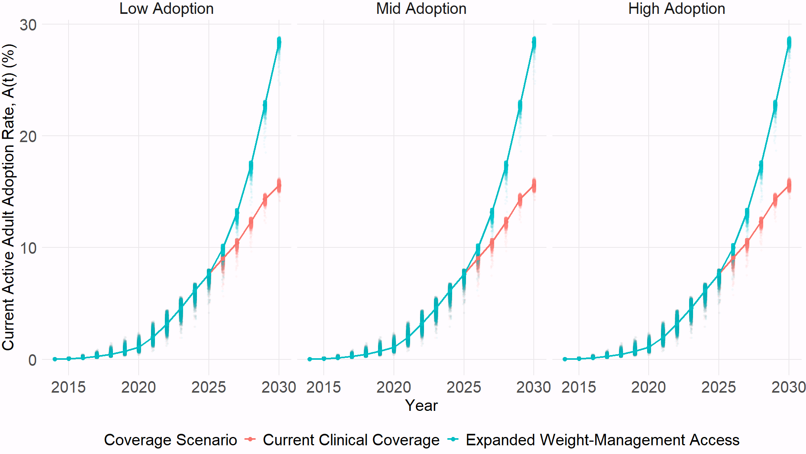
Canada
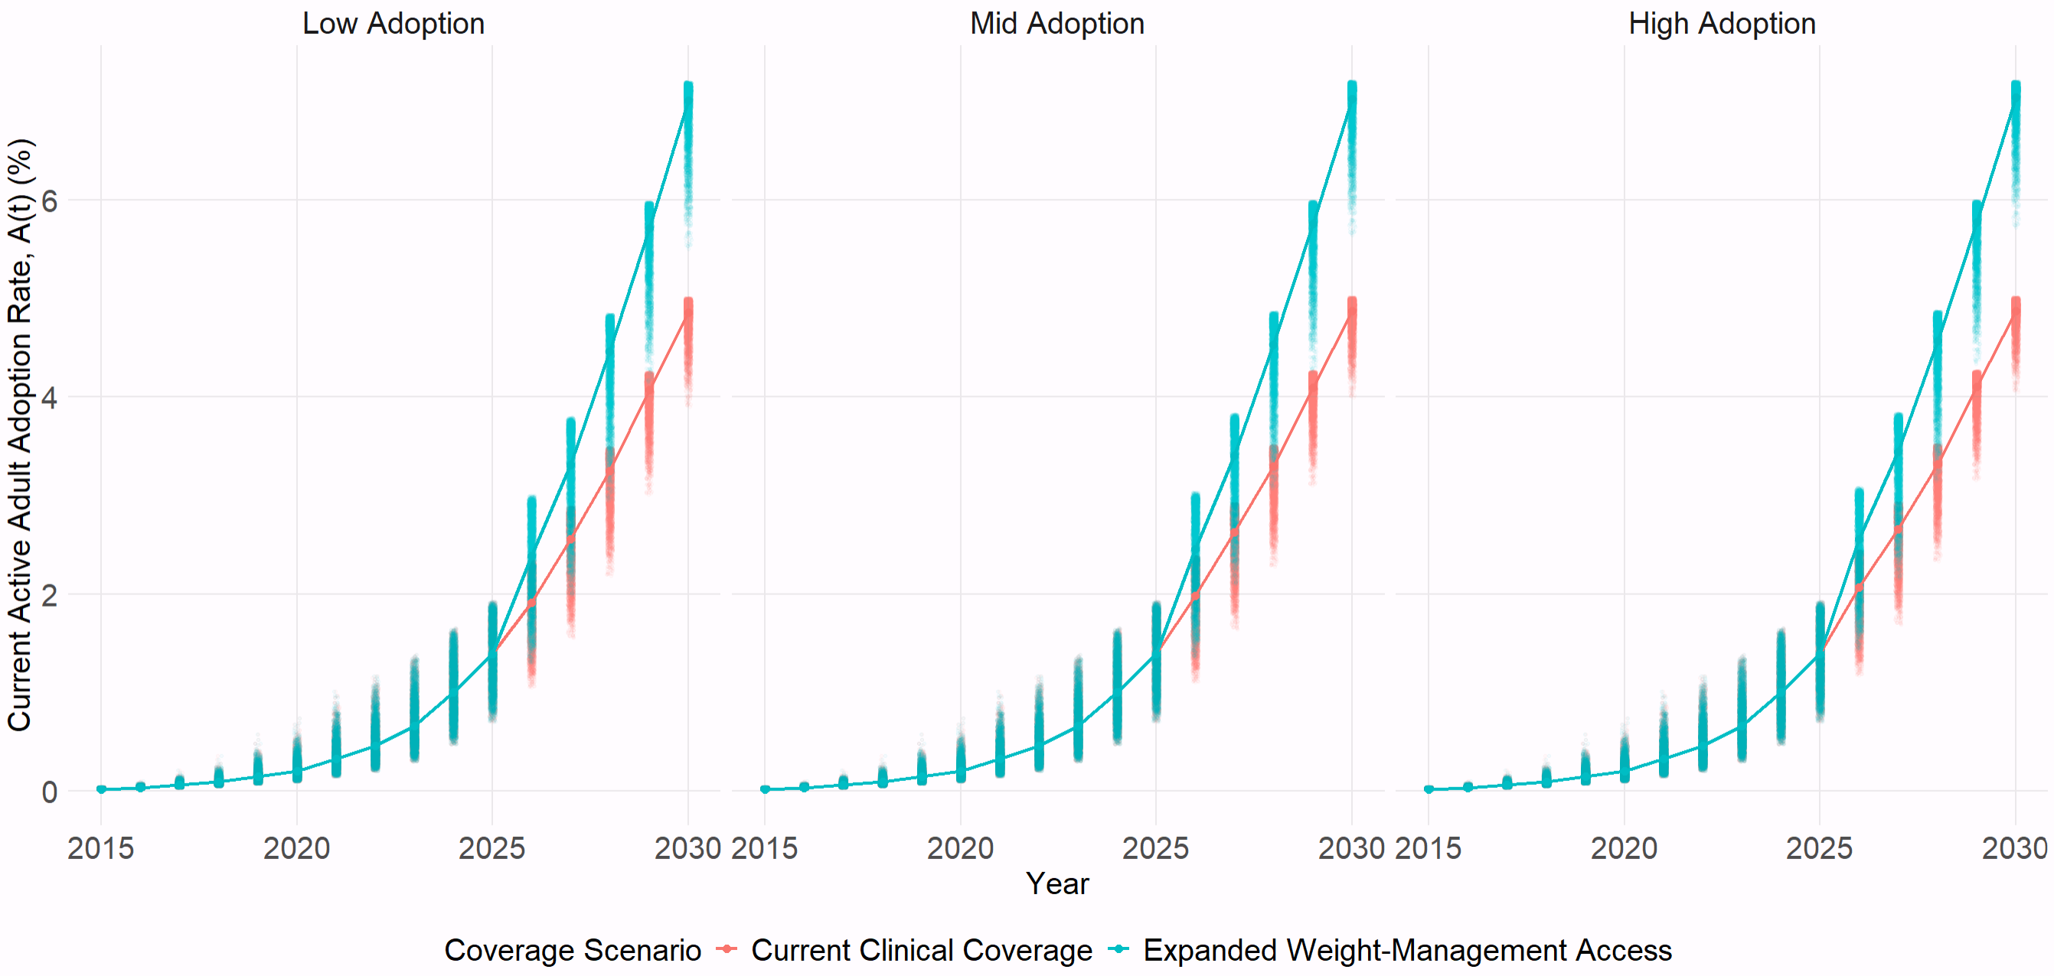

Mexico
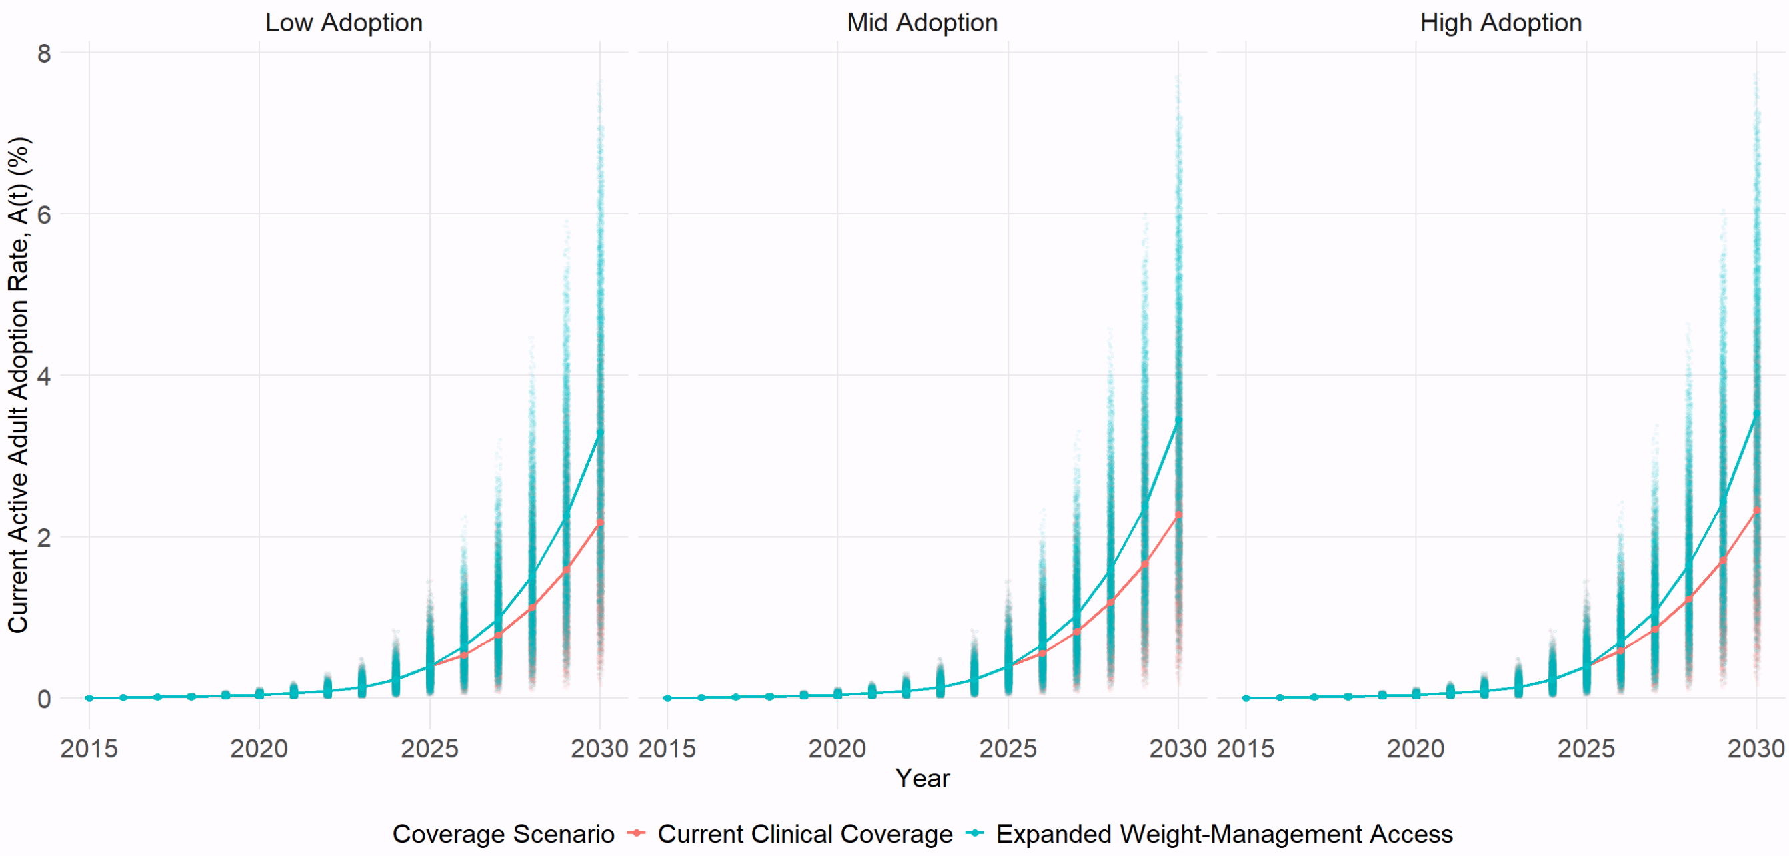
Fig. S1 | Simulated GLP-1 current active adult adoption rates under low, middle, and high adoption pathways. Panels report simulated current active adult adoption rates for the United States, Canada, and Mexico under three market-effort pathways (low, middle, and high adoption; columns) and two coverage scenarios, current clinical coverage and expanded weight-management access. Solid lines denote median simulated trajectories and the surrounding distributions represent parameter uncertainty. For the United States, uncertainty is propagated from posterior parameter draws from the estimated Bayesian GBM; for Canada and Mexico, it reflects prior-predictive draws because comparable historical adoption data are unavailable for country-specific posterior estimation.

Table S1. Adoption Rate Among Adult for Middle Pathway (%)
 | U.S. |  | CA |  | MX
 | Current Clinical Coverage | Expanded Weight-management Access | Current Clinical Coverage | Expanded Weight-management Access | Current Clinical Coverage | Expanded Weight-management Access
2026 | 9.00 | 9.90 | 1.93 | 2.41 | 0.61 | 0.73
2027 | 10.44 | 13.12 | 2.55 | 3.31 | 0.90 | 1.13
2028 | 12.28 | 17.33 | 3.20 | 4.41 | 1.27 | 1.71
2029 | 14.34 | 22.74 | 4.01 | 5.61 | 1.76 | 2.50
2030 | 15.58 | 28.38 | 4.81 | 6.91 | 2.36 | 3.57

Definition of Outcome Variables
Table S2. Definitions of Global Trade Analysis Project (GTAP)- the Recursive Dynamic (RD) model outcome variables
Farmgate price | Price received by domestic producers for a sector’s output at the producer or supply level.
Domestic production volume | Quantity of output produced and supplied by the domestic sector.
Import volume | Quantity of a sector’s aggregate imports entering the domestic economy from foreign sources.
Export volume | Quantity of a sector’s aggregate exports supplied by the domestic economy to foreign markets.
Land use change | Percentage change in the quantity of the land endowment employed by a sector relative to the baseline. In GTAP-RD, land is treated as a sluggish factor that is imperfectly mobile across agricultural activities and reallocates in response to sector-specific land returns. Aggregate regional land supply may also respond to land rents through the model’s land-supply relationship. The reported measure therefore represents changes in sectoral land-factor use rather than direct physical land-cover change or hectares converted.
Real wages | Real return to labor, defined as the return to the labor factor relative to the regional consumer price level. It therefore captures the change in labor compensation after accounting for changes in purchasing power.
Capital returns | Real return to capital used as a primary factor of production, measured relative to the regional consumer price level. It captures changes in the purchasing-power-adjusted compensation to capital services, rather than the value of the capital stock itself.
Agricultural land rents | Real return to agricultural land as a primary factor of production, measured relative to the regional consumer price level. It represents the change in the economic rental return to land and is distinct from the quantity of land used.
Note: Unless otherwise stated, outcomes are reported as percentage deviations from the corresponding 2030 baseline. Price and quantity measures therefore represent proportional changes relative to the baseline rather than absolute price or quantity changes. Real wages, capital returns, and agricultural land rents are real primary-factor returns derived from the GTAP-RD factor-return measure.

Sensitivity Analysis Under Low and High Diffusion Pathways
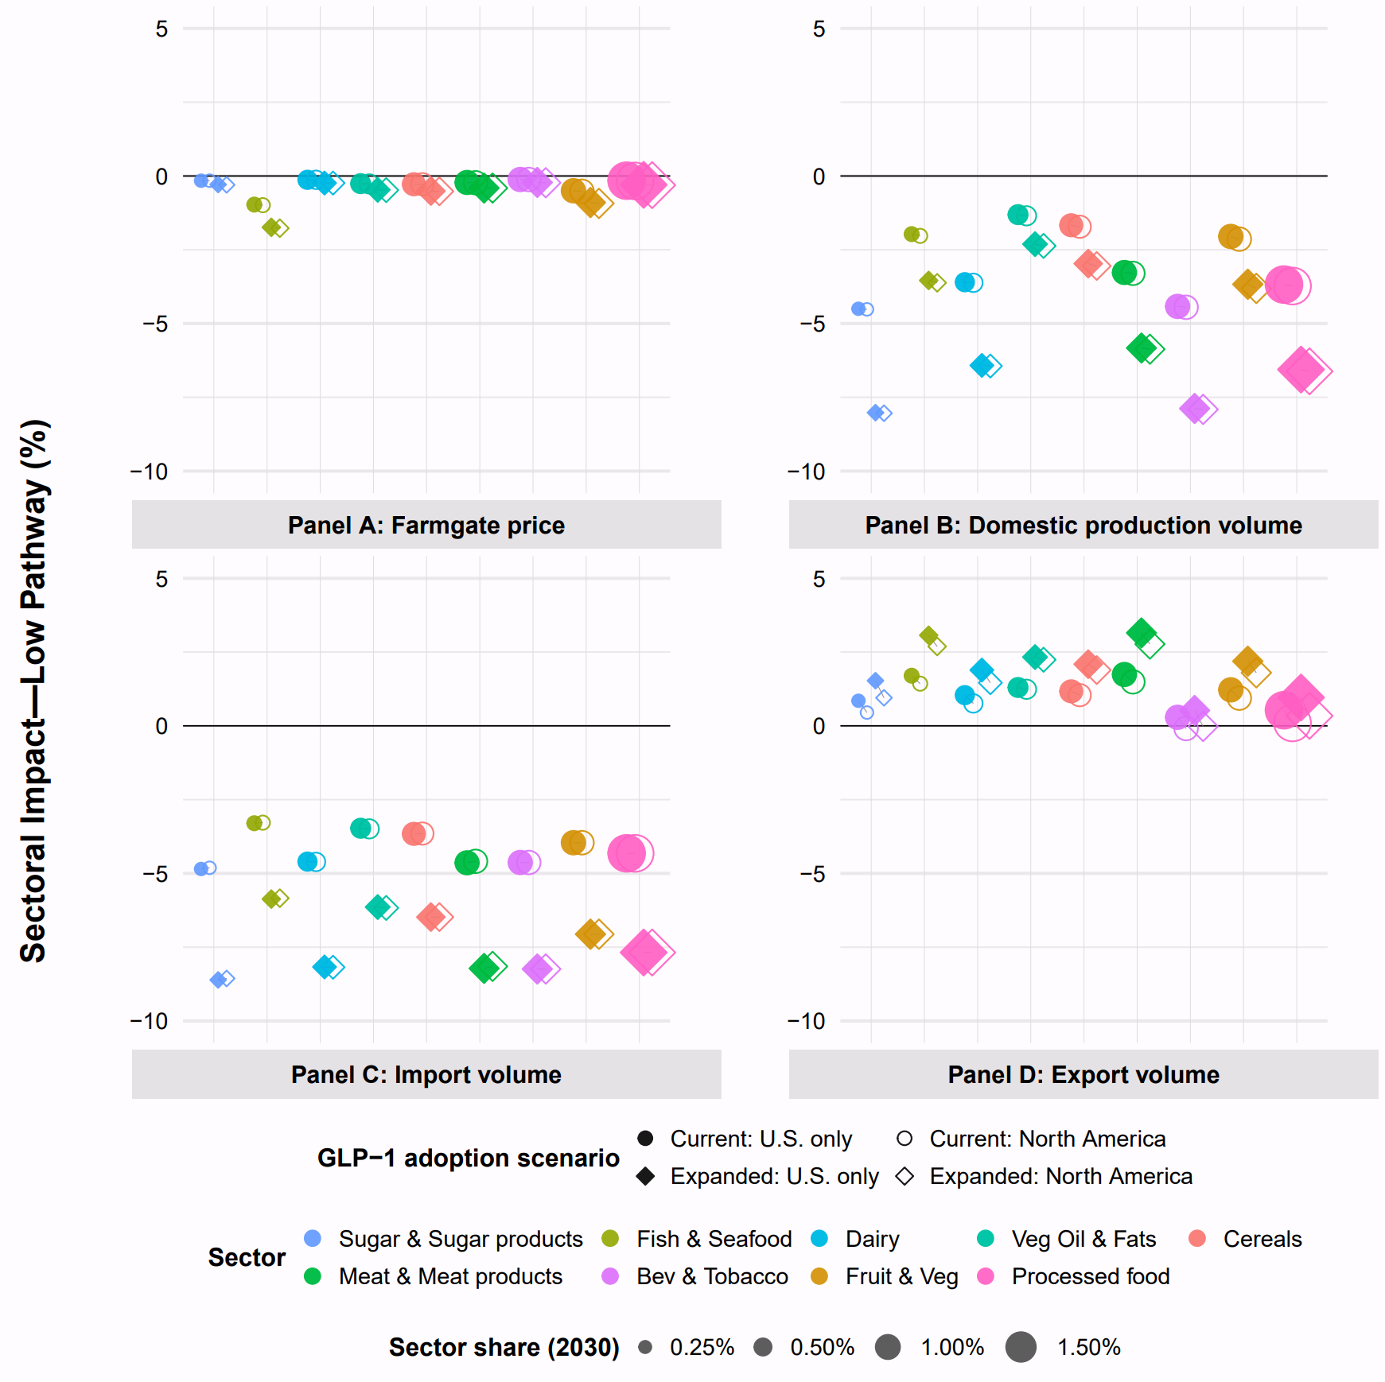
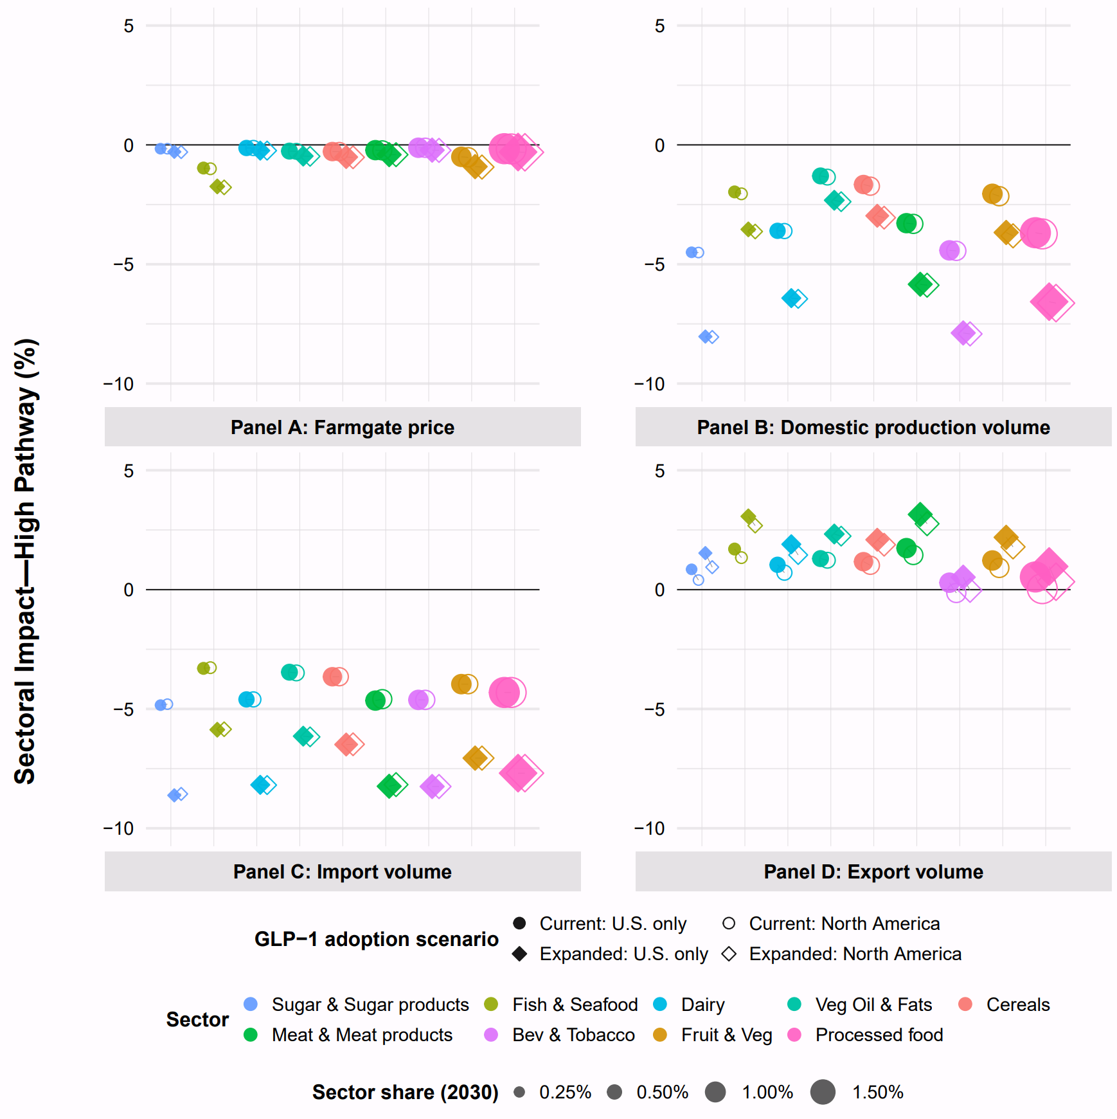
Fig. S2 | Cumulative sectoral deviations from the 2030 baseline in the U.S. under low- and high-adoption pathway across different scenarios. Panels A to D report farmgate prices, domestic production volume, import volume, and export volume, respectively. Together, the nine food-related sectors shown account for approximately 7% of total U.S. domestic production value in the 2030 GTAP baseline. Marker size represents each sector’s relative share, and sectors are ordered from smallest to largest from left to right. For each sector, filled and hollow circles represent sector-specific percentage changes relative to the baseline under current clinical coverage with U.S.-only and North America-wide GLP-1 adoption, respectively. Filled and hollow diamonds represent the corresponding changes under expanded weight-management access with U.S.-only and North America-wide GLP-1 adoption, respectively. Positive values indicate increases relative to the baseline, whereas negative values indicate contractions.

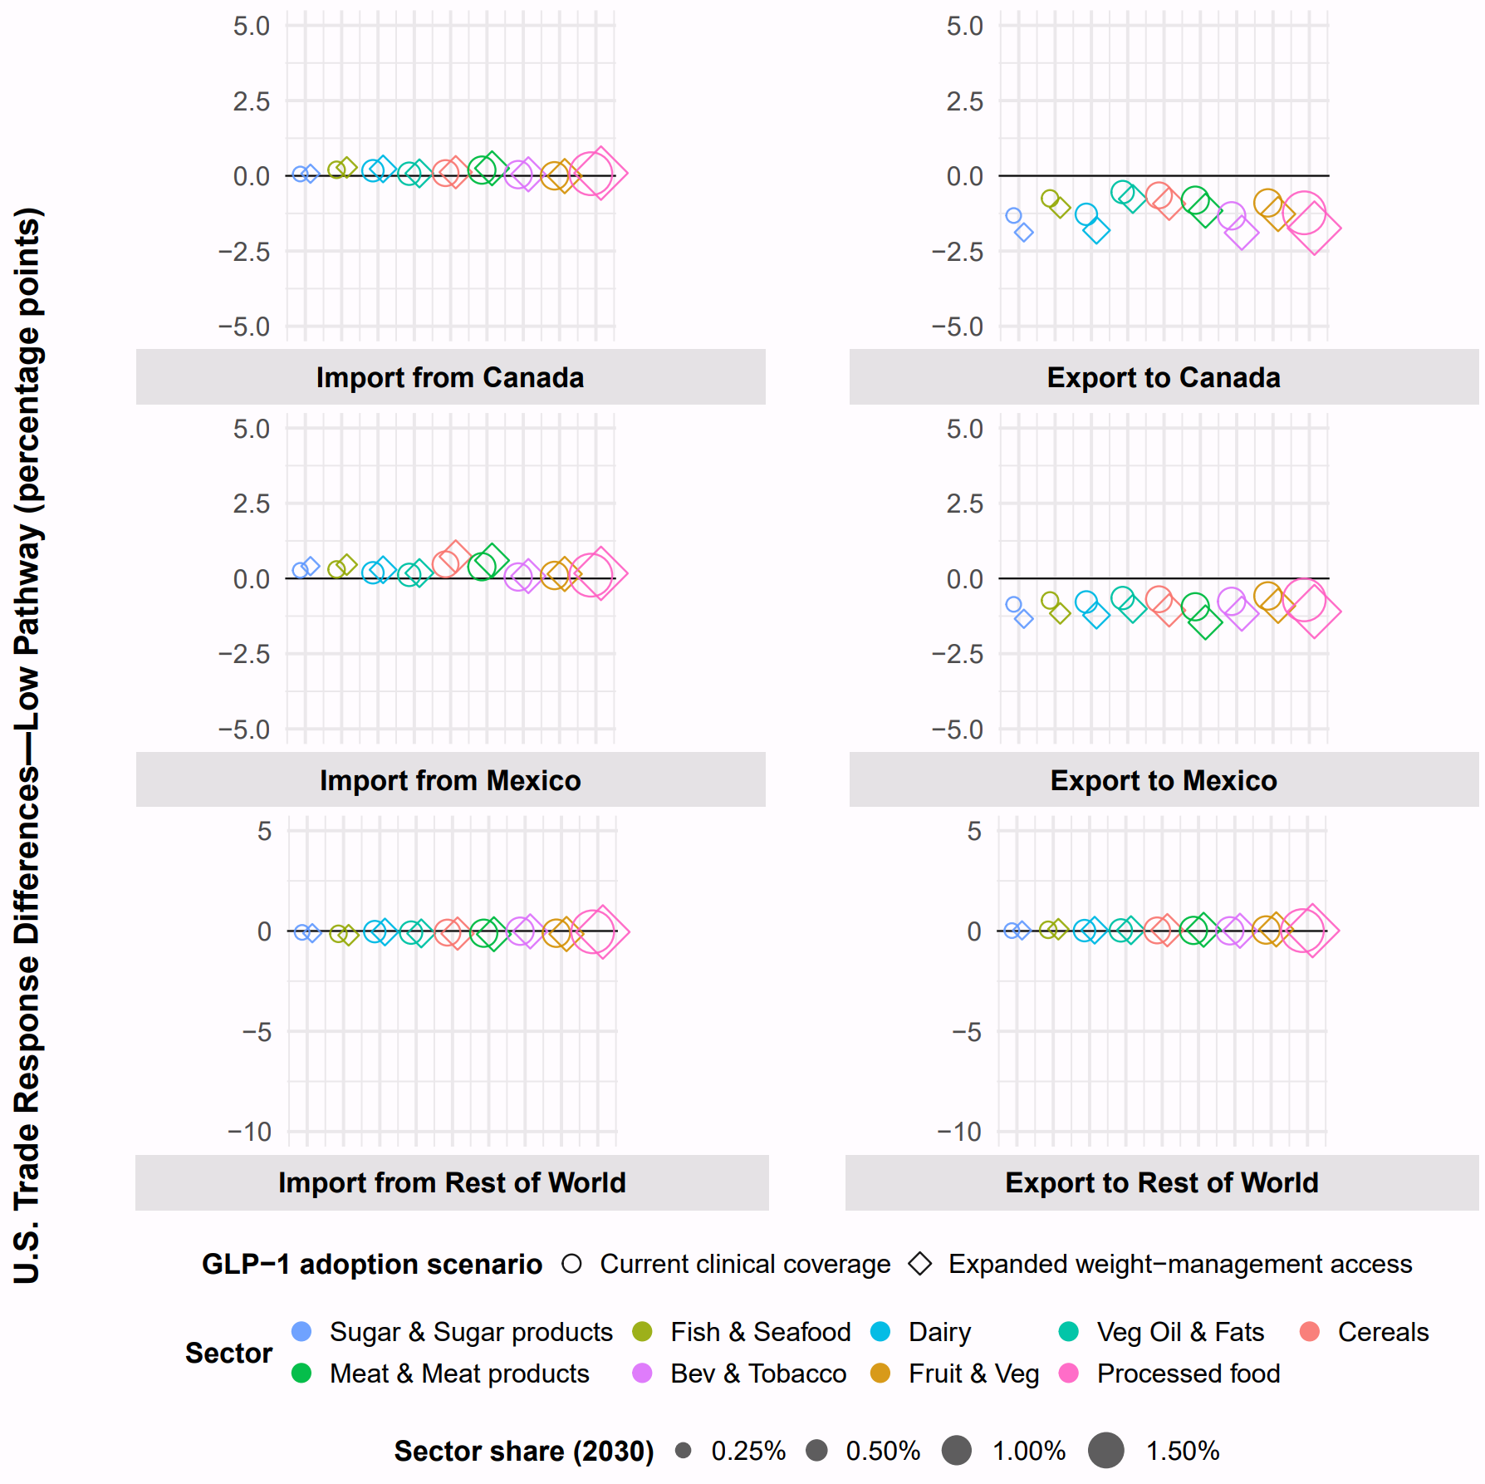
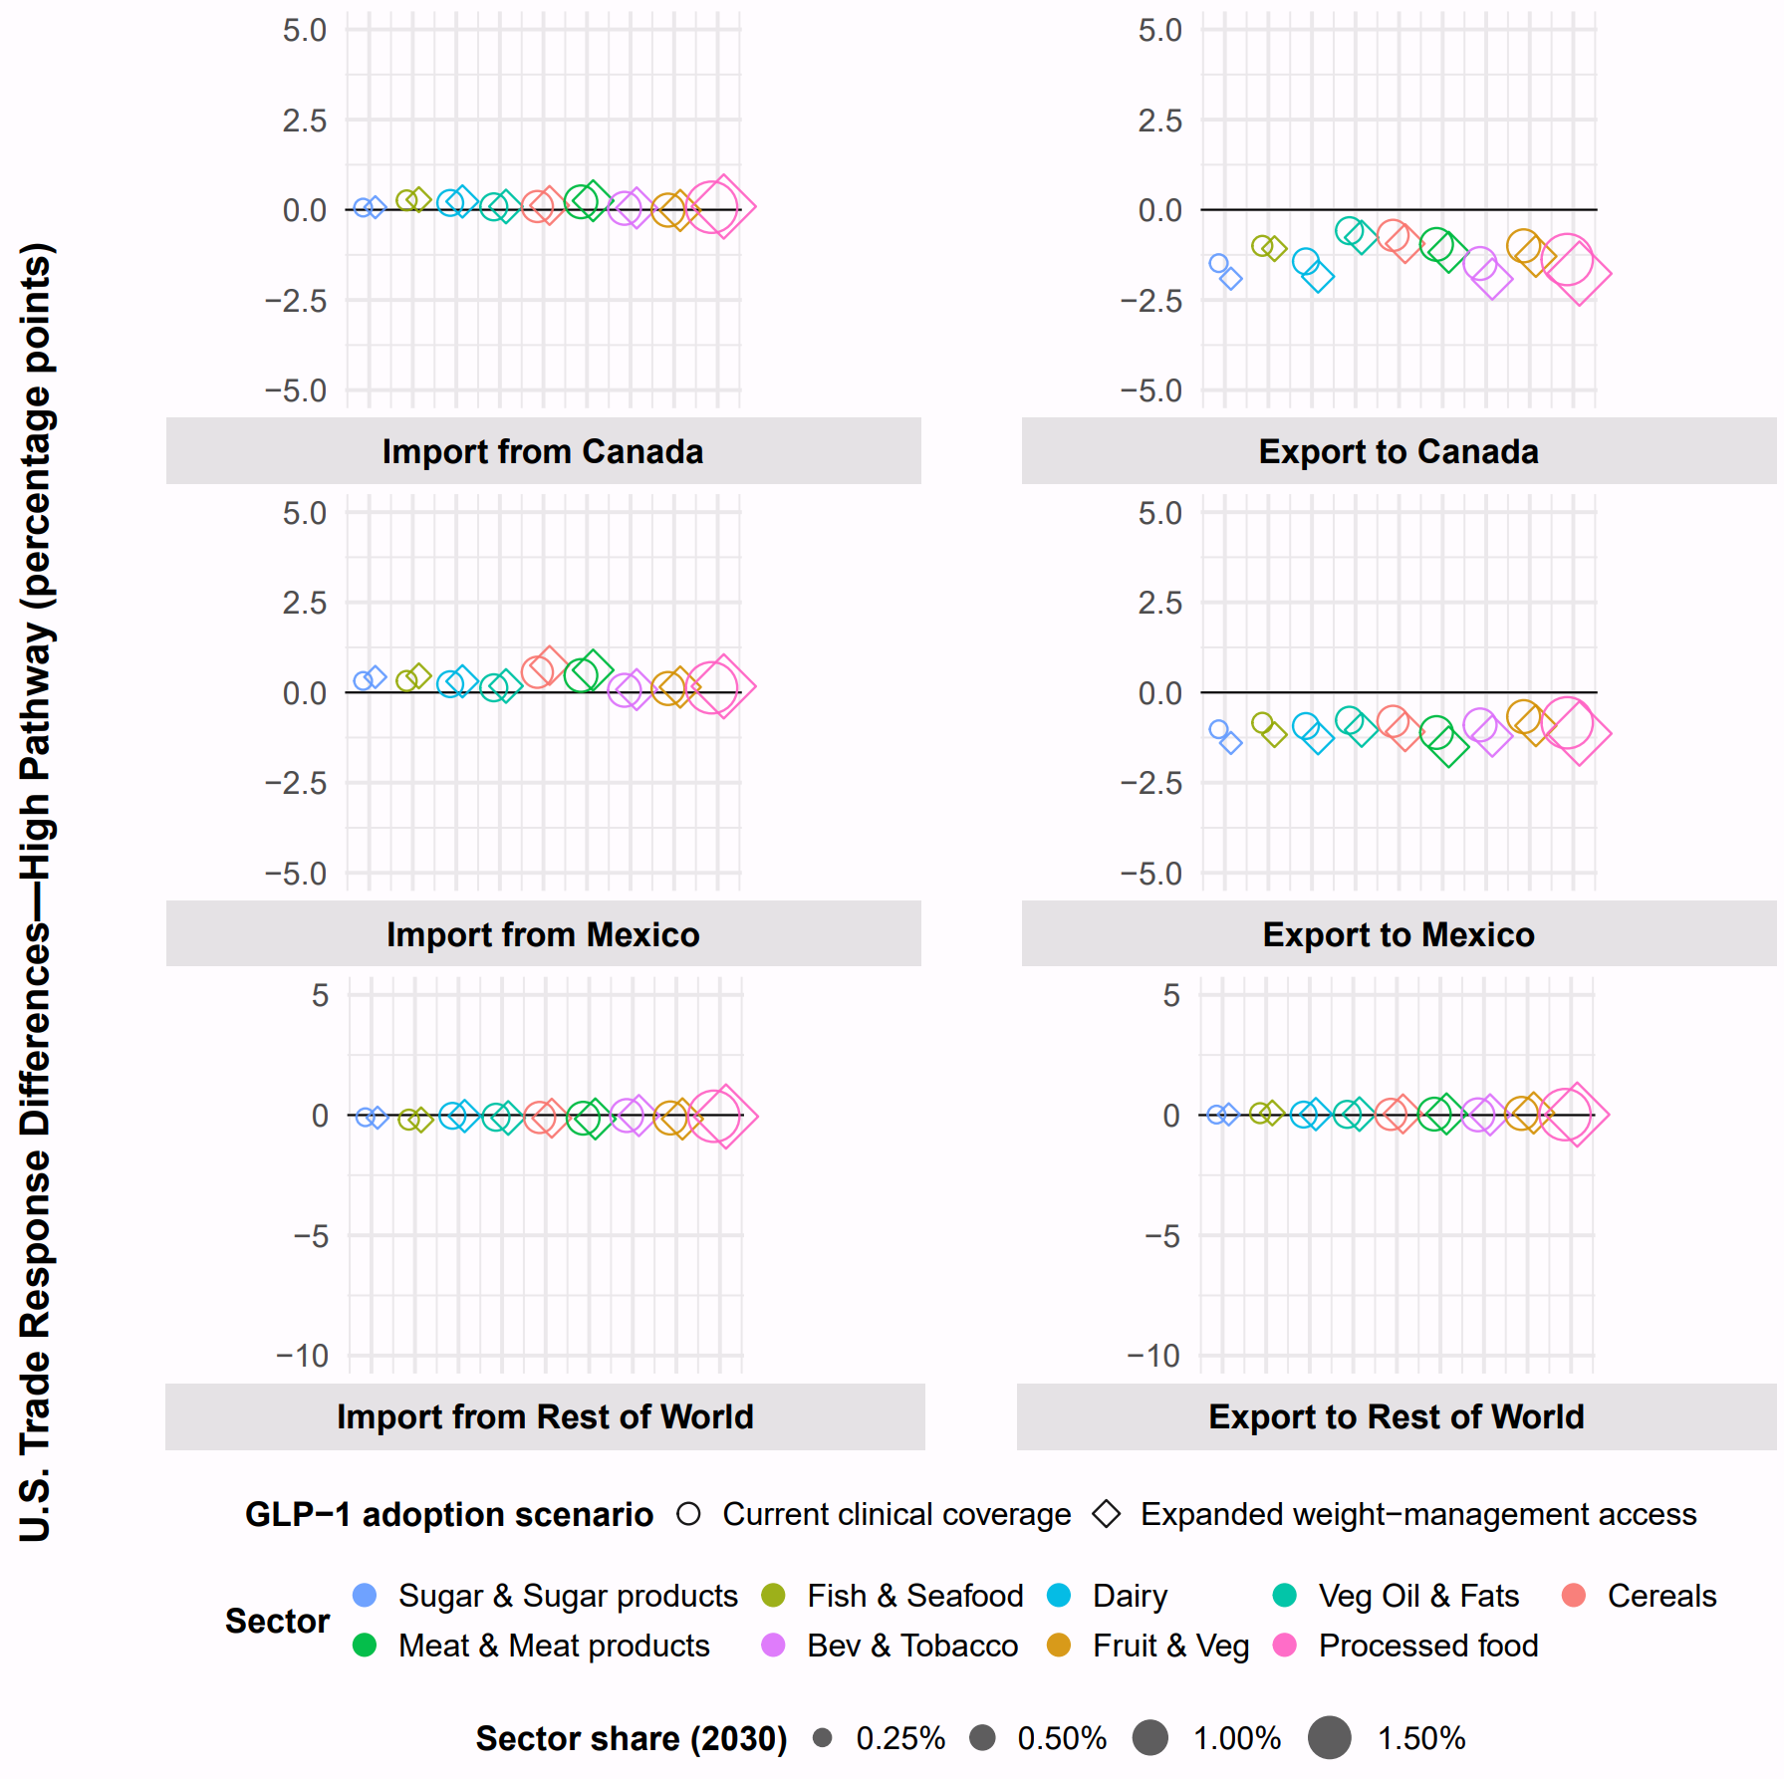
Fig. S3 | Differences in U.S. cumulative import and export responses relative to the 2030 baseline between North America-wide and U.S.-only GLP-1 adoption scenarios under the low- and high--adoption pathway. Panels report percentage-point differences in U.S. imports from and exports to Canada, Mexico, and the rest of the world. Together, the nine food-related sectors shown account for approximately 7% of total U.S. domestic production value in the 2030 GTAP baseline. Marker size represents each sector’s relative share, and sectors are ordered from smallest to largest from left to right. For each sector, circles and diamonds represents the North America-wide minus U.S. only deviation from 2030 baseline under the middle adoption path for current clinical coverage and expanded weight-management access, respectively. Positive values indicate larger U.S. imports or exports deviation under the North America-wide scenario relative to the U.S.-only scenario, while negative values indicate smaller trade flows under North America-wide adoption.

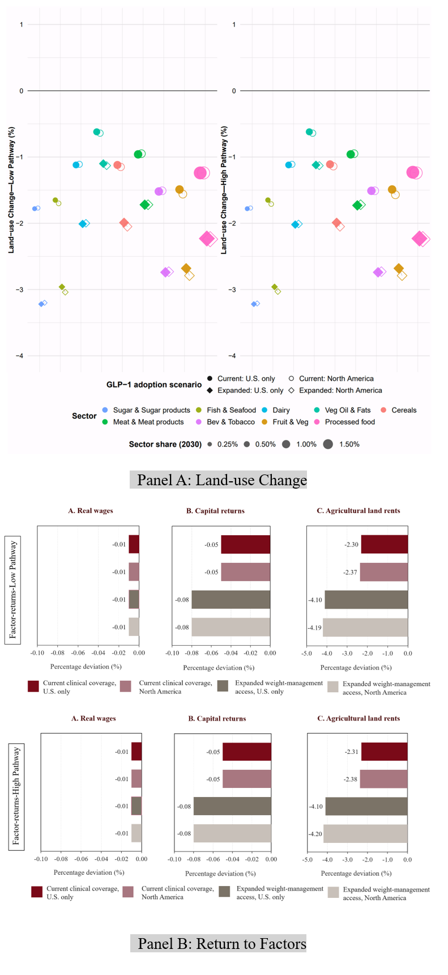
Fig. S4 | Cumulative land-use and factor-return deviations from the 2030 U.S. baseline under low- and high-adoption pathways. Panel A reports cumulative percentage changes in land use across nine food-related sectors, which together account for approximately 7% of total U.S. domestic production value in the 2030 GTAP baseline. Marker size represents each sector’s baseline share, and sectors are ordered from smallest to largest from left to right. Filled and hollow circles represent current clinical coverage with U.S.-only and North America-wide GLP-1 adoption, respectively, while filled and hollow diamonds represent expanded weight-management access under U.S.-only and North America-wide adoption. Positive values indicate increases relative to the baseline, whereas negative values indicate contractions. Panel B reports cumulative percentage deviations in real wages, capital returns, and agricultural land rents under the corresponding coverage and geographic-adoption scenarios for the low- and high-adoption pathways. Across scenarios, changes in real wages and capital returns are small, while agricultural land rents exhibit substantially larger declines, particularly under expanded weight-management access.

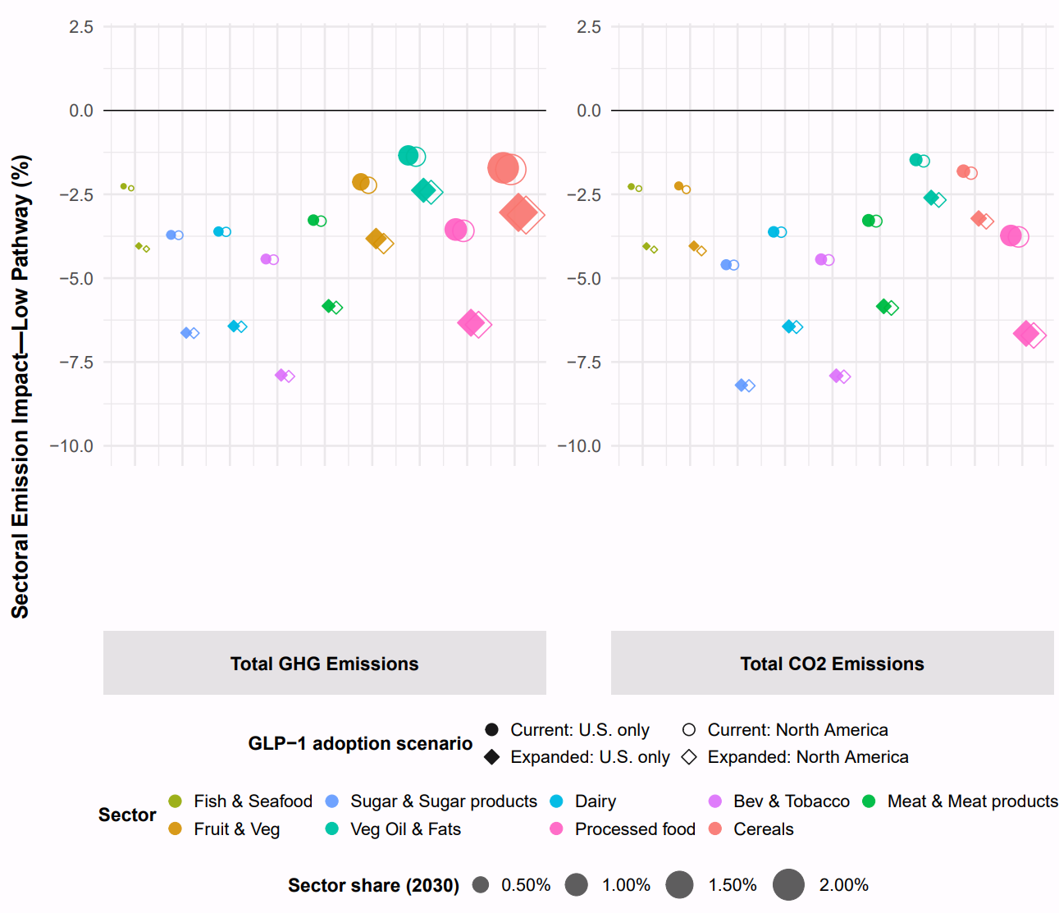
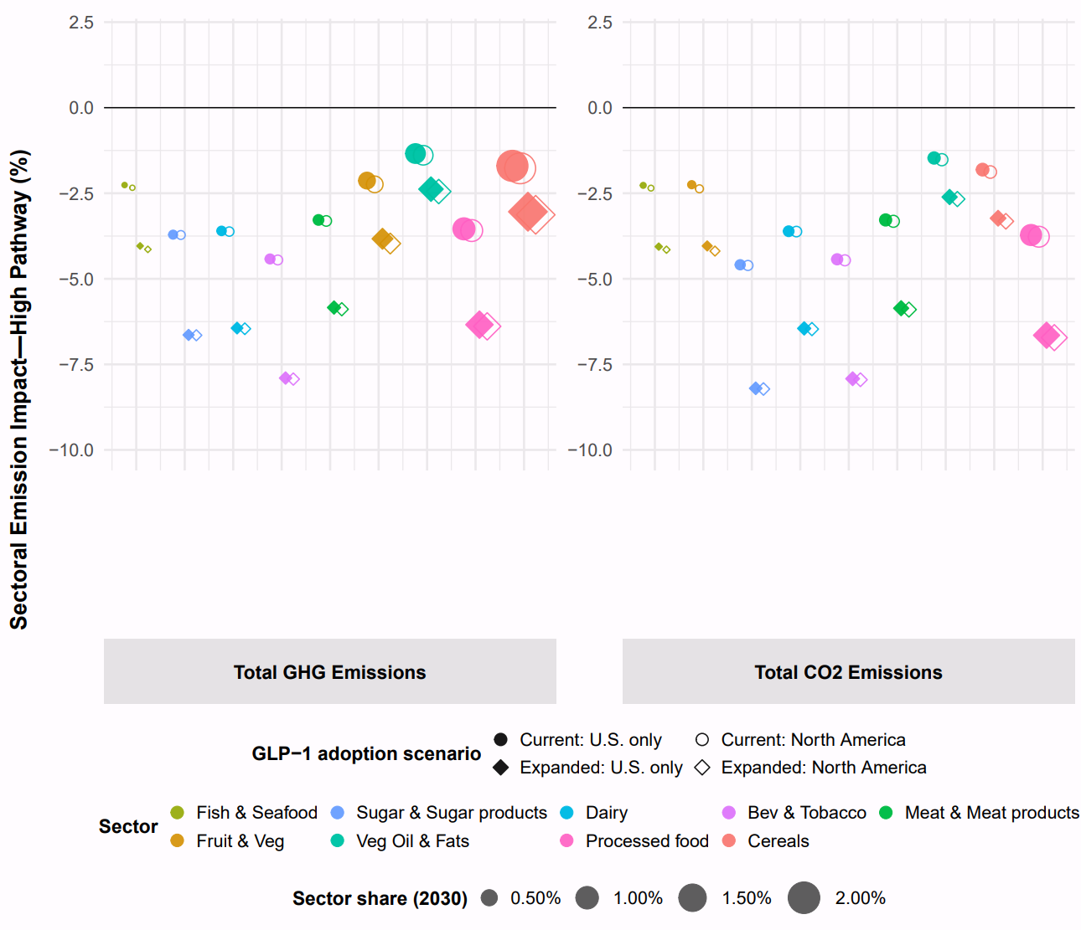
Fig. S5 | Cumulative sectoral emissions deviation from the 2030 baseline under the low- and high-adoption pathway across different scenarios. The left panel reports total GHG emissions, including CO2, and the right panel reports CO2 emissions only. Together, the nine food-related sectors shown account for approximately 4.5% and 2.2% of total U.S. GHG emissions and CO2 emissions from production, respectively, in the 2030 GTAP baseline. Marker size represents each sector’s relative share, and sectors are ordered from smallest to largest from left to right within each panel. For each sector, filled and hollow circles represent sector-specific percentage changes relative to the baseline under current clinical coverage with U.S.-only and North America-wide GLP-1 adoption, respectively. Filled and hollow diamonds represent the corresponding changes under expanded weight-management access with U.S.-only and North America-wide GLP-1 adoption, respectively. Positive values indicate an increase relative to the baseline, while negative values denote a contraction.

GLP-1 Induced Dietary Responses and Food-demand Pathways
Emerging evidence indicates that GLP-1 receptor agonists affect food demand through both lower total energy intake and changes in the composition of food choices. Clinical evidence is strongest for the reduction in total intake. A recent review of 10 dietary-intake studies reports reductions in caloric intake of 16–39% among users of GLP-1 or dual GIP/GLP-1 receptor agonists relative to placebo, while also noting that substantially fewer studies directly measure changes in dietary composition¹. In individual randomized trials, semaglutide reduced total ad libitum daily energy intake by approximately 24% and reduced intake of high-fat, non-sweet foods by about 35%². Other experimental evidence reports a 40.7% reduction in energy intake from high-fat foods with semaglutide³, while another research⁴ shows a substantial reduction in energy intake at an ad libitum meal. Evidence on food composition is more heterogeneous. Randomized studies indicate lower liking or craving for high-fat, sweet, savory, dairy, and starchy foods, but the number of studies measuring food preferences remains limited⁵. Survey and revealed-purchase evidence similarly indicate lower overall consumption and shifts away from several energy-dense food categories^{6,7}. At the same time, protein demand need not decline proportionally with total food intake. Higher willingness to pay and lower price sensitivity for several protein products among GLP-1 users, consistent with users consuming smaller quantities while placing greater value on protein-dense foods⁸. Because the clinical evidence identifies the overall energy response more precisely than category-specific quantity effects, we treat the food-category responses below as RCT-anchored, evidence-constrained scenario inputs rather than independently identified category-specific causal effects.
Supplementary Table S3 reports the calibrated per-user dietary responses for the nine food categories matched to the GTAP sector aggregation. We first use FAO Food Balance Sheets to characterize country-specific baseline caloric availability and map the underlying commodities to the nine GTAP food categories. The aggregate reduction in food intake is anchored to the randomized clinical evidence on GLP-1-induced energy-intake reductions, while the relative distribution of that reduction across food categories is informed by the experimental, survey, purchase and demand evidence described above. Country-specific baseline caloric composition is then used to reconcile these category patterns with the aggregate energy-intake response. The resulting calibration places the largest reduction on vegetable oils and fats, at approximately 41% in each country, consistent with experimental estimates showing reductions of approximately 35–41% in high-fat food intake. Meat and meat products decline by approximately 36%. This reduction is consistent with evidence of lower meat quantities among GLP-1 users while allowing for the higher per-unit valuation of protein documented in recent demand studies. Cereals decline by approximately 33% in the United States, 36% in Canada and 35% in Mexico, with the modest cross-country differences reflecting differences in baseline dietary composition. Fruit and vegetables and fish and seafood are assigned more moderate reductions of 25%. Dairy, sugar and sugar products, beverages and tobacco, and processed food and other products decline by approximately 36%. Evidence for the exact magnitudes in these latter categories is less direct, and their values therefore primarily reflect the calibration needed to obtain a coherent food-basket response consistent with the aggregate clinical evidence. Because beverages and tobacco are represented as a single GTAP commodity, the calibrated response for this composite should not be interpreted as evidence of a tobacco-specific behavioral effect.
The calibrated per-user responses are converted into country-, year-, and food-category-specific aggregate household food-demand pathways using projected active treatment prevalence, rather than first-time adoption. For country r, food category c, and year t, the demand pathway is defined as
$$D_{crt} = A_{rt}δ_{cr}$$
where A_{rt} denotes active treatment prevalence, δ_{cr} denotes the calibrated per-user dietary response and D_{crt} denotes the resulting aggregate household-demand change. Because GTAP private-household demand is not age-stratified, the projected adult active-treatment prevalence is used as the scaling share for the corresponding household food-demand composite. This provides a transparent approximation linking the treated adult population to aggregate household food demand. The resulting pathways are externally constructed before the economy-wide simulation and enter GTAP-RD as exogenous household quantity-demand changes. This treatment is consistent with established food-system scenario analyses in which dietary or behavioral pathways are specified outside the equilibrium model and the resulting production, price, trade and resource adjustments are determined endogenously. Springmann et al.⁹, for example, construct counterfactual dietary scenarios by imposing changes in food composition and energy intake relative to a socioeconomic baseline, while Lopez Barrera and Hertel¹⁰ explicitly impose exogenous shifts in food demand in selected regions and allow the resulting market adjustments elsewhere to occur endogenously.
Table S3. The Calibrated Food Basket Changes (%) based on Calories per Capita per Day
 | U.S. | Canada | Mexico
Cereal | -33.24 | -35.6 | -35.27
Veg_Fru | -25 | -25 | -25
Fish & Seafood | -25 | -25 | -25
Meat & Meat products | -35.84 | -35.84 | -35.84
Vegoil_F | -40.8 | -40.8 | -40.8
Dairy | -35.9 | -35.9 | -35.9
Sugar | -35.9 | -35.9 | -35.9
Beve_Tob | -35.9 | -35.9 | -35.9
Processed food & others | -35.9 | -35.9 | -35.9

Bayesian Estimation of the Generalized Bass Model
This supplementary materials supports the Methods section. Section 6.1 presents the standard Bass diffusion model and derives its closed-form solution. Section 6.2 extends the derivation to the generalized Bass model (GBM) with market effort and obtains the cumulative adoption function of Equation (3) of the main text. Section 6.3 describes how the market potential m_{t} and the market-effort variables (Affordability and Awareness) are constructed from regulatory, insurance, and market information. Sections 6.4–6.6 detail the likelihood, priors, posterior, the Markov chain Monte Carlo (MCMC) estimation algorithm, and convergence diagnostics. Section 6.7 and 6.8 describes posterior predictive forecasting, scenario analysis, and the propagation of parameter uncertainty into the active-adoption module of Equations (12)–(16). Section 6.9 calibrates the reinitiation component of that module.

The Standard Bass Model and Its Closed-form Solution
The standard Bass diffusion model states that the probability that an initial purchase is made at time $t$, given that no purchase has yet been made, is a linear function of the number of previous adopters:
$P(t) = \frac{f(t)}{1-F(t)} = p + \frac{q}{m}Y(t)$ (1)
where $p$ is the innovation coefficient, $q$ is the imitation coefficient, and $m$ is the market potential. $F(t)$ denotes the cumulative proportion of adopters by time $t$ (so that $1-F(t)$ is the probability that a purchase has not yet been made), $F(t)$ is the corresponding adoption density, and $Y(t)$ is the cumulative number of previous adopters, $Y(t)=mF(t)$.
Since $f\left(t\right)=dF(t)/dt$, Equation (A.1) is transformed into
$\frac{\frac{dF(t)}{dt}}{1-F(t)} = p + qF(t)$ (2)
Multiplying both sides by $1-F$ and expanding the right-hand side gives
$\frac{dF}{dt} = (1-F)(p+qF) = p + (q-p)F - qF^{2}$ (3)
Separating variables and using the partial-fraction decomposition
$\frac{1}{(1-F)(p+qF)} = \frac{1}{p+q}\frac{1}{1-F} + \frac{q}{p+q}\frac{1}{p+qF}$ (4)
and integrating from 0 to $t$ with the initial condition $F\left(0\right)=0$, the solution to the differential equation (A.3) is
$F(t) = \frac{1-e^{-(p+q)t}}{1+\frac{q}{p}e^{-(p+q)t}}$ (5)
The corresponding density function is
$f(t) = \frac{\frac{{(p+q)}^{2}}{p}e^{-(p+q)t}}{{(1+\frac{q}{p}e^{-(p+q)t})}^{2}}$ (6)
Denoting the total sales at time $t$ by $S(t)$, then $S\left(t\right)=m_{t}F\left(t\right)-m_{t-1}F\left(t-1\right)+u_{t}$ where $u_{t}∼N(0,σ^{2})$ and cumulative sales are given by $Y\left(t\right)=m_{t}F(t)$, (Equations 5–6 of the main text). In continuous time the instantaneous adoption rate implied by (A.6) is
$S(t) = m_{t}\frac{\frac{{(p+q)}^{2}}{p}e^{-(p+q)t}}{{(1+\frac{q}{p}e^{-(p+q)t})}^{2}}$ (7)

The Generalized Bass Model and the Cumulative Adoption Function
For the generalized Bass model, the only change to Equation (A.1) is the addition of a multiplicative market-effort term $x(t)$ on the right-hand side. Throughout, $x(t)$ denotes the instantaneous market effort and $X(t)$ its cumulative (integrated) counterpart; Equation (2) of the main text is the cumulative form $X(t)$. The GBM hazard, written in terms of $F(t)$alone, is
$\frac{f(t)}{1-F(t)} = [p+qF(t)] x(t)$ (8)
Following Bass, Krishnan, and Jain (1994), the instantaneous market effort is one plus a linear combination of the proportional growth rates of the covariates,
$x(t) = 1 + β_{1}\frac{d ln Affordability(t)}{dt} + β_{2}\frac{d ln Awareness(t)}{dt}$ (9)
so that integrating $x(τ)$ from 0 to $t$ yields the cumulative market effort of Equation (2) of the main text:
$X(t) = ∫ _{0} ^{t}x(τ)dτ = t + β_{1} ln\frac{{Affordability}_{t}}{{Affordability}_{0}} + β_{2} ln\frac{{Awareness}_{t}}{{Awareness}_{0}}$ (10)
Separating variables in (A.8) gives $\frac{dF\left(t\right)}{\left[p+qF\right]}=x\left(t\right)dt$. Applying exactly the same partial-fraction decomposition as in (A.4) and integrating from 0 to t, with $F\left(0\right)=0$ and $X\left(0\right)=0$, yields
$ln\frac{p+qF(t)}{p [1-F(t)]} = (p+q)X(t)$ (11)
Solving (A.11) for $F(t)$ gives the closed-form cumulative adoption function,
$F(t) = \frac{1-exp[-(p+q)X(t)]}{1+(\frac{q}{p}) exp[-(p+q)X(t)]}$ (12)
which is Equation (3) of the main text. Comparing (A.12) with (A.5) shows that the GBM solution is the standard Bass solution with calendar time t replaced by “effort time” $X(t)$: if $β1=β2=0.$ Then $X\left(t\right)=t$ and the GBM reduces to the standard Bass model. Because $F(t)$ is increasing in $X(t)$, favorable affordability and awareness paths accelerate adoption toward the ceiling m_{t} without changing the ceiling itself, consistent with the interpretation in the main text.

Construction of the Market Potential and Market-effort Variables
Market potential m_{t}. The adoption ceiling is operationalized as the share of the adult population that is both realistically eligible for and regulatorily able to access GLP-1 weight-management treatment in each country (United States, Canada, Mexico):
$m_{t} =e_{t} × a_{t}$ (13)
where e_{t} is the realistically-eligibility share either obesity or overweight, and a_{t} is the practical-access share. Eligibility e_{t} is determined by chronic weight management (Using the standard adult BMI definitions, obesity is defined as BMI ≥ 30, while overweight is defined here as BMI ≥ 25, meaning the overweight column includes adults with obesity) and changes as step increases when a regulator (FDA, Health Canada, COFEPRIS) approves a new GLP-1 medicine or a new indication. Practical access a_{t} captures the fraction of eligible adults who could regulatorily obtain treatment, reflecting insurance and public coverage decisions. Major regulatory and coverage events therefore enter the model through m_{t} (changing the ceiling), while gradual changes in cost and attention enter through the market-effort variables $Z\left(t\right)$ (changing the speed of diffusion).
The comparable historical data as Table S4 shows for obesity values are based on World Health Organization / Non-Communicable Disease Risk Factor Collaboration (WHO/NCD-RisC) age-standardized adult estimates; the overweight values are based on WHO/World Bank/Our World in Data definitions and World Bank/Census and Economic Information Center (CEIC)-reported 2022 levels, with 2023–2030 treated as trend-based projections rather than observed values. WHO defines adult overweight as BMI ≥ 25 and reports that the indicator is based on measured height and weight and NCD-RisC/Lancet 2024 estimation methods ¹¹. WHO defines adult obesity as BMI ≥ 30 and reports it as an age-standardized adult prevalence indicator ¹². NCD-RisC provides the adult country-level BMI estimates used for 1990–2022, while the World Obesity Atlas 2025 describes national adult overweight/obesity projections from 2000 to 2030 ¹³ ¹⁴. For overweight, CEIC reports U.S. adult overweight at 72.43% in 2022 and Mexico at 73.38% in 2022, while the World Bank Gender Data Portal reports Canada at 53.6% in 2022 ¹⁵ ¹⁶.
Table S4. The Historical and Projected overweight and Obesity Rate ($e_{t})$ among United States, Canada and Mexico from Year 2014 to 2030.
Year | U.S. obesity (%) | U.S. overweight (%) | Canada obesity (%) | Canada overweight (%) | Mexico obesity (%) | Mexico overweight (%)
2014 | 37.9 | 66.9 | — | — | — | —
2015 | 38.4 | 67.6 | 25.1 | 52.1 | 31.4 | 68.7
2016 | 39 | 68.3 | 25.3 | 52.3 | 32 | 69.4
2017 | 39.5 | 69 | 25.4 | 52.5 | 32.7 | 70
2018 | 40 | 69.7 | 25.6 | 52.7 | 33.3 | 70.7
2019 | 40.5 | 70.4 | 25.7 | 53 | 34 | 71.4
2020 | 41 | 71 | 25.9 | 53.2 | 34.7 | 72
2021 | 41.5 | 71.7 | 26 | 53.4 | 35.3 | 72.7
2022 | 42 | 72.4 | 26.2 | 53.6 | 36 | 73.4
2023 | 42.5 | 73.1 | 26.4 | 53.8 | 36.7 | 74
2024 | 43 | 73.8 | 26.5 | 54 | 37.3 | 74.7
2025 | 43.5 | 74.5 | 26.7 | 54.2 | 38 | 75.4
2026 | 44 | 75.2 | 26.8 | 54.5 | 38.7 | 76.1
2027 | 44.5 | 75.9 | 27 | 54.7 | 39.3 | 76.7
2028 | 45 | 76.6 | 27.1 | 54.9 | 40 | 77.4
2029 | 45.5 | 77.3 | 27.3 | 55.1 | 40.7 | 78.1
2030 | 46 | 78 | 27.5 | 55.3 | 41.3 | 78.7
Table S5–S7 The practical-access rate $a_{t}$is designed as a country-specific index for the fraction of eligible adults who can realistically obtain GLP-1 treatment after considering for regulatory approval, insurance coverage, public reimbursement, drug price, prescribing infrastructure, and market availability. For the United States, $a_{t}$is set highest because the U.S. GLP-1 market is the largest and fastest-moving: FDA approvals of Wegovy for chronic weight management and Zepbound for adults with obesity or overweight plus a weight-related condition expanded the approved treatment base, and Wegovy later received a cardiovascular-risk indication that strengthens reimbursement justification for some adults with obesity or overweight and established cardiovascular disease ^{17–19}. However, $a_{t}$remains well below one because access is still constrained by high prices, insurance restrictions, and public-program limits: KFF reports that Medicare coverage for GLP-1s used specifically for obesity treatment remains prohibited under current law, and only 13 state Medicaid fee-for-service programs covered GLP-1s for obesity treatment as of January 2026, often with utilization controls such as prior authorization ^{20,21}. Private coverage is broader but incomplete: Reuters reports that 44% of U.S. employers with more than 500 workers covered weight-loss drugs in 2024, rising from 41% in 2023, while coverage among the largest employers exceeded 60%; at the same time, cost pressures are causing some employers to add restrictions or even drop coverage ^{22,23}. The U.S. also receives a faster projected increase after 2025 because market size and price competition are expanding: U.S. GLP-1 spending increased from $13.7 billion in 2018 to $71.7 billion in 2023, global anti-obesity medication spending exceeded $30 billion in 2024, and direct-to-consumer/self-pay price reductions lowered some U.S. cash prices from more than $1,000 per month toward several-hundred-dollar monthly levels ^{24–26}.
For Canada, $a_{t}$is designed lower than the U.S. because regulatory availability exists but reimbursement and insurance coverage remain much narrower. Health Canada authorized Wegovy for chronic weight management in adults with BMI ≥ 30, or BMI ≥ 27 with at least one weight-related comorbidity, but Canada’s public reimbursement environment has been restrictive: Canadian Agency for Drugs and Technologies in Health (CADTH) initially recommended that Wegovy should not be reimbursed by public drug plans for broad chronic weight management, and the 2025 Canada’s Drug Agency recommendation limited reimbursement to adults with BMI ≥ 27 and established cardiovascular disease under specified conditions ^{27,28}. Private insurance access is also limited: Obesity Canada states that fewer than 20% of private drug plans cover obesity medications and public plans do not cover them broadly, while the Canadian Medical Association notes that only a small number of private plans offer partial coverage for GLP-1 drugs approved for chronic weight management and that public plans generally do not cover them for weight management ^{29,30}. Therefore, Canada’s $a_{t}$rises gradually rather than sharply, reflecting prescription availability and growing clinical acceptance, but it remains below the U.S. because most patients still face private-plan restrictions or out-of-pocket costs; future increases after 2025 are justified by conditional reimbursement decisions, additional approved obesity medications, and the possibility of price pressure as the GLP-1 market matures ³¹.
For Mexico, $a_{t}$is assigned the lowest path because regulatory authorization and clinical availability exist, but practical access is more dependent on private purchase, specialist prescribing, pharmacy availability, and out-of-pocket affordability. Mexican clinical guidelines report that long-term pharmacological options for adult overweight and obesity are available in Mexico, including semaglutide and liraglutide, and Comisión Federal para la Protección contra Riesgos Sanitarios (COFEPRIS) identifies Wegovy and Saxenda as authorized prescription medicines for weight control ³². However, access is kept lower than in the U.S. and Canada because coverage through broad public or employer-sponsored insurance channels is less established in the available evidence, so realized access is likely to depend more heavily on private clinics, licensed pharmacies, and household willingness to pay. COFEPRIS also warns about indiscriminate use and unauthorized/counterfeit GLP-1 products, which supports treating Mexico as a market with regulatory availability but weaker practical access and greater reliance on formal prescription channels ³³. Thus, Mexico’s $a_{t}$increases slowly through 2025 and then rises more under the expanded-access scenario after 2026, reflecting broader availability of semaglutide/liraglutide for obesity treatment and potential price/market expansion, but it remains below the U.S. and Canada because affordability, insurance coverage, and formal access channels are more binding constraints.
Table S5. The Access Rate ($a_{t}$) and Market Potential ($m_{t}$) for United States from Year 2014 to 2030.
Year | ($a_{t}$) Current | ($m_{t}$) Current | ($a_{t}$) Expanded | ($m_{t}$) Expanded
2014 | 0.119 | 0.045 | 0.067 | 0.045
2015 | 0.12 | 0.046 | 0.068 | 0.046
2016 | 0.121 | 0.047 | 0.069 | 0.047
2017 | 0.129 | 0.051 | 0.074 | 0.051
2018 | 0.14 | 0.056 | 0.08 | 0.056
2019 | 0.151 | 0.061 | 0.087 | 0.061
2020 | 0.161 | 0.066 | 0.093 | 0.066
2021 | 0.193 | 0.08 | 0.112 | 0.08
2022 | 0.238 | 0.1 | 0.138 | 0.1
2023 | 0.294 | 0.125 | 0.171 | 0.125
2024 | 0.36 | 0.155 | 0.21 | 0.155
2025 | 0.437 | 0.19 | 0.255 | 0.19
2026 | 0.523 | 0.23 | 0.319 | 0.24
2027 | 0.618 | 0.275 | 0.408 | 0.31
2028 | 0.733 | 0.33 | 0.529 | 0.405
2029 | 0.868 | 0.395 | 0.686 | 0.53
2030 | 1 | 0.46 | 0.872 | 0.68

Table S6. The Access Rate ($a_{t}$) and Market Potential ($m_{t}$) for Canada from Year 2014 to 2030.
Year | ($a_{t}$) Current | ($m_{t}$) Current | ($a_{t}$) Expanded | ($m_{t}$) Expanded
2015 | 0.08 | 0.02 | 0.038 | 0.02
2016 | 0.079 | 0.02 | 0.038 | 0.02
2017 | 0.087 | 0.022 | 0.042 | 0.022
2018 | 0.09 | 0.023 | 0.044 | 0.023
2019 | 0.097 | 0.025 | 0.047 | 0.025
2020 | 0.1 | 0.026 | 0.049 | 0.026
2021 | 0.112 | 0.029 | 0.054 | 0.029
2022 | 0.122 | 0.032 | 0.06 | 0.032
2023 | 0.136 | 0.036 | 0.067 | 0.036
2024 | 0.155 | 0.041 | 0.076 | 0.041
2025 | 0.18 | 0.048 | 0.089 | 0.048
2026 | 0.216 | 0.058 | 0.119 | 0.065
2027 | 0.263 | 0.071 | 0.155 | 0.085
2028 | 0.321 | 0.087 | 0.2 | 0.11
2029 | 0.392 | 0.107 | 0.254 | 0.14
2030 | 0.473 | 0.13 | 0.316 | 0.175

Table S7. The Access Rate ($a_{t}$) and Market Potential ($m_{t}$) for Mexico from Year 2014 to 2030.
Year | ($a_{t}$) Current | ($m_{t}$) Current | ($a_{t}$) Expanded | ($m_{t}$) Expanded
2015 | 0.041 | 0.013 | 0.019 | 0.013
2016 | 0.041 | 0.013 | 0.019 | 0.013
2017 | 0.046 | 0.015 | 0.021 | 0.015
2018 | 0.051 | 0.017 | 0.024 | 0.017
2019 | 0.059 | 0.02 | 0.028 | 0.02
2020 | 0.063 | 0.022 | 0.031 | 0.022
2021 | 0.071 | 0.025 | 0.034 | 0.025
2022 | 0.081 | 0.029 | 0.04 | 0.029
2023 | 0.093 | 0.034 | 0.046 | 0.034
2024 | 0.113 | 0.042 | 0.056 | 0.042
2025 | 0.145 | 0.055 | 0.073 | 0.055
2026 | 0.168 | 0.065 | 0.095 | 0.072
2027 | 0.198 | 0.078 | 0.12 | 0.092
2028 | 0.235 | 0.094 | 0.152 | 0.118
2029 | 0.278 | 0.113 | 0.192 | 0.15
2030 | 0.327 | 0.135 | 0.241 | 0.19
Tables S8–S10 report the country-specific market-effort variables used in the generalized Bass model for the United States, Canada, and Mexico, respectively. Two annual market-effort variables are defined for each country: affordability/accessibility (AF) and awareness (AW). AF captures the effective ease of obtaining GLP-1 weight-management treatment through price, insurance or reimbursement coverage, product availability, and prescribing access, while AW captures patient, provider, and public familiarity with GLP-1 medications for weight management. These variables are specified as normalized annual indices rather than observed adoption rates; in the model, they enter as relative changes from the initial year. The low, middle, and high paths represent alternative assumptions about the speed of market-effort expansion. For the United States, the values are calibrated to reflect early but limited obesity-pharmacotherapy availability after Saxenda’s approval for chronic weight management, stronger clinical and market expansion after Wegovy’s FDA approval, and the rapid increase in public awareness of GLP-1 drugs reported in recent national surveys ^{34–36}. For Canada, the values remain low before the mid-2020s because Wegovy was approved by Health Canada in 2021 but was not commercially available until 2024; the post-2025 divergence across low, middle, and high scenarios reflects uncertainty over reimbursement expansion, as Canada’s Drug Agency recommended reimbursement only under clinical criteria and conditions ^{27,28,37}. For Mexico, the values start at lower levels than in the United States and Canada because the weight-management GLP-1 market is more constrained by affordability and more dependent on private access; the post-2025 increase reflects the announced availability of semaglutide 2.4 mg for weight management in Mexico beginning in April 2025, while the low path accounts for continuing cost barriers and regulatory concerns regarding unsupervised or inappropriate use of semaglutide and liraglutide for weight loss ^{38,39}. Therefore, Tables 2–4 should be interpreted as scenario-based market-environment assumptions that translate regulatory approval, commercial availability, reimbursement conditions, and public/provider awareness into adoption-enabling indices for the diffusion model.
TableS8. Market Effort Variables Design for Unites States
Year | Low AF | Low AW | Mid AF | Mid AW | High AF | High AW | Interpretation
2014 | 0.03126 | 0.01 | 0.03126 | 0.01 | 0.03126 | 0.01 | Saxenda approval, but GLP-1 weight-management use remains very niche
2015 | 0.03792 | 0.01 | 0.03792 | 0.01 | 0.03792 | 0.01 | Early post-approval prescribing; high cost and weak coverage
2016 | 0.04539 | 0.02 | 0.04539 | 0.02 | 0.04539 | 0.02 | Slow clinical learning; limited public attention
2017 | 0.05205 | 0.03 | 0.05205 | 0.03 | 0.05205 | 0.03 | Gradual provider familiarity; affordability still restrictive
2018 | 0.06442 | 0.04 | 0.06442 | 0.04 | 0.06442 | 0.04 | Modest expansion; obesity pharmacotherapy still limited
2019 | 0.07598 | 0.05 | 0.07598 | 0.05 | 0.07598 | 0.05 | Growing clinical experience, but weak demand-side awareness
2020 | 0.09244 | 0.06 | 0.09244 | 0.06 | 0.09244 | 0.06 | Pre-Wegovy market; GLP-1s mainly diabetes-oriented
2021 | 0.12046 | 0.09 | 0.12046 | 0.09 | 0.12046 | 0.09 | Wegovy approval begins stronger weight-management diffusion
2022 | 0.1746 | 0.13 | 0.1746 | 0.13 | 0.1746 | 0.13 | Demand begins rising, but access remains price- and coverage-constrained
2023 | 0.2354 | 0.19 | 0.2354 | 0.19 | 0.2354 | 0.19 | Zepbound approval and rising media/public attention
2024 | 0.2656 | 0.32 | 0.2656 | 0.32 | 0.2656 | 0.32 | Broader legitimacy after cardiovascular indication; KFF awareness anchor
2025 | 0.30014 | 0.46 | 0.30014 | 0.46 | 0.30014 | 0.46 | More provider familiarity, rising use, but affordability remains binding
2026 | 0.32 | 0.56 | 0.35 | 0.59 | 0.38 | 0.62 | Scenario split begins; low assumes slower coverage, high assumes faster access
2027 | 0.36 | 0.64 | 0.4 | 0.77 | 0.46 | 0.79 | Public coverage and employer-plan decisions increasingly affect speed
2028 | 0.4 | 0.71 | 0.45 | 0.8 | 0.54 | 0.82 | Market normalization; broader prescribing environment
2029 | 0.43 | 0.77 | 0.5 | 0.85 | 0.62 | 0.86 | Mature but still constrained market; affordability improves under high scenario
2030 | 0.45 | 0.82 | 0.55 | 0.87 | 0.7 | 0.92 | High-awareness market with remaining price and coverage differences
Note: AF is Affordability and AW is awareness in this table. They are normalized indices used to shift the speed of diffusion, not observed coverage rates or adoption shares. Values from 2014–2025 represent the historical market environment and are therefore identical across low, middle, and high adoption scenarios. Scenario divergence begins in 2026, with the low scenario assuming persistent price and coverage barriers, the middle scenario assuming gradual coverage and prescribing normalization, and the high scenario assuming faster price relief, broader employer and public coverage, and sustained public awareness.

Table S9. Market Effort Variables Design for Canada
Year | Low AF | Low AW | Mid AF | Mid AW | High AF | High AW | Interpretation
2015 | 0.02 | 0.01 | 0.02 | 0.01 | 0.02 | 0.01 | Pre-obesity GLP-1 expansion; market mainly diabetes-centered and awareness very limited.
2016 | 0.021 | 0.011 | 0.021 | 0.011 | 0.021 | 0.011 | Very slow diffusion; affordability and provider familiarity remain low.
2017 | 0.022 | 0.012 | 0.022 | 0.012 | 0.022 | 0.012 | Early clinical learning; obesity pharmacotherapy remains niche.
2018 | 0.023 | 0.013 | 0.023 | 0.013 | 0.023 | 0.013 | Modest increase in awareness, but weight-management use remains limited.
2019 | 0.024 | 0.014 | 0.024 | 0.014 | 0.024 | 0.014 | Pre-Wegovy obesity indication; private-pay interest still weak.
2020 | 0.025 | 0.015 | 0.025 | 0.015 | 0.025 | 0.015 | Pandemic-period healthcare disruption; access and awareness grow only slightly.
2021 | 0.026 | 0.016 | 0.026 | 0.016 | 0.026 | 0.016 | Regulatory approval begins to support future adoption, but effective access remains narrow.
2022 | 0.027 | 0.017 | 0.027 | 0.017 | 0.027 | 0.017 | Post-approval market still slow because reimbursement and supply channels remain limited.
2023 | 0.029 | 0.02 | 0.029 | 0.02 | 0.029 | 0.02 | Growing public attention from GLP-1 discussion, but affordability remains restrictive.
2024 | 0.031 | 0.05 | 0.031 | 0.05 | 0.031 | 0.05 | Awareness rises faster through media and U.S. spillover, while coverage remains uneven.
2025 | 0.033 | 0.1 | 0.033 | 0.1 | 0.033 | 0.1 | Conditional reimbursement discussion increases policy visibility; broad access remains limited.
2026 | 0.04 | 0.15 | 0.05 | 0.2 | 0.08 | 0.25 | Scenario divergence begins; low path assumes cautious coverage, high path assumes faster private and payer response.
2027 | 0.06 | 0.2 | 0.1 | 0.3 | 0.15 | 0.4 | Middle and high paths assume broader provider familiarity and improving affordability.
2028 | 0.085 | 0.25 | 0.15 | 0.4 | 0.22 | 0.55 | Expanded market access becomes more plausible under middle/high adoption assumptions.
2029 | 0.12 | 0.3 | 0.2 | 0.5 | 0.29 | 0.7 | High adoption reflects stronger commercial diffusion and payer uptake; low remains gradual.
2030 | 0.15 | 0.35 | 0.25 | 0.6 | 0.36 | 0.85 | Mature but coverage-sensitive market; adoption depends heavily on affordability and reimbursement breadth.

Table S10. Market Effort Variables Design for Mexico
Year | Low AF | Low AW | Mid AF | Mid AW | High AF | High AW | Interpretation
2015 | 0.012 | 0.006 | 0.012 | 0.006 | 0.012 | 0.006 | Very early GLP-1 environment; use mainly diabetes-oriented and awareness minimal.
2016 | 0.0125 | 0.0065 | 0.0125 | 0.0065 | 0.0125 | 0.0065 | Limited prescribing familiarity; affordability remains highly restrictive.
2017 | 0.013 | 0.007 | 0.013 | 0.007 | 0.013 | 0.007 | Slow private-clinic learning; weight-management use remains very niche.
2018 | 0.0135 | 0.0075 | 0.0135 | 0.0075 | 0.0135 | 0.0075 | Gradual awareness growth, but access is constrained by out-of-pocket cost.
2019 | 0.014 | 0.008 | 0.014 | 0.008 | 0.014 | 0.008 | Small urban/private-sector diffusion; national market effort remains weak.
2020 | 0.0145 | 0.009 | 0.0145 | 0.009 | 0.0145 | 0.009 | Pandemic disruption limits systematic obesity-treatment expansion.
2021 | 0.015 | 0.01 | 0.015 | 0.01 | 0.015 | 0.01 | Early public interest begins, but affordability and formal access remain low.
2022 | 0.0155 | 0.011 | 0.0155 | 0.011 | 0.0155 | 0.011 | GLP-1 awareness grows slowly through diabetes treatment and private providers.
2023 | 0.0165 | 0.014 | 0.0165 | 0.014 | 0.0165 | 0.014 | Media visibility increases, but formal weight-management adoption remains limited.
2024 | 0.018 | 0.025 | 0.018 | 0.025 | 0.018 | 0.025 | Demand grows, but cost, medical supervision, and irregular-market concerns constrain access.
2025 | 0.02 | 0.05 | 0.02 | 0.05 | 0.02 | 0.05 | Weight-management launch period raises awareness; affordability remains the main bottleneck.
2026 | 0.024 | 0.075 | 0.03 | 0.095 | 0.04 | 0.12 | Scenario divergence begins as launch effects diffuse through private providers and pharmacies.
2027 | 0.031 | 0.105 | 0.046 | 0.15 | 0.065 | 0.2 | Middle/high paths assume faster urban uptake and broader provider familiarity.
2028 | 0.04 | 0.14 | 0.065 | 0.215 | 0.095 | 0.29 | Adoption expands under middle/high assumptions, but low path remains constrained by price.
2029 | 0.052 | 0.18 | 0.088 | 0.29 | 0.13 | 0.39 | High adoption reflects stronger commercial diffusion; low remains private-pay limited.
2030 | 0.066 | 0.225 | 0.115 | 0.375 | 0.17 | 0.5 | Market remains affordability-sensitive; high path reaches broader but still uneven access.

Likelihood, Prior Distributions, and Posterior
Stacking the T observed annual new-adoption flows into the vector S, and writing $M= \{m_{t}\}$ for the market-potential path and $ΔMF_{t}(p, q, β) = m_{t}F_{t} - m_{t-1}F_{t-1}$ for the model-implied flow (Equation 9 of the main text), the normality of the error term u_{t} in Equations (5)–(6) implies the Gaussian likelihood of Equation (8):
$f(S∣p,q,β,σ^{2},Z,M) = {(\frac{1}{2πσ^{2}})}^{T/2} exp\{-\frac{1}{2σ^{2}}[S-MΔF(p,q,β)]'[S-MΔF(p,q,β)]\}$ (14)
Because no directly comparable historical GLP-1 weight-loss market exists, the prior distributions are literature-informed (forecasting by analogy; Ramírez-Hassan and Montoya-Blandón, 2020). For the U.S. estimation, the innovation and imitation coefficients receive uniform priors over ranges consistent with pharmaceutical and consumer-durable diffusion studies, $p \sim Uniform (p_{L}, p_{U})$ and $q \sim Uniform (q_{L}, q_{U})$. The market-effort coefficients receive truncated normal priors restricted to positive values, $β_{1}, β_{2} \sim N(μ, σ²)$ truncated to $(0, ∞)$, reflecting the assumption that improvements in affordability and awareness weakly accelerate diffusion (Equation 10 of the main text). The error variance receives a Scaled-Beta2 prior, $σ² \sim SBeta2(a_{0}, b_{0}, κ)$, which is constructed from the odds of a beta-distributed variable, $σ² = κ ω/(1-ω)$ with $ω \sim Beta(a_{0}, b_{0})$. We set $a_{0} = b_{0} = 1$, so that $κ$ is the prior median of $σ²$, and fix $κ= 5 × Var(ΔC)$, five times the sample variance of the observed annual new-adoption flow, giving a weakly informative prior. This Scaled-Beta2 specification (Fúquene et al., 2014; Ramírez-Hassan and Montoya-Blandón, 2020) avoids the impropriety of the limiting inverse-gamma prior for variance parameters (Gelman, 2006). All priors are mutually independent. By Bayes’ rule the posterior is proportional to the likelihood times the joint prior,
$π(p,q,β,σ^{2}∣S,Z,M) ∝ f(S∣p,q,β,σ^{2},Z,M) π(p,q,β,σ^{2})$ (15)
Because F(t) in Equation (A.12) is a highly nonlinear function of $(p, q, β_{1}, β_{2})$ the posterior in (A.15) has no closed form and is explored by MCMC simulation.

Historical Data and Parameters of Innovation and Imitation
Recent evidence documented rapid growth in GLP-1 use. Public polling and survey-based studies report that between 6 and 12 percent of U.S. adults have used a GLP-1 medication at some point ⁴⁰ ⁴¹, with 8.3 percent reporting use in mid-2024 ⁴² and approximately 11.9 percent reporting current use in 2025 ⁸. Together these sources are used to construct the historical U.S. cumulative adoption series used to estimate the Bayesian GBM.
GLP-1 medicines are prescription medicines rather than consumer products, and their diffusion follows well-documented patterns of medical technology uptake ⁴³. Empirical work on pharmaceuticals shows that internal and evidence-driven mechanisms play dominant roles in shaping adoption over time ⁴⁴. Studies of prescribing behavior ⁴⁵ and diffusion analyses for specialty drugs ⁴⁶ demonstrate that adoption becomes increasingly imitation-driven once clinical evidence accumulates and prescribing patterns become established. In the case of GLP-1 medicines, rapid dissemination of evidence on cardiometabolic benefits, real-world effectiveness, and shared clinical experiences within medical networks create conditions in which imitation effects are expected to dominate (Rizzo et al., 2018; Han et al., 2024). These dynamics justify using relatively high values of $q$ and high $q$ to $p$ ratios in our parameterization, particularly for the United States where the diffusion of clinical knowledge is fast.
In the United States, large-scale market entry for obesity treatment occurred with the approval of semaglutide 2.4 mg (Wegovy) in 2021. Between 2020 and 2022, GLP-1 use for weight-loss treatment increased by approximately 300 percent ⁴⁹. Given rapid dissemination of clinical evidence and strong professional-network effects, we adopt parameter ranges of $p∈[0.01, 0.04]$ and $q∈[0.30, 0.80]$. For Canada and Mexico, comparable historical GLP-1 adoption series are unavailable for country-specific posterior estimation. We therefore characterize uncertainty in the innovation and imitation parameters through literature-informed truncated-normal distributions and conduct prior-predictive scenario simulations.
In Canada, liraglutide (Saxenda) was approved in 2015, with semaglutide introduced later. Cross-country diffusion studies indicate systematically lower innovation coefficients in settings where direct-to-consumer pharmaceutical advertising is restricted. A reports mentions innovation parameters in such markets are roughly half those observed in the United States ⁵⁰. Accordingly, we use $p∈[0.005, 0.02]$ and $q∈[0.25, 0.65]$ for Canada.
In Mexico, GLP-1-based obesity medicines are expected to receive broader regulatory approval around 2026 ⁵¹. Pharmaceutical diffusion in developing and middle-income settings is typically slower due to lower insurance coverage, more limited specialist access, and lower per capita pharmaceutical expenditure. Evidence from a research ⁵² documents slower diffusion and lower saturation rates in such contexts. We therefore assume large-scale diffusion begins in 2026 and adopt parameter ranges of $p∈[0.003, 0.015]$ and $q∈[0.20, 0.55]$. Large-scale meta-analyses of Bass parameter estimates provide a general empirical benchmark. ⁵³ report average values of $p$ near 0.03 and $q$ near 0.38 across more than 200 consumer and durable products. Synthesizing evidence from a broad set of diffusion applications, ⁵⁴ shows that $p$ is typically small, often below 0.03, while q is substantially larger and commonly lies in the range of roughly 0.2-0.6. However, diffusion studies focusing on pharmaceuticals consistently document stronger imitation effects than those observed in consumer market (Ching & Ishihara, 2010; Narayanan & Manchanda, 2009). These findings support an upward adjustment of $q$ for GLP-1 therapies in our analysis.

Markov Chain Monte Carlo Estimation
Because the generalized Bass model is nonlinear and the posterior distribution does not have a closed-form solution, we estimate the U.S. model using Markov chain Monte Carlo (MCMC) simulation implemented in JAGS through the R2jags interface in R. The observed annual first-time adoption flows are modeled using the Gaussian likelihood described in Section 5.4, conditional on the time-varying market-potential path and market-effort variables. The parameters sampled from the posterior include the innovation coefficient $p$, imitation coefficient $q$, the affordability and awareness coefficients $β_{1}$ and $β_{2}$, and the error-variance component.
We run three parallel MCMC chains of 100,000 iterations each. The first 50,000 iterations of each chain are discarded as burn-in, and every twentieth draw from the remaining iterations is retained. This procedure yields 2,500 retained draws per chain and 7,500 posterior draws in total. The chains are initialized from dispersed values within the support of the prior distributions to facilitate assessment of convergence from different starting points. A fixed random seed is used to ensure reproducibility. For subsequent scenario simulations, we randomly select up to 5,000 draws from the retained U.S. posterior distribution.
For each retained parameter draw, the model evaluates cumulative market effort, $X_{t}​=t+β_{1}​Z_{1t}​+β_{2}​Z_{2t}​,$ and uses the generalized Bass cumulative adoption function to obtain the corresponding annual first-time adoption flow. Future adoption scenarios are therefore generated by combining posterior uncertainty in the estimated diffusion parameters with alternative exogenous paths for market potential, affordability, and awareness. The posterior draws are subsequently passed to the active-use module to account for discontinuation and reinitiation.

Convergence Diagnostics and Posterior Summaries
Posterior sampling performance is assessed using the diagnostic information returned by JAGS for the three MCMC chains. For each estimated parameter, we examine the Gelman–Rubin potential scale reduction factor ($\hat{R}$) and the effective sample size reported by the JAGS output. Values of $\hat{R}$ close to one indicate that the parallel chains have converged to a common stationary distribution, while sufficiently large effective sample sizes indicate that posterior summaries are based on an adequate number of effectively independent draws.
After discarding burn-in and applying thinning, posterior draws of the innovation coefficient $p$, imitation coefficient $q$, and the market-effort coefficients for affordability and awareness are extracted from the JAGS output. The retained draws are used directly for subsequent scenario simulations. For descriptive reporting, posterior summaries are calculated from these retained draws, including measures of central tendency and posterior uncertainty. In particular, posterior medians of $p$, $q$, $β_{1}$, and $β_{2}$ are also calculated for parameter interpretation and for transferring the market-effort coefficients to the Canada and Mexico simulations.

Scenario Forecasting and Propagation of Parameter Uncertainty
Scenario projections are generated by evaluating the generalized Bass model for each retained parameter draw under alternative future paths of market potential, affordability, and awareness. We consider two market-potential scenarios. Current clinical coverage represents continued access under the existing clinical eligibility framework and is operationalized using adults with obesity (BMI ≥ 30) as the potentially eligible population, multiplied by the country- and year-specific practical-access rate. Expanded weight-management access represents a broader treatment environment in which weight-management eligibility and access extend to the larger population with overweight (BMI ≥ 25, including adults with obesity), combined with a scenario-specific practical-access path reflecting broader regulatory availability, insurance or reimbursement coverage, prescribing access, and market availability. Thus, the expanded-access scenario increases the potential treatment population as well as the share of eligible adults who can realistically obtain treatment.
Within each market-potential scenario, three market-effort pathways (low, middle, and high adoption) represent alternative trajectories for affordability and awareness. These pathways affect the speed of diffusion toward the scenario-specific market potential but do not change the market-potential ceiling itself. The combination of two market-potential scenarios and three market-effort pathways therefore produces six adoption scenarios for each country.
For the United States, we randomly select up to 5,000 draws from the retained MCMC posterior distribution. For each draw , the model computes cumulative market effort, $X_{t}^{(d)}​=t+β_{1}^{(d)}​Z_{1t}​+β_{1}^{(d)}​Z_{2t}$, and evaluates the generalized Bass cumulative adoption function using $p^{(d)}$, $q^{(d)}$, and the scenario-specific market-potential path $m_{t}$. Annual first-time adoption is calculated as the change in cumulative adoption implied by adjacent periods. This procedure generates a distribution of projected adoption trajectories that reflects uncertainty in the estimated diffusion parameters.
The projected first-time adoption flow from each parameter draw is then passed through the active-use module. Current active adoption accounts for treatment discontinuation and reinitiation through the calibrated discontinuation rate $d_{t}$, the annual reinitiation rate $ρ$, and the returnable share $λ$. These parameters are held fixed at their calibrated values while uncertainty in the diffusion parameters is propagated draw by draw through the active-adoption recursion.
For each country, coverage scenario, adoption pathway, and year, the simulated distributions are summarized using the mean, median, and the 2.5th and 97.5th percentiles. Figures use the median trajectory as the central estimate, with the 2.5th and 97.5th percentiles representing simulation uncertainty.
For Canada and Mexico, comparable historical adoption data are unavailable for estimating country-specific GBMs. We therefore conduct prior-predictive scenario simulations rather than posterior estimation. Country-specific $p$ and $q$ values are drawn from the specified truncated-normal distributions, while the affordability and awareness coefficients are fixed at their U.S. posterior median estimates. Five thousand parameter draws are used for each country, and the same scenario and active-use procedures are applied.

Calibration of Discontinuation and Reinitiation
The active-use adjustment of Equations (12)–(16) distinguishes cumulative first-time GLP-1 adoption from current active treatment use. This distinction is important because some individuals discontinue treatment, while some prior users restart treatment after discontinuation. In the main model, the Generalized Bass Model projects annual new first-time adoption, while the active-use adjustment accounts for discontinuation and reinitiation after initial adoption. This appendix calibrates the two reinitiation parameters: $λ$, the share of discontinuers who enter the returnable inactive-user pool, and $ρ$, the annual reinitiation rate among returnable inactive prior users.
We calibrate the reinitiation component using two pieces of evidence. First, a study shows discontinuation and reinitiation of GLP-1 receptor agonists among U.S. adults with overweight or obesity, 36.3% of discontinuers reinitiated GLP-1 treatment within one year, and 46.4% reinitiated within two years after discontinuation ⁵⁷. Second, a study reports that approximately 50% of previous GLP-1 users are likely to use these medications again in the future ⁵⁸. We interpret this value as the long-run share of discontinuers who enter the returnable inactive-user pool. Therefore, we set λ =0.50, where $λ$ represents the share of discontinuers who are likely to reinitiate treatment in the future.
Let $ρ$ denote the annual reinitiation rate among returnable inactive prior users. For a cohort of discontinuers $D_{t}$ the returnable inactive stock is $λD_{t}$. If a constant annual reinitiation rate $ρ$ is applied to this stock, cumulative reinitiation within $k$ years is:
$C_{k}=λD_{t}[1-{\left(1-ρ\right)}^{k}]$ (19)
Dividing both sides by $D_{t}$, the cumulative reinitiation share among all discontinuers is:
$c_{k}=λ[1-{\left(1-ρ\right)}^{k}]$ (20)
Using the one-year reinitiation rate for adults without type 2 diabetes, the calibration of 1st year is $0.363=0.50ρ$, which gives $ρ=0.726$. Using the two-year reinitiation rate gives a very similar value $0.464=0.50[1-{\left(1-ρ\right)}^{2}]$, so $ρ=0.732$. Because the one-year and two-year calibrations are nearly identical, we use $ρ=0.73$ as the annual reinitiation rate among returnable inactive prior users.
This structure allows the model to capture reinitiation beyond the first year. The reason is that users who do not reinitiate in year $t$ remain in $B_{t}$, and a fraction $ρ_{t}$ of the remaining stock can reinitiate in later years. For example, if 100 users discontinue and $λ=0.50$, then 50 users enter the returnable inactive-user stock. With $ρ=0.73$, 36.5 users reinitiate within one year. The remaining 13.5 users stay in $B_{t}$, and 0.73 of them reinitiate in the second year, giving an additional 9.86 users. Therefore, cumulative two-year reinitiation is approximately 46.4 users, matching the observed two-year reinitiation rate. This stock-flow structure shows that the model does not only capture first-year reinitiation; it also captures later reinitiation because the remaining returnable inactive users continue to be carried forward in $B_{t}$ (Equation 16 of the main text). The calibration assumes a constant $ρ$; in the recursions of Equations (13)–(16) this corresponds to setting $ρ_{t}=ρ=0.73$ in all years of the baseline scenario.
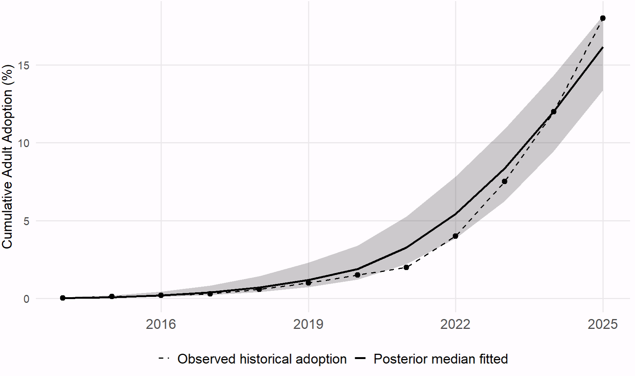
Fig. S6 | Observed versus fitted U.S. cumulative adult GLP-1 adoption, 2014–2025. The dashed line and points show the historical adoption values used in the Bayesian generalized Bass model estimation. The solid line shows the posterior median fitted trajectory, and the shaded area represents the 95% credible interval.

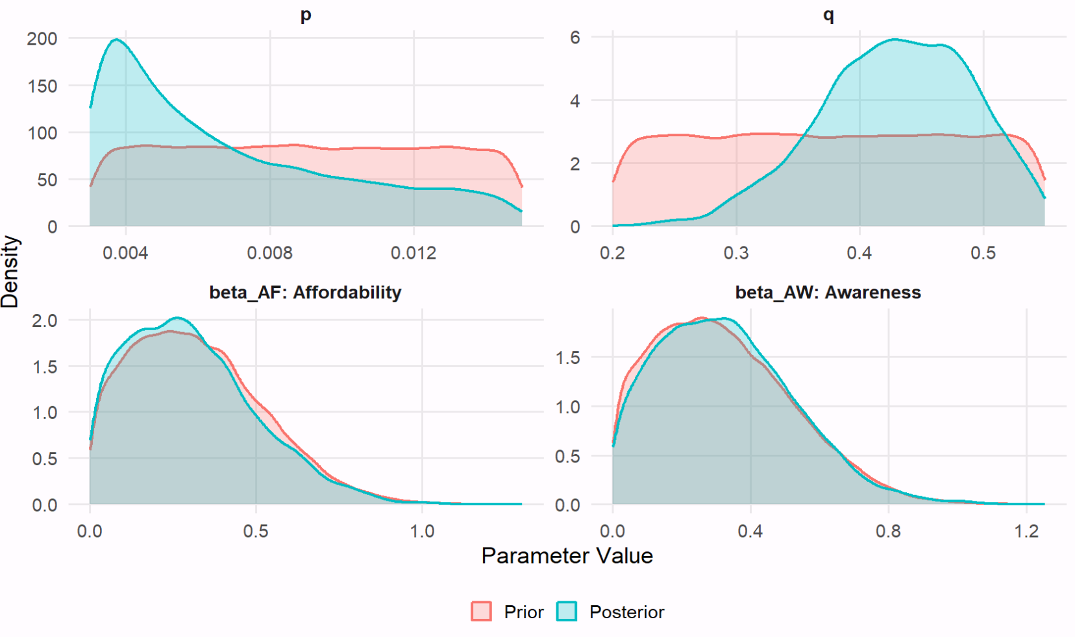
Fig. S7 | Prior and posterior distributions of U.S. Bayesian generalized Bass model parameters. The figure compares the specified prior distributions with the posterior distributions estimated from the U.S. historical adoption data for the innovation parameter $p$, imitation parameter $q$, affordability effect $β_{AF}$, and awareness effect $β_{AW}$. Differences between the prior and posterior distributions indicate how strongly the U.S. historical adoption data update the prior information. Larger shifts or increased concentration of the posterior relative to the prior indicate greater information contributed by the data, whereas substantial overlap indicates more limited updating. Canada and Mexico are not shown because their parameters are not independently estimated from country-specific historical adoption data. For Canada and Mexico, and are generated from country-specific prior-predictive distributions, while and are fixed at the corresponding U.S. posterior median estimates.

Table S11. Posterior estimates and convergence diagnostics.
Parameter | Mean | Median | 2.5th percentile | 97.5th percentile | R_hat | Effective_sample  _size
P | 0.01 | 0.01 | 0.00 | 0.01 | 1.00 | 6758
Q | 0.43 | 0.43 | 0.30 | 0.53 | 1.00 | 7553
beta_AF (Affordability) | 0.30 | 0.28 | 0.02 | 0.74 | 1.00 | 7996
beta_AW (Awareness) | 0.33 | 0.31 | 0.02 | 0.75 | 1.00 | 7317
Sigma  (Residual SD) | 0.01 | 0.01 | 0.01 | 0.01 | 1.00 | 7351

Table S12. Historical U.S. adoption series and data provenance.
Year | Cumulative_adoption  _used (%) | Original_source
2014 | 0.04 | Constructed/calibrated. No nationally representative cumulative ever-use estimate was identified for 2014. Watanabe et al. (2024) document very low early GLP-1 RA utilization in a large health-system cohort over 2014–2022; during 2014–2018, only Trulicity and Victoza exceeded 5,000 annual users. We therefore treat 0.04% as an early-diffusion baseline rather than a directly observed national prevalence estimate ⁵⁹.
2015 | 0.12 | Constructed/calibrated. No national cumulative ever-use estimate was available. The 0.12% value is a manually calibrated point on the early diffusion path, informed by the low utilization documented during 2014–2018 by Watanabe et al. (2024); it is not directly reported by that study ⁵⁹.
2016 | 0.2 | Constructed/calibrated. No national cumulative ever-use estimate was available. The 0.20% value continues the calibrated early-adoption trajectory consistent with the low level of GLP-1 RA utilization documented before 2018 by Watanabe et al. (2024) ⁵⁹.
2017 | 0.3 | Constructed/calibrated. No national cumulative ever-use estimate was available. The 0.30% value is a calibrated transition point between the early low-use period documented by Watanabe et al. (2024) and the claims-based 2018 benchmark; it is not a directly reported statistic ⁵⁹.
2018 | 0.6 | Calibrated to claim evidence. Ukhanova et al. (2025) report 745 GLP-1 RA users per 100,000 enrollees (0.745%) in 2018 using MarketScan commercial and Medicare Supplemental data. Because this is annual use among insured enrollees rather than cumulative ever-use among all U.S. adults, we use it as a magnitude benchmark rather than a direct observation; the model value was set at 0.60% ⁶⁰.
2019 | 1 | Calibrated/rounded. FAIR Health reports that 0.9% of commercially insured U.S. adults were prescribed any GLP-1 drug in 2019. Because prescription prevalence among commercially insured adults is not identical to cumulative ever-use among all adults, 0.9% was used as a benchmark and the model historical series uses 1.0% ⁶¹.
2020 | 1.5 | Interpolated/calibrated. Published EHR evidence indicates that GLP-1 prescribing was still approximately 1% around 2020 and subsequently accelerated. The model value of 1.50% is the midpoint between the calibrated 2019 value of 1.0% and 2021 value of 2.0%, and is therefore treated as an interpolated cumulative-adoption value rather than a direct observation. Gratzl et al. (2024) provide the supporting prescribing trajectory ⁶².
2021 | 2 | Calibrated/rounded. A retrospective Epic Research series reports 1,884 GLP-1 prescriptions per 100,000 U.S. adult patients (1.884%) in Q2 2021 ⁶³. We use this as a contemporaneous utilization benchmark and round/calibrate the cumulative historical value to 2.0%. The source statistic is prescribing prevalence, not cumulative ever-use.
2022 | 4 | Constructed/calibrated. No directly comparable national cumulative ever-use percentage was identified. Watanabe et al. (2024) document strong acceleration by 2022—for example, Ozempic users in their health-system data increased from 569 in 2019 to 22,891 in 2022, with Wegovy reaching 2,992 users in 2022 ⁵⁹. The 4.0% model value is therefore a calibrated transition point capturing this acceleration, not a statistic directly reported in the study.
2023 | 7.5 | Calibrated from population survey evidence. Hristakeva et al. report that 11.5% of U.S. households had at least one GLP-1 user in October 2023, corresponding to a population-level incidence of 5.5%; by July 2024 these measures increased to 16.3% and 8.3%, respectively. Because the reported population incidence is a contemporaneous-use measure rather than cumulative ever-use, 5.5% was used as a lower/current-use benchmark and the model uses a calibrated cumulative value of 7.5%, also constrained by the subsequent 12% ever-use estimate in 2024 ⁴².
2024 | 12 | Direct observation. In a nationally representative U.S. adult survey conducted April 23–May 1, 2024, KFF reports that 12% of adults had ever used a GLP-1 drug, including 6% who were currently using one. Because “ever used” corresponds directly to the cumulative-adoption concept, the reported 12% was used without adjustment ⁴¹.
2025 | 18 | Direct late-year observation. In a nationally representative survey conducted October 27–November 2, 2025, KFF reports that 18% of U.S. adults had ever taken a GLP-1 agonist, including 12% who were currently taking one. The 18% ever-use estimate was used directly as the 2025 cumulative-adoption value. A separate RAND survey conducted in April–May 2025 reported 11.8% having taken a GLP-1 at least once; because that observation was collected earlier in the year, we use it as a mid-year cross-check rather than the year-end model endpoint. ^{64,65}.

GTAP-RD Model, Database, Baseline and Counterfactual Implementation

Model Structure and Database Aggregation
We evaluate economy-wide food-system responses using GTAP-RD, the recursive-dynamic version of the Global Trade Analysis Project computable general equilibrium model ⁶⁶. GTAP-RD represents multiple regional economies connected through bilateral trade, with firms producing commodities using intermediate inputs and primary factors within nested production structures. Regional income is allocated across private consumption, government expenditure and savings, while commodities are allocated across intermediate demand, final consumption, investment, and international trade. This framework is well suited to the present analysis because changes in private-household food demand can propagate through production, bilateral trade, prices, input use, and factor markets, allowing the economy-wide consequences of the GLP-1-induced demand pathways to be quantified.
As shown in Fig. S8, production combines intermediate inputs and value added in fixed proportions through a Leontief structure. Intermediate inputs include feed, seed, energy, and chemicals, while value added combines primary factors, including land, labor, capital, and natural resources, using a constant-elasticity-of-substitution specification. Domestic output is allocated between domestic and export markets, and bilateral trade links regional economies through differentiated trade flows. On the demand side, domestic and imported varieties are treated as imperfect substitutes under the Armington structure. Commodities are used by firms as intermediate inputs and by private households, government, and investment demand. This structure allows an exogenous change in private-household food demand to generate endogenous adjustments in domestic production, import sourcing, bilateral trade, prices, intermediate-input use, and primary-factor allocation.
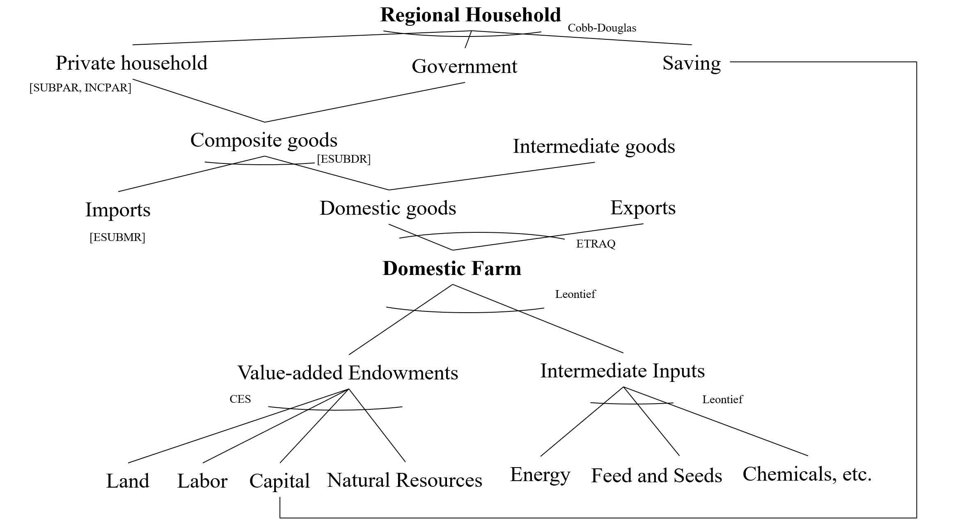
Fig. S8 | Hybrid nested CGE production–trade structure. This model adopts a standard GTAP-style nested production and trade structure. Production combines value-added and intermediate inputs in fixed proportions (Leontief), while value-added is modeled as a CES aggregation of primary factors. Trade follows the Armington assumption for import–domestic substitution and a constant elasticity of transformation (CET) structure for export transformation
We use Version 11 of the GTAP Data Base, with a reference year of 2017. The original database distinguishes 160 regions, which we aggregate into four regional economies for the present analysis: the United States, Canada, Mexico, and the Rest of the World. The original factor endowments are similarly aggregated into four primary-factor categories comprising land, labor, capital, and natural resources. This aggregation preserves the North American economies in which GLP-1 diffusion is explicitly modeled while retaining the rest of the global economy as a single region through which trade and general-equilibrium adjustments can occur.
The original 65 GTAP sectors are aggregated into 16 sectors for the analysis. The aggregation preserves nine food categories that can be directly matched to the per-user dietary responses developed in Section 6: cereals; fruit and vegetables; fish and seafood; meat and meat products; vegetable oils and fats; dairy, sugar, and sugar products; beverages and tobacco; and processed food and other food products. The two GTAP meat-processing sectors are combined into a single meat category. A tenth agricultural aggregate, Other Agricultural Products, which accounts for 1.15% of total U.S. domestic production value in the 2030 GTAP baseline, is retained to capture upstream agricultural linkages but does not receive a direct GLP-1-induced household-demand shock. Energy-producing and energy-intensive sectors are retained to preserve input-output and emissions channels, while the remaining manufacturing and service activities are grouped into a residual sector. Direct private-household demand informed the food-sector aggregation, and Table S13 reports the resulting 16-sector concordance with the Central Product Classification, Version 2.1, and the International Standard Industrial Classification of All Economic Activities, Revision 4.
The GLP-1-induced food-demand pathways are mapped to private-household purchases of the nine directly matched GTAP food composites. These nine sectors therefore receive the exogenous household-demand changes described below, whereas Other Agricultural Products and the remaining energy, manufacturing and service sectors do not receive direct GLP-1 demand shocks. These unshocked sectors can nevertheless respond endogenously through changes in intermediate demand, production, prices, trade and factor use. Food-service activities are not separately assigned a GLP-1 dietary-response pathway and can therefore be affected only through the general-equilibrium adjustments generated elsewhere in the model.
Table S13. Sectors Aggregation in GTAP Data Base
 | Sector | Food Categories | Description (CPC v2.1/ISIC Rev.4) | Direct GLP-1 demand shock
1 | Cereals | Cereal grains nec | Cereal grains not elsewhere classified (n.e.c.), such as barley, maize (corn), rye, oats, millet, sorghum, buckwheat, quinoa, triticale, and other cereals except paddy rice (0113) and wheat (0111). CPC codes include 0112, 0114–0119. paddy rice (0113), wheat (0111) | Yes
2 | Fruit & Veg | Vegetables, fruit, nuts | Fresh or chilled vegetables (012), fruits and nuts (013), leguminous vegetables (015), and edible roots/tubers (017); includes unprocessed produce for direct consumption or further processing. | Yes
3 | Fish & Seafood | Fishing | Capture fishery products from ocean, coastal, and inland waters for human consumption and other uses (ISIC 031, 032). Includes aquaculture outputs. | Yes
4 | Meat & Meat products | Meat and Meat products | Fresh, chilled, or frozen bovine meat and edible offal (21111, 21112, 21115-21119, 2113, 2115); Fresh, chilled, or frozen meat from pigs, poultry, and other animals, plus edible offal (21113, 21114, 2112, 2116-2119). | Yes
5 | Veg Oil & Fats | Vegetable oils and fats | Crude/refined vegetable oils and fats, margarine (215-219). | Yes
6 | Dairy | Dairy products | Milk, cream, butter, cheese, yogurt, and other dairy products; hen eggs, preserved or processed (22). | Yes
7 | Sugar & Sugar products | Sugar | Raw and refined sugar from cane or beet, sugar syrups and molasses (235). | Yes
8 | Bev & Tobacco | Beverages and tobacco products | Alcoholic and non-alcoholic beverages (24), tobacco products (25). | Yes
9 | Processed food & others | Food products n.e.c. (Other food that not elsewhere classified) | Prepared and preserved foods not elsewhere classified (212-214, 2311-2314, 2317, 2318, 232-234, 236-239), including bakery products, pasta, ready-to-eat meals, condiments, and seasonings.  sugar cane and sugar beet (018). | Yes
10 | Other Agricultural Products | Livestock and agricultural products that not elsewhere classified | Bovine cattle, sheep and goats (0211-0213, 0299), animal products n.e.c. (0214, 0215, 0219, 023, 024, 0291-0293, 0295, 0296), raw milk (022), wool and silk-worm cocoons (0294), crops n.e.c. (016, 0191, 0193-0197, 0199), plant-based fibers (0192). | No
11 | Coal | Coal | Gas (ISIC 05) | No
12 | Oil | Oil | Oil (ISIC 061, 091(part)) | No
13 | Gas | Gas and Gas manufacture | Gas and Gas manufacture, distribution (ISIC 062, 091(part), 352) | No
14 | Oil Products | Petroleum & Coke | Petroleum, coal products (ISIC 19) | No
15 | Energy | Energy related sectors | Other extraction (ISIC 07, 08, 099), Chemical products(ISIC 20), Basic pharmaceutical products (ISIC 21), Rubber and plastic products (ISIC 22), Mineral products n.e.c. (ISIC 23), Ferrous metals (ISIC 24), Metals n.e.c. (ISIC 242, 2432), Electricity; steam and air conditioning supply (351, 353) | No
16 | Other sectors | Manufacturing and services sectors | The codes are listed in the Version 11 GTAP Data Base documentation corresponding to ISIC version 4 but not including elsewhere | No
Note: Food and agricultural sectors concordances against CPC version 2.1. Other sectors concordances against ISIC version 4. Since this study includes the Green House Gas emission estimation while the related sectors. Energy sectors are retained because GTAP calculates GHG emissions through the full input-output structure of the economy. Even when the initial shock is applied to food demand, changes in production, intermediate input use, transportation, electricity, and fuel consumption affect economy-wide emissions. Omitting oil, gas, and electricity sectors would remove key channels through which CO₂ emissions are generated and would understate the total emissions response.

SSP2 baseline construction
GTAP-RD is calibrated to the 2017 GTAP benchmark and recursively advanced through annual equilibria to 2030 to construct the reference SSP2 baseline. The baseline imposes annual trajectories for population, labor supply and real GDP consistent with the SSP2 macroeconomic and demographic pathway, while excluding any GLP-1-induced household-demand intervention. Because the model is recursive dynamic, the equilibrium reached in each year provides the economic structure and factor stocks carried forward into the subsequent period. The resulting sequence of annual equilibria defines the reference trajectory against which each GLP-1 counterfactual is evaluated.
Within the SSP2 baseline closure, real GDP follows the exogenous country-specific growth trajectory, while aggregate factor-augmenting productivity adjusts endogenously to reconcile the prescribed GDP path with projected population, labor supply, capital accumulation and the model’s production structure. This closure ensures that each regional economy follows the SSP2 macroeconomic growth path while allowing the productivity requirement consistent with that trajectory to be determined within the model.
GTAP-RD links successive annual equilibria through recursive capital accumulation and factor-supply adjustment. Investment in each period contributes to the capital stock available in subsequent periods, so the productive capacity of each regional economy evolves over time rather than being reset independently in each annual simulation. The dynamic closure also allows sluggish and fixed primary factors to adjust according to the corresponding GTAP-RD factor-supply relationships. Each annual equilibrium therefore reflects the effects of prior-period investment and factor adjustment. This sequence generates the common baseline used by all GLP-1 scenarios.

GLP-1 Counterfactual Demand Pathways and Model Closure
The country-, year-, and food-category-specific demand pathways introduced into GTAP-RD combine projected active treatment prevalence with the calibrated per-user dietary responses described in Sections 5 and 6. For country r, food category c, and year t, the population food-demand pathway is defined as
$$D_{crt} = A_{rt}δ_{cr}$$
where A_{rt} denotes active treatment prevalence in country r and year t, δ_{cr} denotes the calibrated per-user dietary response for food category c in country r, and D_{crt} denotes the resulting population-level demand change. This mapping is applied to the nine food categories matched between the dietary-response analysis and the GTAP sector aggregation, translating pharmaceutical diffusion and treatment persistence into the demand pathways used in the economy-wide simulations.
The resulting demand pathways are imposed on private-household demand for the corresponding Armington composite commodities. In the counterfactual closure, the GTAP variable q_{pa}, which represents private-household quantity demand for the Armington composite, is treated as exogenous for the nine targeted food categories in regions receiving the GLP-1 demand intervention. The corresponding household-demand slack variable, qpaslack, becomes endogenous. The GLP-1 intervention is therefore implemented as a quantity-demand counterfactual rather than as a commodity-price shock, an estimated preference or taste shock, or a standard endogenous household demand response.
Conditional on these imposed private-household quantities, the remaining economy-wide adjustment is determined endogenously within GTAP-RD. These responses include changes in producer prices, domestic production, domestic-versus-imported sourcing, bilateral imports and exports, intermediate-input demand, land and other factor allocation, wages, returns to capital, agricultural land rents, and production-side emissions. The directly imposed household quantities for the targeted food categories in the shocked regions do not subsequently adjust endogenously in response to equilibrium changes in prices or income. Instead, production, trade, prices, input use, and factor markets adjust around the specified household-demand pathways.
The GLP-1 demand pathways are introduced recursively from 2026 to 2030. The 2026 simulation introduces the initial demand change associated with active treatment prevalence in that year. Subsequent annual simulations introduce the additional change associated with the evolution of active treatment prevalence rather than reapplying the full demand change in each period. Conceptually, for years after 2026, the annual increment is given by
$$ΔD_{crt} = D_{crt} - D_{cr,t-1}$$
Annual demand shocks are therefore constructed from year-to-year changes in the target population demand pathway, allowing the intervention to accumulate recursively as active treatment prevalence evolves. Because each annual equilibrium is carried forward into the subsequent period, the economy in later years incorporates both the accumulated GLP-1 demand intervention and the general-equilibrium adjustments generated in preceding years.
Geographic scope, treatment eligibility and access, and diffusion determine the counterfactual pathways imposed on the model. Under U.S.-only adoption, the nine food-demand pathways are imposed only in the United States. Under North America-wide adoption, corresponding country-specific pathways are imposed in the United States, Canada, and Mexico. Current eligibility and access conditions and expanded weight-management access determine the scale of active treatment prevalence, while the low, middle, and high diffusion pathways determine the speed at which treatment use approaches the corresponding market potential. All counterfactual simulations retain the same underlying SSP2 macroeconomic and demographic trajectory as the baseline, and outcomes are reported as deviations from the corresponding SSP2 baseline. The simulations should therefore be interpreted as conditional counterfactuals rather than as unconditional forecasts or causal estimates of future market outcomes.

Production-side Environmental Accounting
Changes in household food demand alter agricultural and food production and, in turn, the intermediate inputs required across the production system. These adjustments propagate to energy-producing and energy-intensive activities, including electricity, petroleum products, transportation-related inputs, and other upstream sectors. Retaining these sectors in the aggregation therefore preserves the indirect production and input-output channels through which GLP-1-induced food-demand changes can affect economy-wide emissions.
We report changes in CO₂ and total greenhouse-gas emissions generated through the production and intermediate-input adjustments captured by GTAP-RD. These outcomes should be interpreted as production-side emissions responses within the model. They do not represent full life-cycle emissions, consumption-based carbon footprints, or a comprehensive environmental assessment of GLP-1 treatment. Pharmaceutical manufacturing, distribution, and use are also outside the environmental accounting boundary unless explicitly represented in the GTAP production structure.

References
1. Christensen, S., Robinson, K., Thomas, S. & Williams, D. R. Dietary intake by patients taking GLP-1 and dual GIP/GLP-1 receptor agonists: A narrative review and discussion of research needs. Obes. Pillars 11, 100121 (2024).
2. Blundell, J. et al. Effects of once-weekly semaglutide on appetite, energy intake, control of eating, food preference and body weight in subjects with obesity. Diabetes Obes. Metab. 19, 1242–1251 (2017).
3. Gibbons, C. et al. Effects of oral semaglutide on energy intake, food preference, appetite, control of eating and body weight in subjects with type 2 diabetes. Diabetes Obes. Metab. 23, 581–588 (2021).
4. Friedrichsen, M., Breitschaft, A., Tadayon, S., Wizert, A. & Skovgaard, D. The effect of semaglutide 2.4 mg once weekly on energy intake, appetite, control of eating, and gastric emptying in adults with obesity. Diabetes Obes. Metab. 23, 754–762 (2021).
5. Aldawsari, M. et al. The Efficacy of GLP-1 Analogues on Appetite Parameters, Gastric Emptying, Food Preference and Taste Among Adults with Obesity: Systematic Review of Randomized Controlled Trials. Diabetes Metab. Syndr. Obes. Targets Ther. 16, 575–595 (2023).
6. Dilley, A., Adhikari, S., Silwal, P., L. Lusk, Jayson. & McFadden, B. R. Characteristics and food consumption for current, previous, and potential consumers of GLP-1 s. Food Qual. Prefer. 129, 105507 (2025).
7. Sørensen, K. K. et al. Consumer Food Purchases After Glucagon-Like Peptide-1 Receptor Agonist Initiation. JAMA Netw. Open 9, e2555449 (2026).
8. Bina, J. D., Tonsor, G. T. & Richards, T. J. GLP-1 use and protein demand. Food Policy 138, 103026 (2026).
9. Springmann, M. et al. Options for keeping the food system within environmental limits. Nature 562, 519–525 (2018).
10. Lopez Barrera, E. & Hertel, T. Solutions to the double burden of malnutrition also generate health and environmental benefits. Nat. Food 4, 616–624 (2023).
11. World Health Organization, W. H. O. Share of adults who are overweight or obese – WHO. Our World in Data https://ourworldindata.org/grapher/share-of-adults-who-are-overweight (2026).
12. World Health Organization, W. H. O. Age-standardized prevalence of obesity among adults (18+ years). WHO Data https://data.who.int/indicators/i/C6262EC/BEFA58B (2026).
13. NCD Risk Factor Collaboration (NCD-RisC). Worldwide trends in underweight and obesity from 1990 to 2022: a pooled analysis of 3663 population-representative studies with 222 million children, adolescents, and adults. Lancet 403, 1027–1050 (2024).
14. World Obesity Federation, W. O. F. World Obesity Atlas 2025. World Obesity Federation https://www.worldobesity.org/resources/resource-library/world-obesity-atlas-2025 (2025).
15. CEIC Data, C. D. United States Prevalence of Overweight: % of Adults. https://www.ceicdata.com/en/united-states/social-health-statistics/prevalence-of-overweight--of-adults.
16. World Bank Group. Prevalence of overweight (% of adults). World Bank Gender Data Portal https://genderdata.worldbank.org/en/indicator/sh-sta-owad-zs.
17. Pearson, S. D., Whaley, C. M. & Emond, S. K. Affordable access to GLP-1 obesity medications: strategies to guide market action and policy solutions in the US. J. Comp. Eff. Res. 14, e250083 (2025).
18. U.S. Food and Drug Administration. FDA Approves New Medication for Chronic Weight Management. FDA https://www.fda.gov/news-events/press-announcements/fda-approves-new-medication-chronic-weight-management (2024).
19. U.S. Food and Drug Administration. FDA Approves First Treatment to Reduce Risk of Serious Heart Problems Specifically in Adults with Obesity or Overweight. FDA https://www.fda.gov/news-events/press-announcements/fda-approves-first-treatment-reduce-risk-serious-heart-problems-specifically-adults-obesity-or (2024).
20. KFF. Medicaid Coverage of and Spending on GLP-1s. KFF https://www.kff.org/medicaid/medicaid-coverage-of-and-spending-on-glp-1s/ (2026).
21. KFF. What to Know About the BALANCE Model for GLP-1s in Medicare and Medicaid and the Medicare GLP-1 Bridge. KFF https://www.kff.org/medicare/what-to-know-about-the-balance-model-for-glp-1s-in-medicare-and-medicaid/ (2026).
22. Reuters. Weight-loss drug coverage rises among largest US employers, Mercer survey finds. Reuters (2024).
23. Reuters. Some US employers to drop coverage of GLP-1 obesity drugs in 2027 as use increases. Reuters (2026).
24. Goldman, N. B., Maya. Novo Nordisk reduces Ozempic, Wegovy prices. Axios https://www.axios.com/2025/11/17/ozempic-wegovy-glp-1-prices (2025).
25. IQVIA. Outlook for obesity in 2025: more than a transition year. https://www.iqvia.com/locations/emea/blogs/2025/01/outlook-for-obesity-in-2025-more-than-a-transition-year (2025).
26. Tsipas, S., Khan, T., Loustalot, F., Myftari, K. & Wozniak, G. Spending on Glucagon-Like Peptide-1 Receptor Agonists Among US Adults. JAMA Netw. Open 8, e252964 (2025).
27. CDA-AMC, C.-A. semaglutide | CDA-AMC. https://www.cda-amc.ca/semaglutide-2?utm_source=chatgpt.com (2024).
28. Health Canada. Regulatory Decision Summary for Wegovy. https://dhpp.hpfb-dgpsa.ca/review-documents/resource/RDS00896 (2021).
29. CMA. Can you get GLP‑1 drugs in Canada? | CMA. https://www.cma.ca/healthcare-for-real/can-you-get-glp-1-drugs-canada.
30. Obesity Canada. A new chapter in obesity pharmacotherapy: What the latest guideline update means for Canadians. Obesity Canada https://obesitycanada.ca/news/obesity-pharmacotherapy-guideline-update/ (2025).
31. Pedersen, S. D. et al. Pharmacotherapy for obesity management in adults: 2025 clinical practice guideline update. CMAJ Can. Med. Assoc. J. J. Assoc. Medicale Can. 197, E797–E809 (2025).
32. Chávez-Manzanera, E. A. et al. Mexican Clinical Practice Guidelines for Adult Overweight and Obesity Management. Curr. Obes. Rep. 13, 643–666 (2024).
33. OPS. Alerta Epidemiológica: Uso Indebido de Medicamentos Agonistas Del Receptor GLP-1 y Sus Consideraciones Para La Región de Las Américas. https://www.paho.org/sites/default/files/2026/02/2026-feb-27-phe-alerta-agonistas-glp-1-es.pdf#:~:text=La%20obesidad%20es%20reconocida%20por,un%20abordaje%20integral%20y%20sostenido. (2026).
34. kfftiffanyf. Poll: 1 in 8 Adults Say They’ve Taken a GLP-1 Drug, Including 4 in 10 of Those with Diabetes and 1 in 4 of Those with Heart Disease. KFF https://www.kff.org/health-costs/poll-1-in-8-adults-say-theyve-taken-a-glp-1-drug-including-4-in-10-of-those-with-diabetes-and-1-in-4-of-those-with-heart-disease/ (2024).
35. U.S. Food and Drug Administration, U. S. F. and D. A. FDA approves weight management drug for patients aged 12 and older. FDA https://www.fda.gov/drugs/news-events-human-drugs/fda-approves-weight-management-drug-patients-aged-12-and-older (2021).
36. U.S. Food and Drug Administration, U. S. F. and D. A. FDA Approves New Drug Treatment for Chronic Weight Management, First Since 2014. U.S. Food and Drug Administration https://content.govdelivery.com/accounts/USFDA/bulletins/2e2adc7 (2021).
37. Novo Nordisk Canada, N. N. C. Wegovy® (semaglutide injection) available in Canada. Novo Nordisk Canada https://www.novonordisk.ca/content/dam/nncorp/ca/en/press-releases/2024/wegovy-commercial-availability-press-release-en-may-2-24.pdf (2024).
38. COFEPRIS, C. Cofepris advierte sobre riesgos de automedicación con fármacos para bajar de peso: se asocia con depresión e ideas suicidas. COFEPRIS http://www.gob.mx/cofepris/articulos/cofepris-advierte-sobre-riesgos-de-automedicacion-con-farmacos-para-bajar-de-peso-se-asocia-con-depresion-e-ideas-suicidas?utm_source=chatgpt.com (2024).
39. Mexico Business News, M. B. N. Novo Nordisk to Launch Semaglutide 2.4mg in Mexico. Mexico Business https://mexicobusiness.news/health/news/novo-nordisk-launch-semaglutide-24mg-mexico (2025).
40. Witters, D. & Maese, E. Injectable Weight Loss Drugs: Who Uses Them, and Do They Work? Gallup.com https://news.gallup.com/poll/644861/injectable-weight-loss-drugs-uses-work.aspx (2024).
41. Montero, A., Sparks, G., Presiado, M. & Hamel, L. KFF Health Tracking Poll May 2024: The Public’s Use and Views of GLP-1 Drugs. KFF https://www.kff.org/health-costs/kff-health-tracking-poll-may-2024-the-publics-use-and-views-of-glp-1-drugs/ (2024).
42. Hristakeva, S., Liaukonyte, J. & Feler, L. The No-Hunger Games: How GLP-1 Medication Adoption is Changing Consumer Food Demand. SSRN Scholarly Paper at https://doi.org/10.2139/ssrn.5073929 (2024).
43. Latif, W., Lambrinos, K. J., Patel, P. & Rodriguez, R. Compare and Contrast the Glucagon-Like Peptide-1 Receptor Agonists (GLP1RAs). in StatPearls (StatPearls Publishing, Treasure Island (FL), 2025).
44. Van den Bulte, C. & Lilien, G. L. Medical Innovation Revisited: Social Contagion versus Marketing Effort. Am. J. Sociol. 106, 1409–1435 (2001).
45. Dunn, A. G. et al. Nation-scale adoption of new medicines by doctors: an application of the Bass diffusion model. BMC Health Serv. Res. 12, 248 (2012).
46. Vakratsas, D. & Wang, W.-L. Scientific Evidence Production and Specialty Drug Diffusion. J. Mark. 88, 116–137 (2024).
47. Rizzo, M. et al. GLP-1 receptor agonists and reduction of cardiometabolic risk: Potential underlying mechanisms. Biochim. Biophys. Acta BBA - Mol. Basis Dis. 1864, 2814–2821 (2018).
48. Han, S. H. et al. Public Interest in the Off-Label Use of Glucagon-like Peptide 1 Agonists (Ozempic) for Cosmetic Weight Loss: A Google Trends Analysis. Aesthet. Surg. J. 44, 60–67 (2024).
49. Jain, S. 2023 TRENDS SHAPING THE HEALTH ECONOMY. (2023).
50. Van den Bulte, C. Want to know how diffusion speed varies across countries and products? Try using a Bass model. PDMA Vis. 26, 12–15 (2002).
51. Mexico Business News. Obesity Drugs Reshape Global Health, Policy. https://mexicobusiness.news/health/news/obesity-drugs-reshape-global-health-policy (2025).
52. Desiraju, R., Nair, H. & Chintagunta, P. Diffusion of new pharmaceutical drugs in developing and developed nations. Int. J. Res. Mark. 21, 341–357 (2004).
53. Sultan, F., Farley, J. U. & Lehmann, D. R. A Meta-Analysis of Applications of Diffusion Models. J. Mark. Res. 27, 70–77 (1990).
54. Orbach, Y. Parametric analysis of the Bass model. Innov. Mark. 12, 29–40 (2016).
55. Ching, A. & Ishihara, M. The effects of detailing on prescribing decisions under quality uncertainty. QME 8, 123–165 (2010).
56. Narayanan, S. & Manchanda, P. Heterogeneous Learning and the Targeting of Marketing Communication for New Products. Mark. Sci. 28, 424–441 (2009).
57. Rodriguez, P. J. et al. Discontinuation and Reinitiation of Dual-Labeled GLP-1 Receptor Agonists Among US Adults With Overweight or Obesity. JAMA Netw. Open 8, e2457349 (2025).
58. Circana. GLP-1 Users Will Represent 35% of U.S. Food and Beverage Sales by 2030. https://www.circana.com/post/glp-1-medication-users-to-represent-35-percent-of-u-s-food-and-beverage-sales-by-2030 (2025).
59. Watanabe, J. H., Kwon, J., Nan, B. & Reikes, A. Trends in glucagon-like peptide 1 receptor agonist use, 2014 to 2022. J. Am. Pharm. Assoc. JAPhA 64, 133–138 (2024).
60. Ukhanova, M., Wozny, J. S., Truong, C. N., Ghosh, L. & Krause, T. M. Trends in glucagon-like peptide 1 receptor agonist prescribing patterns. Am. J. Manag. Care 31, e228–e234 (2025).
61. Fair Health. White Paper on Obesity and GLP-1 Drugs Released by FAIR Health. http://www.fairhealth.org/article/white-paper-on-obesity-and-glp-1-drugs-released-by-fair-health (2025).
62. Gratzl, S. et al. Monitoring Report: GLP-1 RA Prescribing Trends - March 2024 Data. 2024.01.18.24301500 Preprint at https://doi.org/10.1101/2024.01.18.24301500 (2024).
63. Epic Research. GLP-1 Use Has More Than Quadrupled Since 2021 as Obesity Rates Continue to Show Signs of Decline. https://www.epicresearch.org/articles/glp-1-use-has-more-than-quadrupled-since-2021-as-obesity-rates-continue-to-show-signs-of-decline/ (2026).
64. Bozick, R., Donofry, S. D. & Rancaño, K. M. New Weight Loss Drugs: GLP-1 Agonist Use and Side Effects in the United States. https://www.rand.org/pubs/research_reports/RRA4153-1.html (2025).
65. KFF. KFF Health Tracking Poll: Prescription Drug Costs, Views on Trump Administration Actions, and GLP-1 Use. KFF https://www.kff.org/public-opinion/kff-health-tracking-poll-prescription-drug-costs-views-on-trump-administration-actions-and-glp-1-use/ (2025).
66. Aguiar, A., Corong, E. & van der Mensbrugghe, D. The GTAP Recursive Dynamic (GTAP-RD) Model: Version 1.0. (2020).

