Appendix A

Figures A1 and A2 that show the individual Fourier amplitude spectra and HVSR curves for EKONA and ETEKE, respectively.

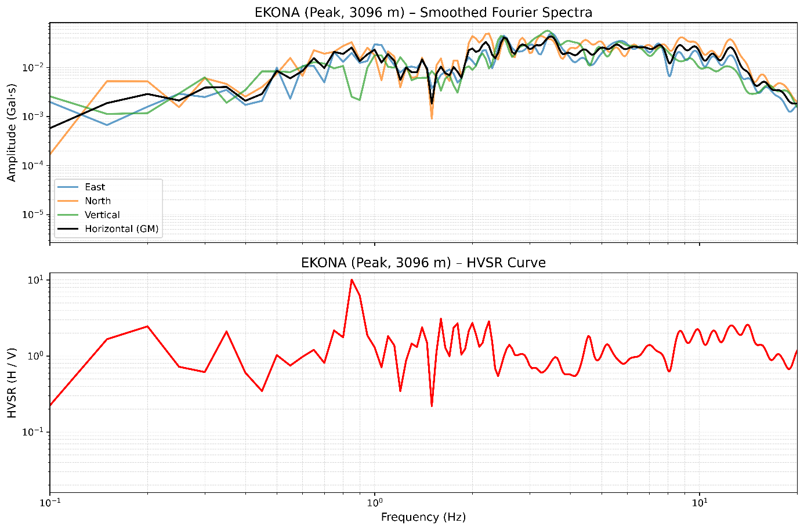
Figure A1. Smoothed Fourier amplitude spectra and HVSR curve for EKONA. The HVSR curve (red) exhibits a dominant peak at 0.85 Hz.

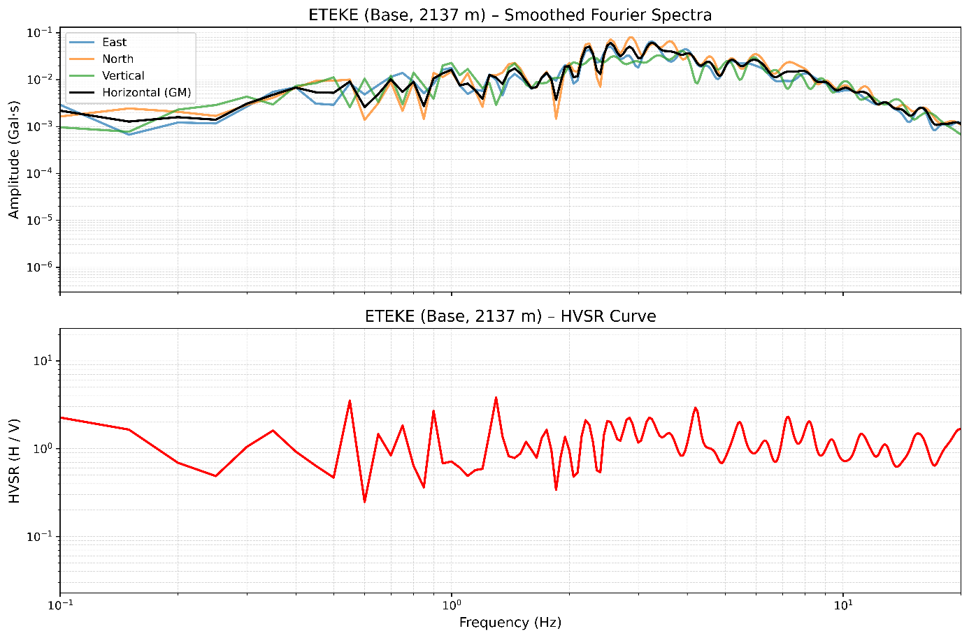
Figure A2. Smoothed Fourier amplitude spectra and HVSR curve for ETEKE (base). The HVSR curve (red) shows peaks at 0.55 Hz and 1.30 Hz, corresponding to local site response at the base.

