Supplementary Table
Table S1 Acquisition parameters of MRI scanning
Parameter | Main center | External center
Manufacturer (model) | GE Medical Systems (Discovery MR750); Siemens Healthineers (MAGNETOM Prisma) | Philips Medical Systems (Ingenia); GE HealthCare (SIGNA Hero XT)
Magnetic field strength | 3.0 T | 3.0 T
T1-weighted imaging
Repetition time | 420–552 ms | 634–650 ms
Echo time | 6.68–9.00 ms | 6.17–12.0 ms
Matrix | 320×320 to 512×512 | 320×320 to 512×512
Field of view | 200×200 to 220×220 mm² | 210×210 to 240×240 mm²
Slice thickness | 5.0–5.5 mm | 4.0–5.0 mm
Slice gap | 1.0–1.1 mm | 0.4–1.0 mm
Contrast-enhanced T1-weighted imaging*
Repetition time | 581–732 ms | 626–650 ms
Echo time | 9.70–13.0 ms | 7.07–12.0 ms
Matrix | 256×256 to 512×512 | 320×320 to 512×512
Field of view | 200×200 to 220×220 mm² | 220×220 to 240×240 mm²
Slice thickness | 5.0 mm | 4.0–5.0 mm
Slice gap | 1.0 mm | 0.4–1.0 mm
Fat suppression | Yes | Yes
T2-weighted imaging
Repetition time | 3233–5700 ms | 2519–4500 ms
Echo time | 73.0–102 ms | 80.3–90.0 ms
Matrix | 512×512 to 768×768 | 320×320 to 432×432
Field of view | 200×200 to 220×220 mm² | 220×220 to 240×240 mm²
Slice thickness | 5.0–5.5 mm | 4.0–5.0 mm
Slice gap | 1.0–1.1 mm | 0.4–1.0 mm
Fat suppression | Yes | Yes
*Contrast-enhanced T1-weighted sequences were acquired approximately 60 s after intravenous administration of a gadolinium-based contrast agent at a dose of 0.1 mmol/kg.

Table S2 PyRadiomics settings for radiomics feature extraction
Parameter | Setting
Software | PyRadiomics v3.0.1
Image types | Original; LoG; Wavelet
LoG sigma | 3.0, 4.0, and 5.0 mm
Intensity normalization | Enabled
normalizeScale | 100
Resampled voxel size | 3 × 3 × 3 mm³
Image interpolator | B-spline (sitkBSpline)
Gray-level discretization | Fixed bin width
binWidth | 5
voxelArrayShift | 300
Feature classes | First-order, shape, GLCM, GLRLM, GLSZM, GLDM, NGTDM
GLCM SumAverage | Not extracted
ROI label | 1
Radiomics features were extracted using a uniform parameter configuration across all centers, imaging time points, and ROIs. Original, Laplacian-of-Gaussian (LoG), and wavelet-transformed images were enabled. For GLCM features, SumAverage was excluded to avoid redundancy with JointAverage. Parameters not explicitly specified in the configuration file were retained at the default settings of PyRadiomics. GLCM, gray-level co-occurrence matrix; GLRLM, gray-level run-length matrix; GLSZM, gray-level size-zone matrix; GLDM, gray-level dependence matrix; NGTDM, neighboring gray-tone difference matrix.

Table S3 Cross-validation performance of candidate classifiers in the training cohort
Classifier | Mean CV AUC | SD | Best hyperparameters / settings
Logistic regression (LR) | 0.867 | 0.032 | penalty = L2; C = 1.0
Support vector machine (SVM) | 0.830 | 0.050 | kernel = RBF; C = 1; gamma = scale
K-nearest neighbors (KNN) | 0.801 | 0.061 | n_neighbors = 7; weights = distance; metric = Minkowski
Random forest (RF) | 0.842 | 0.045 | n_estimators = 500; max_depth = 5; min_samples_leaf = 2
XGBoost | 0.816 | 0.052 | n_estimators = 200; learning_rate = 0.03; max_depth = 3
Candidate classifiers were optimized using grid search with cross-validation in the training cohort. Mean AUC and SD were calculated across cross-validation folds. The classifier with the highest mean cross-validated AUC was selected as the final classifier and subsequently fixed for downstream model construction and evaluation. Hyperparameter tuning and feature selection were performed using training data only.

Table S4 Comparison of the predictive performance of the intratumoral radiomics model across the training, internal validation, and independent test cohorts
Cohort | Signature | Accuracy | AUC (95% CI) | Sensitivity | Specificity | PPV | NPV
Train | Pre-treatment-Intra | 0.795 | 0.806 (0.733–0.880) | 0.582 | 0.964 | 0.929 | 0.743
 | On-treatment-Intra | 0.775 | 0.823 (0.755–0.890) | 0.940 | 0.643 | 0.677 | 0.931
 | Longitudinal-Intra | 0.781 | 0.843 (0.779–0.908) | 0.806 | 0.762 | 0.730 | 0.831
Val | Pre-treatment-Intra | 0.606 | 0.524 (0.367–0.682) | 0.500 | 0.659 | 0.423 | 0.725
 | On-treatment-Intra | 0.697 | 0.723 (0.590–0.856) | 0.818 | 0.636 | 0.529 | 0.875
 | Longitudinal-Intra | 0.727 | 0.716 (0.581–0.851) | 0.545 | 0.818 | 0.600 | 0.783
Test | Pre-treatment-Intra | 0.667 | 0.738 (0.637–0.840) | 0.829 | 0.569 | 0.537 | 0.846
 | On-treatment-Intra | 0.742 | 0.700 (0.580–0.821) | 0.686 | 0.776 | 0.649 | 0.804
 | Longitudinal-Intra | 0.806 | 0.752 (0.641–0.864) | 0.743 | 0.845 | 0.743 | 0.845

Table S5 Comparison of the predictive performance of longitudinal peritumoral radiomics models at different scales across the training, internal validation, and independent test cohorts
Cohort | Model | Accuracy | AUC (95% CI) | Sensitivity | Specificity | PPV | NPV
Train | M4₁ | 0.748 | 0.805 (0.732–0.878) | 0.761 | 0.738 | 0.699 | 0.795
Train | M4₃ | 0.781 | 0.839 (0.772–0.906) | 0.791 | 0.774 | 0.736 | 0.823
Train | M4₅ | 0.808 | 0.877 (0.818–0.936) | 0.821 | 0.798 | 0.764 | 0.848
Val | M4₁ | 0.727 | 0.729 (0.593–0.865) | 0.727 | 0.727 | 0.571 | 0.842
Val | M4₃ | 0.742 | 0.735 (0.600–0.870) | 0.727 | 0.750 | 0.593 | 0.846
Val | M4₅ | 0.697 | 0.698 (0.557–0.839) | 0.682 | 0.705 | 0.536 | 0.816
Test | M4₁ | 0.742 | 0.769 (0.664–0.874) | 0.743 | 0.741 | 0.634 | 0.827
Test | M4₃ | 0.763 | 0.777 (0.673–0.881) | 0.771 | 0.759 | 0.659 | 0.846
Test | M4₅ | 0.710 | 0.732 (0.621–0.843) | 0.714 | 0.707 | 0.595 | 0.804

Table S6 Performance metrics of candidate spatiotemporal radiomics models across different peritumoral dilation scales in the training, internal validation, and external test cohorts
Cohort | Model | Accuracy | AUC (95% CI) | Sensitivity | Specificity | PPV | NPV
Train | M5₁ | 0.781 | 0.843 (0.778–0.908) | 0.791 | 0.774 | 0.736 | 0.823
Train | M5₃ | 0.828 | 0.906 (0.861–0.952) | 0.836 | 0.821 | 0.789 | 0.863
Train | M5₅ | 0.801 | 0.869 (0.812–0.925) | 0.806 | 0.798 | 0.761 | 0.838
Val | M5₁ | 0.712 | 0.715 (0.573–0.856) | 0.682 | 0.727 | 0.556 | 0.821
Val | M5₃ | 0.742 | 0.740 (0.605–0.875) | 0.727 | 0.750 | 0.593 | 0.846
Val | M5₅ | 0.727 | 0.730 (0.588–0.873) | 0.727 | 0.727 | 0.571 | 0.842
Test | M5₁ | 0.774 | 0.796 (0.700–0.892) | 0.771 | 0.776 | 0.675 | 0.849
Test | M5₃ | 0.796 | 0.818 (0.730–0.906) | 0.800 | 0.793 | 0.700 | 0.868
Test | M5₅ | 0.774 | 0.795 (0.702–0.889) | 0.743 | 0.793 | 0.684 | 0.836
Each candidate spatiotemporal radiomics model was constructed by score-level fusion of the predicted probabilities from M3 (Longitudinal-Intra) and the corresponding longitudinal peritumoral model using logistic regression. Specifically, M5₁ combined the predicted probabilities from M3 and M4₁, M5₃ combined those from M3 and M4₃, and M5₅ combined those from M3 and M4₅. Candidate model selection was based on the mean AUC obtained from 10-fold cross-validation within the training cohort, and M5₃ was selected as the final spatiotemporal radiomics model (M5). The classification cutoff for each model was determined in the training cohort by maximizing the Youden index and was then fixed and applied unchanged to the internal validation and independent external test cohorts.
AUC, area under the receiver operating characteristic curve; CI, confidence interval; PPV, positive predictive value; NPV, negative predictive value; train, training cohort (n = 151); val, internal validation cohort (n = 66); test, external test cohort (n = 93).

Table S7 Pairwise comparison of discrimination and reclassification performance among the principal prediction models
Cohort | Comparison | ΔAUC | DeLong P | Continuous NRI (95% CI) | NRI P | IDI (95% CI) | IDI P
Train | M3 (Longitudinal-Intra) vs M0 (Clinical) | +0.136 | 0.006 | 0.360 (0.115,0.605) | 0.004 | 0.102 (0.037,0.167) | 0.002
Train | M5 (Spatiotemporal) vs M0 (Clinical) | +0.199 | <0.001 | 0.490 (0.198,0.782) | <0.001 | 0.158 (0.064,0.252) | <0.001
Train | M6 (Clinical-Spatiotemporal) vs M0 (Clinical) | +0.221 | <0.001 | 0.580 (0.235,0.925) | <0.001 | 0.207 (0.084,0.330) | <0.001
Train | M5 (Spatiotemporal) vs M3 (Longitudinal-Intra) | +0.063 | 0.014 | 0.240 (0.035,0.445) | 0.022 | 0.056 (0.010,0.102) | 0.017
Train | M6 (Clinical-Spatiotemporal) vs M3 (Longitudinal-Intra) | +0.085 | 0.003 | 0.390 (0.143,0.637) | 0.002 | 0.105 (0.038,0.172) | 0.002
Train | M6 (Clinical-Spatiotemporal) vs M5 (Spatiotemporal) | +0.022 | 0.043 | 0.180 (0.030,0.330) | 0.020 | 0.049 (0.006,0.092) | 0.026
Val | M3 (Longitudinal-Intra) vs M0 (Clinical) | −0.077 | 0.340 | −0.140 (−0.488,0.208) | 0.430 | −0.036 (−0.103,0.031) | 0.290
Val | M5 (Spatiotemporal) vs M0 (Clinical) | −0.053 | 0.490 | −0.070 (−0.403,0.263) | 0.680 | −0.018 (−0.076,0.040) | 0.540
Val | M6 (Clinical-Spatiotemporal) vs M0 (Clinical) | +0.063 | 0.180 | 0.270 (−0.070,0.610) | 0.120 | 0.074 (−0.009,0.157) | 0.080
Val | M5 (Spatiotemporal) vs M3 (Longitudinal-Intra) | +0.024 | 0.610 | 0.120 (−0.229,0.469) | 0.500 | 0.018 (−0.038,0.074) | 0.529
Val | M6 (Clinical-Spatiotemporal) vs M3 (Longitudinal-Intra) | +0.140 | 0.009 | 0.480 (0.125,0.835) | 0.008 | 0.110 (0.029,0.191) | 0.008
Val | M6 (Clinical-Spatiotemporal) vs M5 (Spatiotemporal) | +0.116 | 0.018 | 0.410 (0.090,0.730) | 0.012 | 0.092 (0.014,0.170) | 0.021
Test | M3 (Longitudinal-Intra) vs M0 (Clinical) | +0.153 | 0.012 | 0.330 (0.067,0.593) | 0.014 | 0.091 (0.024,0.158) | 0.008
Test | M5 (Spatiotemporal) vs M0 (Clinical) | +0.219 | <0.001 | 0.470 (0.172,0.768) | 0.002 | 0.142 (0.057,0.227) | <0.001
Test | M6 (Clinical-Spatiotemporal) vs M0 (Clinical) | +0.265 | <0.001 | 0.570 (0.230,0.910) | <0.001 | 0.191 (0.077,0.305) | <0.001
Test | M5 (Spatiotemporal) vs M3 (Longitudinal-Intra) | +0.066 | 0.047 | 0.220 (−0.027,0.467) | 0.081 | 0.051 (0.001,0.101) | 0.046
Test | M6 (Clinical-Spatiotemporal) vs M3 (Longitudinal-Intra) | +0.112 | 0.008 | 0.390 (0.112,0.668) | 0.006 | 0.100 (0.036,0.164) | 0.003
Test | M6 (Clinical-Spatiotemporal) vs M5 (Spatiotemporal) | +0.046 | 0.041 | 0.240 (0.018,0.462) | 0.034 | 0.049 (0.005,0.093) | 0.029
ΔAUC, continuous NRI, and IDI were calculated as the first model minus the second model in each comparison. Positive values indicate improved discrimination or reclassification performance of the first model. DeLong P values were obtained using paired DeLong tests.

Supplementary Figure
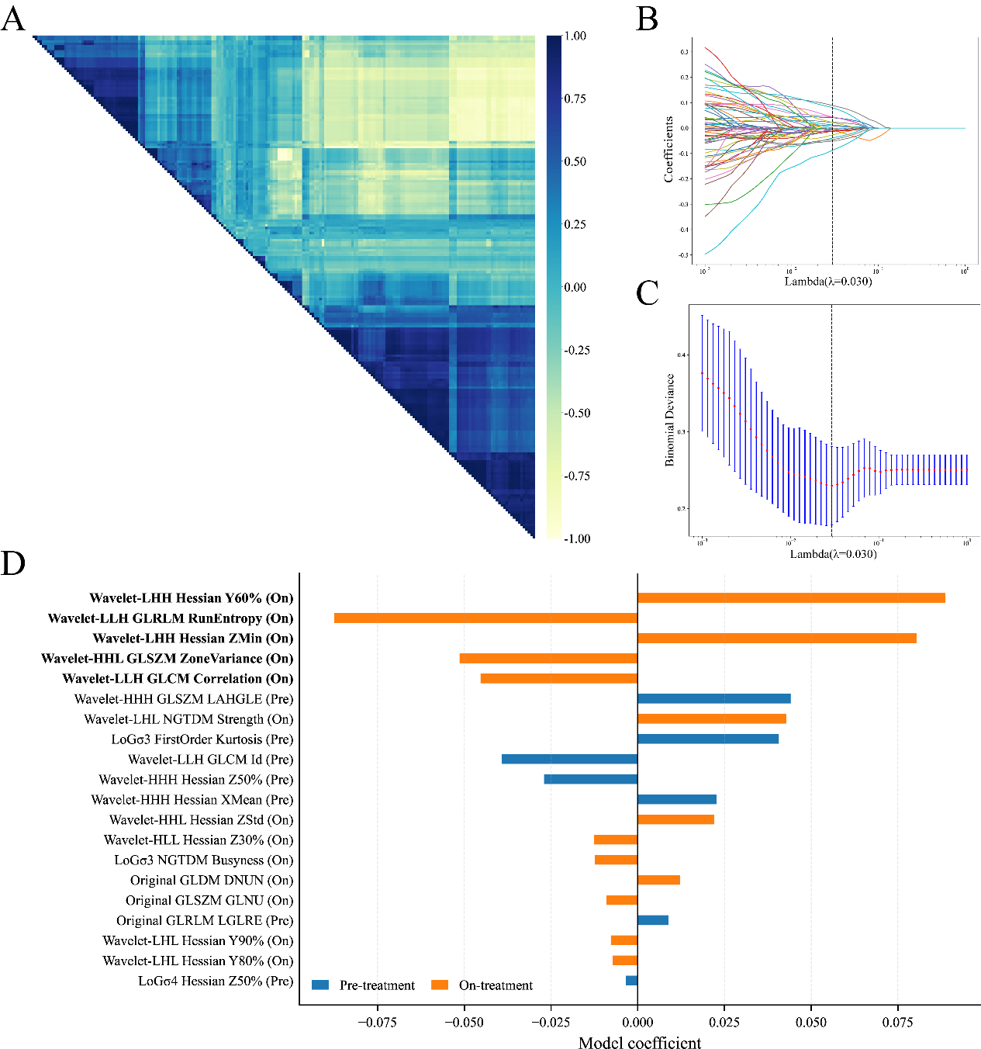
Figure S1 Longitudinal 1-mm peritumoral radiomic feature selection predicting neoadjuvant chemoimmunotherapy response in HNSCC. (A) Pearson correlation matrix of candidate radiomics features, used to identify and remove highly correlated redundant features (|r| > 0.90). (B) Regularization paths of radiomics feature coefficients in LASSO logistic regression as a function of the penalty parameter λ. The vertical dashed line indicates the optimal regularization parameter (λ = 0.030). (C) Binomial deviance as a function of λ based on 10-fold cross-validation. The vertical dashed line indicated the optimal λ (λ = 0.030). (D) Regression coefficients of the 20 longitudinal peritumoral radiomics features with nonzero coefficients retained at the optimal λ. Positive coefficients indicated that higher radiomics feature values were associated with pCR, whereas negative coefficients indicated an association with non-pCR. Blue bars represent pre-treatment baseline radiomics features, and orange bars represent radiomics features obtained during the second treatment cycle.

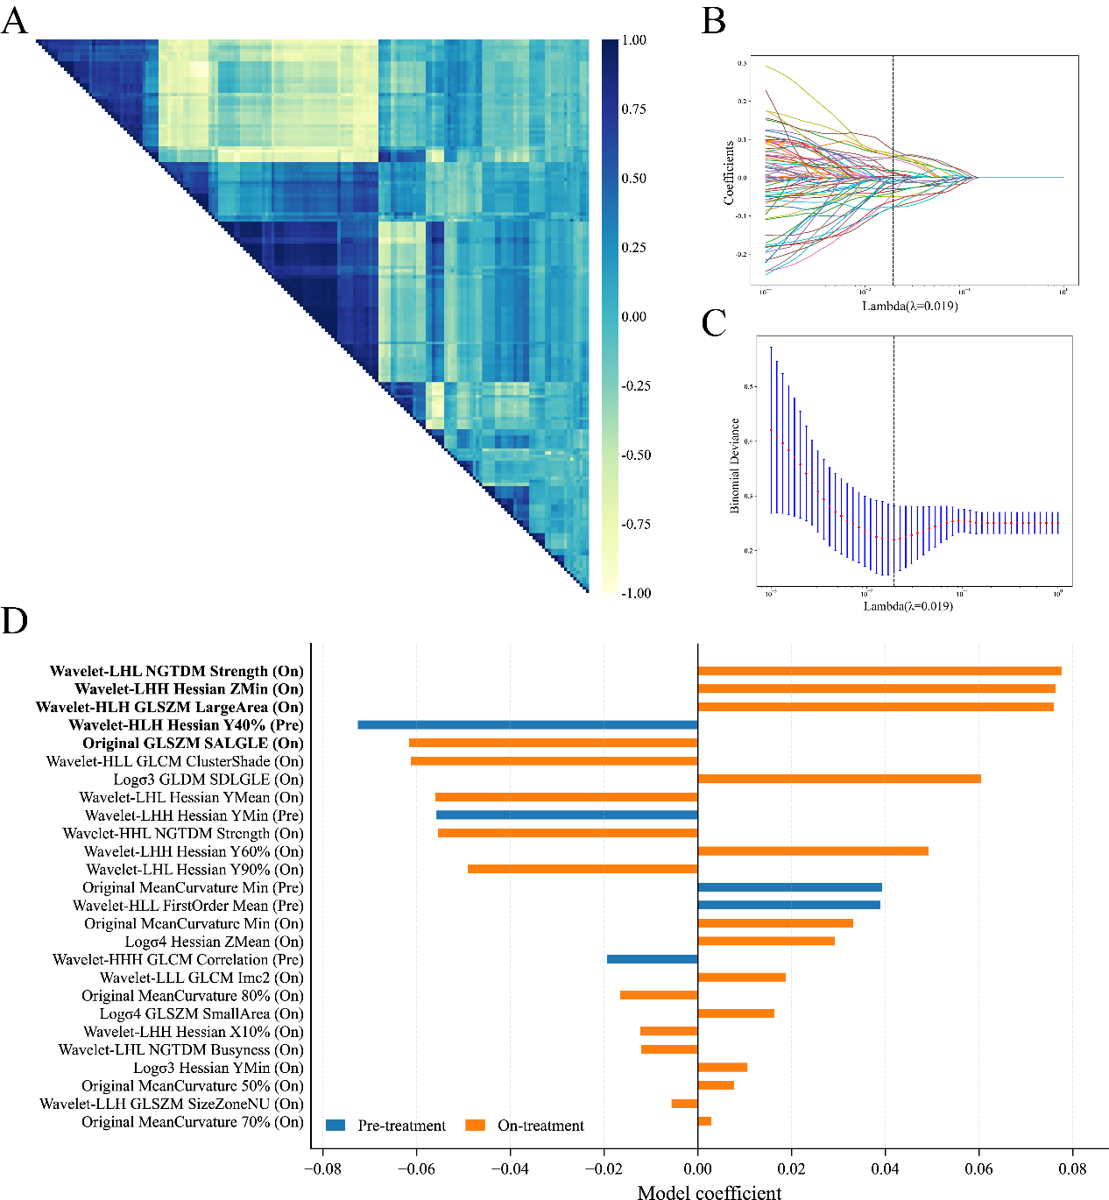
Figure S2 Longitudinal 3-mm peritumoral radiomic feature selection predicting neoadjuvant chemoimmunotherapy response in HNSCC. (A) Pearson correlation matrix of candidate radiomics features, used to identify and remove highly correlated redundant features (|r| > 0.90). (B) Regularization paths of radiomics feature coefficients in LASSO logistic regression as a function of the penalty parameter λ. The vertical dashed line indicates the optimal regularization parameter (λ = 0.019). (C) Binomial deviance as a function of λ based on 10-fold cross-validation. The vertical dashed line indicates the optimal λ (λ = 0.019). (D) Regression coefficients of the 26 longitudinal peritumoral radiomics features with nonzero coefficients retained at the optimal λ. Positive coefficients indicated that higher radiomics feature values were associated with pCR, whereas negative coefficients indicated an association with non-pCR. Blue bars represent pre-treatment baseline radiomics features, and orange bars represent radiomics features obtained during the second treatment cycle.

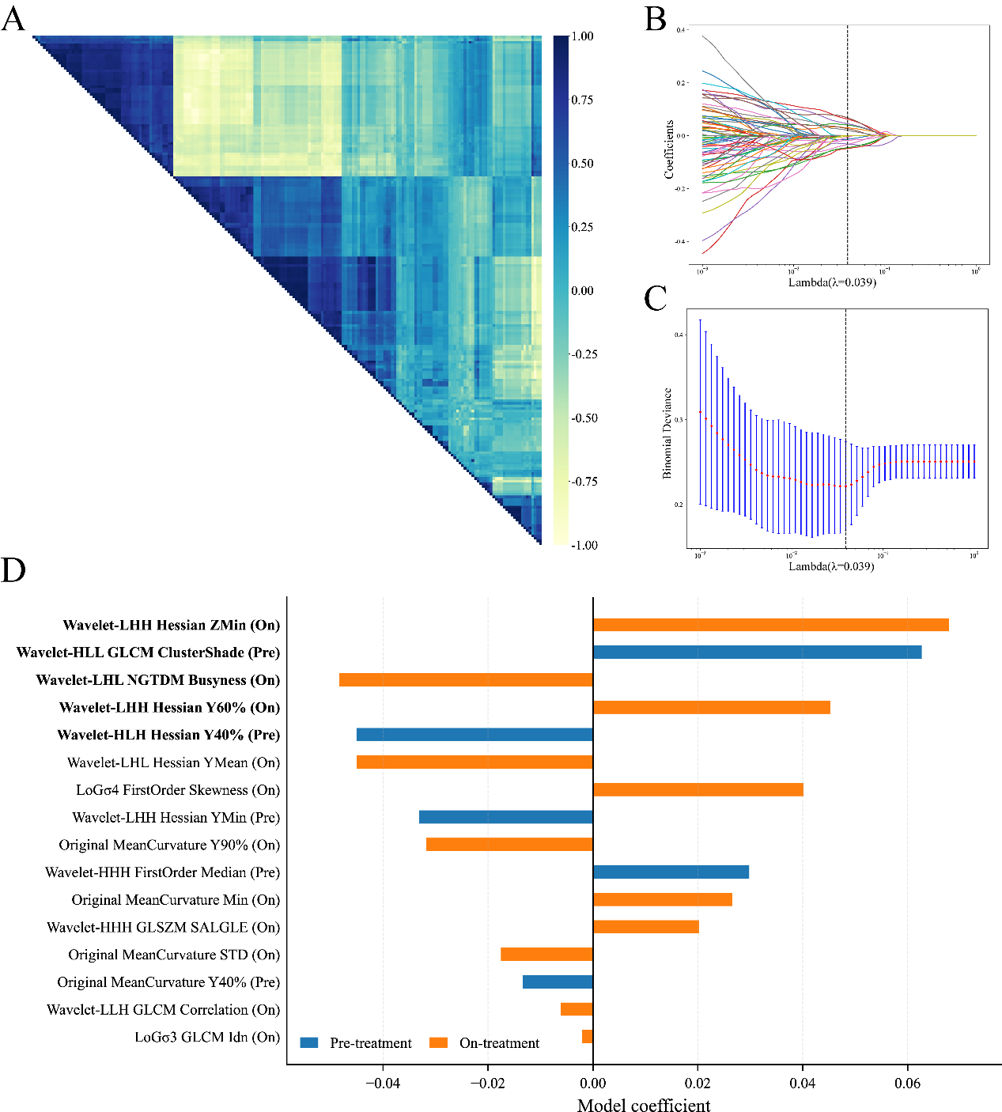
Figure S3 Longitudinal 5-mm peritumoral radiomic feature selection predicting neoadjuvant chemoimmunotherapy response in HNSCC. (A) Pearson correlation matrix of candidate radiomics features, used to identify and remove highly correlated redundant features (|r| > 0.90). (B) Regularization paths of radiomics feature coefficients in LASSO logistic regression as a function of the penalty parameter λ. The vertical dashed line indicates the optimal regularization parameter (λ = 0.039). (C) Binomial deviance as a function of λ based on 10-fold cross-validation. The vertical dashed line indicates the optimal λ (λ = 0.039). (D) Regression coefficients of the 16 longitudinal peritumoral radiomics features with nonzero coefficients retained at the optimal λ. Positive coefficients indicated that higher radiomics feature values were associated with pCR, whereas negative coefficients indicated an association with non-pCR. Blue bars represent pre-treatment baseline radiomics features, and orange bars represent radiomics features obtained during the second treatment cycle.

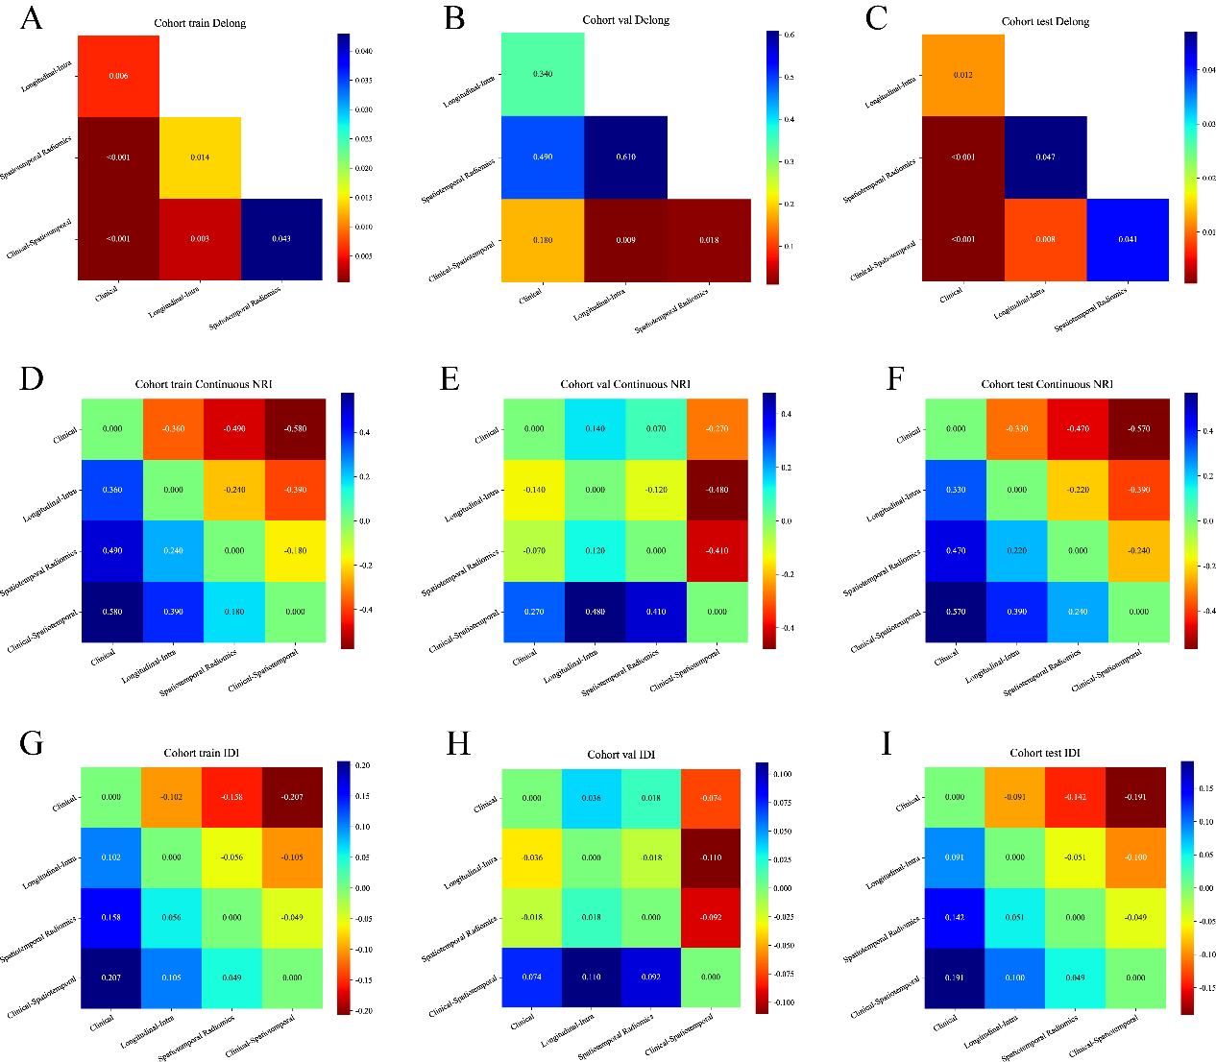
Figure S4 Pairwise statistical comparisons and heatmaps of incremental discrimination performance across the training, internal validation, and external test cohorts. (A–C) Heatmaps of P values from pairwise DeLong tests comparing the receiver operating characteristic curves of the models in the training cohort (A), internal validation cohort (B), and independent external test cohort (C). Warmer colors indicate smaller P values and greater statistical significance. (D–F) Matrices of pairwise continuous net reclassification improvement (NRI) in the training cohort (D), internal validation cohort (E), and external test cohort (F). (G–I) Matrices of pairwise integrated discrimination improvement (IDI) in the training cohort (G), internal validation cohort (H), and external test cohort (I). Positive values (blue) indicate improved discriminative performance, whereas negative values (red) indicate reduced discriminative performance. Clinical (M0), clinical model; Longitudinal-Intra (M3), longitudinal intratumoral radiomics model; Spatiotemporal Radiomics (M5), spatiotemporal radiomics model; Clinical-Spatiotemporal (M6), clinical-spatiotemporal radiomics model; NRI, net reclassification improvement; IDI, integrated discrimination improvement.

