Bio-based benzoxazine electrically conductive adhesives for sustainable and epoxy-free hybrid printed electronics.

Petsagkourakis I.¹ , Hagel O.J. ¹, Sawatdee A. ¹, Carniello S.², Schwarz-Funder E.², Gasslander A.³, Strandberg J. ¹, Alvi N.H. ¹, Makhinia A.¹, Beni V. ¹ and Sandberg M. ^{1*}

¹RISE Research Institutes of Sweden, Unit of Printed and Organic Electronics, Södra Grytsgatan 4, 602 23, Norrköping, Sweden

²Joanneum Research Forschungsgesellschaft mbH, Institute for Climate, Energy Systems, and Society, 8010 Graz, Austria

³RISE Research Institutes of Sweden, Unit of Advanced Electronics, Group "Electronics Reliability", Argongatan 30, 431 53, Mölndal, Sweden

* Corresponding author: mats.sandberg@ri.se

Section S1 : Nuclear Magnetic Resonance

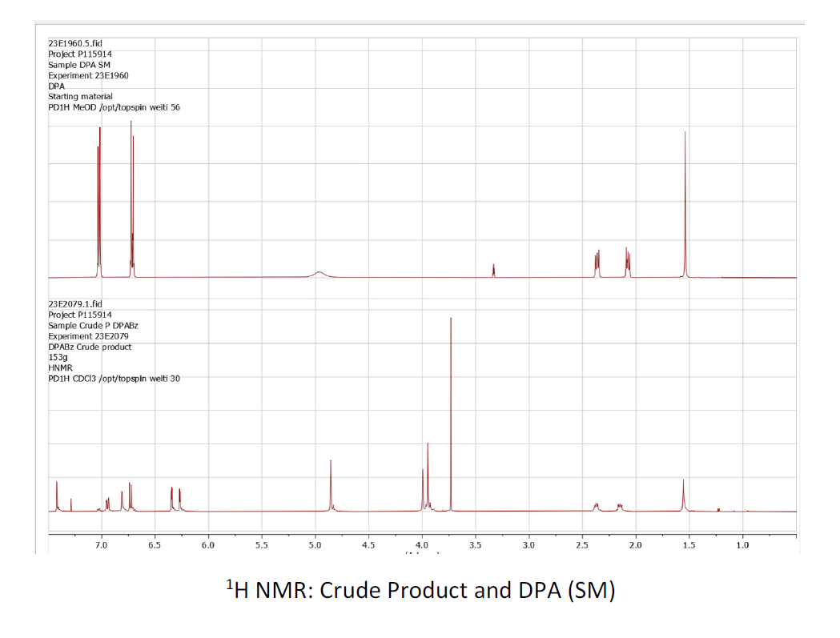
Figure S1: The 1H NMR for the DPA starting material (up) and the DPA-Bz Crude product (down)

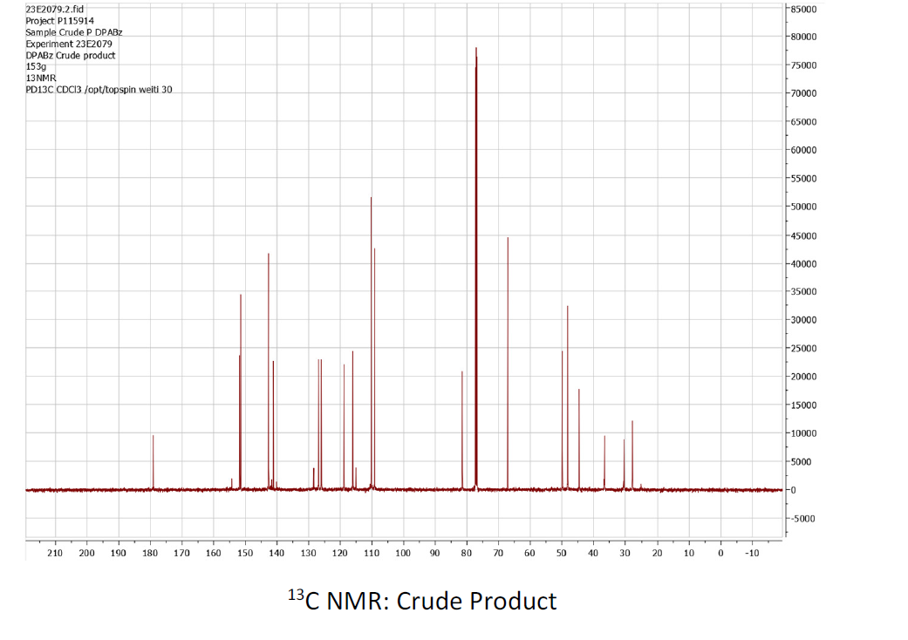
Figure S2: The 13C NMR for the DPA-Bz crude product

Section S2: Anisotropicity

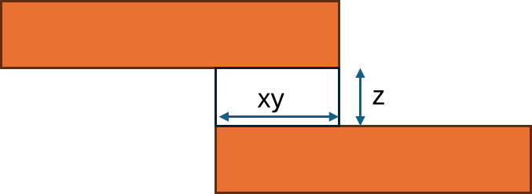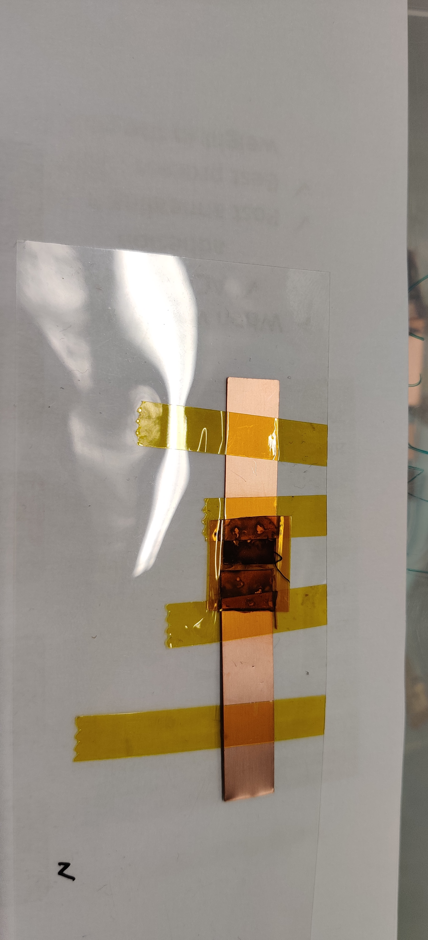
Figure S3: (left) A schematic representation of the directions for the bond ; (right) A photographic depiction of a test sample that was used for the Isotropic Conductive Adhesive investigation (measurement in xy direction)

Section S3 : ACA Process engineering, electromechanical testing and assembly

Table S1: The engineered conditions of the bonding with the thermode
Thermode Temperature T(ºC) | Post annealing (150C , 1h) | Post annealing M (g) | Is it conductive ? | Does it stick ?
25ºC | Yes | 500 | Yes | Yes
25ºC | Yes | 0 | No | No
25ºC | No | 0 | Yes | No
150ºC | Yes | 500 | Yes | Yes
150ºC | Yes | 0 | No | No
150ºC | No | 0 | Yes | No
200ºC | Yes | 500 | Yes | Yes
200ºC | Yes | 0 | Yes | Yes
200ºC | No | 0 | Yes | No

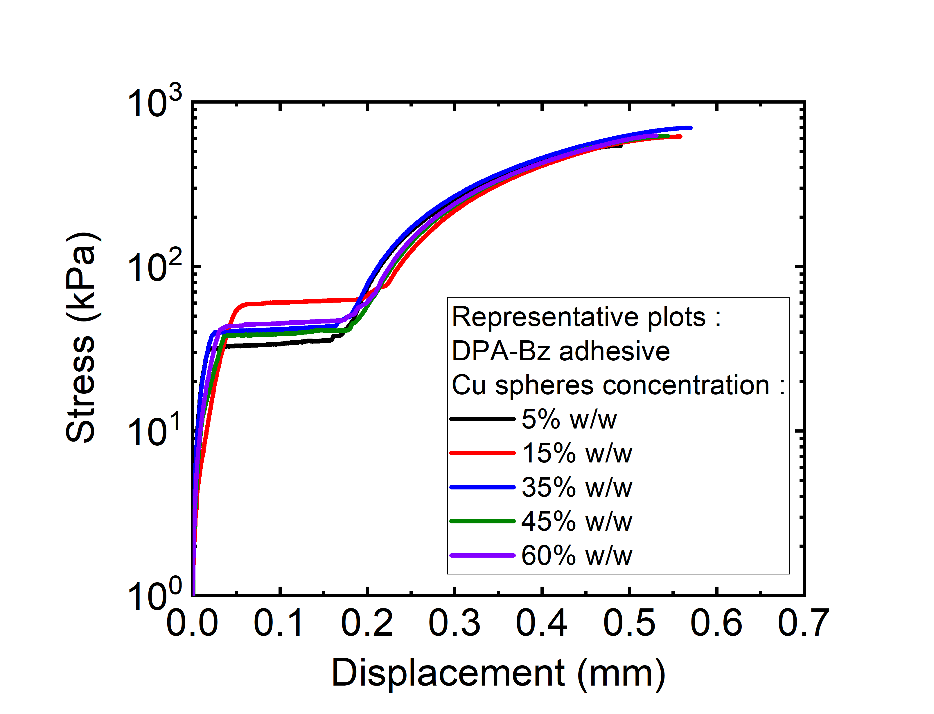
Figure S4: The Stress vs Displacement plots for representative ACAs of various concentrations in the conductive filler

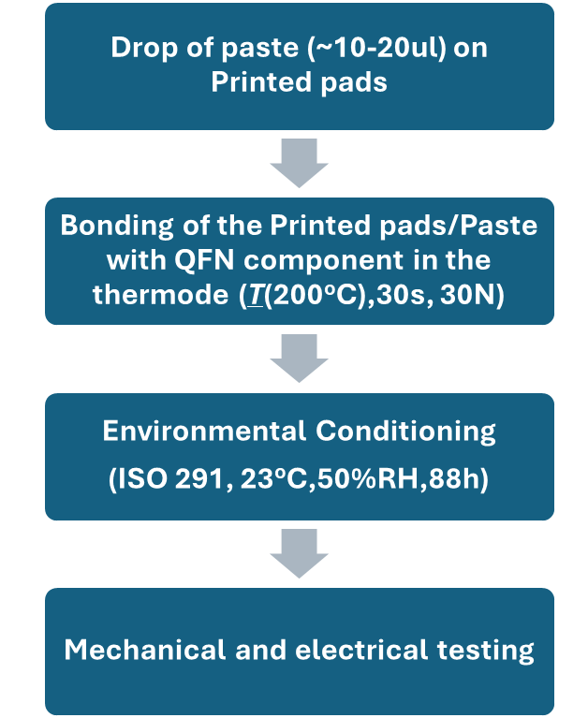
FigureS5: The updated process for the QFN SMD process

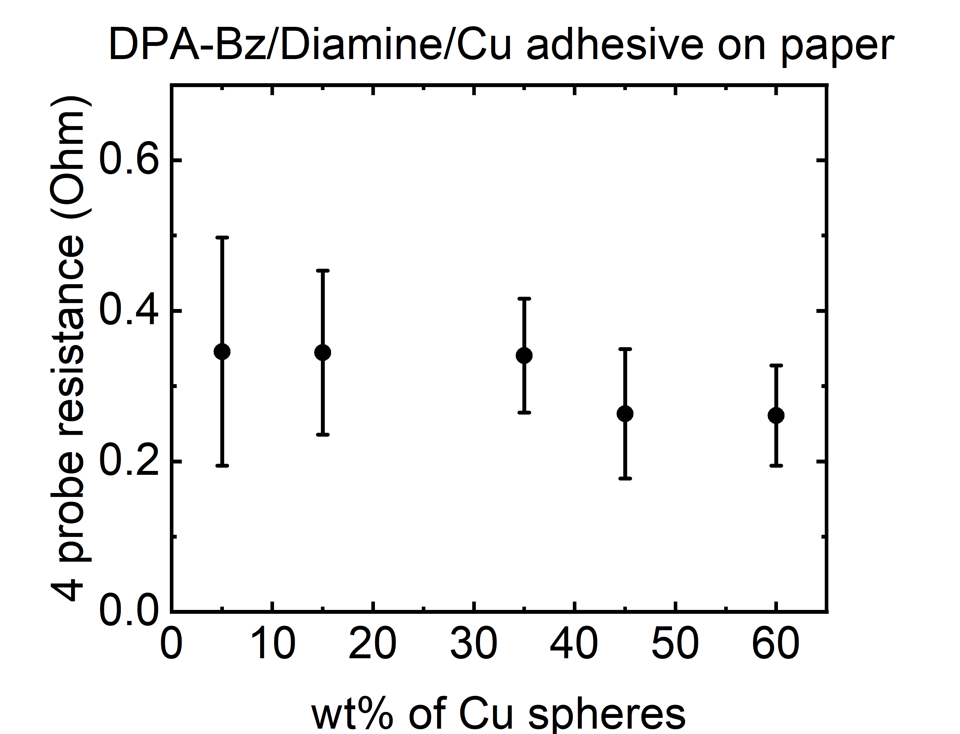
FigureS6: The 4-probe resistance of the SMD components on XD200 paper for the various concentrations of the ACA

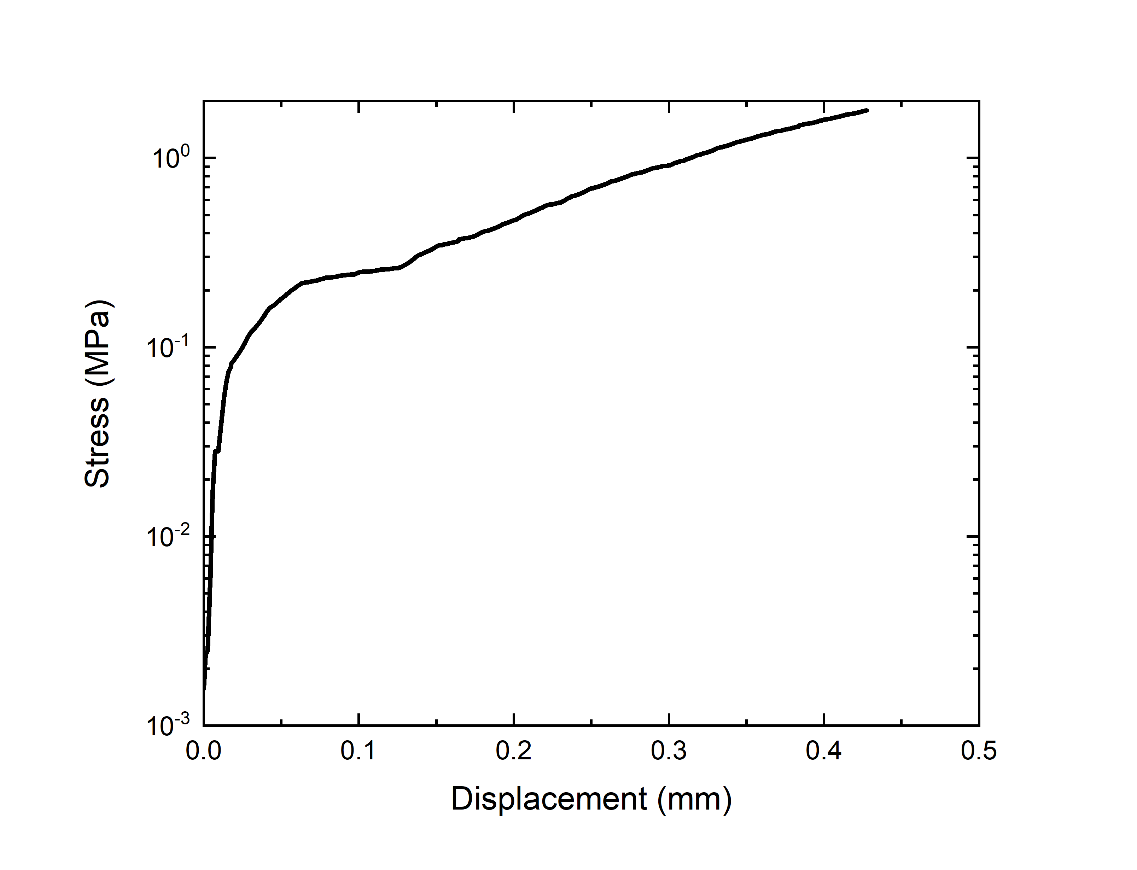
Figure S7 : The mechanical performance of an SMD component mounted on the Kapton foil

Section S4 : LCA Inventories

Table S2 : The LCA inventory for the Cu ACA
Cu ACA | Amount (g/FU, Wh/FU) | LCI unit process, source
Cu extraction and processing - primary | 0.02205 | IEA estimation of GWP¹
Cu extraction and processing - secondary | 0 | IEA estimation of GWP¹
Polymeric matrix (DPA Bz + DIADO) | 0.02457 | Stoichiometric model base on RISE information, integrated with Ningbo patent. DIADO approximated hexamethylenediamine
Solvent (Benzyl acetone) | 0.01638 | Stoichiometric model base on Kuhn et al.²
Storage | NA | Storage at room temperature possible
Curing | 1.33 | Primary data, EU electricity mix (EEA)³

Table S3 : The LCA inventory for the Ni ACA
Ni ACA | Amount (g/FU, Wh/FU) | LCI unit process, source
Ni extraction and processing - primary | 0.01325 | IEA estimation of GWP
Ni extraction and processing - secondary | 0 | IEA estimation of GWP
Polymeric matrix (epoxy resin + Bisphenol A) | 0.03975 | Composition extrapolated from datasheet
solvent | NA
Storage | 0.1 | 6 months storage in small lab fridge. Primary data, EU electricity mix (EEA)³
Curing | 1.33 | Primary data, EU electricity mix (EEA)³

Table S4 : The LCA inventory for the GWP
 | Ni-ACA |  |  | Cu-ACA
contribution | worst case | market ave | best case | worst case | market ave | best case
primary metal | 0.133 | 0.111 | 0.000 | 0.138 | 0.062 | 0.000
secondary metal | 0.000 | 0.003 | 0.020 | 0.000 | 0.019 | 0.034
matrix | 0.200 | 0.200 | 0.200 | 0.130 | 0.130 | 0.130
solvent | 0.000 | 0.000 | 0.000 | 0.078 | 0.078 | 0.078
storage energy | 0.019 | 0.019 | 0.019 | 0.000 | 0.000 | 0.000
curing energy | 0.249 | 0.249 | 0.249 | 0.249 | 0.249 | 0.249

References

1. Recycling of Critical Minerals, strategies to scale up recycling and urban mining. A World Energy Outlook Special Report; International Energy Agency: 2024.
2. Senft, W. K. H.-U. F. G. Process for the preparation of benzylacetone. 2001.
3. Greenhouse gas emission intensity of electricity generation in Europe. https://www.eea.europa.eu/en/analysis/indicators/greenhouse-gas-emission-intensity-of-1?activeAccordion=309c5ef9-de09-4759-bc02-802370dfa366.

