Supplementary Materials
Prognostic and Immune Microenvironment Significance of Opioid Receptor- and Pain-Related Gene Signatures in Gastric and Colorectal Cancer

Supplementary Figures
Supplementary Figure S1. Associations of MSI status and the TMB proxy with risk groups.
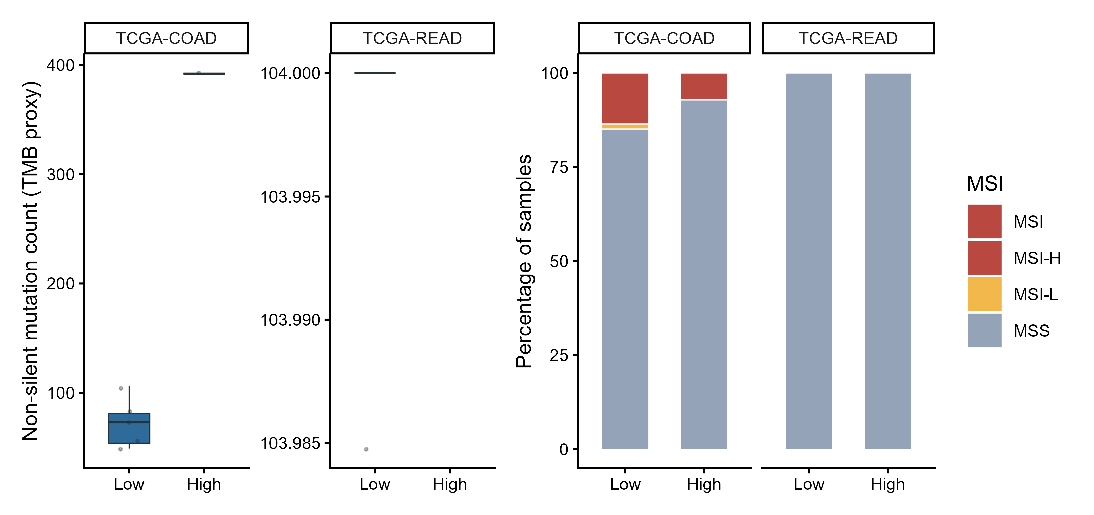
Supplementary Figure S2. Expression localization of candidate genes in GSE146771 immune-cell subsets.
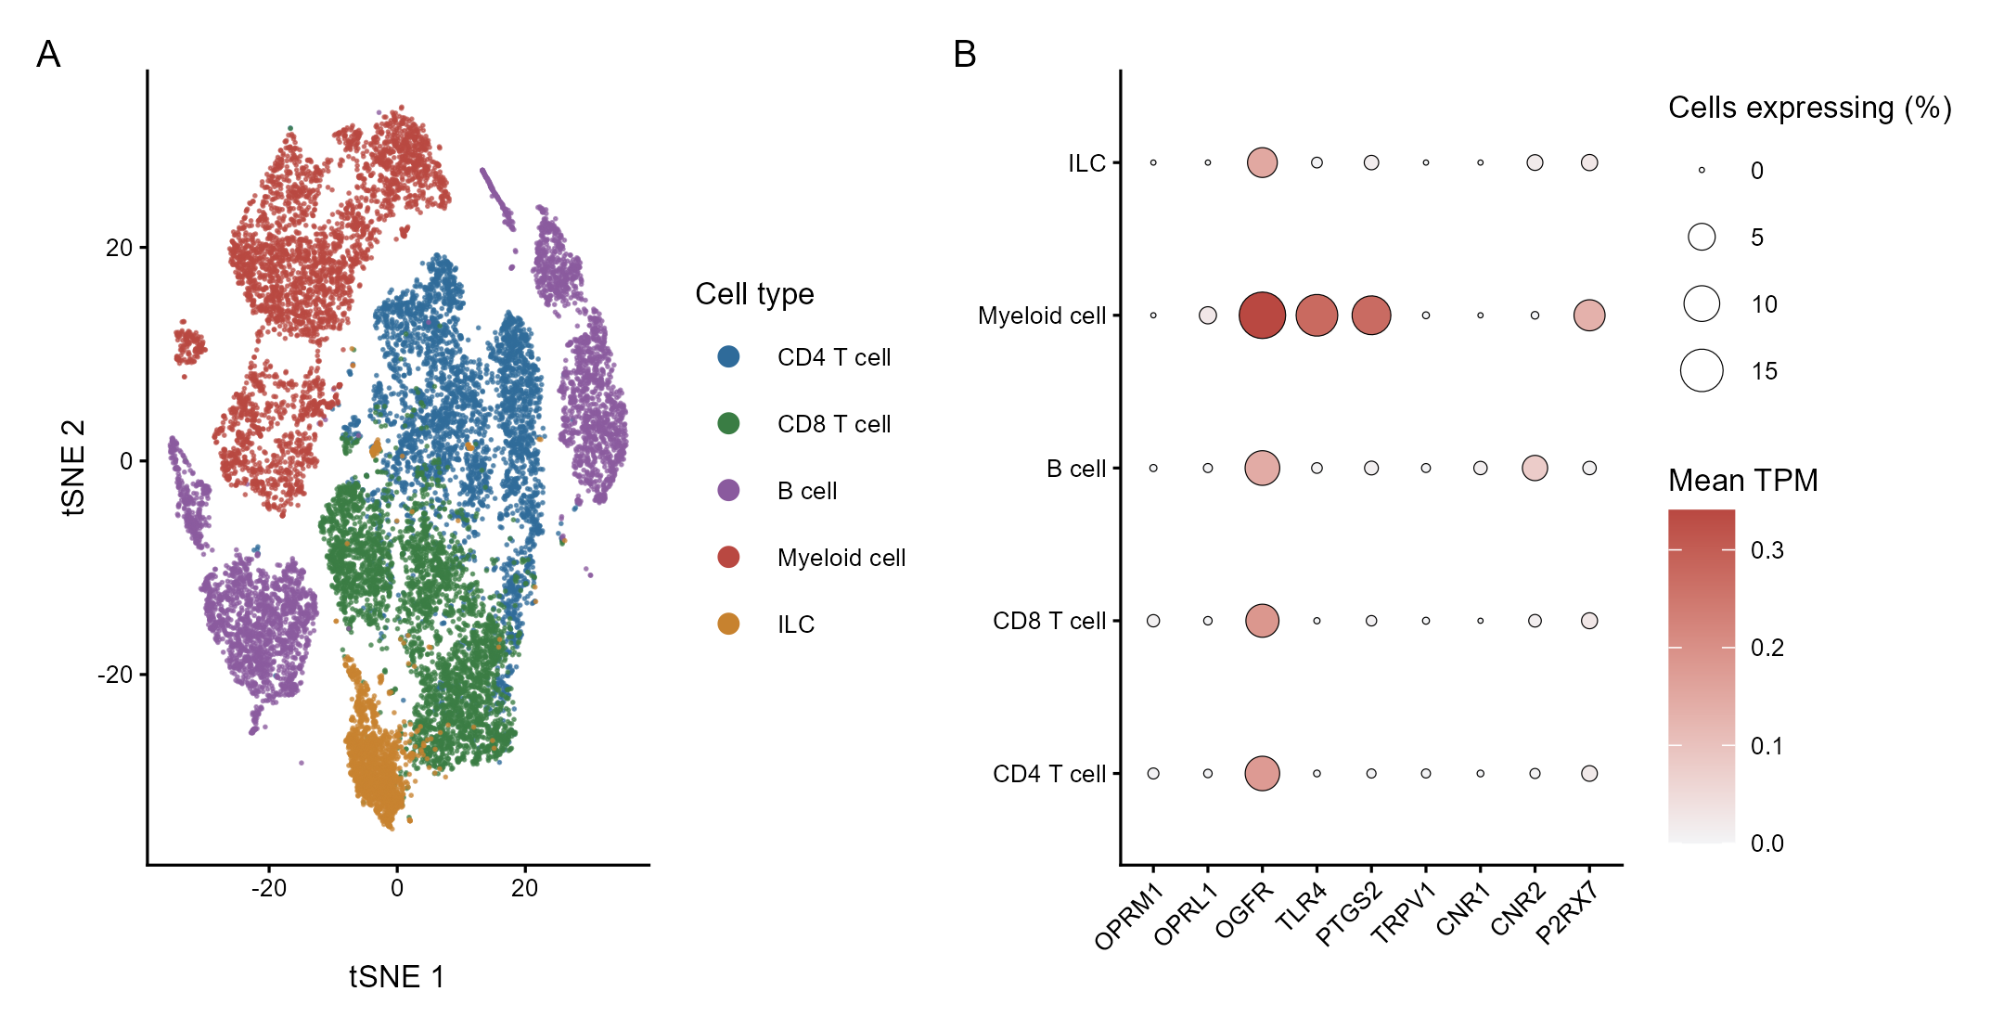

Supplementary Figure S3. Multivariable Cox model nomogram, calibration curve, and decision curve.
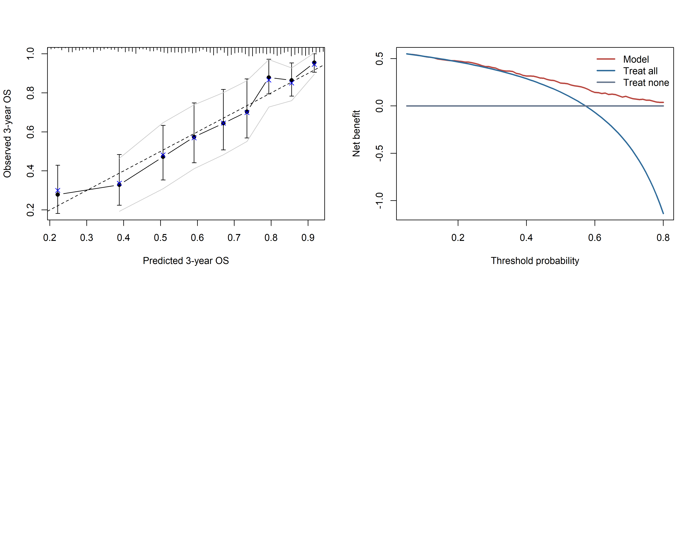

Supplementary Tables
Supplementary Table S1. Candidate genes
Category | Gene | Full_name | Rationale
Opioid receptor-related genes | OPRM1 | Mu opioid receptor | Classical opioid analgesic target; potential immune and tumor microenvironment relevance
Opioid receptor-related genes | OPRK1 | Kappa opioid receptor | Opioid receptor involved in analgesia and stress response
Opioid receptor-related genes | OPRD1 | Delta opioid receptor | Opioid receptor involved in analgesia and inflammatory regulation
Opioid receptor-related genes | OPRL1 | Nociceptin opioid receptor | Nociceptin receptor related to pain and immune modulation
Opioid receptor-related genes | OGFR | Opioid growth factor receptor | Growth-related opioid axis component
Pain, inflammation and neuroimmune-related genes | TLR4 | Toll-like receptor 4 | Inflammation and innate immune receptor linked to pain sensitization
Pain, inflammation and neuroimmune-related genes | PTGS2 | Prostaglandin-endoperoxide synthase 2 | COX-2 inflammatory mediator and prostaglandin synthesis enzyme
Pain, inflammation and neuroimmune-related genes | TRPV1 | Transient receptor potential cation channel subfamily V member 1 | Nociception and neurogenic inflammation marker
Pain, inflammation and neuroimmune-related genes | CNR1 | Cannabinoid receptor 1 | Endocannabinoid receptor related to pain and neural signaling
Pain, inflammation and neuroimmune-related genes | CNR2 | Cannabinoid receptor 2 | Endocannabinoid receptor enriched in immune regulation
Pain, inflammation and neuroimmune-related genes | P2RX7 | Purinergic receptor P2X 7 | Purinergic receptor related to inflammatory pain and immune activation

Supplementary Table S2. Differential expression and single-gene prognostic analysis of candidate genes
Cohort | Gene | Tumor n | Normal n | Tumor median | Normal median | Delta median | DE FDR | Cox HR  (95% CI) | Cox P | Cox FDR
TCGA-COAD | CNR1 | 286 | 41 | 2.56 | 6.89 | -4.32 | <0.001 | 1.05  (0.93-1.20) | 0.421 | 0.667
TCGA-COAD | OPRM1 | 286 | 41 | 0.00 | 0.49 | -0.49 | <0.001 | 0.82  (0.25-2.63) | 0.736 | 0.810
TCGA-COAD | CNR2 | 286 | 41 | 1.18 | 3.55 | -2.37 | <0.001 | 1.06  (0.87-1.30) | 0.563 | 0.689
TCGA-COAD | OPRL1 | 286 | 41 | 3.72 | 4.92 | -1.20 | <0.001 | 1.16  (0.96-1.39) | 0.132 | 0.484
TCGA-COAD | OGFR | 286 | 41 | 10.67 | 10.05 | 0.62 | <0.001 | 1.17  (0.80-1.71) | 0.424 | 0.667
TCGA-COAD | P2RX7 | 286 | 41 | 3.95 | 5.40 | -1.45 | <0.001 | 1.11  (0.95-1.29) | 0.196 | 0.538
TCGA-COAD | TLR4 | 286 | 41 | 8.69 | 9.08 | -0.39 | 0.083 | 0.95  (0.81-1.11) | 0.512 | 0.689
TCGA-COAD | OPRK1 | 286 | 41 | 0.00 | 0.00 | 0.00 | 0.108 | 1.25  (0.99-1.57) | 0.058 | 0.321
TCGA-COAD | TRPV1 | 286 | 41 | 6.66 | 6.82 | -0.16 | 0.115 | 1.42  (1.02-1.97) | 0.036 | 0.321
TCGA-COAD | PTGS2 | 286 | 41 | 7.28 | 6.71 | 0.57 | 0.340 | 0.94  (0.83-1.05) | 0.258 | 0.568
TCGA-COAD | OPRD1 | 286 | 41 | 0.00 | 0.00 | 0.00 | 0.941 | 1.03  (0.81-1.31) | 0.823 | 0.823
TCGA-READ | OPRM1 | 94 | 10 | 0.00 | 0.91 | -0.91 | <0.001 | 0.41  (0.05-3.08) | 0.386 | 0.974
TCGA-STAD | CNR1 | 415 | 35 | 5.03 | 6.98 | -1.95 | <0.001 | 1.09  (1.03-1.16) | 0.004 | 0.045

Supplementary Table S3. Cox regression results for the risk score
Model | Analysis | Variable | N | Events | HR (95% CI) | P
TCGA_ALL_GI | Univariate | Risk score: risk_score | 758 | 245 | 3.49 (2.47-4.94) | <0.001
TCGA_ALL_GI | Univariate | Risk group: risk_groupHigh | 758 | 245 | 2.31 (1.78-3.00) | <0.001
TCGA_ALL_GI | Multivariate | risk_score | 724 | 229 | 1.90 (1.18-3.05) | 0.008
TCGA_ALL_GI | Multivariate | age_at_initial_pathologic_diagnosis | 724 | 229 | 1.04 (1.03-1.05) | <0.001
TCGA_ALL_GI | Multivariate | stage_groupII | 724 | 229 | 1.55 (0.91-2.64) | 0.103
TCGA_ALL_GI | Multivariate | stage_groupIII | 724 | 229 | 2.84 (1.72-4.70) | <0.001
TCGA_ALL_GI | Multivariate | stage_groupIV | 724 | 229 | 6.11 (3.48-10.73) | <0.001
TCGA_ALL_GI | Multivariate | cohortTCGA-READ | 724 | 229 | 0.71 (0.40-1.28) | 0.252
TCGA_ALL_GI | Multivariate | cohortTCGA-STAD | 724 | 229 | 2.07 (1.44-2.98) | <0.001

Supplementary Table S4. External validation results
GEO | N | Events | High-risk n | Low-risk n | HR  high vs low | 95% CI | Cox P | Log-rank P
GSE39582 | 573 | 176 | 287 | 286 | 1.43 | 1.06-1.93 | 0.019 | 0.018
GSE62254 | 300 | 82 | 150 | 150 | 1.25 | 0.80-1.93 | 0.325 | 0.324
GSE84437 | 431 | 163 | 216 | 215 | 1.59 | 1.16-2.17 | 0.004 | 0.003

Supplementary Table S5. Immune marker and immune checkpoint comparisons between high- and low-risk groups
Feature_type | Feature | High-risk n | Low-risk n | High-risk median | Low-risk median | Delta median | P | FDR
Immune marker score | Endothelial_score | 379 | 379 | 0.57 | -0.54 | 1.11 | <0.001 | <0.001
Immune marker score | Dendritic_cell_score | 379 | 379 | 0.43 | -0.51 | 0.94 | <0.001 | <0.001
Immune marker score | Treg_score | 379 | 379 | 0.48 | -0.43 | 0.91 | <0.001 | <0.001
Immune marker score | CD4_T_cell_score | 379 | 379 | 0.54 | -0.44 | 0.98 | <0.001 | <0.001
Immune marker score | B_cell_score | 379 | 379 | 0.52 | -0.53 | 1.04 | <0.001 | <0.001
Immune checkpoint | PDCD1LG2 | 379 | 379 | 6.07 | 4.27 | 1.80 | <0.001 | <0.001
Immune checkpoint | HAVCR2 | 379 | 379 | 8.12 | 6.68 | 1.43 | <0.001 | <0.001
Immune marker score | Macrophage_score | 379 | 379 | 0.47 | -0.50 | 0.96 | <0.001 | <0.001
Immune marker score | NK_cell_score | 379 | 379 | 0.39 | -0.49 | 0.88 | <0.001 | <0.001
Immune checkpoint | TIGIT | 379 | 379 | 6.24 | 4.79 | 1.45 | <0.001 | <0.001
Immune checkpoint | LAG3 | 379 | 379 | 6.85 | 5.42 | 1.43 | <0.001 | <0.001
Immune marker score | CAF_score | 379 | 379 | 0.45 | -0.30 | 0.75 | <0.001 | <0.001
Immune checkpoint | PDCD1 | 379 | 379 | 5.81 | 4.35 | 1.46 | <0.001 | <0.001
Immune checkpoint | CTLA4 | 379 | 379 | 5.96 | 4.75 | 1.22 | <0.001 | <0.001
Immune checkpoint | CD274 | 379 | 379 | 5.29 | 4.12 | 1.17 | <0.001 | <0.001
Immune marker score | CD8_T_cell_score | 379 | 379 | 0.28 | -0.31 | 0.59 | <0.001 | <0.001
Immune checkpoint | IDO1 | 379 | 379 | 7.79 | 6.46 | 1.33 | <0.001 | <0.001
Immune marker score | Neutrophil_score | 379 | 379 | 0.24 | -0.24 | 0.48 | <0.001 | <0.001
Immune checkpoint | CD276 | 379 | 379 | 11.15 | 10.84 | 0.31 | <0.001 | <0.001

Supplementary Table S6. Multivariable Cox model for the nomogram
variable | HR | CI_low | CI_high
risk_score | 1.898 | 1.182 | 3.049
age_at_initial_pathologic_diagnosis | 1.038 | 1.025 | 1.051
stage_groupII | 1.552 | 0.914 | 2.636
stage_groupIII | 2.841 | 1.719 | 4.696
stage_groupIV | 6.11 | 3.481 | 10.728
cohortTCGA-READ | 0.710 | 0.396 | 1.275
cohortTCGA-STAD | 2.06 | 1.437 | 2.979

