Supplementary material

Supplementary Table S1

Multilevel model of TIMSS 2019 mathematics achievement: complete cases vs. multiple imputation

Effects | Complete cases |  | Multiple imputation |  | Comparison
Effects | Estimate | SE | Estimate | SE | Diff. (MI - CC) | % change
Fixed effects
(Intercept) | 0.174* | 0.075 | 0.001 | 0.060 | -0.173 | -99.4%
BSBGHER | 0.155*** | 0.013 | 0.143*** | 0.011 | -0.013 | -7.7%
BSBGSCM | 0.299*** | 0.013 | 0.288*** | 0.009 | -0.010 | -3.7%
BSBGSEC | 0.036*** | 0.007 | 0.022*** | 0.005 | -0.014 | -38.9%
BCBG03A | -0.106*** | 0.029 | -0.119*** | 0.017 | -0.012 | -12.3%
BCBGDAS | 0.071*** | 0.016 | 0.052*** | 0.012 | -0.019 | -26.8%
BCBGEAS | 0.088*** | 0.022 | 0.114*** | 0.011 | 0.026 | +29.5%
BTBG10 | 0.114** | 0.035 | 0.023 | 0.017 | -0.091 | -79.8%
BTBGLSN | 0.135*** | 0.027 | 0.081*** | 0.017 | -0.054 | -40.0%
BTBGTJS | -0.036** | 0.013 | -0.014 | 0.015 | 0.022 | +61.1%
BTDMNUM | 0.015 | 0.010 | 0.024* | 0.012 | 0.010 | +60.0%
BTDMALG | 0.082 | 0.046 | 0.013 | 0.022 | -0.070 | -84.1%
BTDMDAT | 0.025** | 0.008 | 0.018 | 0.011 | -0.007 | -28.0%
HDI | 0.368** | 0.131 | 0.347*** | 0.068 | -0.021 | -5.8%
ExpEdu | -0.136 | 0.075 | -0.085 | 0.070 | 0.051 | +37.5%
Random effects
cntschid (intercept) | 0.104*** | 0.012 | 0.119*** | 0.013 | 0.015 | +14.4%
IDCNTRY (intercept) | 0.096* | 0.040 | 0.139*** | 0.038 | 0.043 | +44.8%
Residual | 0.310*** | 0.022 | 0.348*** | 0.017 | 0.038 | +12.3%

Note. Complete cases: N = 87,739 observations. Multiple imputation: N = 228,158, m = 10 imputations, each fitted with 5 plausible values; estimates pooled with Rubin's rules. Random effects as reported by summary.mixPV. % change = 100 x (MI - CC) / |CC|; negative values mean the complete-case estimate was larger than the MI estimate. * p < .05, ** p < .01, *** p < .001.

Supplementary Table S2
Leave-one-country-out (LOCO) influence diagnostics for regression coefficients. Values are DFBETAS, expressed in standard-error units, for each country omitted in turn. The table reports the 10 countries showing the largest absolute influence across the 38-country sample. Values exceeding $2/\sqrt{G}=0.32$, where $G=38$is the number of countries, are highlighted as potentially influential.

Country | Class size (BTBG10) | Teaching limited by student needs (BTBGLSN) | Algebra coverage (BTDMALG) | Education Expenditure (ExpEdu) | Human Development Index (HDI)
ZAF | -3.87 | 0.34 | -0.20 | 0.35 | -0.46
ARE | -0.27 | 2.18 | -3.40 | 0.16 | -0.24
SAU | -0.95 | 0.05 | -0.38 | 0.14 | -0.09
ENG | 0.11 | -0.02 | 0.85 | 0.01 | -0.05
SGP | 0.22 | 0.05 | 0.38 | -0.56 | 0.51
USA | 0.27 | 0.36 | 0.56 | 0.03 | -0.01
KAZ | -0.28 | -0.53 | 0.19 | 0.03 | 0.00
IRN | 0.52 | -0.21 | -0.20 | -0.01 | -0.00
HKG | 0.50 | 0.41 | 0.11 | -0.23 | 0.35
LTU | 0.49 | -0.08 | 0.08 | -0.01 | 0.01

Supplementary Figure S1

Percentage of missing values by country and variable, TIMSS 2019 8th grade mathematics. Rows represent participating countries (sample size, n, shown in parentheses); columns represent student, school, and teacher background variables. Cell shading indicates the percentage of missing responses for each variable within each country, ranging from white (0% missing) to red (higher percentages of missing data up to 100%). Regions and benchmark participants (Dubai and Abu Dhabi–UAE, Moscow City, and the Canadian provinces of Ontario and Quebec) were excluded prior to analysis.

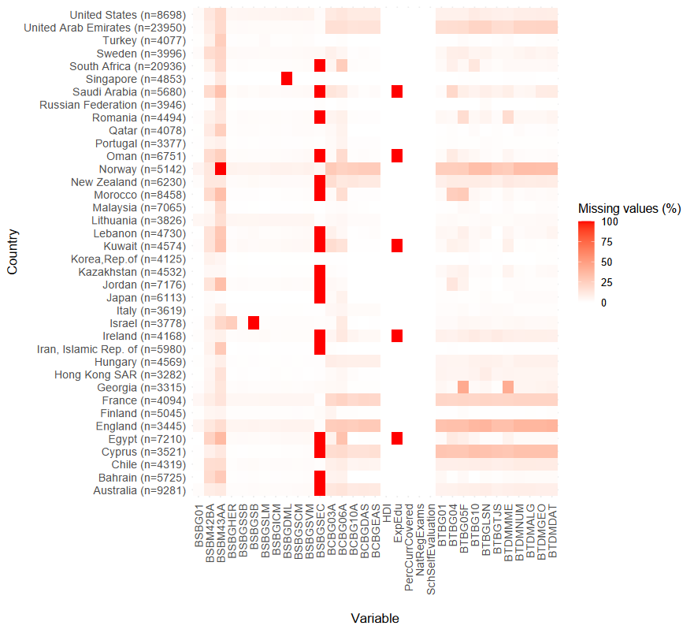

Supplementary Figure S2

Leave-one-country-out (LOCO) influence diagnostics for the regression coefficients across the 38 countries. Points represent DFBETAS obtained when each country is omitted in turn; the solid horizontal line indicates the full-data coefficient estimate, and dashed lines represent the corresponding 95% confidence interval. The horizontal reference lines at zero facilitate interpretation of the direction of influence. Values beyond $±2/\sqrt{G}$($G=38$) indicate potentially influential country exclusions. Country codes follow ISO alpha-3 conventions.

