Supplementary Information
Interface-Engineered Diffuse Morphotropic Phase Boundary in Hafnia–Zirconia Nanolaminates for DRAM Capacitors
Zhongming Liu¹, Shibing Long^{1*}
¹School of Microelectronics, University of Science and Technology of China, Hefei, China
*Email: shibinglong@ustc.edu.cn

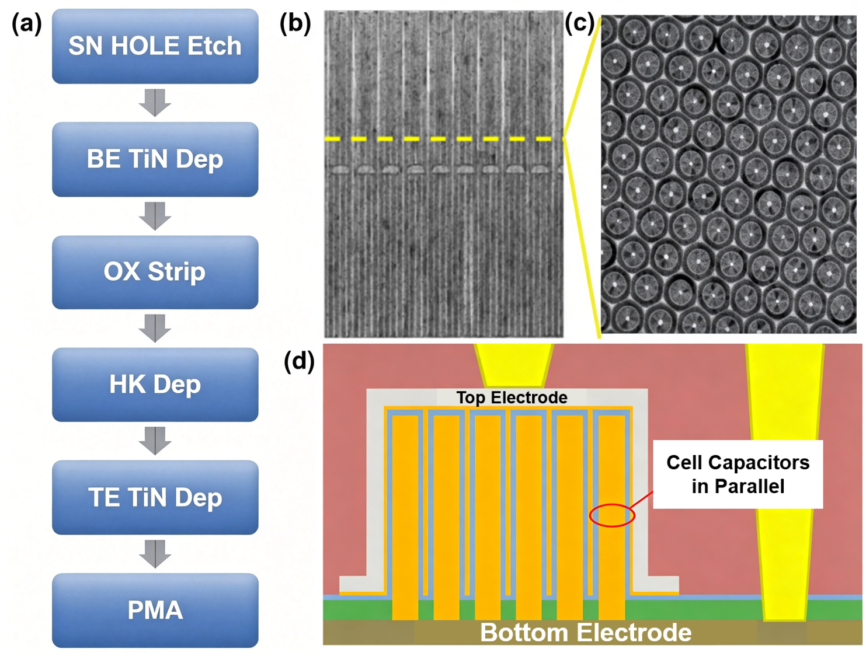
Fig. S1 Process flow and structural characterization of HAR DRAM cylindrical capacitors. (a) Schematic process flow for the fabrication of 3D DRAM cylindrical capacitors: storage-node (SN) hole etching, bottom electrode (BE) TiN deposition by atomic layer deposition (ALD), oxide strip, high-κ (HK) dielectric deposition, top electrode (TE) TiN deposition, and post-metallization annealing (PMA). (b) Cross-sectional scanning electron microscopy (SEM) image showing the high-aspect-ratio cylindrical capacitor array. The yellow dashed line marks the cross-section plane for the top-view image. (c) Top-view SEM image revealing the hexagonal close-packed arrangement of cylindrical holes. (d) Schematic cross-section of the parallel-connected capacitor array used for electrical characterization, showing thousands of cell capacitors connected in parallel via metal interconnects to form a macroscopic testable device.

The fabrication of DRAM capacitors with high aspect ratios imposes severe conformality requirements on both the electrode and dielectric depositions. Atomic layer deposition (ALD) is employed here to ensure uniform coating along the entire trench depth, as non-conformal deposition would lead to pinholes and early breakdown. The parallel-connected array structure is necessitated by the femtofarad-scale capacitance of a single cylindrical cell, which falls below the resolution limit of conventional semiconductor parameter analyzers. By connecting thousands of cells in parallel, the total capacitance is boosted to the picofarad range, enabling reliable extraction of dielectric constant while averaging out cell-to-cell process variations. The hexagonal arrangement maximizes the array density and mimics the layout of production-grade DRAM, ensuring that the electrical data reported in the main text are representative of scalable integration conditions.

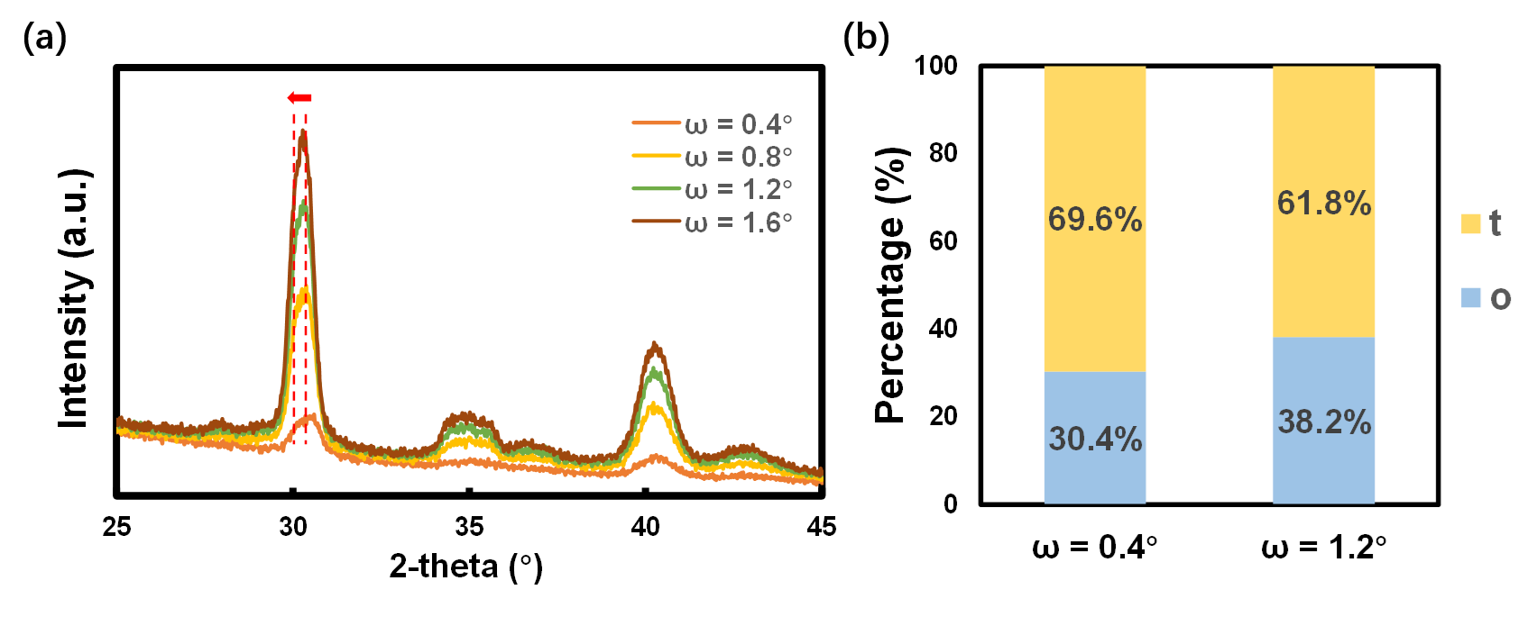
Fig. S2 Depth-resolved GIXRD phase analysis of the FE/AFE nanolaminate. (a) Grazing-incidence X-ray diffraction (GIXRD) patterns measured at incidence angles ω = 0.4°, 0.8°, 1.2°, and 1.6°, probing progressively deeper regions of the dielectric film from the top surface toward the bottom electrode. The peak positions correspond to the tetragonal (t) and orthorhombic (o) phases of the fluorite structure; no monoclinic (m) phase is detected within the sensitivity limit. (b) Quantitative phase fractions extracted from Rietveld refinement at ω = 0.4° (near-surface) and ω = 1.2° (deeper region), showing a t-phase fraction of 69.6% and 61.8%, respectively, and a complementary o-phase fraction of 30.4% and 38.2%. The systematic increase in o-phase content with probing depth indicates a depth-dependent phase inhomogeneity arising from ALD precursor flux decay and thermal gradients during post-metallization annealing in the high-aspect-ratio cylindrical structure.

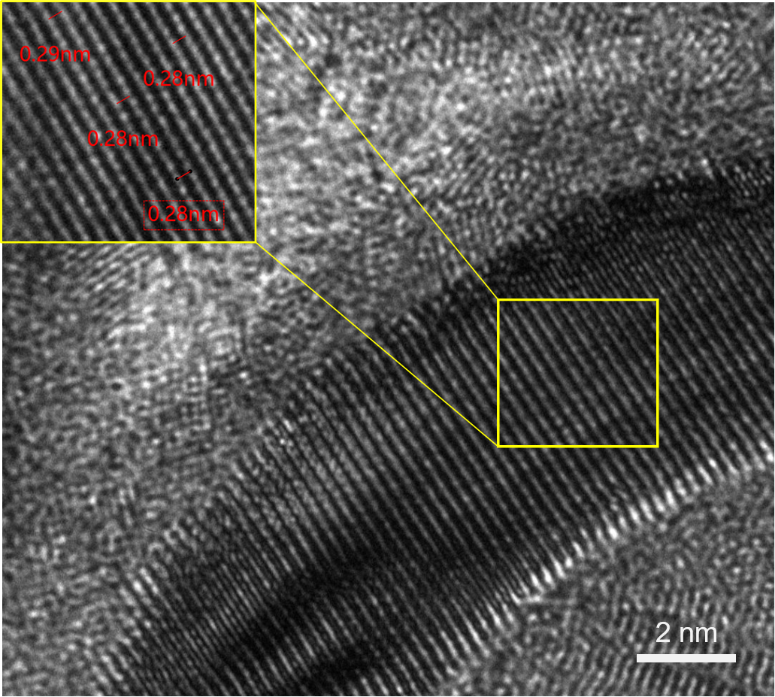
Fig. S3 High-resolution TEM lattice image of the fully crystallized FE/AFE stack. High-resolution cross-sectional transmission electron microscopy (HRTEM) image of the optimized FE/AFE nanolaminate stack. The measured interplanar spacing of 2.8–2.9 Å (inset, red labels) is consistent with the {111} lattice planes of the fluorite-structured tetragonal or orthorhombic phase, confirming that the dielectric film is fully crystallized throughout the high-aspect-ratio structure. The absence of monoclinic-phase lattice fringes—which would exhibit a characteristic spacing of ~3.15 Å—corroborates the GIXRD result that the m-phase is effectively suppressed in the optimized stack, thereby enabling coherent interfacial lattice distortion.

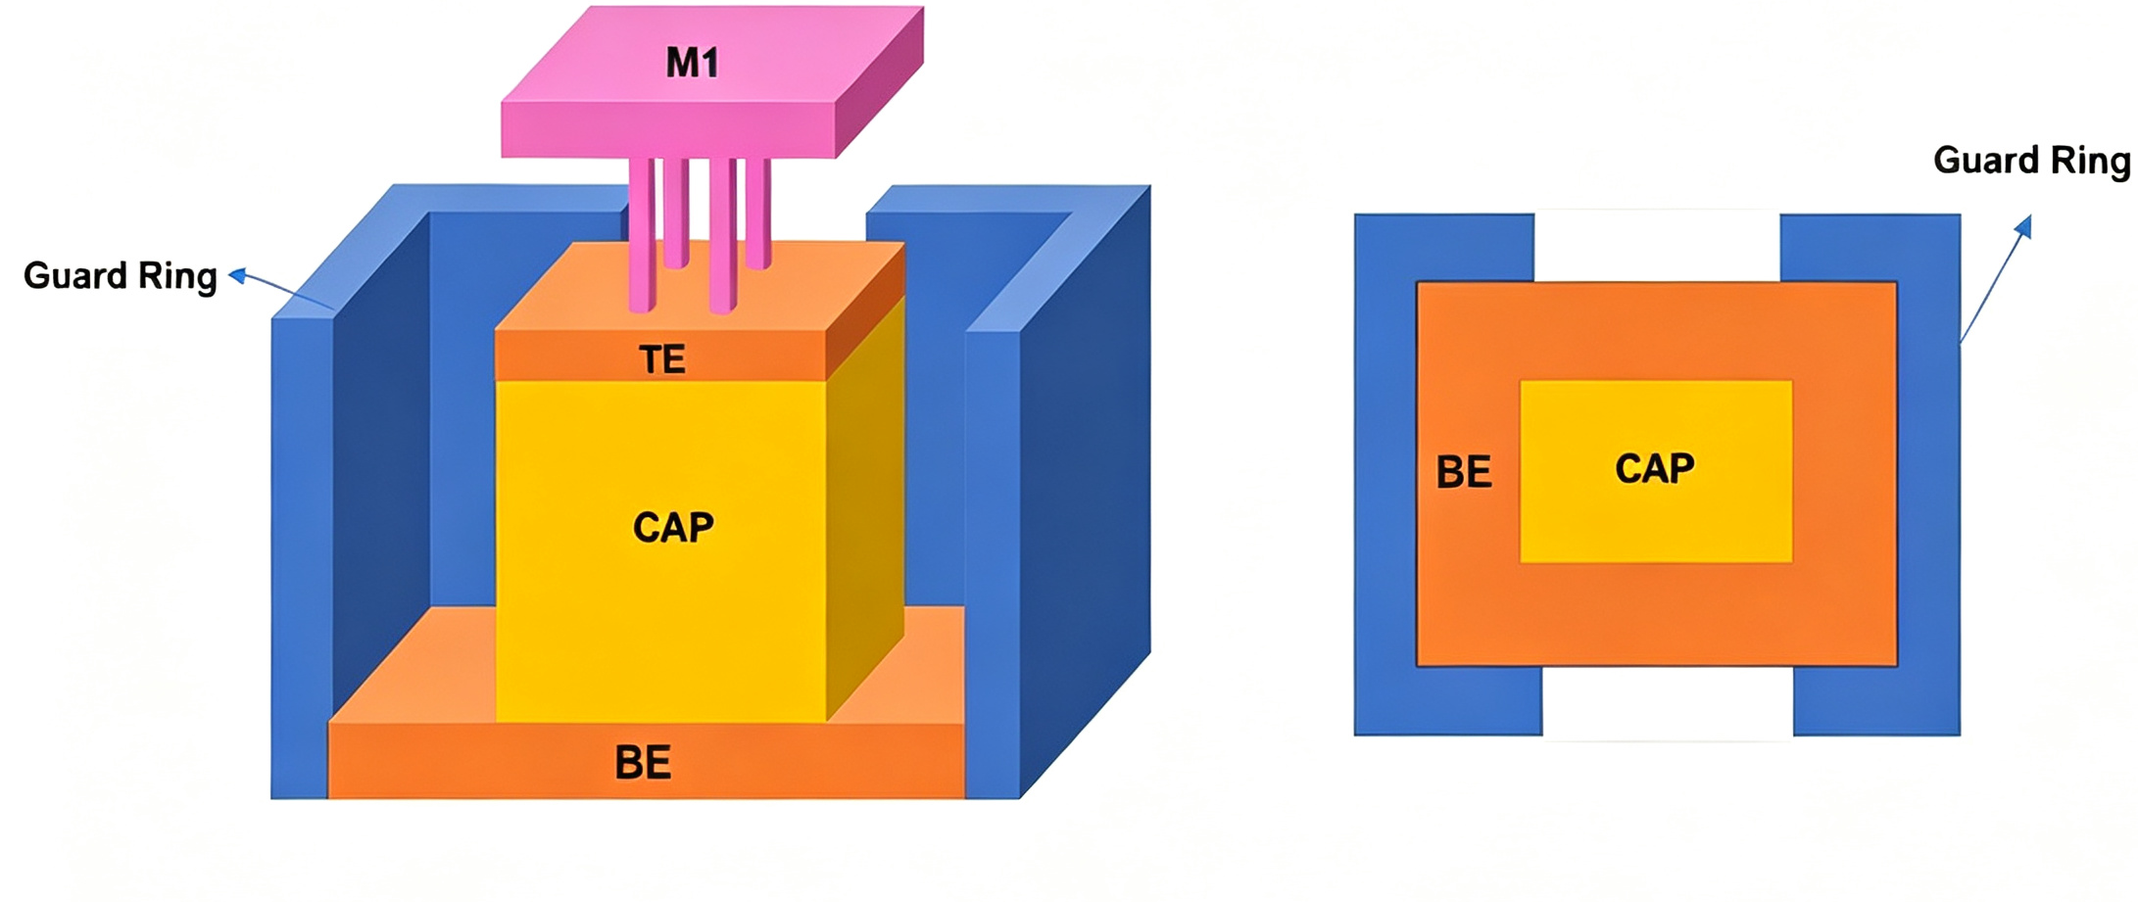
Fig. S4 Guard-ring test structure for parasitic suppression and high-frequency de-embedding. Three-dimensional schematic of the guard-ring test structure, showing the inner signal pad (M1), top electrode (TE), capacitor under test (CAP, yellow), bottom electrode (BE, orange), and outer guard ring (blue). The guard ring surrounds the device under test to confine the electric field and suppress parasitic current paths from the probe pads. Top-view schematic illustrating the coaxial arrangement of the inner capacitor (BE/CAP) and the outer guard ring, which is biased at the same potential as the signal pad to eliminate fringing-field-induced parasitic capacitance. This design enables reliable extraction of intrinsic capacitance up to gigahertz frequencies by de-embedding pad and interconnect parasitics.

Accurate high-frequency characterization of DRAM capacitors is complicated by parasitic components, including pad capacitance, interconnect inductance, and substrate coupling, that become comparable to the intrinsic device impedance above ~100 MHz. In the high-aspect-ratio cylindrical geometry, these parasitics are exacerbated by the large peripheral area of the probe pads relative to the active capacitor array. The guard-ring structure addresses this challenge by biasing the outer ring at the same potential as the inner signal pad, creating an equipotential shield that confines the electric field to the active region and diverts fringing currents away from the measurement path. De-embedding is then performed by subtracting the open/short dummy structures from the raw S-parameters, yielding the intrinsic capacitance shown in Fig. 4d of the main text. Without this guard-ring design, the apparent capacitance would be artificially inflated by parasitic contributions, and the ~26% degradation observed from 100 kHz to 1 GHz could not be reliably quantified.

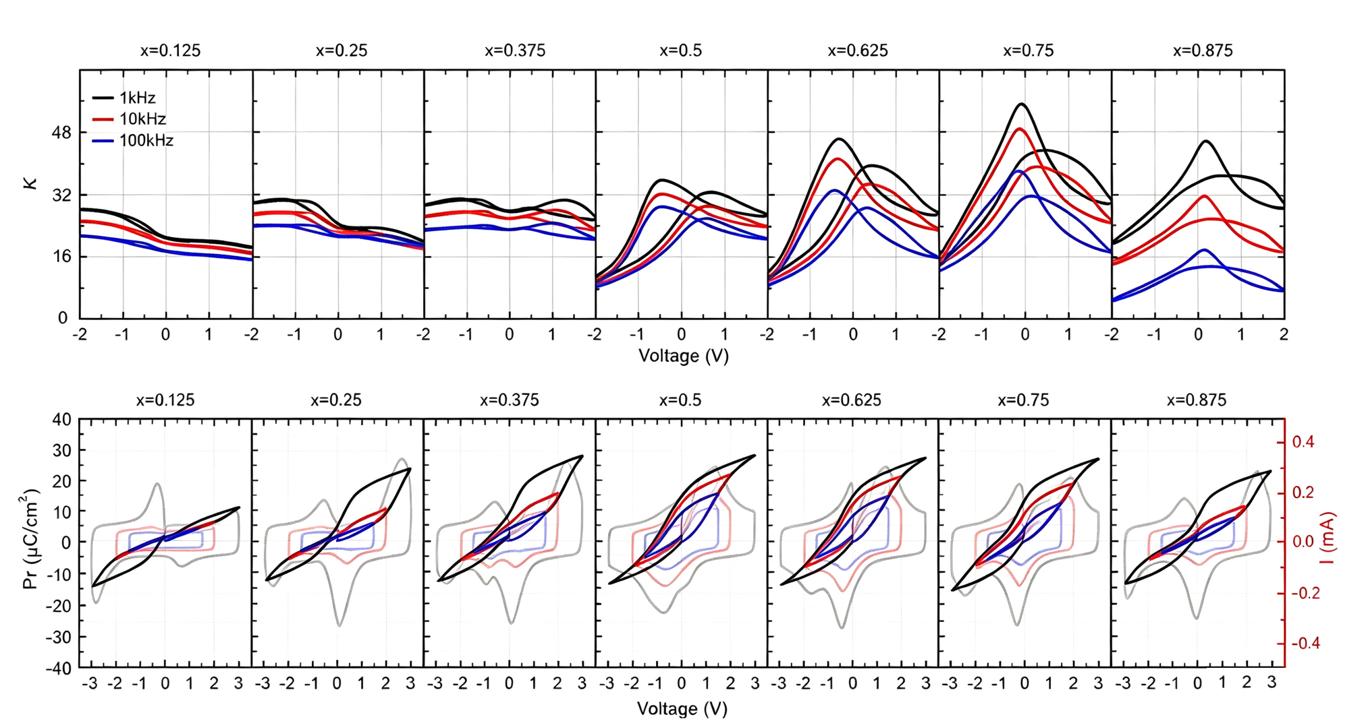
Fig. S5 Composition-dependent capacitance–voltage and polarization–voltage characteristics of Hf₁₋ₓZrₓO₂ DRAM capacitors. Upper panel: Capacitance–voltage (C–V) characteristics measured from −2 V to +2 V at 1 kHz (black), 10 kHz (red), and 100 kHz (blue) for Hf₁₋ₓZrₓO₂ compositions ranging from x = 0.125 to x = 0.875. The dielectric response evolves from linear dielectric-like (x = 0.125), through ferroelectric-like (x = 0.5, butterfly maximum), to antiferroelectric-like (x = 0.875, suppressed peak), with the strongest frequency dispersion observed near the morphotropic phase boundary (MPB) compositions (x ≈ 0.625–0.75). Lower panel: Corresponding polarization–voltage (P–V) hysteresis loops (left axis, full curves) and current–voltage (I–V) response (right axis, translucent curves) measured at 1 kHz from −3 V to +3 V (black); −2 V to +2 V (red); −1.5 V to +1.5 V (blue).

The composition-dependent evolution of the C–V and P–V characteristics corroborates the phase landscape calculated in Fig. 1b–c of the main text. The pronounced frequency dispersion near x ≈ 0.625–0.75 is the hallmark of the MPB, where the shallow energy landscape between the tetragonal and orthorhombic polymorphs enables low-barrier polarization rotation. In the P–V response, the pinched loops observed at x ≈ 0.375–0.625 arise from the coexistence of polar and non-polar domains that switch at distinct coercive fields, producing the characteristic double-peak I–V signature.

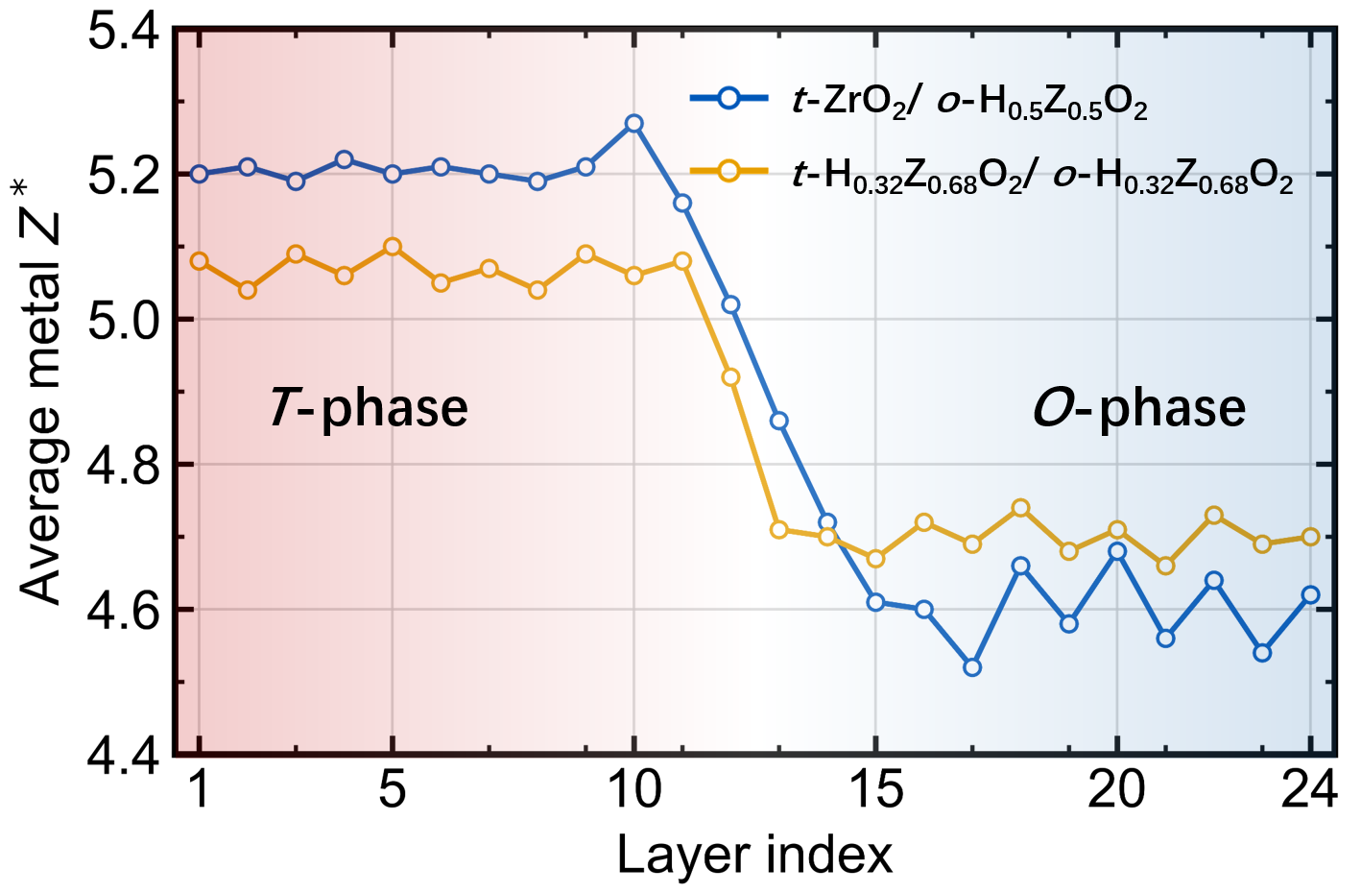
Fig. S6 Layer-resolved average metal-cation Born effective charge across the FE/AFE heterointerface. Layer-resolved average Born effective charge of the metal cations (Z*) along the stacking direction across two heterostructures: t-ZrO₂/o-Hf₀.₅Zr₀.₅O₂ (blue circles) and t-Hf₀.₃₂Zr₀.₆₈O₂/o-Hf₀.₃₂Zr₀.₆₈O₂ (orange circles). In the end-member-mismatched t-ZrO₂/o-Hf₀.₅Zr₀.₅O₂ system, Z* stabilizes at ~5.2 in the t-phase bulk region (left shaded area) and drops to ~4.5 in the o-phase bulk region (right shaded area), with a broad transition spanning layers 10–16 that defines the interfacial corridor. In the homogeneous-composition t-Hf₀.₃₂Zr₀.₆₈O₂/o-Hf₀.₃₂Zr₀.₆₈O₂ system, the transition is noticeably narrower. The enhanced width of the Z* transition in the end-member system correlates with the amplified oxygen Born effective charges (Fig. 3b) and confirms that mixed-cation coordination broadens the polarizable interfacial region beyond the sub-nanometer domain-wall limit.
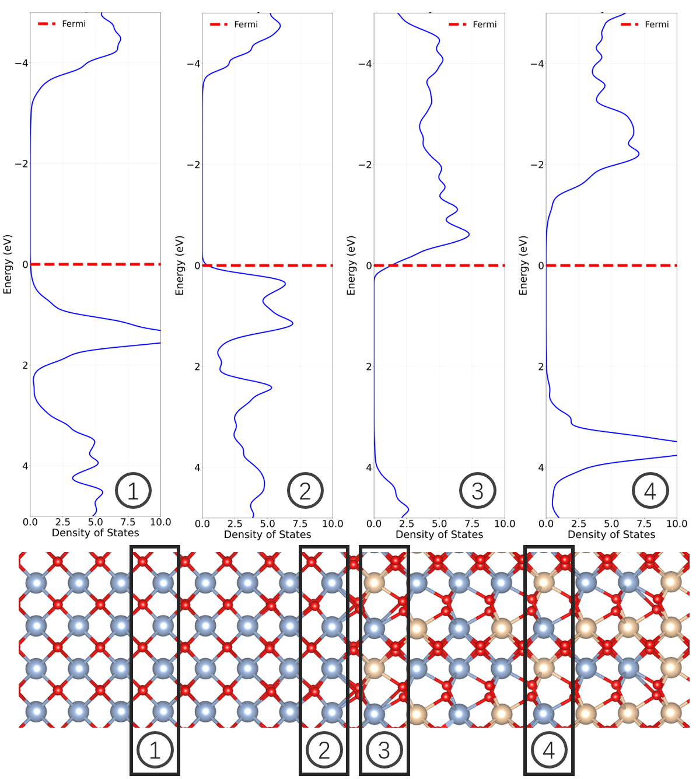
Fig. S7 Layer-resolved projected density of states and atomic structure across the FE/AFE heterointerface. Upper panel: Layer-resolved projected density of states (PDOS) for the t-ZrO₂/o-Hf₀.₅Zr₀.₅O₂(100) heterointerface at four representative regions: (1) t-ZrO₂ bulk-like region, (2) t-phase interface-adjacent layer, (3) o-phase interface-adjacent layer, and (4) o-Hf₀.₅Zr₀.₅O₂ bulk-like region. The O-2p states (dominant contribution near the valence band maximum, ~0 to −4 eV) shift toward the Fermi level at the interface (panels 2 and 3) compared to the bulk regions (panels 1 and 4), indicating enhanced polarizability and increased covalency in the interfacial corridor. Lower panel: Corresponding atomic structure models for regions 1–4, showing the evolution from the tetragonal (blue atoms, symmetric oxygen coordination) to the orthorhombic (beige atoms, asymmetric oxygen displacement) coordination environment across the interfacial transition zone. The interfacial layers (2 and 3) exhibit intermediate coordination geometries that lower the local symmetry and amplify the Born effective charges.

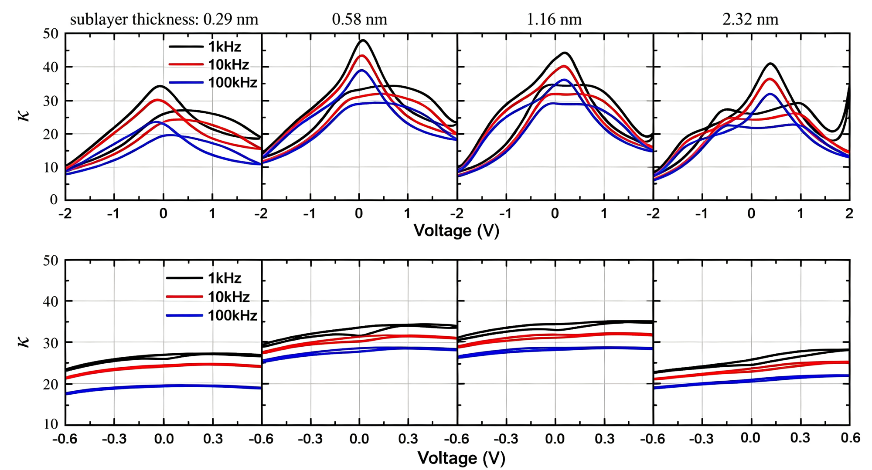
Fig. S8 Sublayer-thickness-dependent dielectric response of HfO₂/ZrO₂ nanolaminates. Upper panel: Capacitance–voltage (κ–V) characteristics measured from −2 V to +2 V at 1 kHz (black), 10 kHz (red), and 100 kHz (blue) for FE/AFE nanolaminates with sublayer thicknesses of 0.29 nm, 0.58 nm, 1.16 nm, and 2.32 nm. The dielectric constant peaks at a sublayer thickness of approximately 1.16 nm, consistent with the theoretically predicted interfacial corridor width of ~1.3 nm where distortion fields from adjacent interfaces overlap optimally. Thinner sublayers (0.29 nm) behave as a solid solution with degraded κ, whereas thicker sublayers (2.32 nm) revert toward a series-average response due to the dilution of interfacial zones by bulk-like regions. Lower panel: Corresponding κ–V characteristics within the practical DRAM operating window (−0.6 V to +0.6 V), showing flat profiles that confirm polarization switching occurs outside the normal operating voltage range. The optimal sublayer thickness of ~1.16 nm maintains the highest capacitance value (~40 at 1 kHz) within ±0.6 V.

The thickness-dependent κ–V data provide direct experimental validation of the interfacial corridor concept introduced in the main text. At a sublayer thickness of ~1.16 nm, comparable to the DFT-predicted corridor width of ~1.3 nm, the distortion fields from the two bounding interfaces pervade the entire sublayer, maximizing the volume fraction of the MPB-like region. When the sublayer is reduced to 0.29 nm (approximately one unit cell), the two phases lose their distinct crystallographic identities and the stack behaves as a homogeneous solid solution, collapsing the lattice mismatch that drives the corridor formation. Conversely, at 2.32 nm the bulk-like regions dominate, and the effective dielectric constant reverts toward the series-average limit of the constituent layers. The peak at ~1.16 nm therefore represents a geometric resonance condition where the architectural control of the MPB is most effective, establishing a quantitative design rule for nanolaminate engineering.

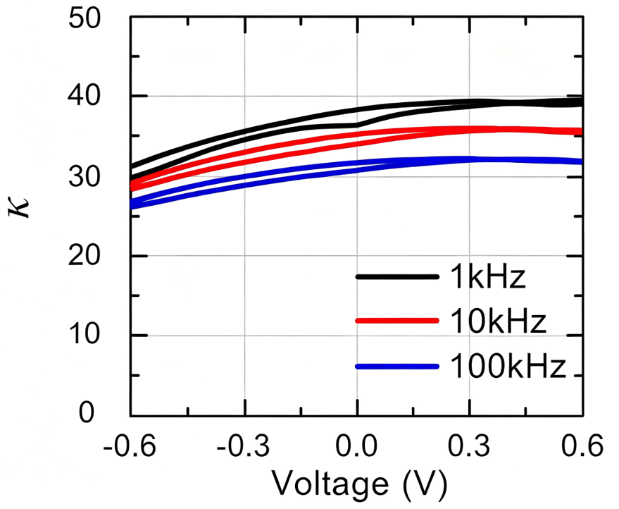
Fig. S9 Dielectric constant of the optimized FE/AFE nanolaminate within the DRAM operating window. Capacitance–voltage (κ–V) characteristics of the optimized TiN/H_{0.5}Z_{0.5}O₂/ZrO₂/TiN FE/AFE nanolaminate measured from −0.6 V to +0.6 V at 1 kHz (black), 10 kHz (red), and 100 kHz (blue). Within the DRAM operating window of ±0.6 V, κ remains elevated and exhibits weak voltage dependence, reaching approximately 40 at 1 kHz and 32 at 100 kHz at the operating points. The modest frequency dispersion (~20% degradation from 1 kHz to 100 kHz) and the absence of polarization switching features within this range confirm the suitability of the lattice-distortion-stabilized MPB for high-speed DRAM operation.

Within the DRAM operating window of ±0.6 V, the FE/AFE nanolaminate maintains a dielectric constant of ~40, which is approximately 13% higher than that of the uniform MPB reference measured under identical conditions. This enhancement is preserved at the operating points because the interfacial lattice distortion stabilizes the MPB corridor independently of the applied field; unlike ferroelectric switching, which requires coercive voltages beyond the DRAM supply, the MPB response here arises from the intrinsic polarizability of the mixed-phase corridor. The flat κ–V profile within ±0.6 V is essential for DRAM reliability, as voltage-dependent capacitance would introduce sensing margin variations across the memory array. The frequency dispersion of ~20% from 1 kHz to 100 kHz is comparable to that of homogeneous MPB films and significantly lower than that of pure ferroelectric HZO, confirming that the nanolaminate architecture suppresses the slow domain-wall relaxation that plagues fully polar phases.

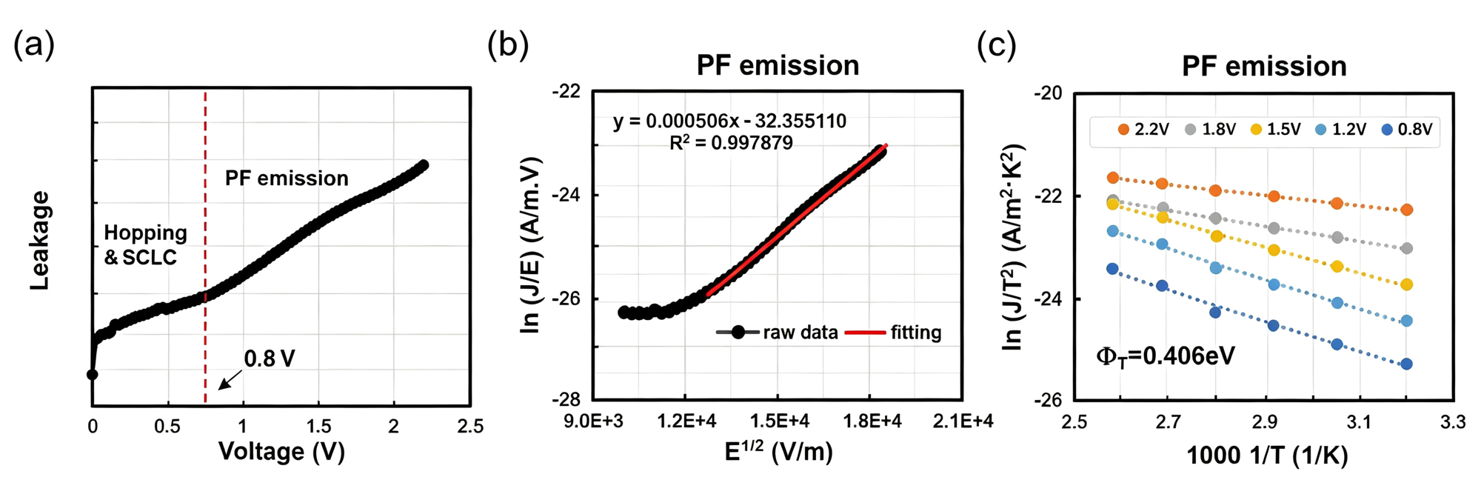
Fig. S10 Leakage conduction mechanism analysis of the FE/AFE nanolaminate. (a) Current density–voltage (J–V) characteristic of the optimized FE/AFE stack at room temperature, delineating three conduction regimes: hopping and space-charge-limited current (SCLC) below ~0.8 V (linear and quadratic dependence, respectively), and Poole–Frenkel (PF) emission above ~0.8 V (exponential dependence). (b) Poole–Frenkel plot of ln(J/E) versus E^{1/2} for the high-field regime (>0.8 V), showing linear behavior with a fitting correlation coefficient R² = 0.998, confirming PF emission as the dominant mechanism in this range. (c) Temperature-dependent PF emission analysis: Arrhenius plot of ln(J/T²) versus 1000/T at various bias voltages (0.8 V to 2.2 V), yielding a trap energy barrier Φ_{T} = 0.406 eV. Since DRAM capacitors operate below 0.8 V, the leakage is governed by hopping and SCLC processes. Further suppression can be achieved by reducing bulk defect density in the HZO dielectric.

The leakage current density of the FE/AFE stack remains well below 10⁻⁷ A cm⁻² at the DRAM operating voltage of ±0.6 V, satisfying the stringent charge-retention requirements of modern DRAM. The conduction mechanism analysis identifies three distinct regimes: below ~0.5 V, hopping conduction dominates with an Ohmic-like J–V relationship; between 0.5 V and 0.8 V, the slope of the log(J)–log(V) plot approaches ~2, characteristic of trap-limited space-charge-limited current (SCLC) following Child’s law; above ~0.8 V, Poole–Frenkel emission from deep traps becomes dominant, with an extracted trap barrier of Φ_{T} = 0.406 eV. Because DRAM capacitors never exceed 0.8 V in normal operation, the PF emission regime is irrelevant to refresh-period charge loss, and the leakage is instead controlled by the density of bulk defects that mediate hopping and SCLC. This insight directs process optimization toward defect reduction, through improved ALD precursor purity, optimized annealing ambient, or post-deposition plasma treatment, rather than interface engineering, as the latter would have limited impact on bulk-dominated conduction.

