Appendix A:
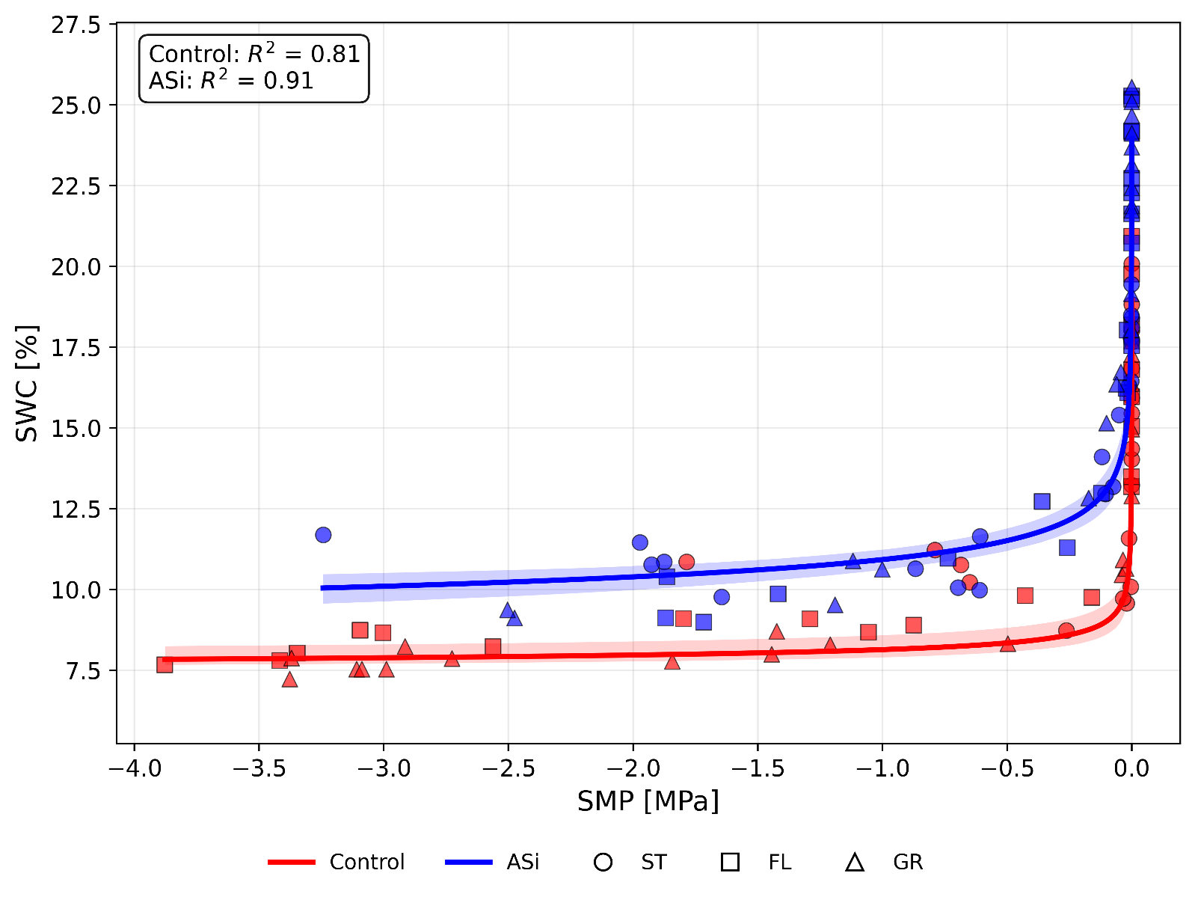

Fig. 1A: Relationship between soil matric potential (SMP; in MPa) and soil water content (SWC; in %) during drought for control (in red) and ASi (in blue) treatments. Individual observations are shown for stem elongation (ST, circles), flowering (FL, squares), and grain filling (GR, triangles). Red and blue lines represent the fitted soil water retention curves for control and ASi treatments, respectively, with shaded areas indicating 95% confidence intervals.

