Supplementary Table 1. Descriptive statistics and distributional characteristics of scale total scores.
Variable | N | M | (Q1, Q3) | Shapiro-Wilk W | Shapiro_p
GMS (Total Score) | 1041 | 20.00 | (13.00, 26.00) | 0.971 | <0.001
SVAS (Total Score) | 1041 | 37.00 | (31.00, 44.00) | 0.987 | <0.001
CD-RISC (Total Score) | 1041 | 25.00 | (17.00, 38.00) | 0.943 | <0.001
GSES (Total Score) | 1041 | 22.00 | (16.00, 27.00) | 0.969 | <0.001
Note. M = median; Q1 = first quartile; Q3 = third quartile; GMS = Growth Mindset Scale; SVAS = Short Video Addiction Scale; CD-RISC = Connor–Davidson Resilience Scale; GSES = General Self-Efficacy Scale. Normality was assessed using the Shapiro–Wilk test. All values represent total scores calculated by summing the corresponding scale items.

Supplementary Table 2. Generalized variance inflation factors for the predictors.
Variable | GVIF | DF | GVIF^(1/(2×DF))
Growth Mindset Scale | 1.091 | 1 | 1.045
Connor-Davidson Resilience Scale | 1.184 | 1 | 1.088
General Self-Efficacy Scale | 1.182 | 1 | 1.087
Age | 1.883 | 1 | 1.372
Gender | 1.071 | 1 | 1.035
Ethnicity | 1.019 | 1 | 1.010
Household registration | 1.023 | 1 | 1.011
Education level | 2.551 | 1 | 1.597
Academic year | 5.364 | 3 | 1.323
Voluntary choice of nursing major | 1.392 | 1 | 1.180
Nursing as first-choice major | 1.363 | 1 | 1.168
Started clinical internship | 3.182 | 1 | 1.784
Note. GVIF = generalized variance inflation factor; DF = degrees of freedom; adjusted GVIF = GVIF^(1/(2×DF)). For predictors with one degree of freedom, GVIF is equivalent to VIF. All GVIF and adjusted GVIF values were below conventional thresholds, suggesting no substantial multicollinearity among the predictors.

Supplementary Table 3. Coding scheme for categorical variables.
Categorical variable name | Assignment
Gender
Male | 1
Female | 2
Ethnicity
Han ethnicity | 1
Ethnic minority | 2
Household registration
Rural household registration | 1
Urban household registration | 2
Education level
Junior college | 1
Bachelor's degree | 2
Academic year
Freshman | 1
Sophomore | 2
Junior | 3
Senior | 4
Voluntary choice of nursing major
Yes | 1
No | 2
Nursing as first-choice major
Yes | 1
No | 2
Started clinical internship
Yes | 1
No | 2
Supplementary Table 4. Distribution of binary responses after item-level dichotomization.
Node | N(0) | N(1) | Prevalence (1) | Prevalence (2)
C1 | 537 | 504 | 0.484 | 0.516
C2 | 552 | 489 | 0.470 | 0.530
C3 | 544 | 497 | 0.477 | 0.523
C4 | 548 | 493 | 0.474 | 0.526
C5 | 569 | 472 | 0.453 | 0.547
C6 | 566 | 475 | 0.456 | 0.544
D1 | 712 | 329 | 0.316 | 0.684
D2 | 766 | 275 | 0.264 | 0.736
D3 | 735 | 306 | 0.294 | 0.706
D4 | 698 | 343 | 0.329 | 0.671
D5 | 658 | 383 | 0.368 | 0.632
D6 | 692 | 349 | 0.335 | 0.665
D7 | 716 | 325 | 0.312 | 0.688
D8 | 707 | 334 | 0.321 | 0.679
D9 | 723 | 318 | 0.305 | 0.695
D10 | 791 | 250 | 0.240 | 0.760
D11 | 748 | 293 | 0.281 | 0.719
D12 | 755 | 286 | 0.275 | 0.725
D13 | 679 | 362 | 0.348 | 0.652
D14 | 601 | 440 | 0.423 | 0.577
K1 | 698 | 343 | 0.329 | 0.671
K2 | 543 | 498 | 0.478 | 0.522
K3 | 657 | 384 | 0.369 | 0.631
K4 | 596 | 445 | 0.427 | 0.573
K5 | 610 | 431 | 0.414 | 0.586
K6 | 608 | 433 | 0.416 | 0.584
K7 | 456 | 585 | 0.562 | 0.438
K8 | 692 | 349 | 0.335 | 0.665
K9 | 689 | 352 | 0.338 | 0.662
K10 | 675 | 366 | 0.352 | 0.648
K11 | 685 | 356 | 0.342 | 0.658
K12 | 566 | 475 | 0.456 | 0.544
K13 | 541 | 500 | 0.480 | 0.520
K14 | 662 | 379 | 0.364 | 0.636
K15 | 658 | 383 | 0.368 | 0.632
K16 | 649 | 392 | 0.377 | 0.623
K17 | 687 | 354 | 0.340 | 0.660
K18 | 681 | 360 | 0.346 | 0.654
K19 | 559 | 482 | 0.463 | 0.537
K20 | 525 | 516 | 0.496 | 0.504
K21 | 535 | 506 | 0.486 | 0.514
K22 | 502 | 539 | 0.518 | 0.482
K23 | 665 | 376 | 0.361 | 0.639
K24 | 667 | 374 | 0.359 | 0.641
K25 | 660 | 381 | 0.366 | 0.634
Z1 | 650 | 391 | 0.376 | 0.624
Z2 | 665 | 376 | 0.361 | 0.639
Z3 | 683 | 358 | 0.344 | 0.656
Z4 | 688 | 353 | 0.339 | 0.661
Z5 | 625 | 416 | 0.400 | 0.600
Z6 | 621 | 420 | 0.403 | 0.597
Z7 | 605 | 436 | 0.419 | 0.581
Z8 | 580 | 461 | 0.443 | 0.557
Z9 | 688 | 353 | 0.339 | 0.661
Z10 | 691 | 350 | 0.336 | 0.664
Note. Each item was dichotomized according to its scale-specific scoring rule. For the Growth Mindset items, scores of 1–3 were coded as 0 and scores of 4–6 as 1; for Short Video Addiction items, scores of 1–3 were coded as 0 and scores of 4–5 as 1; for Resilience items, scores of 0–1 were coded as 0 and scores of 2–4 as 1; and for General Self-Efficacy items, scores of 1–2 were coded as 0 and scores of 3–4 as 1. Proportions are calculated using the total analytic sample $\text{N=1,041}$.

Supplementary Table 5. Spearman correlations among key study variables.
Variable | Growth mindset | Short-video addiction | Resilience | General self-efficacy
Growth mindset | - | - | - | -
Short-video addiction | -0.327** | - | - | -
Resilience | 0.206** | -0.386** | - | -
General self-efficacy | 0.235** | -0.334** | 0.328** | -
Note. Spearman’s ρ coefficients are reported. Only the lower triangle is shown. *p < 0.05; **p < 0.01; ***p < 0.001, two-tailed.

Supplementary Table 6. Regression analysis of resilience and general self-efficacy in the relation between growth mindset and short-video addiction
Dependent variable | Independent variable | R² | F(HC3) | β | SE(HC3) | t | p | Boot LLCI | Boot ULCI
Resilience | Growth mindset | 0.058 | 6.109*** | 0.204 | 0.031 | 6.659*** | <0.001 | 0.144 | 0.264
Resilience | Gender | 0.058 | 6.109*** | -0.101 | 0.110 | -0.913 | 0.361 | -0.317 | 0.115
Resilience | Ethnicity | 0.058 | 6.109*** | 0.241 | 0.140 | 1.726 | 0.085 | -0.033 | 0.515
Resilience | Household registration | 0.058 | 6.109*** | -0.004 | 0.064 | -0.056 | 0.955 | -0.129 | 0.122
Resilience | Education level | 0.058 | 6.109*** | 0.038 | 0.141 | 0.268 | 0.789 | -0.239 | 0.314
Resilience | Academic year | 0.058 | 6.109*** | -0.152 | 0.073 | -2.076* | 0.038 | -0.295 | -0.008
Resilience | Voluntary choice of nursing major | 0.058 | 6.109*** | 0.151 | 0.079 | 1.922 | 0.055 | -0.003 | 0.305
Resilience | Nursing as first-choice major | 0.058 | 6.109*** | 0.032 | 0.076 | 0.418 | 0.676 | -0.117 | 0.181
Resilience | Started clinical internship | 0.058 | 6.109*** | -0.118 | 0.139 | -0.851 | 0.395 | -0.392 | 0.155
Resilience | Age | 0.058 | 6.109*** | -0.022 | 0.043 | -0.520 | 0.603 | -0.106 | 0.062
General self-efficacy | Growth mindset | 0.153 | 16.444*** | 0.168 | 0.029 | 5.894*** | <0.001 | 0.112 | 0.224
General self-efficacy | Resilience | 0.153 | 16.444*** | 0.317 | 0.031 | 10.242*** | <0.001 | 0.256 | 0.378
General self-efficacy | Gender | 0.153 | 16.444*** | -0.143 | 0.101 | -1.423 | 0.155 | -0.341 | 0.054
General self-efficacy | Ethnicity | 0.153 | 16.444*** | 0.098 | 0.156 | 0.631 | 0.528 | -0.208 | 0.405
General self-efficacy | Household registration | 0.153 | 16.444*** | 0.009 | 0.059 | 0.156 | 0.876 | -0.107 | 0.126
General self-efficacy | Education level | 0.153 | 16.444*** | -0.041 | 0.130 | -0.318 | 0.750 | -0.296 | 0.214
General self-efficacy | Academic year | 0.153 | 16.444*** | 0.065 | 0.066 | 0.991 | 0.322 | -0.064 | 0.194
General self-efficacy | Voluntary choice of nursing major | 0.153 | 16.444*** | -0.080 | 0.072 | -1.114 | 0.266 | -0.221 | 0.061
General self-efficacy | Nursing as first-choice major | 0.153 | 16.444*** | 0.069 | 0.069 | 1.009 | 0.313 | -0.065 | 0.204
General self-efficacy | Started clinical internship | 0.153 | 16.444*** | -0.021 | 0.130 | -0.162 | 0.871 | -0.276 | 0.234
General self-efficacy | Age | 0.153 | 16.444*** | -0.017 | 0.039 | -0.435 | 0.663 | -0.095 | 0.060
Short-video addiction | Growth mindset | 0.263 | 33.778*** | -0.214 | 0.028 | -7.627*** | <0.001 | -0.269 | -0.159
Short-video addiction | Resilience | 0.263 | 33.778*** | -0.291 | 0.028 | -10.246*** | <0.001 | -0.347 | -0.235
Short-video addiction | General self-efficacy | 0.263 | 33.778*** | -0.186 | 0.029 | -6.527*** | <0.001 | -0.242 | -0.130
Short-video addiction | Gender | 0.263 | 33.778*** | 0.058 | 0.094 | 0.618 | 0.537 | -0.242 | 0.126
Short-video addiction | Ethnicity | 0.263 | 33.778*** | 0.141 | 0.134 | 1.048 | 0.295 | -0.123 | 0.405
Short-video addiction | Household registration | 0.263 | 33.778*** | 0.046 | 0.056 | 0.819 | 0.413 | -0.064 | 0.155
Short-video addiction | Education level | 0.263 | 33.778*** | 0.168 | 0.117 | 1.437 | 0.151 | -0.061 | 0.396
Short-video addiction | Academic year | 0.263 | 33.778*** | 0.008 | 0.065 | 0.125 | 0.901 | -0.120 | 0.136
Short-video addiction | Voluntary choice of nursing major | 0.263 | 33.778*** | 0.021 | 0.068 | 0.305 | 0.760 | -0.112 | 0.153
Short-video addiction | Nursing as first-choice major | 0.263 | 33.778*** | -0.164 | 0.065 | -2.534* | 0.011 | -0.290 | -0.037
Short-video addiction | Started clinical internship | 0.263 | 33.778*** | -0.095 | 0.132 | -0.721 | 0.471 | -0.355 | 0.164
Short-video addiction | Age | 0.263 | 33.778*** | 0.006 | 0.037 | 0.156 | 0.876 | -0.067 | 0.078
Note. β = standardized regression coefficients; SE = robust standard errors (HC3); Boot LLCI and Boot ULCI = 95% confidence intervals derived from bootstrap resampling (5,000); F-test significance refers to the overall model fit; *p < 0.05; ***p < 0.001; All models included all covariates.

Supplementary Table 7. Welch’s t-tests comparing simulated network sum scores under NIRA node perturbations.
Node | + 2SD |  |  |  |  |  | - 2SD
Node | Mean | 95%CI | 95%CI | t | P_{raw} | P_{bonf} | Mean | 95%CI | 95%CI | t | P_{raw} | P_{bonf}
Node | Sum score | Lower | Upper | t | P_{raw} | P_{bonf} | Sum score | Lower | Upper | t | P_{raw} | P_{bonf}
original | 18.447 | 18.305 | 18.589 | NA | NA | NA | 18.447 | 18.305 | 18.589 | NA | NA | NA
C1 | 18.658 | 18.519 | 18.798 | 2.083 | 0.037 | 1.000 | 18.267 | 18.128 | 18.406 | -1.769 | 0.077 | 1.000
C2 | 19.114 | 18.976 | 19.251 | 6.605 | ＜0.001 | ＜0.001 | 17.919 | 17.781 | 18.058 | -5.209 | ＜0.001 | ＜0.001
C3 | 19.451 | 19.313 | 19.589 | 9.942 | ＜0.001 | ＜0.001 | 17.592 | 17.457 | 17.728 | -8.522 | ＜0.001 | ＜0.001
C4 | 19.708 | 19.573 | 19.844 | 12.572 | ＜0.001 | ＜0.001 | 17.500 | 17.363 | 17.637 | -9.408 | ＜0.001 | ＜0.001
C5 | 19.662 | 19.524 | 19.799 | 12.023 | ＜0.001 | ＜0.001 | 17.401 | 17.265 | 17.538 | -10.395 | ＜0.001 | ＜0.001
C6 | 19.301 | 19.164 | 19.438 | 8.467 | ＜0.001 | ＜0.001 | 17.483 | 17.344 | 17.623 | -9.487 | ＜0.001 | ＜0.001
D1 | 18.947 | 18.806 | 19.088 | 4.893 | ＜0.001 | ＜0.001 | 17.969 | 17.829 | 18.109 | -4.696 | ＜0.001 | ＜0.001
D10 | 18.939 | 18.797 | 19.080 | 4.807 | ＜0.001 | ＜0.001 | 18.030 | 17.891 | 18.169 | -4.107 | ＜0.001 | 0.002
D11 | 18.596 | 18.458 | 18.734 | 1.472 | 0.141 | 1.000 | 18.107 | 17.967 | 18.246 | -3.347 | 0.001 | 0.045
D12 | 18.320 | 18.183 | 18.458 | -1.253 | 0.210 | 1.000 | 18.368 | 18.225 | 18.510 | -0.772 | 0.440 | 1.000
D13 | 18.922 | 18.783 | 19.061 | 4.681 | ＜0.001 | ＜0.001 | 17.932 | 17.791 | 18.074 | -5.024 | ＜0.001 | ＜0.001
D14 | 18.396 | 18.257 | 18.535 | -0.503 | 0.615 | 1.000 | 18.261 | 18.120 | 18.402 | -1.816 | 0.069 | 1.000
D2 | 19.227 | 19.086 | 19.368 | 7.644 | ＜0.001 | ＜0.001 | 18.042 | 17.901 | 18.182 | -3.972 | ＜0.001 | 0.004
D3 | 19.058 | 18.917 | 19.199 | 5.978 | ＜0.001 | ＜0.001 | 18.025 | 17.884 | 18.166 | -4.130 | ＜0.001 | 0.002
D4 | 19.067 | 18.926 | 19.208 | 6.065 | ＜0.001 | ＜0.001 | 18.006 | 17.866 | 18.145 | -4.339 | ＜0.001 | 0.001
D5 | 19.014 | 18.875 | 19.153 | 5.589 | ＜0.001 | ＜0.001 | 17.855 | 17.714 | 17.997 | -5.780 | ＜0.001 | ＜0.001
D6 | 18.998 | 18.856 | 19.140 | 5.381 | ＜0.001 | ＜0.001 | 17.812 | 17.675 | 17.950 | -6.278 | ＜0.001 | ＜0.001
D7 | 19.100 | 18.963 | 19.237 | 6.489 | ＜0.001 | ＜0.001 | 17.773 | 17.635 | 17.912 | -6.647 | ＜0.001 | ＜0.001
D8 | 19.029 | 18.890 | 19.169 | 5.728 | ＜0.001 | ＜0.001 | 17.867 | 17.729 | 18.005 | -5.733 | ＜0.001 | ＜0.001
D9 | 18.813 | 18.675 | 18.951 | 3.619 | ＜0.001 | 0.016 | 18.070 | 17.930 | 18.210 | -3.695 | ＜0.001 | 0.012
K1 | 19.475 | 19.333 | 19.617 | 10.040 | ＜0.001 | ＜0.001 | 17.830 | 17.692 | 17.968 | -6.096 | ＜0.001 | ＜0.001
K10 | 19.820 | 19.676 | 19.963 | 13.311 | ＜0.001 | ＜0.001 | 17.597 | 17.465 | 17.730 | -8.565 | ＜0.001 | ＜0.001
K11 | 19.501 | 19.360 | 19.642 | 10.315 | ＜0.001 | ＜0.001 | 17.783 | 17.646 | 17.919 | -6.603 | ＜0.001 | ＜0.001
K12 | 19.461 | 19.319 | 19.602 | 9.912 | ＜0.001 | ＜0.001 | 17.825 | 17.687 | 17.963 | -6.152 | ＜0.001 | ＜0.001
K13 | 19.877 | 19.735 | 20.019 | 13.943 | ＜0.001 | ＜0.001 | 17.372 | 17.238 | 17.507 | -10.745 | ＜0.001 | ＜0.001
K14 | 19.551 | 19.406 | 19.695 | 10.679 | ＜0.001 | ＜0.001 | 17.921 | 17.784 | 18.058 | -5.217 | ＜0.001 | ＜0.001
K15 | 19.755 | 19.611 | 19.898 | 12.704 | ＜0.001 | ＜0.001 | 17.763 | 17.629 | 17.897 | -6.854 | ＜0.001 | ＜0.001
K16 | 19.564 | 19.424 | 19.705 | 10.954 | ＜0.001 | ＜0.001 | 17.576 | 17.439 | 17.712 | -8.655 | ＜0.001 | ＜0.001
K17 | 19.290 | 19.147 | 19.433 | 8.191 | ＜0.001 | ＜0.001 | 17.892 | 17.756 | 18.028 | -5.523 | ＜0.001 | ＜0.001
K18 | 19.500 | 19.360 | 19.640 | 10.342 | ＜0.001 | ＜0.001 | 17.815 | 17.678 | 17.953 | -6.254 | ＜0.001 | ＜0.001
K19 | 19.420 | 19.280 | 19.560 | 9.560 | ＜0.001 | ＜0.001 | 17.744 | 17.605 | 17.882 | -6.947 | ＜0.001 | ＜0.001
K2 | 19.096 | 18.953 | 19.239 | 6.308 | ＜0.001 | ＜0.001 | 17.695 | 17.555 | 17.834 | -7.391 | ＜0.001 | ＜0.001
K20 | 19.393 | 19.252 | 19.533 | 9.262 | ＜0.001 | ＜0.001 | 17.574 | 17.437 | 17.711 | -8.666 | ＜0.001 | ＜0.001
K21 | 19.576 | 19.437 | 19.714 | 11.154 | ＜0.001 | ＜0.001 | 17.523 | 17.389 | 17.657 | -9.268 | ＜0.001 | ＜0.001
K22 | 19.598 | 19.458 | 19.738 | 11.307 | ＜0.001 | ＜0.001 | 17.469 | 17.335 | 17.603 | -9.809 | ＜0.001 | ＜0.001
K23 | 19.833 | 19.689 | 19.977 | 13.428 | ＜0.001 | ＜0.001 | 17.764 | 17.630 | 17.898 | -6.854 | ＜0.001 | ＜0.001
K24 | 19.834 | 19.690 | 19.978 | 13.452 | ＜0.001 | ＜0.001 | 17.644 | 17.511 | 17.778 | -8.061 | ＜0.001 | ＜0.001
K25 | 19.531 | 19.389 | 19.673 | 10.583 | ＜0.001 | ＜0.001 | 17.769 | 17.634 | 17.904 | -6.771 | ＜0.001 | ＜0.001
K3 | 19.380 | 19.236 | 19.524 | 9.040 | ＜0.001 | ＜0.001 | 17.819 | 17.681 | 17.958 | -6.199 | ＜0.001 | ＜0.001
K4 | 19.154 | 19.012 | 19.297 | 6.884 | ＜0.001 | ＜0.001 | 17.858 | 17.721 | 17.995 | -5.842 | ＜0.001 | ＜0.001
K5 | 19.434 | 19.293 | 19.575 | 9.663 | ＜0.001 | ＜0.001 | 17.822 | 17.687 | 17.957 | -6.250 | ＜0.001 | ＜0.001
K6 | 19.560 | 19.419 | 19.700 | 10.901 | ＜0.001 | ＜0.001 | 17.874 | 17.738 | 18.010 | -5.704 | ＜0.001 | ＜0.001
K7 | 19.075 | 18.933 | 19.216 | 6.138 | ＜0.001 | ＜0.001 | 17.839 | 17.701 | 17.976 | -6.025 | ＜0.001 | ＜0.001
K8 | 19.528 | 19.386 | 19.670 | 10.533 | ＜0.001 | ＜0.001 | 17.880 | 17.744 | 18.016 | -5.645 | ＜0.001 | ＜0.001
K9 | 19.351 | 19.209 | 19.493 | 8.813 | ＜0.001 | ＜0.001 | 17.850 | 17.713 | 17.987 | -5.927 | ＜0.001 | ＜0.001
Z1 | 19.643 | 19.501 | 19.784 | 11.691 | ＜0.001 | ＜0.001 | 17.525 | 17.390 | 17.660 | -9.221 | ＜0.001 | ＜0.001
Z10 | 19.943 | 19.797 | 20.089 | 14.373 | ＜0.001 | ＜0.001 | 17.878 | 17.742 | 18.014 | -5.659 | ＜0.001 | ＜0.001
Z2 | 19.511 | 19.368 | 19.654 | 10.327 | ＜0.001 | ＜0.001 | 17.606 | 17.471 | 17.741 | -8.408 | ＜0.001 | ＜0.001
Z3 | 19.545 | 19.402 | 19.688 | 10.668 | ＜0.001 | ＜0.001 | 17.758 | 17.623 | 17.893 | -6.878 | ＜0.001 | ＜0.001
Z4 | 19.588 | 19.445 | 19.731 | 11.092 | ＜0.001 | ＜0.001 | 17.749 | 17.614 | 17.884 | -6.973 | ＜0.001 | ＜0.001
Z5 | 19.545 | 19.402 | 19.687 | 10.694 | ＜0.001 | ＜0.001 | 17.809 | 17.673 | 17.946 | -6.339 | ＜0.001 | ＜0.001
Z6 | 19.671 | 19.529 | 19.814 | 11.932 | ＜0.001 | ＜0.001 | 17.657 | 17.519 | 17.794 | -7.825 | ＜0.001 | ＜0.001
Z7 | 19.513 | 19.368 | 19.657 | 10.299 | ＜0.001 | ＜0.001 | 17.784 | 17.649 | 17.919 | -6.627 | ＜0.001 | ＜0.001
Z8 | 19.678 | 19.535 | 19.820 | 11.991 | ＜0.001 | ＜0.001 | 17.601 | 17.468 | 17.734 | -8.508 | ＜0.001 | ＜0.001
Z9 | 19.595 | 19.452 | 19.739 | 11.132 | ＜0.001 | ＜0.001 | 17.937 | 17.800 | 18.074 | -5.060 | ＜0.001 | ＜0.001
Note. The table compares the simulated network sum score under each node-specific threshold perturbation with the original, unperturbed condition. Mean Sum Score represents the average network sum score across 5,000 NIRA simulations. CI lower and CI upper denote the lower and upper limits of the 95% normal-approximation confidence interval. Praw = unadjusted p-value; Pbonf = Bonferroni-adjusted p-value. Bonferroni correction was applied separately within each perturbation direction across 55 node–baseline comparisons.

Supplementary Table 8. NIRA inter-node Bootstrap difference tests.
Focal  node | Comparison node | Direction | Observed  difference | Bootstrap mean  difference | CI  lower | CI  upper
K13 | C5 | - 2SD | 0.029 | 0.028 | -0.293 | 0.374
K13 | K22 | - 2SD | 0.096 | 0.097 | -0.195 | 0.447
K13 | C6 | - 2SD | 0.111 | 0.110 | -0.207 | 0.433
K13 | C4 | - 2SD | 0.127 | 0.128 | -0.177 | 0.446
K13 | K21 | - 2SD | 0.150 | 0.150 | -0.158 | 0.447
K13 | Z1 | - 2SD | 0.152 | 0.152 | -0.162 | 0.464
K13 | K20 | - 2SD | 0.202 | 0.200 | -0.114 | 0.530
K13 | K16 | - 2SD | 0.203 | 0.205 | -0.117 | 0.529
K13 | C3 | - 2SD | 0.220 | 0.218 | -0.093 | 0.538
K13 | K10 | - 2SD | 0.225 | 0.224 | -0.132 | 0.521
K13 | Z8 | - 2SD | 0.228 | 0.227 | -0.081 | 0.541
K13 | Z2 | - 2SD | 0.233 | 0.234 | -0.069 | 0.571
K13 | K24 | - 2SD | 0.272 | 0.271 | -0.052 | 0.595
K13 | Z6 | - 2SD | 0.284 | 0.284 | -0.056 | 0.635
K13 | K2 | - 2SD | 0.322 | 0.322 | 0.004 | 0.655
K13 | K19 | - 2SD | 0.371 | 0.369 | 0.069 | 0.673
K13 | Z4 | - 2SD | 0.377 | 0.375 | 0.054 | 0.690
K13 | Z3 | - 2SD | 0.386 | 0.384 | 0.039 | 0.688
K13 | K15 | - 2SD | 0.391 | 0.391 | 0.047 | 0.702
K13 | K23 | - 2SD | 0.392 | 0.392 | 0.095 | 0.683
K13 | K25 | - 2SD | 0.396 | 0.395 | 0.083 | 0.681
K13 | D7 | - 2SD | 0.401 | 0.400 | 0.086 | 0.750
K13 | K11 | - 2SD | 0.410 | 0.408 | 0.123 | 0.719
K13 | Z7 | - 2SD | 0.412 | 0.409 | 0.089 | 0.708
K13 | Z5 | - 2SD | 0.437 | 0.437 | 0.104 | 0.754
K13 | D6 | - 2SD | 0.440 | 0.440 | 0.133 | 0.788
K13 | K18 | - 2SD | 0.443 | 0.443 | 0.088 | 0.765
K13 | K3 | - 2SD | 0.447 | 0.446 | 0.134 | 0.744
K13 | K5 | - 2SD | 0.450 | 0.448 | 0.137 | 0.772
K13 | K12 | - 2SD | 0.452 | 0.451 | 0.126 | 0.753
K13 | K1 | - 2SD | 0.457 | 0.458 | 0.139 | 0.805
K13 | K7 | - 2SD | 0.466 | 0.465 | 0.145 | 0.824
K13 | K9 | - 2SD | 0.477 | 0.476 | 0.171 | 0.806
K13 | D5 | - 2SD | 0.483 | 0.481 | 0.125 | 0.801
K13 | K4 | - 2SD | 0.486 | 0.485 | 0.193 | 0.821
K13 | D8 | - 2SD | 0.495 | 0.492 | 0.159 | 0.825
K13 | K6 | - 2SD | 0.502 | 0.501 | 0.185 | 0.800
K13 | Z10 | - 2SD | 0.506 | 0.507 | 0.184 | 0.827
K13 | K8 | - 2SD | 0.508 | 0.508 | 0.198 | 0.816
K13 | K17 | - 2SD | 0.519 | 0.519 | 0.195 | 0.828
K13 | C2 | - 2SD | 0.547 | 0.546 | 0.214 | 0.898
K13 | K14 | - 2SD | 0.549 | 0.549 | 0.240 | 0.895
K13 | D13 | - 2SD | 0.560 | 0.560 | 0.246 | 0.885
K13 | Z9 | - 2SD | 0.564 | 0.564 | 0.250 | 0.863
K13 | D1 | - 2SD | 0.596 | 0.596 | 0.254 | 0.912
K13 | D4 | - 2SD | 0.633 | 0.634 | 0.332 | 0.991
K13 | D3 | - 2SD | 0.653 | 0.652 | 0.318 | 0.971
K13 | D10 | - 2SD | 0.657 | 0.656 | 0.327 | 0.989
K13 | D2 | - 2SD | 0.669 | 0.668 | 0.337 | 0.985
K13 | D9 | - 2SD | 0.698 | 0.696 | 0.358 | 1.026
K13 | D11 | - 2SD | 0.734 | 0.734 | 0.413 | 1.050
K13 | D14 | - 2SD | 0.889 | 0.888 | 0.544 | 1.197
K13 | C1 | - 2SD | 0.895 | 0.894 | 0.543 | 1.204
K13 | D12 | - 2SD | 0.995 | 0.994 | 0.645 | 1.322
Z10 | K13 | + 2SD | 0.066 | 0.067 | -0.275 | 0.401
Z10 | K24 | + 2SD | 0.109 | 0.111 | -0.239 | 0.462
Z10 | K23 | + 2SD | 0.110 | 0.112 | -0.208 | 0.440
Z10 | K10 | + 2SD | 0.123 | 0.125 | -0.254 | 0.455
Z10 | K15 | + 2SD | 0.188 | 0.192 | -0.163 | 0.524
Z10 | C4 | + 2SD | 0.235 | 0.237 | -0.095 | 0.567
Z10 | Z8 | + 2SD | 0.265 | 0.267 | -0.068 | 0.610
Z10 | Z6 | + 2SD | 0.272 | 0.273 | -0.072 | 0.610
Z10 | C5 | + 2SD | 0.281 | 0.282 | -0.031 | 0.595
Z10 | Z1 | + 2SD | 0.300 | 0.304 | -0.019 | 0.659
Z10 | K22 | + 2SD | 0.345 | 0.347 | 0.030 | 0.692
Z10 | Z9 | + 2SD | 0.348 | 0.350 | 0.040 | 0.691
Z10 | Z4 | + 2SD | 0.355 | 0.356 | 0.015 | 0.691
Z10 | K21 | + 2SD | 0.367 | 0.369 | 0.037 | 0.683
Z10 | K16 | + 2SD | 0.379 | 0.381 | 0.062 | 0.707
Z10 | K6 | + 2SD | 0.383 | 0.384 | 0.018 | 0.720
Z10 | K14 | + 2SD | 0.392 | 0.393 | 0.050 | 0.708
Z10 | Z3 | + 2SD | 0.398 | 0.397 | 0.074 | 0.739
Z10 | Z5 | + 2SD | 0.398 | 0.399 | 0.078 | 0.756
Z10 | K25 | + 2SD | 0.412 | 0.413 | 0.086 | 0.746
Z10 | K8 | + 2SD | 0.415 | 0.417 | 0.068 | 0.761
Z10 | Z7 | + 2SD | 0.430 | 0.433 | 0.100 | 0.749
Z10 | Z2 | + 2SD | 0.432 | 0.435 | 0.086 | 0.765
Z10 | K11 | + 2SD | 0.442 | 0.442 | 0.110 | 0.777
Z10 | K18 | + 2SD | 0.443 | 0.444 | 0.127 | 0.780
Z10 | K1 | + 2SD | 0.468 | 0.471 | 0.128 | 0.794
Z10 | K12 | + 2SD | 0.482 | 0.484 | 0.167 | 0.807
Z10 | C3 | + 2SD | 0.492 | 0.493 | 0.157 | 0.831
Z10 | K5 | + 2SD | 0.509 | 0.509 | 0.157 | 0.835
Z10 | K19 | + 2SD | 0.523 | 0.525 | 0.191 | 0.890
Z10 | K20 | + 2SD | 0.550 | 0.552 | 0.238 | 0.881
Z10 | K3 | + 2SD | 0.563 | 0.566 | 0.234 | 0.934
Z10 | K9 | + 2SD | 0.592 | 0.594 | 0.281 | 0.912
Z10 | C6 | + 2SD | 0.642 | 0.643 | 0.302 | 0.973
Z10 | K17 | + 2SD | 0.653 | 0.655 | 0.324 | 0.989
Z10 | D2 | + 2SD | 0.716 | 0.718 | 0.394 | 1.058
Z10 | K4 | + 2SD | 0.789 | 0.789 | 0.456 | 1.123
Z10 | C2 | + 2SD | 0.829 | 0.832 | 0.490 | 1.165
Z10 | D7 | + 2SD | 0.843 | 0.844 | 0.509 | 1.185
Z10 | K2 | + 2SD | 0.847 | 0.849 | 0.498 | 1.204
Z10 | K7 | + 2SD | 0.868 | 0.870 | 0.563 | 1.209
Z10 | D4 | + 2SD | 0.876 | 0.876 | 0.513 | 1.236
Z10 | D3 | + 2SD | 0.885 | 0.886 | 0.521 | 1.236
Z10 | D8 | + 2SD | 0.914 | 0.916 | 0.595 | 1.265
Z10 | D5 | + 2SD | 0.929 | 0.930 | 0.612 | 1.254
Z10 | D6 | + 2SD | 0.945 | 0.946 | 0.631 | 1.276
Z10 | D1 | + 2SD | 0.996 | 0.998 | 0.682 | 1.351
Z10 | D10 | + 2SD | 1.004 | 1.006 | 0.718 | 1.365
Z10 | D13 | + 2SD | 1.021 | 1.023 | 0.688 | 1.369
Z10 | D9 | + 2SD | 1.130 | 1.130 | 0.808 | 1.454
Z10 | C1 | + 2SD | 1.285 | 1.286 | 0.952 | 1.629
Z10 | D11 | + 2SD | 1.347 | 1.351 | 1.004 | 1.655
Z10 | D14 | + 2SD | 1.547 | 1.549 | 1.238 | 1.889
Z10 | D12 | + 2SD | 1.623 | 1.624 | 1.295 | 1.948
Note. NIRA = Network Intervention Analysis. The focal node was the node showing the largest observed intervention effect in the corresponding perturbation direction and was compared with each of the remaining 54 nodes under the same condition. For the −2SD condition, the observed and bootstrap mean differences were calculated as the comparison-node mean network score minus the focal-node mean network score; positive values therefore indicate a larger reduction under the focal-node perturbation. For the +2SD condition, differences were calculated as the focal-node mean network score minus the comparison-node mean network score; positive values indicate a larger increase under the focal-node perturbation. Confidence intervals were percentile-bootstrap confidence intervals based on 5,000 resamples. The confidence level was adjusted using the Bonferroni correction within each perturbation direction: α_adj = 0.05/54 = 0.000926, corresponding to a 99.907% confidence interval. A difference was considered statistically significant when its confidence interval excluded zero.
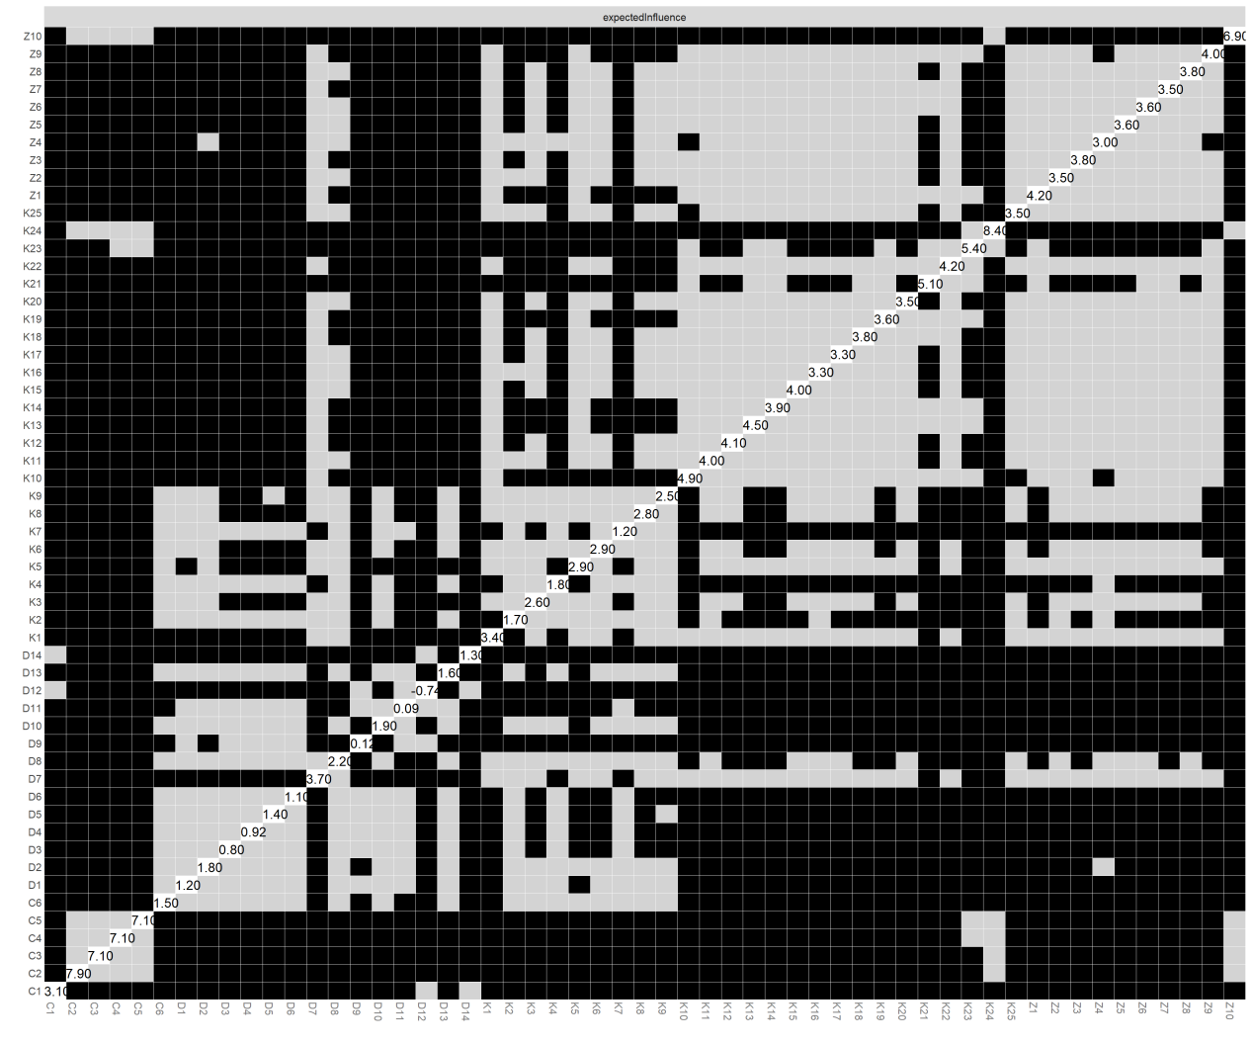Supplementary Fig.1 Bootstrapped difference test for node expected influence in the Ising network.
Note. EI = expected influence. Diagonal entries represent the sample EI estimates. Off-diagonal cells show pairwise nonparametric bootstrap difference tests based on 1,000 bootstrap samples. Black cells indicate that the 95% percentile-bootstrap confidence interval for the pairwise difference excludes zero, whereas gray cells indicate that the interval includes zero.

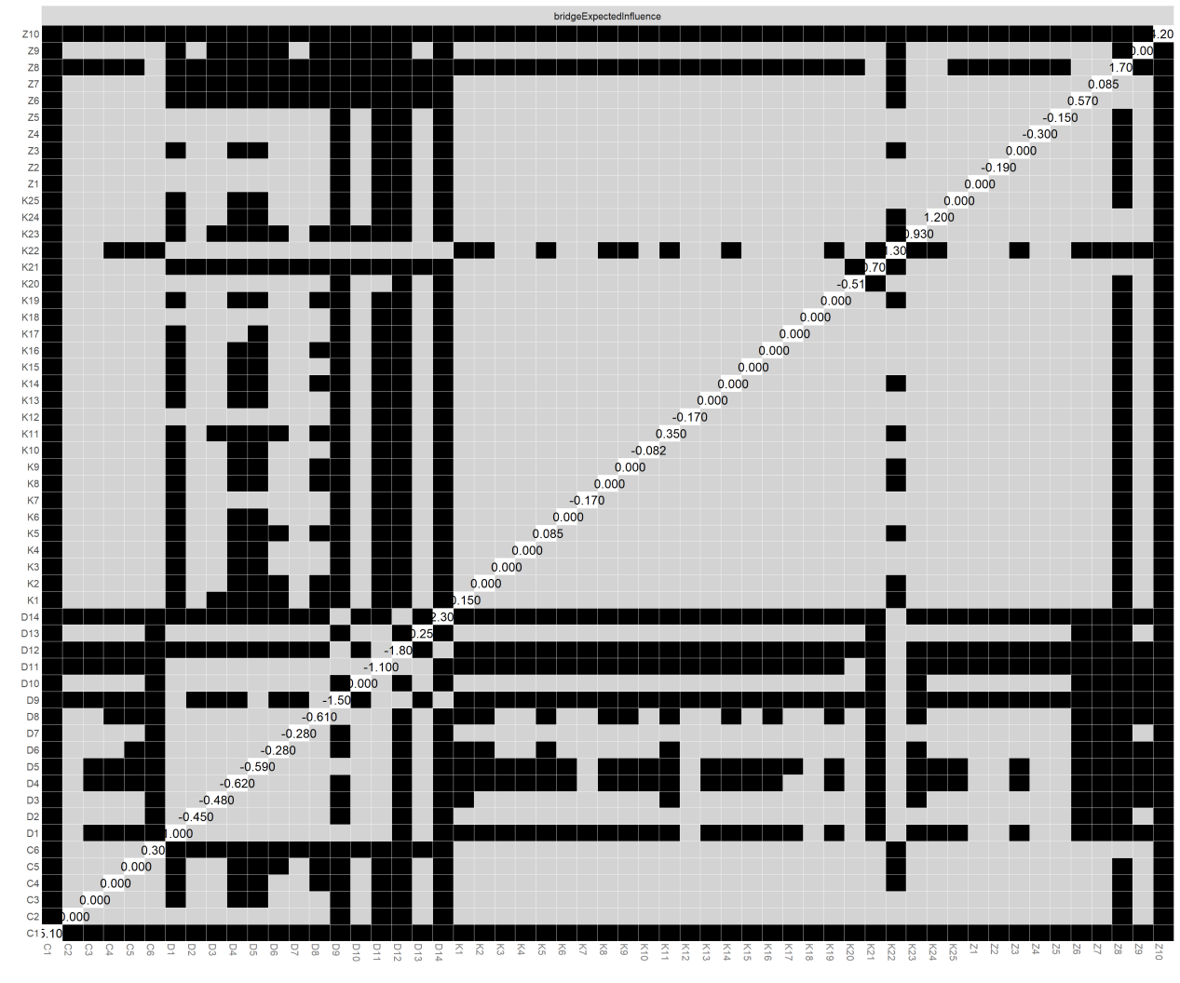
Supplementary Fig.2 Bootstrapped difference test for node bridge expected influence in the Ising network.
Note. BEI = bridge expected influence. BEI was calculated using the predefined community structure. Diagonal entries represent the sample BEI estimates. Off-diagonal cells show pairwise nonparametric bootstrap difference tests based on 1,000 bootstrap samples. Black cells indicate that the 95% percentile-bootstrap confidence interval excludes zero, whereas gray cells indicate that the interval includes zero.

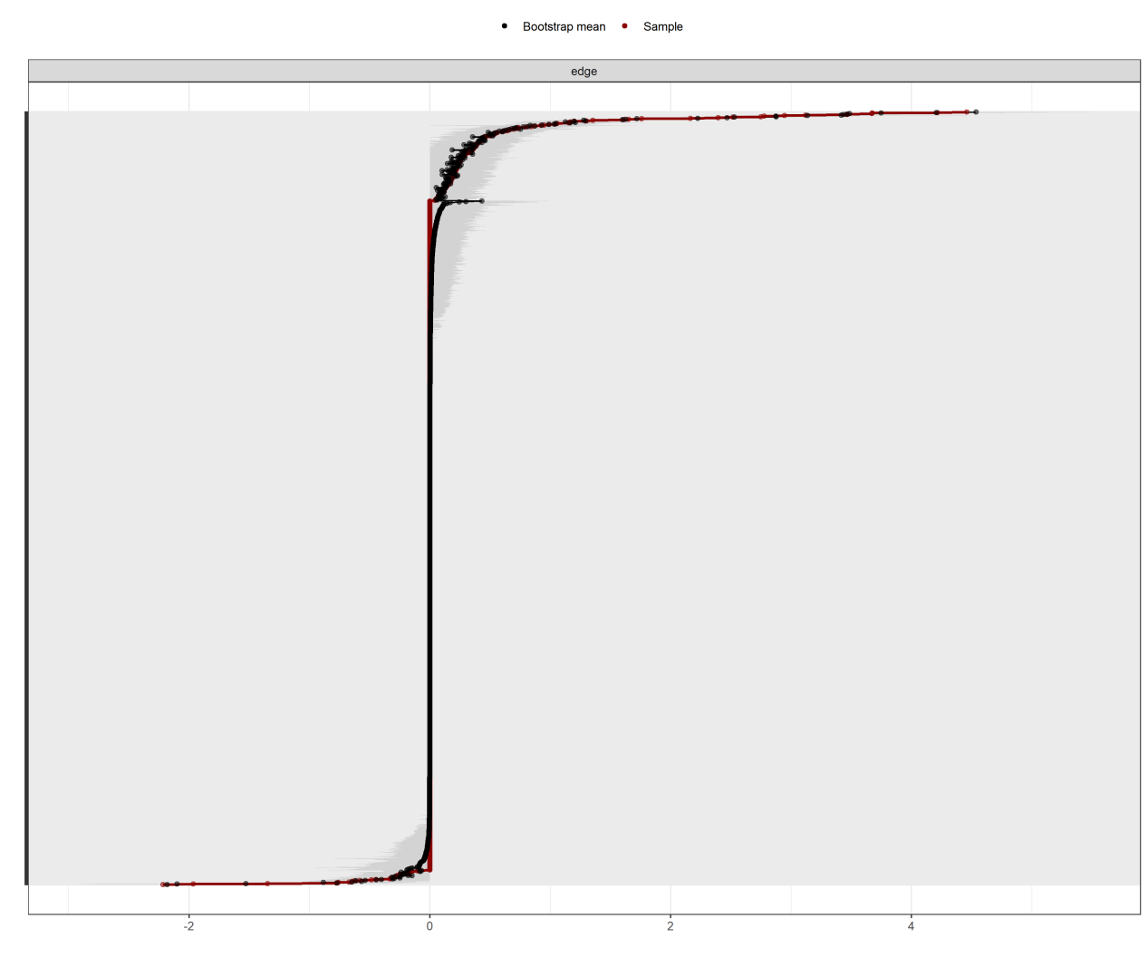
Supplementary Fig. 3. Nonparametric bootstrap confidence intervals for edge-weight estimates in the Ising network.
Note. Red points represent the sample edge-weight estimates, ordered from highest to lowest. Gray intervals represent the 95% bootstrap confidence intervals based on 1,000 nonparametric bootstrap samples. Wider intervals indicate lower estimation precision, whereas narrower intervals indicate higher precision.

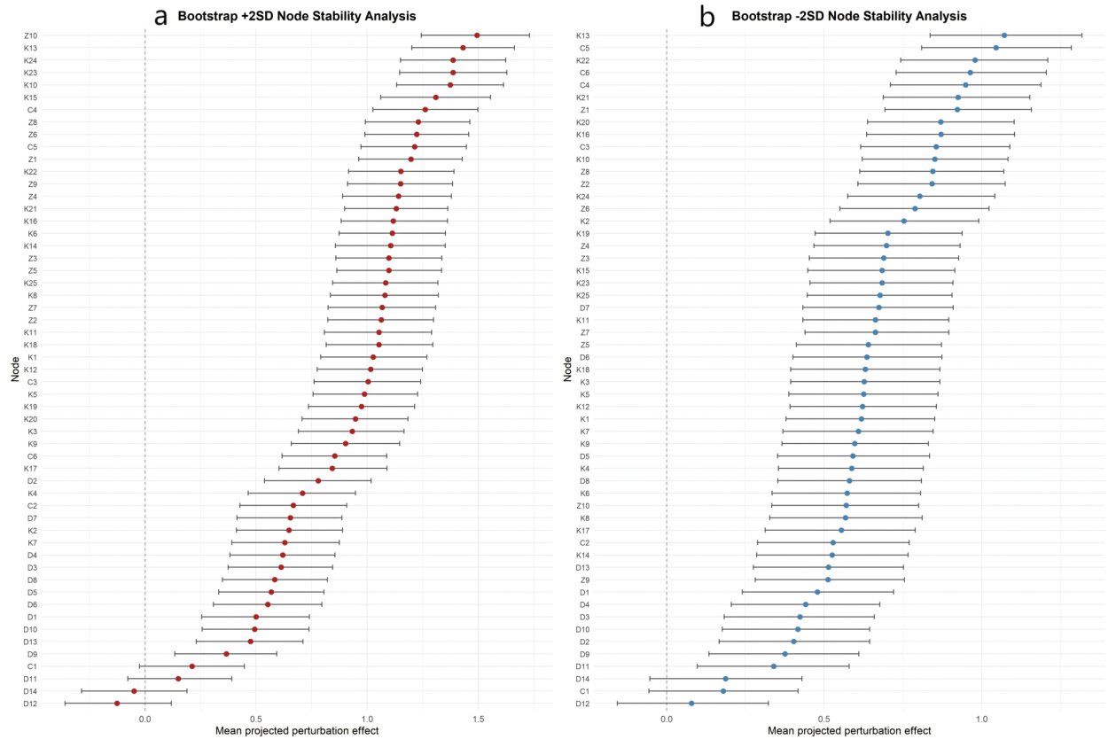
Supplementary Fig. 4. NIRA node-specific intervention effects with bootstrap confidence intervals.
Note. NIRA = Network Intervention Analysis. Panel (a) shows the effects of −2SD threshold perturbations, and panel (b) shows the effects of +2SD threshold perturbations. Each point represents the mean projected intervention effect, and error bars represent Bonferroni-adjusted 99.907% confidence intervals based on 5,000 bootstrap resamples. Positive values indicate a reduction in the network sum score under the −2SD perturbation and an increase in the network sum score under the +2SD perturbation.

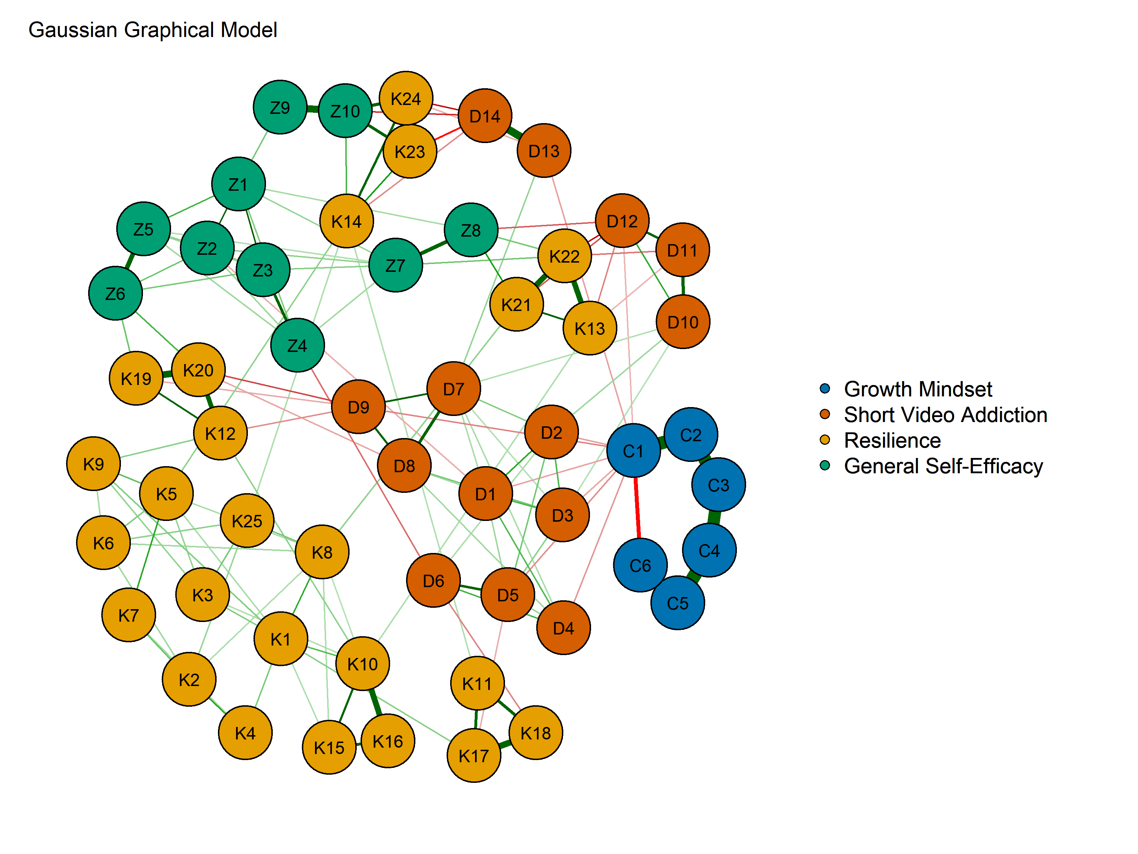
Supplementary Fig. 5. Gaussian graphical model for cross-model sensitivity analysis.
Note. Nodes represent the same 55 scale items included in the Ising network. The Gaussian graphical model was estimated using EBICglasso with γ = 0.50 and the original ordinal item scores with scale-specific response ranges. Green edges indicate positive regularized partial correlations, red edges indicate negative regularized partial correlations, and thicker edges indicate larger absolute partial correlations. This model was used to assess cross-model structural correspondence; the primary centrality and NIRA intervention analyses were based on the Ising network.

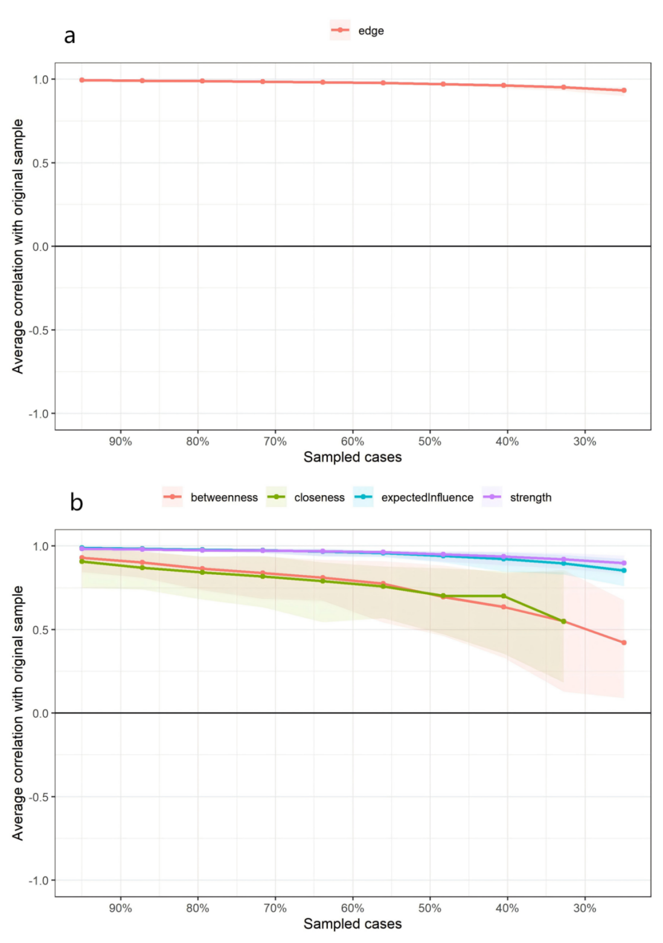
Supplementary Fig. 6. Case-dropping bootstrap stability of edge weights and centrality indices in the Ising network.
Note. Panel (a) shows the stability of edge-weight estimates. Panel (b) shows the stability of strength, expected influence, betweenness, and closeness estimates. Curves represent the mean correlations between estimates obtained from progressively reduced samples and those obtained from the original sample; shaded bands represent the corresponding 95% uncertainty intervals. Higher correlations indicate greater stability. The closeness curve terminates at lower sampling proportions because valid closeness estimates were unavailable in some case-dropping bootstrap samples. CS coefficients were calculated using a correlation threshold of 0.70.

