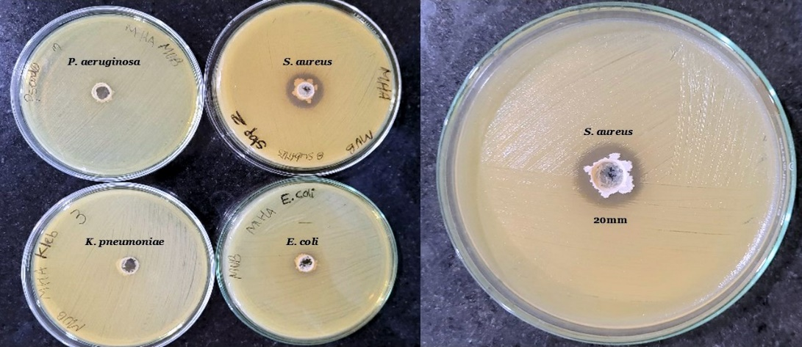
A B
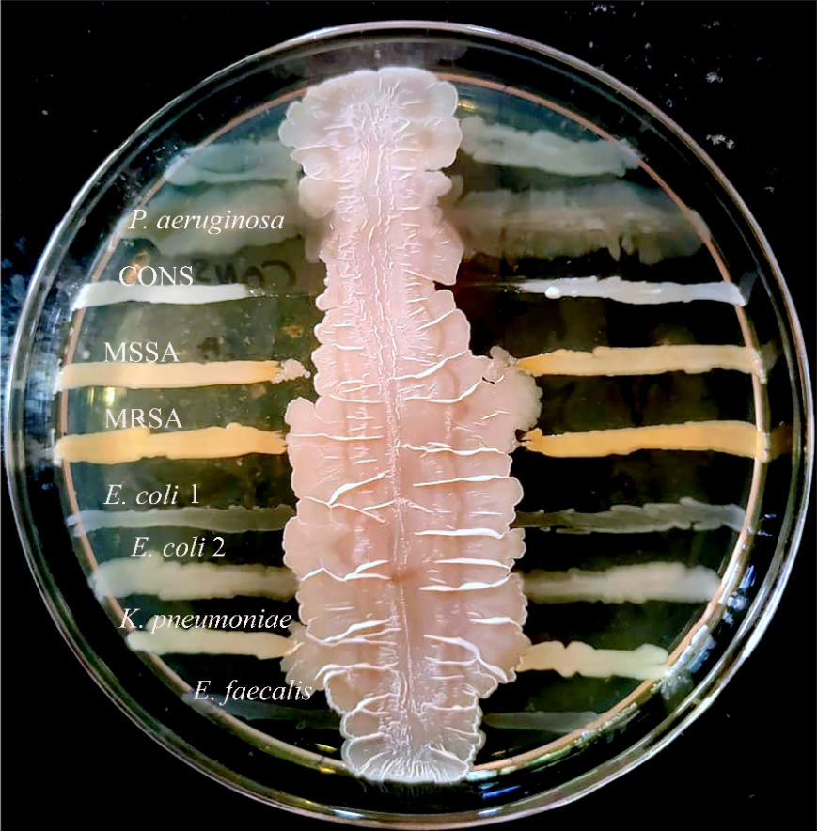
C
Fig. S1: (A) Antibacterial activity of B. subtilis JS03 against, P. aeruginosa MTCC 2295, S. aureus MTCC 737, K. pneumoniae MTCC 3384, and E. coli MTCC 728, (B) Antibacterial activity against S. aureus with a 20 mm diameter. (C) Cross streak of B. subtilis JS03 against different clinical pathogens such as Pseudomonas aeruginosa, Coagulase-negative Staphylococcus spp, Methicillin-sensitive Staphylococcus aureus, Methicillin-resistant Staphylococcus aureus, Escherichia coli 1, Escherichia coli 2, Klebsiella pneumoniae, and Enterococcus faecalis.
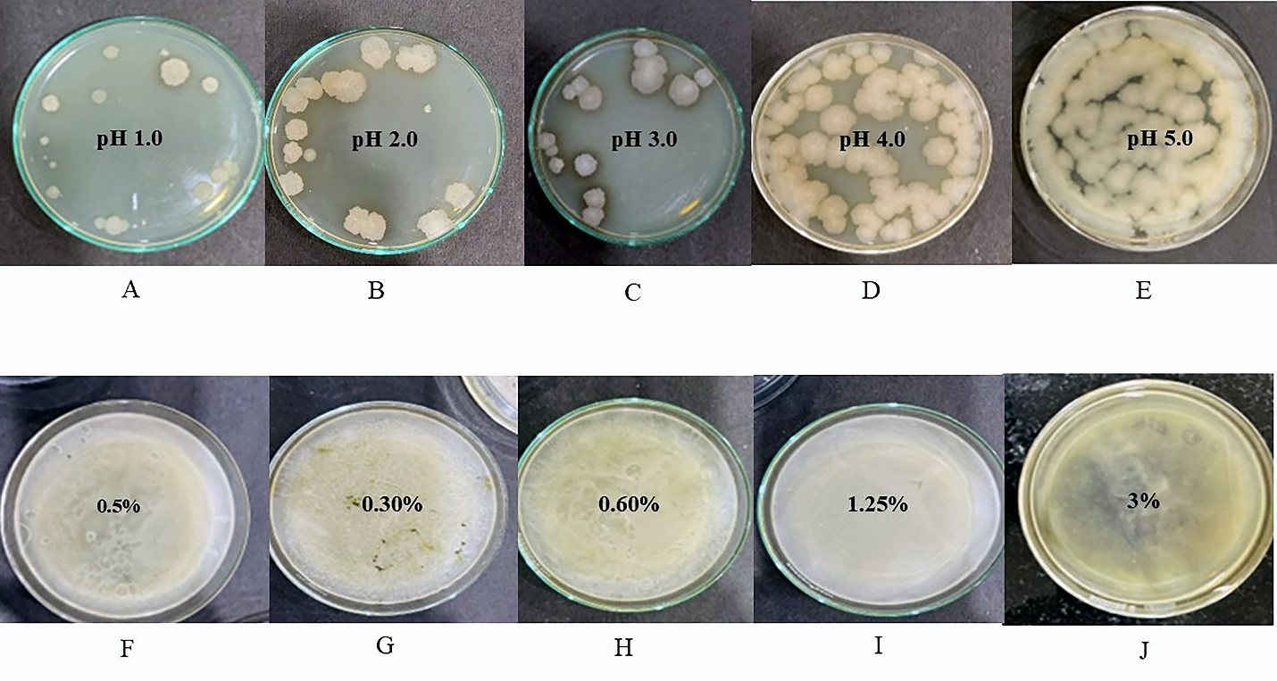
Fig. S2: Acid tolerance test for B. subtilis JS03 incubated for 3, 6, 12 and 24 h at various pH levels (A) pH 1.0, (B) pH 2.0, (C) pH 3.0, (D) pH 4.0, (E) pH 5.0. Bile salt tolerance for B. subtilis JS03incubated for 3, 6, 12 and 24 h at (F) 0.15%, (G) 0.30%, (H) 0.60%, (I) 1.25%, (J) 3.0%.
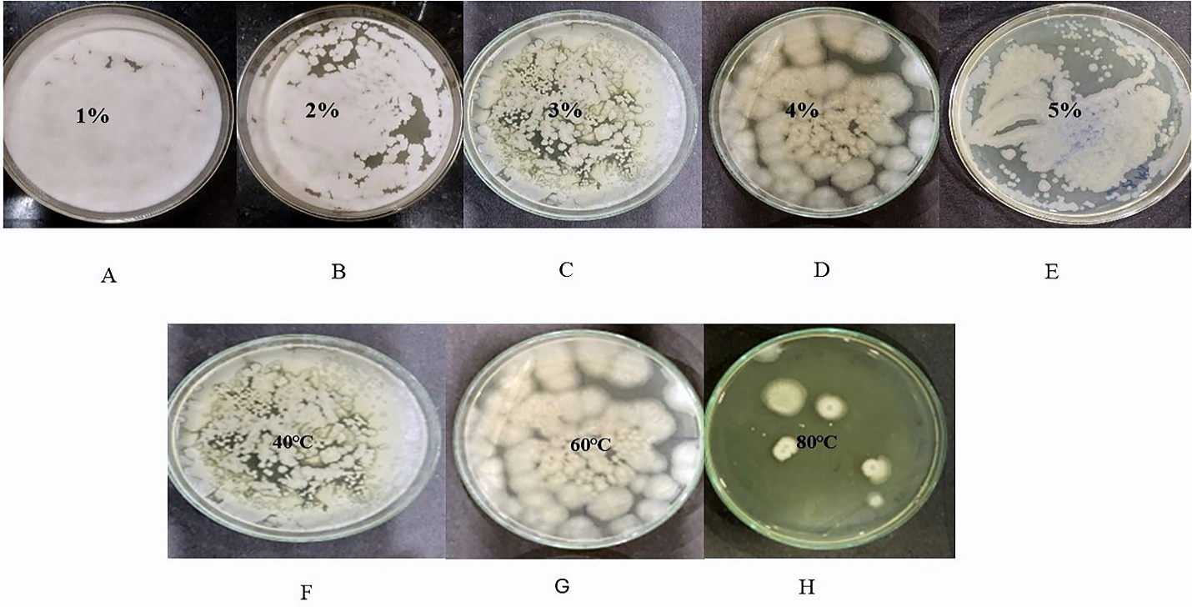
Fig. S3. Sodium chloride tolerance test for B. subtilis JS03 incubated for 3, 6, 12 and 24 h at (A) 1%, (B) 2%, (C) 3%, (D) 4%, (E) 5%, Temperature tolerance test for B. subtilis JS03 exposed for 30 min at (F) 40 ℃, (G) 60 ℃, (H) 80 ℃.

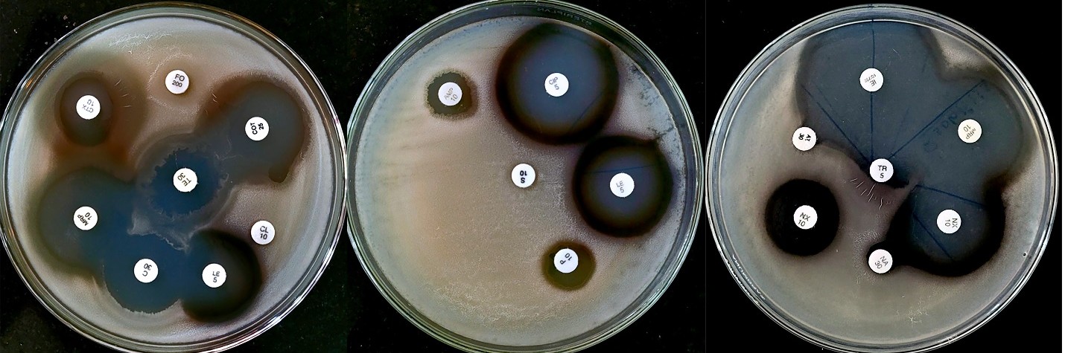
Fig. S4. Antimicrobial susceptibility testing for B. subtilis JS03 against various antibiotics such as Cefotaxime10mcg (R), Fosfomycin 200 (R), Co-trimoxazole 25 (S), Colistin 10 (R), Levofloxacin 5 (S), Chloramphenicol 30 (S), Meropenem 10 (S), Ampicillin 10 (S), Ciprofloxacin 5 (S), Penicillin 10 (R), Streptomycin 10 (R), Norfloxacin 10 (S), Nalidixic acid 30 (R), Aztreonam 30 (R), Imipenem (S), Tetracycline 30 (R).

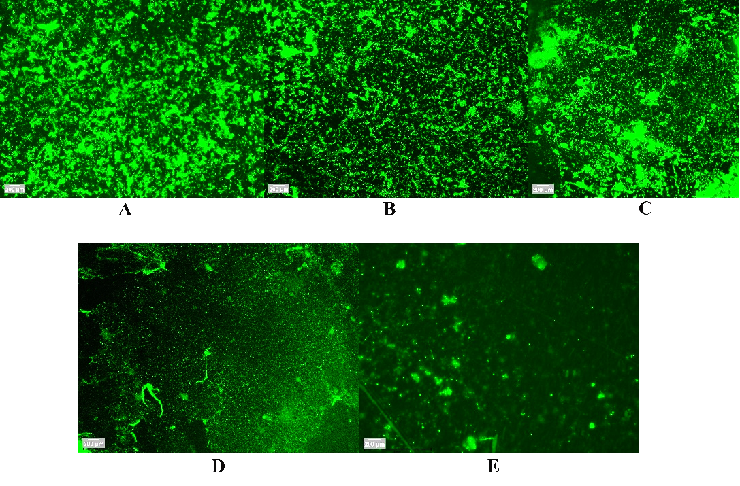

Fig. S5. Biofilm formation of Bacillus subtilis JS03 screened using acridine orange staining at (A) 6 h, (B) 12 h, (C) 24 h, (D) 36 h, (E) 48 h.

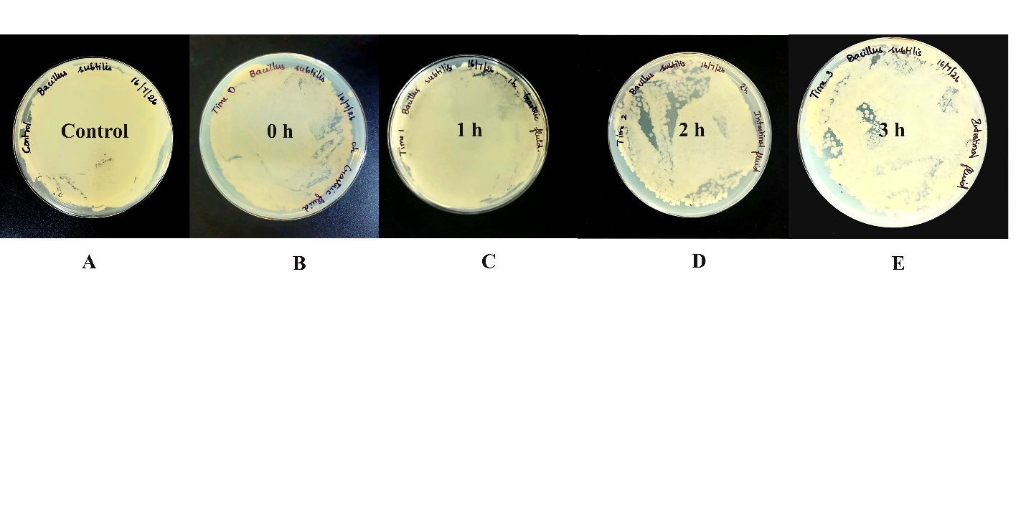
Fig. S6. Gastrointestinal tolerance test for B. subtilis JS03 incubated for 0,1,2,3 h in stimulated gastric fluid.

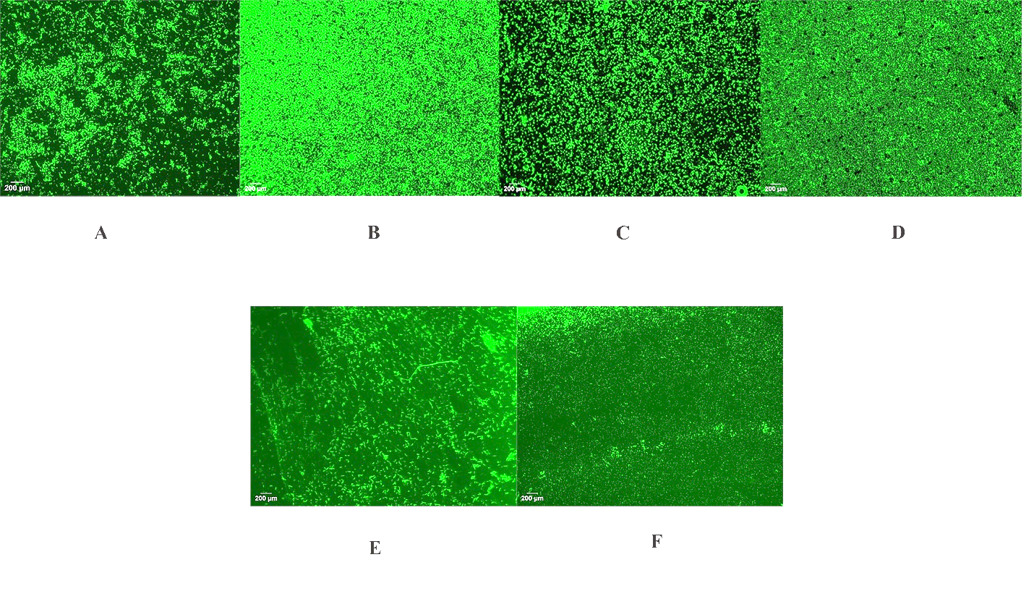

Fig. S7. Biofilm control for (A) E. coli (B) L. monocytogenes (C) MSSA (D) S. aureus (E) B. cereus (F) K. pneumniae.
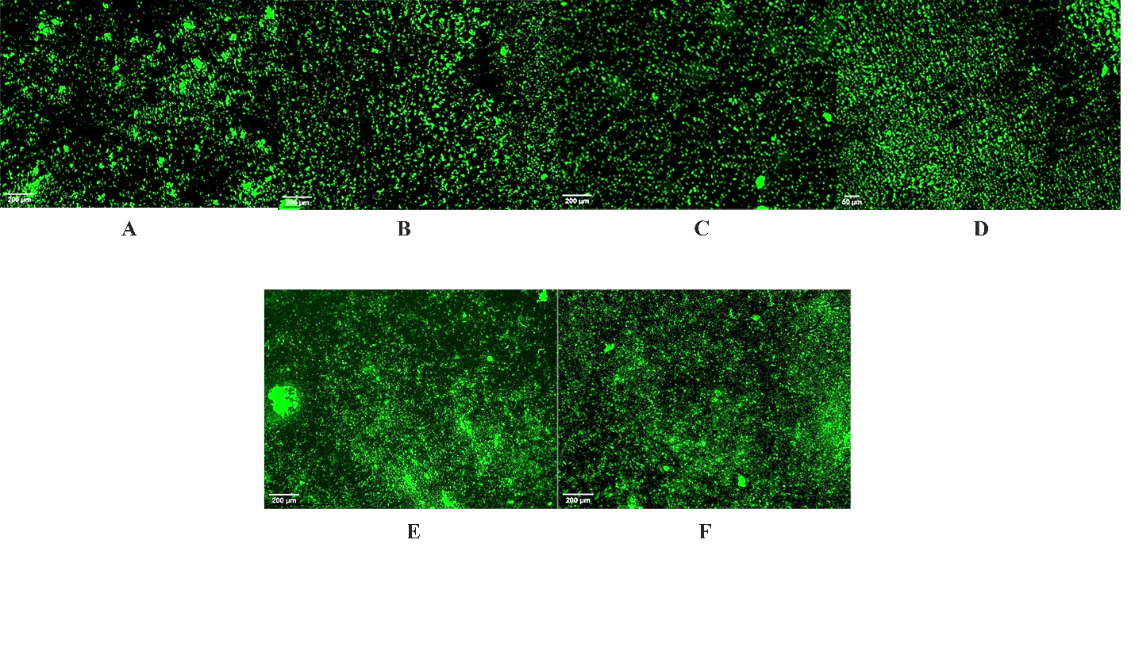
Fig. S8. Biofilm degradation ability of B. subtilis JS03 over biofilm forming clinical pathogens such as (A)E. coli (B) L. monocytogenes (C) MSSA (D) S. aureus (E) B. cereus (F) K. pneumoniae.

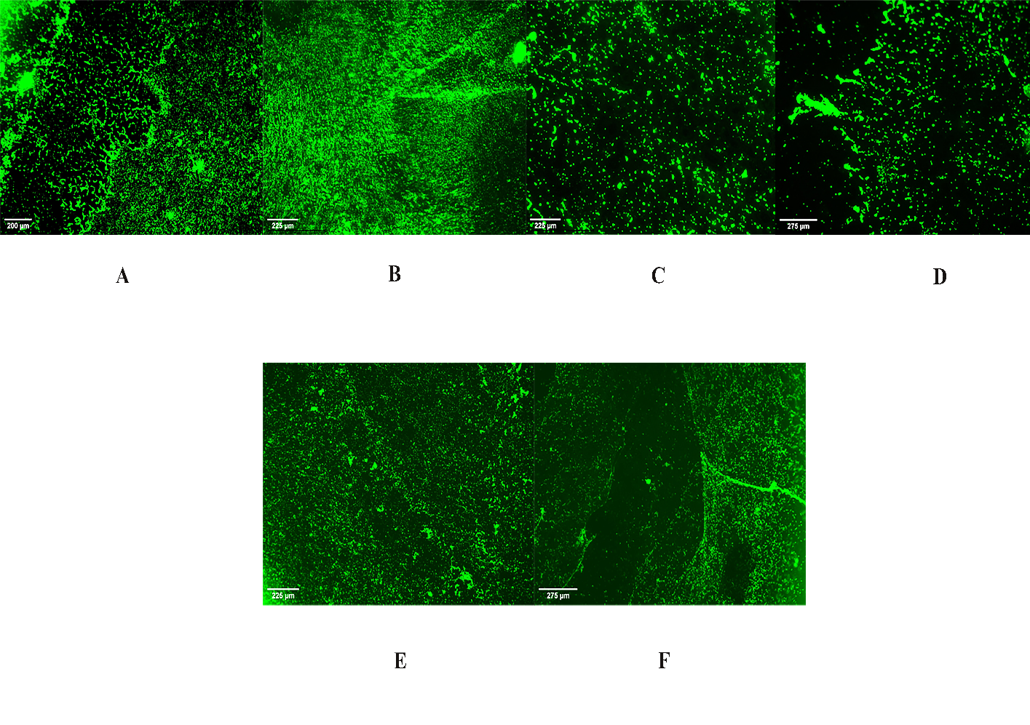

Fig. S9. Biofilm inhibition of B. subtilis JS03 over biofilm forming clinical pathogens such as (A) E. coli (B) L. monocytogenes (C) MSSA (D) S. aureus (E) K. pneumoniae (F) B. cereus

