Supplementary information for
Orchard soil organic and inorganic carbon responses vary across management practices and land-use contrasts: A global meta-analysis

This file includes:
Table S1 to S3
Figure S1 to S2

1.Supplementary Methods
1.1 Depth-standardization procedure
For treatment and control observations, reported bulk density was retained when available. Missing bulk density was estimated from soil organic carbon-derived soil organic matter:

$\text{SOM=SOC/0.58}$ (1)

$\text{B}{\text{D}}_{\text{est}}\text{=}\frac{\text{100}}{\text{SOM/0.244+(100-SOM)/1.64}}$ (2)
1.2 Missing standard deviations
When SD was not given in the study but standard error (SE), use the following equation to convert the latter to SD:
SD = √n × SE (3)

The missing SD will be estimated by the mean coefficient of variation (CV) of each practice. The SD was calculated as:
SD = CV × x (4)

1.3 Data processing
For each original layer $i$, layer thickness was calculated as:
$D_{i}=B_{i}-T_{i}$ (5)
The standardized depth intervals were defined as 0–30, 30–60, 60–100, and 100–200 cm. For each original layer $i$and target interval $j$, the overlap boundaries were:
${\text{T}}_{\text{overlap,ij}}\text{=max(}{\text{T}}_{\text{i}}\text{,}{\text{T}}_{\text{j}}\text{)}$ (6)
${\text{B}}_{\text{overlap,}\text{ij}}\text{=mi}\text{n}\text{(}{\text{B}}_{\text{i}}\text{,}{\text{B}}_{\text{j}}\text{)}$ (7)

For concentration or intensity variables, standardized values were calculated as:
${\overset{ˉ}{x}}_{j}=\frac{\sum_{i}{x_{i}}O_{ij}}{\sum_{i}{O_{ij}}}$ (8)
For each study and treatment–control pair, the maximum observed sampling depth $d$.When measurements from multiple original soil layers overlapped a standardized depth interval, carbon contents were calculated using thickness-weighted averaging:
$\text{S}{\text{C}}_{\text{j}}\text{=}\frac{\sum_{\text{i}}{\text{S}}{\text{C}}_{\text{i}}{\text{L}}_{\text{ij}}}{\sum_{\text{i}}{{\text{L}}_{\text{ij}}}}$ (9)

L_{ij}=max[0,min(B_{i},B_{j})−max(T_{i},T_{j})] (10)
where $\text{S}{\text{C}}_{\text{j}}$is the thickness-weighted carbon content of target interval $j$, $\text{S}{\text{C}}_{\text{i}}$ is the carbon content of original layer $i$, and $L_{ij}$is the overlapping thickness between the original and target intervals.
2. Supplementary Tables
Table S1 Characteristics of the included studies
Literature code | Title | Publication source | Published year
1 | Effects of nitrogen fertilizer application on the distribution of organic carbon and inorganic carbon profile in Korla fragrant pear orchard soil | SOIL AND FERTILIZER SCIENCES IN CHINA | 2023
2 | Effect of Mulching on Soil Inorganic Carbon of Apple Orchard in Loess Plateau | Northwest A&F University (Master’s dissertation) | 2022
3 | Artificial intervention of natural grass growing technology in dryland apple orchard and Effect of Potassium Application in Different Periods before Mining | Northwest A&F University (Master’s dissertation) | 2022
4 | Study on dissolution process and carbon sink effect of carbonate minerals in loess | CAGS (Master’s dissertation) | 2020
5 | STUDY ON THE INFLUENCE OF SOIL CEMENTING COMPOSITION ON AGGREGATE STABILITY IN KARST PEAKCLUSTER DEPRESSION AREA | GXU(Master’s dissertation) | 2022
6 | EFFECTS OF APPLYING NITROGEN FERTILIZER ON CARBON EMISSION FROM CALCAREOUS SOIL | Northwest A&F University (Master’s dissertation) | 2017
7 | Changes in SOC and SIC concentration with land uses and their soil influencing factors in northern marginal zones of Tarim Basin | Journal of China Agricultural University | 2017
8 | Tianjin of soil salinization and its impact on soil carbonate and organic carbon distribution | TNU (Master’s dissertation) | 2014
9 | LONG-TERM IMPACT OF APPLE ORCHARD CONVERTED FROM FARMLAND ON SOIL QUALITY IN THE WEIBEI REGION, NORTHWEST CHINA | Northwest A&F University (Master’s dissertation) | 2016
10 | Calcium Degradation Status of Orchard Soil in Weibei Region, Shaanxi Province, China | Scientia Agricultura Sinica | 2015
11 | Effects of Artificial Forest Types on Soil Properties in Loess Hilly Area of Weibei of Shaanxi | Soils | 2021
12 | The variation of soil nutrients of fruit tree defoliation in early stage and its effects on fruit quality | Agricultural Research in the Arid Areas | 2012
13 | Assessment of Soil Redistribution Following Land Rehabilitation with  an Apple Orchard in Hilly Regions of Central Iran | agronomy | 2022
14 | Bicarbonates in irrigation water contribute to carbonate formation and CO₂ production in orchard soils under drip irrigation | Geoderma | 2016
15 | Biodynamics enriched organic amendments in improving leaf and soil nutrition of Khasi mandarin (Citrus reticulata Blanco) | Journal of Plant Nutrition | 2024
16 | Comparison of Some Properties of Soils Under Different Land Uses:The Case Study of Zonguldak-Ereğli, Türkiye | Forestist
17 | Diverse effects of wetting and drying cycles on soil aggregation: Implications on pesticide leaching | Chemosphere | 2025
18 | Drip Fertigation In Apple Orchards: Impact on Soil Chemical Properties and Nutrient Distribution In Relation to Soil Texture | Journal of Agricultural Sciences | 2021
19 | Does spontaneous cover crop increase the stocks of soil organic carbon and nitrogen in commercial olive orchard? | Soil & Tillage Research | 2024
20 | Effect of Organic Agriculture and Soil Forming Factors on Soil Quality and Physiology of Olive Trees | Agroecology and Sustainable Food Systems | 2013
21 | Effect of Spatial Variability of Plant Nutrients on Fertilizer Requirement and Yield in Table Olive Growing | Applied Fruit Science | 2025
22 | Efficient irrigation management can contribute to reduce soil CO2 emissions in agriculture | Geoderma | 2016
23 | Factors Governing Total and Permanganate Oxidizable C Pools in Agricultural Soils from Southern Italy | agriculture | 2020
24 | Greenhouse gas emissions and soil organic matter dynamics in woody crop orchards with different irrigation regimes | Science of the Total Environment | 2018
25 | Long-Term Effects of Irrigation and Date-Palm Production on Torripsamments, Saudi Arabia | Geoderma | 1989
26 | Long-term vegetation restoration increases deep soil carbon storage in the Northern Loess Plateau | scientific reports | 2021
27 | Midterm effects of irrigation with desalinated seawater on soil properties and constituents in a Mediterranean citrus orchard | Agriculture, Ecosystems and Environment | 2025
28 | Pedogenic carbonate formation by land use changes | Agriculture, Ecosystems and Environment | 2025
29 | Practicing land degradation neutrality (LDN) approach in the Shazand Watershed, Iran | Science of the Total Environment | 2019
30 | Soil carbon fractions and aggregate stability across management zones under flood-irrigated pecan orchards in an arid region | Journal of Cleaner Production | 2026
31 | Sustainable agricultural practices for Mediterranean olive groves.The effect of soil management on soil properties | Spanish Journal of Soil Science | 2011
32 | The effect of short-term plants cultivation on soil organic/inorganic carbon storage in newly formed soils | scientific reports | 2023
33 | The effects of rock fragmentation and ⁄or deep tillage on soil skeletal material and chemical properties in a Mediterranean climate | Soil Use and Management | 2012
34 | The Oasisization Process Promotes the Transformation of Soil Organic Carbon into Soil Inorganic Carbon | land | 2024

Table S2 Heterogeneity statistics for soil-carbon responses by orchard management practice and land-use conversion.
Category | k | n | Q | P | I² (%) | tau²
A.Orchard management
SOC response
Overall | 71 | 14 | 726.15 | <0.001 | 99.74 | 0.3145
Fertilization | 22 | 3 | 362.97 | <0.001 | 98.46 | 0.0165
Irrigation | 16 | 5 | 10.69 | 0.774 | 13.54 | 0.0037
Mulching | 12 | 3 | 6.02 | 0.872 | 0.00 | 0.0000
Integrated management | 21 | 4 | 226.75 | <0.001 | 98.06 | 2.0614
SIC response
Overall | 81 | 15 | 13403.23 | <0.001 | 99.89 | 0.5341
Fertilization | 22 | 3 | 826.69 | <0.001 | 99.76 | 0.0927
Irrigation | 16 | 5 | 5134.63 | <0.001 | 99.61 | 0.2757
Mulching | 22 | 4 | 103.80 | <0.001 | 86.90 | 0.0197
Integrated management | 21 | 4 | 2499.46 | <0.001 | 99.73 | 1.6280
STC response
Overall | 71 | 14 | 1977.01 | <0.001 | 99.73 | 0.2786
Fertilization | 22 | 3 | 888.10 | <0.001 | 99.29 | 0.0342
Irrigation | 16 | 5 | 68.32 | <0.001 | 77.85 | 0.0736
Mulching | 12 | 3 | 15.26 | 0.171 | 44.09 | 0.0059
Integrated management | 21 | 4 | 661.39 | <0.001 | 98.73 | 0.6121
SIC/SOC response
Overall | 71 | 14 | 1159.80 | <0.001 | 99.89 | 1.4239
Fertilization | 22 | 3 | 135.00 | <0.001 | 99.67 | 0.1472
Irrigation | 16 | 5 | 166.21 | <0.001 | 89.70 | 0.2360
Mulching | 12 | 3 | 6.06 | 0.869 | 0.00 | 0.0000
Integrated management | 21 | 4 | 717.45 | <0.001 | 99.26 | 6.9986
B. Land-use conversion
SOC response
Overall | 189 | 19 | 21334.61 | <0.001 | 99.11 | 0.1693
Wasteland | 31 | 6 | 1211.39 | <0.001 | 96.75 | 0.4311
Cropland | 98 | 15 | 3362.18 | <0.001 | 96.69 | 0.0577
Shrubland | 18 | 6 | 1207.51 | <0.001 | 98.28 | 0.1067
Forest | 42 | 7 | 6861.89 | <0.001 | 99.31 | 0.1085
SIC response
Overall | 183 | 19 | 22875.11 | <0.001 | 99.56 | 0.2970
Wasteland | 31 | 6 | 665.84 | <0.001 | 99.48 | 0.2750
Cropland | 98 | 15 | 2068.70 | <0.001 | 97.37 | 0.1219
Shrubland | 18 | 6 | 7766.37 | <0.001 | 99.75 | 0.6567
Forest | 36 | 7 | 10104.92 | <0.001 | 99.77 | 0.2268
STC response
Overall | 188 | 19 | 539.93 | <0.001 | 78.18 | 0.1201
Wasteland | 31 | 6 | 39.16 | 0.122 | 49.43 | 0.1085
Cropland | 97 | 14 | 69.82 | 0.980 | 9.16 | 0.0037
Shrubland | 18 | 6 | 94.86 | <0.001 | 84.71 | 0.0612
Forest | 42 | 7 | 219.86 | <0.001 | 80.36 | 0.2512
SIC/SOC response
Overall | 183 | 19 | 14787.56 | <0.001 | 98.35 | 0.3944
Wasteland | 31 | 6 | 732.11 | <0.001 | 96.33 | 0.5311
Cropland | 98 | 15 | 1431.45 | <0.001 | 95.17 | 0.1703
Shrubland | 18 | 6 | 5142.68 | <0.001 | 99.59 | 1.0871
Forest | 36 | 7 | 4844.55 | <0.001 | 99.11 | 0.4223

Table S3 Egger test and trim-and-fill analysis
Outcome | k | n | beta(SE) | t | df | P | k0 | Side | Original (%) | Adjusted (%)
A. Orchard management
SOC | 71 | 14 | 0.81 | 0.629 | 2.4 | 0.584 | 0 | right | 7.15 | 7.15
SIC | 81 | 15 | -0.635 | -0.806 | 2.4 | 0.491 | 0 | left | 15.44 | 15.44
STC | 71 | 14 | -0.579 | -0.675 | 2 | 0.568 | 0 | left | 21.44 | 21.44
SIC/SOC | 71 | 14 | -0.93 | -0.559 | 2 | 0.632 | 0 | left | 12.64 | 12.64
B. Land-use contrasts
SOC | 189 | 19 | 0.248 | 1.841 | 3.6 | 0.148 | 6 | left | -1.19 | -18.93
SIC | 183 | 19 | 0.097 | 0.2 | 5 | 0.849 | 6 | left | -4.9 | -17.14
STC | 188 | 19 | 0.514 | 0.475 | 5 | 0.655 | 0 | right | -0.37 | -0.37
SIC/SOC | 183 | 19 | -0.244 | -1.633 | 3.7 | 0.183 | 0 | right | -7.51 | -7.51

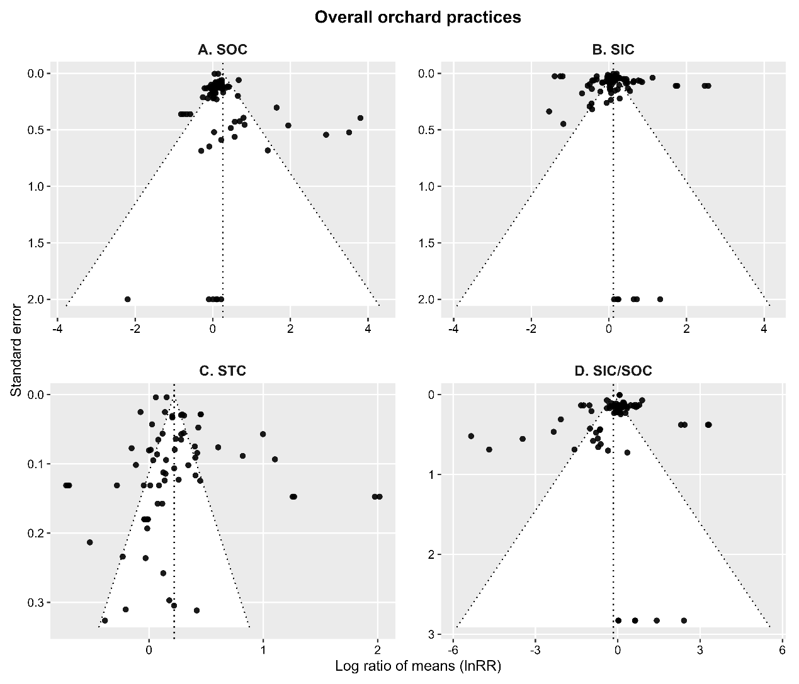
Figure S1 Funnel plots illustrating the possible effect of publication bias on the soil carbon data under different orchard intensive management. The plot illustrates symmetry (i.e., points fall on both sides of the summary effect size

Identification of studies via databases and registers

Records removed before screening:
Duplicate records removed
(n = 10)
Records removed for other reasons (n=2)

Records identified from:
Web of science (n=323)
China National Knowledge
Infrastructure Database (n=69)

Identification

Records excluded:
Based on their title and abstract
(n = 262)

Records screened
(n =380)

Screening

Full-text papers exclude:
(1)Not containing SIC(n=77)
(2) Reporting the same experiment in different literature
(n=7)

Reports sought for retrieval
(n =118)

Studies included in qualitative synthesis (n=34)
Eligibility

Studies included in qualitative synthesis (meta-analysis)
(n=34)
Included

Figure S2 Preferred reporting items for meta-analyses (PRISMA) flow chart describing the article selection process for eligible articles to include in the meta-analysis.

