Appendices
AI-Adaptive Learning Paths and Task-Difficulty Synchronization: A Longitudinal Study of Student Persistence and Engagement
Appendix A
Student Engagement Scale for AI-Adaptive Learning (SES-AI)
The SES-AI was administered at baseline, midpoint, and final measurement points. Items were rated on a five-point Likert scale ranging from 1 = Strongly Disagree to 5 = Strongly Agree.
Table A1
Student Engagement Scale for AI-Adaptive Learning
Dimension | Item ID | Survey Item Statement
Behavioral | B1 | I stay focused on the AI-adaptive tasks even when they are difficult.
Behavioral | B2 | I follow all instructions and interactive cues provided by the AI system.
Behavioral | B3 | I complete the optional AI-recommended activities for special education teaching.
Behavioral | B4 | When I encounter a difficult concept regarding disabilities, I persist until I understand it.
Behavioral | B5 | I regularly log into the AI platform to keep up with my personalized learning path.
Emotional | E1 | The personalized feedback from the AI makes me feel supported in my learning.
Emotional | E2 | I feel excited about using the AI-adaptive system to learn about teaching people with disabilities.
Emotional | E3 | I find the content curated by the AI system to be interesting and professionally relevant.
Emotional | E4 | I feel a sense of accomplishment when the AI recognizes my progress through the levels.
Emotional | E5 | I enjoy the way the AI platform synchronizes its difficulty with my current skill level.
Cognitive | C1 | I look for extra information provided by the AI to better understand specific disabilities.
Cognitive | C2 | I try to connect the AI-guided lessons to my future career as an English teacher in inclusive classrooms.
Cognitive | C3 | When I make a mistake, I analyze the AI’s feedback to correct my understanding.
Cognitive | C4 | I think about how the AI-suggested teaching strategies would work in a real Egyptian classroom.
Cognitive | C5 | I try to mentally organize the different disability types we study into a clear, professional framework.
Note. The instrument was reviewed by seven experts and validated for use in the Egyptian teacher-education context.

Appendix B
Experience Sampling Method Micro-Survey
ESM pulse checks were embedded in the AI platform and designed to be completed in under 60 seconds. The survey was triggered after module completion or after approximately 20 minutes of platform activity.
Table B1
ESM Micro-Survey Pulse Check
Part | Prompt | Response Options
A: Task-Difficulty Synchronization | Thinking about the AI tasks you just finished, how did the level of challenge feel? | Boring: too easy, disinterested, under-challenged; Optimal/Flow: challenging but manageable, time passed quickly; Anxiety-Inducing: too hard, overwhelmed or stressed
B: Current Affect | How do you feel right now regarding your learning process? Select all that apply. | Frustrated: AI feedback is not helping; Curious: I want to see the next personalized module; Excited: I am enjoying this topic or strategy; Neutral: I am completing required tasks
Note. Students could select more than one affective state in Part B.
Table B2
ESM Implementation Timeline
Period | Phase | Focus | ESM Frequency
Semester 2 (2025) | Initial Adaptive Phase | Introduction to disabilities and inclusion; AI learns student baselines | 2x weekly
Summer 2025 | Reflection Period | Optional qualitative check-ins on system perception | Monthly
Semester 1 (2025/2026) | Advanced Synchronization Phase | Specific disabilities including visual, hearing, and motor disabilities; higher difficulty synchronization | 2x weekly
Semester 2 (2026) | Professional Mastery Phase | Classroom management for learners with disabilities; final persistence trajectory tracking | 2x weekly
Note. The ESM schedule was aligned with the longitudinal structure of the course and platform-use periods.

Appendix C
Semi-Structured Interview Protocol
Semi-structured interviews were conducted to explain the quantitative engagement and persistence trajectories. Twenty students were selected for deeper interviews based on high and low persistence patterns.
Table C1
Qualitative Interview Protocol
Interview Focus | Guiding Question
Introduction | We have tracked your journey with the AI system over the past year. We want to understand the “why” behind your engagement patterns.
Flow and Difficulty | There were times the ESM data showed you felt bored or anxious. Can you describe a specific module where the AI difficulty synchronization felt just right, or like flow?
Persistence | As a student in the English Department, how did the AI-adaptive path help you stay persistent in a complex course like “Teaching People with Disabilities” for a full year?
Affective Inclination | Do you feel your passion or inclination toward helping people with disabilities changed because of the way the AI interacted with you? Did it feel like a supportive tutor or just a machine?
Reliability of Adaptation | Did the system’s ability to adjust to your emotional state, such as frustration or excitement, feel accurate to you?
Note. Follow-up prompts were used when participants referred to specific modules, difficulty states, or platform interactions.

Appendix D
Operational Definitions and Measurement Indicators
Table D1
Operational Definitions of Study Variables
Variable | Operational Definition | Primary Indicators
AI-adaptive learning path quality | The perceived and logged appropriateness of AI sequencing, content recommendation, feedback, and pacing. | Student ratings of support and relevance; platform recommendation history; completion of personalized modules.
Task-difficulty synchronization | The alignment between AI-assigned challenge and student readiness or perceived skill. | ESM difficulty response: boring, optimal/flow, anxiety-inducing; progression and error patterns.
Student engagement | Behavioral, emotional, and cognitive involvement in AI-adaptive learning. | SES-AI subscale scores; ESM affect; time-on-task; optional activity completion.
Persistence | Sustained participation and continued effort across the longitudinal study period. | Regular login patterns; completion rates; re-engagement after failed attempts; continued participation across semesters.
Perceived competence | Students’ sense that they can successfully understand and apply course content. | SES-AI emotional and cognitive indicators; interview narratives about confidence and progress.
Note. The indicators combine survey responses, ESM reports, platform logs, and qualitative evidence.

Appendix E
Qualitative Coding Framework and Representative Excerpts
The qualitative coding framework was developed deductively from the hypotheses and conceptual framework and inductively refined during interview analysis.
Table E1
Qualitative Themes, Definitions, Representative Excerpts, and Hypothesis Links
Theme | Analytic Definition | Representative Excerpt | Link
Safety net and cognitive-exhaustion mitigation | AI difficulty adjustment reduced overload and helped students return to difficult modules. | “The AI noticed I was failing the practice tasks and immediately switched to simpler terminology … That’s why I kept logging in.” | H2, H3
Affective shift toward professional advocacy | Students moved from fear of disability education to confidence and professional interest. | “My passion grew because my competence grew.” | H4, H6
Algorithmic ceiling and loss of agency | Some low-persisters felt trapped by remedial pathways or overly corrective feedback. | “It kept me in the easy path even after I understood. I wanted to choose another case.” | Boundary condition
Technical friction and emotional discontinuity | Connectivity problems, slow loading, or session-sync issues disrupted the perceived supportiveness of AI. | “When the session disappeared, I lost the connection with the work.” | Boundary condition
Longitudinal emotional resilience | Repeated successful adaptation strengthened students’ willingness to continue over time. | “It never let me feel stupid; it let me try again.” | H7
Note. Excerpts are anonymized and used to illustrate recurring patterns across high- and low-persistence cases.

Appendix F
Word-Frequency Query and Word-Cloud Output
The word-frequency query was used as a supplementary qualitative check to identify salient terms in the interview and analytic dataset. Because word-frequency output can include coding or procedural vocabulary, interpretation focused on meaningful clusters rather than isolated counts alone.
Table F1
Selected Salient Terms From the Word-Frequency Query
Word | Count | Weighted % | Interpretive Cluster
state | 159 | 1.94 | Difficulty and affective states
changed | 125 | 1.76 | Adaptive change and transformation
cognitive | 122 | 1.35 | Cognitive engagement
quality | 89 | 1.05 | Path quality
process | 86 | 1.42 | Longitudinal learning process
personalized | 66 | 1.24 | AI personalization
continued | 57 | 1.10 | Persistence over time
students | 53 | 2.59 | Participant-centered focus
emotional | 51 | 1.67 | Affective engagement
response | 51 | 1.61 | Student response and feedback
persistence | 50 | 1.87 | Continued participation
helped | 45 | 1.38 | Perceived support
support | 44 | 0.84 | Perceived support
engagement | 42 | 0.59 | Engagement construct
controlling | 33 | 0.62 | Autonomy concern
perceived | 29 | 1.06 | Perceived competence/experience
adaptive | 24 | 0.98 | Adaptive system function
synchronization | 22 | 0.46 | Difficulty synchronization
competence | 17 | 0.35 | Competence mechanism
frustration | 8 | 0.28 | Affective friction
Note. Terms were selected because they were frequent and conceptually relevant to the qualitative themes; procedural or overly general terms were interpreted cautiously.

Figure F1
Word Cloud of Salient Terms in the Qualitative Dataset
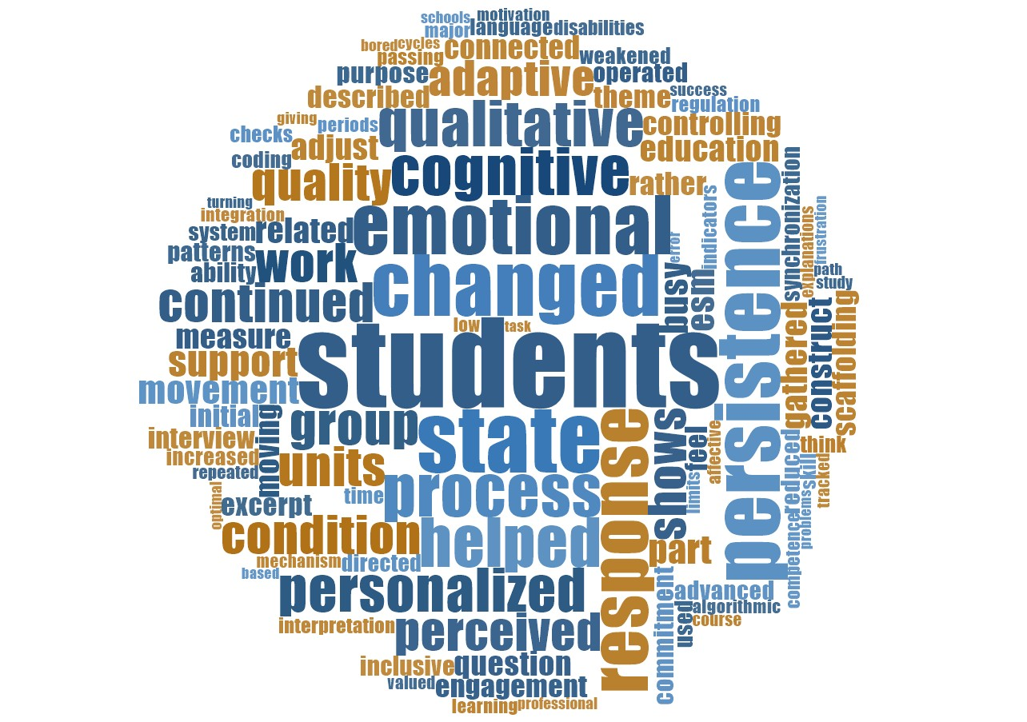
Note. Larger terms represent higher frequency in the qualitative word-frequency query. The figure supports, but does not replace, thematic interpretation.

Appendix G
Supplementary Statistical Summary
This appendix summarizes the main statistical outputs reported in the findings section. The values are included to support transparency and cross-reference between the manuscript narrative, tables, and figures.
Table G1
Summary of Statistical Evidence by Hypothesis
Hypothesis | Analysis | Key Evidence | Conclusion
H1 | Latent growth curve modeling | Intercept = 3.85, SE = 0.03, p < .001; slope = 0.23, SE = 0.02, p < .001; path quality → slope = 0.40, SE = 0.03, p < .001 | Supported
H2/H5 | Cox proportional hazards regression | Task-difficulty synchronization: HR = 0.42, 95% CI [0.25, 0.70], p < .001; interaction HR = 0.49, p = .010 | Supported
H3 | Polynomial regression | Quadratic difficulty term β = −0.37, p < .001; R² = .16; engagement peaked at optimal/flow (vertex ≈ 4.0/7) | Supported
H4 | Path analysis with bootstrapping | AI path → engagement → persistence: indirect = 0.34, 95% CI [0.19, 0.55], p < .001 | Supported
H6 | Path analysis with bootstrapping | Synchronization → competence → engagement: indirect = 0.47, 95% CI [0.23, 0.70], p < .001 | Supported
H7 | Cross-lagged panel model | Engagement T1 → persistence T2: β = 0.27, p = .004; persistence T2 → engagement T3: β = 0.33, p < .001 | Supported
Note. All values are reported as presented in the manuscript findings section.

