Supplementary Figure 1 Clusters Exhibiting Decreased Stimulus - Related Activation under Ayahuasca (High Dose vs. Placebo)
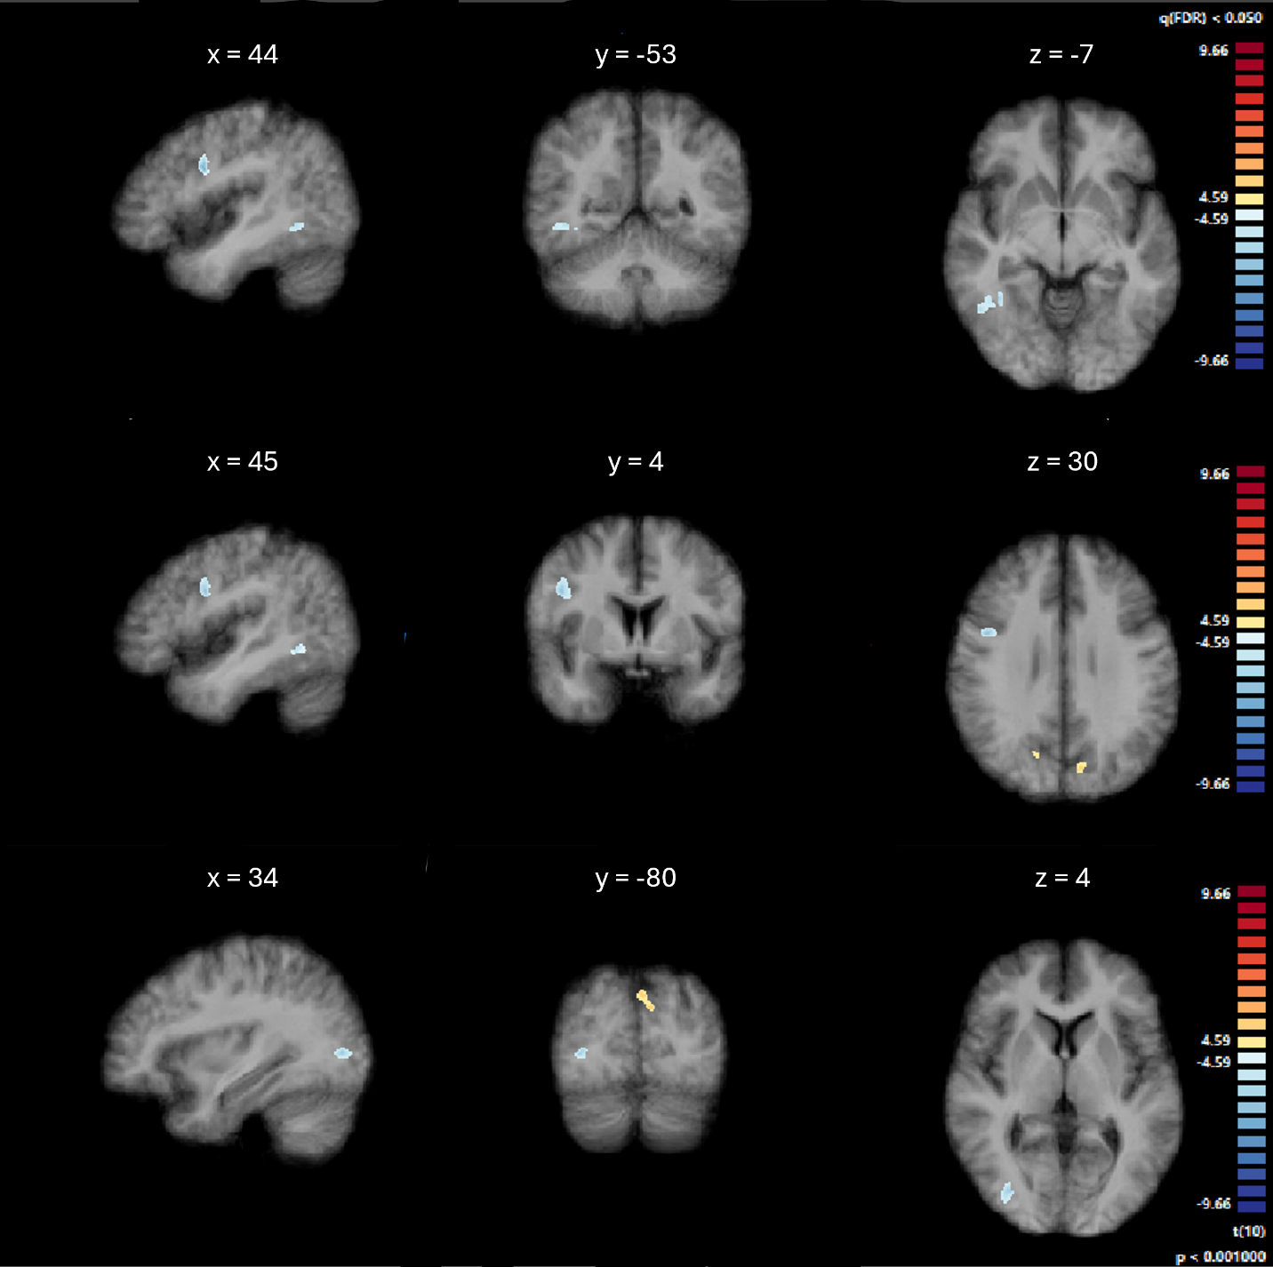Note. Activation maps are overlaid on an average anatomical image computed from all participants, thresholded using cluster-level correction (p < .001, uncorrected voxel-level threshold, k ≥ 39 voxels). Cool colors indicate significantly lower activation under Ayahuasca compared to placebo (negative t-values).

Supplementary Table 1.
Significant Clusters Showing Altered Stimulus-Related Activation Under Ayahuasca Compared to Placebo.
 | Peak MNI (x, y, z) | Size (k) |  | Peak region | Other overlapping regions | t (peak) | p (peak)
+7 -76 +38 |  | 1245 |  | Precuneus | L Cuneal | 7.487829 | 0.000021
-7 -64 +57 |  | 379 |  | Precuneus | - | 5.675908 | 0.000205
+ 38 -50 -6 |  | 420 |  | R TOFusC | R toITG | -7.286313 | 0.000026
 | +46 +4 +30 | 413 |  | R PrCG | - | -7.637352 | 0.000018
 | +33 -79 +5 | 314 |  | R iLOC | - | -7.737690 | 0.000016
Note. Cluster locations and labels are based on the Harvard-Oxford atlas. Size (k) refers to the number of voxels within the cluster. Peak regions are those with the highest t-value within the cluster; overlapping regions are other atlas-defined areas containing a substantial portion of cluster voxels.

Supplementary Table 2.
Pairwise contrasts of beta values in early visual cortex (V1-V3) during visual stimulation across drug conditions
Contrast | df | Mean Difference | SE | t | p
High-dose Ayahuasca vs. Placebo | 10 | -0.034 | 0.109 | -0.309 | 0.763
High-dose vs. Low-dose Ayahuasca | 10 | -0.105 | 0.080 | -1.309 | 0.220
Low-dose Ayahuasca vs. Placebo | 10 | 0.071 | 0.131 | 0.546 | 0.597
Note. Mean differences reflect the contrast in beta values between conditions in response to visual stimulation. SE = standard error.
Supplementary Table 3.
Significant clusters showing stimulus-related modulation of functional connectivity with the seed ROI (averaged across both drug conditions).
Peak MNI (x, y, z) | Size (k) | Peak region | Other overlapping regions | t | p-FDR
+30 –42 –10 | 510 | R TOFusC | R LG, L ICC, R ICC, L LG,  R pPaHC, R pTFusC | -9.57 | 0.000014
+34 –84 +30 | 152 | R sLOC | - | -8.68 | 0.000017
–32 –82 +16 | 89 | L sLOC | L iLOC | -7.07 | 0.000051
+24 –64 –36 | 79 | R Cerebellum Crus I | Cerebellum 6, Crus II, 8 | +8.12 | 0.000021
–32 –54 –16 | 76 | L TOFusC | L LG | -5.72 | 0.000194
+42 –74 +14 | 61 | R sLOC | R iLOC | -6.03 | 0.000153
Note. Cluster locations and labels are based on the Harvard-Oxford atlas. Size (k) refers to the number of voxels within the cluster. Peak regions are those with the highest t-value within the cluster; overlapping regions are other atlas-defined areas containing a substantial portion of cluster voxels.

Supplementary Table 4.
Significant cluster showing increased stimulus-related functional connectivity under Ayahuasca compared to placebo.
Peak MNI (x, y, z) | Size (k) | Peak region | Other overlapping regions | t | p-FDR
+16 –72 +28 | 94 | R Cuneal | Precuneus | +8.70 | 0.000006
Note. Cluster locations and labels are based on the Harvard-Oxford atlas. Size (k) refers to the number of voxels within the cluster. Peak regions are those with the highest T-value within the cluster; overlapping regions are other atlas-defined areas containing a substantial portion of cluster voxels.

