Supplementary Information for
Concealing messages at the atomic-thin level by reaching the limit of writing
Chao Hou^{1,3}, Qirong Yang^{1,3}, Jianxin Guan¹, Jingwen Deng¹, Zihan Xu², Zhihao Yu¹* & Junrong Zheng¹*
¹College of Chemistry and Molecular Engineering, Beijing National Laboratory for Molecular Sciences, Peking University, Beijing 100871, China.
²Shenzhen Sixcarbon Technology, Shenzhen 518106, China.
³These authors contributed equally: Chao Hou, Qirong Yang.
*e-mail: junrong@pku.edu.cn; zhengjunrong@gmail.com; zhihaoyu@pku.edu.cn

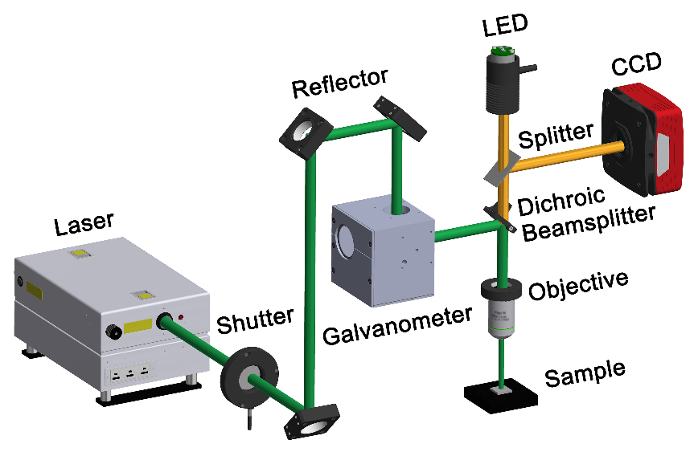

Supplementary Figure 1: A schematic for our home-built laser writing setup.
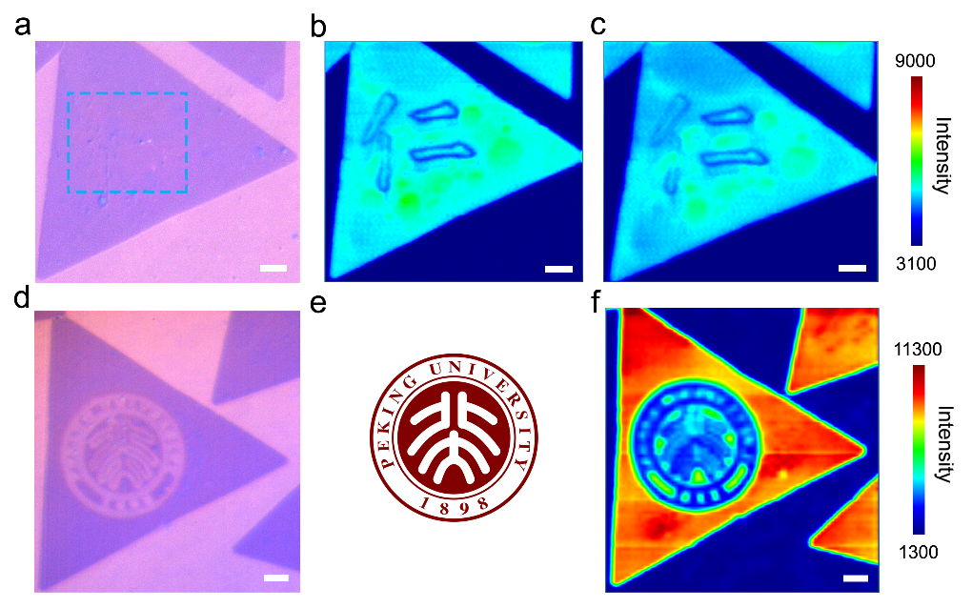
Supplementary Figure 2: The laser over-written examples on monolayer MoS₂. a, The optical image of a monolayer MoS₂ triangle domain after laser writing within the blue rectangle area using “仁” as a pattern, showing slight over-written traces. b&c, The PL mappings before and after erasing by adsorbing H₂O molecules, which indicates that the slight over-written pattern cannot be erased. d, Optical image of a monolayer MoS₂ triangle domain after significant laser over-writing using the badge of the Peking University shown in e as a pattern. f, The corresponding PL mapping for d, which cannot be erased, either. Scale bars are all 4 μm.

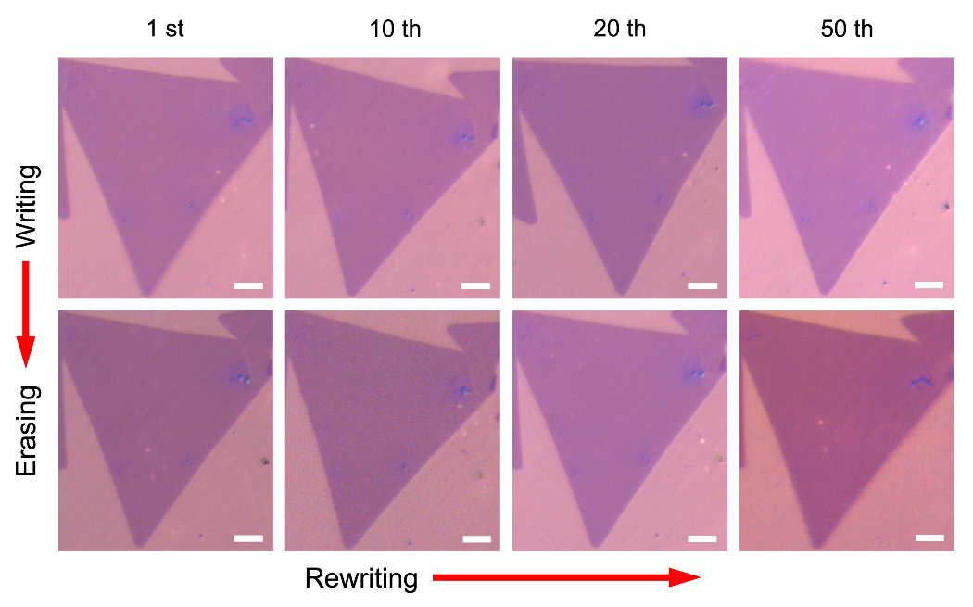
Supplementary Figure 3: Repeatable laser writing and erasing on MoS₂ monolayer. The optical images corresponding to Fig. 3 for the 1st, 10th, 20th, 50th laser writing and erasing cycle on the same monolayer MoS₂ triangle domain. Scale bars are all 4 μm.

