APPENDIX I
Scen1 generators and their characteristics
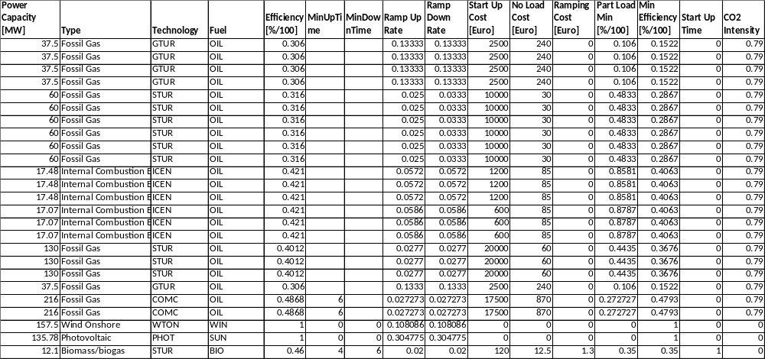

Scen2 generators and their characteristics
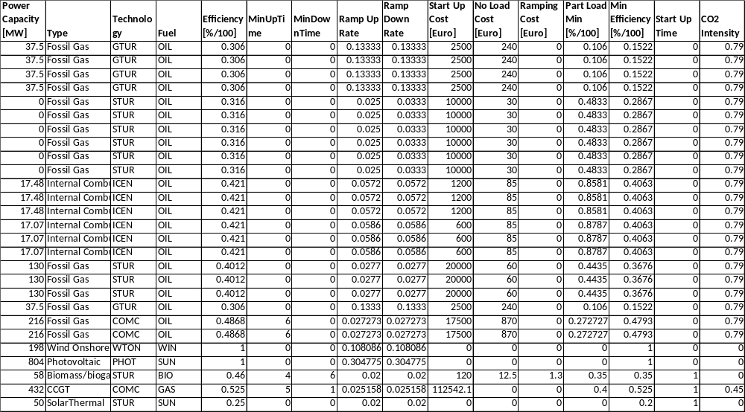

Scen2.1 generators and their characteristics
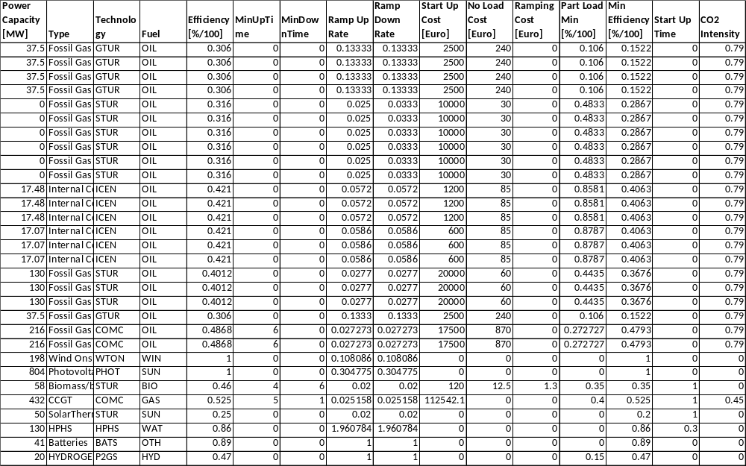
Scen2.2 generators and their characteristics
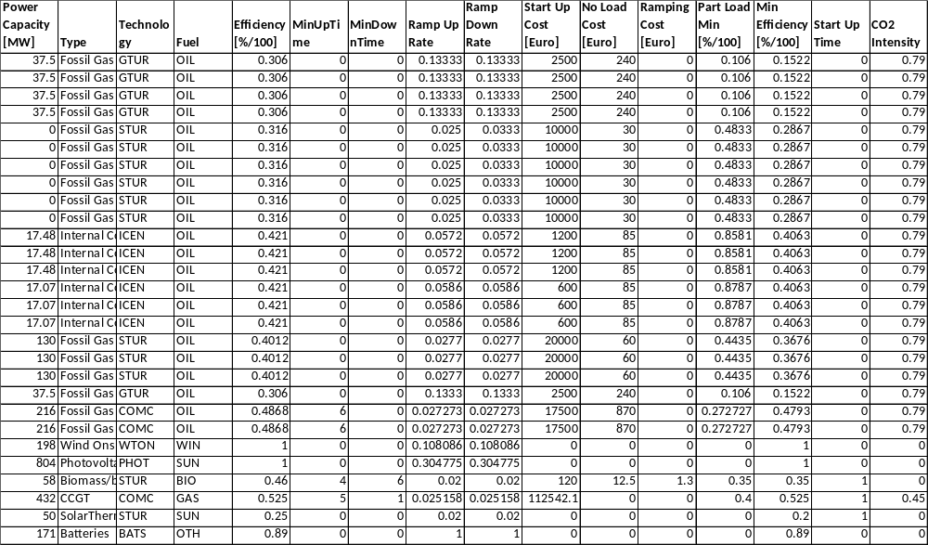

Scen2.3 generators and their characteristics
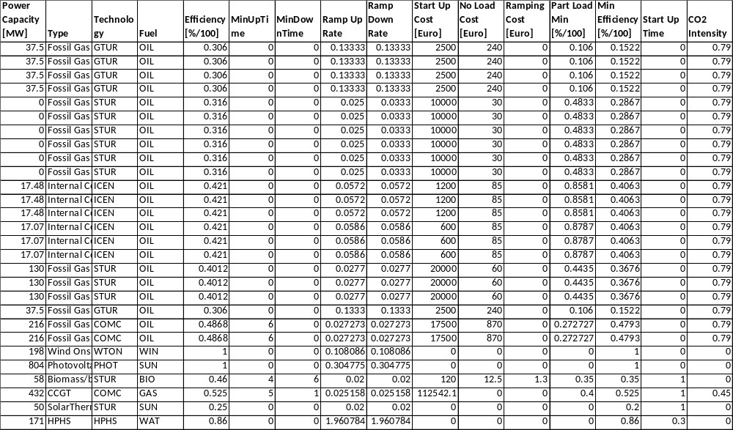

Scen2.4 generators and their characteristics
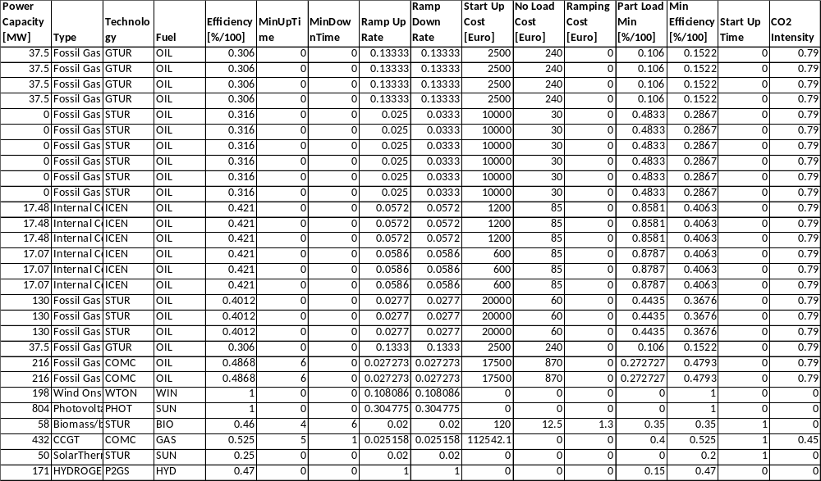
Scen3 generators and their characteristics
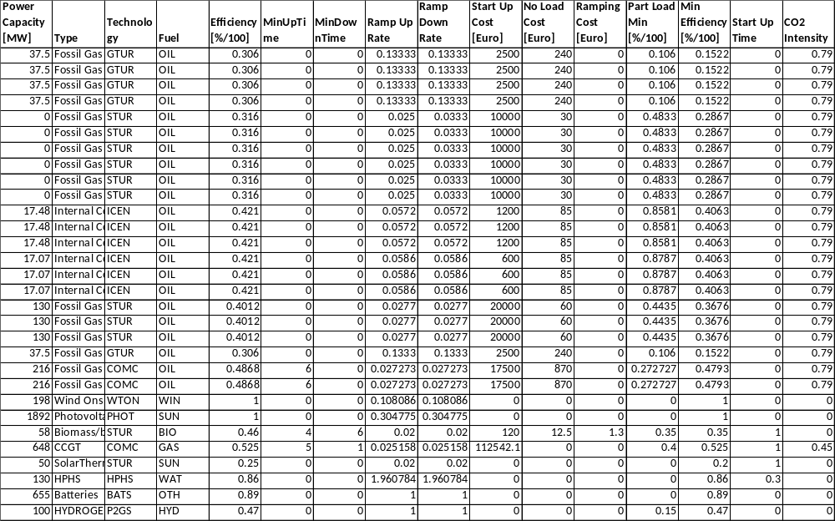

Scen3.1 generators and their characteristics
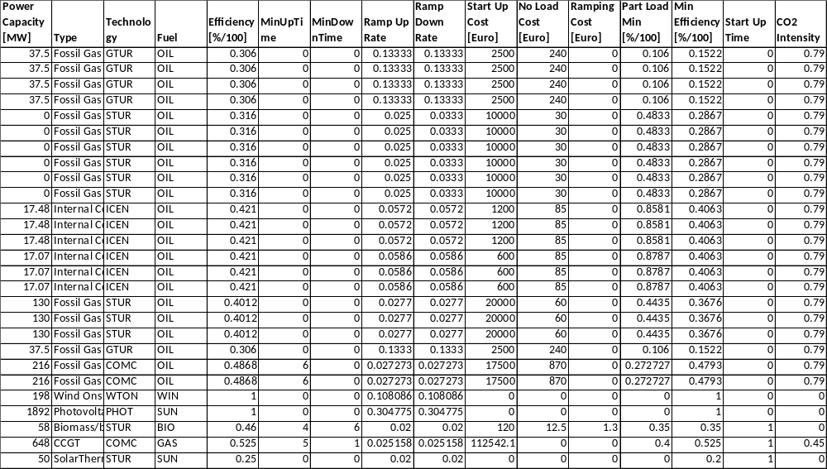

APPENDIX 2
Dispa-SET simulation results graphs – (selection)
SIMULATION SCENARIOS
Scen2.1
Scen3.

APPENDIX 3
Dispa-SET additional simulation results graphs
SIMULATION SCENARIOS
Scen2.1s2

