Supplementary Material

Plastic contamination of the Galapagos marine food web and the relative risks to native species

Jen S. Jones^{1,2}, Adam Porter¹, Juan Pablo Muñoz-Pérez^{3,4}, Daniela Alarcón-Ruales³, Tamara S. Galloway¹, Brendan J. Godley⁵, David Santillo⁶, Jessica Vagg⁵, Ceri Lewis^{1*}

¹ Biosciences, College of Life and Environmental Sciences, University of Exeter, Exeter, UK
² Galapagos Conservation Trust, London, UK
³ Universidad San Francisco de Quito (USFQ) & UNC-Chapel Hill Galápagos Science Center (GSC) Av. Alsacio Northia, Isla San Cristobal, Galápagos, Ecuador
⁴ School of Science and Engineering, University of the Sunshine Coast, QLD, Hervey Bay, Australia
⁵ Centre for Ecology & Conservation, University of Exeter, Penryn, UK
⁶ Greenpeace Research Laboratories, School of Biosciences, Innovation Centre Phase 2, University of Exeter, Exeter, United Kingdom

*Corresponding author: c.n.lewis@exeter.ac.uk

Supplementary Table 1: Summary results of best-fit negative binomial generalised linear models (GLMs) for environmental data. Explanatory variables explored included beach aspect (north/west, south, east), windward vs leeward orientation, site usage (tourism, remote), distance from port and grain size. Statistically significant explanatory variables are denoted with *. AIC - Akaike’s Information Criterion used in the step-wise ranking of models and OD = overdispersion as calculated for the model.

Response variable (particle counts) | Explanatory variables | Estimate | Standard Error | Z value | p value | AIC | OD
Macroplastic | Intercept  Aspect | -5.490  1.318 | 3.956  1.423 | -1.388  0.926 | 0.165  0.354 | 13.069 | 0.40
Large microplastic | Intercept  Usage  Aspect  Distance from port | -1.008  -0.702  1.778  0.032 | 0.942  0.558  0.301  0.014 | -1.070  -1.257  5.910  2.355 | 0.285  0.209  <0.001*  0.0185* | 465.5 | 0.97
Whole sand | Intercept  Usage  Distance from port  Aspect | 3.633  0.182  0.001  0.213 | 1.047  0.635  0.015  0.338 | 3.469  0.286  0.069  0.631 | <0.001  0.775  0.945  0.528 | 452.46 | 1.26
Seawater | Intercept  Distance from port | -1.019  -0.029 | 0.485  0.019 | -2.102  -1.533 | 0.036  0.125 | 40.92 | 0.62

Supplementary Table 2: Macroplastic item counts and categories used to complement OSPAR methods. Items were only categorised as sourced from beach visitors/ local litter if they were found on tourist beaches.

Rank | Macroplastic | Source | Common material | No | %
1 | Fragment > 0.5 mm | UNSOURCED | Polyethylene & Polypropylene | 2240 | 0.49
2 | Cap/Lid | UNSOURCED | Polypropylene | 921 | 0.20
3 | Ropes, Strings, Cords | FISHING/ SHIPPING | Polypropylene | 400 | 0.09
4 | Drinks Bottle | UNSOURCED | Poly(ethylene terephthalate) (PET) | 209 | 0.05
5 | Plastic Bag Fragment | UNSOURCED | Polyethylene | 175 | 0.04
6 | Bottle Ring | UNSOURCED | Polypropylene | 118 | 0.03
7 | Cutlery | BEACH/ LOCAL | Polypropylene | 77 | 0.02
8 | Film | UNSOURCED | Unidentified Plastic | 67 | 0.01
9 | Polystyrene Fragment >0.5mm | UNSOURCED | Polystyrene | 54 | 0.01
10 | Toothbrush | UNSOURCED | Unidentified Plastic | 45 | 0.01
11 | Eel Trap | FISHING/ SHIPPING | Unidentified Plastic | 42 | 0.01
12 | Straw | BEACH/ LOCAL | Polypropylene | 40 | 0.01
13 | Pen | UNSOURCED | Unidentified Plastic | 38 | 0.01
14.5 | Cup | BEACH/ LOCAL | Polypropylene | 32 | 0.01
14.5 | Food Container | BEACH/ LOCAL | Unidentified Plastic | 32 | 0.01
16 | Crisp/Sweet Packet and Lolly Sticks | BEACH/ LOCAL | Unidentified Plastic | 16 | 0.00
17 | Shoe | BEACH/ LOCAL | Unidentified Plastic | 14 | 0.00
18 | Balloon | BEACH/ LOCAL | Styrene Copolymer | 12 | 0.00
19 | Rubber O Ring | UNSOURCED | Synthetic Rubber | 10 | 0.00
20.5 | Cigarette Lighter | BEACH/ LOCAL | Unidentified Plastic | 8 | 0.00
20.5 | Comb/ Hairbrush | UNSOURCED | Unidentified Plastic | 8 | 0.00
22 | Rubber Glove | FISHING/ SHIPPING | Synthetic Rubber | 7 | 0.00
24 | Black Pipe | UNSOURCED | Unidentified Plastic | 6 | 0.00
24 | Floats and Buoys | FISHING/ SHIPPING | Polystyrene | 6 | 0.00
24 | Small Plastic Bags | BEACH/ LOCAL | Polyethylene | 6 | 0.00
26 | Cosmetics Bottle | FISHING/ SHIPPING | Unidentified Plastic | 5 | 0.00
27.5 | Miscellaneous | UNSOURCED | Unidentified Plastic | 4 | 0.00
27.5 | Plate | BEACH/ LOCAL | Unidentified Plastic | 4 | 0.00
31 | Battery Packet | BEACH/ LOCAL | Synthetic Rubber | 2 | 0.00
31 | Cigarette Butts | BEACH/ LOCAL | Cellulose Acetate | 2 | 0.00
31 | Plastic Tape | BEACH/ LOCAL | Unidentified Plastic | 2 | 0.00
31 | Styrofoam Container | BEACH/ LOCAL | Polystyrene | 2 | 0.00
31 | Tangled Nets/Cords/Strings | FISHING/ SHIPPING | Polypropylene | 2 | 0.00
34 | Battery | BEACH/ LOCAL | Unidentified Plastic | 1 | 0.00
35.5 | Clothes - Baseball Cap | BEACH/ LOCAL | Unidentified Plastic | 1 | 0.00
35.5 | Nets and Pieces of Net >0.5mm | UNSOURCED | Polypropylene | 1 | 0.00
35.5 | Toys | BEACH/ LOCAL | Unidentified Plastic | 1 | 0.00

Supplementary Figure 1: Polymer composition (A), colour composition (B) and shape (C) of particles extracted from environmental media and invertebrate specimens.

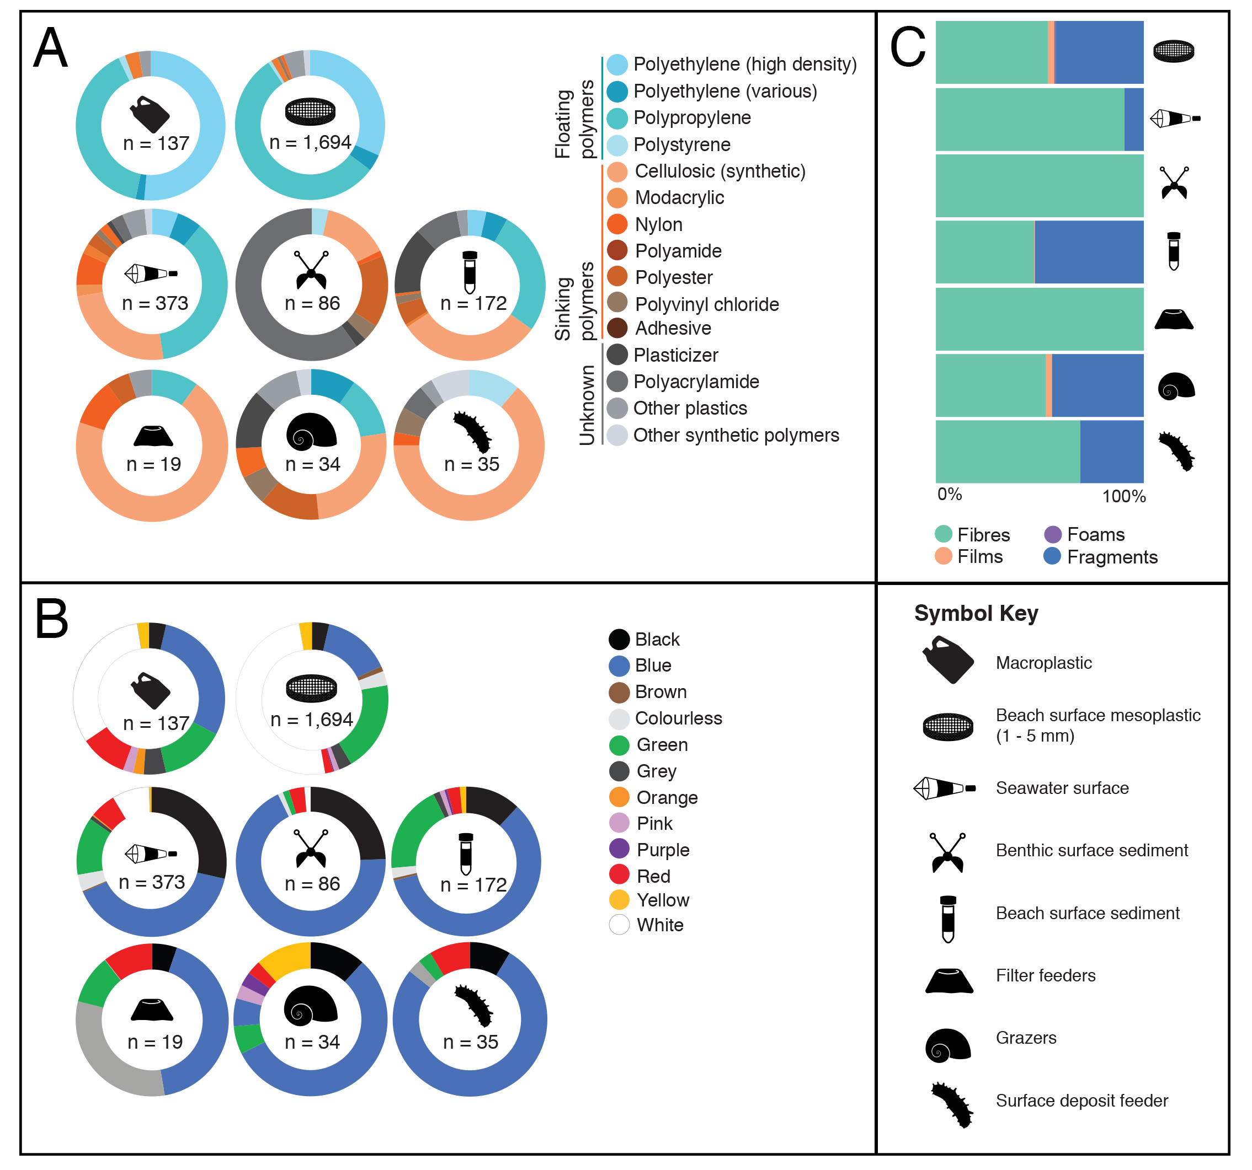

Supplementary Table 3: Summary of particles extracted from marine invertebrates in San Cristobal, Galapagos. Number of individual marine invertebrates sampled from sites with mean no. particles per individual for each site and the overall mean used for the species, size range of ingested particles (see also Supplementary Figure 2) and total number of synthetic particles identified.

Species | No. individuals | Mean no. particles per ind. | Size range (um) | Synthetic particle(s) identified
Goose Barnacle  Lapas anatifera | 7 from Punta Pitt | 0.71 | 367.1 – 2508.1 | 2
Giant Barnacle  Megabalanus peninsularis | 6 from Punta Pitt | 1.17 | 519.1 – 8348.3 | 3  0  7  3  4
Palmate Oyster  Saccostrea palmula | 5 from Loberia de Punta Pitt  7 from Puerto Grande | 0.14  1.20  0.67 overall mean | 733.5 – 1584.87  12572.44 (1 very long fibre) | 6  9
Snail  Nerita scabricosta | 11 from Montones  12 from Rosa Blanca | 0.36  0.92  0.64 overall mean | 250.7 – 1876.1  83.5 – 2016.6 | 4  11
Chiton  Chiton sulcatus | 4 from Loberia de Punta Pitt | 0.5 | 353.4 – 2003.4 | 2
Galapagos Pencil Urchin  Eucidaris thouarsii | 5 from Montones  5 from Punta Pitt (C)  5 from Punta Pitt (D)  5 from Carola  5 from Rosa Blanca | 0.6  1.4  0.6  0  0.8  0.68 overall mean | 166.4 – 2739.3  106.5 – 2121.8  109.5 – 1015.9  0  1252.6 – 3270.9 | 3  8  3  0  4
Sea Cucumber  Holothuria kefersteini | 6 from Montones  5 from PPC  5 from PPD  11 from Rosa Blanca | 0.4  0.2  0.8  2.55  0.99 overall mean | 165.5 – 952  828.7 (1 particle)  346.2 – 2243.3  167.7 – 3213.2 | 2  1  4  28

Supplementary Figure 2: Sizes ($μ$m) of particles extracted from marine invertebrates in San Cristobal, Galapagos by particle shape and species: (i) goose barnacles (Lepas anatifera), (ii) giant barnacles (Megabalanus peninsularis), (iii) palmate oysters (Saccostrea palmula), (iv) rough-ribbed nerite snails (Nerita scabricosta), (v) sculptured chiton (Chiton sulcatus), (vi) slate pencil urchins (Eucidaris galapagensis), (vii) sea cucumber (Holothuria kefersteini).

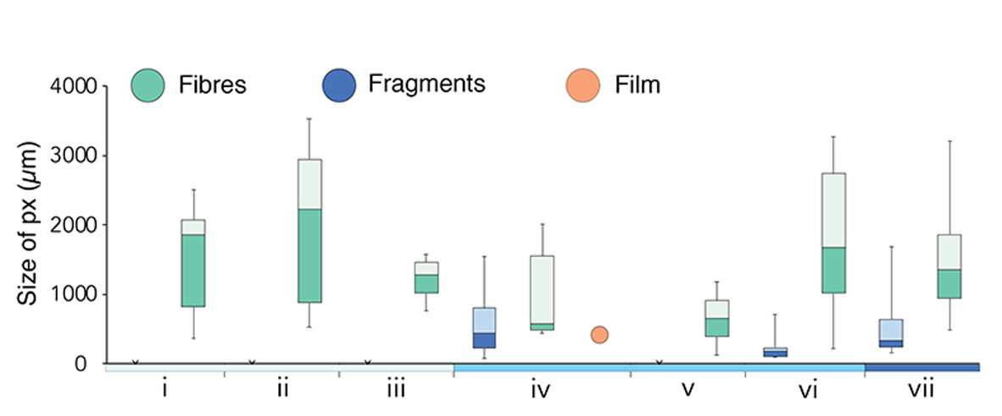

Supplementary Figure 3: Synthetic particles extracted from marine invertebrates in San Cristobal, Galapagos per gram of dry weight tissue across species: (i) goose barnacles (Lepas anatifera), (ii) giant barnacles (Megabalanus peninsularis), (iii) palmate oysters (Saccostrea palmula), (iv) rough-ribbed nerite snails (Nerita scabricosta), (v) sculptured chiton (Chiton sulcatus), (vi) slate pencil urchins (Eucidaris galapagensis), (vii) sea cucumber (Holothuria kefersteini).

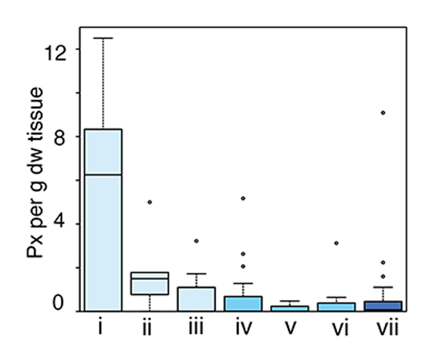

Supplementary Table 4: Summary results of negative binomial generalised linear model (GLM) for microplastics ingested by marine invertebrates collected from San Cristobal, Galapagos, Ecuador. Explanatory variables (out of Species, Feeding Mode, Grain Size, Distance from Port, Site Usage) included for the best fit model. AIC - Akaike’s Information Criterion used in the step-wise ranking of models and OD = overdispersion as calculated for the model.

Count data | Explanatory variables | Estimate | Std Error | Z value | p value | AIC | OD
Particles contained per individual | Intercept  Feeding mode  Aspect | -1.423  0.456  0.261 | 0.607  0.276  0.187 | -2.344  1.654  1.399 | 0.019  0.098  0.162 | 267.33 | 1.08

Supplementary Table 5. Scoring criteria for the species distribution, IUCN Red List status, entanglement literature and ingestion literature categories.
Score | 0 | 1 | 2 | 3
Species Distribution | Invasive | Migratory  Unknown | Native | Endemic
IUCN Red List Status |  | Data Deficient | Near Threatened | Endangered
 |  | Not Evaluated | Vulnerable | Critically Endangered
 |  | Least Concern
Entanglement Literature |  | No Evidence | Moderate | Major
Ingestion Literature |  | No Evidence | Moderate | Major

Supplementary Table 6. Table of the 32 Galapagos marine species scoring >10 points in the plastic pollution risk scoring exercise, scored indicated by E (entanglement) and I (ingestion). Endemism status was determined using the Charles Darwin Foundation DataZone (https://www.darwinfoundation.org/en/datazone) and conservation status and unreferenced population estimates were retrieved from the IUCN Red List (https://www.iucnredlist.org/, retrieved 09/01/2020).

Top Scoring Species | Species Distribution | Conservation Status | Example Evidence from the Literature
Galapagos sea lion  Zalophus wollebaeki  E = 27  I = 18 | Endemic to Galapagos in terms of established breeding population, large colony resident in harbour of Puerto Baquerizo, San Cristobal. | Endangered  Population estimate  9,200 – 10,600 | Entanglement  251 Galapagos sea lions reported entangled in plastic fishing gear between 1995-2003¹. Multiple studies into entanglement interactions with closely related species Californian sea lion (Zalophus californianus) and Steller sea lion (Eumetopias jubatus) from 1976 – 2005^{2,3}.  Ingestion  194 Steller sea lions recorded ingesting longline fishing gear in (85% juveniles) between 2000 and 2007⁴.
Galapagos fur seal  Arctocephalus galapagoensis  E = 27  I = 18 | Endemic to Galapagos, generally restricted to remote areas in the western and central islands. | Endangered  Population estimate  10,000 | Entanglement  Multiple studies into entanglement interactions with closely related species the northern fur seal (Callorhinus ursinus) and Antarctic fur seal (Arctocephalus gazella) 1980 – 2015 mostly with fishing litter such as monofilament netting and lines^{5,6}.  Ingestion  7% Arctocephalus australis (n = 133) had ingested large fragments of plastic bags and fishing gear⁷.
Waved albatross  Phoebastria irrorata  E = 18  I = 27 | Endemic to Ecuador in terms of breeding population (forages in the Eastern Pacific outside of the Galapagos Marine Reserve boundary). Nesting colonies on Española island. | Critically Endangered  Population estimate >34,694 in 2001 (Anderson et al., 2002) | Entanglement  A 2018 review of bird entanglement in plastic and other synthetic materials reports records for 12 out of 21 albatross species⁸.  Ingestion  3 out of 40 dead waved albatross chicks contained suspected plastics in a 2007 survey in Galapagos⁹. During necropsies of 45 black-browed albatrosses (Thalassarche melanophris) and 26 Atlantic yellow-nosed albatrosses (Thalassarche chlororhynchos), 90% of birds sampled had ingested anthropogenic items and plastic represented 85% of debris found in birds’ stomachs¹⁰.
Galapagos petrel  Pterodroma phaeopygia  E = 18  I = 18 | Endemic to Ecuador in terms of breeding population (forages in the Eastern Pacific). Breeding colonies in Floreana, San Cristobal and Santa Cruz islands in Galapagos. | Critically Endangered  Population estimate 6,000 – 15,000 | Entanglement  23% giant petrels (Macronectes giganteus) (7 individuals) over two seasons recorded as entangled in net/ rope – presumed to be debris as opposed to interactions with long-line gear in use¹¹.  Ingestion  Non-lethal sampling (emetic) of Leach’s storm petrels (Oceanodroma leucorhoa) yielded > 50% sample size had ingested plastic and were witnessed giving plastic to offspring¹². A study of southern giant petrels reported as much plastic as cephalopods and fish in the stomachs of birds¹³.
Galapagos penguin  Spheniscus mendiculus  E = 18  I = 18 | Endemic to Galapagos, primary colonies in the western Archipelago but occasional sightings in the central islands and islets. | Endangered  Population estimate  1,200 | Entanglement  Entanglement records for 7 spheniscid penguin species globally, primarily with fishing litter⁸.  Ingestion  A related species, Magellanic penguins (Spheniscus magellanicus), in Brazil were found to have obtained serious injury or death from plastic. Out of 175 birds, 26 had ingested plastic debris, which could have led to death¹⁴.
Flightless cormorant  Phalacrocorax harrisi  E = 18  I = 12 | Endemic to Galapagos, restricted to Isabela and Fernandina islands in the western Archipelago. | Vulnerable  Population estimate 2,080 individuals in 2013 (Jiménez-Uzcátegui, 2013) | Entanglement  47 cases of entanglement of Brandt’s cormorant (Phalacrocorax penicillatus) have been reported by citizen scientists in California 1997 – 2017 mostly in discarded fishing line¹⁵.  Ingestion  Pied cormorant (Phalacrocorax varius) 5 out of 22 birds had ingested plastic including fishing gear¹⁶.
Lava gull  Leucophaeus fuliginosus  E = 12  I = 12 | Endemic to Galapagos, frequently sighted on beaches at study sites in San Cristobal. | Vulnerable  Population estimate  600 - 800 | Entanglement  Study in California on a variety of gull and pelican species, noted frequent fishing net related injuries to all species with higher frequency in the summer months (Dau et al., 2009). 22 freshly dead kelp gulls ﻿Larus dominicanus were reported on a 9-day survey of 6km beach in Argentina due to entanglement in monofilament fishing line¹⁷.  Ingestion  Ingestion of fishing hooks and associated plastic debris (primarily monofilament lines) from recreational fisheries was commonly reported in Korea in black tailed gulls (Larus ridibundus) - ingestion of the hooks was also linked to entanglement in the trailing line sometimes completely preventing movement and resulting in death¹⁸.
Green sea turtle  Chelonia mydas (previously known as Chelonia agassizzii)  E = 18  I = 18 | Native, >40% of Eastern Pacific population in Galapagos with important turtle nesting beaches on several islands (Seminoff, 2007). | Endangered  Population unknown | Entanglement  Global evidence for frequent green turtle entanglement in plastic debris and of mortality in ghost fishing nets as a result of illegal fishing practices as reviewed by Duncan et al.¹⁹.  Ingestion  Multiple studies evidence plastic debris affecting gut function and feeding behaviour, leading to death. A quantitative analysis linked a 50% probability of mortality with sea turtles that ingested >14 pieces of plastic²⁰. Common items found in stomachs include plastic bags, plastic ropes and hard plastic pieces.
Hawksbill turtle  Eretmochelys imbricate  E = 18  I = 18 | Native but uncommon in Galapagos. | Endangered  Population unknown | See Green sea turtle
Leatherback turtle  Dermochelys coriacea  Olive Ridley turtle  Lepidochelys olivacea | Migratory, uncommon in Galapagos |  | See Green sea turtle
Marine iguana  Amblyrhynchus cristatus  E = 12  I = 12 | Endemic to Galapagos, possibly up to 11 sub-species (Miralles et al., 2015). | Vulnerable  Population unknown due to taxonomic uncertainty | No family level evidence, using green sea turtle evidence as a proxy due to algae diet and use of similar nesting sites.
Whale shark  Rhincodon typus  E = 18  I = 18 | Migratory, most sightings July – October | Endangered  Population unknown | Entanglement  Whale shark entanglements were the most frequently reported on Twitter in a study primarily in fishing gear²¹.  Ingestion  Plastic debris including packing straps, food wrappers, a disposable cup and a cigarette butt recovered from gills and gut of stranded whale shark in the Philippines²².
Scalloped  hammerhead  shark  Sphyrna lewini  E = 18  I = 18 | Migratory, nursery grounds confirmed around San Cristobal Island | Critically Endangered  Population unknown | Entanglement  Hammerhead entanglement in fishing gear was reported frequently on Twitter²¹.  Ingestion  Most likely to be exposed via trophic transfer but no evidence found.
Open water sharks considered to have similar risks to scalloped hammerhead: tiger (Galeocerdo cuvier), blue (Prionace glauca), great hammerhead (Sphyrna mokarran), pelagic thresher (Alopias pelagicus), blacktip (Carcharhinus limbatus), whitetip (Triaenodon obesus), oceanic whitetip (Carcharhinus longimanus), grey reef (Carcharhinus amblyrhynchos), sandbar (Carcharhinus plumbeus), silky (Carcharhinus falciformis), shortfin mako (Isurus oxyrinchus).
Salema spp.  Xenichthys agassizi & Xenocys jessiae  E = 12  I = 6 | Endemic to Galapagos |  | Entanglement  Entanglement in plastic debris reported in tropical reef fish is predicted to cause movement restrictions and affect feeding and predator avoidance behaviours²³.  Ingestion  N/A
Wellington’s solitary coral  Rhizopsammia wellingtoni  E = 27  I = 18 | Endemic to Galapagos but extremely rare. | Critically Endangered  Possibly extinct as not reported in over 20 years | Entanglement  Corals trapped under discarded fishing gear showed tissue damage in a study in Thailand²⁴. Likelihood of disease increased from 4% to 89% when corals are in contact with plastic in a study in the Asia-Pacific region²⁵.  Ingestion  Lab experiments demonstrate integration of plastic particles in mesenterial tissue²⁶.
Sun cup coral  Tubastraea floreana  E = 27  I = 18 | Endemic to Galapagos but extremely limited range – only reported in Gardner islet, near Floreana since 2014 | Critically Endangered | See Wellington’s solitary coral
Stony coral spp.  Polycyathus isabela  E = 18  I = 12 | Endemic to Galapagos | Vulnerable | See Wellington’s solitary coral
Stony corals considered to have similar risks to P. isabela: Rhizopsammia verrilli and Porites lobata

References for Supplementary Materials

1. Alava, J. J. & Salazar, S. Status and conservation of otariids in Ecuador and the Galápagos Islands. 495–519 (2006) doi:10.4027/slw.2006.31.
2. Moore, E. et al. Entanglements of marine mammals and seabirds in central California and the north-west coast of the United States 2001-2005. Mar. Pollut. Bull. 58, 1045–1051 (2009).
3. Hanni, K. D. & Pyle, P. Entanglement of pinnipeds in synthetic materials at South-east Farallon Island, California, 1976-1998. Mar. Pollut. Bull. 40, 1076–1081 (2000).
4. Raum-Suryan, K. L., Jemison, L. A. & Pitcher, K. W. Entanglement of Steller sea lions (Eumetopias jubatus) in marine debris: Identifying causes and finding solutions. Mar. Pollut. Bull. 58, 1487–1495 (2009).
5. McIntosh, R. R., Kirkwood, R., Sutherland, D. R. & Dann, P. Drivers and annual estimates of marine wildlife entanglement rates: A long-term case study with Australian fur seals. Mar. Pollut. Bull. 101, 716–725 (2015).
6. Lawson, T. J., Wilcox, C., Johns, K., Dann, P. & Hardesty, B. D. Characteristics of marine debris that entangle Australian fur seals (Arctocephalus pusillus doriferus) in southern Australia. Mar. Pollut. Bull. 98, 354–357 (2015).
7. Denuncio, P. et al. Marine debris ingestion by the South American Fur Seal from the Southwest Atlantic Ocean. Mar. Pollut. Bull. 122, 420–425 (2017).
8. Ryan, P. G. Entanglement of birds in plastics and other synthetic materials. Mar. Pollut. Bull. 135, 159–164 (2018).
9. Anderson, D. J. et al. Population status of the critically endangered waved albatross Phoebastria irrorata, 1999 to 2007. Endanger. Species Res. 5, 185–192 (2008).
10. Colabuono, F. I. & Vooren, C. M. Diet of Black-browed Thalassarche melanophrys and Atlantic Yellow-nosed T. chlororhynchos Albatrosses and White-chinned Procellaria aequinoctialis and Spectacled P. conspicillata Petrels off southern Brazil. Mar. Ornithol. 35, 9–20 (2007).
11. Phillips, R. A. et al. Ingestion of fishing gear and entanglements of seabirds: Monitoring and implications for management. Biol. Conserv. 143, 501–512 (2010).
12. Bond, A. L. & Lavers, J. L. Effectiveness of emetics to study plastic ingestion by Leach’s Storm-petrels (Oceanodroma leucorhoa). Mar. Pollut. Bull. 70, 171–175 (2013).
13. Petry, M. V., de Souza Petersen, E., de Fátima Martins Scherer, J., Krüger, L. & Scherer, L. A. Notas sobre a ocorrência e dieta de macronectes giganteus (procellariiformes:Procellariidae) no Rio Grande do Sul, Brasil. Rev. Bras. Ornitol. 18, 237–239 (2010).
14. Brandão, M. L., Braga, K. M. & Luque, J. L. Marine debris ingestion by Magellanic penguins, Spheniscus magellanicus (Aves: Sphenisciformes), from the Brazilian coastal zone. Mar. Pollut. Bull. 62, 2246–2249 (2011).
15. Donnelly-Greenan, E. L., Nevins, H. M. & Harvey, J. T. Entangled seabird and marine mammal reports from citizen science surveys from coastal California (1997–2017). Mar. Pollut. Bull. 149, 110557 (2019).
16. Roman, L., Schuyler, Q. A., Hardesty, B. D. & Townsend, K. A. Anthropogenic Debris Ingestion by Avifauna in Eastern Australia.(Research Article)(Report). PLoS One 11, 1–10 (2016).
17. Yorio, P., Marinao, C. & Suárez, N. Kelp Gulls (Larus dominicanus) killed and injured by discarded monofilament lines at a marine recreational fishery in northern Patagonia. Mar. Pollut. Bull. 85, 186–189 (2014).
18. Hong, S. et al. Impacts of marine debris on wild animals in the coastal area of Korea. Mar. Pollut. Bull. 66, 117–124 (2013).
19. Duncan, E. M. et al. A global review of marine turtle entanglement in anthropogenic debris: A baseline for further action. Endanger. Species Res. 34, 431–448 (2017).
20. Wilcox, C., Puckridge, M., Schuyler, Q. A., Townsend, K. & Hardesty, B. D. A quantitative analysis linking sea turtle mortality and plastic debris ingestion. Sci. Rep. 1–11 (2018) doi:10.1038/s41598-018-30038-z.
21. Parton, K. J., Galloway, T. S. & Godley, B. J. Global review of shark and ray entanglement in anthropogenic marine debris. Endanger. Species Res. 39, 173–190 (2019).
22. Abreo, N. A. S., Blatchley, D. & Superio, M. D. Stranded whale shark (Rhincodon typus) reveals vulnerability of filter-feeding elasmobranchs to marine litter in the Philippines. Mar. Pollut. Bull. 141, 79–83 (2019).
23. Nunes, J. A. C. C., Sampaio, C. L. S., Barros, F. & Leduc, A. O. H. C. Plastic debris collars: An underreported stressor in tropical reef fishes. Mar. Pollut. Bull. 129, 802–805 (2018).
24. Valderrama Ballesteros, L., Matthews, J. L. & Hoeksema, B. W. Pollution and coral damage caused by derelict fishing gear on coral reefs around Koh Tao, Gulf of Thailand. Mar. Pollut. Bull. 135, 1107–1116 (2018).
25. Lamb, J. B. et al. Plastic waste associated with disease on coral reefs. Science (80-. ). 359, 460–462 (2018).
26. Hall, N. M., Berry, K. L. E., Rintoul, L. & Hoogenboom, M. O. Microplastic ingestion by scleractinian corals. Mar. Biol. 162, 725–732 (2015).

