Supplementary Information
A Visual Metric for Biological Membrane Instability: Geometric Coupling of Lateral Expansion and Acyl Chain Splay as a Geometric Precursor Signature of Packing Defects in Glutamate Transporter Splice Variant Self-assemblies
Alper Karagöl and Taner Karagöl
This document contains seven supplementary figures and three supplementary tables. All analyses were performed with the pipeline described in the Methods (revision 5 of the analysis code), applied to four glutamate transporter assemblies in POPC bilayers: the canonical EAA1 homodimer, two canonical heterodimers (EAA2/A0A2R8Y642 and EAA1/E7EUV6), and the truncated H0Y7R2 homodimer. No protein-free bilayer was simulated; the reference population is the pooled set of lipids lying more than 16 Å from any protein atom, as stated in the Methods and discussed under Limitations in the main text. Each 50 ns production run was written at 0.5 ns spacing (101 frames); the first 20 ns were treated as equilibration, because the box cross-section and the area per lipid were still relaxing (Figure S2), and the remaining 30 ns (61 frames) were analysed, giving 266,875 lipid-frames for the four assemblies. Unless stated otherwise, panels within a figure share a single colour scale and, where time is plotted, a single time axis in ns, so that systems of different box size remain directly comparable. Defect thresholds are the 95th percentiles of the pooled bulk (> 16 Å) lipid population (89.8 Å² and 75.2°).
Figure S1. Segment-resolved order parameters of both acyl chains against experiment
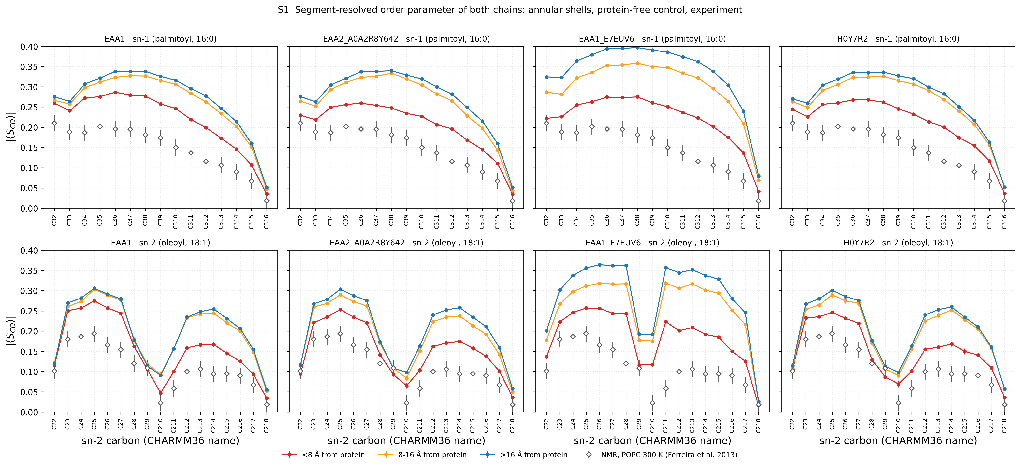
Figure S1. Deuterium order parameter |⟨S_CD⟩| resolved by carbon for the sn-1 (palmitoyl, top row) and sn-2 (oleoyl, bottom row) chains, one column per assembly. In every panel the lipids of that assembly are resolved by their minimum distance to the protein (< 8 Å, 8–16 Å, > 16 Å) and the experimental ¹H–¹³C R-PDLF solid-state NMR values for pure POPC at 300 K of Ferreira et al. [31] are shown as open diamonds with the ± 0.02 uncertainty quoted by the NMRlipids databank, from which the digitised values were taken (doi:10.1039/c2cp42738a, data set 1). Simulated values are computed directly on the C–H bond vectors, which the all-atom trajectories make available and which is the quantity measured by NMR; the signed order parameter is averaged over the hydrogens of each carbon, then over the lipids of the shell in each frame, then over frames, and the modulus is taken last. Error bars are block standard errors of the per-frame shell means. At the sn-2 C22 position the two hydrogens are inequivalent in experiment (|S_CH| = 0.080 and 0.123); their mean is plotted because the simulated value is likewise averaged over both hydrogens. Every profile reproduces the expected features of its chain: for the oleoyl chain a plateau over C23–C27, a pronounced minimum at C29 and C210 corresponding to the C9=C10 double bond, a partial recovery over C212–C214 and a decay to the terminal methyl; for the palmitoyl chain a plateau over C33–C37 followed by a monotonic decay. The sn-2 plateau of the bulk (> 16 Å) lipids is 0.282–0.344 across the four assemblies against 0.176 in experiment, so the simulated values lie +0.11 to +0.17 above experiment; the sn-1 values are 0.311–0.371 against 0.193. The offset is present along both chains in all four systems and is largest for the lipids farthest from the protein; it is a property of the simulation protocol common to the four systems and is discussed under Limitations in the main text, where it is stated that absolute order parameters are not compared with experiment. The difference between the < 8 Å and > 16 Å curves of each assembly is the annular perturbation of chain order: the sn-2 plateau of the first shell is 0.257, 0.233, 0.245 and 0.233 for EAA1, EAA2/A0A2R8Y642, EAA1/E7EUV6 and H0Y7R2, lower than the bulk value in all four assemblies, by 0.03 to 0.10, with the 8–16 Å shell in between; the sn-1 chain behaves the same way (lower than the bulk value in all four assemblies, by 0.04 to 0.11).
Figure S2. Convergence diagnostics
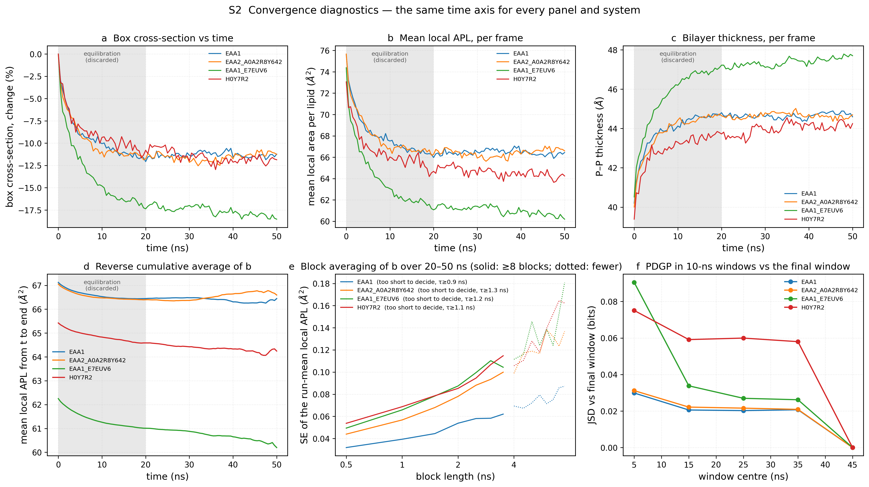
Figure S2. Six convergence diagnostics for every system on the same time axis (ns); the shaded interval is the equilibration excluded from every statistic. (a) Box cross-sectional area as the percentage change from the first frame. (b) Mean local area per lipid of each frame. (c) Phosphorus–phosphorus bilayer thickness of each frame. (d) Reverse cumulative average of panel b, that is the average of all frames from time t to the end of the run; a plateau from the right marks the equilibrated portion. (e) Block averaging of the per-frame series of panel b over the analysis window, following Flyvbjerg and Petersen [33]: the series is divided into blocks of every length with at least four blocks, and the standard error of the run-mean local area per lipid is computed from the block means; solid lines cover block lengths with at least eight blocks, which are used for the estimate, dotted lines the noisier remainder. The standard error rises with block length while the blocks are shorter than the correlation time of the series and levels off once they are longer; the legend states for each system whether a plateau was found, whether the curve was still rising at the largest usable block, or whether the window is too short to decide, together with the correlation time (a lower bound unless a plateau was found). The plateau value, or otherwise the largest standard error, is the uncertainty reported in Table 1. (f) Jensen–Shannon divergence between the PDGP of each consecutive 10 ns window and the PDGP of the final 10 ns window (0 = identical), which tests convergence of the defect population specifically rather than of the bulk. Over the 30 ns window the block standard error of the mean local area was still rising at the largest usable block length (4 ns) for all four assemblies, so the series are too short to establish a plateau; the correlation times are 0.9–1.3 ns (lower bounds wherever no plateau was found), and the confidence intervals of Table 1 are read accordingly in the main text.
Figure S3. Coupling between the phosphodiester torsion and the P–N tilt
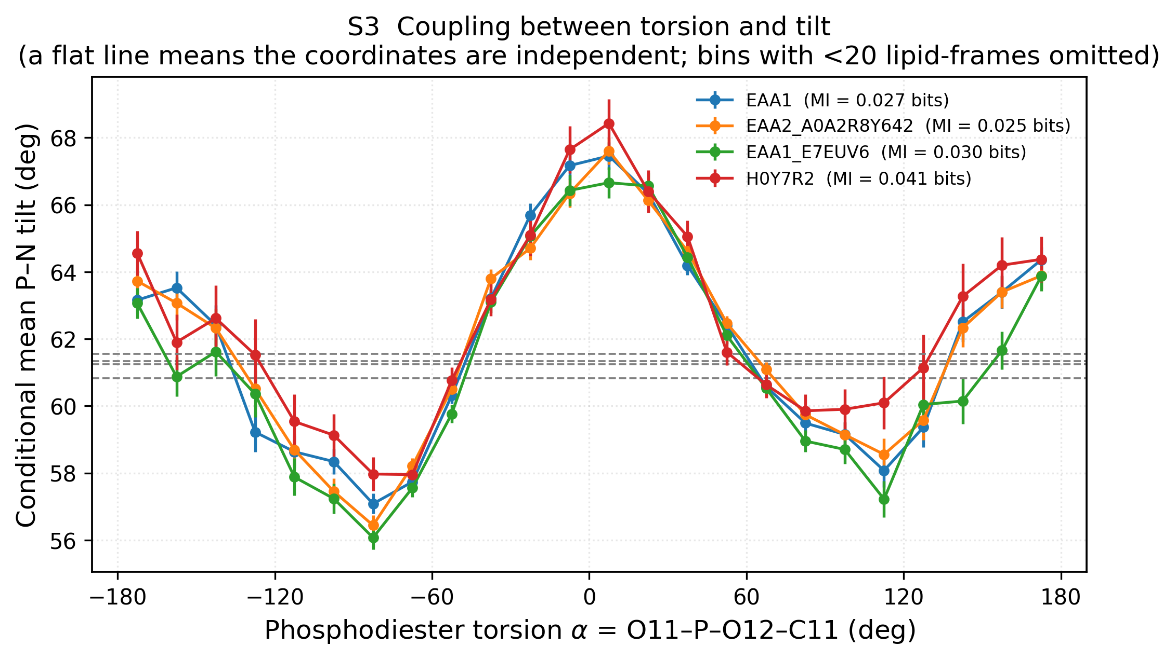
Figure S3. Conditional mean P–N tilt angle as a function of the phosphodiester torsion α = O11–P–O12–C11, in 15° bins over the full circle, with standard errors, for the four assemblies. Bins holding fewer than 20 lipid-frames are omitted. Dashed horizontal lines mark the unconditional mean tilt of each system. A flat line indicates that the two coordinates are independent. Mutual information between the two coordinates is given in the legend: 0.025–0.041 bits across the four assemblies, which is negligible. The Tilt-Torsion map is therefore a joint conformational landscape rather than a correlation.
Figure S4. Solvent-exposure validation of the defect assignment
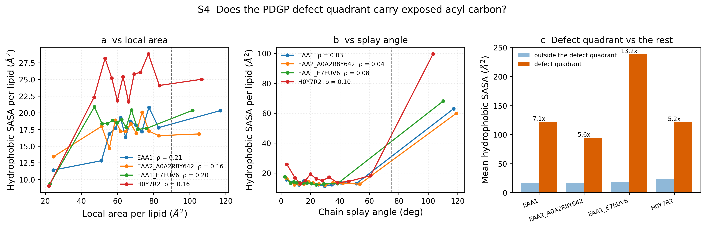
Figure S4. Test of whether the PDGP defect quadrant contains lipids with elevated hydrophobic exposure, for the four assemblies. Per-lipid solvent-accessible surface area of the aliphatic carbons was computed with a 1.4 Å probe and 256 sphere points per atom on every tenth analysed frame. (a) Mean hydrophobic SASA against local area per lipid, binned by decile, with the Spearman rank correlation for each system in the legend. (b) The same against chain splay angle. Dashed vertical lines mark the defect-state thresholds. (c) Mean hydrophobic SASA of lipids inside the defect quadrant compared with the remaining lipids, with the fold enrichment annotated. Rank correlations with the individual coordinates are weak (0.16–0.21 with local area, 0.03–0.10 with splay) because exposure is nearly flat across most of the range and rises steeply only beyond roughly 50° of splay. The behaviour is one of a threshold rather than of proportionality: at that threshold, lipids in the defect quadrant carry 5.2–13.2 times the hydrophobic surface area of the remaining lipids in the four assemblies.
Figure S5. Grid-based defect analysis against the PDGP
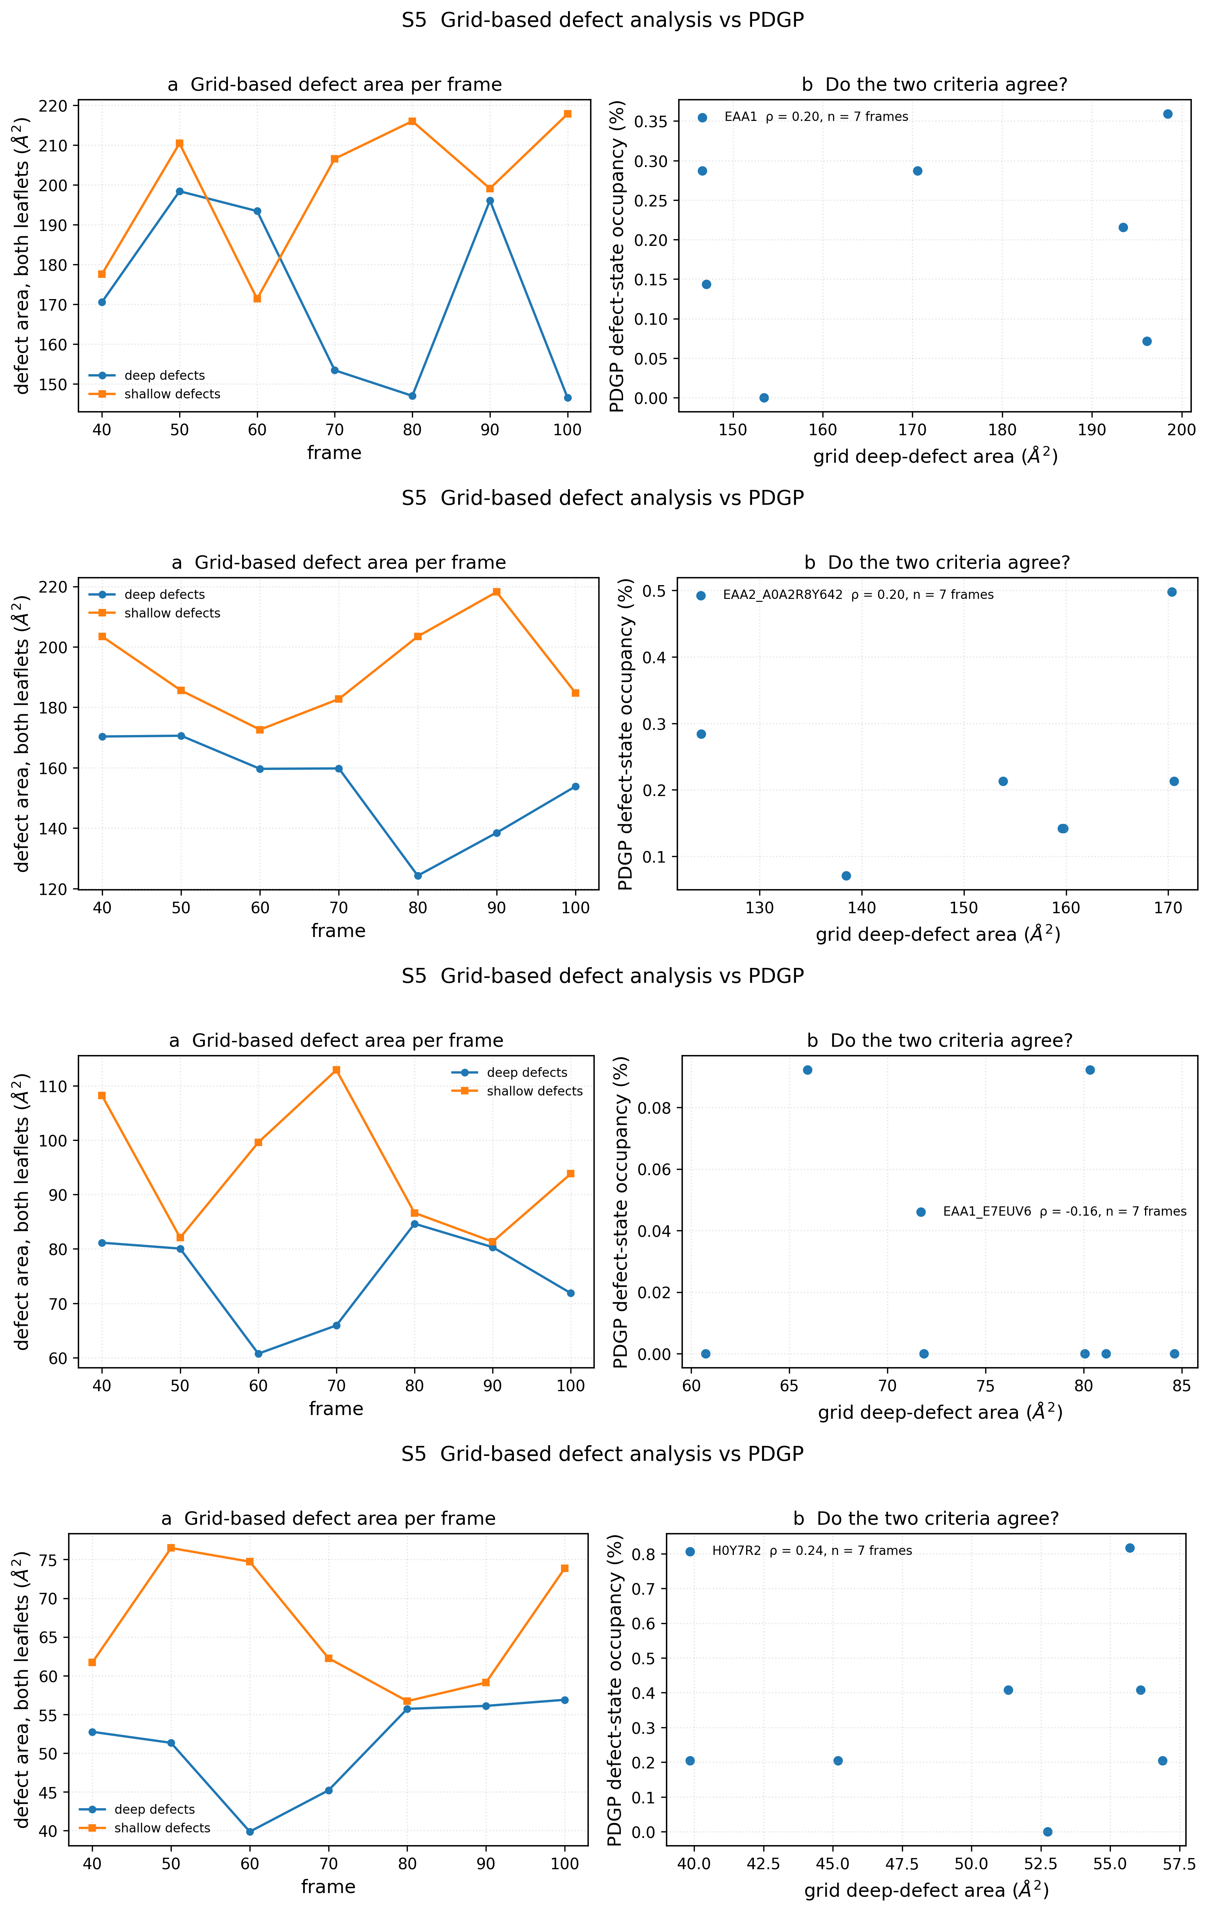
Figure S5. Comparison of the PDGP with a grid-based interfacial defect analysis implemented following Gautier et al. [14], one panel pair per system in the order EAA1, EAA2/A0A2R8Y642, EAA1/E7EUV6, H0Y7R2. A 1 Å grid is laid over the membrane plane; for each grid point the solvent-most atom whose van der Waals sphere covers it is identified, and the point is labelled a deep defect if that atom is an aliphatic carbon lying below the leaflet mean glycerol level, and a shallow defect if it is an aliphatic carbon above it. (a) Deep and shallow defect area per frame, summed over both leaflets. (b) Per-frame grid deep-defect area against PDGP defect-state occupancy, with the Spearman correlation and the number of frames. Within systems the two criteria track each other loosely, with correlations of −0.16 to 0.24 over seven analysed frames of the analysis window, values too imprecise to be individually informative. Between systems they disagree: expressed as a fraction of leaflet area the grid deep-defect fraction is EAA1/E7EUV6 0.104%; H0Y7R2 0.140%; EAA2/A0A2R8Y642 0.153%; EAA1 0.171%, which places H0Y7R2, the assembly the PDGP ranks highest, third of four on the grid criterion (rank correlation between the two orderings 0.40).
Figure S6. Annular profile under three independent defect criteria
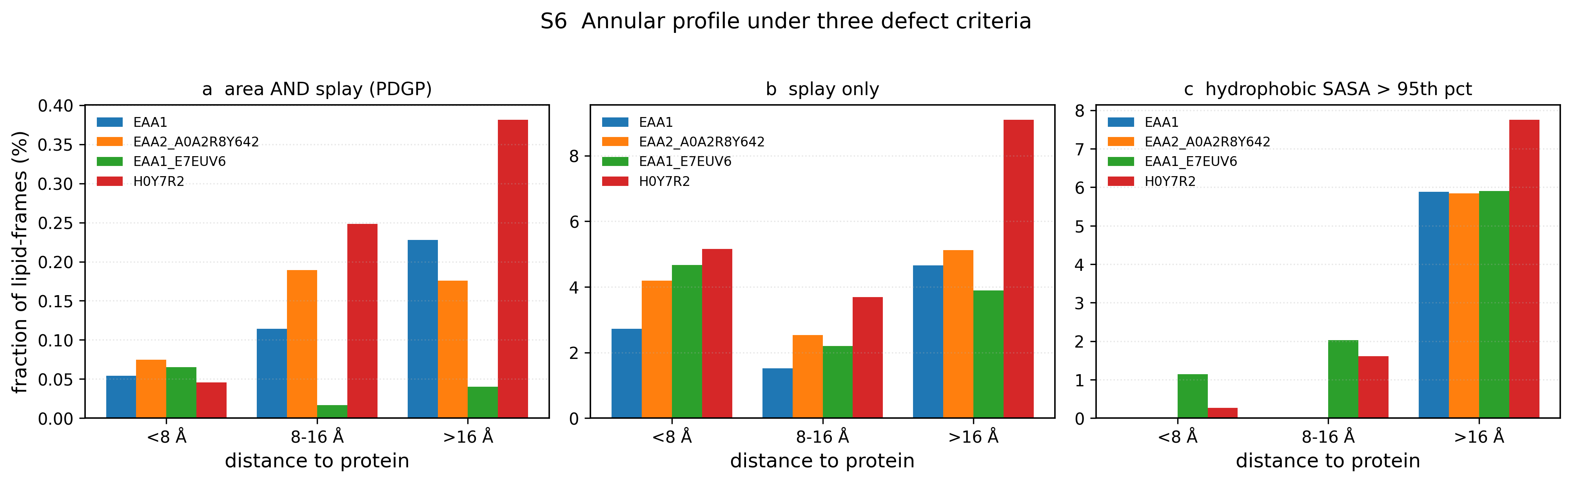
Figure S6. Fraction of lipid-frames meeting each of three defect criteria, stratified by the minimum distance from any lipid heavy atom to any protein heavy atom, for the four assemblies. (a) The combined PDGP criterion, local area and splay angle both above the 95th percentile of the pooled bulk lipid population. (b) Splay angle alone, which is independent of the Voronoi tessellation. (c) Per-lipid hydrophobic SASA above its 95th percentile. Two of the three criteria carry confounds that are stated in the main text: the area component of (a) is truncated for protein-adjacent lipids because protein atoms act as tessellation centres, and the exposure in (c) is reduced near the protein because the protein physically occludes the adjacent acyl chains, so both are lowest in the first shell in every assembly by construction. Criterion (b) carries neither confound and is the one the text relies on: Extreme splay events beyond the threshold are less frequent within 8 Å of the protein than beyond 16 Å in EAA1, EAA2/A0A2R8Y642 and H0Y7R2 but not in EAA1/E7EUV6 (EAA1/E7EUV6: 4.7% against 3.9%; Supplementary Figure S6b). The mean splay angle itself is higher within 8 Å of the protein than beyond 16 Å in all four assemblies (EAA1 30.6° against 28.4°, EAA2/A0A2R8Y642 33.0° against 29.1°, EAA1/E7EUV6 30.1° against 20.2°, H0Y7R2 34.3° against 31.9°). In every assembly the 8–16 Å shell has both the lowest mean splay and the fewest extreme events.
Figure S7. Depth–disorder plots by annular shell for all four assemblies
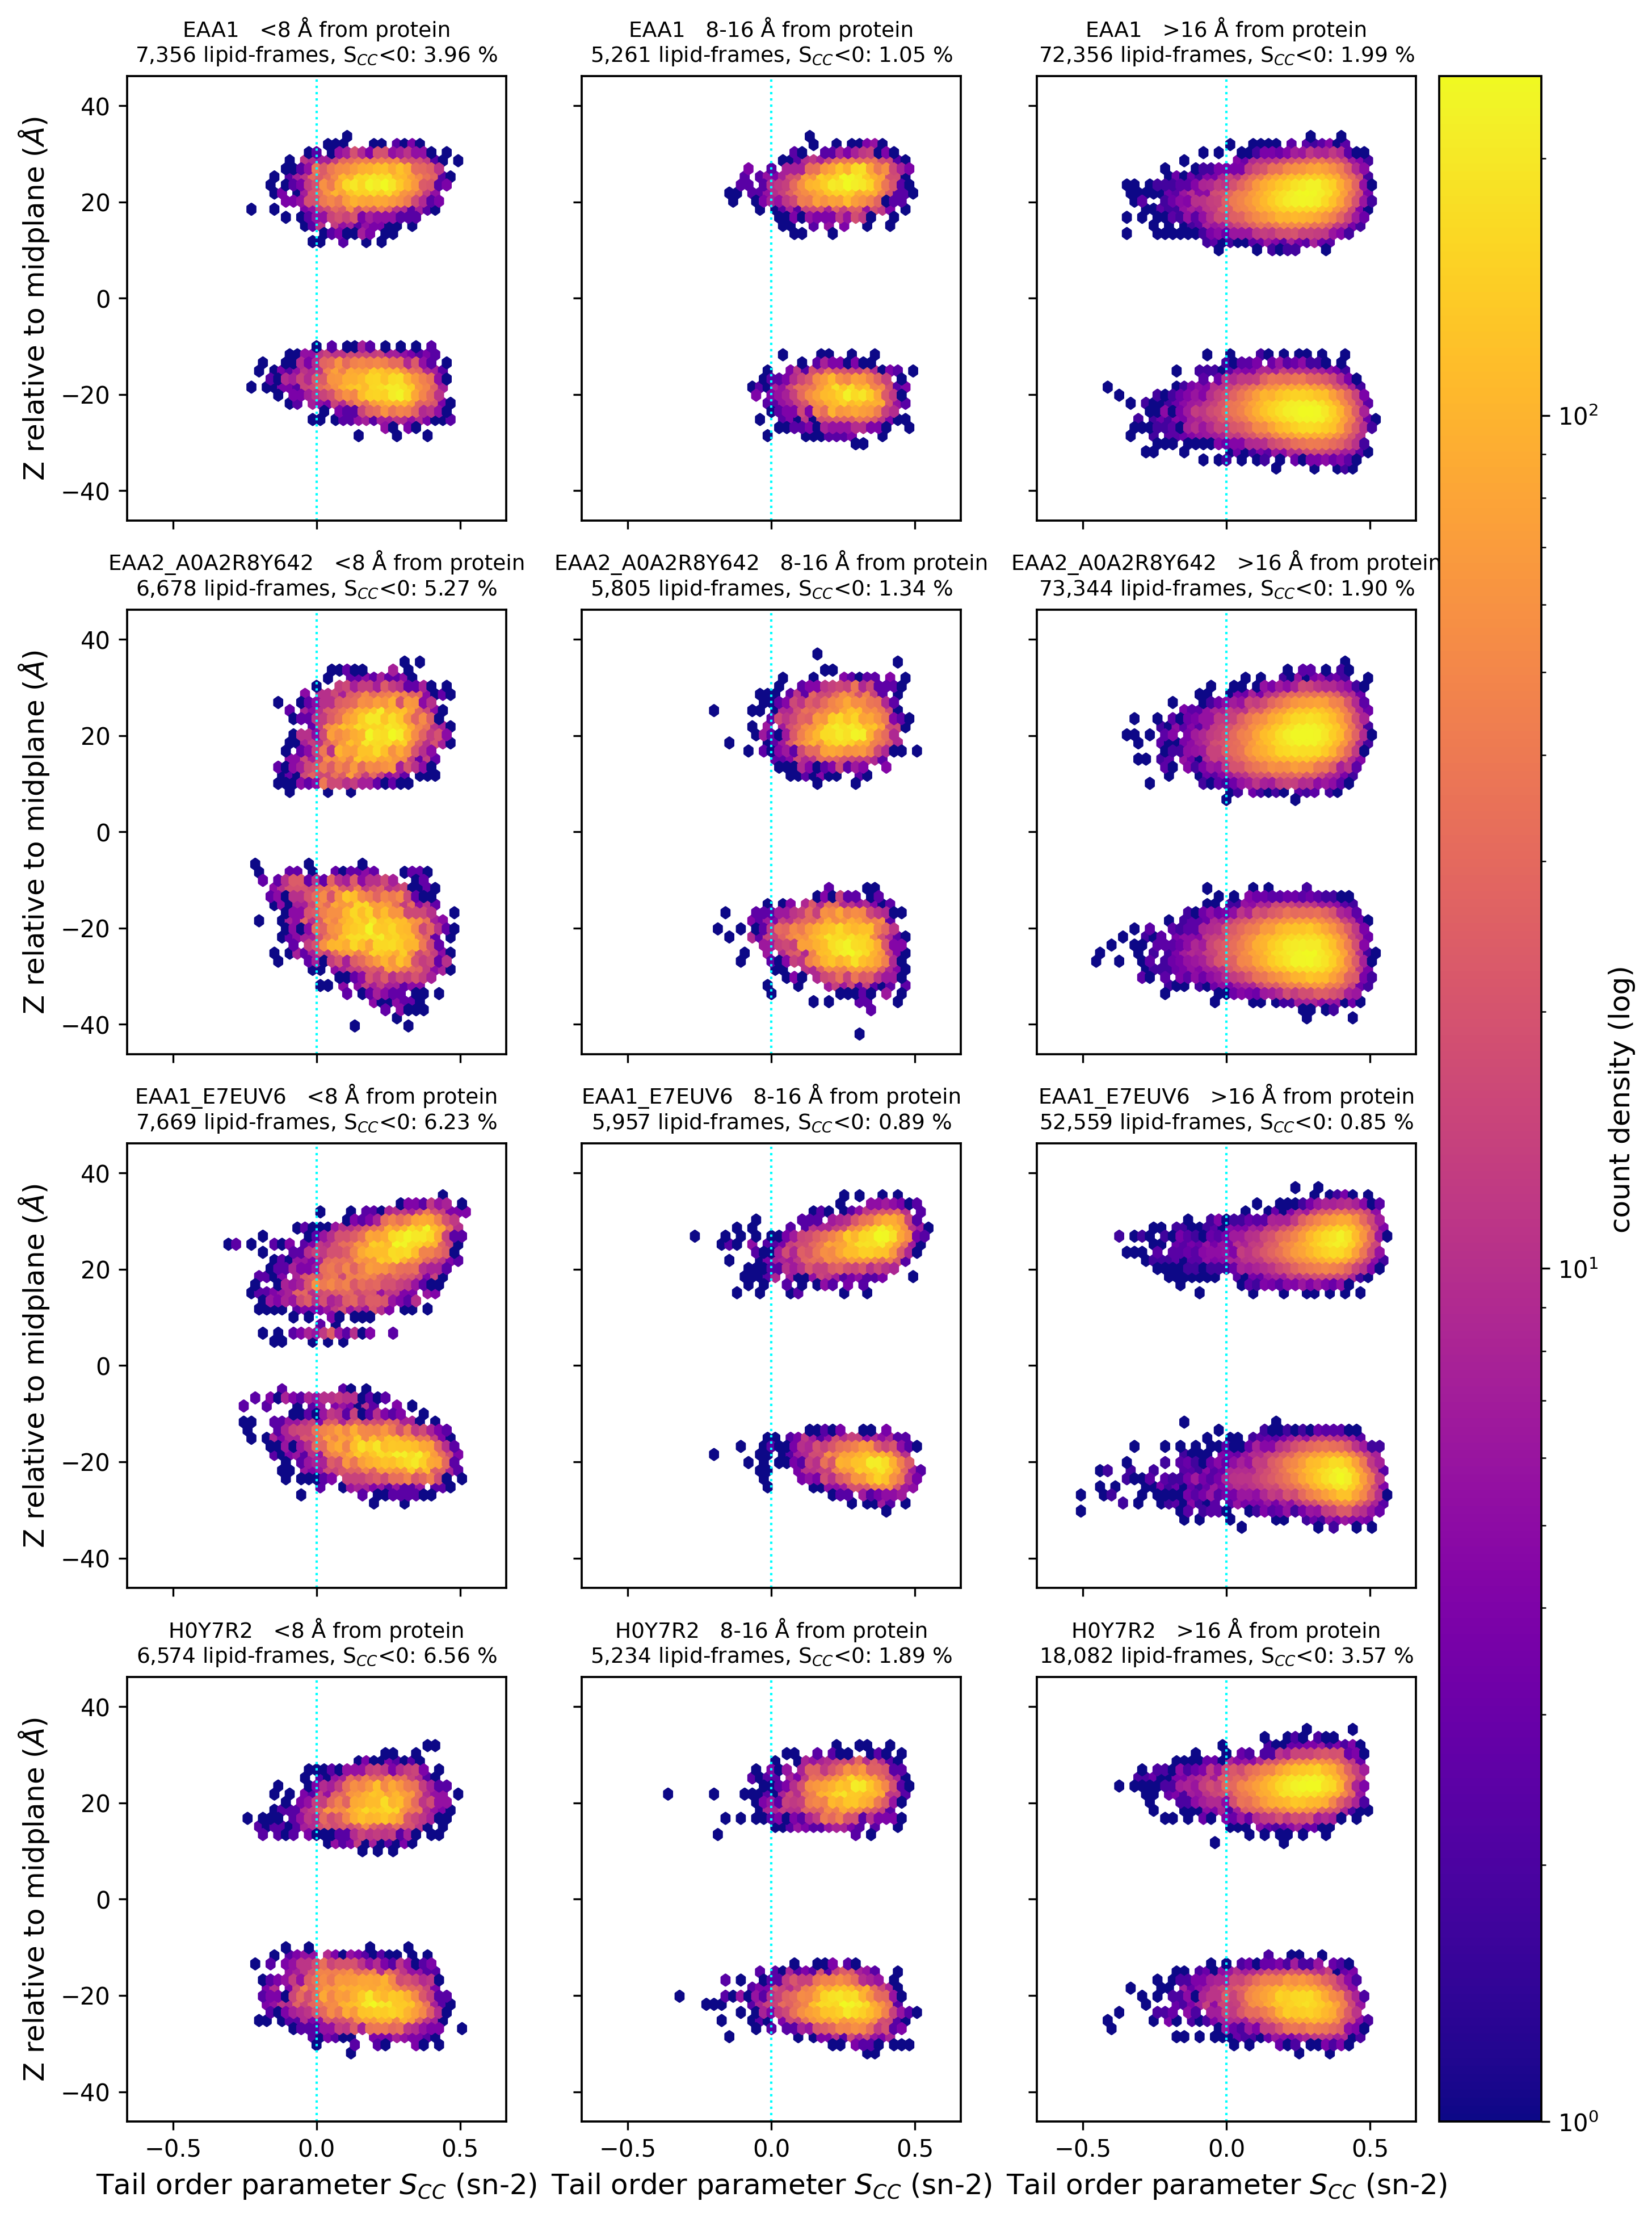
Figure S7. The Depth–Disorder correlation plot of Figure 2a for each of the four assemblies (rows), stratified by the minimum distance of each lipid to the protein surface (columns: < 8 Å, 8–16 Å, > 16 Å), with a single colour scale. Each panel title gives the number of lipid-frames in the shell and the fraction with S_CC < 0, which is 4.0–6.6% within 8 Å of the protein, 0.9–1.9% at 8–16 Å and 0.8–3.6% beyond 16 Å across the four assemblies: the negative-S_CC tail is concentrated in the first annular shell and the second shell is the most ordered. Figure 2c shows the H0Y7R2 row of this figure.
Table S1. Atom-name mapping across force fields
Quantity | CHARMM36 | Slipids | AMBER Lipid21 | this work
Voronoi centre / depth reference | P | P | P31 | P
P–N vector terminus | N | N | N31 | N
α torsion (rotation about P–O12): atoms 1–4 | O11, P, O12, C11 | O11, P, O12, C11 | verify against topology | O11, P, O12, C11
α_g torsion (rotation about O11–P): atoms 1–4 | C1, O11, P, O12 | C1, O11, P, O12 | verify against topology | C1, O11, P, O12
Non-bridging phosphoryl oxygens (in no torsion) | O13, O14 | O13, O14 | O33, O34 | O13, O14
sn-2 (oleoyl) chain vector | C22 → C29 | C22 → C29 | C12 → C19 (OL) | C22 → C29
sn-1 (palmitoyl) chain vector | C32 → C39 | C32 → C39 | C12 → C19 (PA) | C32 → C39
sn-2 chain, order parameters | C22–C218 | C22–C218 | C12–C118 (OL) | C22–C218
sn-1 chain, order parameters | C32–C316 | C32–C316 | C12–C116 (PA) | C32–C316
|S_CD| plateau, sn-2 / sn-1 | C23–C27 / C33–C37 | C23–C27 / C33–C37 | C13–C17 (OL) / C13–C17 (PA) | C23–C27 / C33–C37
Glycerol reference for defect depth | C2, C21, C31 | C2, C21, C31 | C31, C32 (PC) | C2, C21, C31

Table S1. Atom names used for each geometric quantity, with equivalents in other force fields. Analyses in this work use CHARMM36 naming, in which the bonded path from glycerol to choline is C1–O11–P–O12–C11–C12–N, O13 and O14 are the non-bridging phosphoryl oxygens, the C2n carbons form the sn-2 (oleoyl) chain and the C3n carbons the sn-1 (palmitoyl) chain. The analysis code verifies before any frame is analysed that every torsion and chain listed here is a bonded path in the topology actually used. The AMBER Lipid21 column is indicative only: Lipid21 splits POPC into separate PC, OL and PA residues, so atom names must be confirmed against the topology with the discovery routine distributed with the code.
Table S2. Sensitivity of defect-state occupancy to the threshold percentile
Percentile | area (Å²) | splay (°) | EAA1 | EAA2_A0A2R8Y642 | EAA1_E7EUV6 | H0Y7R2
90 | 83.7 | 53.2 | 1.085 | 1.011 | 0.212 | 1.245
95 | 89.8 | 75.2 | 0.206 | 0.169 | 0.041 | 0.284
99 | 102.5 | 105.0 | 0.013 | 0.002 | 0.000 | 0.007

Table S2. Defect-state occupancy, as a percentage of lipid-frames, computed at the 90th, 95th and 99th percentiles of the reference distribution, the pooled lipids lying more than 16 Å from the protein in the four assemblies (216,341 lipid-frames). The area and splay thresholds corresponding to each percentile are given in the second and third columns. The rank ordering of the four systems is the same at all three percentiles, so it does not depend on where the threshold is placed. The block-averaged confidence intervals on these occupancies overlap between systems (Table 1), and the ordering is not reproduced by the grid-based criterion of Figure S5, so it is reported in the main text as a trend rather than a resolved difference.
Table S3. Composition of the simulated systems
System | Assembly | Atoms | POPC | Protein residues (atoms) | Water | K⁺ | Cl⁻ | Initial box (nm)
EAA1 | canonical homodimer | 841,926 | 1,393 | 914 (14,323) | 198,548 | 556 | 563 | 23.82 × 23.82 × 14.40
EAA2_A0A2R8Y642 | canonical heterodimer | 1,083,901 | 1,407 | 894 (13,822) | 278,454 | 781 | 776 | 23.87 × 23.87 × 18.55
EAA1_E7EUV6 | canonical heterodimer | 606,609 | 1,085 | 563 (8,948) | 139,022 | 390 | 405 | 20.92 × 20.92 × 13.43
H0Y7R2 | truncated homodimer | 305,840 | 490 | 482 (7,588) | 72,214 | 210 | 200 | 14.37 × 14.37 × 14.40

Table S3. Composition of every system read from its topology by the report routine distributed with the analysis code (TableS3_composition.csv). All systems use CHARMM36m/CHARMM36 with TIP3P water at nominally 0.11–0.12 M KCl, and every production run spans 50 ns written at 0.5 ns intervals (101 frames).

