Supporting Information

Membrane testing for bacterial structural colour formation

We tested various membranes to show the versatility of our setup. Among them, we observed that both dialysis tubing and cellophane membranes successfully supported biofilm growth, yielding comparable optical performances, confirming that membrane selection does not significantly affect optical quality under the conditions tested. Cellophane membranes are commercially available transparent thin films made from regenerated cellulose, with a chemical composition analogous to that of a dialysis membrane but with less well-defined porosity. Similarly, homegrown Bacterial Cellulose (BC) membranes (see also Methods) offered comparable results.

Membrane | Material | Thickness | Size descriptor | Value | Reference
Bacterial cellulose (K. hansenii) | Native BC | ~500 µm | Effective pore size | ~2–4 nm | [³⁹]
Dialysis membrane (Membra-Cel™) | Regenerated cellulose | 20 µm | MWCO | 14.000 Da | Manufacture specifications
Cellophane sheets (Sigma Z377600) | Regenerated cellulose | Not specified | Pore size | ~4 nm | [⁴⁰]
Table S1. List of membranes used as support for the biofilm growth.

Cost estimates between agar-based and cellophane membrane-based cultivation methods
We give a simple, materials-only estimate of the substrate cost of the two culture routes. Only substrate-forming materials are counted; labor, equipment and the nutrient medium (common to both methods) are excluded. The agar gelling agent is included, as it is discarded with every culture cycle.
We use 1 m² of biofilm as a reference and assume that the two substrates yield comparably per unit area. Covering this area by the conventional route requires an order of 180 single-use 90 mm Petri dishes, each set with a thin agar gel (~0.25 g of agar) that is discarded after one cycle. The membrane route grows the same area on a sterilised, reusable cellophane sheet, so its cost is counted here as a single-use cost and decreases with each reuse.
Using representative laboratory- and bulk/consumer-grade prices (commercial suppliers, June 2026), the costs break down as in Table S1. At laboratory grade, the Petri dishes (~€45) make up most of the cost, and the agar adds ~€15, so the agar route totals ~€60/m²; the single cellophane sheet is ~€12/m², about fivefold less. In bulk these fall to ~€19 (dishes) and ~€1 (agar) which adds up to ~€20/m² together, against ~€1/m² for cellophane, about twentyfold less.

Item (per m² of biofilm) | Laboratory grade |  | Bulk / consumer grade
Petri dishes (≈180, single-use) |  | ~€45 | ~€19
Agar gel (≈45 g) |  | ~€15 | ~€1
Agar method — total |  | ~€60 | ~€20
Cellophane membrane (single use) |  | ~€12 | ~€1
Cost reduction (agar ÷ cellophane) |  | ~5× | ~20×
Table S2. Approximate substrate material cost per m² of biofilm (materials only; rounded order-of-magnitude estimates).
The advantage is therefore structural rather than incidental: most of the agar-route cost is the single-use Petri dish, which is discarded every cycle and is unaffected by reagent grade, whereas the cellophane membrane is inexpensive and reusable.
*Representative price sources (June 2026): bacteriological / food-grade agar (rpicorp.com); sterile 90 mm Petri dishes (thermofisher.com); regenerated-cellulose cellophane (sigmaaldrich.com). Bulk/consumer-grade equivalents are available from general suppliers.

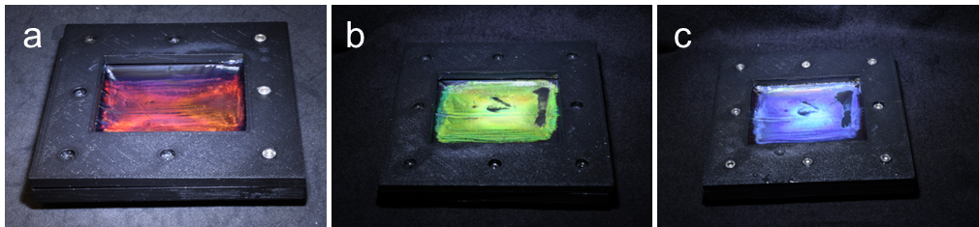
Figure S3. Biofilm of living a) Flavobacterium IR1 M16 and b) C. lytica PLYA2 grown on membranes. c) Same biofilm in b) after butyl glycol treatment.
Optical response is preserved at smaller sizes
As expected, and as shown in Figure S4, smaller particles exhibit lower reflectivity, suggesting that the size-reduction process may affect the original thickness of the biofilm. However, the colouration is maintained overall when viewed by eye.

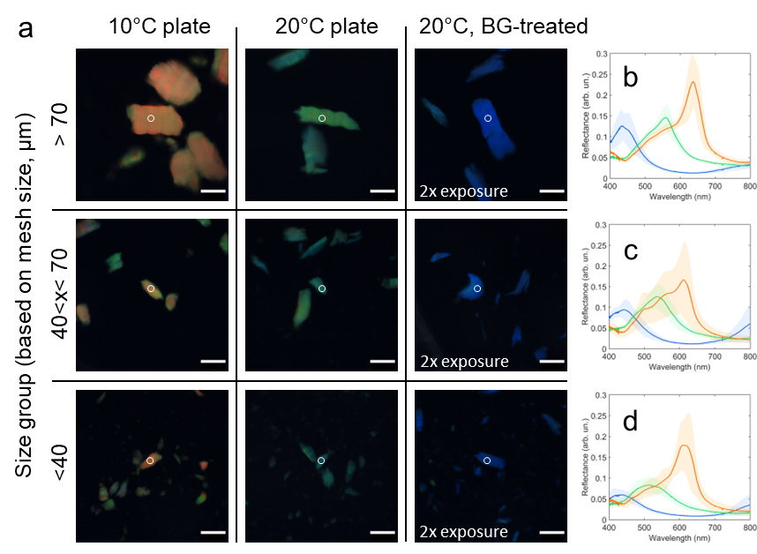
Figure S4. a) Optical micrographs of red, green, and blue flakes (grown on agar plates) of different size and b-d) corresponding reflectance spectra, averaged over 10 flakes for each kind. The standard deviation is shown as lighter coloured contour of the relative averaged spectra. Measurements taken in dark field mode using a 20x objective. Spectra normalised to a white standard. Scalebars 100 µm.

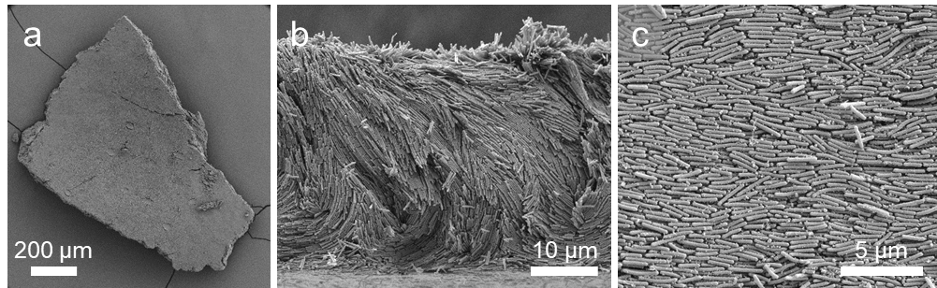
Figure S5. Morphology of bacterial large pigment flakes (green colour). a) Overview of a large flake showing the intact macroscopic structure. b) Cross-section revealing the full biofilm thickness and the crystalline organisation of the cells. c) High-magnification view of the flake surface, confirming that the ordered nanostructure of the rod-shaped bacterial cells is retained within the plane of the film after fixation and mechanical fragmentation.
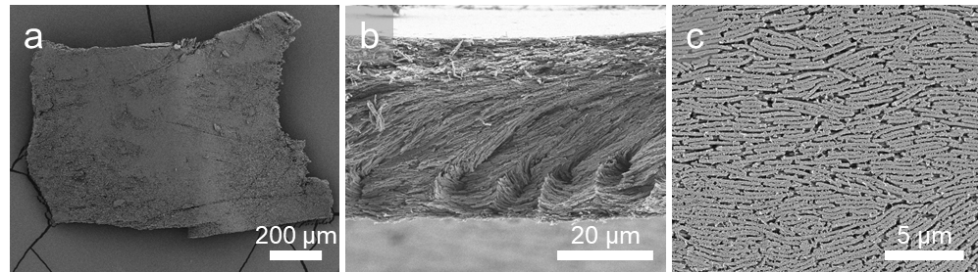
Figure S6. Morphology of bacterial large pigment flakes (blue colour). a) Overview of a large flake showing the intact macroscopic structure. b) Cross-section revealing the full biofilm thickness and the crystalline organisation of the cells. c) High-magnification view of the flake surface, confirming that ordered nanostructure of the rod-shaped bacterial cells is retained within the plane of the film after fixation and mechanical fragmentation.

Collective response of flakes
While the structural integrity of the free-standing films is preserved by critical-point drying, dehydration influences the estimation of the photonic crystal lattice constant, which can be determined instead from the diffraction spots observed in the goniometry heatmaps, as previously reported in ^{26,27}. By matching the diffraction grating equation with the position of the spots in the goniometry heatmaps reported in Figure S7 a-c, the periodicity is estimated to be of d = (425±5) nm for red biofilms and d = (380±15) nm for green biofilms, which reduces to d = (367±12) nm for blue biofilms, consistent with a blueshift of the reflectance peak for smaller periodicities. The angular-dependent response observed for the pigments (Figure S8) shows features analogous to those of the biofilms (see Figures S7d-i). The diffraction spots are less defined for smaller sizes, as expected from the collective response of randomly oriented domains.

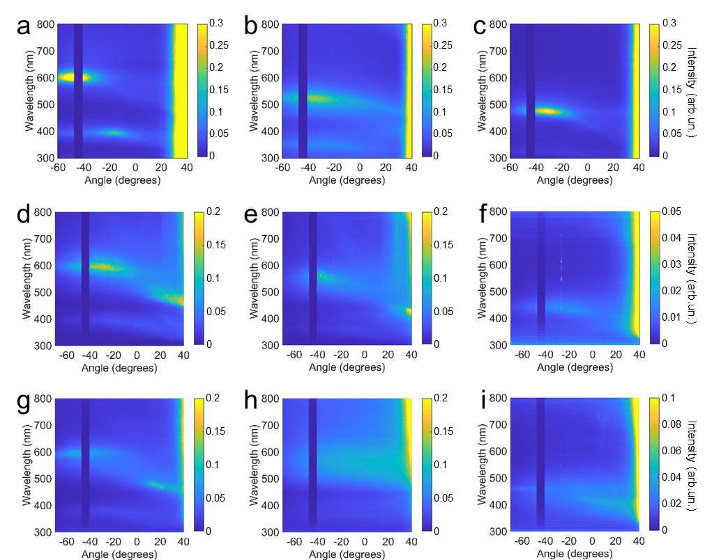
Figure S7. Goniometry heatmaps for a-c) agar-supported biofilms and free-standing biofilms after size reduction with characteristic size of d-f) ~ 1 mm and g-i) ~ 10-100 μm. Scans are done on three different colours: red (a, d, g), green (b, e, h), and blue (c, f, i). Intensity spectra are collected keeping the incident angle fixed at ϑ = 45°.

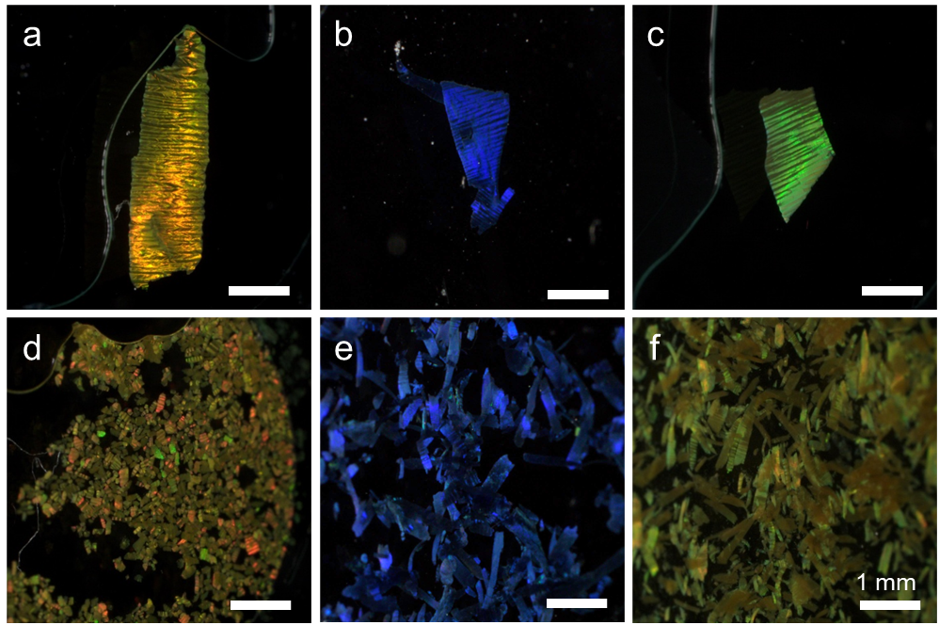
Figure S8. Optical appearance of free-standing biofilms after size reduction for the three different colours. a-c) Red, blue, green flakes with characteristic size ~ 1 mm; d-f) red, blue, green flakes with characteristic size ~ 10-100 μm. Images are acquired for an angle of observation and illumination of ~30°.

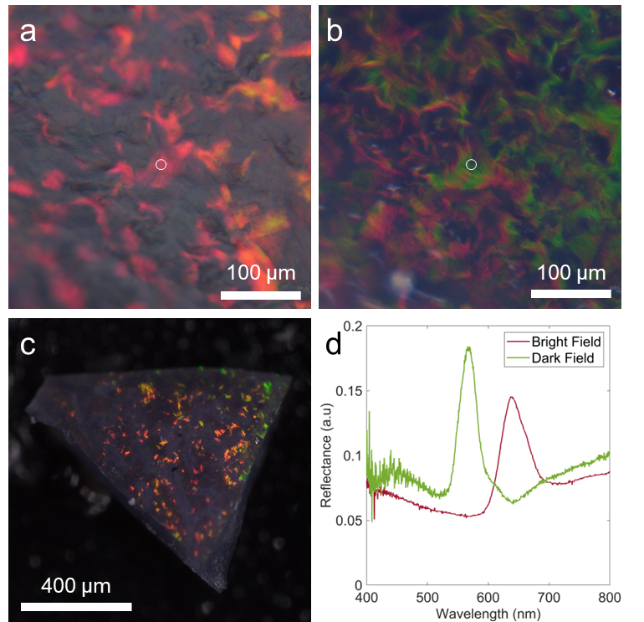

Figure S9. Optical appearance of bacteria pigment flakes after TEOS infiltration. a-b) Micrographs taken in bright field (a) and dark field (b) of a region of the flake shown in c), showing that the colour is preserved after the infiltration, with dark areas corresponding to different orientations of the colonies. d) Corresponding reflectance spectra. Reflectance normalised against a mirror for bright field and against a white standard for dark field.

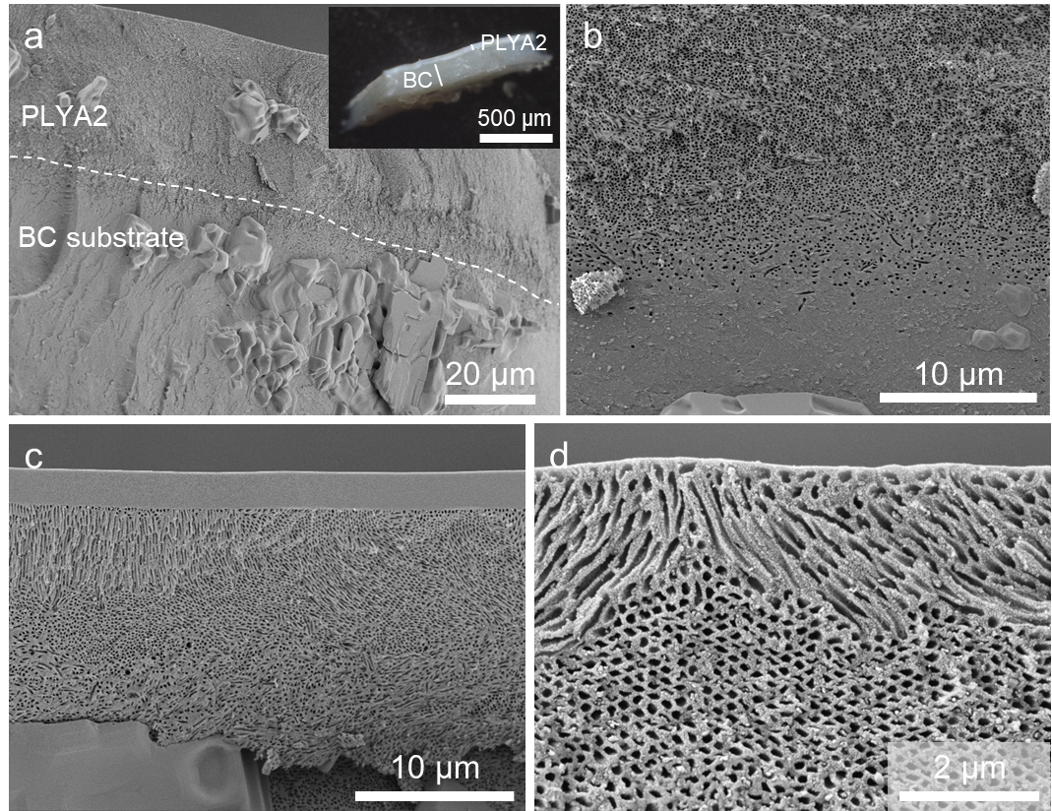
Figure S10. SEM images of C. lytica PLYA2-BC calcinated composite biofilms. Images in panels a,b) show how the structurally coloured biofilm of PlyA2 grows inside the BC membrane, which cannot be removed prior to infiltration and calcination. Images in c,d) highlight different orientations of the C. lytica PLYA2 colonies in the biofilm being fully preserved after calcination.

