Extended Data Figure 1. Longitudinal cfDNA trajectories for the remaining dogs (1/6)
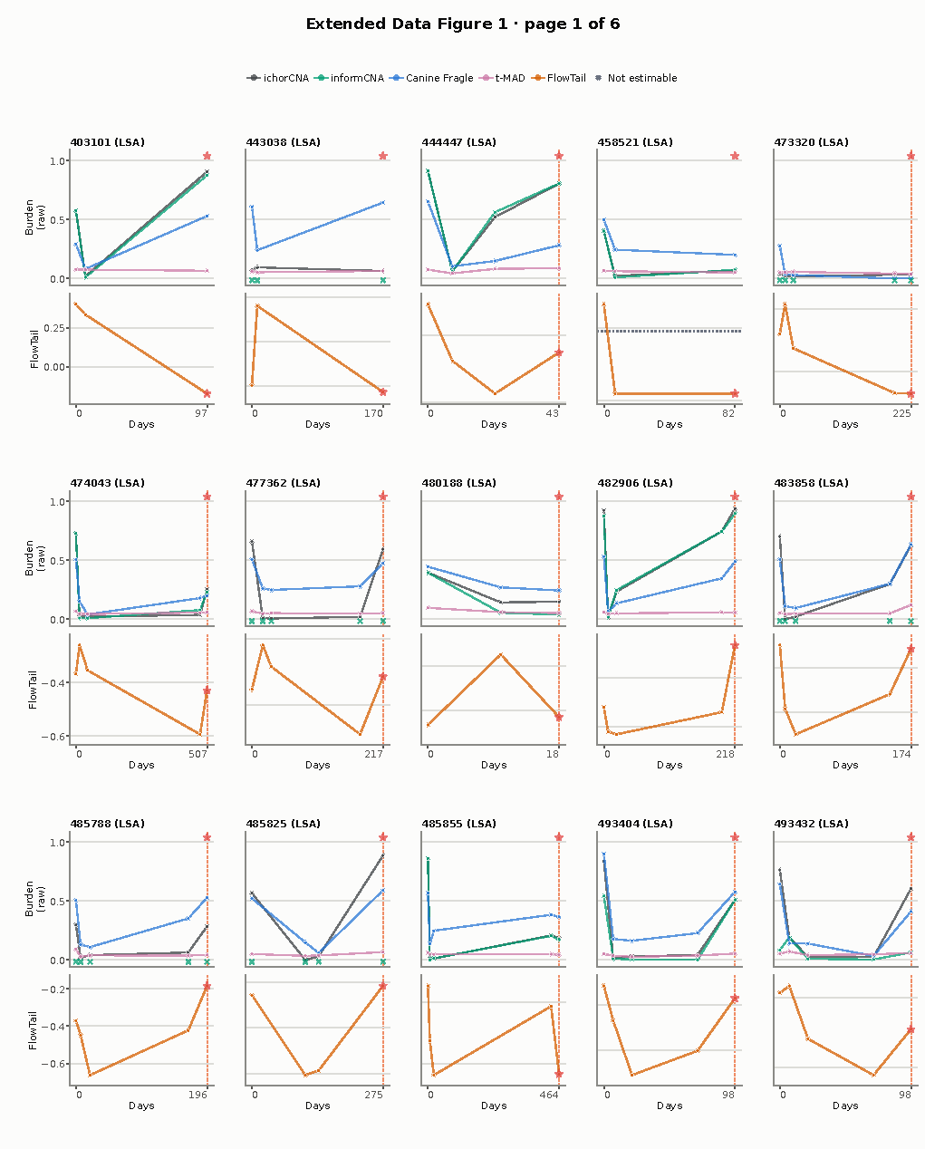
Longitudinal atlas of the 83 dogs complementary to Figure 6: 17 relapse, 12 progression-only, 6 metastasis, 5 event-free remission and 43 other/unclear-course dogs. Each title gives the dog identifier followed by its annotated cancer type. Upper tracks show ichorCNA, informCNA, Canine Fragle and t-MAD on their recorded scales; lower tracks show the FlowTail normalised linear-SVM margin with an individual y-axis range for each dog. Horizontal dotted lines mark the study-specific linear-SVM cutoff selected at a 95% training specificity target when within the displayed range. Colours identify scores consistently with Figure 6. Crosses denote non-estimable measurements; missing estimates interrupt their score trajectories. Stars identify relapse, open circles progression and diamonds metastasis, with vertical lines marking event positions as shown. Collections follow chronological or study-defined visit order, and time units appear on each horizontal axis. The atlas and the 34 dogs in Figure 6 together cover all 117 longitudinal dogs. A six-page rendering presents the same atlas at larger panel size.

Extended Data Figure 1. Longitudinal cfDNA trajectories for the remaining dogs (2/6)
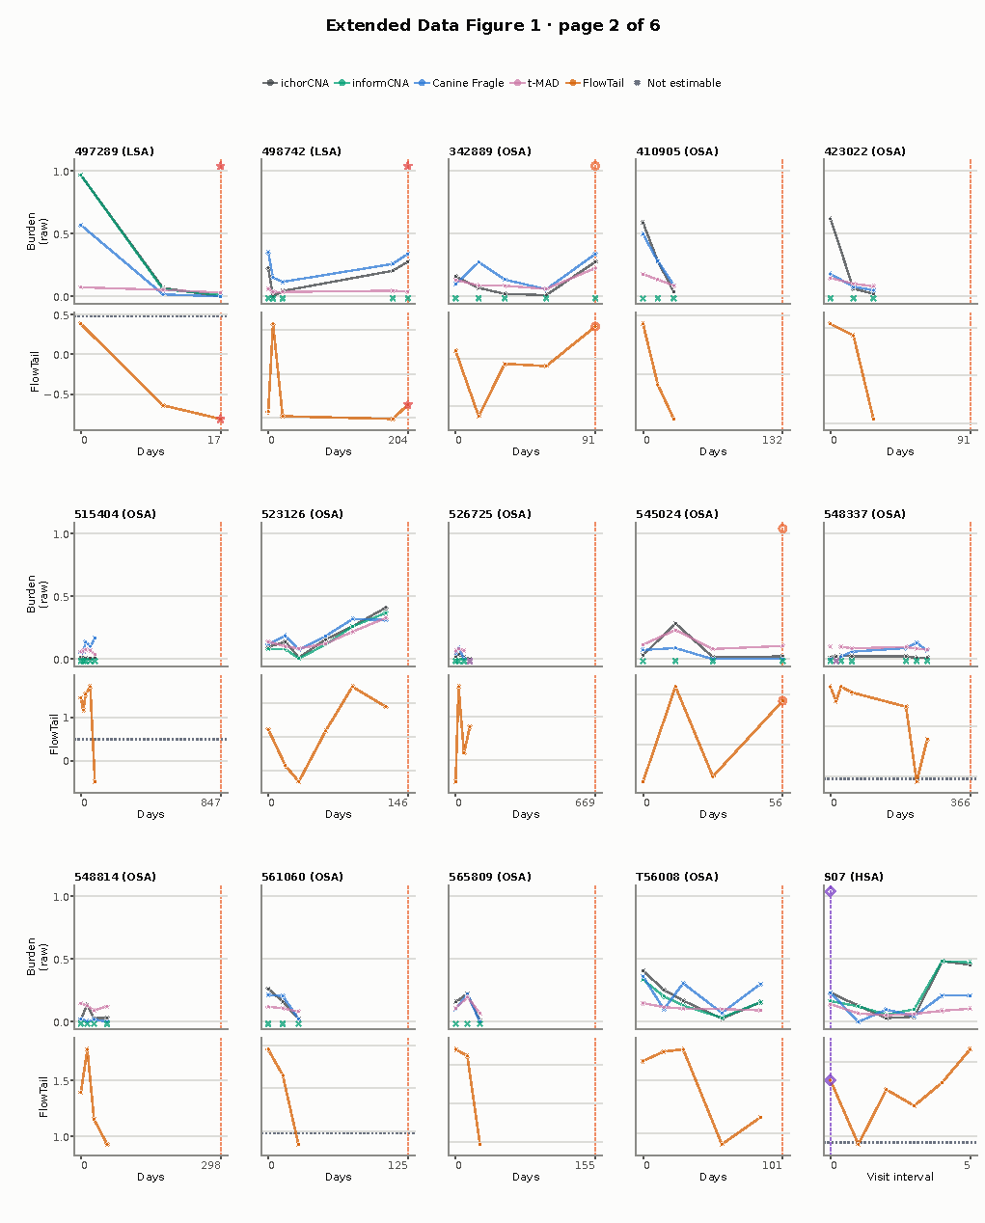

Extended Data Figure 1. Longitudinal cfDNA trajectories for the remaining dogs (3/6)
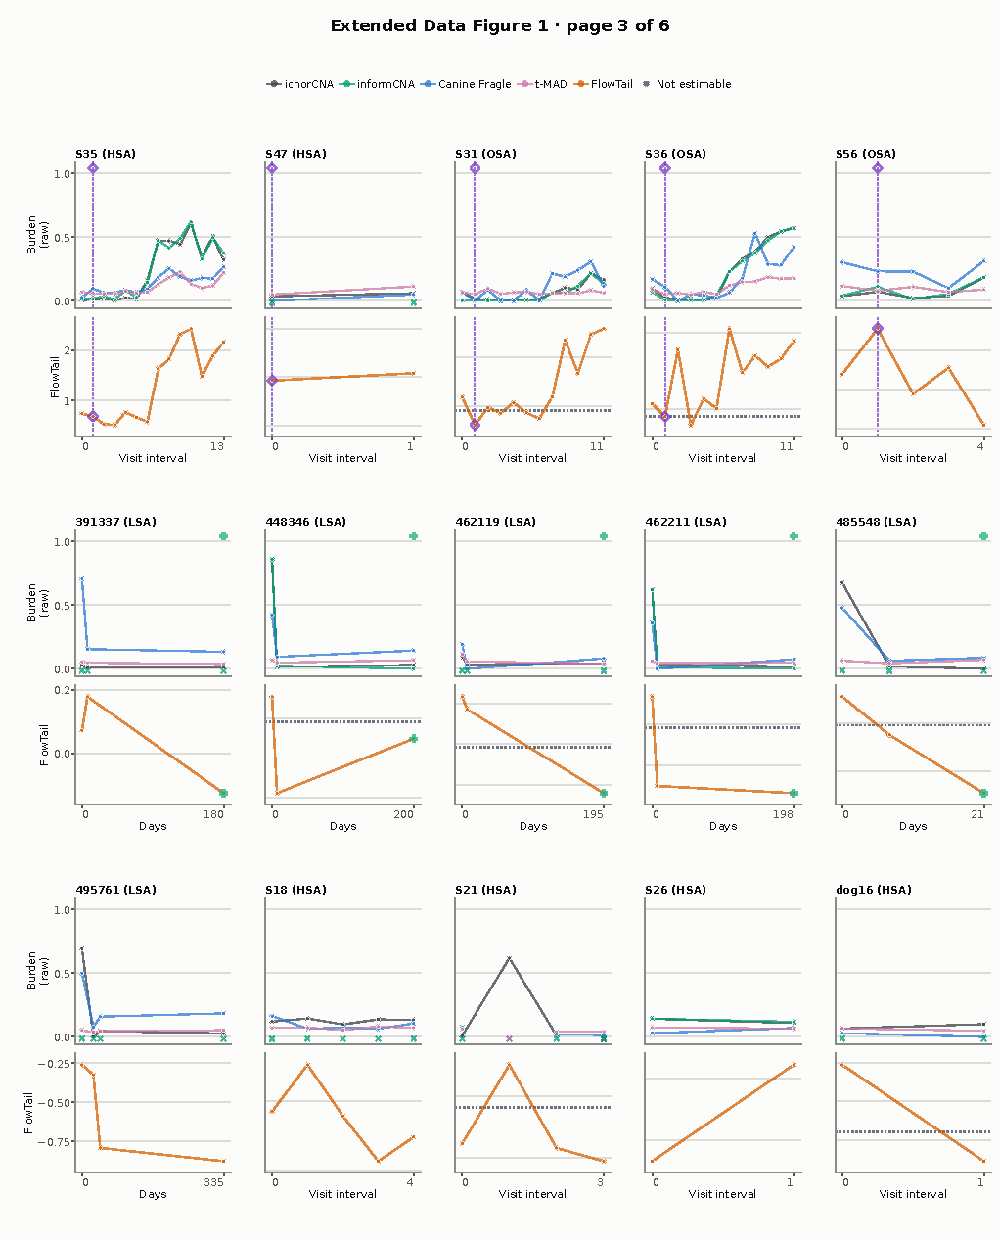

Extended Data Figure 1. Longitudinal cfDNA trajectories for the remaining dogs (4/6)
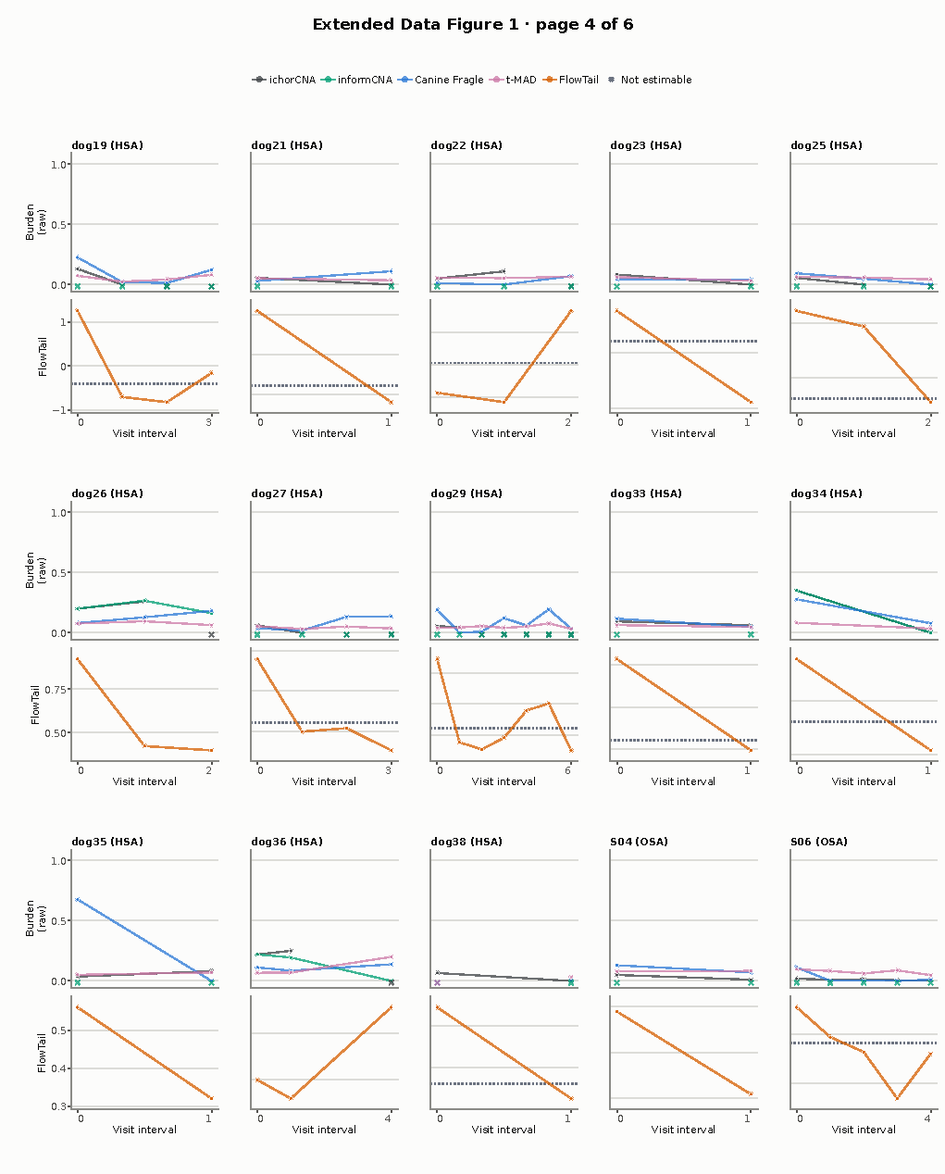

Extended Data Figure 1. Longitudinal cfDNA trajectories for the remaining dogs (5/6)
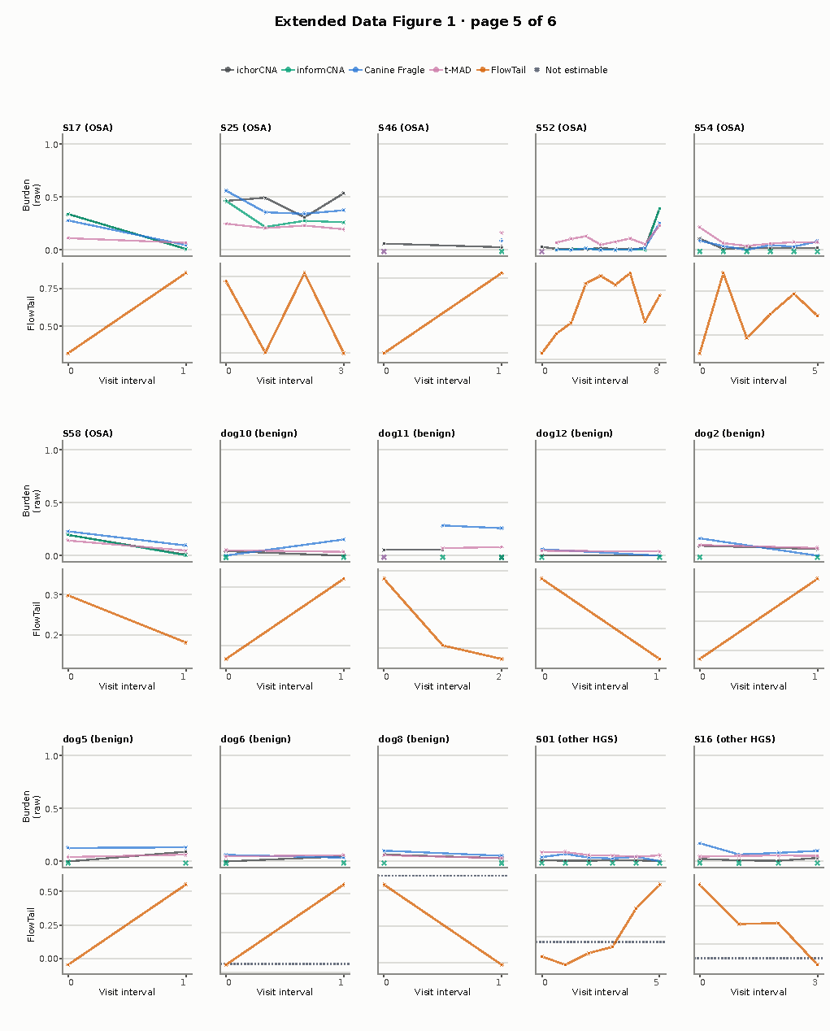

Extended Data Figure 1. Longitudinal cfDNA trajectories for the remaining dogs (6/6)
