Online Appendix for “Varieties of Nationalist Frames and Support for High-skill Immigration in a developmental Setting”

Contents
A.1 Preregistration and Deviations from the Pre-Analysis Plan 2
A.2 Experiment Design: Nationalist Frames and Support for High-Skilled Immigration 3
A.3 Experimental Results and Robustness Checks 7
A.4 Prompt and Coding Scheme for GPT-based Coding of Open-ended Responses 13
A.5 ABS-5 Questions and Descriptive Statistics 20

A.1 Preregistration and Deviations from the Pre-Analysis Plan

Preregistration
The study was registered on the Open Science Framework (OSF). The registration materials specified the data-collection procedures, eligibility and exclusion criteria, experimental design, and hypotheses concerning the effects of different nationalist frames on attitudes toward high-skilled immigration.

Preregistered Hypotheses
H1(Exclusionary): Emphasizing cultural and social threats associated with immigration is expected to reduce support for high-skilled immigration.

H2(Competitive): Emphasizing the contribution of foreign talent to China’s technological competitiveness is expected to increase support for high-skilled immigration.

H3(Model/Learning): Emphasizing how other countries have benefited from high-skilled immigration is expected to increase support for high-skilled immigration.

Table A1 Hypotheses and Experimental Results
Hypothesis | Treatment | Preregistered Expectation | Observed Result | Consistency with Expectation
H1 | Exclusionary | Lower support for high-skilled immigration | Lower support and less favorable perceptions on most outcomes relative to the Control group | Consistent
H2 | Competitive | Higher support for high-skilled immigration | Higher policy support relative to both the Exclusionary and Control groups | Consistent
H3 | Model/Learning | Higher support for high-skilled immigration | Higher policy support relative to both the Exclusionary and Control groups | Consistent
Overall, the experimental results are consistent with the directional expectations specified in the registration.

Deviations from Preregistration
Two minor differences should be noted. First, the condition labeled “Model Nationalism” in the registration is referred to as the “Learning frame” in the manuscript. This is a terminological change and does not alter the treatment or theoretical expectation. Second, the registration specified the theoretical expectations but did not fully specify the statistical models used to estimate the treatment effects. The analyses reported in the manuscript therefore represent the empirical implementation of the registered hypotheses.

A.2 Experiment Design: Nationalist Frames and Support for High-Skilled Immigration

Treatment Materials
-Exclusionary Frame
在全球化迅速发展的今天，外来文化和外国人口的涌入，可能对中国传统文化传承的负面影响。中国文化的纯洁性和历史传承面临着前所未有的挑战。保护文化遗产和强化民族文化认同是当务之急。
In today’s rapidly globalizing world, the influx of foreign cultures and foreign populations may have negative effects on the transmission of China’s traditional culture. The purity and historical continuity of Chinese culture are facing unprecedented challenges. Protecting cultural heritage and strengthening national cultural identity have therefore become urgent tasks.

-Competing Frame
随着中国科技力量的飞速崛起，美国不仅展现出明显的嫉妒心理，还不断强化其“技术孤立主义”，屡屡借口“国家安全”滥用国家机器，无理打压中国科技企业，对中国实施芯片禁售。为抢夺未来科技主导权，解决“卡脖子”问题，中国应大规模招揽世界顶尖科技人才，让中国的技术人才储备达到世界一流水平，才能与美国在高科技领域一决高下。这是中国应对美国科技封锁和技术战的有力回应。
As China’s technological capabilities rise rapidly, the United States has not only displayed clear signs of anxiety, but has also intensified its “technology isolationism.” Under the pretext of “national security,” it has repeatedly used state power to suppress Chinese technology companies and imposed chip export restrictions on China. To secure future leadership in science and technology and to overcome critical technological bottlenecks, China must attract top scientific and technological talent from around the world. Only by building a world-class pool of technological expertise can China effectively compete with the United States in high-tech fields. Recruiting global talent is therefore a powerful response to U.S. technological containment and its broader technology competition strategy.

-Learning Frame
美国硅谷拥有全球科技领先地位，深受其包容和多元的移民政策所影响。据统计，美国硅谷的创新项目和技术突破都是由来自印度、中国等国的移民人才主导，不仅如此，硅谷科技公司中的许多高管职位也由移民担任。此外，统计显示，在美国从事科学和工程职业的移民占比高达三分之一以上。借鉴美国的成功案例，中国需通过更加开放的政策，积极吸引国际高端人才加入中国的科技创新大潮。
The global technological leadership of Silicon Valley is closely tied to the United States’ inclusive and diverse immigration policies. Studies show that many of Silicon Valley’s major innovations and technological breakthroughs have been led by immigrant talent from countries such as India and China. Immigrants also occupy a significant share of senior positions in leading technology firms. In addition, statistics indicate that immigrants account for more than one-third of individuals working in science and engineering occupations in the United States. Drawing on this successful example, China should adopt more open policies to actively attract high-level international talent and integrate them into China’s technological innovation efforts.

Experimental questions

Key Dependent Variable

Do you support China relaxing its immigration policies to attract more foreign talent to live and work in China?
您支持中国放宽移民政策，以吸引更多外国人才到中国定居和工作吗？
- Strongly support非常支持
- Support支持
- Neutral中立
- Oppose不支持
- Strongly oppose非常不支持

China should encourage international students to stay and work in China after completing their studies.
我国应该鼓励国际留学生在完成学业后，留在中国工作。

- Strongly agree非常同意
- Agree同意
- Neutral中立
- Disagree不同意
- Strongly disagree非常不同意

Overall, attracting more foreigners to live and work in China will benefit China’s future economic and technological development.
总体而言，吸引更多外国人来中国定居、工作，有利于中国今后的经济和科技发展。
- Strongly agree非常同意
- Agree同意
- Neutral中立
- Disagree不同意
- Strongly disagree非常不同意

More foreigners moving to China will benefit China’s economic and technological progress.
更多的外国人移居到中国，有利于中国的经济和科技进步。
- Strongly agree非常同意
- Agree同意
- Neutral中立
- Disagree不同意
- Strongly disagree非常不同意

Control and Demographic Variables
What is your household registration type (hukou)?
请问你的户口类型是？
- Urban hukou城镇户口
- Rural hukou农村户口

Where are you currently working?
请问您目前在哪里工作？
- I am a student我是学生
- Government agency政府部门
- State-owned institution国有机构（国企或事业单位）
- Private organization民营机构（民企或民间社会组织）
- Self-employed / Business owner经商或个体户
- Foreign enterprise or foreign institution外企或外国机构
- Farming务农
- Unemployed, not working, or retired失业、无业或退休
- Non-profit organization非赢利组织

What is your frequency of reading news? 你平时阅读新闻的频率是？
Several times a day 一天数次；Once a day 一天一次；Several times a week一周数次；Once a week 一周一次； less than once a week 少于一周一次

What is your primary platform for obtaining news?
你获取新闻的主要平台是？
- Social media (e.g., WeChat, Douyin, Weibo, etc.) 社交媒体（如微信、抖音、微博等）
- Radio or television广播或者电视

Do you usually follow news reports from foreign media outlets?
(For example: The New York Times, BBC, CNN, The Times, or through international social media such as Twitter or Facebook.)
你平时浏览境外新闻媒体的报道吗？（比如：纽约时报、BBC、CNN、泰晤士报等媒体，或从推特、脸书这类境外社交媒体获取新闻信息）
- Multiple times a day每天多次浏览
- Frequently经常浏览
- Occasionally偶尔浏览
- Never从没浏览过

Do you have any sons aged 18–30?
您是否有年龄处于18-30岁的儿子？
- No没有
- One 1名
- Two 2名
- Three or more 3名或更多

A.3 Experimental Results and Robustness Checks
Table A2 Descriptive Statistics of the Experimental Sample
 | (1) | (2) | (3) | (4) | (5)
 | Mean | SD | Min | Max | N
Female | 0.502 | 0.500 | 0 | 1 | 2396
Age | 29.581 | 7.872 | 18 | 72 | 2396
Below middle school | 0.032 | 0.176 | 0 | 1 | 2396
High school/ technical secondary school | 0.131 | 0.338 | 0 | 1 | 2396
Bachelor’s degree | 0.774 | 0.418 | 0 | 1 | 2396
Graduate degree or above | 0.063 | 0.243 | 0 | 1 | 2396
Party member | 0.127 | 0.333 | 0 | 1 | 2396
Eastern region | 0.571 | 0.495 | 0 | 1 | 2396
Central region | 0.194 | 0.395 | 0 | 1 | 2396
Northeastern region | 0.047 | 0.211 | 0 | 1 | 2396
Western region | 0.189 | 0.392 | 0 | 1 | 2396

Table A3 Randomization Balance across Experimental Groups
 | (1) | (2) | (3) | (4) | (5) | (6) | (7) | (8) | (9)
 | Female | Age | High school/ technical secondary school | Bachelor’s degree | Graduate degree or above | Party member | Central region | Northeastern region | Western region
Competing | -0.0344 | 0.192 | -0.00441 | 0.00891 | 0.00371 | -0.0162 | 0.0211 | -0.00983 | 0.0395*
 | (0.0290) | (0.463) | (0.0190) | (0.0243) | (0.0148) | (0.0189) | (0.0227) | (0.0120) | (0.0223)
Learning | -0.0117 | -0.431 | -0.00334 | 0.0234 | -0.0151 | 0.0151 | 0.0284 | 0.00502 | 0.0318
 | (0.0289) | (0.455) | (0.0191) | (0.0240) | (0.0138) | (0.0199) | (0.0228) | (0.0129) | (0.0220)
Control | -0.0126 | -0.177 | 0.0300 | -0.00723 | -0.0107 | -0.00480 | 0.00950 | -0.00884 | 0.0428*
 | (0.0288) | (0.459) | (0.0200) | (0.0245) | (0.0140) | (0.0192) | (0.0223) | (0.0121) | (0.0222)
Joint test p-value | 0.689 | 0.557 | 0.275 | 0.611 | 0.498 | 0.447 | 0.611 | 0.571 | 0.186
Observations | 2396 | 2396 | 2396 | 2396 | 2396 | 2396 | 2396 | 2396 | 2396
Standard errors in parentheses* p < 0.10, ** p < 0.05, *** p < 0.01

Table A4 Effects of Developmental Nationalist Frames on Immigration Attitudes (Baseline Group: Exclusionary Group)
 | (1) | (2) | (3) | (4)
 | Support for Foreign Talent | Support for Int'l Students | Perceived Economic and Tech Growth | Perceived Overall Economic Impact
Competing | 0.0386*** | 0.0779*** | 0.0240* | 0.0229*
 | (0.0146) | (0.0141) | (0.0136) | (0.0128)
Learning | 0.0616*** | 0.0713*** | 0.0410*** | 0.0277**
 | (0.0141) | (0.0136) | (0.0136) | (0.0123)
Control | -0.00129 | 0.0463*** | 0.0263* | 0.0343***
 | (0.0145) | (0.0141) | (0.0135) | (0.0127)
Female | 0.00497 | 0.0220** | 0.000883 | -0.0120
 | (0.0104) | (0.00993) | (0.00973) | (0.00906)
Age | 0.00216*** | 0.00146** | 0.00228*** | 0.00148**
 | (0.000671) | (0.000626) | (0.000608) | (0.000616)
High school/ technical secondary school | 0.0253 | 0.00169 | 0.0225 | 0.000668
 | (0.0334) | (0.0292) | (0.0286) | (0.0299)
Bachelor's degree | 0.0378 | 0.00645 | 0.0274 | 0.0201
 | (0.0313) | (0.0272) | (0.0268) | (0.0281)
Graduate degree or above | 0.0542 | 0.00231 | 0.0180 | -0.000292
 | (0.0377) | (0.0337) | (0.0327) | (0.0342)
Party member | 0.0663*** | 0.0244 | 0.0490*** | 0.0387***
 | (0.0168) | (0.0151) | (0.0148) | (0.0141)
Central region | -0.0219 | -0.0178 | -0.0116 | -0.0234**
 | (0.0137) | (0.0132) | (0.0127) | (0.0117)
Northeastern region | -0.0278 | 0.0139 | -0.0245 | -0.0317
 | (0.0256) | (0.0230) | (0.0250) | (0.0233)
Western region | -0.0340** | -0.0199 | -0.0270** | -0.0198*
 | (0.0134) | (0.0127) | (0.0126) | (0.0118)
Constant | 0.421*** | 0.560*** | 0.511*** | 0.520***
 | (0.0384) | (0.0335) | (0.0328) | (0.0336)
Observations | 2396 | 2396 | 2396 | 2396
Robust standard errors in parentheses.* p<0.10, ** p<0.05, *** p<0.01

Table A5 Effects of Developmental Nationalist Frames on Immigration Attitudes (Baseline Group: Control Group)
 | (1) | (2) | (3) | (4)
 | Support for Foreign Talent | Support for Int'l Students | Perceived Economic and Tech Growth | Perceived Overall Economic Impact
Exclusionary | 0.00129 | -0.0463*** | -0.0263* | -0.0343***
 | (0.0145) | (0.0141) | (0.0135) | (0.0127)
Competing | 0.0399*** | 0.0316** | -0.00223 | -0.0114
 | (0.0150) | (0.0141) | (0.0136) | (0.0131)
Learning | 0.0629*** | 0.0250* | 0.0147 | -0.00663
 | (0.0146) | (0.0136) | (0.0136) | (0.0127)
Female | 0.00497 | 0.0220** | 0.000883 | -0.0120
 | (0.0104) | (0.00993) | (0.00973) | (0.00906)
Age | 0.00216*** | 0.00146** | 0.00228*** | 0.00148**
 | (0.000671) | (0.000626) | (0.000608) | (0.000616)
High school/ technical secondary school | 0.0253 | 0.00169 | 0.0225 | 0.000668
 | (0.0334) | (0.0292) | (0.0286) | (0.0299)
Bachelor's degree | 0.0378 | 0.00645 | 0.0274 | 0.0201
 | (0.0313) | (0.0272) | (0.0268) | (0.0281)
Graduate degree or above | 0.0542 | 0.00231 | 0.0180 | -0.000292
 | (0.0377) | (0.0337) | (0.0327) | (0.0342)
Party member | 0.0663*** | 0.0244 | 0.0490*** | 0.0387***
 | (0.0168) | (0.0151) | (0.0148) | (0.0141)
Central region | -0.0219 | -0.0178 | -0.0116 | -0.0234**
 | (0.0137) | (0.0132) | (0.0127) | (0.0117)
Northeastern region | -0.0278 | 0.0139 | -0.0245 | -0.0317
 | (0.0256) | (0.0230) | (0.0250) | (0.0233)
Western region | -0.0340** | -0.0199 | -0.0270** | -0.0198*
 | (0.0134) | (0.0127) | (0.0126) | (0.0118)
Constant | 0.420*** | 0.606*** | 0.537*** | 0.555***
 | (0.0383) | (0.0335) | (0.0333) | (0.0342)
Observations | 2396 | 2396 | 2396 | 2396
Robust standard errors in parentheses.* p<0.10, ** p<0.05, *** p<0.01

Robust standard errors in parentheses.* p<0.10, ** p<0.05, *** p<0.01
Table A6 Heterogeneous Effects of Nationalist Frames by Gender
 | (1) | (2) | (3) | (4) | (5) | (6) | (7) | (8)
 | Male - Support for Foreign Talent | Male - Support for Int’l Students | Male - Perceived Economic and Tech Growth | Male - Perceived Overall Economic Impact | Female - Support for Foreign Talent | Female - Support for Int’l Students | Female - Perceived Economic and Tech Growth | Female - Perceived Overall Economic Impact
Exclusionary | -0.0101 | -0.224** | -0.148* | -0.182** | 0.0161 | -0.169** | -0.0803 | -0.132*
 | (0.0893) | (0.0920) | (0.0888) | (0.0920) | (0.0719) | (0.0738) | (0.0729) | (0.0705)
Competing | 0.141 | 0.0718 | -0.0522 | -0.0247 | 0.174** | 0.187** | 0.0253 | -0.0803
 | (0.0875) | (0.0896) | (0.0863) | (0.0894) | (0.0783) | (0.0754) | (0.0768) | (0.0784)
Learning | 0.161* | 0.0650 | -0.0331 | -0.00540 | 0.337*** | 0.142** | 0.155** | -0.0449
 | (0.0875) | (0.0890) | (0.0891) | (0.0886) | (0.0732) | (0.0701) | (0.0731) | (0.0734)
Observations | 1193 | 1193 | 1193 | 1193 | 1203 | 1203 | 1203 | 1203

Table A7 Heterogeneous Effects of Nationalist Frames by Age
 | (1) | (2) | (3) | (4) | (5) | (6) | (7) | (8)
 | Under 29 - Support for Foreign Talent | Under 29 - Support for Int’l Students | Under 29 - Perceived Economic and Tech Growth | Under 29 - Perceived Overall Economic Impact | 29 and Above - Support for Foreign Talent | 29 and Above - Support for Int’l Students | 29 and Above - Perceived Economic and Tech Growth | 29 and Above - Perceived Overall Economic Impact
Exclusionary | -0.0295 | -0.295*** | -0.156** | -0.288*** | 0.0375 | -0.0937 | -0.0678 | -0.0298
 | (0.0786) | (0.0834) | (0.0794) | (0.0789) | (0.0815) | (0.0822) | (0.0819) | (0.0828)
Competing | 0.160** | 0.0983 | -0.0279 | -0.0230 | 0.160* | 0.161* | 0.00579 | -0.0737
 | (0.0801) | (0.0827) | (0.0819) | (0.0821) | (0.0850) | (0.0832) | (0.0815) | (0.0852)
Learning | 0.181** | 0.0495 | 0.0530 | -0.0873 | 0.319*** | 0.154* | 0.0655 | 0.0265
 | (0.0771) | (0.0773) | (0.0789) | (0.0759) | (0.0841) | (0.0827) | (0.0844) | (0.0864)
Observations | 1168 | 1168 | 1168 | 1168 | 1228 | 1228 | 1228 | 1228
Robust standard errors in parentheses.* p<0.10, ** p<0.05, *** p<0.01

A.4 Prompt and Coding Scheme for GPT-based Coding of Open-ended Responses

After answering the dependent-variable questions, respondents were asked the following optional open-ended question: “What other thoughts do you have about immigrants and immigration policies?”

Prompt used for automated coding:
Please read each respondent’s open-ended answer about immigrants and immigration policies. Code the answer according to the coding scheme below. For binary variables, use 1 if the respondent clearly mentions the theme and 0 otherwise. For scaled variables, higher values indicate stronger presence of the coded attitude or evaluation. If the answer is blank, irrelevant, or ambiguous, code conservatively and assign a lower confidence score. Return one row for each respondent with all variables listed below.

Table A8 Coding Scheme for GPT-based Coding of Open-ended Responses
Variable | Meaning | Coding rule
v1_support_liberal_immigration | Support for a more open immigration policy | Scaled evaluation
v2_mention_regulation | Mentions regulation or policy management | Binary indicator
v3_public_safety_concerns | Mentions public safety, crime, order, or stability concerns | Binary indicator
v4_resource_concerns | Mentions concerns about welfare, jobs, education, housing, or public resources | Binary indicator
v5_attitude_foreign_immigrants | General attitude toward foreign immigrants | Scaled evaluation
v6_value_econ_social | Mentions economic or social value | Binary indicator
v7_selective_immigration | Supports selective immigration based on skills, quality, or contribution | Scaled evaluation
v8_support_overseas_students | Supports retaining international students | Scaled evaluation
v9_mention_patriotism_requirement | Mentions patriotism, loyalty, or respect for China | Binary indicator
v10_value_sci_tech | Mentions science, technology, innovation, or high-skilled value | Binary indicator
v11_prioritize_chinese | Mentions prioritizing China’s citizens or domestic workers | Binary indicator
v12_spy_concerns | Mentions espionage, infiltration, or national security concerns | Binary indicator
v13_need_talents | Mentions the need for foreign talent or high-skilled workers | Binary indicator
v14_low_quality_concerns | Mentions low-quality, low-skilled, illegal, or undesirable immigrants | Binary indicator
v15_privilege_concerns | Mentions privileges, preferential treatment, or unfair advantages for foreigners | Binary indicator
v16_cultural_erosion_concerns | Mentions cultural erosion, cultural conflict, or value threat | Binary indicator
v17_value_marriage | Mentions marriage, family, fertility, or demographic value | Binary indicator
v18_view_current_policy | Evaluation of current immigration policy | Scaled evaluation
v19_support_short_term | Supports short-term stay, work, exchange, or study | Scaled evaluation
v20_support_long_term | Supports long-term residence, work, or settlement | Scaled evaluation
v21_dont_know_or_care | Indicates no opinion, indifference, or lack of knowledge | Binary indicator
v22_view_regulation_convenience | Mentions visa procedures, administrative convenience, or regulatory efficiency | Scaled evaluation
v23_races_mentioned | Mentions specific racial or ethnic groups | Text category
confidence | Model confidence score | Higher values indicate higher confidence
id | Respondent identifier | Text ID

Figure A1 Themes in Open-ended Responses across Experimental Groups, Part I
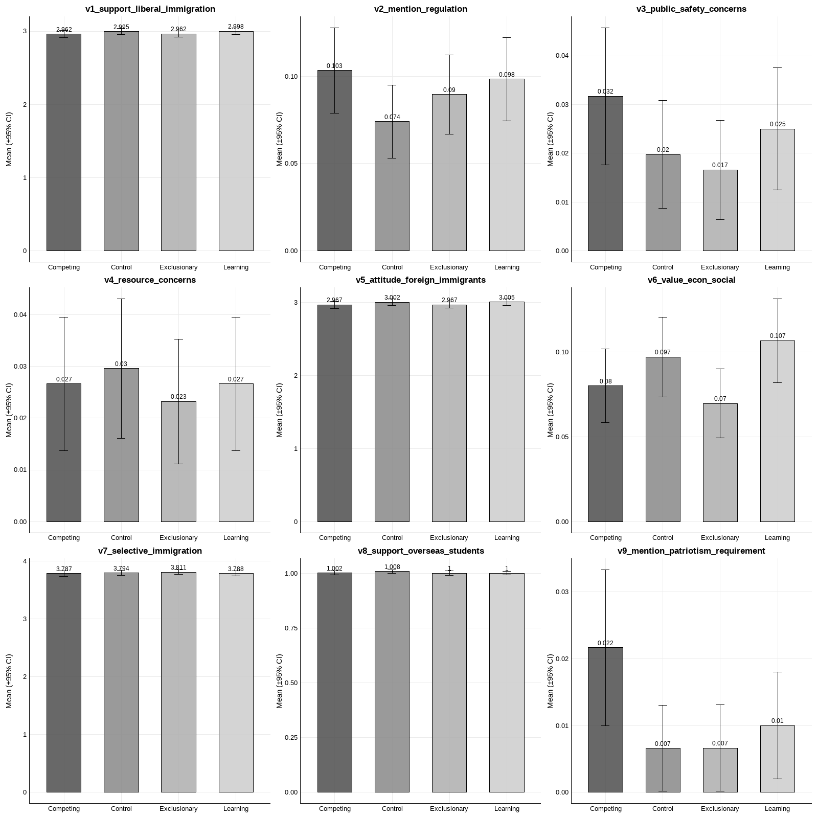

Figure A2 Themes in Open-ended Responses across Experimental Groups, Part II
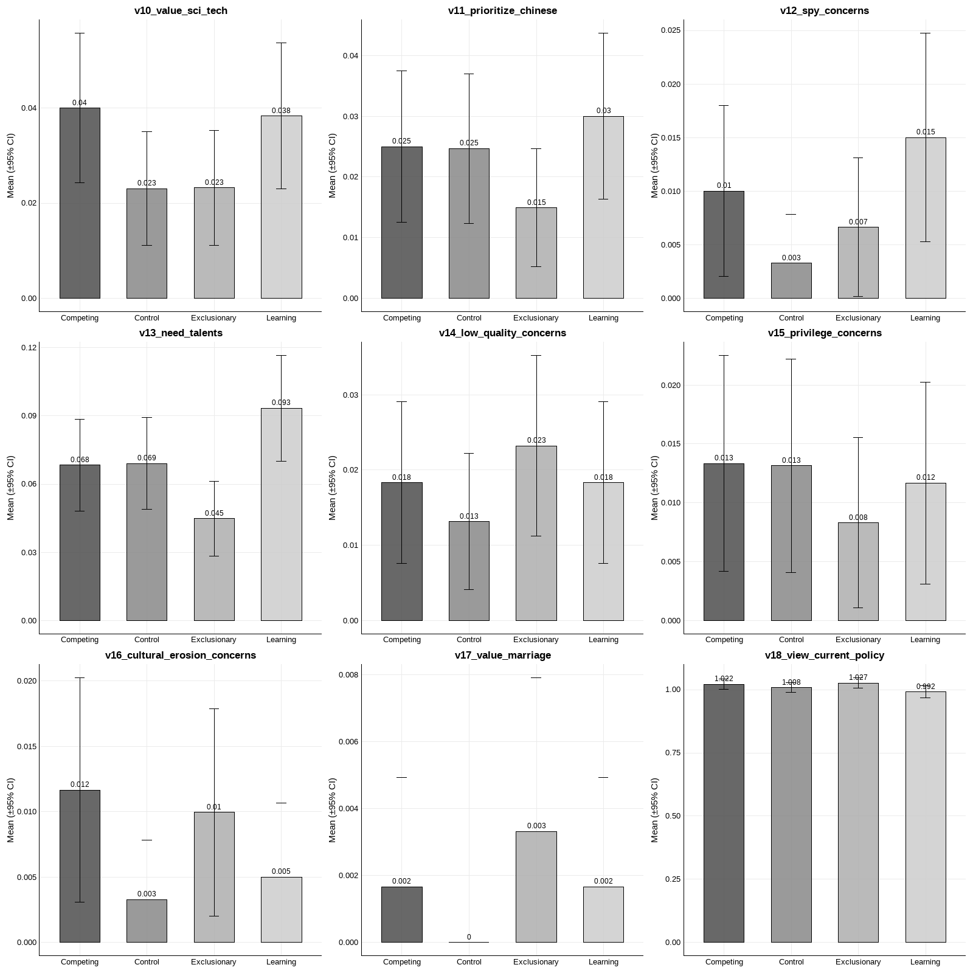

Figure A3 Themes in Open-ended Responses across Experimental Groups, Part III
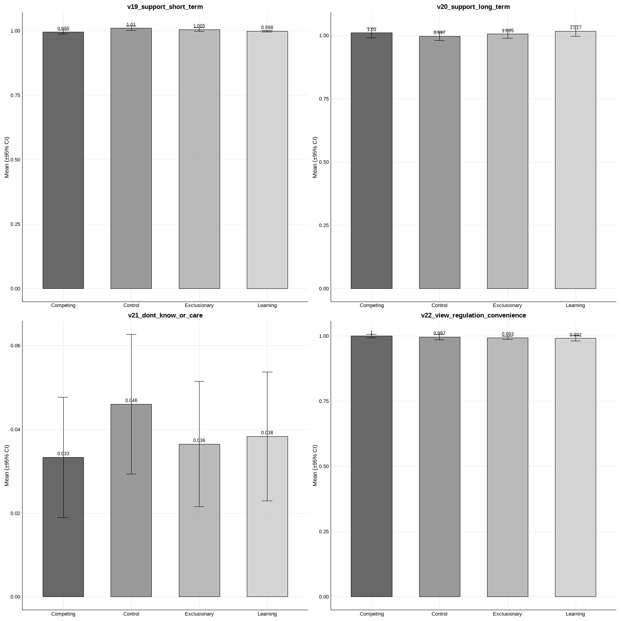

Figure A4 Mentions of Black People across Experimental Groups
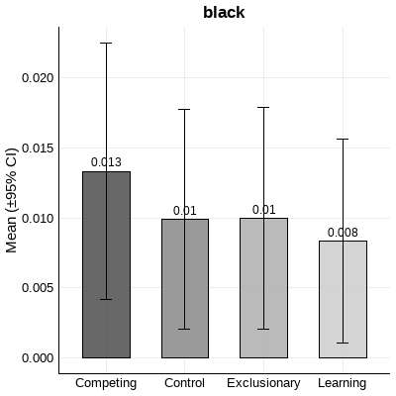

A.5 ABS-5 Questions and Descriptive Statistics
158. Do you think the government should increase or decrease the inflow of foreigners who come to work in our country?
- The government should increase the inflow of foreigners
- The government should maintain the current inflow of foreigners
- The government should reduce the inflow of foreigners
- The government should not allow any more foreigners
- [Do not read] Do not understand the question
- [Do not read] Can’t choose
- [Do not read] Decline to answer

Q174 Which country has the most influence in Asia?
- China
- Japan
- India
- United States
- Other (please name)
- [Do not read] Do not understand the question
- [Do not read] Can’t choose
- [Do not read] Decline to answer

Q179 In ten years, which country will have the most influence in Asia?
- China
- Japan
- India
- United States
- Other (please name)
- [Do not read] Do not understand the question
- [Do not read] Can’t choose
- [Do not read] Decline to answer
Note: Country teams may consider adding Russia as a country-specific option.

Q184 Generally speaking, the influence the United States has on our country is…
- Very positive
- Positive
- Somewhat positive
- Somewhat negative
- Negative
- Very negative
- [Do not read] Do not understand the question
- [Do not read] Can’t choose
- [Do not read] Decline to answer

Q156 National development preference
Statement 1: Our country should do more to defend our way of life.
Statement 2: Our country should do more to learn from other countries even if we might lose our country’s distinct way of life (or culture).
- [Do not read] Do not understand the question
- [Do not read] Can’t choose
- [Do not read] Decline to answer

Q156a Do you strongly agree or just agree with the chosen statement?
- Strongly agree
- Agree

Control Variables
Q175 Does the United States do more good or harm to Asia?
- Much more good than harm
- Somewhat more good than harm
- Somewhat more harm than good
- Much more harm than good
- [Do not read] Do not understand the question
- [Do not read] Can’t choose
- [Do not read] Decline to answer

Q176 Using a scale from 1 to 10, how positive or negative is the influence of the United States on world affairs today?
If “1” means highly negative and “10” means highly positive, where would you place the U.S. today?
Highly Negative — Highly Positive
1 2 3 4 5 6 7 8 9 10
- [Do not read] Do not understand the question
- [Do not read] Can’t choose
- [Do not read] Decline to answer

Q166 How proud are you to be a citizen of (COUNTRY)?
Are you…
- Very proud
- Somewhat proud
- Not very proud
- Not proud at all
- [Do not read] Do not understand the question
- [Do not read] Can’t choose
- [Do not read] Decline to answer

Q9 Trust in the national government
How much trust do you have in the national government (in the capital city)?
- Trust fully
- Trust a lot
- Trust somewhat
- Distrust somewhat
- Distrust a lot
- Distrust fully
- [Do not read] Do not understand the question
- [Do not read] Can’t choose
- [Do not read] Decline to answer

Q15 Trust in the local government
How much trust do you have in the local government?
- Trust fully
- Trust a lot
- Trust somewhat
- Distrust somewhat
- Distrust a lot
- Distrust fully
- [Do not read] Do not understand the question
- [Do not read] Can’t choose
- [Do not read] Decline to answer

Q22 General trust in people
Would you say that…
Most people can be trusted
You must be very careful in dealing with people
- [Do not read] Do not understand the question
- [Do not read] Can’t choose
- [Do not read] Decline to answer

Q50 Use of social media networks
Do you currently use any of the following social media networks (e.g., Facebook, Twitter, Telegram, WhatsApp, YouTube, Tumblr, Instagram, Snapchat)?
- Yes
- No

- [Do not read] Do not understand the question
- [Do not read] Can’t choose
- [Do not read] Decline to answer

Q46 Interest in politics
How interested would you say you are in politics?
- Very interested
- Somewhat interested
- Not very interested
- Not at all interested
- [Do not read] Do not understand the question
- [Do not read] Can’t choose
- [Do not read] Decline to answer

Q47 Frequency of following political news
How often do you follow news about politics and government?
- Everyday
- Several times a week
- Once or twice a week
- Not even once a week
- Practically never
- [Do not read] Do not understand the question
- [Do not read] Can’t choose
- [Do not read] Decline to answer

Q141 Perceived political ability
“I think I have the ability to participate in politics.”
- Strongly agree
- Somewhat agree
- Somewhat disagree
- Strongly disagree
- [Do not read] Do not understand the question
- [Do not read] Can’t choose
- [Do not read] Decline to answer

Q142 Perceived political understanding
“Sometimes politics and government seem so complicated that a person like me can’t really understand what is going on.”
- Strongly agree
- Somewhat agree
- Somewhat disagree
- Strongly disagree
- [Do not read] Do not understand the question
- [Do not read] Can’t choose
- [Do not read] Decline to answer

Q143 Perceived political influence
“People like me don’t have any influence over what the government does.”
- Strongly agree
- Somewhat agree
- Somewhat disagree
- Strongly disagree
- [Do not read] Do not understand the question
- [Do not read] Can’t choose
- [Do not read] Decline to answer

SE3 Birth year and actual age
Use year of birth, then convert to actual age.
(Lower limit: voting age; no upper limit)

SE5 Education
What is your highest level of education?
- No formal education
- Incomplete primary/elementary
- Complete primary/elementary
- Incomplete secondary/high school: technical/vocational
- Complete secondary/high school: technical/vocational
- Incomplete secondary/high school
- Complete secondary/high school
- Some university education
- University education completed
- Post-graduate degree

SE2 Gender
- Male
- Female

SE4 Marital status
- What is your marital status
- Single / Never married
- Married
- Living-in as married
- Widowed
- Separated / Not living with legal spouse
- Divorced
- Decline to answer

Q4 Perceived family economic condition
- As for your own family, how do you rate the economic situation of your family today?
- Very good
- Good
- So so (not good nor bad)
- Bad
- Very bad
- [Do not read] Do not understand the question
- [Do not read] Can’t choose
- [Do not read] Decline to answer

Table A9 Descriptive Statistics of ABS Data
 | Mean | SD | Min | Max
Support for immigration | 2.626493 | .6786868 | 1 | 4
Competitive nationalism | .4741955 | .4993842 | 0 | 1
Learning nationalism | .0445254 | .2062802 | 0 | 1
National pride | 3.591075 | .5377484 | 1 | 4
Age | 48.88403 | 17.30889 | 18 | 94
Education level | 5.179789 | 2.595319 | 1 | 10
Subjective income level | 3.185792 | .7339983 | 1 | 5
Gender | .5274236 | .4992979 | 0 | 1
Married | .7911354 | .4065386 | 0 | 1
Trust in central government | 5.273629 | .8217752 | 1 | 6
Trust in local government | 4.366727 | 1.070301 | 1 | 6
Social trust | 2.46691 | .5992302 | 1 | 3
Social media use | .7946772 | .2566721 | 0 | 1
Political news attention | 3.476017 | 1.544771 | 1 | 5
Political interest | 2.302267 | .7957141 | 1 | 4
Political efficacy1 | 2.228496 | .5779392 | 1 | 4
Political efficacy2 | 2.265736 | .5535292 | 1 | 4
Political efficacy3 | 2.282028 | .6010692 | 1 | 4
U.S. influence in the world | 6.076098 | 2.075078 | 1 | 10
U.S. influence on China | 3.926128 | 1.116497 | 1 | 6
China’s influence in Asia | 1.367739 | .8059518 | 0 | 2
Observations | 4941

