Supplementary materials
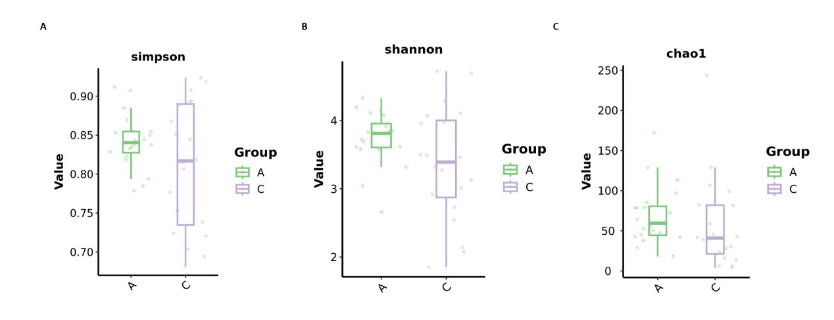
Supplementary Figure S1. Alpha diversity of CSF-associated microbial communities in the discovery cohort.
(A) Simpson diversity, (B) Shannon diversity, and (C) Chao1 richness were compared between patients with ALS and non-ALS neurological controls using the Wilcoxon rank-sum test. No significant between-group differences were observed (all P > 0.05). Boxes show medians and interquartile ranges, and points represent individual samples. A, ALS; C, non-ALS neurological controls.

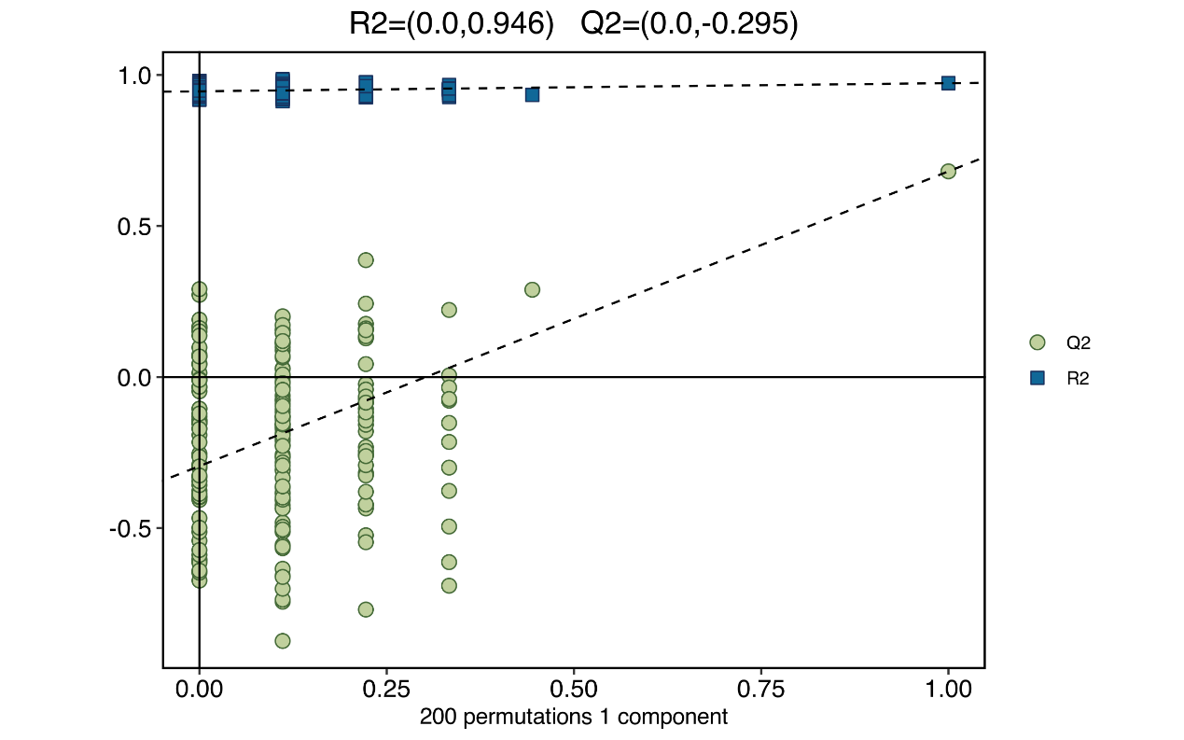
Supplementary Figure S2. Permutation testing of the discovery-cohort OPLS-DA model.
Permutation validation (200 permutations) of the OPLS-DA model distinguishing ALS patients (n = 18) from non-ALS neurological controls (n = 18) based on CSF metabolomics. Blue squares and green circles denote permuted R² and Q² values, respectively; dashed lines show the corresponding regression lines. The original model (rightmost points) achieved R² = 0.946 and Q² = 0.676, with regression intercepts of 0.0 for R² and −0.295 for Q². The negative Q² intercept did not indicate obvious overfitting in this permutation assessment.

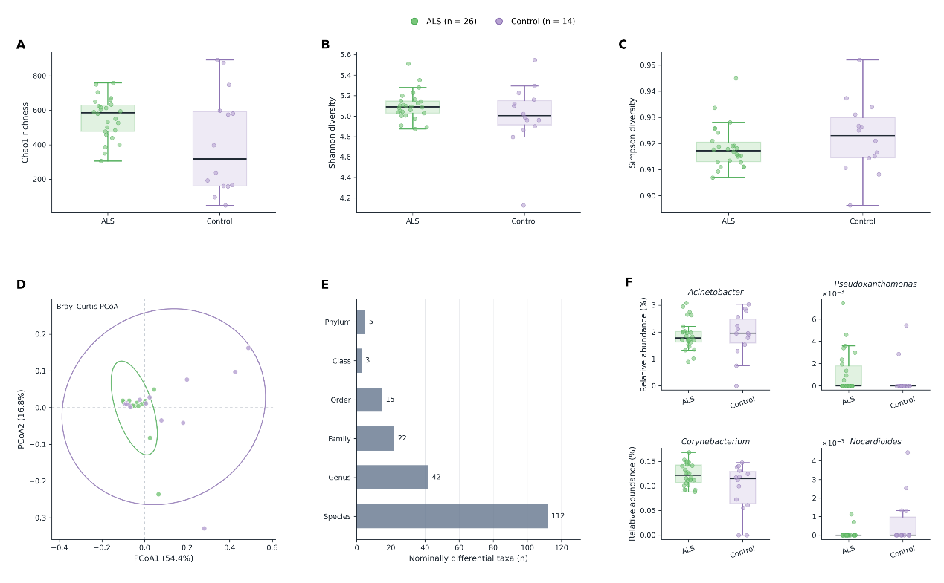
Supplementary Figure S3. Microbiome findings in the validation cohort.
(A–C) Comparison of Chao1 richness, Shannon diversity, and Simpson diversity between patients with ALS and non-ALS neurological controls. No significant between-group differences were detected (two-sided Mann–Whitney U test: Chao1, P = 0.076; Shannon, P = 0.266; Simpson, P = 0.318).
(D) Principal coordinate analysis based on Bray–Curtis dissimilarity. PCoA1 and PCoA2 explained 54.4% and 16.8% of the variation, respectively. A group-associated difference was detected by PERMANOVA (pseudo-F = 6.089, R² = 0.138, P = 0.002) and supported by ANOSIM (R = 0.229, P = 0.005). Considerable overlap and broader dispersion among controls remained evident; therefore, the ordination should not be interpreted as complete separation between the groups.
(E) Numbers of taxa showing nominal between-group differences at each taxonomic level (P < 0.05). None remained significant after Benjamini–Hochberg correction.
(F) Relative abundances of the four candidate genera identified in the discovery cohort. None differed significantly in the validation cohort. Boxes represent the interquartile range, horizontal lines indicate medians, whiskers extend to 1.5 times the interquartile range, and points represent individual participants.

