Supplementary Table 1. Regional distribution of COVID-19 incidence rates per 1,000 residents across 197 public housing estates in Hong Kong.
Region | n | Mean | Median | SD | Min | Max
Kowloon East | 50 | 2.16 | 1.61 | 1.76 | 0.06 | 8.92
Kowloon West | 25 | 1.86 | 1.66 | 0.85 | 0.58 | 4.05
New Territories West | 58 | 1.81 | 1.37 | 1.91 | 0.04 | 13.64
New Territories East | 47 | 1.30 | 1.18 | 0.77 | 0.21 | 4.58
Hong Kong Island | 17 | 1.14 | 0.86 | 1.40 | 0.16 | 6.06

Supplementary Table 2. District-level distribution of COVID-19 incidence rates per 1,000 residents across 197 public housing estates in Hong Kong.
District | n | Mean | Median | SD | Min | Max
Wong Tai Sin | 18 | 2.96 | 2.16 | 2.36 | 0.06 | 8.92
Tsuen Wan | 4 | 2.70 | 2.22 | 1.70 | 1.30 | 5.07
Kwai Tsing | 21 | 2.41 | 1.55 | 2.77 | 0.04 | 13.64
Kowloon City | 6 | 2.01 | 1.78 | 0.74 | 1.18 | 3.00
Sham Shui Po | 18 | 1.87 | 1.74 | 0.87 | 0.58 | 4.05
Tuen Mun | 13 | 1.85 | 1.67 | 0.85 | 1.06 | 4.28
Kwun Tong | 32 | 1.71 | 1.40 | 1.13 | 0.21 | 6.01
Tai Po | 6 | 1.48 | 1.43 | 0.81 | 0.51 | 2.82
Sha Tin | 20 | 1.40 | 1.23 | 0.95 | 0.21 | 4.58
Eastern | 11 | 1.34 | 0.77 | 1.71 | 0.16 | 6.06
Sai Kung | 10 | 1.27 | 1.03 | 0.63 | 0.64 | 2.67
Yuen Long | 15 | 1.12 | 0.97 | 0.84 | 0.10 | 3.50
North | 11 | 1.04 | 0.92 | 0.44 | 0.30 | 1.84
Southern | 6 | 0.76 | 0.93 | 0.45 | 0.17 | 1.29
Yau Tsim Mong | 1 | 0.63 | — | — | 0.63 | 0.63
Islands | 5 | 0.60 | 0.33 | 0.65 | 0.10 | 1.72

Supplementary Table 3. Kruskal-Wallis test results comparing COVID-19 incidence rates by region and district across public housing estates in Hong Kong.
Grouping | H | df | p-value | η² | Effect size
Region | 20.92 | 4 | < 0.001 | 0.107 | Moderate
District | 45.67 | 15 | < 0.001 | 0.233 | Large

Supplementary Table 4. Pairwise regional comparisons of COVID-19 incidence rates using Dunn’s post hoc test with Bonferroni correction.
Group 1 | Group 2 | p (Bonferroni) | Significant
Hong Kong Island | Kowloon East | 0.003 | Yes ✓
Hong Kong Island | Kowloon West | 0.006 | Yes ✓
Hong Kong Island | New Territories East | 1.000 | No
Hong Kong Island | New Territories West | 0.066 | No
Kowloon East | Kowloon West | 1.000 | No
Kowloon East | New Territories East | 0.032 | Yes ✓
Kowloon East | New Territories West | 1.000 | No
Kowloon West | New Territories East | 0.079 | No
Kowloon West | New Territories West | 1.000 | No
New Territories East | New Territories West | 1.000 | No

Supplementary Table 5. Highest-ranked Spearman rank correlations between estate-level socioeconomic predictors and COVID-19 incidence rates per 1,000 residents, with Benjamini-Hochberg false discovery rate correction.
Variable | Domain | ρ | p (unadj.) | q (BH)
Average household size | Demographic | -0.192 | 0.007 | 0.102
Rent-to-income ratio | Socioeconomic | 0.182 | 0.011 | 0.102
Single-person HH proportion | Demographic | 0.173 | 0.015 | 0.102
Craft & related workers proportion | Occupational | 0.164 | 0.022 | 0.108
Median HH income (HK$) | Socioeconomic | -0.147 | 0.039 | 0.157
Low-income HH proportion | Socioeconomic | 0.134 | 0.061 | 0.202
Elderly (65+) proportion | Demographic | 0.111 | 0.122 | 0.348

Supplementary Table 6. Full Spearman rank correlation results for estate-level socioeconomic, demographic, occupational, and living-environment predictors of COVID-19 incidence.
Variable | Domain | ρ | p (unadj.) | q (BH) | Effect size
Average household size | Demographic | -0.192 | 0.007 | 0.102 | Weak
Rent-to-income ratio | Socioeconomic | 0.182 | 0.011 | 0.102 | Weak
Single-person HH proportion | Demographic | 0.173 | 0.015 | 0.102 | Weak
Craft & related workers proportion | Occupational | 0.164 | 0.022 | 0.108 | Weak
Median HH income (HK$) | Socioeconomic | -0.147 | 0.039 | 0.157 | Weak
Low-income HH proportion | Socioeconomic | -0.134 | 0.061 | 0.202 | Weak
Elderly (65+) proportion | Demographic | 0.111 | 0.122 | 0.348 | Weak
Elderly × Single-person HH | Demographic | 0.094 | 0.189 | 0.474 | Negligible
Median floor area (m²) | Living Environment | -0.088 | 0.221 | 0.491 | Negligible
Estate share of district population | Living Environment | -0.078 | 0.276 | 0.551 | Negligible
Manual/on-site index | Occupational | 0.067 | 0.352 | 0.586 | Negligible
Associate professionals proportion | Occupational | -0.071 | 0.325 | 0.586 | Negligible
High-contact service index | Occupational | 0.043 | 0.548 | 0.783 | Negligible
Service & sales workers proportion | Occupational | 0.043 | 0.548 | 0.783 | Negligible
Floor area per person (m²) | Living Environment | 0.019 | 0.792 | 0.932 | Negligible
Remote-capable index | Occupational | -0.038 | 0.598 | 0.797 | Negligible
Clerical support workers proportion | Occupational | -0.009 | 0.902 | 0.991 | Negligible
Elementary occupations proportion | Occupational | -0.022 | 0.764 | 0.932 | Negligible
Professionals proportion | Occupational | 0.003 | 0.968 | 0.991 | Negligible
Managers proportion | Occupational | 0.001 | 0.991 | 0.991 | Negligible

Supplementary Table 7. Performance of the Random Forest regression model in predicting log-transformed COVID-19 incidence rates per 1,000 residents across 197 public housing estates
Metric | 5-Fold CV (training set) | Held-out test set
RMSE | 0.431 ± 0.038 | 0.364
MAE | 0.325 ± 0.025 | 0.292
R² | ≈0 (−0.073±0.161) | 0.225
Explained Variance | ≈0 | 0.228

Supplementary Table 8. SHAP-based feature importance for the Random Forest model predicting log-transformed COVID-19 incidence rates across 197 public housing estates in Hong Kong.
Rank | Feature | Mean |φ| | 95% CI | Primary SHAP direction
1 | Low-income households (<10k) | 0.0445 | 0.040-0.049 | Positive (high values → higher incidence)
2 | Elderly isolation rate | 0.0436 | 0.039-0.049 | Predominantly positive
3 | Craft workers proportion | 0.0420 | 0.038-0.047 | Predominantly positive (with variance)
4 | Avg. household size | 0.0377 | 0.034-0.041 | Bidirectional (context-dependent)
5 | Rent-to-income ratio | 0.0368 | 0.033-0.041 | Positive
6 | Remote-capable index | 0.0298 | 0.027-0.033 | Predominantly negative (protective)
7 | Elderly (65+) proportion | 0.0260 | 0.023-0.029 | Positive
8 | Single-person household proportion | 0.0215 | 0.018-0.025 | Positive
9 | Floor area per person (m²) | 0.0199 | 0.017-0.022 | Negative (protective)

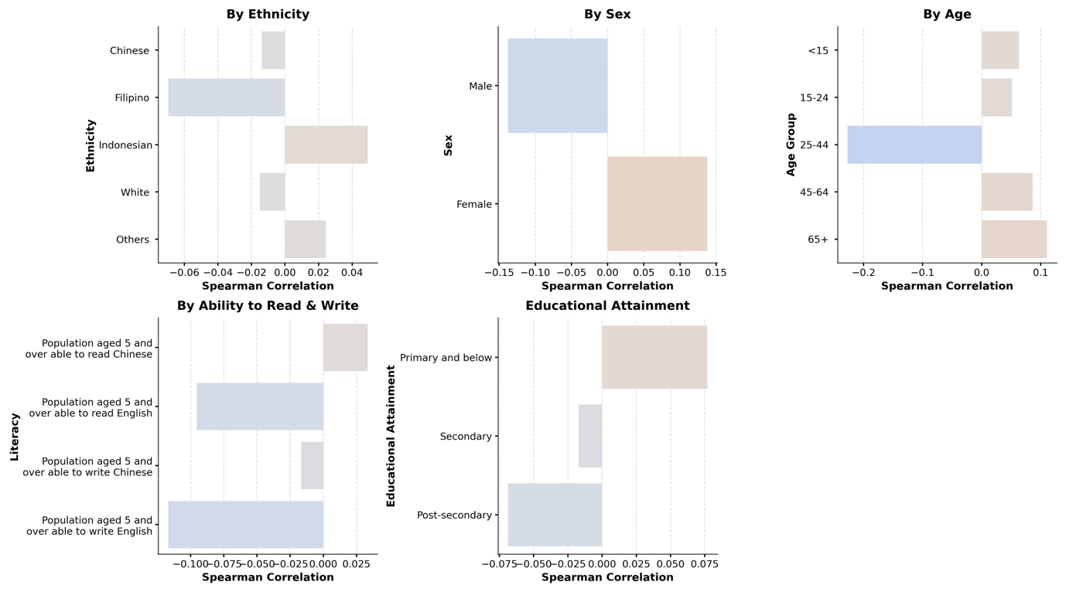
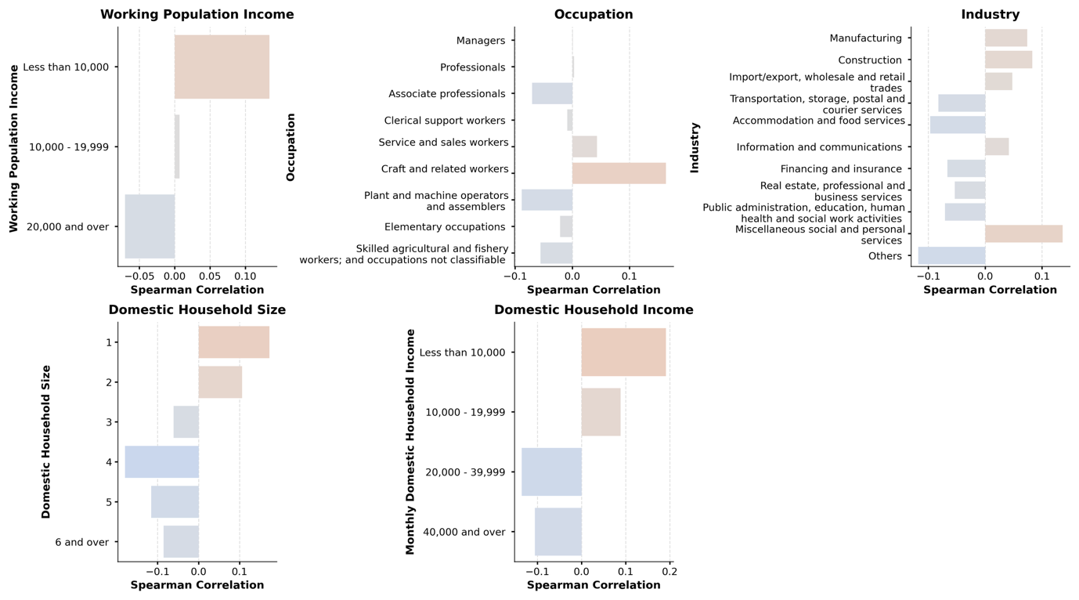
Supplementary Figure 1. Spearman rank correlation coefficients between estate-level public housing characteristics and COVID-19 incidence rates in Hong Kong. Variables are grouped by thematic domain, including demographic composition, socioeconomic status, education, employment and occupational structure, living environment, housing affordability, and financial burden. Positive correlations are shown in red and negative correlations in blue.

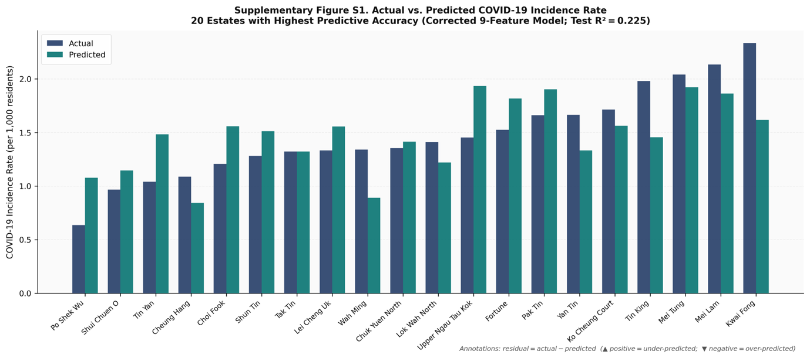
Supplementary Figure 2. Predicted against observed COVID-19 incidence in the held-out test set. The bar chart compares model-predicted COVID-19 incidence with observed values for each test-set observation, illustrating the agreement between predicted and actual outcomes.

