Supplementary Information

Detection of candidate gene LsACOS5 and development of InDel marker for male sterility by ddRAD-seq and whole-genome sequencing in lettuce (Lactuca sativa L.)

This file includes:
Supplementary Fig. S1 and S2
Supplementary Table S1

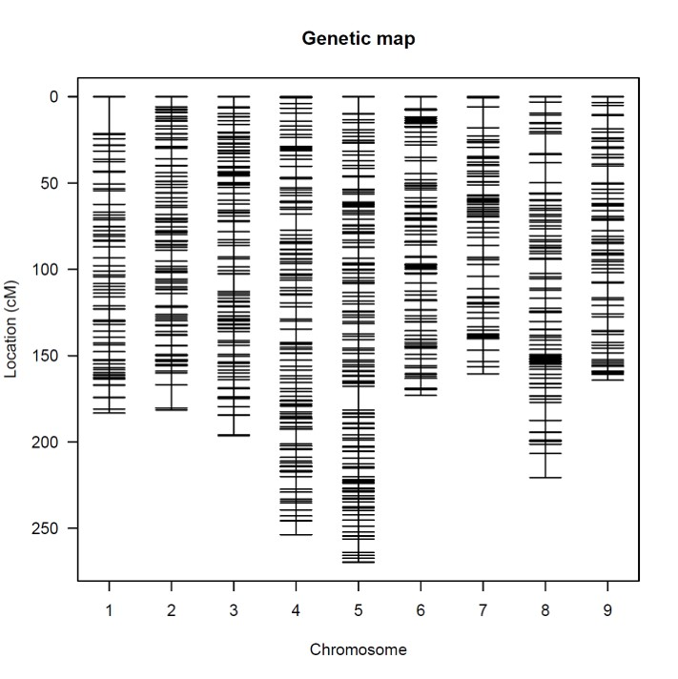
Fig. S1
Schematic representation of consensus map for an F₂ population derived from a cross between ‘2008–83(MS)’ and ‘UenoyamaMaruba’. The horizontal lines indicate the positions of loci of the markers on each linkage group

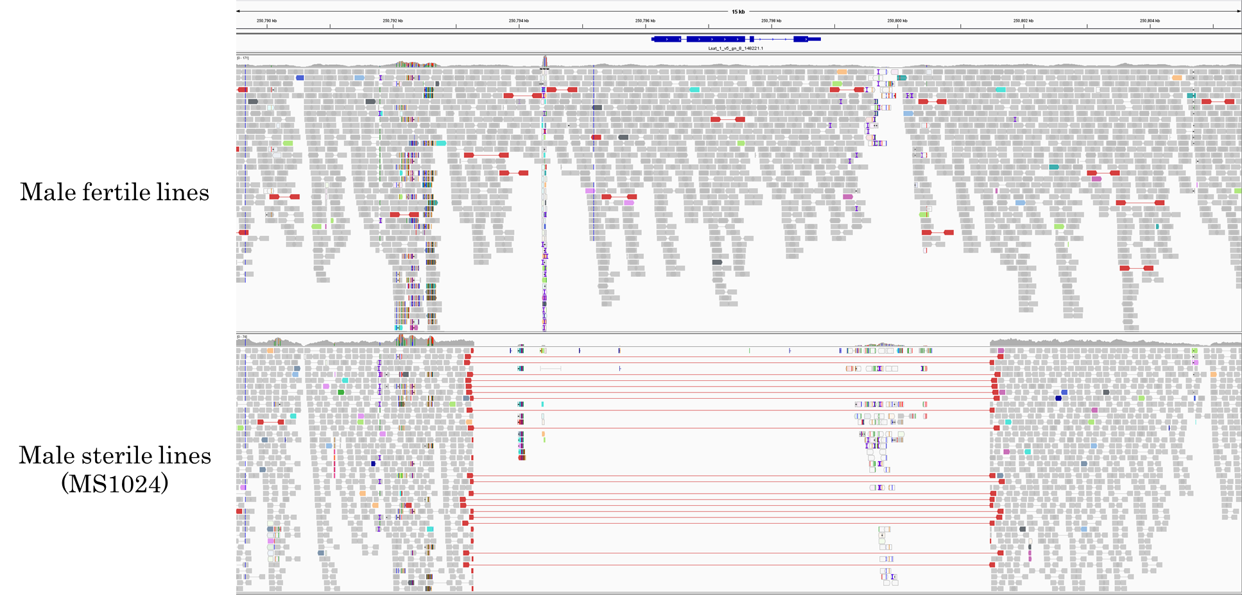
Fig. S2
Screenshot of IGV software at around 250.7Mb on LG8. Sequence reads of male-fertile and sterile lines aligned against a reference genome sequence. The deletion is displayed only in the male-sterile lines (MS1024).
Table S1
Polymorphisms in the predicted genes between LG8_v8_246.869Mbp and LG8_v8_257.031Mbp
