Additional file 1
Divergent drivers of enteric disease burden in six East Asian settings, 1990–2023: a decomposition analysis of the Global Burden of Disease Study 2023
Supplementary tables and figures

Table S2. Case definitions for diarrhoeal diseases and typhoid and paratyphoid fevers in GBD 2023
Disease | Definition (GBD 2023)
• Typhoid and paratyphoid fevers | Defined as febrile illness caused by Salmonella enterica serovar Typhi or Paratyphi, treating reported cases as confirmed despite limited blood culture sensitivity.  All cases corresponding to ICD-10 code A01 (typhoid and paratyphoid fevers) were included.
• Diarrhoeal diseases | Defined as three or more loose stools within a 24-hour period, with self-reported prevalence as the reference definition.  Inpatient and claims-based episodes identified using ICD-9 (001–009.9) and ICD-10 (A00–A09) codes were treated as alternative definitions.

Table S3. Trends in age-standardised prevalence and DALYs of typhoid and paratyphoid, 1990–2023
 | 1990 ASR | 2023 ASR | EAPC (%)
Prevalence
China | 1.16 (0.82–1.63) | 0.58 (0.42–0.82) | −2.21 (−2.30 to −2.11)
Japan | 0.01 (0.01–0.01) | 0.01 (0.01–0.02) | 0.34 (0.21 to 0.47)
ROK | 0.00 (0.00–0.00) | 0.00 (0.00–0.00) | −5.02 (−5.21 to −4.82)
DPRK | 0.41 (0.29–0.57) | 0.07 (0.05–0.09) | −5.37 (−5.42 to −5.32)
Mongolia | 0.01 (0.01–0.01) | 0.00 (0.00–0.00) | −6.36 (−6.57 to −6.14)
Taiwan | 0.20 (0.14–0.28) | 0.03 (0.02–0.04) | −5.93 (−6.09 to −5.77)
DALYs
China | 12.37 (5.84–22.28) | 4.91 (2.42–8.52) | −2.88 (−2.94 to −2.82)
Japan | 0.04 (0.04–0.05) | 0.02 (0.01–0.02) | −3.52 (−4.73 to −2.30)
ROK | 0.00 (0.00–0.00) | 0.00 (0.00–0.00) | −5.92 (−6.09 to −5.75)
DPRK | 5.15 (2.76–8.45) | 0.88 (0.46–1.57) | −4.97 (−5.04 to −4.89)
Mongolia | 0.13 (0.07–0.23) | 0.01 (0.01–0.02) | −6.49 (−6.82 to −6.16)
Taiwan | 0.50 (0.38–0.65) | 0.06 (0.04–0.09) | −5.91 (−6.71 to −5.10)
Data in parentheses are 95% uncertainty intervals, and rates are expressed per 100 000 population.
Abbreviations: ROK, Republic of Korea; DPRK, Democratic People's Republic of Korea; ASR, Age-standardized rate; DALYs, Disability-Adjusted Life Years; EAPC, Estimated Annual Percentage Change

Table S4. Trends in age-standardised incidence, YLDs, and YLLs of diarrhoeal diseases, 1990–2023
 | 1990 ASR | 2023 ASR | EAPC (%)
Incidence
China | 29,286.42 (24,838.00–34,832.38) | 15,554.44 (12,311.80–19,082.84) | −4.72 (−5.34 to −4.10)
Japan | 25,449.54 (21,268.49–31,103.83) | 20,286.34 (16,650.87–24,484.14) | 0.89 (0.41 to 1.37)
ROK | 6,163.93 (5,133.37–7,533.11) | 5,517.00 (4,605.83–6,658.81) | 0.04 (−0.16 to 0.24)
DPRK | 9,260.92 (78,26.42–10,847.61) | 65,355.84 (53,738.43–78,070.77) | 6.66 (6.37 to 6.95)
Mongolia | 14,751.89 (12,265.06–17,697.99) | 3,135.58 (2,539.76–3,918.73) | −4.52 (−5.18 to −3.85)
Taiwan | 15,843.50 (13,681.90–18,179.28) | 54,370.55 (46,218.34–61,710.86) | 4.12 (3.75 to 4.48)
YLDs
China | 55.99 (39.09–80.09) | 27.35 (17.99–39.04) | −5.19 (−5.87 to −4.51)
Japan | 48.77 (33.52–69.77) | 38.06 (25.61–53.50) | 0.65 (0.23 to 1.07)
ROK | 10.57 (7.05–15.25) | 9.59 (6.36–13.58) | 0.07 (−0.13 to 0.27)
DPRK | 15.93 (10.53–21.71) | 123.82 (85.54–173.91) | 7.00 (6.69 to 7.32)
Mongolia | 26.30 (17.64–37.54) | 5.06 (3.38–7.51) | −4.75 (−5.47 to −4.03)
Taiwan | 28.52 (19.39–39.62) | 93.79 (64.76–128.24) | 4.00 (3.60 to 4.40)
YLLs
China | 718.56 (582.74–886.40) | 9.67 (7.41–13.76) | −13.62 (−14.22 to −13.03)
Japan | 21.22 (19.22–23.53) | 14.19 (12.27–16.53) | −0.85 (−1.34 to −0.35)
ROK | 80.25 (51.75–101.69) | 24.95 (17.25–40.94) | −2.67 (−3.17 to −2.16)
DPRK | 112.96 (56.18–196.85) | 28.37 (16.02–47.43) | −4.18 (−4.41 to −3.95)
Mongolia | 1,192.63 (671.54–1,888.83) | 19.42 (11.73–30.68) | −12.96 (−13.47 to −12.44)
Taiwan | 57.79 (52.42–62.91) | 8.78 (7.66–10.13) | −5.67 (−6.48 to −4.86)
Data in parentheses are 95% uncertainty intervals, and rates are expressed per 100 000 population.
Abbreviations: ROK, Republic of Korea; DPRK, Democratic People’s Republic of Korea; ASR, Age-standardized rate; YLDs, Years Lived with Disability; YLLs, Years of Life Lost; EAPC, Estimated Annual Percentage Change.

Table S5. Trends in age-standardised incidence, YLDs, and YLLs of typhoid and paratyphoid, 1990–2023
 | 1990 ASR | 2023 ASR |  | EAPC (%)
Incidence
China | 20.41 (16.47–24.57) | 10.32 (8.53–12.14) |  | −2.19 (−2.29 to −2.10)
Japan | 0.20 (0.15–0.26) | 0.24 (0.18–0.31) |  | 0.35 (0.22 to 0.48)
ROK | 0.00 (0.00–0.01) | 0.00 (0.00–0.00) |  | −5.03 (−5.22 to −4.84)
DPRK | 7.29 (6.00–8.67) | 1.18 (0.96–1.43) |  | −5.37 (−5.42 to −5.32)
Mongolia | 0.17 (0.13–0.20) | 0.02 (0.02–0.03) |  | −6.34 (−6.55 to −6.12)
Taiwan | 3.56 (2.90–4.28) | 0.46 (0.37–0.55) |  | −5.94 (−6.09 to −5.78)
YLDs
China | 0.15 (0.09–0.26) | 0.08 (0.05–0.13) |  | −2.24 (−2.34 to −2.14)
Japan | 0.00 (0.00–0.00) | 0.00 (0.00–0.00) |  | 0.30 (0.18 to 0.43)
ROK | 0.00 (0.00–0.00) | 0.00 (0.00–0.00) |  | −4.99 (−5.18 to −4.80)
DPRK | 0.05 (0.03–0.09) | 0.01 (0.01–0.02) |  | −5.38 (−5.43 to −5.33)
Mongolia | 0.00 (0.00–0.00) | 0.00 (0.00–0.00) |  | −6.41 (−6.63 to −6.18)
Taiwan | 0.03 (0.02–0.04) | 0.00 (0.00–0.01) |  | −5.92 (−6.08 to −5.76)
YLLs
China | 12.22 (5.68–22.16) | 4.84 (2.32–8.45) |  | −2.89 (−2.95 to −2.83)
Japan | 0.04 (0.03–0.05) | 0.02 (0.01–0.02) |  | −3.79 (−5.07 to −2.48)
ROK | 0.00 (0.00–0.00) | 0.00 (0.00–0.00) |  | −5.93 (−6.10 to −5.77)
DPRK | 5.10 (2.70–8.40) | 0.87 (0.45–1.56) |  | −4.96 (−5.04 to −4.89)
Mongolia | 0.13 (0.07–0.23) | 0.01 (0.01–0.02) |  | −6.49 (−6.83 to −6.16)
Taiwan | 0.47 (0.36–0.62) | 0.06 (0.04–0.08) |  | −5.91 (−6.76 to −5.05)
Data in parentheses are 95% uncertainty intervals, and rates are expressed per 100 000 population.
Abbreviations: ROK, Republic of Korea; DPRK, Democratic People’s Republic of Korea; ASR, Age-standardized rate; YLDs, Years Lived with Disability; YLLs, Years of Life Lost; EAPC, Estimated Annual Percentage Change.

Table S6. Age-standardised incidence, prevalence, DALYs, YLDs, and YLLs of diarrhoeal diseases among men in 1990 and 2023
 | 1990 ASR | 2023 ASR | EAPC (%)
MALE
Prevalence
China | 526.23 (453.63–618.34) | 238.17 (189.67–302.50) | −5.34 (−5.99 - −4.68)
Japan | 429.37 (354.98–539.59) | 342.11 (280.23–418.12) | 0.61 (0.19 to 1.03)
ROK | 89.13 (73.65–110.41) | 82.18 (67.93–104.24) | 0.11 (−0.07 to 0.30)
DPRK | 116.36 (97.69–134.82) | 624.28 (501.02–777.04) | 5.22 (4.97 to 5.46)
Mongolia | 218.26 (179.84–263.80) | 43.84 (35.50–54.16) | −4.56 (−5.29 to −3.82)
Taiwan | 245.16 (212.87–281.09) | 674.71 (578.27–780.17) | 3.07 (2.64 to 3.49)
Incidence
China | 30,987.81 (26,117.40–36,919.93) | 15,113.88 (11,934.53–18,779.74) | −4.85 (−5.44 to −4.26)
Japan | 25,435.19 (20,962.83–31,136.79) | 20,642.96 (17,030.46–25,019.81) | 0.84 (0.37 to 1.32)
ROK | 5,884.36 (4,751.85–7,268.42) | 5,353.97 (4,350.03–6,544.97) | 0.09 (−0.10 to 0.27)
DPRK | 7,592.89 (6,374.49–8,837.32) | 38,733.14 (30650.68–46,752.00) | 5.08 (4.85 to 5.30)
Mongolia | 14,158.96 (11,463.98–17,225.37) | 3,152.52 (2571.31–3,909.15) | −4.33 (−5.00 to −3.65)
Taiwan | 15,154.43 (12,936.26–17,445.23) | 43,170.60 (36,576.70–50,165.77) | 3.18 (2.81 to 3.55)
DALYs
China | 885.37 (651.17–1167.49) | 37.72 (26.96–50.33) | −11.55 (−12.14 to −10.94)
Japan | 72.79 (55.89–93.41) | 57.13 (44.15–73.02) | 0.26 (−0.16 to 0.68)
ROK | 92.65 (51.54–131.42) | 35.35 (21.66–66.07) | −2.05 (−2.44 to −1.67)
DPRK | 145.13 (71.49–268.74) | 106.06 (72.62–144.22) | −1.21 (−1.43 to −1.00)
Mongolia | 1348.81 (709.62–2599.78) | 25.19 (13.69–45.58) | −12.27 (−12.69 to −11.85)
Taiwan | 93.29 (81.73–105.79) | 85.72 (61.16–111.44) | 0.02 (−0.74 to 0.79)
YLDs
China | 60.27 (41.82–86.08) | 27.09 (17.98–39.45) | −5.36 (−6.02 to −4.70)
Japan | 48.89 (33.51–69.98) | 38.67 (25.97–54.50) | 0.60 (0.18 to 1.02)
ROK | 10.10 (6.54–14.82) | 9.32 (6.15–13.75) | 0.11 (−0.08 to 0.29)
DPRK | 13.39 (8.95–19.19) | 70.67 (47.80–100.19) | 5.16 (4.92 to 5.41)
Mongolia | 25.26 (16.68–35.58) | 5.09 (3.36–7.58) | −4.55 (−5.28 to −3.80)
Taiwan | 27.79 (19.07–38.92) | 75.33 (51.35–101.35) | 3.02 (2.62 to 3.43)
YLLs
China | 825.10 (585.47–1,110.08) | 10.63 (7.26–16.97) | −13.64 (−14.16 to −13.12)
Japan | 23.90 (20.84–27.65) | 18.46 (15.52–21.98) | −0.54 (−1.04 to −0.04)
ROK | 82.55 (42.32–121.32) | 26.03 (14.07–57.96) | −2.58 (−3.02 to −2.13)
DPRK | 131.74 (59.39–255.82) | 35.40 (15.33–71.22) | −3.93 (−4.15 to −3.71)
Mongolia | 1323.55 (682.18–2,578.74) | 20.11 (9.08–40.70) | −13.08 (−13.57 to −12.58)
Taiwan | 65.50 (57.15–72.60) | 10.39 (8.82–12.35) | −5.38 (−6.21 to −4.55)
Data in parentheses are 95% uncertainty intervals, and rates are expressed per 100 000 population.
Abbreviations: ROK, Republic of Korea; DPRK, Democratic People’s Republic of Korea; ASR, Age-standardized rate; DALYs, Disability-Adjusted Life Years; YLDs, Years Lived with Disability; YLLs, Years of Life Lost; EAPC, Estimated Annual Percentage Change.

Table S7. Age-standardised incidence, prevalence, DALYs, YLDs, and YLLs of diarrhoeal diseases among women in 1990 and 2023
Female
Prevalence
China | 449.02 (386.23–535.18) | 243.72 (194.71–303.47) | −4.96 (−5.66 to −4.25)
Japan | 428.72 (355.68–533.83) | 332.04 (272.21–408.40) | 0.71 (0.29 to 1.13)
ROK | 96.37 (79.23–117.76) | 86.17 (72.66–103.52) | 0.05 (−0.19 to 0.28)
DPRK | 160.15 (132.65–189.88) | 1561.27 (1271.95–1923.73) | 8.00 (7.62 to 8.39)
Mongolia | 236.82 (197.54–288.36) | 43.42 (35.07–53.18) | −4.96 (−5.66 to −4.25)
Taiwan | 260.81 (228.46–300.39) | 1007.28 (867.61–1174.56) | 4.74 (4.32 to 5.16)
Incidence
China | 27,362.23 (23,272.52–32,652.63) | 15,982.78 (12,659.85–19,610.13) | −4.58 (−5.25 to −3.92)
Japan | 25,440.07 (20,838.03–31,226.14) | 19,998.65 (16,435.50–24,331.71) | 0.95 (0.46 to 1.44)
ROK | 6,397.26 (5,271.65–7,802.54) | 5,626.55 (4,687.12–6,786.34) | −0.02 (−0.24 to 0.21)
DPRK | 10,661.51 (8,773.62–12,724.50) | 91,148.85 (74,558.67–110,552.00) | 7.51 (7.16 to 7.87)
Mongolia | 15,354.51 (126,24.41–18,507.75) | 3,125.52 (2,535.74–3,893.90) | −4.70 (−5.34 to −4.05)
Taiwan | 16,561.03 (14,192.28–19,100.57) | 64,734.66 (54,852.56–74,480.16) | 4.74 (4.36 to 5.11)
DALYs
China | 648.59 (492.58–852.12) | 36.19 (26.98–48.57) | −11.17 (−11.91 to −10.42)
Japan | 67.43 (51.37–89.26) | 48.02 (34.77–63.70) | 0.27 (−0.14 to 0.68)
ROK | 88.27 (59.02–115.51) | 32.83 (24.26–46.75) | −2.21 (−2.66 to −1.75)
DPRK | 113.12 (51.10–241.69) | 197.36 (135.83–284.87) | 1.97 (1.59 to 2.35)
Mongolia | 1,087.20 (440.77–2,278.60) | 23.82 (13.31–40.29) | −12.00 (−12.45 to −11.55)
Taiwan | 78.83 (64.45–93.24) | 118.11 (82.53–159.36) | 1.95 (1.22 to 2.68)
YLDs
China | 51.21 (35.75–73.44) | 27.54 (17.94–39.60) | −5.00 (−5.71 to −4.29)
Japan | 48.60 (33.41–69.70) | 37.57 (25.22–52.97) | 0.71 (0.29 to 1.12)
ROK | 10.98 (7.03–15.59) | 9.78 (6.22–14.43) | 0.02 (−0.21 to 0.26)
DPRK | 18.07 (12.09–25.31) | 175.83 (119.39–251.15) | 7.98 (7.60 to 8.37)
Mongolia | 27.36 (18.92–38.90) | 5.04 (3.30–7.58) | −4.94 (−5.65 to −4.24)
Taiwan | 29.25 (19.63–40.86) | 110.83 (76.18–152.63) | 4.67 (4.27 to 5.08)
YLLs
China | 597.38 (444.30–796.63) | 8.65 (6.54–11.65) | −13.55 (−14.25 to −12.85)
Japan | 18.83 (16.17–22.20) | 10.45 (8.30–12.59) | −1.20 (−1.70 to −0.70)
ROK | 77.28 (47.30–104.36) | 23.06 (15.50–37.91) | −2.85 (−3.41 to −2.29)
DPRK | 95.06 (34.94–227.40) | 21.53 (10.11–45.40) | −4.56 (−4.81 to −4.31)
Mongolia | 1,059.84 (415.05–2,247.81) | 18.78 (9.17–35.17) | −12.81 (−13.36 to −12.26)
Taiwan | 49.58 (43.34–56.92) | 7.28 (5.87–8.90) | −5.99 (−6.83 to −5.14)
Data in parentheses are 95% uncertainty intervals, and rates are expressed per 100 000 population.
Abbreviations: ROK, Republic of Korea; DPRK, Democratic People’s Republic of Korea; ASR, Age-standardized rate; DALYs, Disability-Adjusted Life Years; YLDs, Years Lived with Disability; YLLs, Years of Life Lost; EAPC, Estimated Annual Percentage Change.

Table S8. Age-standardised incidence, prevalence, DALYs, YLDs, and YLLs of typhoid and paratyphoid among men in 1990 and 2023
 | 1990 ASR | 2023 ASR | EAPC (%)
MALE
Prevalence
China | 1.21 (0.85–1.70) | 0.61 (0.44–0.85) | −2.21 (−2.30 to −2.11)
Japan | 0.01 (0.01–0.01) | 0.01 (0.01–0.02) | 0.45 (0.31 to 0.60)
ROK | 0.00 (0.00–0.00) | 0.00 (0.00–0.00) | −5.41 (−5.73 to −5.08)
DPRK | 0.42 (0.30–0.58) | 0.06 (0.05–0.09) | −5.52 (−5.60 to −5.44)
Mongolia | 0.01 (0.00–0.01) | 0.00 (0.00–0.00) | −5.21 (−5.23 to −5.20)
Taiwan | 0.20 (0.15–0.28) | 0.02 (0.02–0.03) | −6.21 (−6.43 to −6.00)
Incidence
China | 21.38 (17.24–25.80) | 10.81 (8.96–12.64) | −2.20 (−2.29 to −2.10)
Japan | 0.20 (0.14–0.26) | 0.26 (0.19–0.33) | 0.47 (0.32 to 0.61)
ROK | 0.01 (0.00–0.01) | 0.00 (0.00–0.00) | −5.42 (−5.75 to −5.09)
DPRK | 7.51 (6.18–8.96) | 1.15 (0.93–1.38) | −5.52 (−5.60 to −5.44)
Mongolia | 0.13 (0.10–0.16) | 0.02 (0.02–0.03) | −5.21 (−5.23 to −5.20)
Taiwan | 3.63 (2.96–4.35) | 0.42 (0.34–0.51) | −6.22 (−6.43 to −6.00)
DALYs
China | 12.86 (5.85–23.78) | 5.23 (2.50–9.09) | −2.83 (−2.90 to −2.76)
Japan | 0.06 (0.05–0.08) | 0.03 (0.02–0.04) | −1.99 (−3.42 to −0.55)
ROK | 0.00 (0.00–0.00) | 0.00 (0.00–0.00) | −6.03 (−6.25 to −5.81)
DPRK | 5.55 (2.94–9.49) | 0.88 (0.44–1.53) | −5.27 (−5.34 to −5.21)
Mongolia | 0.10 (0.05–0.17) | 0.01 (0.01–0.03) | −5.25 (−5.66 to −4.84)
Taiwan | 0.36 (0.27–0.45) | 0.06 (0.04–0.08) | −5.58 (−6.46 to −4.68)
YLDs
China | 0.16 (0.10–0.28) | 0.08 (0.05–0.14) | −2.23 (−2.33 to −2.13)
Japan | 0.00 (0.00–0.00) | 0.00 (0.00–0.00) | 0.41 (0.28 to 0.54)
ROK | 0.00 (0.00–0.00) | 0.00 (0.00–0.00) | −5.37 (−5.70 to −5.04)
DPRK | 0.06 (0.03–0.09) | 0.01 (0.00–0.01) | −5.53 (−5.61 to −5.44)
Mongolia | 0.00 (0.00–0.00) | 0.00 (0.00–0.00) | −5.21 (−5.23 to −5.19)
Taiwan | 0.03 (0.02–0.04) | 0.00 (0.00–0.01) | −6.20 (−6.42 to −5.99)
YLLs
China | 12.70 (5.62–23.63) | 5.15 (2.40–9.02) | −2.84 (−2.91 to −2.77)
Japan | 0.06 (0.04–0.07) | 0.03 (0.02–0.04) | −2.12 (−3.63 to −0.58)
ROK | 0.00 (0.00–0.00) | 0.00 (0.00–0.00) | −6.04 (−6.26 to −5.82)
DPRK | 5.50 (2.88–9.44) | 0.87 (0.43–1.52) | −5.27 (−5.34 to −5.21)
Mongolia | 0.09 (0.05–0.17) | 0.01 (0.01–0.03) | −5.25 (−5.66 to −4.84)
Taiwan | 0.33 (0.25–0.43) | 0.05 (0.03–0.08) | −5.52 (−6.46 to −4.57)
Data in parentheses are 95% uncertainty intervals, and rates are expressed per 100 000 population.
Abbreviations: ROK, Republic of Korea; DPRK, Democratic People’s Republic of Korea; ASR, Age-standardized rate; DALYs, Disability-Adjusted Life Years; YLDs, Years Lived with Disability; YLLs, Years of Life Lost; EAPC, Estimated Annual Percentage Change.

Table S9. Age-standardised incidence, prevalence, DALYs, YLDs, and YLLs of typhoid and paratyphoid among women in 1990 and 2023
Female | 1990 ASR | 2023 ASR | EAPC (%)
Prevalence
China | 1.10 (0.78–1.55) | 0.55 (0.40–0.77) | −2.21 (−2.31 to −2.11)
Japan | 0.01 (0.01–0.02) | 0.01 (0.01–0.01) | 0.14 (−0.06 to 0.33)
ROK | 0.00 (0.00–0.00) | 0.00 (0.00–0.00) | −4.79 (−4.91 to −4.67)
DPRK | 0.40 (0.28–0.56) | 0.07 (0.05–0.09) | −5.22 (−5.26 to −5.18)
Mongolia | 0.01 (0.01–0.01) | 0.00 (0.00–0.00) | −7.24 (−7.61 to −6.87)
Taiwan | 0.19 (0.14–0.27) | 0.03 (0.02–0.04) | −5.63 (−5.76 to −5.51)
Incidence
China | 19.36 (15.63–23.26) | 9.79 (8.04–11.57) | −2.19 (−2.29 to −2.10)
Japan | 0.23 (0.17–0.28) | 0.23 (0.17–0.29) | 0.15 (−0.05 to 0.35)
ROK | 0.00 (0.00–0.01) | 0.00 (0.00–0.00) | −4.79 (−4.91 to −4.67)
DPRK | 7.08 (5.75–8.42) | 1.20 (0.98–1.46) | −5.22 (−5.26 to −5.18)
Mongolia | 0.20 (0.16–0.24) | 0.02 (0.02–0.02) | −7.24 (−7.61 to −6.87)
Taiwan | 3.48 (2.79–4.22) | 0.50 (0.40–0.60) | −5.64 (−5.77 to −5.52)
DALYs
China | 11.82 (5.56–21.63) | 4.56 (2.26–8.26) | −2.95 (−3.00 to −2.90)
Japan | 0.03 (0.02–0.04) | 0.01 (0.01–0.01) | −5.92 (−7.03 to −4.80)
ROK | 0.00 (0.00–0.00) | 0.00 (0.00–0.00) | −5.84 (−5.98 to −5.71)
DPRK | 4.73 (2.53–7.82) | 0.89 (0.47–1.47) | −4.61 (−4.74 to −4.49)
Mongolia | 0.16 (0.08–0.29) | 0.01 (0.01–0.02) | −7.56 (−7.90 to −7.22)
Taiwan | 0.65 (0.44–0.94) | 0.07 (0.04–0.11) | −6.05 (−7.05 to −5.04)
YLDs
China | 0.15 (0.09–0.25) | 0.07 (0.04–0.12) | −2.24 (−2.35 to −2.14)
Japan | 0.00 (0.00–0.00) | 0.00 (0.00–0.00) | 0.11 (−0.08 to 0.30)
ROK | 0.00 (0.00–0.00) | 0.00 (0.00–0.00) | −4.78 (−4.90 to −4.66)
DPRK | 0.05 (0.03–0.09) | 0.01 (0.01–0.02) | −5.22 (−5.26 to −5.18)
Mongolia | 0.00 (0.00–0.00) | 0.00 (0.00–0.00) | −7.25 (−7.63 to −6.88)
Taiwan | 0.02 (0.01–0.04) | 0.00 (0.00–0.01) | −5.62 (−5.74 to −5.50)
YLLs
China | 11.68 (5.36–21.52) | 4.49 (2.17–8.18) | −2.96 (−3.01 to −2.91)
Japan | 0.03 (0.02–0.04) | 0.01 (0.00–0.01) | −6.57 (−7.80 to −5.33)
ROK | 0.00 (0.00–0.00) | 0.00 (0.00–0.00) | −5.86 (−5.99 to −5.72)
DPRK | 4.68 (2.47–7.77) | 0.88 (0.46–1.45) | −4.61 (−4.73 to −4.48)
Mongolia | 0.16 (0.08–0.28) | 0.01 (0.01–0.02) | −7.56 (−7.90 to −7.22)
Taiwan | 0.63 (0.42–0.91) | 0.06 (0.03–0.11) | −6.07 (−7.12 to −5.01)
Data in parentheses are 95% uncertainty intervals, and rates are expressed per 100 000 population.
Abbreviations: ROK, Republic of Korea; DPRK, Democratic People’s Republic of Korea; ASR, Age-standardized rate; DALYs, Disability-Adjusted Life Years; YLDs, Years Lived with Disability; YLLs, Years of Life Lost; EAPC, Estimated Annual Percentage Change.

Table S10. Age-stratified prevalence and DALY rates of diarrhoeal diseases in 1990 and 2023 in China
 | 1990 Prevalence | 2023 Prevalence | 1990 DALYs | 2023 DALYs
<1 year | 3,709.5 (3,044.6–4,500.2) | 188.3 (150.2–225.6) | 24,594.4 (19,013.7–31,064.3) | 191.61 (149.3–237.4)
12–23 months | 2,716.3 (2,013.8–3,584.8) | 170.2 (122.6–228.7) | 4,265.1 (3,462.4–5,300.4) | 88.8 (69.6–115.3)
2–4 years | 1,592.1 (1,093.5–2,180.2) | 236.7 (151.7–334.1) | 1,146.7 (898.24–1,423.9) | 42.1 (29.8–59.9)
5–9 years | 802.2 (511.5–1,184.5) | 360.8 (211.6–564.1) | 292.8 (164.86–430.1) | 47.6 (28.8–73.3)
10–14 years | 514.7 (304.5–847.2) | 379.0 (205.3–653.4) | 153.8 (91.96–218.3) | 47.6 (25.3–81.7)
15–19 years | 295.6 (199.7–415.3) | 281.2 (194.4–383.2) | 89.8 (55.28–127.7) | 34.6 (21.3–54.2)
20–24 years | 159.5 (109.1–231.3) | 221.8 (147.4–321.1) | 61.3 (34.86–91.9) | 27.3 (15.7–42.4)
25–29 years | 161.1 (119.4–219.9) | 220.0 (156.4–301.4) | 56.7 (34.26–80.2) | 27.0 (16.3–40.2)
30–34 years | 163.6 (129.1–208.8) | 217.1 (165.2–278.2) | 63.9 (36.20–91.7) | 26.8 (17.0–38.5)
35–39 years | 168.8 (139.9–204.6) | 216.8 (175.6–267.9) | 61.4 (37.94–88.4) | 26.4 (16.9–37.1)
40–44 years | 174.4 (146.4–212.1) | 217.3 (176.7–266.0) | 70.8 (42.45–109.7) | 26.9 (18.3–36.9)
45–49 years | 180.3 (145.1–221.2) | 217.7 (176.1–269.5) | 83.1 (53.17–124.1) | 27.4 (18.3–37.6)
50–54 years | 185.6 (144.0–237.9) | 218.0 (172.1–287.4) | 93.6 (56.33–137.3) | 27.4 (18.4–38.5)
55–59 years | 189.6 (141.8–255.3) | 219.6 (165.3–295.6) | 110.1 (61.63–169.5) | 28.0 (18.8–39.5)
60–64 years | 201.2 (155.5–265.2) | 201.3 (148.4–274.1) | 142.8 (76.89–231.5) | 27.2 (18.4–38.9)
65–69 years | 223.2 (180.0–273.6) | 157.6 (119.5–212.9) | 184.3 (96.99–287.9) | 23.9 (17.2–33.5)
70–74 years | 246.9 (194.6–310.9) | 114.8 (92.7–148.5) | 275.5 (132.15–441.4) | 22.6 (15.9–33.3)
75–79 years | 271.8 (198.2–360.6) | 73.8 (56.8–96.6) | 375.7 (181.60–596.7) | 23.4 (14.7–36.7)
80+ years | 283.8 (214.3–370.4) | 64.2 (51.1–82.5) | 533.8 (257.97–836.4) | 37.5 (23.7–67.1)
Data in parentheses are 95% uncertainty intervals, and rates are expressed per 100 000 population.
Abbreviations: DALYs, Disability-Adjusted Life Years.

Table S11. Age-stratified prevalence and DALY rates of diarrhoeal diseases in 1990 and 2023 in Japan
 | 1990 Prevalence | 2023 Prevalence | 1990 DALYs | 2023 DALYs
<1 year | 1,756.2 (1,367.7–2,266.5) | 1,224.7 (998.7–1,499.8) | 547.6 (449.5–654.2) | 293.8 (240.8–365.3)
12–23 months | 1318.3 (925.6–1,811.7) | 988.8 (708.7–1,338.0) | 254.2 (188.4–341.9) | 145.4 (100.4–210.3)
2–4 years | 1040.3 (659.6–1502.4) | 812.9 (520.9–1,175.6) | 141.7 (90.5–218.0) | 101.1 (59.6–157.8)
5–9 years | 722.5 (410.1–1119.3) | 546.6 (308.5–842.3) | 88.8 (47.6–141.4) | 65.5 (34.4–102.0)
10–14 years | 476.2 (252.5–832.8) | 338.4 (182.9–611.1) | 57.2 (30.0–103.5) | 40.4 (21.4–75.0)
15–19 years | 329.8 (214.3–483.3) | 229.9 (151.5–336.8) | 39.7 (23.5–61.5) | 27.9 (16.3–44.5)
20–24 years | 237.6 (157.3–341.8) | 164.8 (105.9–241.7) | 29.2 (17.0–46.1) | 20.6 (12.1–31.3)
25–29 years | 236.8 (161.8–322.4) | 170.8 (119.6–238.2) | 29.2 (17.1–43.2) | 21.3 (13.2–31.3)
30–34 years | 236.8 (175.3–308.7) | 177.7 (130.7–229.4) | 28.9 (18.2–42.9) | 22.2 (14.4–32.9)
35–39 years | 236.6 (183.6–300.7) | 184.8 (144.6–231.3) | 29.7 (19.3–43.3) | 23.9 (15.8–33.5)
40–44 years | 236.5 (186.7–299.0) | 192.0 (151.4–239.7) | 30.6 (20.4–43.1) | 26.2 (18.2–35.8)
45–49 years | 236.2 (183.3–310.0) | 199.3 (152.7–254.1) | 32.2 (22.5–43.9) | 28.2 (19.4–37.7)
50–54 years | 236.3 (172.2–322.0) | 206.3 (150.8–275.3) | 34.5 (24.2–47.0) | 31.0 (21.7–42.6)
55–59 years | 237.0 (162.1–343.0) | 213.7 (149.4–295.7) | 38.5 (27.3–52.2) | 36.1 (25.7–48.8)
60–64 years | 252.9 (177.5–355.0) | 242.1 (182.1–323.8) | 43.8 (32.9–58.1) | 43.4 (32.3–57.2)
65–69 years | 288.6 (226.3–363.7) | 294.5 (240.5–356.8) | 53.6 (41.9–67.5) | 58.2 (46.2–72.6)
70–74 years | 325.3 (245.3–423.9) | 343.1 (276.0–427.7) | 69.1 (54.5–86.7) | 78.4 (63.2–95.1)
75–79 years | 362.3 (254.0–498.3) | 387.4 (294.0–495.1) | 103.3 (83.7–128.6) | 106.2 (87.4–128.7)
80+ years | 654.9 (513.1–832.2) | 809.6 (657.1–994.4) | 267.5 (221.2–316.0) | 302.6 (226.4–357.9)
Data in parentheses are 95% uncertainty intervals, and rates are expressed per 100 000 population.
Abbreviations: DALYs, Disability-Adjusted Life Years.

Table S12. Age-stratified prevalence and DALY rates of diarrhoeal diseases in 1990 and 2023 in the Republic of Korea
 | 1990 Prevalence | 2023 Prevalence | 1990 DALYs | 2023 DALYs
<1 year | 290.6 (248.6–341.5) | 296.5 (256.8–348.5) | 1,132.2 (846.0–1,400.3) | 233.0 (175.9–308.4)
12–23 months | 222.0 (160.9–292.1) | 218.9 (158.1–297.0) | 255.3 (178.1–342.3) | 54.4 (37.3–81.0)
2–4 years | 200.7 (128.7–287.3) | 184.5 (121.1–263.7) | 98.7 (73.9–131.3) | 29.3 (18.2–46.5)
5–9 years | 152.2 (85.0–241.0) | 127.0 (73.3–207.5) | 47.8 (24.3–69.2) | 20.0 (11.4–31.4)
10–14 years | 102.3 (55.7–177.1) | 83.0 (43.6–147.7) | 26.8 (14.8–39.5) | 13.8 (7.0–23.7)
15–19 years | 70.5 (47.9–101.4) | 58.5 (38.8–84.5) | 20.8 (11.2–30.4) | 9.9 (5.9–15.4)
20–24 years | 52.1 (32.6–77.9) | 44.2 (27.8–66.5) | 15.1 (8.7–21.5) | 8.4 (4.5–13.5)
25–29 years | 52.9 (36.5–73.9) | 44.2 (29.6–62.5) | 15.6 (9.5–22.3) | 8.7 (5.1–14.0)
30–34 years | 53.5 (38.5–70.9) | 44.2 (32.1–58.9) | 15.6 (9.3–23.4) | 8.5 (4.9–13.4)
35–39 years | 54.2 (41.5–67.8) | 44.5 (34.6–56.8) | 18.8 (11.4–27.1) | 9.7 (5.8–15.2)
40–44 years | 54.9 (43.9–66.9) | 44.7 (35.0–56.1) | 25.1 (12.6–37.0) | 11.6 (7.3–19.1)
45–49 years | 55.7 (45.1–68.9) | 44.9 (34.7–58.5) | 32.1 (16.3–45.4) | 13.4 (8.8–24.2)
50–54 years | 56.4 (44.2–71.8) | 45.1 (33.8–61.9) | 41.2 (20.4–60.0) | 16.9 (11.1–31.0)
55–59 years | 57.0 (42.4–76.2) | 45.3 (31.2–65.2) | 48.2 (26.4–69.1) | 21.2 (13.4–41.3)
60–64 years | 64.4 (50.1–82.6) | 57.1 (43.5–75.9) | 71.7 (39.3–102.0) | 30.1 (18.9–61.7)
65–69 years | 82.3 (68.5–97.8) | 86.1 (71.8–103.6) | 121.5 (60.0–169.6) | 46.9 (29.6–89.8)
70–74 years | 101.2 (84.5–120.4) | 118.6 (102.5–138.8) | 204.4 (85.0–305.2) | 75.7 (49.6–142.4)
75–79 years | 122.4 (99.3–150.0) | 155.9 (131.8–184.3) | 364.9 (144.3–527.0) | 150.2 (99.2–253.2)
80+ years | 204.7 (174.1–238.7) | 301.3 (260.8–340.7) | 850.1 (325.3–1249.0) | 497.2 (275.3–786.2)
Data in parentheses are 95% uncertainty intervals, and rates are expressed per 100 000 population.
Abbreviations: DALYs, Disability-Adjusted Life Years.

Table S13. Age-stratified prevalence and DALY rates of diarrhoeal diseases in 1990 and 2023 in the Democratic People’s Republic of Korea
 | 1990 Prevalence | 2023 Prevalence | 1990 DALYs | 2023 DALYs
<1 year | 1,002.3 (803.7–1,263.1) | 1,356.2 (1,141.1–1,590.4) | 3,639.5 (1,561.1–6,993.8) | 877.1 (474.3–1,564.5)
12–23 months | 751.0 (547.0–982.4) | 919.4 (688.0–1,154.3) | 784.9 (415.5–1,340.2) | 228.1 (143.3–356.3)
2–4 years | 443.2 (309.9–604.5) | 1,180.8 (797.3–1,648.8) | 208.8 (131.6–325.1) | 165.9 (103.8–256.9)
5–9 years | 187.3 (108.3–291.8) | 1,589.2 (923.7–2,440.1) | 48.2 (24.8–79.3) | 193.7 (111.7–304.4)
10–14 years | 94.5 (47.3–167.2) | 1460.2 (788.9–2,506.2) | 27.3 (13.0–46.0) | 176.3 (94.4–307.8)
15–19 years | 56.5 (35.8–81.7) | 1022.1 (674.7–1,420.7) | 19.3 (9.0–36.1) | 123.3 (73.4–199.5)
20–24 years | 38.2 (23.4–57.6) | 768.8 (488.2–1,116.9) | 14.4 (6.1–25.4) | 94.4 (49.2–148.1)
25–29 years | 45.6 (32.4–62.4) | 829.9 (588.7–1,142.2) | 15.5 (7.6–25.5) | 101.0 (58.5–146.7)
30–34 years | 53.5 (41.2–70.4) | 906.0 (699.3–1,164.9) | 17.7 (8.3–29.9) | 109.9 (70.1–161.5)
35–39 years | 60.9 (47.3–79.2) | 983.5 (780.9–1,254.9) | 18.0 (8.9–30.3) | 118.4 (79.0–168.1)
40–44 years | 68.2 (53.3–86.5) | 1,053.3 (847.1–1,291.2) | 21.1 (9.9–36.7) | 124.8 (81.7–178.0)
45–49 years | 76.9 (58.0–100.1) | 1,108.4 (876.9–1,380.9) | 26.0 (13.0–46.6) | 133.3 (90.7–186.8)
50–54 years | 83.3 (62.5–113.2) | 1,174.2 (902.4–1,498.5) | 27.7 (13.6–49.7) | 139.5 (89.8–199.3)
55–59 years | 95.4 (67.5–132.7) | 1,258.8 (932.5–1,667.9) | 31.2 (15.4–53.6) | 148.2 (95.0–219.4)
60–64 years | 105.0 (79.5–140.1) | 1,215.1 (913.0–1,621.9) | 38.4 (19.2–70.6) | 145.4 (93.4–213.5)
65–69 years | 116.4 (93.7–144.7) | 994.9 (779.6–1,253.9) | 45.7 (20.5–88.7) | 122.8 (83.7–170.1)
70–74 years | 128.2 (102.4–159.8) | 807.8 (647.2–988.2) | 59.0 (26.8–114.3) | 106.5 (74.2–146.2)
75–79 years | 138.6 (105.0–181.9) | 640.9 (505.7–793.3) | 78.7 (33.8–165.4) | 96.4 (66.0–134.0)
80+ years | 155.8 (120.9–195.6) | 688.5 (563.9–829.3) | 104.7 (43.8–220.5) | 117.3 (78.7–164.8)
Data in parentheses are 95% uncertainty intervals, and rates are expressed per 100 000 population.
Abbreviations: DALYs, Disability-Adjusted Life Years.

Table S14. Age-stratified prevalence and DALY rates of diarrhoeal diseases in 1990 and 2023 in Mongolia
 | 1990 Prevalence | 2023 Prevalence | 1990 DALYs | 2023 DALYs
<1 year | 2,300.9 (1,856.9–2,731.9) | 112.8 (97.6–132.5) | 41,496.2 (22,847.1–69,084.7) | 660.5 (371.4–1,131.0)
12–23 months | 1,594.8 (1,195.7–2,074.0) | 81.4 (63.0–101.0) | 9210.3 (5290.0–15853.1) | 123.3 (70.8–198.5)
2–4 years | 1,013.0 (726.3–1,348.2) | 94.6 (65.7–129.1) | 2665.0 (1645.6–4426.7) | 39.5 (24.4–58.7)
5–9 years | 407.1 (229.7–602.8) | 93.3 (56.2–135.2) | 100.7 (52.9–152.5) | 15.1 (8.3–23.7)
10–14 years | 181.3 (100.5–315.5) | 64.4 (36.1–109.7) | 39.9 (21.7–63.0) | 10.0 (5.3–18.0)
15–19 years | 102.1 (67.6–148.9) | 40.8 (28.4–58.3) | 20.4 (11.6–33.5) | 6.0 (3.2–9.3)
20–24 years | 55.4 (36.2–80.3) | 27.2 (17.6–39.6) | 18.1 (8.4–27.4) | 4.6 (2.7–7.2)
25–29 years | 51.1 (35.4–72.1) | 27.1 (19.7–37.3) | 18.3 (9.2–28.5) | 4.5 (2.8–6.8)
30–34 years | 47.0 (34.0–64.1) | 27.0 (20.7–34.8) | 19.2 (7.6–31.5) | 4.9 (3.0–7.3)
35–39 years | 43.1 (32.5–57.0) | 26.9 (21.4–33.1) | 19.4 (7.7–30.8) | 5.2 (3.4–7.5)
40–44 years | 39.2 (30.5–50.3) | 26.8 (21.7–33.1) | 24.0 (8.4–40.4) | 5.5 (3.7–8.0)
45–49 years | 35.3 (28.5–43.4) | 26.7 (21.3–33.2) | 22.5 (8.4–36.8) | 5.7 (3.8–8.3)
50–54 years | 31.6 (25.4–39.8) | 26.6 (20.6–34.5) | 26.1 (8.9–42.3) | 5.7 (3.7–8.5)
55–59 years | 28.0 (21.2–37.0) | 26.4 (19.2–36.3) | 28.0 (8.5–48.7) | 5.9 (3.8–8.6)
60–64 years | 23.7 (17.3–32.8) | 24.4 (17.0–34.2) | 33.6 (9.1–61.0) | 5.6 (3.6–8.1)
65–69 years | 18.8 (14.0–25.4) | 20.1 (15.0–26.9) | 34.3 (9.6–60.4) | 5.0 (3.3–7.3)
70–74 years | 13.8 (11.0–17.7) | 15.9 (12.4–20.2) | 33.6 (9.3–61.1) | 5.1 (3.3–7.6)
75–79 years | 8.9 (7.0–11.1) | 11.8 (8.8–15.5) | 33.5 (8.2–57.5) | 4.9 (3.1–7.1)
80+ years | 7.0 (5.6–8.9) | 9.0 (6.4–12.3) | 45.3 (12.5–78.1) | 7.2 (4.5–11.9)
Data in parentheses are 95% uncertainty intervals, and rates are expressed per 100 000 population.
Abbreviations: DALYs, Disability-Adjusted Life Years.

Table S15. Age-stratified prevalence and DALY rates of diarrhoeal diseases in 1990 and 2023 in Taiwan
 | 1990 Prevalence | 2023 Prevalence | 1990 DALYs | 2023 DALYs
<1 year | 2,169.7 (1,919.8–2,430.3) | 4,033.8 (3,463.7–4,596.4) | 1,376.9 (1,228.5–1,538.6) | 633.4 (474.4–828.8)
12–23 months | 1,296.4 (997.4–1,625.0) | 2,695.7 (1,929.2–3,662.8) | 435.3 (356.5–517.1) | 331.7 (211.8–510.8)
2–4 years | 695.0 (465.5–990.0) | 1,837.8 (1,210.3–2,638.1) | 145.8 (108.6–201.8) | 216.9 (126.1–350.6)
5–9 years | 246.6 (140.3–384.9) | 899.0 (524.4–1,419.0) | 53.9 (38.8–73.0) | 105.0 (56.6–170.1)
10–14 years | 102.4 (52.8–185.1) | 463.4 (256.3–841.8) | 28.0 (20.5–40.5) | 54.5 (28.0–99.6)
15–19 years | 58.8 (36.6–87.1) | 283.7 (174.3–423.6) | 21.5 (16.9–27.7) | 34.4 (19.2–56.0)
20–24 years | 39.2 (23.7–60.9) | 199.2 (121.8–303.2) | 17.0 (13.8–20.9) | 24.1 (13.1–42.0)
25–29 years | 51.3 (37.0–71.0) | 241.0 (171.4–332.1) | 18.7 (14.9–23.1) | 28.9 (18.0–45.4)
30–34 years | 64.2 (48.9–86.0) | 284.2 (219.2–374.6) | 22.0 (17.6–27.4) | 34.2 (20.5–52.5)
35–39 years | 77.6 (59.2–102.1) | 330.6 (248.4–440.5) | 23.2 (18.6–29.7) | 39.6 (24.5–60.9)
40–44 years | 91.6 (67.3–121.8) | 377.7 (276.1–514.0) | 27.3 (22.2–34.4) | 45.3 (27.3–69.4)
45–49 years | 106.2 (77.2–143.7) | 423.9 (302.9–600.4) | 33.9 (27.6–42.4) | 51.2 (31.8–77.9)
50–54 years | 121.7 (87.0–169.9) | 470.3 (328.9–700.5) | 36.5 (29.4–46.0) | 56.7 (35.8–93.0)
55–59 years | 137.1 (95.2–195.4) | 517.3 (352.3–778.1) | 42.3 (33.7–51.9) | 63.3 (38.1–99.7)
60–64 years | 217.3 (167.9–280.3) | 872.4 (681.8–1165.9) | 62.7 (51.4–75.5) | 101.2 (65.7–143.5)
65–69 years | 388.9 (324.8–452.4) | 1,678.8 (1,372.1–2,065.8) | 90.1 (74.0–109.3) | 188.6 (127.1–251.0)
70–74 years | 570.6 (492.0–641.5) | 2,572.8 (2,137.5–3,064.0) | 139.4 (117.3–166.6) | 282.9 (197.1–378.9)
75–79 years | 762.9 (666.9–861.3) | 3,578.6 (2,974.9–4,177.1) | 209.7 (177.5–241.4) | 397.3 (279.7–531.5)
80+ years | 891.4 (800.3–982.9) | 4,058.5 (3,584.6–4,525.3) | 307.4 (263.4–349.2) | 471.2 (356.4–609.8)
Data in parentheses are 95% uncertainty intervals, and rates are expressed per 100 000 population.
Abbreviations: DALYs, Disability-Adjusted Life Years.

Table S16. Age-stratified prevalence and DALY rates of typhoid and paratyphoid in 1990 and 2023 in China
 | 1990 Prevalence | 2023 Prevalence | 1990 DALYs | 2023 DALYs
<1 year | 1.9 (1.3–3.0) | 2.3 (1.7–3.3) | 30.1 (13.8–59.1) | 21.3 (9.7–40.6)
12–23 months | 2.2 (1.4–3.2) | 2.2 (1.5–3.1) | 28.7 (13.1–52.8) | 24.6 (10.9–44.4)
2–4 years | 2.3 (1.4–3.5) | 1.5 (1.0–2.2) | 34.8 (16.1–66.4) | 17.3 (7.9–30.8)
5–9 years | 2.2 (1.5–3.3) | 0.8 (0.5–1.1) | 34.7 (15.4–66.1) | 8.3 (4.0–15.4)
10–14 years | 2.0 (1.3–2.9) | 0.5 (0.4–0.8) | 22.6 (10.0–40.5) | 5.5 (2.7–9.4)
15–19 years | 1.7 (1.2–2.5) | 0.6 (0.4–0.9) | 15.9 (7.5–29.4) | 5.1 (2.5–9.2)
20–24 years | 1.4 (0.9–2.2) | 0.6 (0.4–0.9) | 10.7 (4.4–20.3) | 4.6 (2.0–8.6)
25–29 years | 1.1 (0.8–1.7) | 0.5 (0.4–0.8) | 7.2 (3.3–13.2) | 3.5 (1.7–6.9)
30–34 years | 0.8 (0.6–1.2) | 0.4 (0.3–0.6) | 5.0 (2.5–9.0) | 2.5 (1.3–4.6)
35–39 years | 0.6 (0.4–0.9) | 0.3 (0.2–0.5) | 3.1 (1.5–5.4) | 1.8 (0.9–3.2)
40–44 years | 0.4 (0.3–0.7) | 0.3 (0.2–0.5) | 2.2 (1.0–3.7) | 1.5 (0.8–2.5)
45–49 years | 0.4 (0.3–0.7) | 0.3 (0.2–0.5) | 1.8 (0.8–3.1) | 1.2 (0.6–2.1)
50–54 years | 0.4 (0.2–0.6) | 0.3 (0.2–0.4) | 1.5 (0.7–2.7) | 0.9 (0.5–1.7)
55–59 years | 0.3 (0.2–0.5) | 0.2 (0.2–0.3) | 1.1 (0.5–2.1) | 0.7 (0.3–1.3)
60–64 years | 0.3 (0.2–0.4) | 0.2 (0.2–0.3) | 0.8 (0.4–1.5) | 0.6 (0.3–1.1)
65–69 years | 0.3 (0.2–0.4) | 0.2 (0.2–0.3) | 0.7 (0.3–1.2) | 0.5 (0.3–0.9)
70–74 years | 0.3 (0.2–0.4) | 0.2 (0.2–0.3) | 0.6 (0.3–0.9) | 0.4 (0.2–0.7)
75–79 years | 0.3 (0.2–0.4) | 0.2 (0.1–0.3) | 0.4 (0.2–0.7) | 0.4 (0.2–0.6)
80+ years | 0.2 (0.2–0.4) | 0.2 (0.2–0.4) | 0.3 (0.2–0.5) | 0.3 (0.2–0.5)
Data in parentheses are 95% uncertainty intervals, and rates are expressed per 100 000 population.
Abbreviations: DALYs, Disability-Adjusted Life Years.

Table S17. Age-stratified prevalence and DALY rates of typhoid and paratyphoid in 1990 and 2023 in Japan
 | 1990 Prevalence | 2023 Prevalence | 1990 DALYs | 2023 DALYs
<1 year | 0.0 (0.0–0.1) | 0.0 (0.0–0.0) | 0.4 (0.3–0.5) | 0.1 (0.1–0.2)
12–23 months | 0.0 (0.0–0.0) | 0.0 (0.0–0.0) | 0.3 (0.2–0.4) | 0.1 (0.1–0.1)
2–4 years | 0.0 (0.0–0.0) | 0.0 (0.0–0.0) | 0.1 (0.1–0.1) | 0.0 (0.0–0.0)
5–9 years | 0.0 (0.0–0.0) | 0.0 (0.0–0.0) | 0.0 (0.0–0.0) | 0.0 (0.0–0.0)
10–14 years | 0.0 (0.0–0.0) | 0.0 (0.0–0.0) | 0.0 (0.0–0.0) | 0.0 (0.0–0.0)
15–19 years | 0.0 (0.0–0.0) | 0.0 (0.0–0.0) | 0.0 (0.0–0.0) | 0.0 (0.0–0.0)
20–24 years | 0.0 (0.0–0.0) | 0.0 (0.0–0.0) | 0.0 (0.0–0.0) | 0.0 (0.0–0.0)
25–29 years | 0.0 (0.0–0.0) | 0.0 (0.0–0.0) | 0.1 (0.0–0.1) | 0.0 (0.0–0.0)
30–34 years | 0.0 (0.0–0.0) | 0.0 (0.0–0.0) | 0.0 (0.0–0.0) | 0.0 (0.0–0.0)
35–39 years | 0.0 (0.0–0.0) | 0.0 (0.0–0.0) | 0.0 (0.0–0.0) | 0.0 (0.0–0.0)
40–44 years | 0.0 (0.0–0.0) | 0.0 (0.0–0.0) | 0.0 (0.0–0.0) | 0.0 (0.0–0.0)
45–49 years | 0.0 (0.0–0.0) | 0.0 (0.0–0.0) | 0.1 (0.0–0.1) | 0.0 (0.0–0.0)
50–54 years | 0.0 (0.0–0.0) | 0.0 (0.0–0.0) | 0.0 (0.0–0.0) | 0.0 (0.0–0.0)
55–59 years | 0.0 (0.0–0.0) | 0.0 (0.0–0.0) | 0.0 (0.0–0.0) | 0.0 (0.0–0.0)
60–64 years | 0.0 (0.0–0.0) | 0.0 (0.0–0.0) | 0.0 (0.0–0.0) | 0.0 (0.0–0.0)
65–69 years | 0.0 (0.0–0.0) | 0.0 (0.0–0.0) | 0.0 (0.0–0.0) | 0.0 (0.0–0.0)
70–74 years | 0.0 (0.0–0.0) | 0.0 (0.0–0.0) | 0.0 (0.0–0.0) | 0.0 (0.0–0.0)
75–79 years | 0.0 (0.0–0.0) | 0.0 (0.0–0.0) | 0.0 (0.0–0.0) | 0.0 (0.0–0.0)
80+ years | 0.1 (0.0–0.1) | 0.0 (0.0–0.1) | 0.1 (0.1–0.1) | 0.1 (0.1–0.1)
Data in parentheses are 95% uncertainty intervals, and rates are expressed per 100 000 population.
Abbreviations: DALYs, Disability-Adjusted Life Years.

Table S18. Age-stratified prevalence and DALY rates of typhoid and paratyphoid in 1990 and 2023 in the Republic of Korea
 | 1990 Prevalence | 2023 Prevalence | 1990 DALYs | 2023 DALYs
<1 year | 0.0 (0.0–0.0) | 0.0 (0.0–0.0) | 0.0 (0.0–0.0) | 0.0 (0.0–0.0)
12–23 months | 0.0 (0.0–0.0) | 0.0 (0.0–0.0) | 0.0 (0.0–0.0) | 0.0 (0.0–0.0)
2–4 years | 0.0 (0.0–0.0) | 0.0 (0.0–0.0) | 0.0 (0.0–0.0) | 0.0 (0.0–0.0)
5–9 years | 0.0 (0.0–0.0) | 0.0 (0.0–0.0) | 0.0 (0.0–0.0) | 0.0 (0.0–0.0)
10–14 years | 0.0 (0.0–0.0) | 0.0 (0.0–0.0) | 0.0 (0.0–0.0) | 0.0 (0.0–0.0)
15–19 years | 0.0 (0.0–0.0) | 0.0 (0.0–0.0) | 0.0 (0.0–0.0) | 0.0 (0.0–0.0)
20–24 years | 0.0 (0.0–0.0) | 0.0 (0.0–0.0) | 0.0 (0.0–0.0) | 0.0 (0.0–0.0)
25–29 years | 0.0 (0.0–0.0) | 0.0 (0.0–0.0) | 0.0 (0.0–0.0) | 0.0 (0.0–0.0)
30–34 years | 0.0 (0.0–0.0) | 0.0 (0.0–0.0) | 0.0 (0.0–0.0) | 0.0 (0.0–0.0)
35–39 years | 0.0 (0.0–0.0) | 0.0 (0.0–0.0) | 0.0 (0.0–0.0) | 0.0 (0.0–0.0)
40–44 years | 0.0 (0.0–0.0) | 0.0 (0.0–0.0) | 0.0 (0.0–0.0) | 0.0 (0.0–0.0)
45–49 years | 0.0 (0.0–0.0) | 0.0 (0.0–0.0) | 0.0 (0.0–0.0) | 0.0 (0.0–0.0)
50–54 years | 0.0 (0.0–0.0) | 0.0 (0.0–0.0) | 0.0 (0.0–0.0) | 0.0 (0.0–0.0)
55–59 years | 0.0 (0.0–0.0) | 0.0 (0.0–0.0) | 0.0 (0.0–0.0) | 0.0 (0.0–0.0)
60–64 years | 0.0 (0.0–0.0) | 0.0 (0.0–0.0) | 0.0 (0.0–0.0) | 0.0 (0.0–0.0)
65–69 years | 0.0 (0.0–0.0) | 0.0 (0.0–0.0) | 0.0 (0.0–0.0) | 0.0 (0.0–0.0)
70–74 years | 0.0 (0.0–0.0) | 0.0 (0.0–0.0) | 0.0 (0.0–0.0) | 0.0 (0.0–0.0)
75–79 years | 0.0 (0.0–0.0) | 0.0 (0.0–0.0) | 0.0 (0.0–0.0) | 0.0 (0.0–0.0)
80+ years | 0.0 (0.0–0.0) | 0.0 (0.0–0.0) | 0.0 (0.0–0.0) | 0.0 (0.0–0.0)
Data in parentheses are 95% uncertainty intervals, and rates are expressed per 100 000 population.
Abbreviations: DALYs, Disability-Adjusted Life Years.

Table S19. Age-stratified prevalence and DALY rates of typhoid and paratyphoid in 1990 and 2023 in the Democratic People’s Republic of Korea
 | 1990 Prevalence | 2023 Prevalence | 1990 DALYs | 2023 DALYs
<1 year | 1.0 (0.7–1.4) | 0.2 (0.1–0.2) | 15.3 (7.4–28.3) | 2.8 (1.2–5.1)
12–23 months | 1.0 (0.7–1.5) | 0.2 (0.1–0.2) | 12.9 (6.5–22.4) | 1.8 (0.9–3.6)
2–4 years | 0.9 (0.6–1.3) | 0.1 (0.1–0.2) | 13.0 (6.5–23.5) | 1.8 (0.8–3.3)
5–9 years | 0.7 (0.4–1.0) | 0.1 (0.1–0.2) | 10.3 (5.3–18.6) | 1.3 (0.7–2.3)
10–14 years | 0.6 (0.3–0.8) | 0.1 (0.1–0.1) | 7.8 (3.8–13.3) | 1.3 (0.7–2.4)
15–19 years | 0.5 (0.4–0.8) | 0.1 (0.1–0.1) | 8.2 (3.9–15.0) | 1.5 (0.7–2.8)
20–24 years | 0.5 (0.3–0.7) | 0.1 (0.0–0.1) | 5.8 (2.7–10.7) | 1.2 (0.6–2.4)
25–29 years | 0.4 (0.3–0.6) | 0.1 (0.0–0.1) | 4.2 (2.0–7.2) | 1.0 (0.5–1.9)
30–34 years | 0.3 (0.2–0.5) | 0.1 (0.0–0.1) | 3.0 (1.6–5.0) | 0.7 (0.4–1.2)
35–39 years | 0.2 (0.2–0.4) | 0.0 (0.0–0.1) | 2.1 (1.1–3.5) | 0.4 (0.2–0.8)
40–44 years | 0.2 (0.1–0.3) | 0.0 (0.0–0.0) | 1.5 (0.8–2.5) | 0.3 (0.2–0.5)
45–49 years | 0.2 (0.1–0.3) | 0.0 (0.0–0.0) | 1.3 (0.7–2.2) | 0.3 (0.1–0.5)
50–54 years | 0.2 (0.1–0.2) | 0.0 (0.0–0.0) | 1.0 (0.5–1.7) | 0.2 (0.1–0.4)
55–59 years | 0.1 (0.1–0.2) | 0.0 (0.0–0.0) | 0.7 (0.4–1.3) | 0.1 (0.1–0.3)
60–64 years | 0.1 (0.1–0.2) | 0.0 (0.0–0.0) | 0.6 (0.3–1.1) | 0.1 (0.0–0.2)
65–69 years | 0.1 (0.1–0.2) | 0.0 (0.0–0.0) | 0.5 (0.3–0.8) | 0.1 (0.1–0.2)
70–74 years | 0.1 (0.1–0.2) | 0.0 (0.0–0.0) | 0.4 (0.2–0.6) | 0.1 (0.0–0.1)
75–79 years | 0.1 (0.1–0.2) | 0.0 (0.0–0.0) | 0.3 (0.2–0.5) | 0.1 (0.0–0.1)
80+ years | 0.1 (0.1–0.2) | 0.0 (0.0–0.0) | 0.2 (0.1–0.4) | 0.0 (0.0–0.1)
Data in parentheses are 95% uncertainty intervals, and rates are expressed per 100 000 population.
Abbreviations: DALYs, Disability-Adjusted Life Years.

Table S20. Age-stratified prevalence and DALY rates of typhoid and paratyphoid in 1990 and 2023 in Mongolia
 | 1990 Prevalence | 2023 Prevalence | 1990 DALYs | 2023 DALYs
<1 year | 0.0 (0.0–0.1) | 0.0 (0.0–0.0) | 1.1 (0.5–2.1) | 0.1 (0.0–0.1)
12–23 months | 0.0 (0.0–0.0) | 0.0 (0.0–0.0) | 0.6 (0.3–1.1) | 0.0 (0.0–0.1)
2–4 years | 0.0 (0.0–0.0) | 0.0 (0.0–0.0) | 0.5 (0.3–1.0) | 0.0 (0.0–0.1)
5–9 years | 0.0 (0.0–0.0) | 0.0 (0.0–0.0) | 0.3 (0.1–0.5) | 0.0 (0.0–0.1)
10–14 years | 0.0 (0.0–0.0) | 0.0 (0.0–0.0) | 0.1 (0.1–0.2) | 0.0 (0.0–0.0)
15–19 years | 0.0 (0.0–0.0) | 0.0 (0.0–0.0) | 0.1 (0.0–0.1) | 0.0 (0.0–0.0)
20–24 years | 0.0 (0.0–0.0) | 0.0 (0.0–0.0) | 0.0 (0.0–0.1) | 0.0 (0.0–0.0)
25–29 years | 0.0 (0.0–0.0) | 0.0 (0.0–0.0) | 0.0 (0.0–0.1) | 0.0 (0.0–0.0)
30–34 years | 0.0 (0.0–0.0) | 0.0 (0.0–0.0) | 0.0 (0.0–0.1) | 0.0 (0.0–0.0)
35–39 years | 0.0 (0.0–0.0) | 0.0 (0.0–0.0) | 0.0 (0.0–0.1) | 0.0 (0.0–0.0)
40–44 years | 0.0 (0.0–0.0) | 0.0 (0.0–0.0) | 0.0 (0.0–0.1) | 0.0 (0.0–0.0)
45–49 years | 0.0 (0.0–0.0) | 0.0 (0.0–0.0) | 0.0 (0.0–0.0) | 0.0 (0.0–0.0)
50–54 years | 0.0 (0.0–0.0) | 0.0 (0.0–0.0) | 0.0 (0.0–0.0) | 0.0 (0.0–0.0)
55–59 years | 0.0 (0.0–0.0) | 0.0 (0.0–0.0) | 0.0 (0.0–0.0) | 0.0 (0.0–0.0)
60–64 years | 0.0 (0.0–0.0) | 0.0 (0.0–0.0) | 0.0 (0.0–0.0) | 0.0 (0.0–0.0)
65–69 years | 0.0 (0.0–0.0) | 0.0 (0.0–0.0) | 0.0 (0.0–0.0) | 0.0 (0.0–0.0)
70–74 years | 0.0 (0.0–0.0) | 0.0 (0.0–0.0) | 0.0 (0.0–0.0) | 0.0 (0.0–0.0)
75–79 years | 0.0 (0.0–0.0) | 0.0 (0.0–0.0) | 0.0 (0.0–0.0) | 0.0 (0.0–0.0)
80+ years | 0.0 (0.0–0.0) | 0.0 (0.0–0.0) | 0.0 (0.0–0.1) | 0.0 (0.0–0.0)
Data in parentheses are 95% uncertainty intervals, and rates are expressed per 100 000 population.
Abbreviations: DALYs, Disability-Adjusted Life Years.

Table S21. Age-stratified prevalence and DALY rates of typhoid and paratyphoid in 1990 and 2023 in Taiwan
 | 1990 Prevalence | 2023 Prevalence | 1990 DALYs | 2023 DALYs
<1 year | 0.5 (0.3–0.7) | 0.1 (0.0–0.1) | 1.4 (0.9–2.0) | 0.2 (0.1–0.3)
12–23 months | 0.5 (0.3–0.7) | 0.1 (0.0–0.1) | 2.5 (1.7–3.4) | 0.2 (0.1–0.3)
2–4 years | 0.4 (0.3–0.6) | 0.1 (0.0–0.1) | 1.1 (0.7–1.7) | 0.1 (0.0–0.1)
5–9 years | 0.3 (0.2–0.5) | 0.0 (0.0–0.1) | 0.7 (0.5–0.8) | 0.1 (0.0–0.1)
10–14 years | 0.3 (0.2–0.4) | 0.0 (0.0–0.1) | 0.5 (0.4–0.7) | 0.1 (0.0–0.1)
15–19 years | 0.3 (0.2–0.4) | 0.0 (0.0–0.0) | 0.4 (0.2–0.6) | 0.0 (0.0–0.1)
20–24 years | 0.2 (0.2–0.3) | 0.0 (0.0–0.0) | 0.3 (0.2–0.4) | 0.0 (0.0–0.1)
25–29 years | 0.2 (0.1–0.3) | 0.0 (0.0–0.0) | 0.3 (0.2–0.5) | 0.0 (0.0–0.1)
30–34 years | 0.2 (0.1–0.2) | 0.0 (0.0–0.0) | 0.4 (0.2–0.5) | 0.0 (0.0–0.1)
35–39 years | 0.1 (0.1–0.2) | 0.0 (0.0–0.0) | 0.3 (0.2–0.3) | 0.0 (0.0–0.1)
40–44 years | 0.1 (0.1–0.1) | 0.0 (0.0–0.0) | 0.6 (0.4–0.7) | 0.1 (0.1–0.2)
45–49 years | 0.1 (0.1–0.1) | 0.0 (0.0–0.0) | 0.4 (0.3–0.6) | 0.1 (0.0–0.1)
50–54 years | 0.1 (0.1–0.1) | 0.0 (0.0–0.0) | 0.3 (0.2–0.4) | 0.1 (0.1–0.1)
55–59 years | 0.1 (0.0–0.1) | 0.0 (0.0–0.0) | 0.2 (0.1–0.2) | 0.0 (0.0–0.1)
60–64 years | 0.1 (0.0–0.1) | 0.0 (0.0–0.0) | 0.2 (0.1–0.3) | 0.0 (0.0–0.1)
65–69 years | 0.1 (0.0–0.1) | 0.0 (0.0–0.0) | 0.0 (0.0–0.0) | 0.0 (0.0–0.0)
70–74 years | 0.1 (0.0–0.1) | 0.0 (0.0–0.0) | 0.4 (0.3–0.6) | 0.1 (0.0–0.1)
75–79 years | 0.1 (0.0–0.1) | 0.0 (0.0–0.0) | 1.2 (0.9–1.6) | 0.2 (0.1–0.3)
80+ years | 0.1 (0.0–0.1) | 0.0 (0.0–0.0) | 0.1 (0.0–0.1) | 0.0 (0.0–0.0)
Data in parentheses are 95% uncertainty intervals, and rates are expressed per 100 000 population.
Abbreviations: DALYs, Disability-Adjusted Life Years.

Table S22. Age-stratified DALY rates of diarrhoeal diseases attributable to major risk factors in 1990 and 2023 in China
 | 1990 | 2023
<5 year | Unsafe water source  4637.27 (2489.37–6328.54) | Unsafe water source  39.89 (15.88–62.41)
<5 year | Unsafe sanitation  4156.67 (3271.75–5118.65) | Child growth failure  29.30 (12.15–49.90)
<5 year | Suboptimal breastfeeding  1868.95 (1345.49–2482.60) | Unsafe sanitation  27.48 (19.61–37.20)
5–14 years | Unsafe water source  160.93 (68.33–259.98) | Unsafe water source  25.72 (8.17–55.67)
5–14 years | Unsafe sanitation  144.19 (84.54–203.16) | Unsafe sanitation  17.15 (9.67–28.74)
5–14 years | No access to handwashing facility  31.61 (3.02–69.19) | No access to handwashing facility  1.59 (0.27–4.38)
15–49 years | Unsafe water source  49.47 (23.44–77.71) | Unsafe water source  14.94 (5.06–26.31)
15–49 years | Unsafe sanitation  44.34 (26.50–62.22) | Unsafe sanitation  9.88 (6.13–14.53)
15–49 years | No access to handwashing facility  9.60 (1.00–20.58) | No access to handwashing facility  0.91 (0.16–2.40)
50–69 years | Unsafe water source  90.18 (37.89–141.37) | Unsafe water source  14.34 (4.78–24.14)
50–69 years | Unsafe sanitation  80.72 (46.08–125.53) | Unsafe sanitation  9.52 (5.81–14.90)
50–69 years | No access to handwashing facility  17.42 (1.72–38.77) | No access to handwashing facility  0.86 (0.15–2.06)
70+ years | Unsafe water source  257.31 (102.44–426.49) | Unsafe water source  14.54 (5.01–24.77)
70+ years | Unsafe sanitation  230.66 (111.93–375.08) | Unsafe sanitation  9.78 (6.09–17.02)
70+ years | No access to handwashing facility  49.49 (4.82–111.20) | No access to handwashing facility  0.90 (0.14–2.20)
Data in parentheses are 95% uncertainty intervals, and rates are expressed per 100 000 population.
Abbreviations: DALYs, Disability-Adjusted Life Years.

Table S23. Age-stratified DALY rates of diarrhoeal diseases attributable to major risk factors in 1990 and 2023 in Japan
 | 1990 | 2023
<5 year | Child growth failure  56.12 (9.30–110.27) | Child growth failure  24.81 (0.67–55.69)
<5 year | Suboptimal breastfeeding  44.20 (32.58–55.88) | Suboptimal breastfeeding  22.09 (16.09–29.71)
<5 year | Unsafe water source  36.78 (6.61–91.40) | Unsafe water source  21.17 (3.38–56.02)
5–14 years | Unsafe water source  10.96 (1.79–32.74) | Unsafe water source  7.64 (1.22–24.08)
5–14 years | Unsafe sanitation  6.11 (2.43–11.84) | Unsafe sanitation  2.40 (0.93–4.90)
5–14 years | No access to handwashing facility  0.98 (0.11–2.39) | No access to handwashing facility  0.48 (0.08–1.32)
15–49 years | Unsafe water source  4.79 (0.83–12.33) | Unsafe water source  3.56 (0.60–9.73)
15–49 years | Unsafe sanitation  2.62 (1.26–4.50) | Unsafe sanitation  1.11 (0.51–1.96)
15–49 years | No access to handwashing facility  0.42 (0.04–0.99) | No access to handwashing facility  0.22 (0.04–0.59)
50–69 years | Unsafe water source  6.32 (1.08–15.89) | Unsafe water source  6.01 (1.07–16.92)
50–69 years | Unsafe sanitation  3.51 (1.89–5.85) | Unsafe sanitation  1.88 (0.95–3.29)
50–69 years | No access to handwashing facility  0.56 (0.05–1.32) | No access to handwashing facility  0.38 (0.06–0.89)
70+ years | Unsafe water source  21.75 (3.77–56.68) | Unsafe water source  27.09 (5.25–76.97)
70+ years | Unsafe sanitation  12.09 (7.04–18.46) | Unsafe sanitation  8.54 (4.74–14.19)
70+ years | No access to handwashing facility  1.92 (0.18–4.46) | No access to handwashing facility  1.70 (0.27–4.05)
Data in parentheses are 95% uncertainty intervals, and rates are expressed per 100 000 population.
Abbreviations: DALYs, Disability-Adjusted Life Years.

Table S24. Age-stratified DALY rates of diarrhoeal diseases attributable to major risk factors in 1990 and 2023 in the Republic of Korea
 | 1990 | 2023
<5 year | Child growth failure  159.41 (79.87–265.27) | Suboptimal breastfeeding  20.53 (13.73–28.16)
<5 year | Suboptimal breastfeeding  111.67 (82.29–147.34) | Child growth failure  17.54 (4.04–36.28)
<5 year | Unsafe water source  76.80 (15.06–164.70) | Unsafe water source  9.45 (1.54–26.13)
5–14 years | Unsafe water source  8.46 (1.72–21.44) | Unsafe water source  2.24 (0.34–6.69)
5–14 years | Unsafe sanitation  6.26 (3.08–10.41) | Unsafe sanitation  0.66 (0.27–1.33)
5–14 years | No access to handwashing facility  0.80 (0.08–1.94) | No access to handwashing facility  0.14 (0.02–0.40)
15–49 years | Unsafe water source  4.38 (0.97–10.30) | Unsafe water source  1.37 (0.24–4.05)
15–49 years | Unsafe sanitation  3.23 (1.64–5.34) | Unsafe sanitation  0.40 (0.18–0.76)
15–49 years | No access to handwashing facility  0.41 (0.05–1.01) | No access to handwashing facility  0.09 (0.01–0.23)
50–69 years | Unsafe water source  14.20 (2.95–32.25) | Unsafe water source  3.67 (0.71–10.00)
50–69 years | Unsafe sanitation  10.46 (5.00–17.91) | Unsafe sanitation  1.09 (0.50–2.26)
50–69 years | No access to handwashing facility  1.34 (0.15–3.47) | No access to handwashing facility  0.23 (0.03–0.66)
70+ years | Unsafe water source  91.81 (17.55–218.48) | Unsafe water source  31.87 (6.12–86.97)
70+ years | Unsafe sanitation  67.66 (25.88–117.19) | Unsafe sanitation  9.52 (4.50–19.09)
70+ years | No access to handwashing facility  8.64 (0.76–21.79) | No access to handwashing facility  2.04 (0.25–5.60)
Data in parentheses are 95% uncertainty intervals, and rates are expressed per 100 000 population.
Abbreviations: DALYs, Disability-Adjusted Life Years.

Table S25. Age-stratified DALY rates of diarrhoeal diseases attributable to major risk factors in 1990 and 2023 in the Democratic People’s Republic of Korea
 | 1990 | 2023
<5 year | Child growth failure  838.86 (353.64–1528.63) | Child growth failure  180.96 (34.79–336.70)
<5 year | Unsafe sanitation  532.00 (248.78–966.98) | Unsafe water source  147.19 (38.83–305.11)
<5 year | Unsafe water source  507.44 (112.45–1218.09) | Unsafe sanitation  127.43 (74.98–205.54)
5–14 years | Unsafe sanitation  18.72 (9.12–31.79) | Unsafe water source  85.91 (22.88–189.07)
5–14 years | Unsafe water source  17.48 (4.94–36.47) | Unsafe sanitation  74.95 (36.34–128.69)
5–14 years | No access to handwashing facility  2.34 (0.22–5.91) | No access to handwashing facility  8.67 (1.35–21.76)
15–49 years | Unsafe sanitation  9.00 (4.50–16.23) | Unsafe water source  53.37 (15.57–99.93)
15–49 years | Unsafe water source  8.38 (2.30–17.11) | Unsafe sanitation  46.33 (26.54–66.21)
15–49 years | No access to handwashing facility  1.12 (0.12–2.70) | No access to handwashing facility  5.37 (0.88–12.95)
50–69 years | Unsafe sanitation  16.47 (7.98–31.83) | Unsafe water source  65.30 (19.10–123.83)
50–69 years | Unsafe water source  15.32 (4.28–29.38) | Unsafe sanitation  56.91 (35.71–87.92)
50–69 years | No access to handwashing facility  2.07 (0.20–4.96) | No access to handwashing facility  6.59 (1.07–15.87)
70+ years | Unsafe sanitation  36.06 (15.84–71.74) | Unsafe water source  49.17 (16.24–86.62)
70+ years | Unsafe water source  33.46 (8.94–73.89) | Unsafe sanitation  43.02 (27.06–61.37)
70+ years | No access to handwashing facility  4.58 (0.41–12.29) | No access to handwashing facility  5.04 (0.68–12.75)
Data in parentheses are 95% uncertainty intervals, and rates are expressed per 100 000 population.
Abbreviations: DALYs, Disability-Adjusted Life Years.

Table S26. Age-stratified DALY rates of diarrhoeal diseases attributable to major risk factors in 1990 and 2023 in Mongolia
 | 1990 | 2023
<5 year | Unsafe water source  8542.32 (3617.49–15415.47) | Unsafe water source  118.68 (44.50–218.01)
<5 year | Child growth failure  7879.81 (4045.30–13250.62) | Unsafe sanitation  98.26 (55.18–162.09)
<5 year | Unsafe sanitation  7612.58 (4273.92–12331.20) | Child growth failure  64.49 (26.55–129.77)
5–14 years | Unsafe water source  50.63 (22.40–86.33) | Unsafe water source  8.54 (3.16–15.04)
5–14 years | Unsafe sanitation  45.59 (26.58–69.98) | Unsafe sanitation  7.11 (4.05–10.51)
5–14 years | No access to handwashing facility  12.80 (1.89–27.77) | No access to handwashing facility  1.31 (0.22–3.13)
15–49 years | Unsafe water source  13.91 (5.70–24.05) | Unsafe water source  3.47 (1.43–5.42)
15–49 years | Unsafe sanitation  12.52 (6.31–19.16) | Unsafe sanitation  2.90 (1.82–4.20)
15–49 years | No access to handwashing facility  3.51 (0.53–7.39) | No access to handwashing facility  0.53 (0.08–1.21)
50–69 years | Unsafe water source  20.94 (6.11–39.90) | Unsafe water source  3.77 (1.55–6.01)
50–69 years | Unsafe sanitation  18.86 (5.93–32.78) | Unsafe sanitation  3.14 (2.05–4.59)
50–69 years | No access to handwashing facility  5.29 (0.59–11.37) | No access to handwashing facility  0.58 (0.10–1.28)
70+ years | Unsafe water source  25.62 (6.24–49.60) | Unsafe water source  3.75 (1.49–6.07)
70+ years | Unsafe sanitation  23.06 (6.32–40.75) | Unsafe sanitation  3.15 (1.95–4.74)
70+ years | No access to handwashing facility  6.45 (0.65–14.28) | No access to handwashing facility  0.58 (0.09–1.48)
Data in parentheses are 95% uncertainty intervals, and rates are expressed per 100 000 population.
Abbreviations: DALYs, Disability-Adjusted Life Years.

Table S27. Age-stratified DALY rates of diarrhoeal diseases attributable to major risk factors in 1990 and 2023 in Taiwan
 | 1990 | 2023
<5 year | Unsafe water source  241.43 (91.96–372.87) | Unsafe water source  88.70 (17.50–189.05)
<5 year | Child growth failure  196.02 (83.17–299.26) | Child growth failure  46.48 (−11.12–116.52)
<5 year | Unsafe sanitation  189.06 (136.14–237.55) | Suboptimal breastfeeding  32.46 (21.49–45.48)
5–14 years | Unsafe water source  21.69 (7.28–36.49) | Unsafe water source  22.81 (4.56–56.57)
5–14 years | Unsafe sanitation  16.99 (11.10–23.68) | Unsafe sanitation  7.79 (3.28–15.15)
5–14 years | No access to handwashing facility  1.52 (0.15–3.62) | No access to handwashing facility  0.84 (0.14–2.38)
15–49 years | Unsafe water source  11.88 (4.08–19.34) | Unsafe water source  10.87 (2.18–25.71)
15–49 years | Unsafe sanitation  9.29 (6.57–11.93) | Unsafe sanitation  3.69 (1.72–6.32)
15–49 years | No access to handwashing facility  0.83 (0.09–1.87) | No access to handwashing facility  0.40 (0.07–1.07)
50–69 years | Unsafe water source  29.30 (10.33–47.26) | Unsafe water source  28.26 (6.34–65.45)
50–69 years | Unsafe sanitation  22.94 (17.04–29.80) | Unsafe sanitation  9.66 (4.70–16.27)
50–69 years | No access to handwashing facility  2.05 (0.20–4.76) | No access to handwashing facility  1.05 (0.16–2.60)
70+ years | Unsafe water source  105.38 (38.30–170.95) | Unsafe water source  105.75 (23.67–243.23)
70+ years | Unsafe sanitation  82.48 (62.21–103.42) | Unsafe sanitation  36.17 (19.39–61.27)
70+ years | No access to handwashing facility  7.37 (0.71–16.49) | No access to handwashing facility  3.94 (0.68–9.73)
Data in parentheses are 95% uncertainty intervals, and rates are expressed per 100 000 population.
Abbreviations: DALYs, Disability-Adjusted Life Years.

Figure S1. Age-standardised incidence of diarrhoeal diseases in 1990 and 2023
(A) 1990
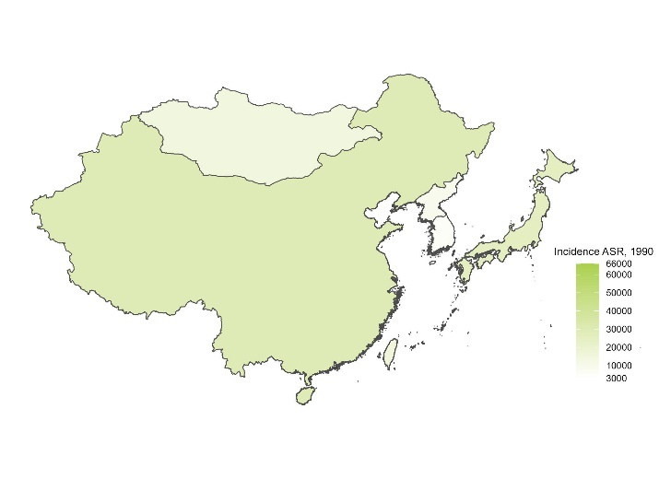
(B) 2023
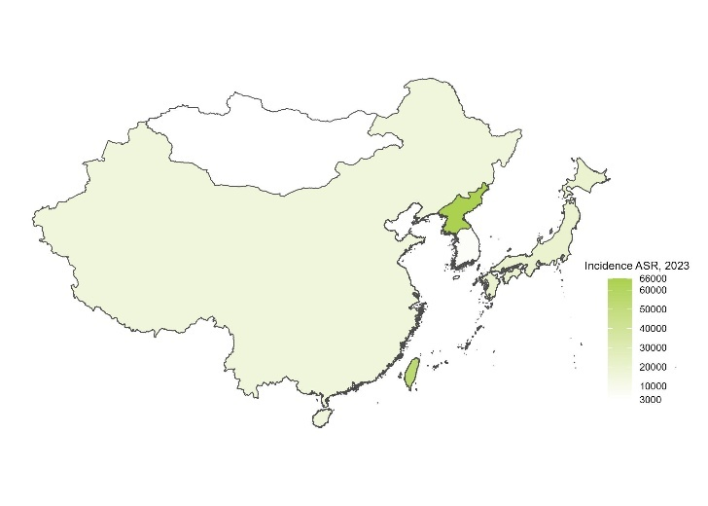
Rates are expressed per 100 000 population.
Abbreviations: ASR, Age-standardized rate.

Figure S2. Age-standardised YLDs of diarrhoeal diseases in 1990 and 2023
(A) 1990
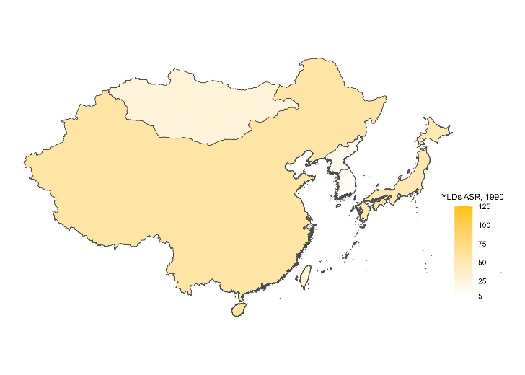
(B) 2023
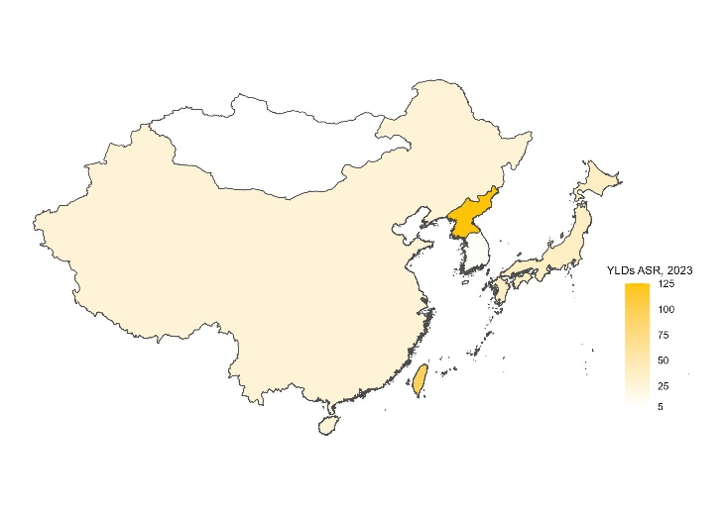
Rates are expressed per 100 000 population.
Abbreviations: ASR, Age-standardized rate; YLDs, Years Lived with Disability.

Figure S3. Age-standardised YLLs of diarrhoeal diseases in 1990 and 2023
(A) 1990
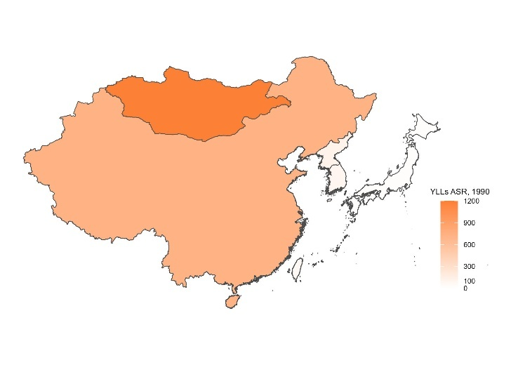
(B) 2023
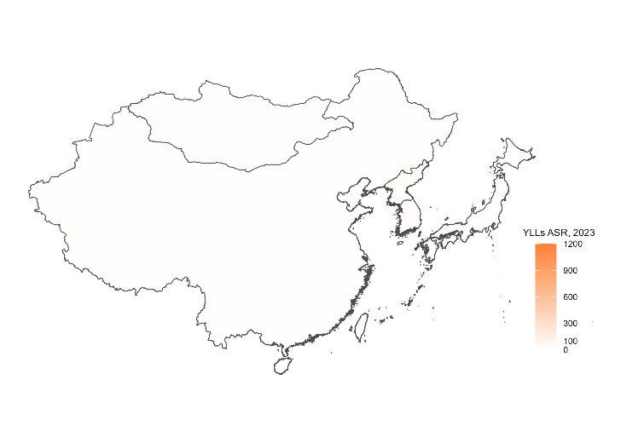
Rates are expressed per 100 000 population.
Abbreviations: ASR, Age-standardized rate; YLLs, Years of Life Lost.

Figure S4. Age-standardised incidence of typhoid and paratyphoid fevers in 1990 and 2023
(A) 1990
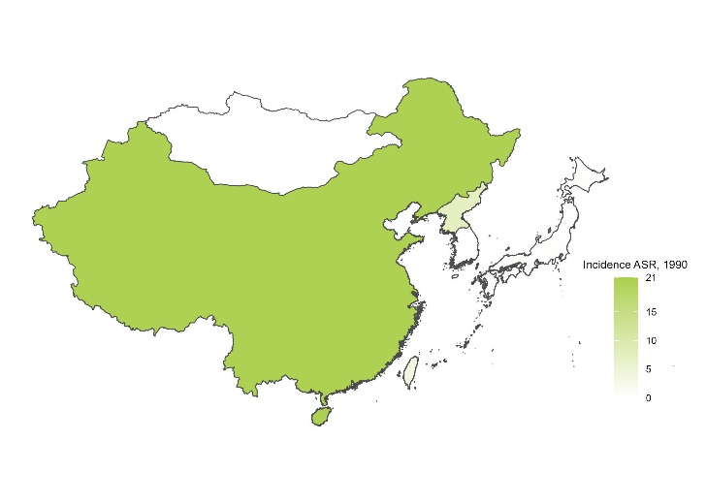
(B) 2023
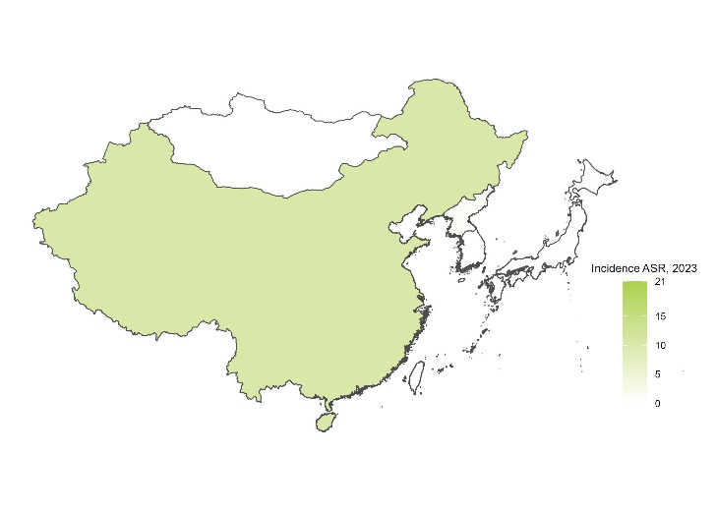
Rates are expressed per 100 000 population.
Abbreviations: ASR, Age-standardized rate.

Figure S5. Age-standardised YLDs of typhoid and paratyphoid fevers in 1990 and 2023
(A) 1990
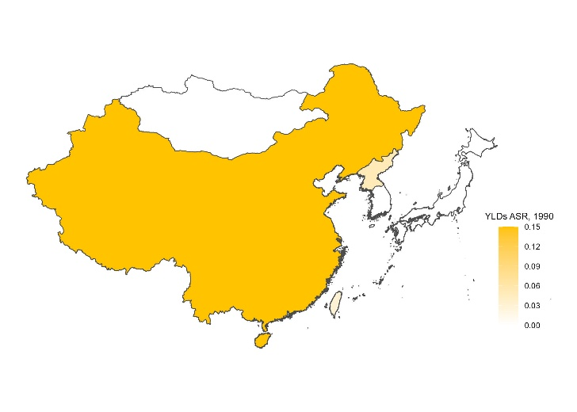
(B) 2023
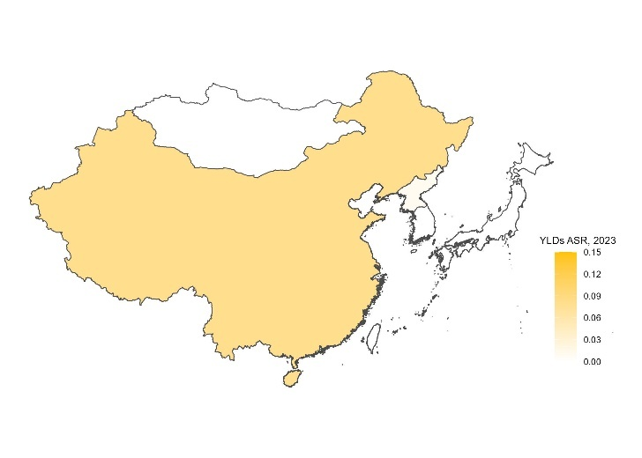
Rates are expressed per 100 000 population.
Abbreviations: ASR, Age-standardized rate; YLDs, Years Lived with Disability.

Figure S6. Age-standardised YLLs of typhoid and paratyphoid fevers in 1990 and 2023
(A) 1990
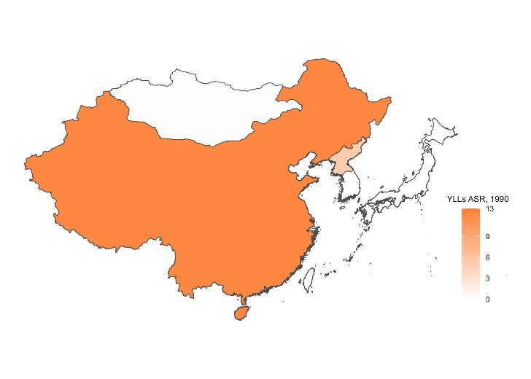
(B) 2023
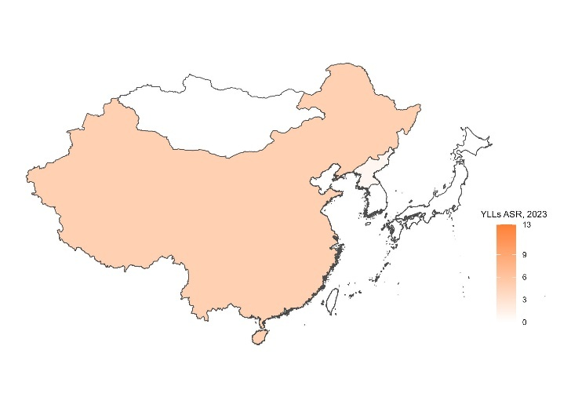
Rates are expressed per 100 000 population.
Abbreviations: ASR, Age-standardized rate; YLLs, Years of Life Lost.

Figure S7. Trends in age-standardised incidence of diarrhoeal diseases by sex, 1990–2023
(A) Men
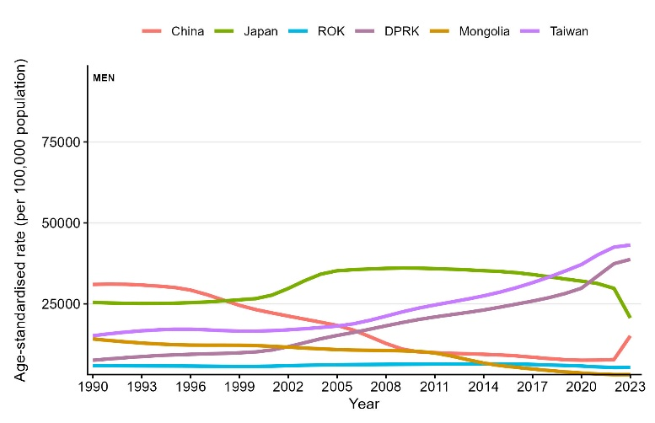
(B) Women
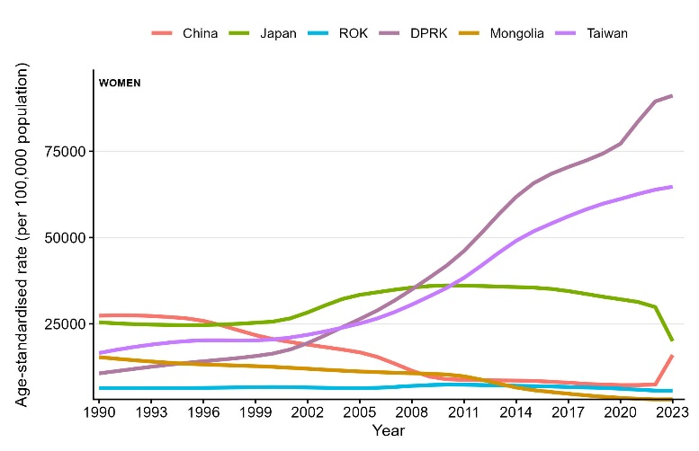
Rates are expressed per 100 000 population.
Abbreviations: ROK, Republic of Korea; DPRK, Democratic People’s Republic of Korea.

Figure S8. Trends in age-standardised DALYs of diarrhoeal diseases by sex, 1990–2023
(A) Men
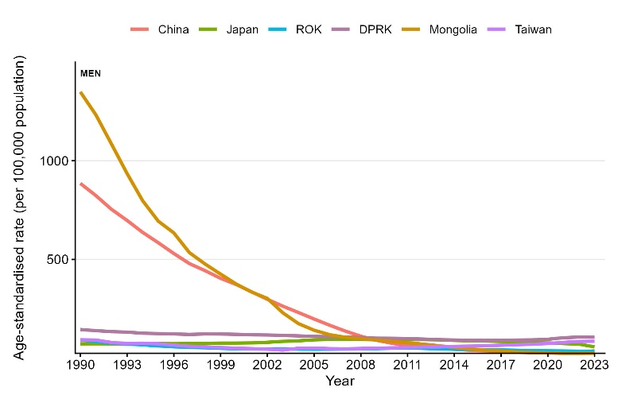
(B) Women
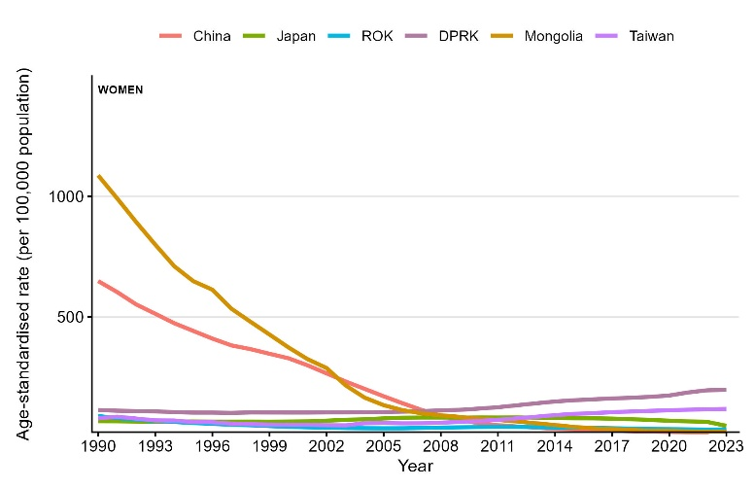
Rates are expressed per 100 000 population.
Abbreviations: ROK, Republic of Korea; DPRK, Democratic People’s Republic of Korea; DALYs, Disability-Adjusted Life Years.

Figure S9. Trends in age-standardised YLDs of diarrhoeal diseases by sex, 1990–2023
(A) Men
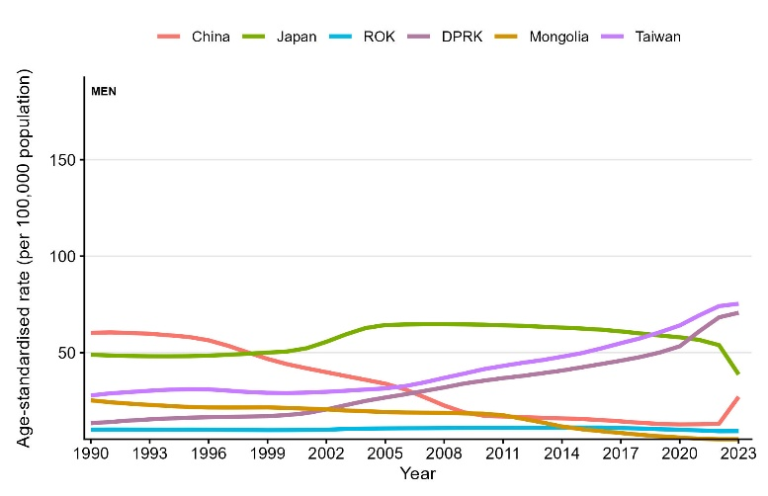
(B) Women
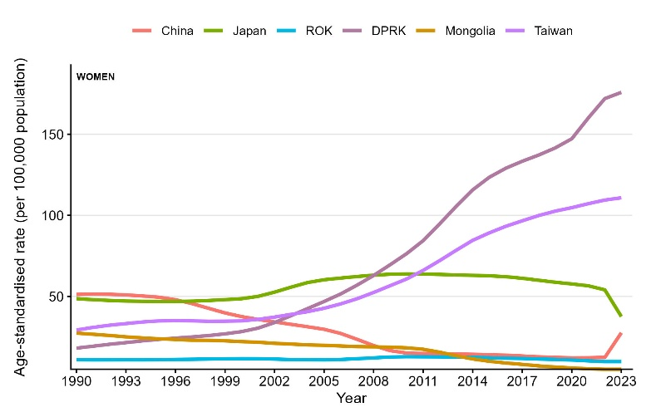
Rates are expressed per 100 000 population.
Abbreviations: ROK, Republic of Korea; DPRK, Democratic People’s Republic of Korea; YLDs, Years Lived with Disability.

Figure S10. Trends in age-standardised YLLs of diarrhoeal diseases by sex, 1990–2023
(A) Men
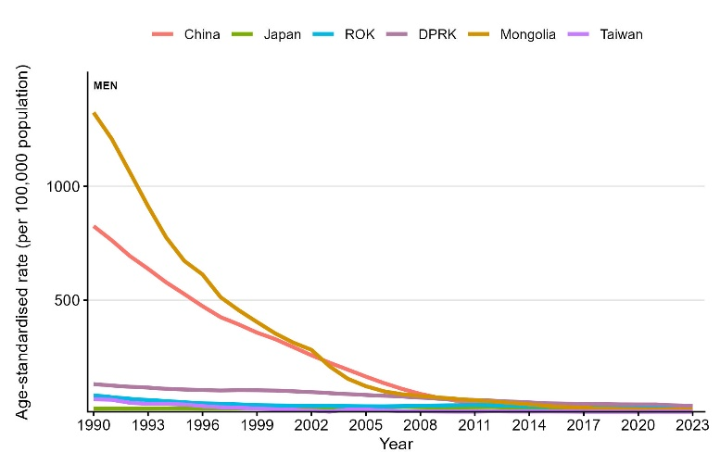
(B) Women
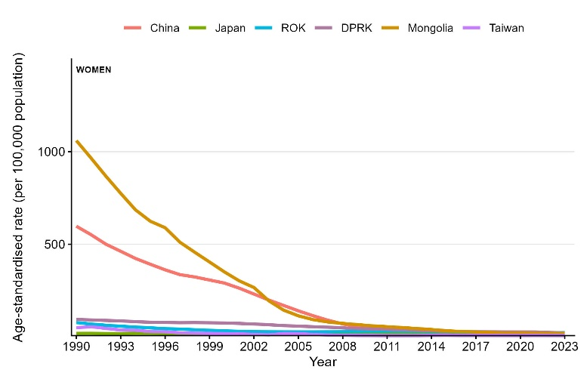
Rates are expressed per 100 000 population.
Abbreviations: ROK, Republic of Korea; DPRK, Democratic People’s Republic of Korea; YLLs, Years of Life Lost.

Figure S11. Trends in age-standardised incidence of typhoid and paratyphoid fevers by sex, 1990–2023
(A) Men
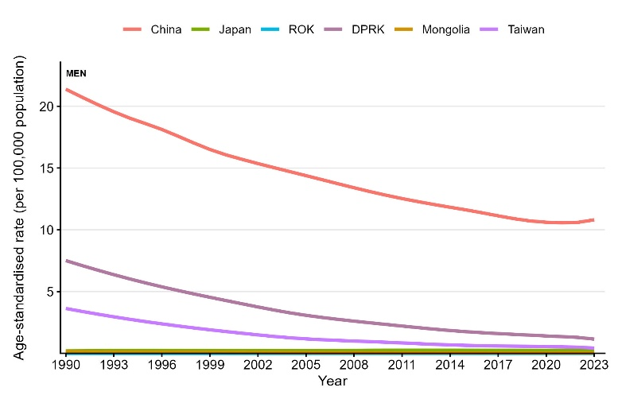
(B) Women
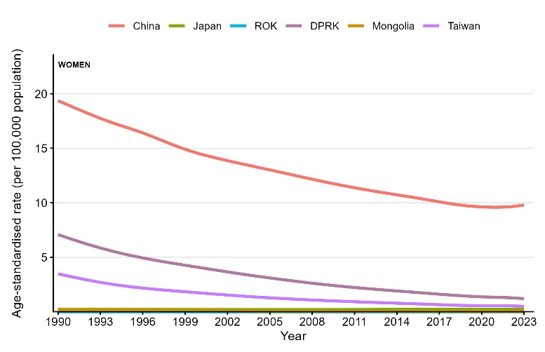
Rates are expressed per 100 000 population.
Abbreviations: ROK, Republic of Korea; DPRK, Democratic People’s Republic of Korea.

Figure S12. Trends in age-standardised DALYs of typhoid and paratyphoid fevers by sex, 1990–2023
(A) Men
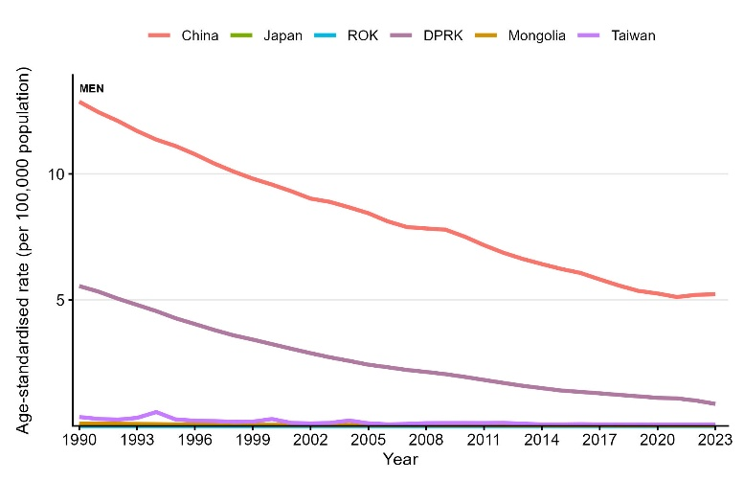
(B) Women
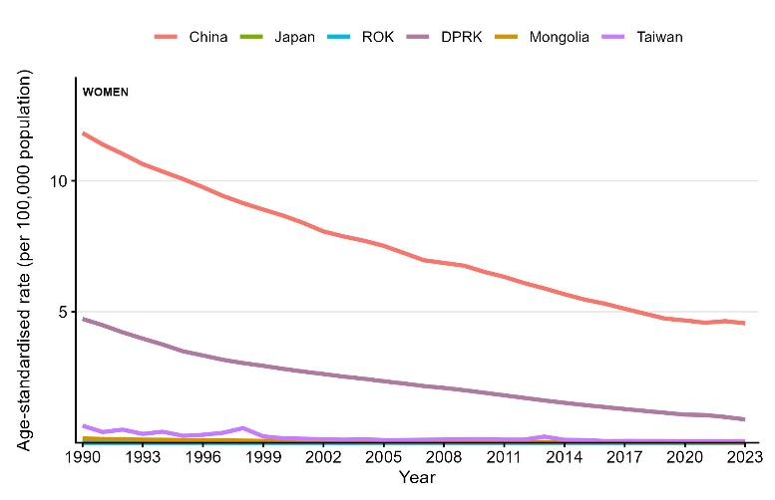
Rates are expressed per 100 000 population.
Abbreviations: ROK, Republic of Korea; DPRK, Democratic People’s Republic of Korea; DALYs, Disability-Adjusted Life Years.

Figure S13. Trends in age-standardised YLDs of typhoid and paratyphoid fevers by sex, 1990–2023
(A) Men
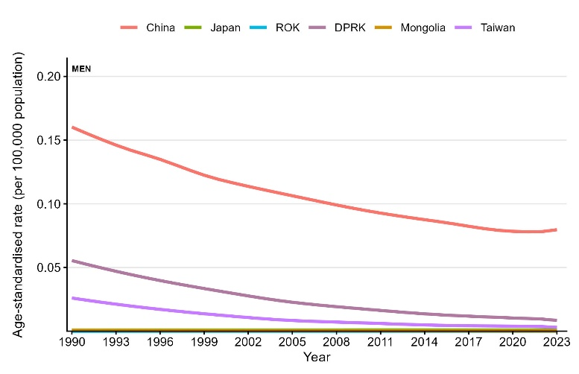
(B) Women
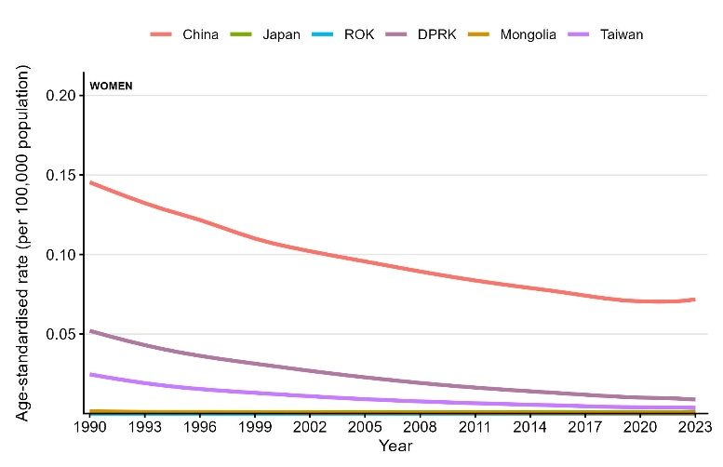
Rates are expressed per 100 000 population.
Abbreviations: ROK, Republic of Korea; DPRK, Democratic People’s Republic of Korea; YLDs, Years Lived with Disability.

Figure S14. Trends in age-standardised YLLs of typhoid and paratyphoid fevers by sex, 1990–2023
(A) Men
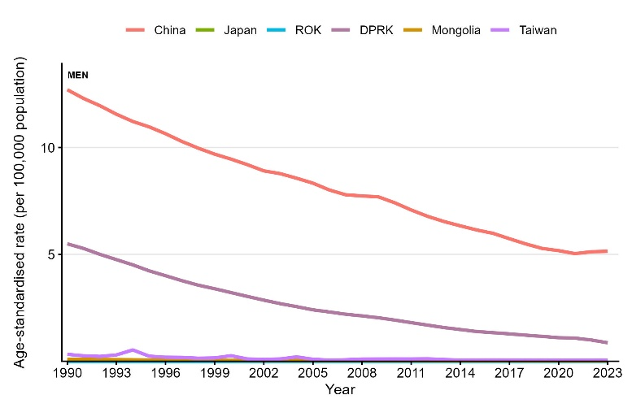
(B) Women
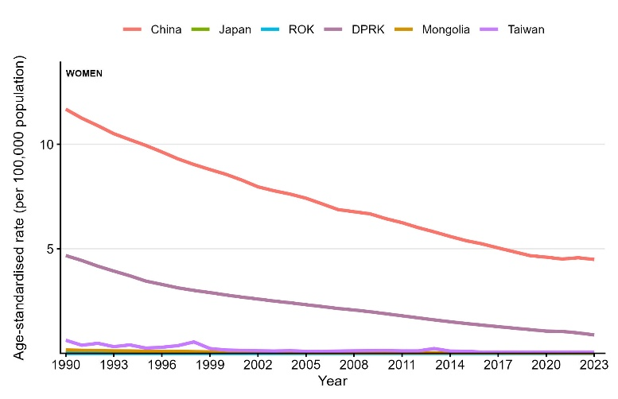
Rates are expressed per 100 000 population.
Abbreviations: ROK, Republic of Korea; DPRK, Democratic People’s Republic of Korea; YLLs, Years of Life Lost.

