Appendix for Divergent drivers of enteric disease burden in six East Asian settings, 1990–2023: a decomposition analysis of the Global Burden of Disease Study 2023

This appendix provides the GATHER checklist and further methodological detail for Divergent drivers of enteric disease burden in six East Asian settings, 1990–2023: a decomposition analysis of the Global Burden of Disease Study 2023.

Portions of this appendix have been reproduced or adapted from GBD 2023 Causes of Death Collaborators¹ and GBD 2023 Disease and Injury and Risk Factor Collaborators ². References are provided for reproduced sections.

Table of Contents
Table of Contents 2
Section 1 List of acronyms and abbreviations 2
Section 2 Guidelines for Accurate and Transparent Health Estimates Reporting (GATHER) compliance 3
Table S1 GATHER checklist 3
Section 3 Typhoid and paratyphoid fevers 4
Section 3.1 Flow chart 4
Section 3.2 Case definition 5
Section 3.3 Input data 5
Section 4.3.1 Model inputs 5
Section 4.3.2 Severity splits 5
Section 4.3.2.1 Table 1 5
Section 4.3.2.2 Table 2 6
Section 3.4 Modeling Strategy 6
Section 3.5 Changes from GBD 2021 to GBD 2023 7
Section 3.6 PRISMA flow diagram 7
Section 4 Diarrhoeal diseases 8
Section 4.1 Flow chart 8
Section 4.2 Case definition 9
Section 4.3 Input data 9
Section 4.3.1 Model inputs 9
Section 4.4 Result 15
Section 4.4.1 Data crosswalks 15
Section 5.4.2 Age-sex splits 15
Section 5.4.3 Severity split inputs 15
Section 4.5 Modelling strategy 16
Section 4.5.1 Diarrhoea incidence and prevalence 16
Section 4.5.2 Aetiologies 16
Section 4.6 References 21

List of acronyms and abbreviations
Abbreviation/acronym | Full phrase
ASR | Age-standardised rate
DALYs | Disability-adjusted life-years
DPRK | Democratic People’s Republic of Korea
EAPC | Estimated annual percentage change
GBD | Global Burden of Disease
ROK | Republic of Korea
SDGs | Sustainable Development Goals
SDI | Socio-demographic Index
UI | Uncertainty interval
YLDs | Years lived with disability
YLLs | Years of life lost

Guidelines for Accurate and Transparent Health Estimates Reporting (GATHER) compliance
This study complies with GATHER recommendations.³ See table S1 below for the GATHER checklist. The GATHER recommendations can be found on the GATHER website.
- GATHER checklist
Item # | Checklist item | Reported location
Objectives and funding
1 | Define the indicator(s), populations (including age, sex, and geographic entities), and time period(s) for which estimates were made. | This study analysed age-standardised and crude rates of prevalence, incidence, years lived with disability (YLDs), years of life lost (YLLs) and disability-adjusted life-years (DALYs) for diarrhoeal diseases and typhoid and paratyphoid fevers by age, sex, and location across six East Asian settings from 1990 to 2023, using estimates from the Global Burden of Disease Study 2023.
2 | List the funding sources for the work. | See main manuscript ‘Funding’ section
Data Inputs
For all data inputs from multiple sources that are synthesized as part of the study:
3 | Describe how the data were identified and how the data were accessed. | Data for this study were identified from Global Burden of Disease Study 2023 estimates and accessed via the Global Health Data Exchange (GHDx); no primary data collection was undertaken.
4 | Specify the inclusion and exclusion criteria. Identify all ad-hoc exclusions. | Inclusion and exclusion criteria for all data inputs were defined within the Global Burden of Disease 2023 study. The present analysis applied no additional or ad-hoc inclusion or exclusion criteria.
5 | Provide information on all included data sources and their main characteristics. For each data source used, report reference information or contact name/institution, population represented, data collection method, year(s) of data collection, sex and age range, diagnostic criteria or measurement method, and sample size, as relevant. | https://ghdx.healthdata.org/gbd-2023
6 | Identify and describe any categories of input data that have potentially important biases (e.g., based on characteristics listed in item 5). | Input data categories in GBD 2023, including vital registration, survey and administrative sources, and environmental exposure data, may be affected by under-reporting, misclassification, heterogeneous data quality, and measurement error. These biases were addressed through the standardised GBD 2023 modelling framework.
For data inputs that contribute to the analysis but were not synthesized as part of the study:
7 | Describe and give sources for any other data inputs. | https://ghdx.healthdata.org/gbd-2023
For all data inputs:
8 | Provide all data inputs in a file format from which data can be efficiently extracted (e.g., a spreadsheet rather than a PDF), including all relevant meta-data listed in item 5. For any data inputs that cannot be shared because of ethical or legal reasons, such as third-party ownership, provide a contact name or the name of the institution that retains the right to the data. | https://ghdx.healthdata.org/gbd-2023
Data analysis
9 | Provide a conceptual overview of the data analysis method. A diagram may be helpful. | This study is a secondary analysis of GBD 2023 estimates. We summarised temporal trends in age-standardised rates with the estimated annual percentage change (EAPC), decomposed the change in crude rates into epidemiological and demographic components using an exact log identity, characterised the age composition of prevalent cases, and repeated endpoint-dependent analyses with 2022 as the endpoint (see main manuscript, Methods).
10 | Provide a detailed description of all steps of the analysis, including mathematical formulae. This description should cover, as relevant, data cleaning, data pre-processing, data adjustments and weighting of data sources, and mathematical or statistical model(s). | Estimation of the underlying rates, including data cleaning, preprocessing and statistical modelling, was undertaken within GBD 2023. From the published estimates the authors computed: the EAPC, as 100 × (exp(β) − 1) from a log-linear regression of the age-standardised rate on calendar year; crude rates, as all-age counts divided by GBD 2023 population estimates; the decomposition log(crude rate) = log(ASR) + log(crude rate / ASR), differenced between 1990 and the endpoint; and the proportion of prevalent cases aged under 5 and 60 years and older and their mean age, from age-specific case counts (see main manuscript, Methods).
11 | Describe how candidate models were evaluated and how the final model(s) were selected. | No candidate models were evaluated or selected as part of this study. All model evaluation and selection were conducted within the Global Burden of Disease Study 2023 analytical framework, and the present analysis used the final published GBD 2023 estimates without modification.
12 | Provide the results of an evaluation of model performance, if done, as well as the results of any relevant sensitivity analysis. | No evaluation of GBD model performance was undertaken. Because the GBD 2023 non-fatal estimates for China and Japan show a discontinuity between 2022 and 2023, a sensitivity analysis using 2022 rather than 2023 as the endpoint was conducted (see main manuscript, Methods and Results; Additional file 3: Tables S29–S32).
13 | Describe methods for calculating uncertainty of the estimates. State which sources of uncertainty were, and were not, accounted for in the uncertainty analysis. | Uncertainty intervals for GBD estimates were derived from draw-based simulations in GBD 2023, propagating uncertainty from data inputs and model parameters; structural model assumptions and unmeasured sources of bias were not captured. Confidence intervals for the EAPC reflect uncertainty in the fitted trend only; decomposition components and age-composition measures were calculated from point estimates and are presented without uncertainty intervals.
14 | State how analytic or statistical source code used to generate estimates can be accessed. | https://ghdx.healthdata.org/gbd-2023
Results and Discussion
15 | Provide published estimates in a file format from which data can be efficiently extracted. | GBD 2023 estimates are available online in the GBD Results Tool and GBD Compare visualisation
16 | Report a quantitative measure of the uncertainty of the estimates (e.g. uncertainty intervals). | See main manuscript, “Results”
17 | Interpret results in light of existing evidence. If updating a previous set of estimates, describe the reasons for changes in estimates. | See main manuscript, “Discussion”
18 | Discuss limitations of the estimates. Include a discussion of any modelling assumptions or data limitations that affect interpretation of the estimates. | Estimates are subject to limitations of the Global Burden of Disease framework, including reliance on modelled data, heterogeneity in data quality, and uncertainty in exposure assessment. As a secondary analysis, this study inherits GBD modelling assumptions and cannot infer causality. The GBD 2023 non-fatal estimates for China and Japan show a discontinuity in 2023, which is examined in a sensitivity analysis (see main manuscript, Methods and Discussion).

Typhoid and paratyphoid fevers

Flow chart
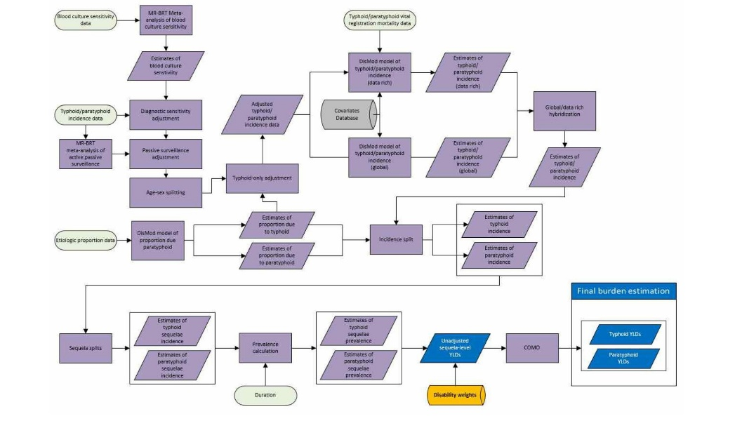

Case definition
Typhoid and paratyphoid are acute bacterial infections that most commonly cause febrile illness and gastrointestinal symptoms. Severe cases are associated with intestinal bleeding and perforation, altered mental state and, in some cases, death. We define a confirmed case as one for which there has been a positive blood culture test for either Salmonella enterica typhi or paratyphi. Diagnostic criteria do not typically accompany national surveillance reports; however, with blood culture being the standard diagnostic, we treat reported cases as confirmed. Given the poor sensitivity of blood culture, however, we estimated case definition as simply febrile illness resulting from an infection with Salmonella enterica typhi or paratyphi. This is effectively a counterfactual definition in which we attempt to estimate the number of true infections regardless of test result. These causes include all ICD-10 codes under the heading A01 (typhoid and paratyphoid fevers).

Input data

Section 4.3.1 Model inputs
Our incidence dataset included a combination of data from prospective cohort studies and national surveillance systems. Similarly, data on proportions due to typhoid and paratyphoid included a combination of prospective cohort studies, national surveillance systems, and facility- or lab-based studies. We updated our systematic reviews of typhoid and paratyphoid data for GBD 2023 (Figure 1).

Section 4.3.2 Severity splits
For GBD 2019, we derived severity splits based on a published review of enteric fever outcomes from (Azmatullah A, Qamar FN, Thaver D, et al. 2005).

Section 4.3.2.1 Table 1
Paratyphoid is split into four sequelae: mild (28.5% [15.6-44.2]), moderate (52.25% [27.2-77.7]), severe (14.25% [8.2-21.8]), and abdominal pain and distention (5.0% [2.8-7.6]):
Table 1: Severity distribution for paratyphoid fever
Sequela | Description | Disability weight
Mild | Has a low fever and mild discomfort, but no difficulty with daily activities. | 0.006  (0.002-0.012)
Moderate | Has a fever and aches, and feels weak, which causes some difficulty with daily activities. | 0.051  (0.032-0.074)
Severe | Has a high fever and pain, and feels very weak, which causes great difficulty with daily activities. | 0.133  (0.088-0.19)
Abdominal pain & distention due to paratyphoid | Has pain in the belly and feels nauseated. The person has difficulties with daily activities. | 0.114  (0.078-0.159)

Section 4.3.2.2 Table 2
Similarly, typhoid is split into four sequelae: moderate (35.0% [26.0-44.3]), severe (47.75% [38.0-57.4]), severe abdominal pain and distention (17.0% [10.0-25.7]), and intestinal bleeding (0.25% [0-2.0]):

Table 2: Severity distribution for typhoid fever
Sequela | Description | Disability weight
Moderate | Has a fever and aches, and feels weak, which causes some difficulty with daily activities. | 0.051  (0.032-0.074)
Severe | Has a high fever and pain, and feels very weak, which causes great difficulty with daily activities. | 0.133  (0.088-0.19)
Gastrointestinal bleeding | Vomits blood and feels nauseated. | 0.325  (0.209-0.462)
Abdominal pain and distention (includes intestinal perforation) | Has severe pain in the belly and feels nauseated. The person is anxious and unable to carry out daily activities. | 0.324  (0.22-0.442)

Modeling Strategy
We first model total incidence of typhoid and paratyphoid combined. Second, we model the proportion of this total due to typhoid and the proportion due to paratyphoid. Finally, we split the case estimates into sequelae representing different major symptoms and levels of severity.
Before modelling, we applied four adjustments to the incidence data: 1) diagnostic sensitivity adjustment, 2) passive surveillance adjustment, 3) typhoid-only adjustment, and 4) age/sex splits.
Incidence data were inflated to account for poor diagnostic sensitivity, based on an internal meta analysis of the sensitivity of blood culture, the most common diagnostic used for typhoid: we estimate a sensitivity of 60.3% (50.3-68.8). We performed a crosswalk to adjust for incomplete case capture data from passive versus active surveillance, with active surveillance as the reference using a MR-BRT model and adjusted the data before modelling. Where incidence data were from studies that only tested for typhoid fever, we used estimates from our aetiological proportion models to adjust these typhoid-only sources and calculated an adjusted joint incidence (ie, including both typhoid and paratyphoid cases) by dividing the typhoid-only incidence by the estimated proportion due to typhoid. We performed this calculation using posterior simulation with 1000 draws to propagate uncertainty from both the incidence data and the proportion estimate. Finally, where incidence data were reported for both sexes combined or for age categories spanning more than 25 years, we produced datapoints that were age- and sex-specific based on a MR-BRT model of sex ratios, and a DisMod model of age patterns.
Total incidence was modelled using DisMod-MR, using the summary exposure values (SEV) for unsafe sanitation and the proportion of the population living in the Indian Ocean monsoon belt as covariates. Similarly, we used a DisMod model to estimate aetiological proportions, using a single model of the proportion of enteric fever due to Salmonella paratyphi. We model the proportion due to paratyphoid instead of the proportion due to typhoid as we’ve found that this approach results in better a better model fit for sub-Saharan Africa, where the proportion of enteric fever due to Salmonella typhi approaches 1.0, as DisMod performs better with proportions that are near zero than with proportions that are near one.
Typhoid cases are split between four sequelae: moderate typhoid fever, severe typhoid fever, severe typhoid fever with intestinal bleeding, and typhoid fever with abdominal complications. Paratyphoid cases are split between four sequelae: mild paratyphoid fever, moderate paratyphoid fever, severe paratyphoid fever, and paratyphoid fever with abdominal complications.

Changes from GBD 2021 to GBD 2023
We updated our systematic review for GBD 2023 (Figure 1) and updated the code pipeline to improve robustness and efficiency, but made no substantive changes to our modelling strategy for typhoid and paratyphoid between GBD 2021 and GBD 2023.

PRISMA flow diagram
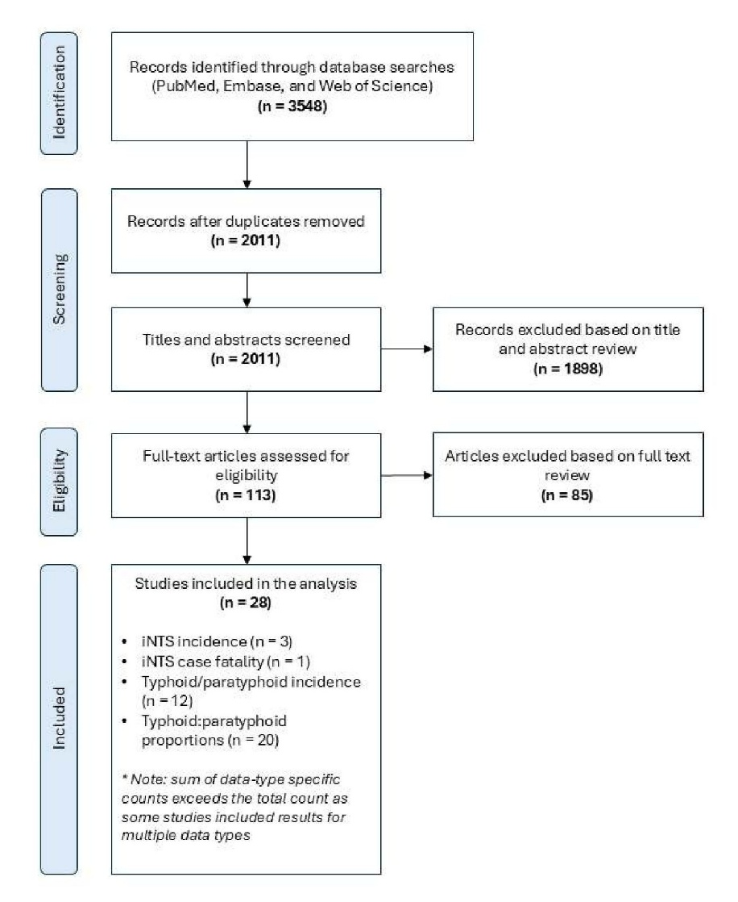

Diarrhoeal diseases

Flow chart
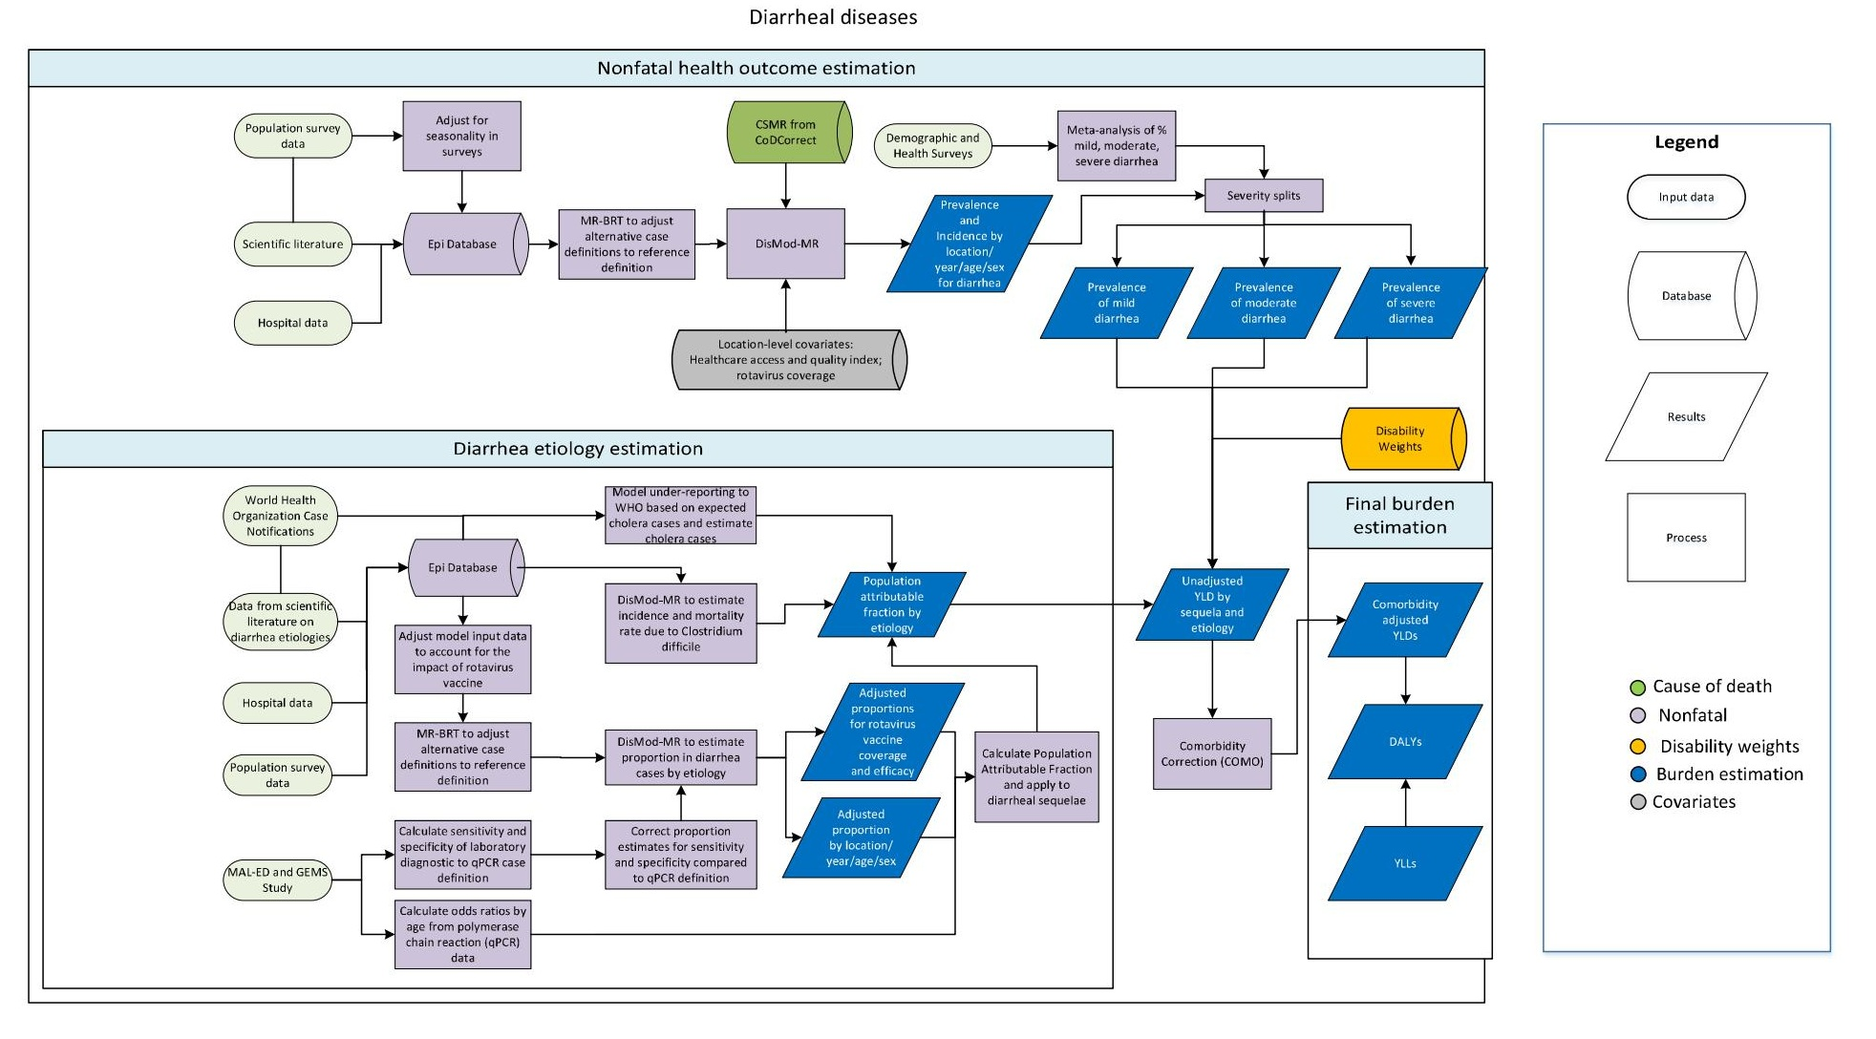

Case definition
We defined diarrhoeal disease episodes as three or more loose stools in a 24-hour period. In the diarrhoea models, self-reported prevalence is the reference category for all data adjustments. Hospital input data use ICD-9 codes 001-009.9 and ICD-10 codes A00-A09.
The case definitions accepted for diarrhoea are shown below.

Table 1
Quantity of interest | Reference or alternative | Definition
Incidence or prevalence of diarrhoea | Reference | Three or more abnormality loose stools in a 24-hour period. Self-reported of pational report for children.
Incidence of inpatient diarrhoea episodes | Alternative | Incidence of diarrhoea episodes that become inpatient reported in health care data.
Incidence of inpatient diarrhoea episodes in clinical claims data | Alternative | Incidence of diarrhoea episodes reported in claims data.

Input data

Section 4.3.1 Model inputs
We used three main types of data in the diarrhoea non-fatal burden estimation: hospital data, population-based surveys, and data from scientific literature.
The first type of data is the incidence of diarrhoea in hospital settings including inpatient and claims data. These data were identified using the ICD-9 codes 001-009.9 and ICD-10 codes A00-A09 and were adjusted prior to modelling for multiple admissions and multiple diagnoses. To be consistent with the population-based survey data, adjusted hospital data were transformed from incidence to prevalence using the following equation:
$$Prevalence=Incidence*\frac{duration(days)}{365}$$
The second type of data are from population-representative surveys, such as the Demographic and Health Surveys and the Multiple Indicator Cluster Surveys. We converted the prevalence of maternal reported two-week period from surveys to point prevalence in one-year age groups using this equation:
$$Point Prevalence=Period Prevalence*\frac{Duration}{(Recall Period+Duration-1)}$$
Where the mean duration was the duration in days, an average of 4.3 days (4.2-4.4) in both equations¹. Survey data were adjusted for seasonality. Surveys are frequently conducted over several months. To account for seasonal variation in diarrhoea prevalence, we fit a mixed-effects generalised additive model for each GBD region with a forced periodicity and a random intercept by country. The ratio between the monthly model-fit diarrhoea prevalence and the corresponding regional diarrhoea prevalence is a scalar to adjust survey data by month and geography.
The third type of data are from scientific literature. Inclusion criteria include diarrhoea as the case definition, studies with a sample size of at least 100, and a study duration of at least one year to avoid bias in the seasonal timing of diarrhoea. We excluded studies that reported on diarrhoeal outbreaks exclusively and studies that combined acute gastroenteritis with and without diarrhoea. We included all literature data sources used in GBD 2021 and conducte an updated review of literature for GBD 2023 covering the period 12/01/2020 to 1/09/2024 for diarrhoea prevalence, incidence, and all diarrhoea aetiologies.

Section 5.3.2 Aetiologies
We extracted data on all aetiologies from scientific literature that reported the proportion of diarrhoea cases that tested positive for each pathogen. For C difficile, we extracted incidence and prevalence. We applied the same inclusion and exclusion criteria described above for diarrhoea.
We searched articles using a PubMed search term that combined non-specific and aetiology-specific diarrhoea using the following search string:
(diarrhoea*[title/abstract] OR "Diarrhea"[Mesh] OR diarrhea*[title/abstract]) AND (2020/12/01:2024/01/09[PDat]) AND (inciden*[title/abstract] OR incidence[Mesh] OR prevalent*[title/abstract] OR cases[title/abstract] OR prevalence[Mesh] OR epidemiology[title/abstract] OR epidemiology[Mesh] OR salmonella[title/abstract] OR salmonella[Mesh] OR aeromona*[title/abstract] OR aeromonas[Mesh] OR shigell*[title/abstract] OR shigella[Mesh] OR enteropathogenic[title/abstract] OR enterotoxigenic[title/abstract] OR "Enterotoxigenic Escherichia coli"[Mesh] OR "Enteropathogenic Escherichia coli"[Mesh] OR *coli[title/abstract] OR campylobacter[title/abstract] OR campylobacter[Mesh] OR amoebiasis[title/abstract] OR "Amebiasis"[Mesh] OR entamoeb*[title/abstract] OR cryptosporid*[title/abstract] OR "Cryptosporidiosis"[Mesh] OR rotavir*[title/abstract] OR rotavirus[Mesh] OR norovirus[title/abstract] norovirus[Mesh] OR adenovirus[title/abstract] OR "Adenovirus Infections, Human"[Mesh] OR clostridium*[title/abstract] OR Clostridioides difficile[title/abstract] OR "Clostridioides difficile"[Mesh] OR c. diff*[title/abstract] OR “astrovir*”[Mesh] OR “astrovir*”[title/abstract] OR “sapovir*”[Mesh] OR “sapovir*”[title/abstract] OR etiolog*[title/abstract] OR aetiolog*[title/abstract] OR pathogen*[title/abstract]) NOT (appendicitis[title/abstract] OR esophag*[title/abstract] OR gastritis[title/abstract] OR liver[title/abstract] OR case report[title/abstract] OR case-report[title/abstract] OR "Case Reports" [Publication Type] OR therapy[title] OR Crohn[title/abstract] OR "inflammatory bowel"[title/abstract] OR irritable[title/abstract] OR travel*[title] OR Outbreak[title] OR Review[ptyp]) NOT (animals[MeSH] NOT humans[MeSH])
We identified 2504 studies, of which 88 met our inclusion criteria. We extracted data for location, sex, year, and age.

Section 5.3.3 PRISMA

Section 5.3.3.1 Figure 1. Diarrhoeal disease systematic review PRISMA diagram
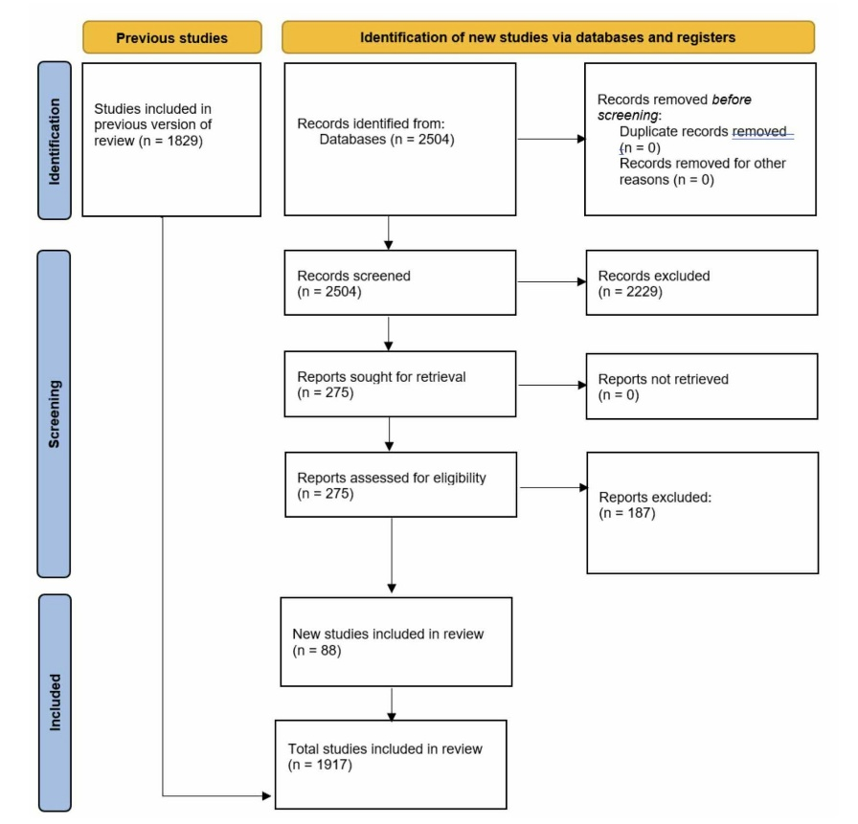
Additionally, we searched specifically for data sources detailing rotavirus coverage and vaccine efficacy (VE) using the following search string:
(((rotavirus[title/abstract] AND vaccine[ title/abstract] AND (efficacy[title/abstract] OR effectiveness[title/abstract]) AND (2020/12/31[PDAT] : 2024/10/22[PDAT])))) NOT Review[Publication Type] NOT (animals[MeSH] NOT humans[MeSH])
We identified 185 studies from this search string along with 108 additional studies identified by reviewing meta-analyses captured by the search string. Of these 293 sources, 14 met our inclusion criteria.

Section 5.3.3.2 Figure 2. Rotavirus VE systematic review PRISMA diagram
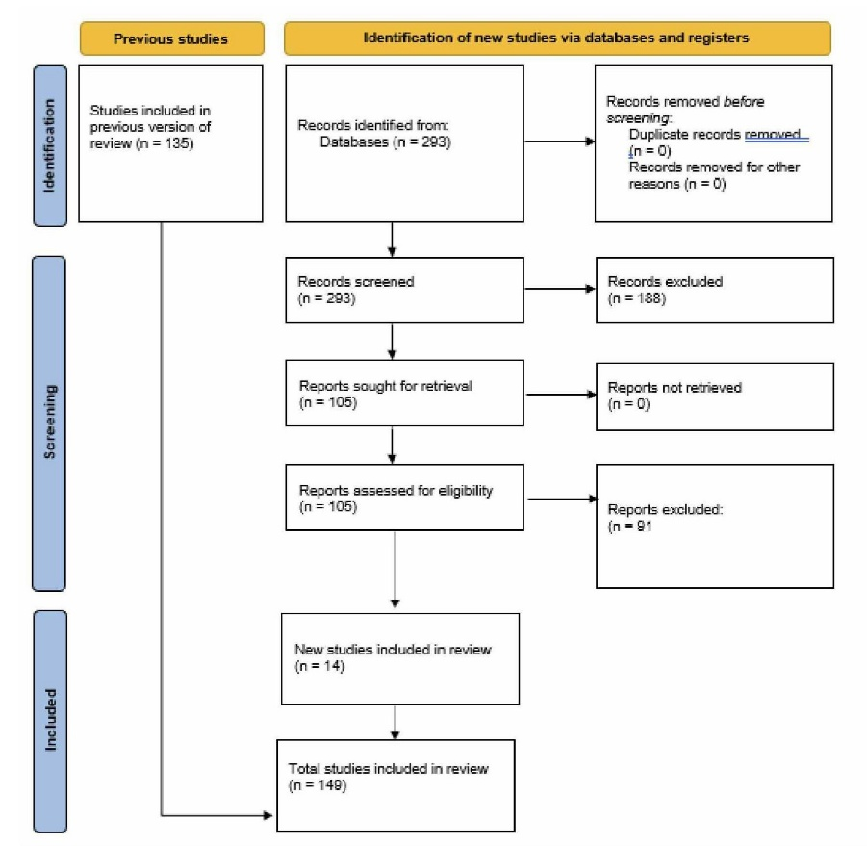
To update our cholera proportion estimates, we used an additional PubMed search string spanning from January 2019 to December 2023:
(cholera*[title/abstract] OR cholera[Mesh]) AND (diarrhea*[title/abstract] OR diarrhoea*[title/abstract] OR diarrhea[Mesh]) AND (epidemiolog*[title/abstract] OR epidemiology[Mesh] OR inciden*[title/abstract] OR incidence[Mesh] OR prevalent*[title/abstract] OR prevalence[Mesh] OR death*[title/abstract] OR = mortality[title/abstract] OR mortality[Mesh] OR fatal*[title/abstract] OR case*[title/abstract] OR proportion*[title/abstract]) NOT (“case report”[title/abstract] OR “case reports”[Publication Type] OR review[Publication Type]) AND (("2019/01/01"[PDat] : "2023/12/21"[PDat])) NOT (animals[MeSH] NOT humans[MeSH])
We identified 244 studies, of which seven met our inclusion criteria.
Case fatality rate (CFR) data for cholera were extracted from an updated systematic review with sources identified using the following PubMed search string capturing sources from January 2016 to October 2024. We identified 354 sources, of which 39 met our inclusion criteria. Additionally, two surveillance data series were updated for India and Malawi.
(Cholera*[TiAb] OR cholera [MeSH] OR “vibrio cholerae” [MeSH]) AND ("case fatality"[TiAb] OR “mortality”[TiAb] OR “cfr”[TiAb]) NOT (animals[MESH] NOT humans[MESH]) ("2016/01/01"[PDAT] : "2024/10/10"[PDAT])

Section 5.3.3.3 Figure 3. Cholera proportion systematic review PRISMA diagram
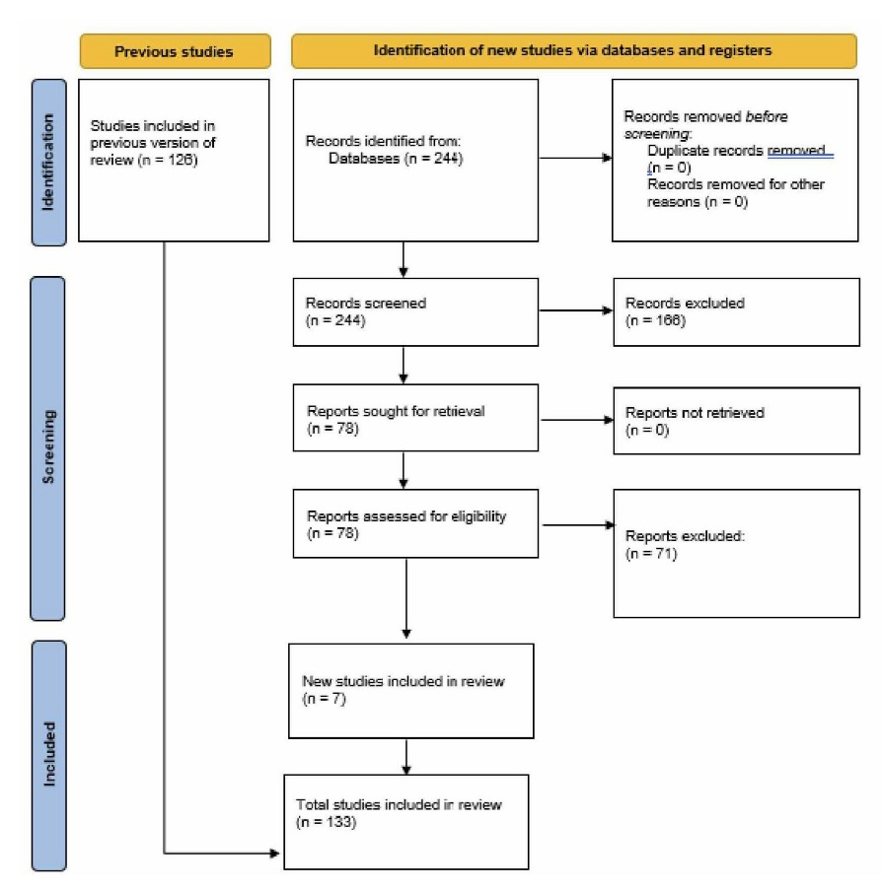

Section 5.3.3.4 Figure 4. Cholera CFR systematic review PRISMA diagram
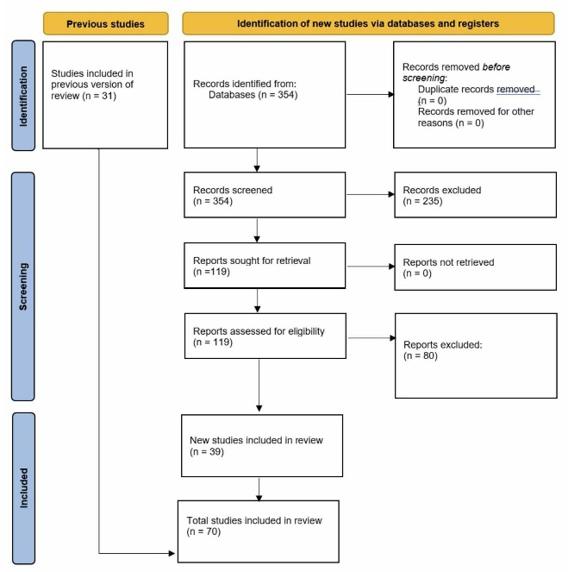
We used the Global Enteric Multicenter Study (GEMS), a seven-site, case-control study of moderate-to severe diarrhoea in children under 5 years,² and the MAL-ED study,³ a multi-site birth cohort, to calculate odds ratios for the diarrhoeal pathogens. We analysed raw data for a systematic reanalysis, representative of the distribution of cases and controls by age and site that were tested for the presence of pathogen using quantitative polymerase chain reaction (qPCR).⁴
Data that did not use qPCR for detection were adjusted for sensitivity and specificity prior to modelling in order to standardise data regardless of detection method. Adjusting these data prior to modelling allowed us to adjust only data that did not use qPCR, as well as better control for values at extreme bounds and capture uncertainty in modelling.
CFR data for Clostridium difficile were collected from ICD-coded hospital records from Austria, Brazil, Canada, Italy, Mexico, New Zealand, and the USA. ICD codes A04.7 (ICD-10) and 008.45 (ICD-9) were used to identify intestinal infections with Clostridium difficile. Supplemental data for Romania collected as part of the International Nosocomial Infection Control Consortium (DOI: 10.1016/j.ajic.2016.01.005) were also included. We standardised age and sex across all datasets to the following most-detailed groups using the GBD causes of death age-sex splitting algorithm for age: 0-6, 7-27, and 28-364 days, and 1-4, 5-9, 10-14, 15-19, 20-24, 25-29, 30-34, 35-39, 40-44, 45-49, 50-54, 55-59, 60-64, 65-69, 70-74, 75-79, 80-84, 85-89, 90-94, 95+ years; and sex: male and female. This algorithm is based on the assumption that the age-sex pattern of the death or case rate for a given infectious syndrome or pathogen is inherent to the pathology of the disease and is therefore constant across location and year. Crude case-fatality rates were then estimated for the input data for each GBD age group and sex.

Result

Section 4.4.1 Data crosswalks
One of the GBD core principles is to use all available data to inform our estimates. To account for differences between studies, we conducted a meta-regression of the ratio of reference to non-reference data using the meta-regression-Bayesian, regularised, trimmed (MR-BRT) tool. When possible, crosswalks based on data matched within studies on age, sex, and location are used. When not possible, ratios between alternative and reference case definitions/methods were based on data matched between studies, nearby in age, year, with exact matches on sex and location. We adjusted inpatient data and claims data up to the level of self-reported data (our reference case definition) (Table 1).
Table 1. Diarrhoeal disease crosswalk coefficients
Data input | Reference of alternative case definition | Gamma | Beta coefficient, logit (95% UI)* | Adjustment factor (95% UI)*
Self-reported diarrhoea | Ref | -- | -- | --
Clinical and literature, inpatient | Alt | 0 | -5.96  (-5.99 to -5.92) | 0.003  (0.003 to 0.003)
Claims, MarketScan | Alt | 0 | 0.02  (-0.13 to 0.16) | 1.02  (0.88 to 1.17)
*MR-BRT crosswalk adjustments can be interpreted as the factor the alternative case definition is adjusted by to reflect what it would have been had it been measured using the reference case definition. If the log/logit beta coefficient is negative, then the alternative is adjusted up to the reference. If the log/logit beta coefficient is positive, then the alternative is adjusted down to the reference.
**The adjustment factor column is the exponentiated beta coefficient. For log beta coefficients, this is the relative rate between the two case definitions. For logit beta coefficients, this is the relative odds between the two case definitions.

Section 5.4.2 Age-sex splits
Data were age- and sex-split based on population and a modelled age-curve generated using age-specific data as inputs in MR-BRT to better estimate the distribution of non-age-specific data.

Section 5.4.3 Severity split inputs
Diarrhoeal diseases have three severity levels: mild, moderate, and severe (Table 2). The proportion of diarrhoea cases that are assigned to each comes from a systematic review of diarrhoea severity.¹ Mild cases are the proportion of diarrhoea cases that did not seek medical care (64.8%); moderate cases are the proportion that sought medical care but did not have severe dehydration or bloody stool (28.9%); and severe cases are the proportion that sought medical care with severe dehydration or bloody stool (6.9%). These proportions are based on the frequency of dehydration and bloody stool among community-based studies reported in the systematic review.
Table 2. Severity distribution, details on the severity levels for diarrhoea and the associated disability weight (DW) with that severity.
Severity level | Lay description | Disabiliy weight (95% CI) | Proportion
Mild | Has diarrhoea defined as 3 or more loose stools in a 24-hour period with no dehydration. | 0.074  (0.049-0.104) | 64.8%
Moderate | Has diarrhoea defined as 3 or more loose stools in a 24-hour period with painful cramps and feeling thirsty and any dehydration. | 0.188  (0.125-0.264) | 28.9%
Severe | Has diarrhoea defined as 3 or more loose stools in a 24-hour period with painful cramps and is very thirsty or feels nauseated or tired and/or severely dehydrated. | 0.247  (0.164-0.348) | 6.9%

Section 4.5 Modelling strategy

Section 4.5.1 Diarrhoea incidence and prevalence
The non-fatal diarrhoeal disease burden is modelled in DisMod-MR 2.1, a Bayesian meta-regression modelling framework. DisMod-MR produces estimates of the incidence, prevalence, and remission of diarrhoea for each age, sex, geographical location, and year. We defined remission, or the time to recovery, as five days average. The reference category for our input data is community-based diarrhoea episodes such as data from population-representative surveys or community cohorts. As described in the data crosswalks section above, input data that are from a different population, such as hospital inpatient groups, are adjusted before modelling by determining a meta-regression ratio of non reference to reference data values, so that they are consistent with the reference category. Country level covariates are used to inform the model (Table 3).
Table 3. Covariates. Summary of covariates used in the diarrhoea DisMod-MR meta-regression model
Covariate | Type | Parameter | Exponentiated beta  (95% uncertainty interval)
RotaC vaccine lagged five-year coverage | Country-level | Prevalence | 0.51  (0.50-0.52)
Socio-demographic Index | Country-level | Prevalence | 0.095  (0.089-0.10)
Sex | Study-level | Prevalence | 0.97  (0.97-0.98)
Healthcare Access and Quality Index | Country-level | Excess mortality rate | 0.94  (0.94-0.94)
Sex | Study-level | Excess mortality rate | 1.33  (1.32-1.34)

Section 4.5.2 Aetiologies
We estimated diarrhoeal disease aetiologies independently from overall diarrhoea envelope using a counterfactual strategy for enteric adenovirus, Aeromonas, Entamoeba histolytica (amoebiasis), Campylobacter, Cryptosporidium, enteropathogenic Escherichia coli (EPEC), enterotoxigenic Escherichia coli (ETEC), norovirus, non-typhoidal Salmonella infections, rotavirus, Shigella, astrovirus, and sapovirus. Vibrio cholerae and C difficile were modelled separately (Table 4).
Table 4. Inpatient to community crosswalk coefficients for diarrhoeal disease aetiologies, not including Vibrio cholerae or C difficile
Aetiology | Data input | Reference or alternative case definition | Gamma | Beta coefficient, logit (95% UI)* | Adjustment factor (95% UI)**
All | Community-based samples | Ref | -- | -- | --
Adenovirus | Clinical, inpatient | Alt | 0.09 | 0.25  (0.06 to 0.43) | 1.28  (1.06 to 1.54)
Aeromonas | Clinical, inpatient | Alt | 0.07 | 0.07  (-0.17 to 0.3) | 1.07  (0.85 to 1.35)
Amoebiasis | Clinical, inpatient | Alt | 0.82 | 0.17  (-0.44 to 0.78) | 1.18  (0.64 to 2.18)
Astrovirus | Clinical, inpatient | Alt | 0 | 0.15  (0.03 to 0.28) | 1.17  (1.03 to 1.32)
Campylobacter | Clinical, inpatient | Alt | 0.25 | -0.09  (-0.32 to 0.13) | 0.91  (0.73 to 1.14)
Cryptosporidium | Clinical, inpatient | Alt | 0.05 | 0.25  (0.11 to 0.38) | 1.28  (1.12 to 1.46)
EPEC | Clinical, inpatient | Alt | 0.02 | 0.03  (-0.09 to 0.16) | 1.03  (0.91 to 1.17)
ETEC | Clinical, inpatient | Alt | 0.00 | 0.11  (0 to 0.21) | 1.11  (1 to 1.24)
Norovirus | Clinical, inpatient | Alt | 0.05 | 0.05  (-0.08 to 0.17) | 1.05  (0.92 to 1.19)
Rotavirus | Clinical, inpatient | Alt | 0.37 | 0.67  (0.49 to 0.85) | 1.96  (1.64 to 2.34)
Salmonella | Clinical, inpatient | Alt | 0.15 | 0.49  (0.21 to 0.78) | 1.64  (1.23 to 2.17)
Sapovirus | Clinical, inpatient | Alt | 0.01 | -0.01  (-0.13 to 0.12) | 0.99  (0.87 to 1.13)
Shigellosis | Clinical, inpatient | Alt | 0.37 | 0.29  (0.03 to 0.56) | 1.34  (1.03 to 1.75)
*MR-BRT crosswalk adjustments can be interpreted as the factor the alternative case definition is adjusted by to reflect what it would have been had it been measured using the reference case definition. If the log/logit beta coefficient is negative, then the alternative is adjusted up to the reference. If the log/logit beta coefficient is positive, then the alternative is adjusted down to the reference.
**The adjustment factor column is the exponentiated beta coefficient. For log beta coefficients, this is the relative rate between the two case definitions. For logit beta coefficients, this is the relative odds between the two case definitions.

Diarrhoeal aetiologies are attributed to diarrhoeal cases using a counterfactual approach. We calculated a population attributable fraction (PAF) from the proportion of diarrhoea cases that are positive for each aetiology. The PAF represents the relative reduction in diarrhoea burden if there was no exposure to a given aetiology. As diarrhoea can be caused by multiple pathogens and the pathogens may co-infect, PAFs can overlap and are not scaled to sum to 100%. We calculated the PAF from the proportion of diarrhoea cases that are positive for each aetiology. We used the following formula to estimate PAF:⁵
$$PAF=Proportion*(1-\frac{1}{OR})$$
Where Proportion is the proportion of diarrhoea cases positive for an aetiology and OR is the odds ratio of diarrhoea given the presence of the pathogen. We dichotomised the continuous qPCR test result using the value of the cycle threshold (Ct) that most accurately discriminated between cases and controls. The Ct values range from 0 to 35 cycles representing the relative concentration of the target gene in the stool sample. A low value indicates a higher concentration of the pathogen, while a value of 35 indicates the absence of the target in the sample. We used the lower Ct value when we had multiple Ct values for the cut-point. The case definition for each pathogen is a Ct value that is below the established cutoff point (Table 5).
Table 5. Single to multi-pathogen study crosswalk coefficients for diarrhoeal disease aetiologies, not including Vibrio cholerae or C difficile
Aetiology | Data input | Reference or alternative case definition | Gamma | Beta coefficient, logit (95% UI)* | Adjustment factor (95% UI)**
All | Multi-pathogen studies | Ref | -- | -- | --
Adenovirus | Single pathogen | Alt | 0.88 | 0.08  (-0.99 to 1.14) | 1.08  (0.37 to 3.13)
Aeromonas | Single pathogen | Alt | N/A | N/A | N/A
Amoebiasis | Single pathogen | Alt | N/A | N/A | N/A
Astrovirus | Single pathogen | Alt | 0 | 1.11  (0.66 to 1.56) | 3.04  (1.93 to 4.78)
Campylobacter | Single pathogen | Alt | N/A | N/A | N/A
Cryptosporidium | Single pathogen | Alt | 0 | 1.46  (0.88 to 2.04) | 4.32  (2.42 to 7.71)
EPEC | Single pathogen | Alt | N/A | N/A | N/A
ETEC | Single pathogen | Alt | 0.00 | 0.15  (0.02 to 0.27) | 1.16  (1.02 to 1.31)
Norovirus | Single pathogen | Alt | 0.56 | 0.15  (-0.52 to 0.83) | 1.17  (0.59 to 2.29)
Rotavirus | Single pathogen | Alt | 0.62 | 0.15  (-0.08 to 0.37) | 1.16  (0.92 to 1.45)
Salmonella | Single pathogen | Alt | 0.00 | 0.32  (0.07 to 0.56) | 1.37  (1.07 to 1.76)
Sapovirus | Single pathogen | Alt | 0.00 | 0.18  (-0.24 to 0.61) | 1.2  (0.78 to 1.85)
Shigellosis | Single pathogen | Alt | 0.00 | 0.42  (0.33 to 0.52) | 1.53  (1.39 to 1.68)
*MR-BRT crosswalk adjustments can be interpreted as the factor the alternative case definition is adjusted by to reflect what it would have been had it been measured using the reference case definition. If the log/logit beta coefficient is negative, then the alternative is adjusted up to the reference. If the log/logit beta coefficient is positive, then the alternative is adjusted down to the reference.
**The adjustment factor column is the exponentiated beta coefficient. For log beta coefficients, this is the relative rate between the two case definitions. For logit beta coefficients, this is the relative odds between the two case definitions.
We used a generalised linear mixed effects logistic regression model to calculate the odds ratio for under 1 year and 1-2 years old for each of our pathogens from the MAL-ED study. The MAL-ED study was used exclusively because the samples tested from that study are community-based samples, which we determined were more representative of non-fatal diarrhoea than the GEMS samples, which tested only moderate-to-severe diarrhoea. The odds ratio for 1-2 years was applied to all GBD age groups over 5 years. There were three pathogen-age odds ratios that were not statistically significant: Aeromonas and amoebiasis in under 1 year and Campylobacter in 1-2 years. If the odds ratio was not statistically significant, we transformed the odds ratios only for those aetiologies in log-space such that exponentiated values could not be below 1. The transformation was:
$$Odds Ratio=exp⁡(\log\left(OR\right)-1))+1$$

We modelled the proportion data using the Bayesian meta-regression tool DisMod-MR to estimate the proportion of positive diarrhoea cases for each separate aetiology by location/year/age/sex and to adjust for the covariates. We used the estimated sensitivity and specificity of the original laboratory diagnostic test results from the pooled GEMS and MAL-ED qPCR stool samples compared to the qPCR test result to adjust our proportion before we modelled the proportions:⁶
$${Proportion}_{True}=\frac{({Proportion}_{Observed}+Specificity-1)}{(Sensitivity+Specificity-1)}$$

We used this correction to account for the fact that the proportions we used are based on a new test that is not consistent with the laboratory-based case definition (qPCR versus GEMS conventional laboratory testing for pathogens).⁷ Because of differences in the type of PCR used in the original (non reference qPCR diagnostic) between GEMS and MAL-ED in detecting norovirus, we combined the sensitivity and specificity results for norovirus such that 50% of the draws were coming from GEMS test results exclusively, and 50% of the draws were coming from MAL-ED test results exclusively. Additionally, because the original laboratory diagnostic technique used for Campylobacter in MAL-ED was one not commonly used, we only used GEMS to determine the sensitivity and specificity of bacterial culture compared to qPCR in detecting Campylobacter.⁸
In order to be consistent with the odds ratios that we obtained, we adjusted our proportion estimates of any EPEC to typical EPEC only. This adjustment was informed by all available data that reported both atypical and typical EPEC. We applied the same approach to differentiate between heat-stable toxin (ST) and heat-labile toxin-producing (LT) ETEC. For the first time, GBD 2019 split these serotypes so that estimates from GBD 2019 onward represent the diarrhoeal disease burden attributable to ST-ETEC. This was based on work showing that ST-ETEC was much more pathogenic than LT-ETEC. As some of our proportion data were extracted for any ETEC, we determined a proportion of all ETEC that produced ST from all available data reporting both ETEC and ST-ETEC and applied that ratio to data representing all ETEC so that they represented ST-ETEC only. For cholera, we used the literature review to estimate the expected number of cholera cases for each country-year using the incidence of diarrhoea (estimated using DisMod-MR) and the proportion of diarrhoea cases that are positive for cholera. We assigned cholera PAF using odds ratios from the qPCR results to estimate a number of cholera-attributable cases. We compared this expected number of cholera cases to the number reported to WHO at the country year level.⁹ We modelled the under-reporting fraction to correct the cholera case notification data for all countries using health system access and the diarrhoea SEV scalar to predict total cholera cases. We used the age-specific proportion of positive cholera samples in DisMod-MR and our incidence estimates to predict the number of cholera cases for each age/sex/year/location. Finally, we modelled the case fatality ratio of cholera using DisMod-MR to estimate the number of cholera deaths.
For C difficile, we modelled incidence data identified via systematic review and excess mortality estimates in DisMod-MR 2.1. Excess mortality rates (EMRs) were computed based on case-fatality rates by age from hospital data and duration using the following equation:
$$EMR=-ln⁡(1-CFR)/duration$$
Duration was assumed to be 1.0 month (0.3-1.7).
C difficile CFRs were calculated using MR-BRT, a meta-analytic mixed effects structure. The main model can be specified as follows:
$$logit\left(y_{i}\right)=X_{i}β+u_{i}1+ϵ_{i}, ϵ_{i}\sim N\left(0, Σ_{i}\right), u_{i}\sim N(0, γ)$$
where
• y_{𝑖} contains CFRs for data source 𝑖
• Design matrix 𝑋_{𝑖} contains as columns the following covariates
o HAQ Index
o dummy-coded indicator for age group
■ neonatal-5 years, 5-50 years, 50-70 years, and 70 years and older
o dummy-coded ICU indicator for data source
■ 1 if data source only compiles information on ICU patients, 0 if a mix between ICU/non-ICU patients
o dummy-coded indicator for pathogen
• 𝛽 are fixed effect multipliers
• 𝜖_{𝑖} are observation error terms with known variances
• u_{𝑖} are data source-specific random intercepts with unknown covariance 𝛾
We also implemented a prior on 𝛾, the data source random effect. Many input data sources cover only a single country, leading to low variability in HAQ Index within each data source. Such collinearity adversely influenced the accuracy of the estimated effect of HAQ Index, which was instrumental in extrapolating trends from the input data to global results. To emphasise the contribution of HAQ Index over data source in the modelled estimates, we implemented a strong Gaussian prior (mean 0, standard error 0.001) on 𝛾. Predictions for Clostridium difficile CFRs were generated for each country and age group as a function of each country’s HAQ Index, assuming mixed ICU/non-ICU patients.
For rotavirus, we explicitly accounted for rotavirus VE when estimating attributable fraction. The impact of the rotavirus vaccine is dependent on modelled vaccine coverage for a location year and on the rotavirus VE. Numerous studies demonstrate a difference in VE by national income and development.¹⁰ We used a meta-regression with Socio-Demographic Index (SDI) as covariate to predict the rotavirus VE by location and year. Starting from GBD 2019, we explicitly incorporated the results from our analysis of VE to produce more robust estimates of the proportion of diarrhoea that has rotavirus over time and space. We assumed that the impact of the vaccine can be represented as 1 minus the product of the estimated vaccine coverage and VE.

$$Vaccine impact=1-vaccine coverage*VE$$

Both of these values vary in time and space but not by age. To avoid discontinuities in our DisMod model, we adjusted the input proportion data to remove the impact of the rotavirus vaccine by dividing the observed proportion by the vaccine impact.
$${Rotavirus Proportion}_{Adjusted}=\frac{Rotavirus Proportion}{1-{Cov}_{RotaV}*{VE}_{Modeled}}$$

The result from DisMod is the modelled proportion of diarrhoea positive for rotavirus in the absence of the vaccine. This modelled value is then multiplied by the impact of the rotavirus vaccine to determine the estimated proportion of diarrhoea positive for rotavirus in the presence of the vaccine. Our modified attributable fraction is then:
$$DisModPAF=Modeled Proportion\left(from DisMod\right)*(1-\frac{1}{OR})$$
The last step is to account for the expected impact of the rotavirus vaccine. We do this using the equation below:
$${PAF}_{Rota}=DisModPAF*\frac{(1-{Cov}_{RotaV}*{VE}_{Modeled})}{(1-DisModPAF*{Cov}_{RotaV}*{VE}_{Modeled})}$$
Where the final attributable fraction for rotavirus is the product of the PAF estimated in DisMod-MR and the expected reduction in that PAF given modelled vaccine coverage and modelled VE by location-year, and this value is only applied to children 28 days to 5 years old. The product of the rotavirus attributable fraction and the number of deaths or cases of diarrhoea is the number of deaths and cases caused by rotavirus.

Section 4.6 References
1 Lamberti LM, Fischer Walker CL, Black RE. Systematic review of diarrhea duration and severity in children and adults in low- and middle-income countries. BMC Public Health 2012; 12: 276.
2 Kotloff KL, Nataro JP, Blackwelder WC, et al. Burden and aetiology of diarrhoeal disease in infants and young children in developing countries (the Global Enteric Multicenter Study, GEMS): a prospective, case-control study. Lancet 2013; 382: 209-22.
3 Platts-Mills JA, Liu J, Rogawski ET, et al. Use of quantitative molecular diagnostic methods to assess the aetiology, burden, and clinical characteristics of diarrhoea in children in low-resource settings: a reanalysis of the MAL-ED cohort study. Lancet Glob Health 2018; 6: e1309-18.
4 Liu J, Gratz J, Amour C, et al. A Laboratory-Developed TaqMan Array Card for Simultaneous Detection of 19 Enteropathogens. J Clin Microbiol 2013; 51: 472-80.
5 Miettinen OS. Proportion of disease caused or prevented by a given exposure, trait or intervention. Am J Epidemiol 1974; 99: 325-32.
6 Reiczigel J, Földi J, Ozsvári L. Exact confidence limits for prevalence of a disease with an imperfect diagnostic test. Epidemiol Infect 2010; 138: 1674-8.
7 Platts-Mills JA, Operario DJ, Houpt ER. Molecular diagnosis of diarrhea: current status and future potential. Curr Infect Dis Rep 2012; 14: 41-6.
8 Platts-Mills JA, Liu J, Gratz J, et al. Detection of Campylobacter in stool and determination of significance by culture, enzyme immunoassay, and PCR in developing countries. J Clin Microbiol 2014; 52: 1074-80.
9 World Health Organization. Global Health Observatory data repository: Cholera. 2016. http://apps.who.int/gho/data/node.main.174?lang=en (accessed Aug 25, 2016).
10 Lamberti LM, Ashraf S, Walker CLF, Black RE. A Systematic Review of the Effect of Rotavirus Vaccination on Diarrhea Outcomes Among Children Younger Than 5 Years. Pediatr Infect Dis J 2016; 35: 992-8.

