Table (4) Shows the deformations, strain, stress of the FGAMC Model.
Total Deformation | 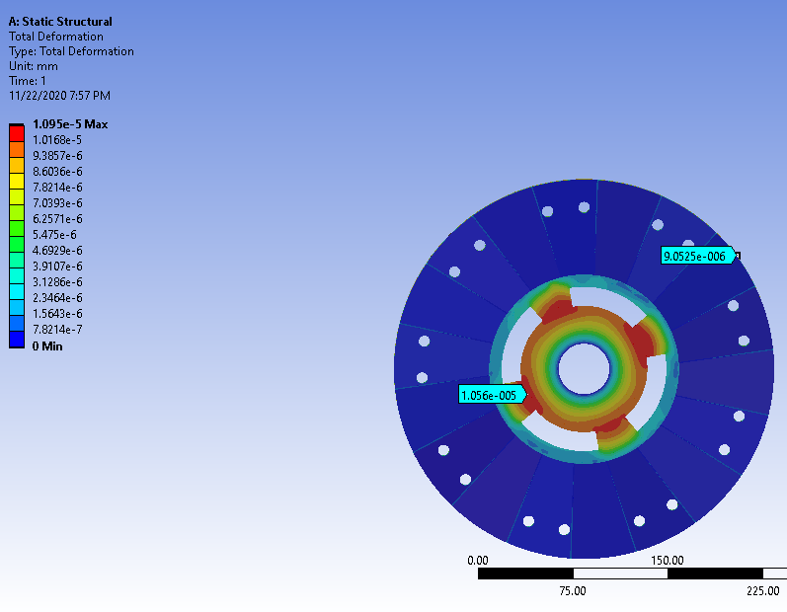
Deformation in X | 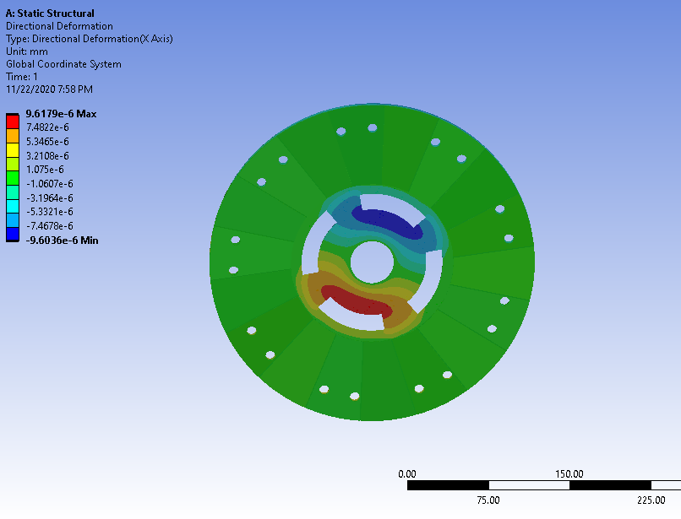
Deformation in Y | 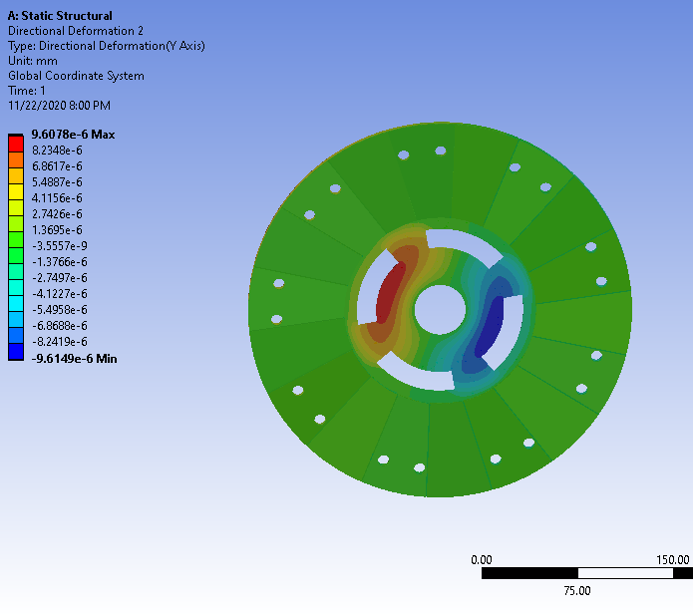
Deformation in Z | 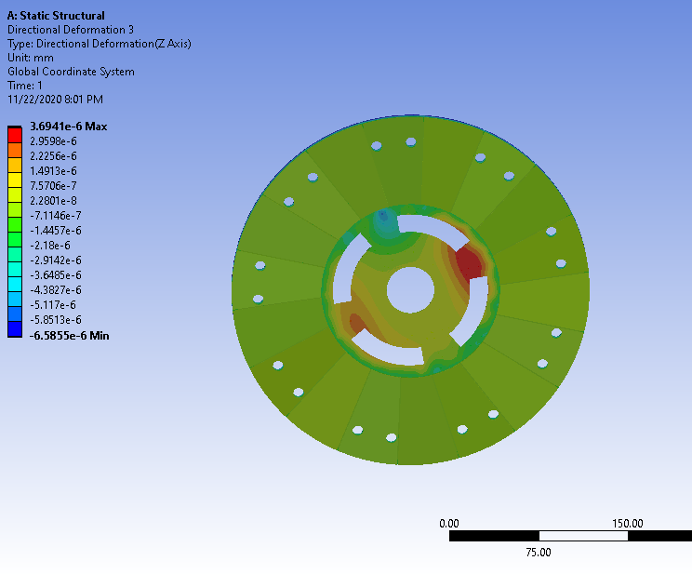
Equivalent (Von-Mises) Stress | 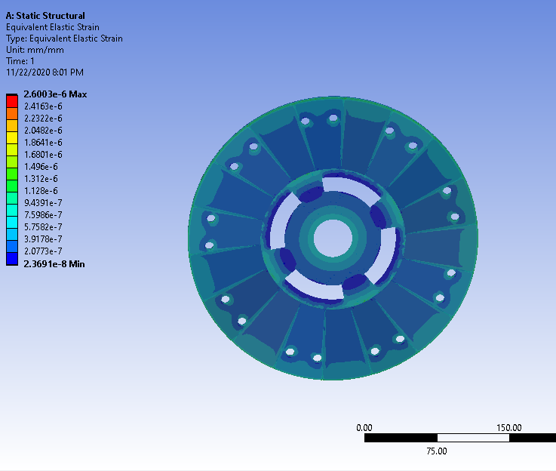
Equivalent Elastic Strain | 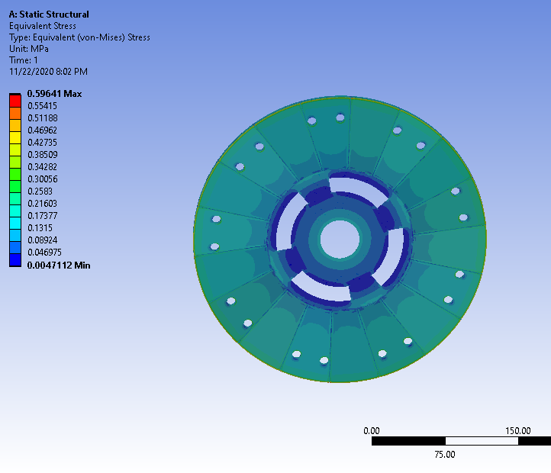

Table (5) Transient analysis of E-glass.
Equivalent Elastic Strain mm/mm | 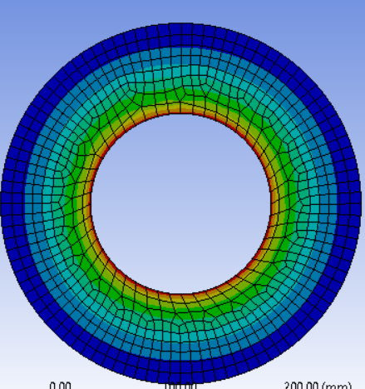 | Max=3.5e-7  Min=4.1e-11
Equivalent Stress Mpa | 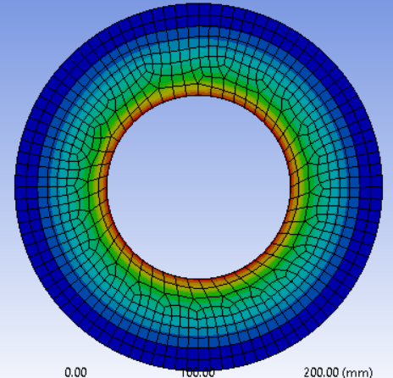 | Max=2.8e-3  Min=1.5e-4
Deformation mm | 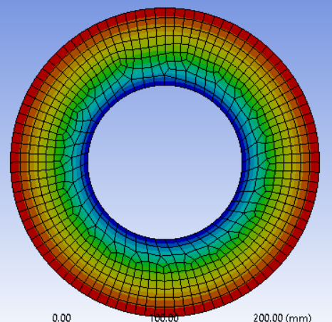 | Max=2.15e-5  Min=6.4e-14
Frictional Stress | 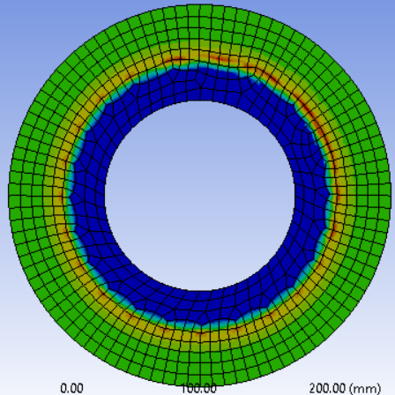 | Max=1.3e-4

Table (6) Transient analysis of AMC.
Equivalent Elastic Strain mm/mm | 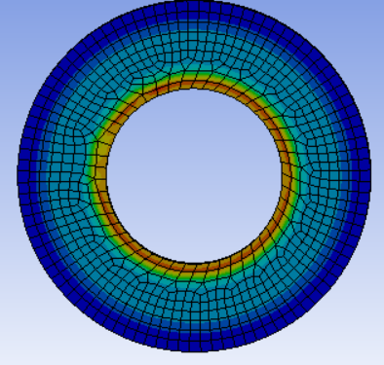 | Max=6.5e-8  Min=3.12e-9
Equivalent Stress Mpa | 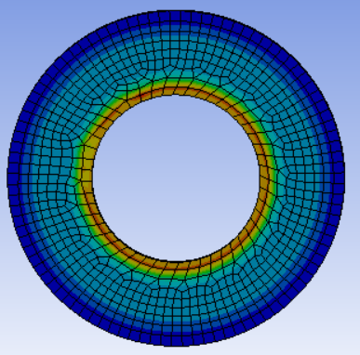 | Max=6.5e-3  Min=1.5e-4
Deformation mm | 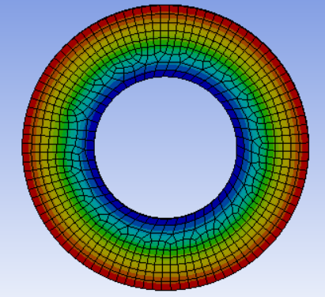 | Max=1.025e-5  Min=4.02e-14
Frictional Stress | 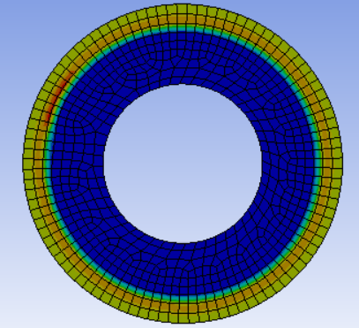 | Max=1.3e-4

Table (7) Transient analysis of FGAMC.
Equivalent Elastic Strain mm/mm | 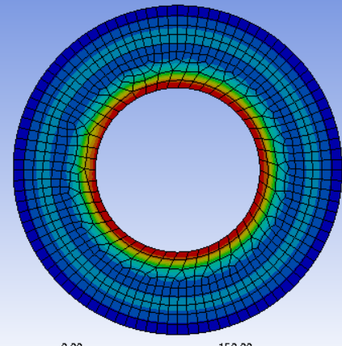 | Max=4.4e-8  Min=3.2e-9
Equivalent Stress Mpa | 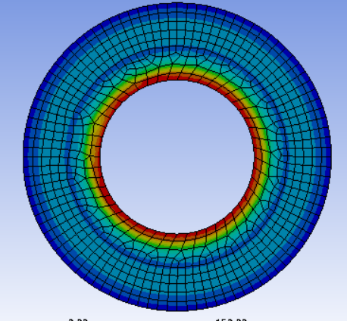 | Max=1.1e-2  Min=3.6e-4
Deformation mm | 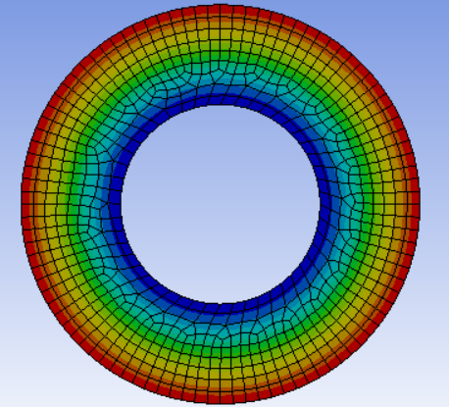 | Max=9.14e-6  Min=6.4e-14
Frictional Stress | 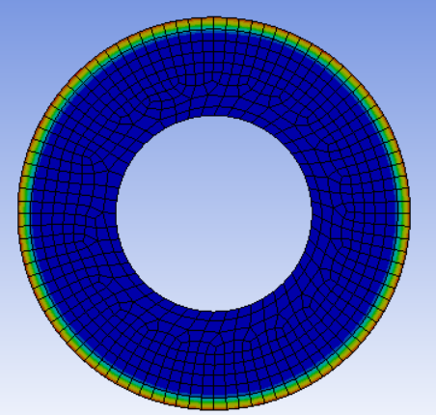 | Max=2.5e-4

Table (8) Wear analysis of AMC.
Total wear in Flywheel and clutch plate (Symmetric Analysis) mm^3  (e-9)  Max = 41 | Flywheel Wear | 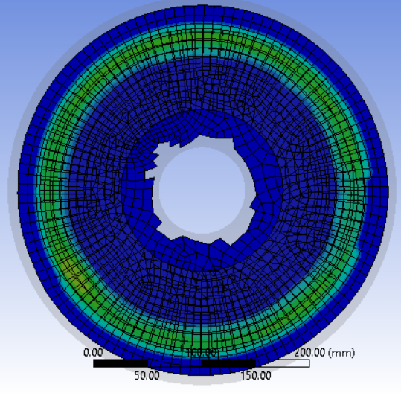
 | Clutch Plate Wear | 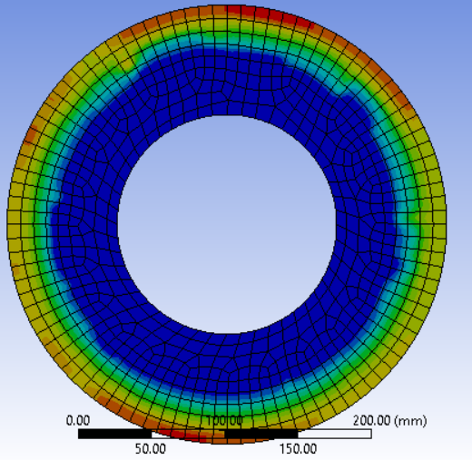
Wear in Asymmetric Condition [Clutch Only]mm^3  (e-9)  Max=35 | 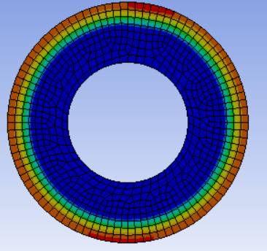

Table (9) Wear analysis of FGAMC.
Total wear in Flywheel and clutch plate (Symmetric Analysis) mm^3  (e-9)  Max = 7.7 | Flywheel Wear | 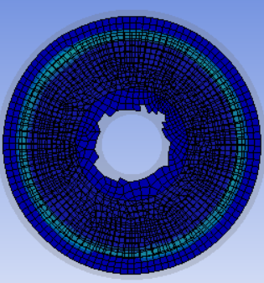
 | Clutch Plate Wear | 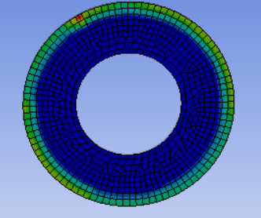
Wear in Asymmetric Condition [Clutch Only]mm^3  (e-9)  Max=3.7 | 