ELECTRONIC SUPPLEMENTARY FILE
Do viral-associated pathways underlie the immune activation during the acute phase of severe major depression?

We obtained 5 milliliters of fasting venous blood from all participants in the study We used Bio-Plex Multiplex Immunoassay kits (Bio-Rad Laboratories Inc., Hercules, USA) to measure the fluorescence intensity (FI) and concentrations of 48 cytokines, chemokines, and growth factors. The blank was subtracted from the IF to obtain accurate results. Table 1 in the Electronic Supplementary File (ESF) lists all the analytes that were measured in our study, along with their gene IDs and aliases. Briefly, the procedure consisted of the following steps: a) diluting the serums using sample diluent (H.B.) (1:4), b) the diluted samples were added to a 96-well plate containing 50µl of microparticle cocktail (including cytokine/chemokines/growth factors) per well and incubated at room temperature with shaking at 850 rpm for 1 hour, c) after three rinses, the plate was added to, and incubated with, 50µl of diluted Streptavidin-PE in each well (shaking at 850 rpm) at room temperature for 10 minutes, d) subsequently, the samples were shaken at room temperature (850 rpm) for 30 seconds with 125 µl of assay buffer added to each well. The subsequent analysis employed the Bio-Plex® 200 System (Bio-Rad Laboratories, Inc.) for the assessment of the cytokines/chemokines/growth factors. For all analytes, the intra-assay CV values were below 11.0%.
Based on the standard concentrations provided by the manufacturer, we obtained the concentrations and evaluated the percentage of the concentrations greater than the lowest measurable concentration (out of range, OOR). ESF, Table 1 lists the number of analytes that were measurable (values higher than OOR). In the statistical analysis, FI values are employed rather than absolute concentration since FI values are more suitable than absolute concentrations, particularly when using numerous plates [34]. Our statistical analysis excluded cytokines/chemokines/growth factors with concentrations that were out of range in more than 80% of the instances. As such, IFN-α2, IL-3, IL-7 and IL-12p40 were excluded. Analytes with quantifiable levels ranging from 20 to 40% were treated in regression analysis as prevalences (dummy variables). As such, IL-17 was introduced as a dummy variable. However, we also computed various immune profiles (see Introduction) that make use of all analytes, except for those with < 20% detectable concentrations [20, 35]].
The main outcome data in this study are the immune profiles that were created using z-unit-weighted composite scores of different cytokines, chemokines, and growth factors. ESF, Table 2 shows the variables that were used to construct M1, M2, M1/M2 (z M1 – zM2), Th-1, Th-2, Th-1/Th-2 (z Th-1 – z Th-2), IRS, CIRS, IRS/CIRS (z IRS – z CIRS), and neurotoxicity profiles. If the immune profiles showed significant differences among the groups, we also entered the single cytokines/chemokines/growth factors.

Assays.
Between 8 and 10 a.m. in the morning, 20 mL of fasting blood was collected using BD Vacutainer® EDTA (10 mL) and BD Vacutainer® SSTTM (5 mL) vials (BD Biosciences, Franklin Lakes, NJ, USA). Blood was allowed to coagulate at ambient temperature for 30 minutes to extract serum. The containers were centrifuged for 10 minutes at 4 degrees Celsius and 1100 g to obtain serum, which was subsequently frozen at -80 degrees Celsius. PBMCs were isolated using Ficoll® Paque Plus (GE Healthcare Life Sciences, Pittsburgh, PA, USA) in a density gradient centrifugation procedure (30 minutes at 900 g). Hemocytometers were used to enumerate the number of cells, and trypan blue, 0.4% solution, pH 7.2-7.3 (Sigma-Aldrich Corporation, St. Louis, MO, USA) was used to determine the percentage of viable cells. Upon counting both total and blue stained cells under various conditions, it was determined that more than 95% of cells were alive.
Anti-human CD3 antibody (OKT3, from eBioscience) was coated at 5 µg/mL on 96-well plates for the evaluation of PBMC stimulation the following day. Each well was injected with 3 x 10⁵ PBMCs and 5 µg/mL anti-human CD28 antibody (CD28.2, eBioscience). To culture the cells, 1% penicillin-streptomycin solution (Gibco Life Technologies, Carlsbad, CA, USA) and 10% fetal bovine serum (FBS) were added to RPMI 1640 containing L-glutamine. The cells were allowed to proliferate at 37 degrees Celsius and 5% carbon dioxide for three days. As a negative control, PBMCs were grown without anti-CD3 and anti-CD28 antibodies for the same amount of time. Consequently, after 72 hours of incubation, samples can be categorized as either unstimulated or stimulated with anti-CD3/CD28 beads. We labeled the 3x10⁵ PBMCs with monoclonal antibodies for 30 minutes to delineate different lymphocyte phenotypes, including CD3-PEcy7, CD4-APCcy7, CD8-APC, CD20-FITC, CB2-AF700, CD40L-FITC, CD69-AF700, CD71-PerCPcy5.5, HLA-DR-PE594, CD25-APC, CD152 PE Dazzle594, GARP-PE, CB1-AF700 and 7-AAD (Biolegend, BD Biosciences and R&D Systems). For Treg cells, we first stained cells with surface markers (CD3, CD4, CD25), then performed intracellular FoxP3 staining using the FoxP3/Transcription Factor Staining Buffer Set (eBioscience) for fixation and permeabilization prior to staining with anti-Foxp3-FITC antibody (Biolegend). Immediately following staining, at least 50,000 lymphocytes were counted using size and granularity criteria by flow cytometry. Our gating techniques for evaluating the lymphocyte phenotypes were displayed in our previous papers [19,20]. We employed the LSRII flow cytometer (BD Biosciences) for the flow cytometry, and FlowJo X (Tree Star Inc., Ashland, OR, USA) to perform data analysis. Consequently, we counted the following cells: CD3+CB2+, CD4+CB2+, CD8+CB2+, CD20+CB2+, CD25+FoxP3+CB1+, CD25+FoxP3+CD152+, CD25+FoxP3+GARP+, CD3+CD71+, CD3+CD40L+, CD3+HLADR+, CD4+CD71+, CD4+CD40L+, CD4+HLADR+, CD8+CD71+, CD8+CD40L+, and CD8+HLADR+.

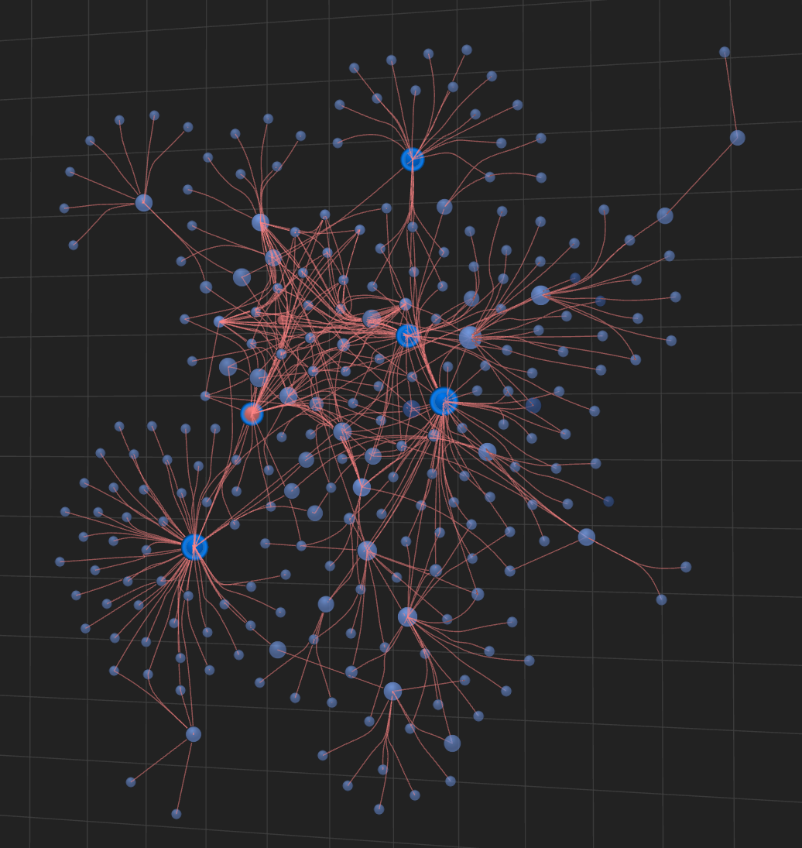
ESF, Figure 1. The extended network visualization of differently expressed cytokine / chemokine / growth factor / CD marker genes of major dysmood disorder. This enlarged network was constructed using OmicsNET analysis and STRING enrichment.
TNF: gene ID of tumor necrosis factor-α; CCL5: chemokine ligand 5 or RANTES; CXCL12: CXC motif chemokine ligand 12 or stromal cell-derived factor 1 (SDF-1); CD4: cluster of differentiation 4; HLA-DR: Human Leukocyte Antigen – DR isotype.

