S1. Adsorption performance
To evaluate the adsorption performance of Fe₃O₄@SiO₂@MPS@MIP toward six strobilurin fungicides, adsorption isotherm and adsorption kinetics experiments were conducted at room temperature using individual standard solutions of each analyte. Each adsorption experiment was performed separately for one target analyte to investigate its adsorption behavior without interference from other compounds.
For the adsorption isotherm experiments, aqueous standard solutions of each target analyte were individually prepared at concentrations of 1, 5, 10, 20, 50, 70, 90, and 100 mg/L. Subsequently, 4 mg of Fe₃O₄@SiO₂@MPS@MIP was added to 5 mL of each standard solution, and the mixture was shaken at 1800 rpm for 30 minutes to achieve adsorption equilibrium. After magnetic separation, the supernatant was filtered through a 0.22 μm membrane, appropriately diluted, and analyzed using UPLC–MS/MS.
For the adsorption kinetics experiments, 4 mg of Fe₃O₄@SiO₂@MPS@MIP was separately added to 5 mL of aqueous standard solution containing each target analyte at a concentration of 20 mg/L. The mixtures were shaken at 1800 rpm for different time intervals (1, 2, 5, 10, 20, 30, 40, 60, 80, and 100 minutes). At each predetermined time point, the adsorbent was separated using an external magnet, and the supernatant was filtered, appropriately diluted, and analyzed by UPLC–MS/MS.The adsorption capacity was calculated using the following formula:
Qₜ = (C₀ − Cₜ)V / m (S1)
where Qₜ is the adsorption capacity at time t (mg/g); C₀ and Cₜ are the initial concentration and the concentration at time t (mg/L), respectively; V is the volume of the adsorption solution (L); and m is the mass of the adsorbent (g). Due to the simultaneous presence of the six analytes, the measured adsorption capacity represents the apparent adsorption capacity under competitive adsorption conditions.
S2. Adsorption kinetics and isotherm models
The adsorption kinetics data were fitted using pseudo-first-order and pseudo-second-order models, expressed as follows:
ln(Qₑ − Qₜ) = lnQₑ − k₁t (S2)
t/Qₜ = 1/(k₂Qₑ²) + t/Qₑ (S3)
where Qₜ and Qₑ are the adsorption capacities (mg/g) at time t and at adsorption equilibrium, respectively; k₁ is the pseudo-first-order rate constant (min⁻¹); and k₂ is the pseudo-second-order rate constant (g·mg⁻¹·min⁻¹).
The equilibrium adsorption data were fitted using Langmuir and Freundlich isotherm models, expressed as follows:
Cₑ/Qₑ = 1/(KₗQₘ) + Cₑ/Qₘ (S4)
lnQₑ = lnKf + (1/n)lnCₑ (S5)
where Cₑ is the equilibrium concentration of the analyte in the solution (mg/L); Qₑ is the equilibrium adsorption capacity (mg/g); Qₘ is the theoretical maximum adsorption capacity (mg/g); Kₗ is the Langmuir adsorption constant (L/mg); and Kf and n are the Freundlich adsorption capacity constant and adsorption intensity constant, respectively. The applicability of each model was evaluated using the coefficient of determination (R²).
S3. Optimization of MSPE conditions
To obtain satisfactory extraction performance for the six strobilurin fungicides, the main parameters affecting the Fe₃O₄@SiO₂@MPS@MIP-based magnetic solid-phase extraction procedure were systematically optimized using 5 mL of mixed aqueous standard solution containing each target analyte at 20 μg/L. The investigated parameters included adsorbent dosage, adsorption pH, adsorption time, desorption solvent composition, desorption solvent volume.Unless otherwise specified, all experiments were performed in triplicate, and the results are expressed as the mean ± standard deviation. The optimized conditions were determined as follows: 14 mg of adsorbent, an adsorption pH of 8.0, an adsorption time of 30 min, methanol/water (1:1, v/v) as the desorption solvent, a desorption solvent volume of 8 mL.
S3.1 Effect of adsorbent dosage
The effect of Fe₃O₄@SiO₂@MPS@MIP dosage on the recoveries of the six target analytes was investigated over the range of 3–20 mg. As shown in Fig. S1(A), the recoveries of the six target analytes gradually increased as the adsorbent dosage increased from 3 to 14 mg. This increase occurred because a larger amount of adsorbent provided more accessible imprinted cavities and functional binding sites for the target analytes. When the dosage reached 14 mg, the recoveries of all six analytes reached their maximum values. A further increase in the adsorbent dosage from 14 to 20 mg produced no significant improvement, indicating that the available binding sites were already sufficient for the fixed amount of analytes in the extraction solution. Excess adsorbent may also increase particle aggregation and reduce the effective utilization of the recognition sites. Therefore, 14 mg was selected as the optimal adsorbent dosage for subsequent experiments.
S3.2 Effect of adsorption pH
The effect of solution pH on the recoveries of the six target analytes was investigated over the range of pH 3–10. As shown in Fig. S1(B), the recoveries gradually increased as the pH increased from 3 to 8 and reached their maximum values at pH 8.0. When the pH was further increased to 9 and 10, a slight decrease in recovery was observed. Under strongly acidic conditions, the high concentration of hydrogen ions altered the hydration state and local polarity of the ionic-liquid-containing polymer layer, thereby weakening the hydrogen-bonding and dipole-related interactions between the target analytes and the recognition sites. As the solution approached neutral and slightly alkaline conditions, the imprinted cavities provided a more favorable microenvironment for hydrogen bonding, dipole–dipole interactions, hydrophobic interactions, and spatial matching with the strobilurin fungicides. At pH values above 8.0, changes in the hydration and swelling behavior of the polymer layer may have reduced the accessibility and binding affinity of the imprinted sites, resulting in slightly decreased recoveries. As the solution approached neutral and slightly alkaline conditions, the functional groups within the imprinted cavities provided a more favorable microenvironment for hydrogen bonding, dipole-related interactions, and spatial matching with the strobilurin fungicides. At pH values above 8.0, changes in the surface charge and hydration state of the polymer layer may have weakened these interactions and reduced the accessibility of the imprinted sites. Similar pH-dependent adsorption behavior of MIPs has been attributed to changes in the charge states of the analyte and polymer, together with variations in hydrogen-bonding and π-related interactions. Therefore, pH 8.0 was selected as the optimal adsorption pH for subsequent experiments.
S3.3 Effect of adsorption time
The effect of adsorption time on the recoveries of the six target analytes was systematically investigated over the range of 10–40 min. As shown in Fig. S1(C), the recoveries increased rapidly as the adsorption time was extended from 10 to 30 min and subsequently remained relatively stable beyond 30 min. During the initial adsorption stage, numerous accessible imprinted cavities and functional binding sites were available on the surface of Fe₃O₄@SiO₂@MPS@MIP, allowing the target analytes to be rapidly retained through hydrogen bonding, π–π stacking, and hydrophobic interactions. As adsorption proceeded, the number of available binding sites gradually decreased, while diffusion of the analytes into the internal pores of the polymer layer increasingly limited the mass-transfer rate. At 30 min, the adsorption process approached equilibrium, and most of the accessible recognition sites had been occupied Further extension of the adsorption time therefore produced no significant improvement in recovery. Consequently, 30 min was selected as the optimal adsorption time for subsequent experiments.
S3.4 Effect of types of desorption solvents
The desorption solvent directly affects the disruption of interactions between the target analytes and the imprinted recognition sites. Therefore, seven solvent systems, including methanol/water (1:1, v/v), methanol/water (3:7, v/v), methanol/water (7:3, v/v), methanol/ammonia solution (9:1, v/v), methanol/acetonitrilev (9:1, v/v), methanol/acetonitrilev (4:1, v/v), and ACN/DMF (1:1, v/v), were evaluated. As shown in Fig. S1(D), methanol/water (1:1, v/v) produced the highest recoveries for all six target analytes. The balanced polarity of this solvent system provided sufficient solubility for the relatively hydrophobic strobilurin fungicides while simultaneously weakening hydrogen bonding, π–π stacking, and hydrophobic interactions between the analytes and the imprinted cavities. Solvent systems containing a higher proportion of water showed insufficient elution strength, whereas excessive organic solvent or strongly acidic or alkaline conditions did not further improve desorption. The ACN/DMF mixture also produced relatively low recoveries, indicating that its polarity and elution ability were not suitable for disrupting the recognition interactions. Therefore, methanol/water (1:1, v/v) was selected as the optimal desorption solvent for subsequent experiments.
S3.5 Effect of desorption solvent volume
The effect of desorption solvent volume on the recoveries of the six target analytes was investigated using methanol/water (1:1, v/v) over the range of 1–10 mL. As shown in Fig. S1(E), the recoveries gradually increased as the desorption solvent volume increased from 1 to 8 mL. At lower solvent volumes, the amount of desorption solvent was insufficient to completely disrupt the interactions between the target analytes and the imprinted recognition sites, resulting in incomplete analyte release. Increasing the solvent volume enhanced contact between the desorption solvent and the adsorbent and maintained a favorable concentration gradient for analyte transfer from the polymer layer into the liquid phase. The maximum recoveries were obtained at 8 mL, indicating that the retained analytes had been sufficiently desorbed under this condition. Further increasing the volume to 10 mL produced no significant improvement and slightly reduced the detected concentrations because of dilution. Therefore, 8 mL was selected as the optimal desorption solvent volume for subsequent experiments.

Figure S1
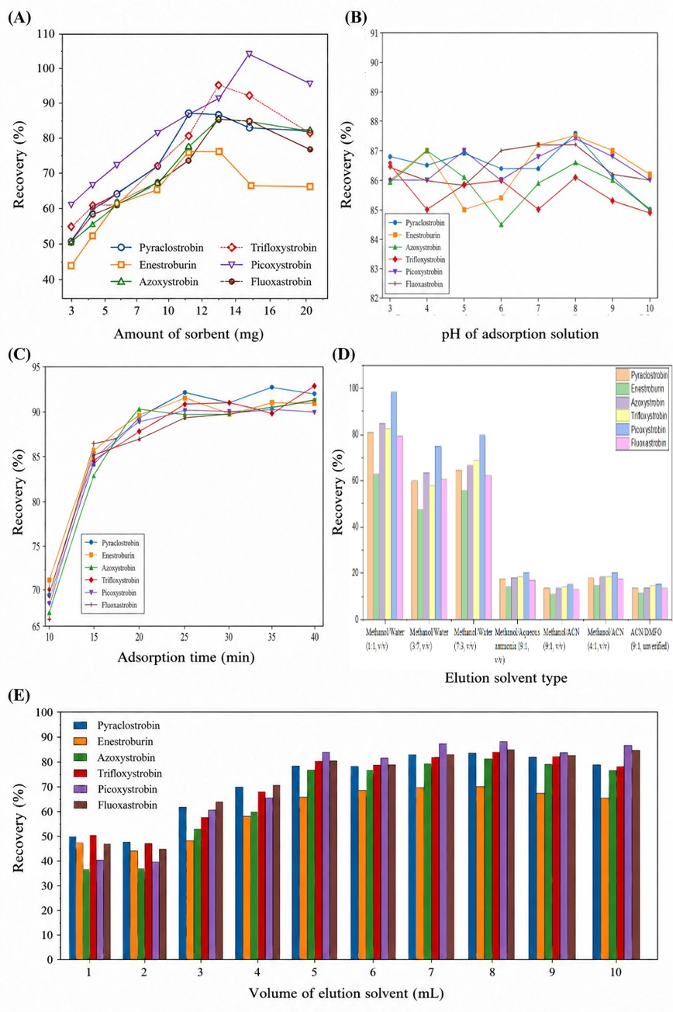
Figure S2
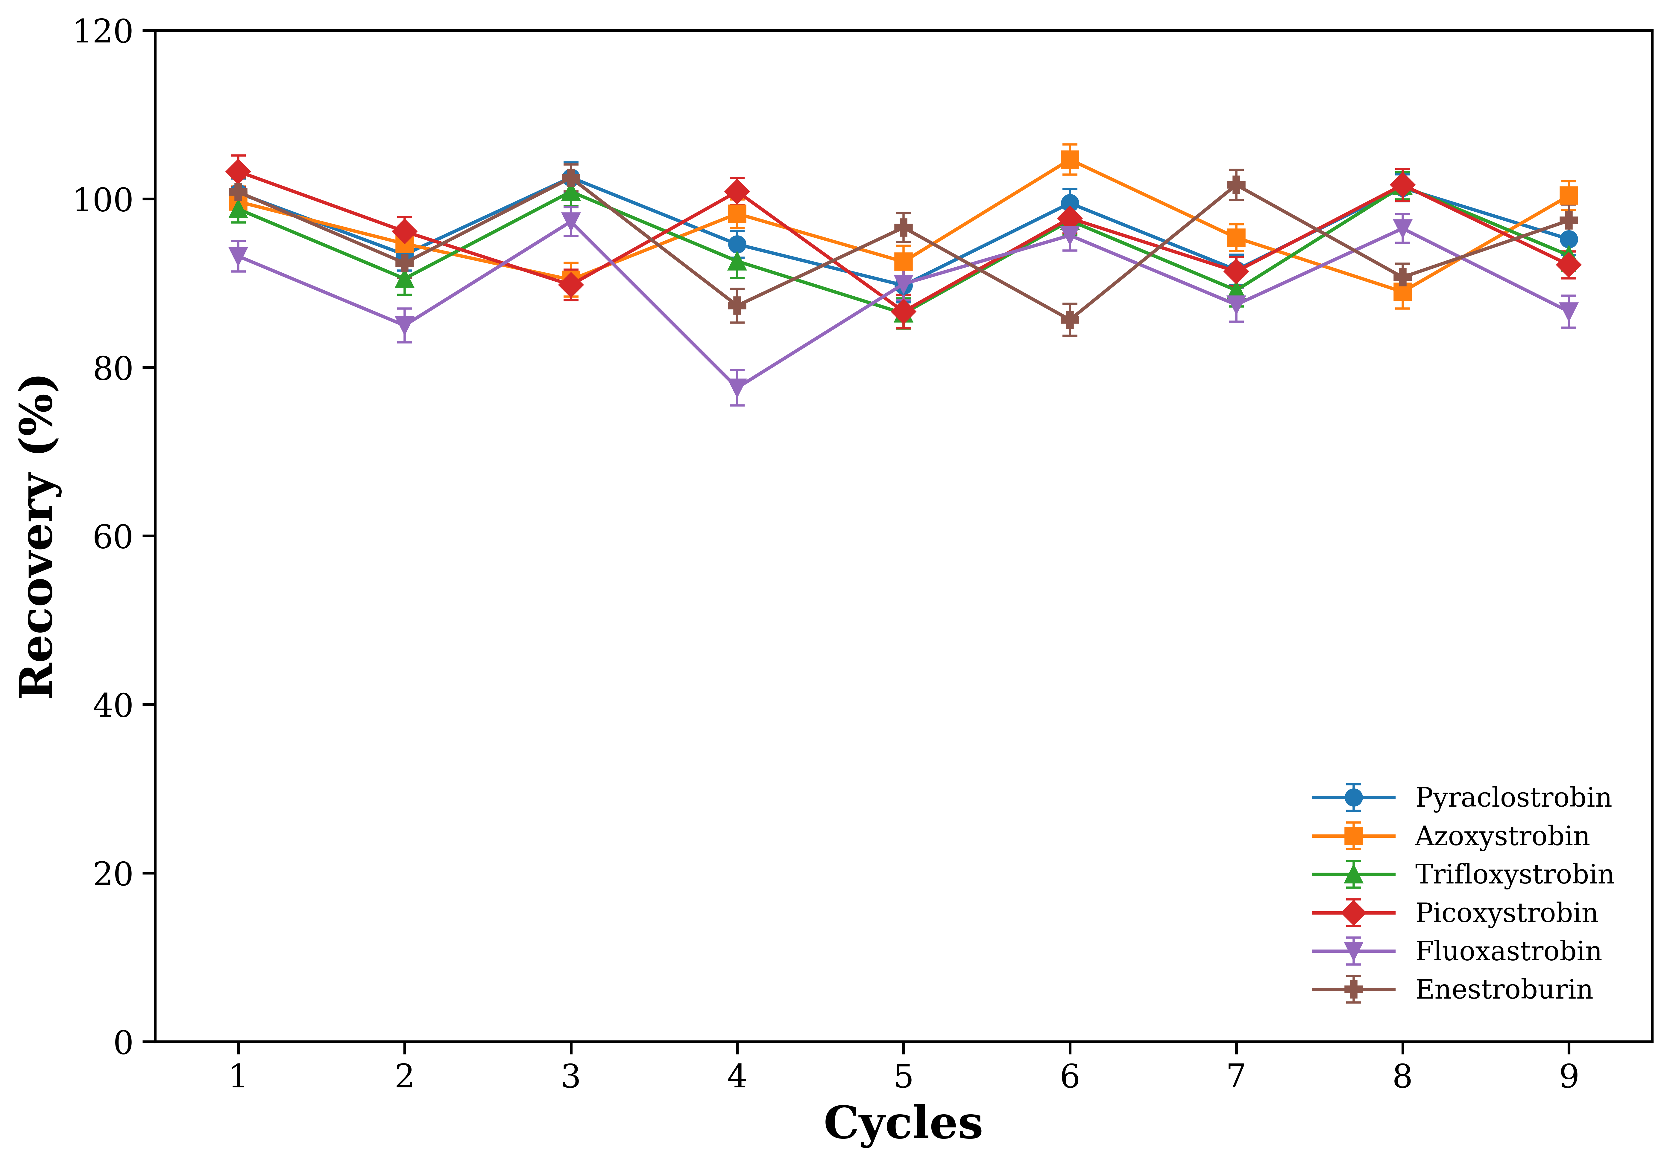

Table S1 Parameters of chromatography and mass spectrometer for the detection of six strobilurin fungicides
Analytes | Structure | Retention  time (min) | Precursor  ion (m/z) | Product ion  (m/z) | CE (V) | Cone (V)
Pyraclostrobin | 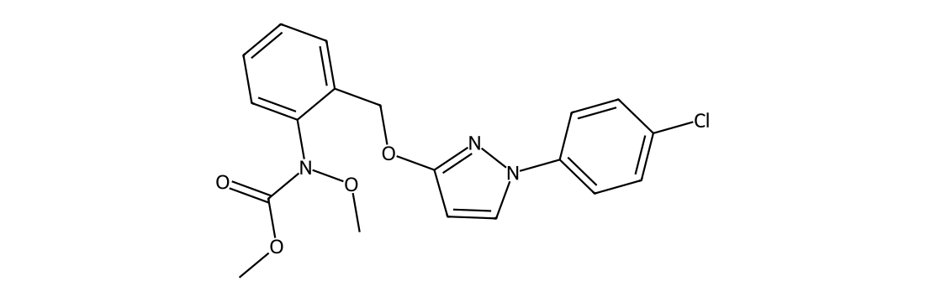 | 6.75 | 388.1 | 193.9*  163.0 | 10  25 | 25  25
Azoxystrobin | 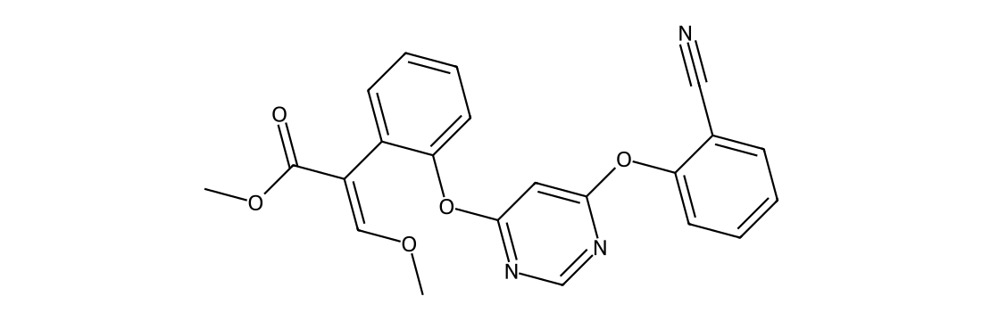 | 5.83 | 404.0 | 372.0*  329.0 | 25  30 | 25  25
Trifloxystrobin | 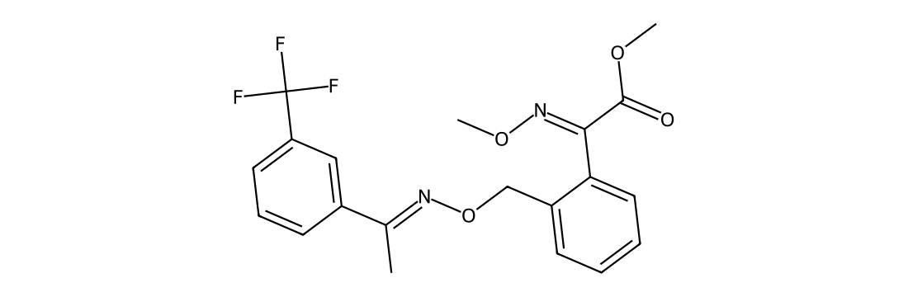 | 7.03 | 409.0 | 186.0*  145.0 | 16  40 | 34  34
Picoxystrobin | 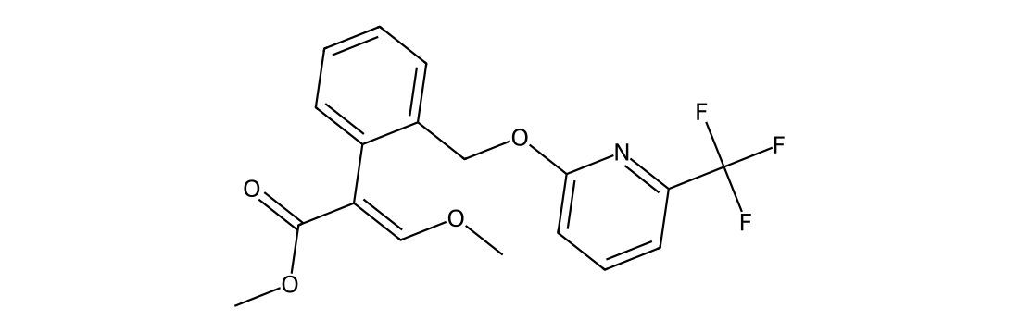 | 6.56 | 368.0 | 205.1*  145.1 | 10  25 | 15  15
Fluoxastrobin | 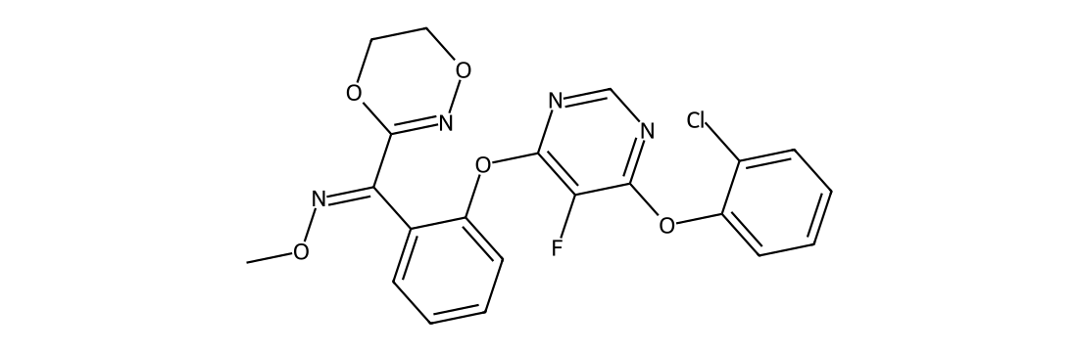 | 6.26 | 459.0 | 427.0*  188.0 | 15  35 | 35  35
Enestroburin | 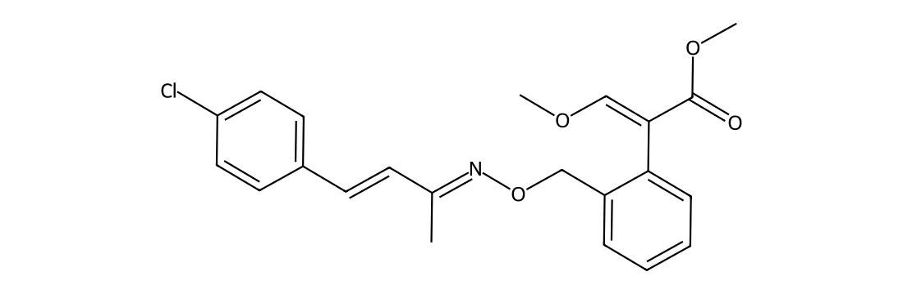 | 7.27 | 400.1 | 178.0*  137.0 | 20  38 | 45  45
*Ions for quantification. All analytes were detected in positive electrospray ionization mode.

Table S2 Adsorption isotherm parameters for the six strobilurin fungicides on Fe₃O₄@SiO₂@MPS@MIP
Analytes | Langmuir R² | Qmax (mg g⁻¹) | KL (L mg⁻¹) | Freundlich R² | 1/n | Kf
Pyraclostrobin | 0.9985 | 21.85 | 0.0572 | 0.9630 | 0.4060 | 3.03
Azoxystrobin | 0.9952 | 19.14 | 0.0586 | 0.9811 | 0.3996 | 2.75
Trifloxystrobin | 0.9977 | 22.85 | 0.0379 | 0.9721 | 0.4734 | 2.15
Picoxystrobin | 0.9989 | 21.25 | 0.0594 | 0.9734 | 0.3992 | 3.07
Fluoxastrobin | 0.9969 | 19.02 | 0.0703 | 0.9464 | 0.3732 | 3.16
Enestroburin | 0.9982 | 19.53 | 0.0666 | 0.9542 | 0.3830 | 3.09

Table S3. Adsorption kinetic parameters for the six strobilurin fungicides on Fe₃O₄@SiO₂@MPS@MIP
Analytes | Pseudo-first-order R² | Q₁ (mg/g) | k₁ (min⁻¹) | Pseudo-second-order R² | Q₂ (mg/g) | k₂ (g·mg⁻¹·min⁻¹)
Pyraclostrobin | 0.9599 | 19.87 | 0.1271 | 0.9913 | 22.37 | 0.00698
Azoxystrobin | 0.9836 | 18.32 | 0.1917 | 0.9990 | 20.06 | 0.01184
Trifloxystrobin | 0.9649 | 22.40 | 0.2427 | 0.9946 | 24.19 | 0.01274
Picoxystrobin | 0.9772 | 20.27 | 0.1531 | 0.9994 | 22.55 | 0.00828
Fluoxastrobin | 0.9717 | 18.05 | 0.1832 | 0.9982 | 19.87 | 0.01124
Enestroburin | 0.9758 | 17.62 | 0.1765 | 0.9976 | 19.45 | 0.01052

Figure Captions
Fig. S1. Optimization of the magnetic solid-phase extraction conditions for the six strobilurin fungicides using Fe₃O₄@SiO₂@MPS@MIP: (A) effect of adsorbent dosage; (B) effect of adsorption solution pH; (C) effect of adsorption time; (D) effect of desorption solvent composition; and (E) effect of desorption solvent volume on the recoveries of the six target analytes.
Fig. S2. Reusability of Fe₃O₄@SiO₂@MPS@MIP for the extraction of six strobilurin fungicides over nine consecutive adsorption–desorption cycles.

