SUPPLEMENTAL MATERIAL
Human Plasma Causal Immunome-Phenome Mapping Reveals Cardiovascular Enrichment and Therapeutic Target Opportunities
Shila Taslima; John Zhang; Huilan Tan; Yanwen Liu; Dhrubo Ahmad; Martin Young; Suresh Verma; Min Xie; Jianli Zhao; Yajing Wang
Contents
Figure S1. Curation and evidence architecture of the 1,007-protein plasma immunome.
Figure S2. Druggability, cellular sourcing, and molecular-layer architecture of the plasma immunome
Figure S3. Instrument construction, discovery-arm Mendelian randomization, and per-disease causal yield.
Figure S4. Phenome-wide causal map across all 2,469 FinnGen R12 endpoints.
Figure S5. Deep-validation layers over the whole-phenome scan.
Figure S6. The cardiovascular evidence chain.
Figure S7. Design of the cardiovascular Plasma Immune Risk Score.
Table S1. Widened 2-population replication, endpoint by endpoint.
Table S2. Protein-level (tier 5) and novel protein-confirmed gene-disease pairs.
Data S1. Precomputed atlas result tables.

Figure S1
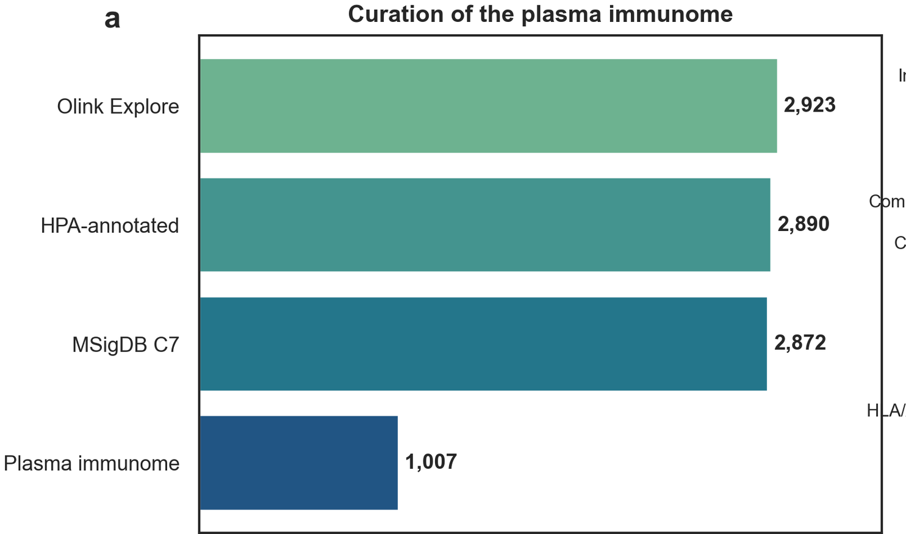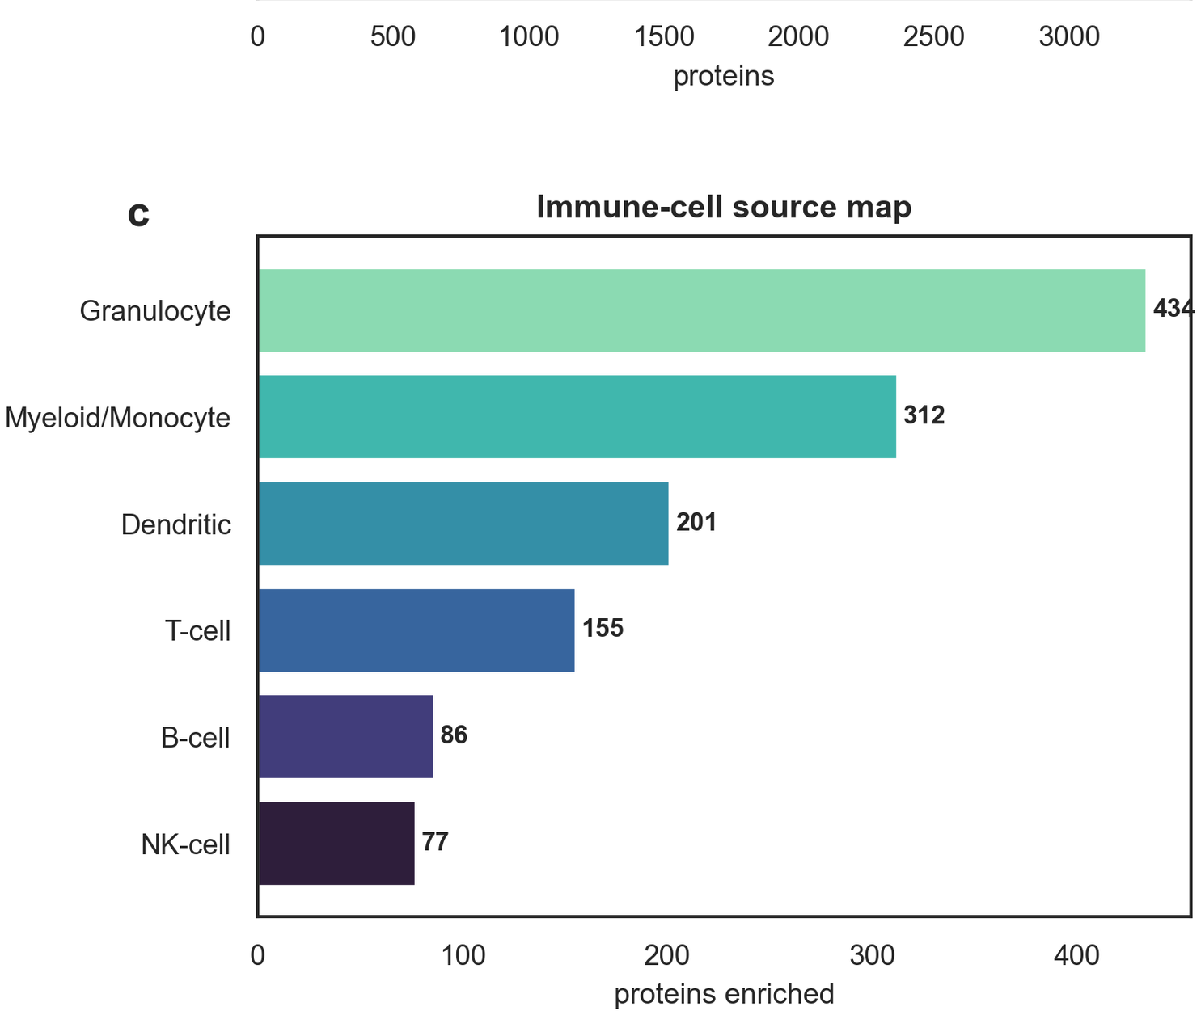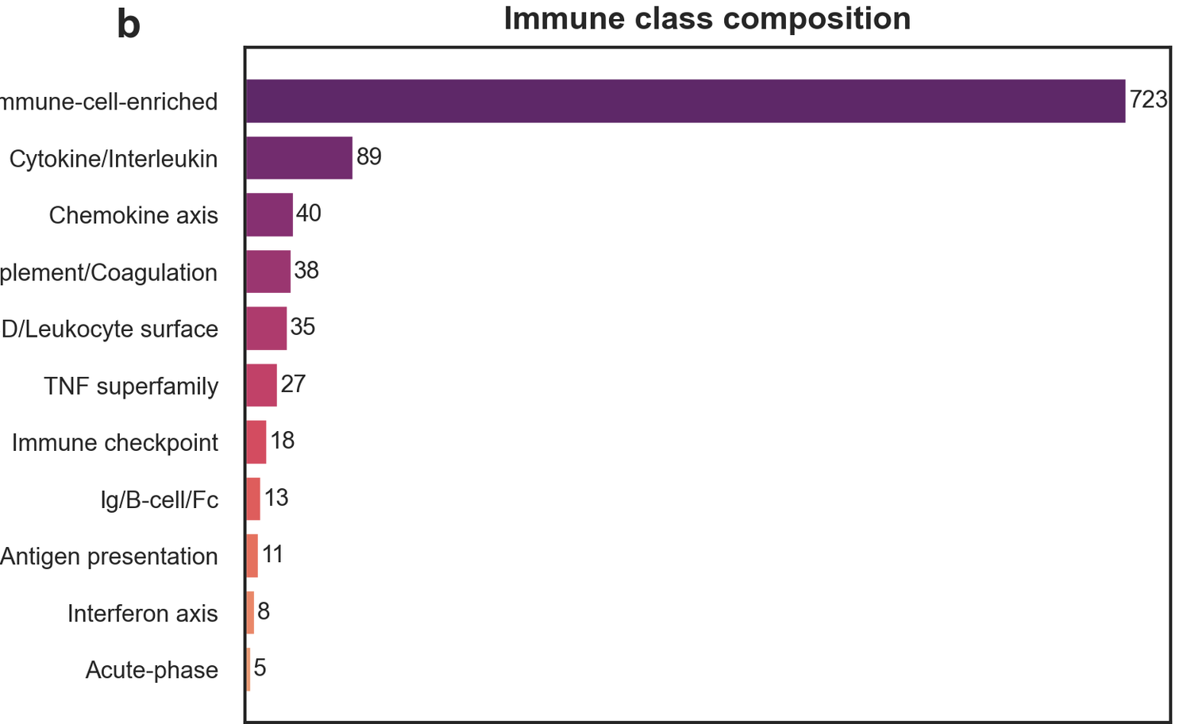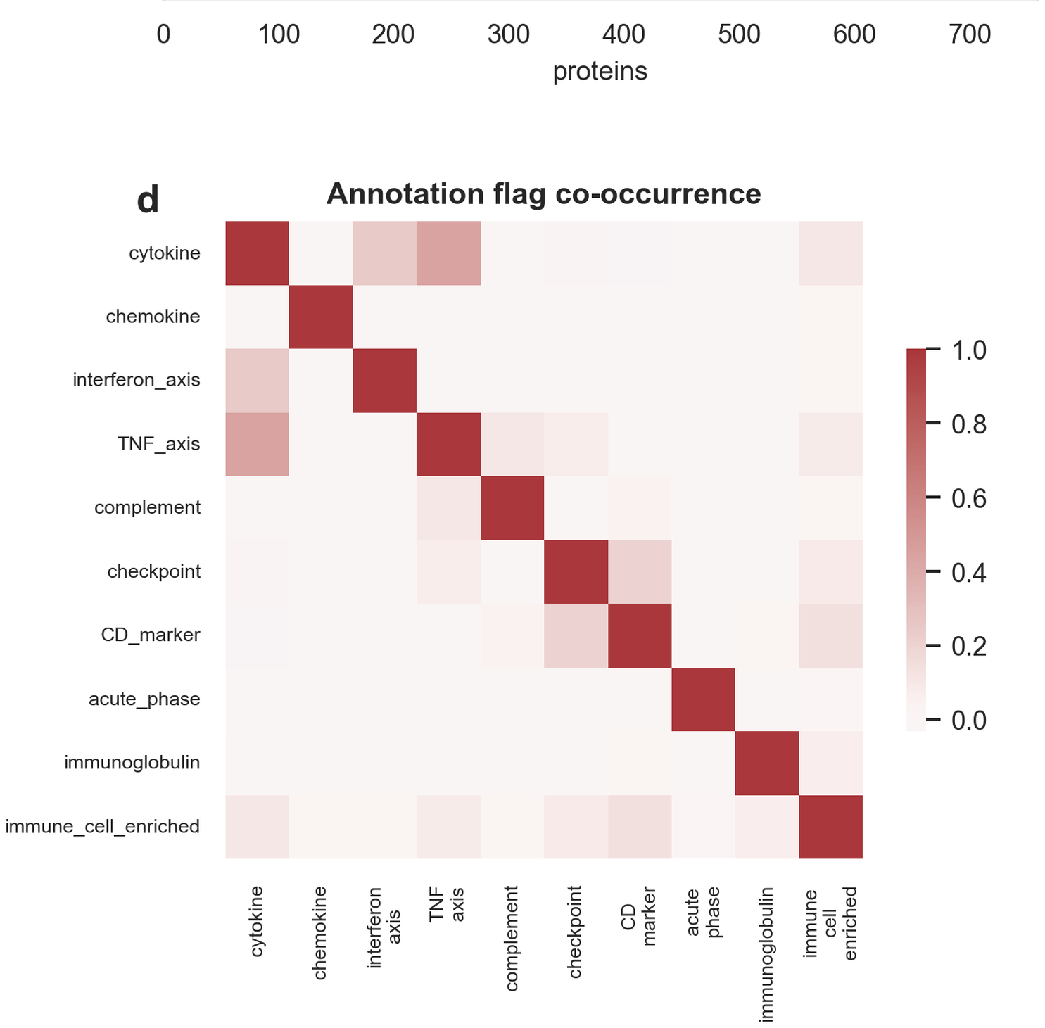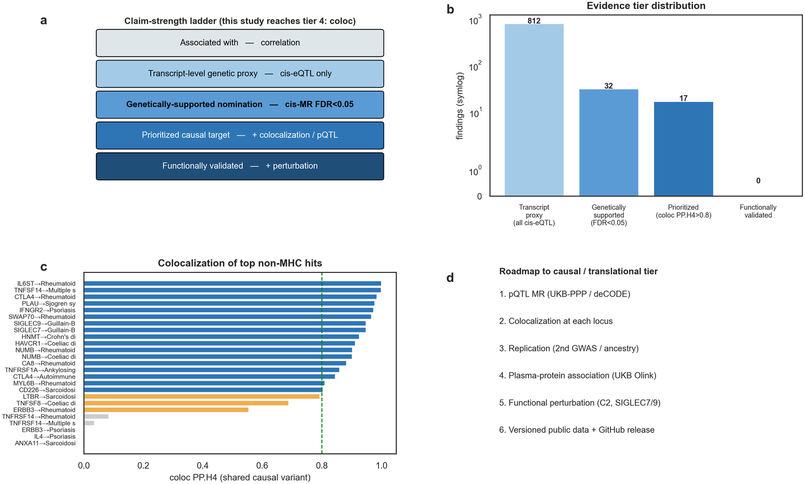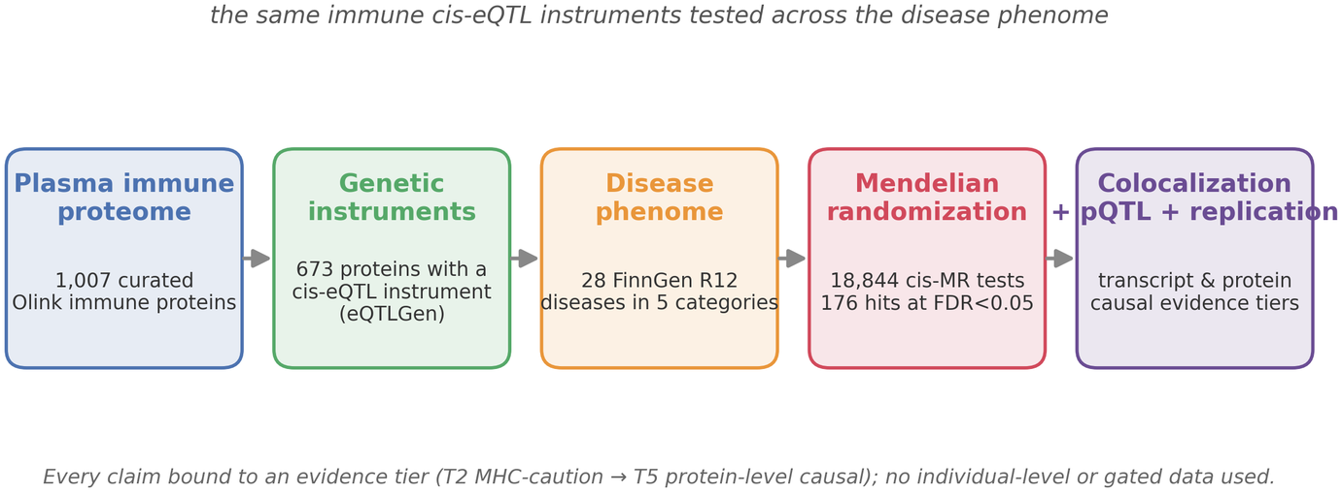
F
E
The same immune cis-eQTL instruments tests across the disease phenome
A
B
C
D

Figure S1 Curation and evidence architecture of the 1,007-protein plasma immunome. A, Curation funnel from the 2,923-assay Olink Explore universe through Human Protein Atlas (HPA) and Molecular Signatures Database annotation to the 1,007-protein plasma immunome. B, Immune class composition of the curated set, from 723 immune-cell-enriched proteins down to 5 acute-phase proteins. C, Immune-cell source map, showing proteins enriched per blood-cell lineage and dominated by granulocyte (434) and myeloid/monocyte (312) origins. D, Annotation-flag co-occurrence across the curation criteria, showing that the flags are largely non-redundant. E, Platform overview: the same immune cis-expression quantitative trait locus instruments are carried unchanged from the curated proteome through instrument construction, the disease phenome, Mendelian randomization, and the colocalization, protein quantitative trait locus, and replication layers, with every claim bound to an evidence tier. F, Computational proteogenomic platform validation roadmap and claim-strength ladder: the evidence ladder each target climbs (a), the resulting tier distribution (b), the colocalization profile of the leading non-major-histocompatibility-complex hits (c), and the route to causal or translational tiers (d). The atlas is built exclusively from public, citable resources; no individual-level, credentialed, or gated dataset was used.

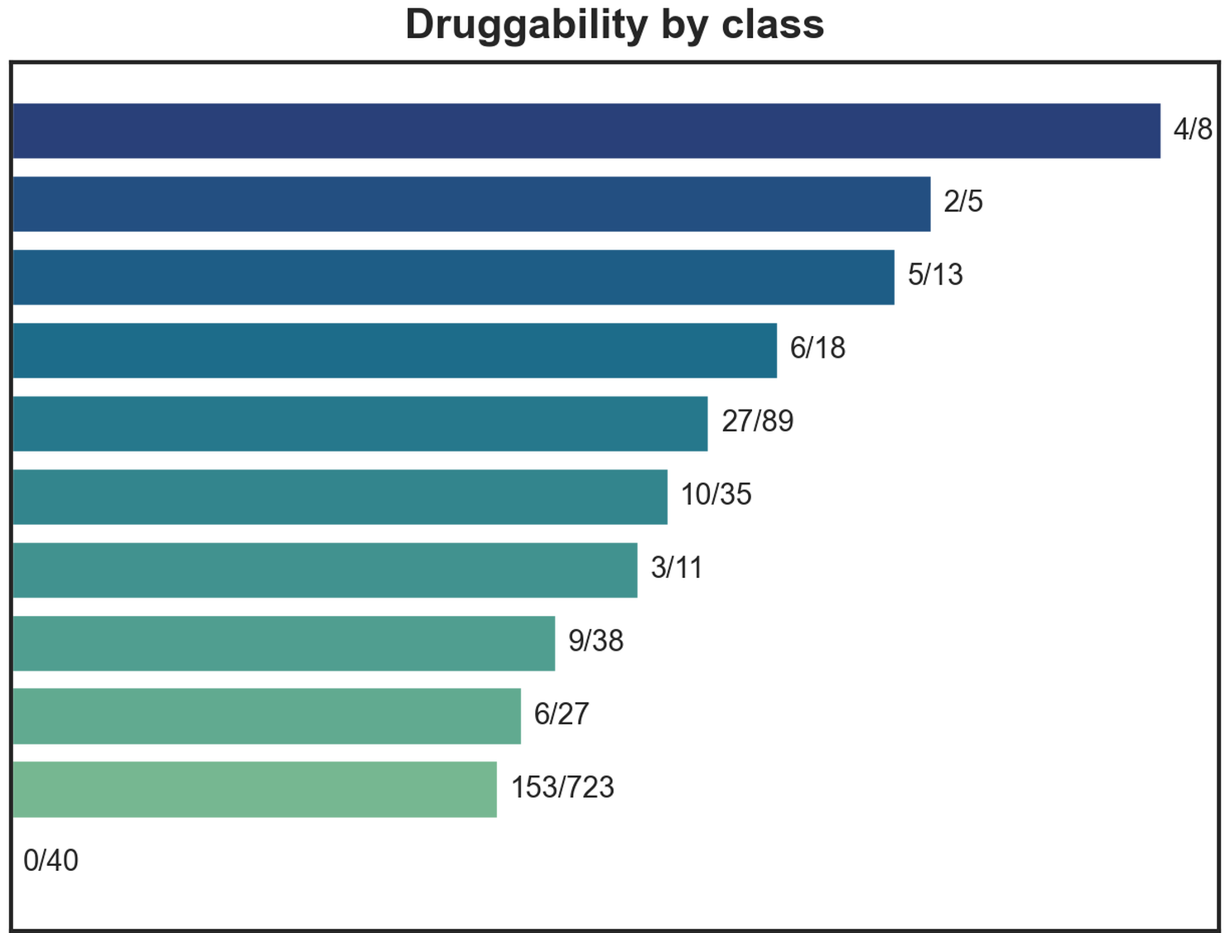
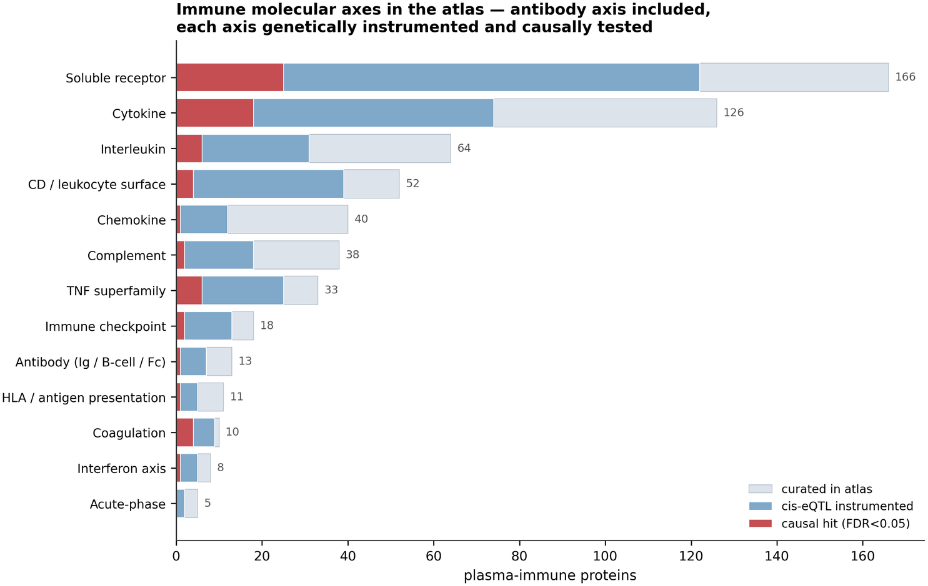
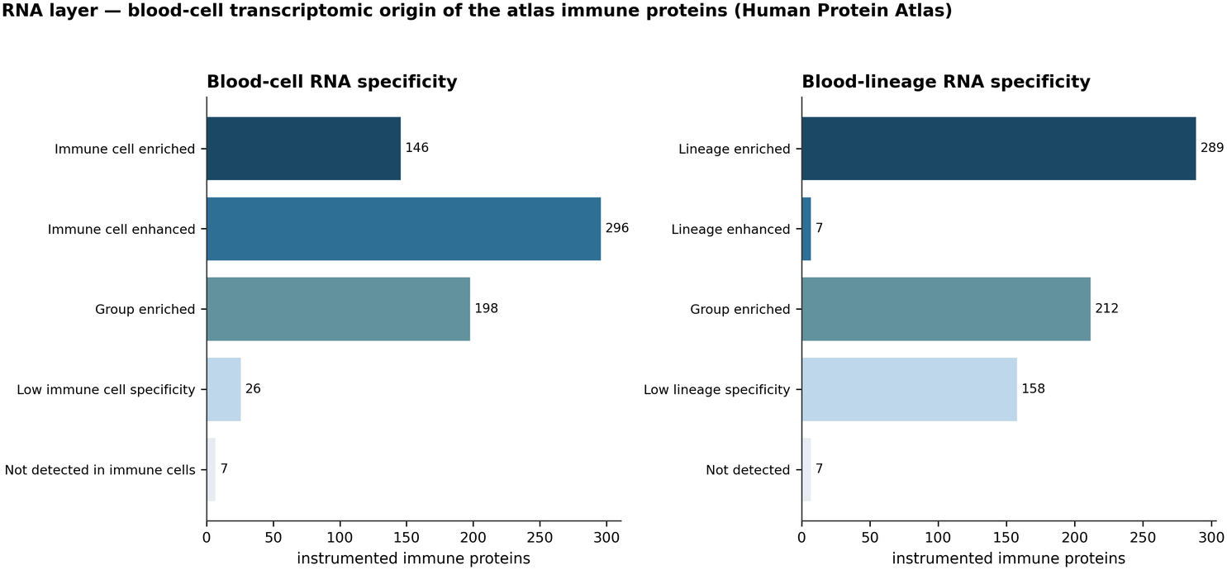
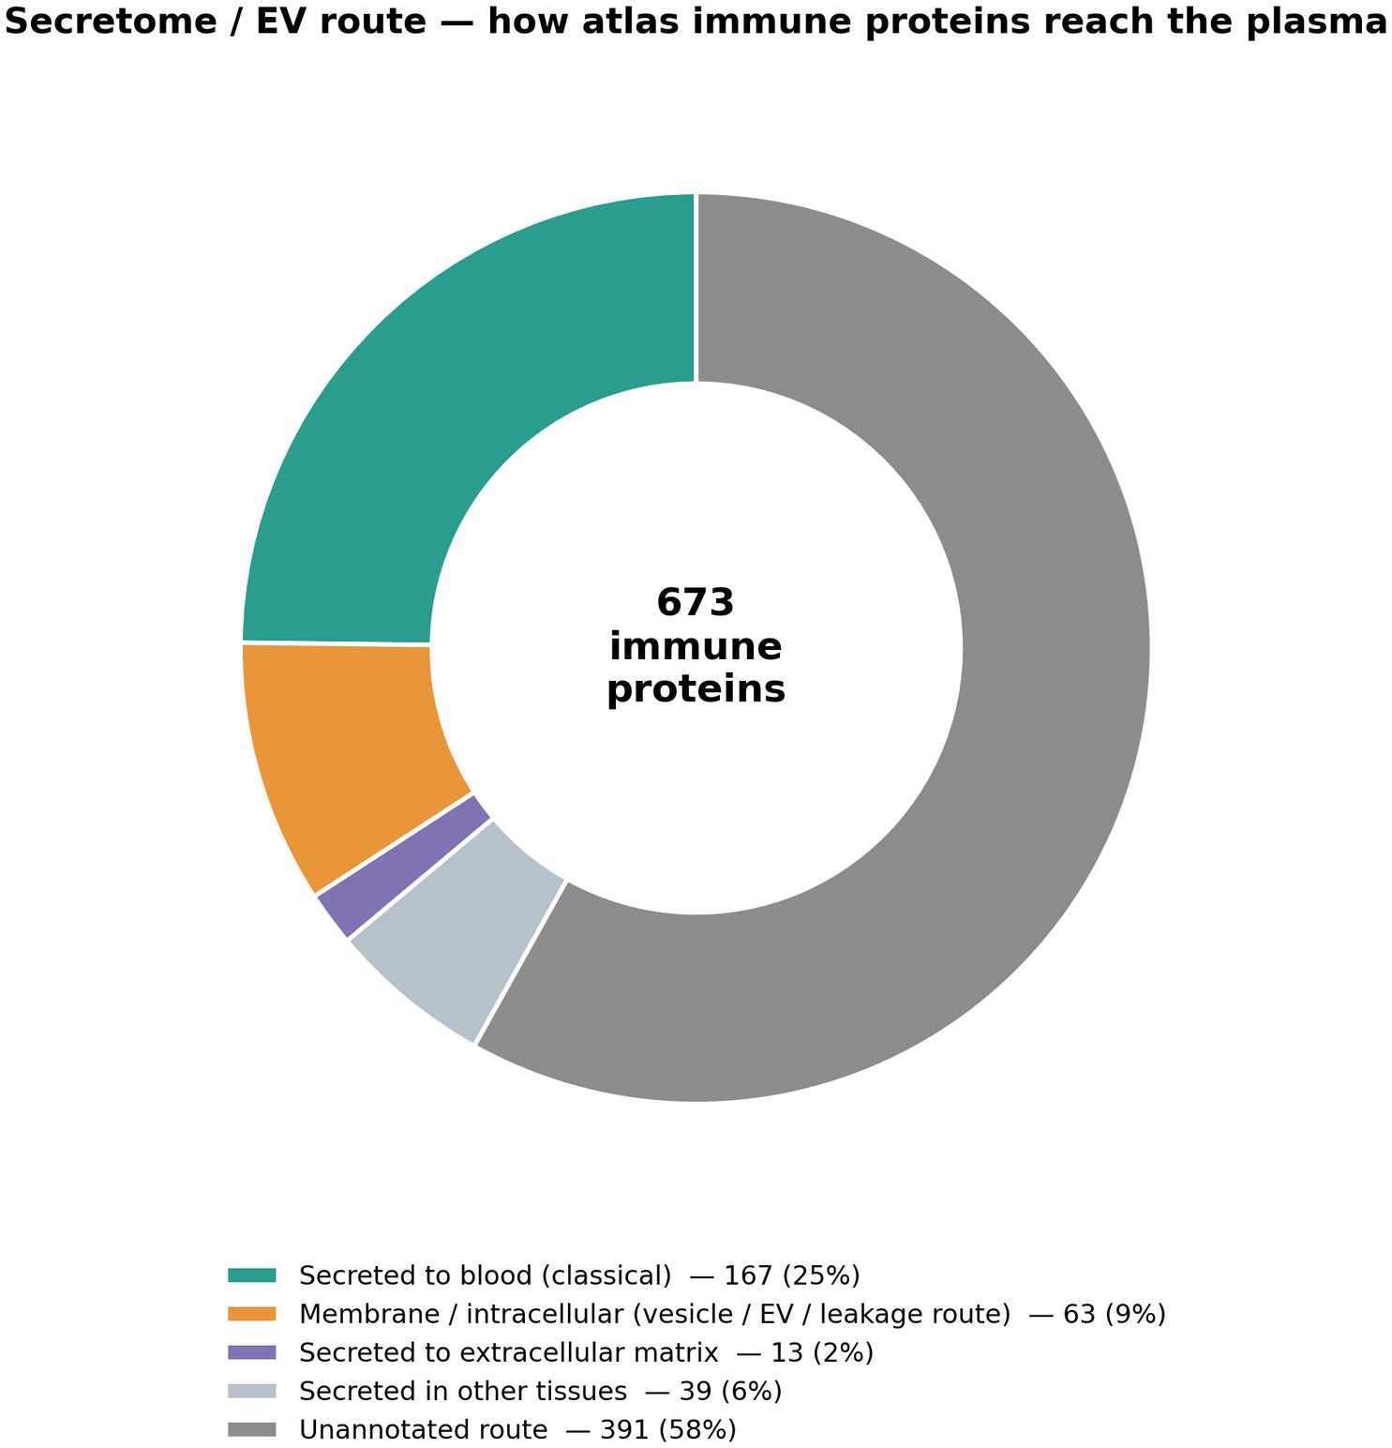
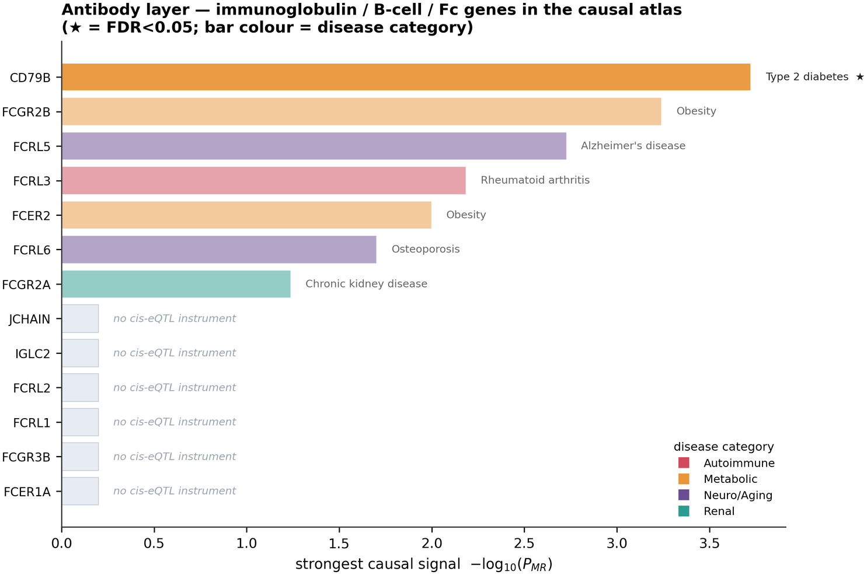
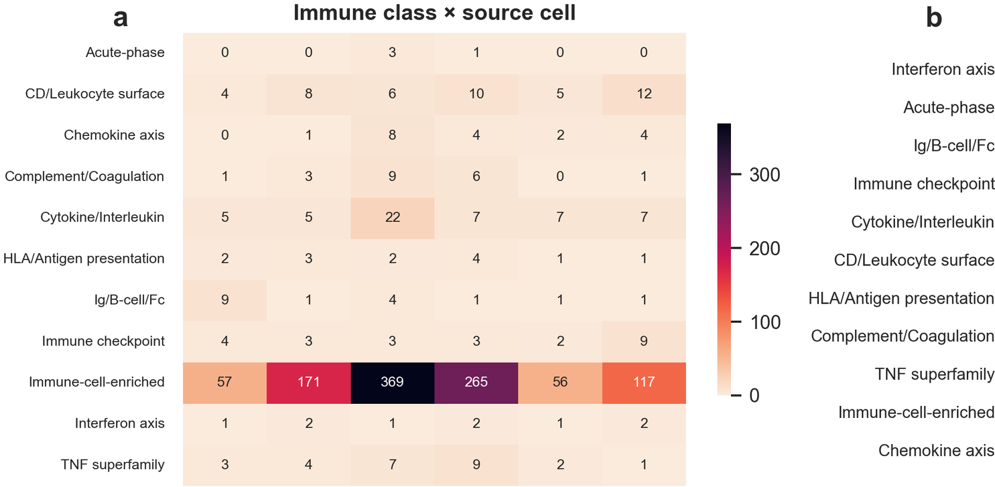
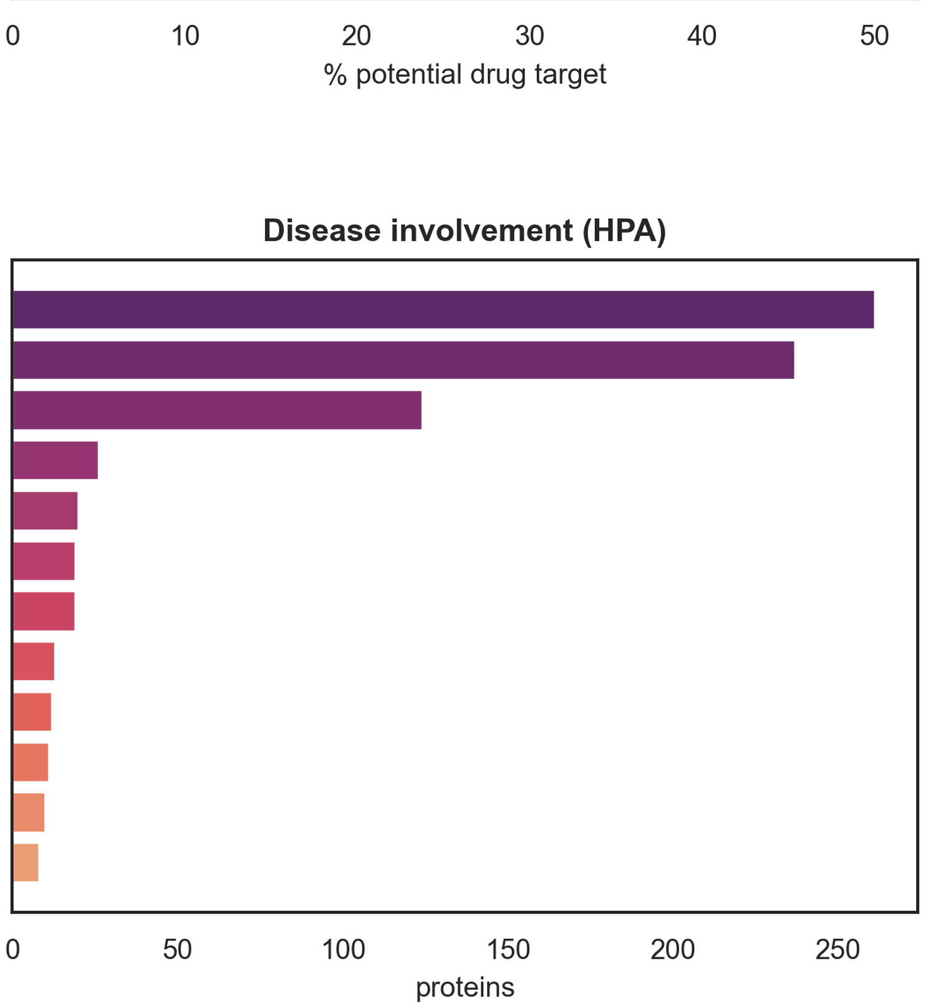
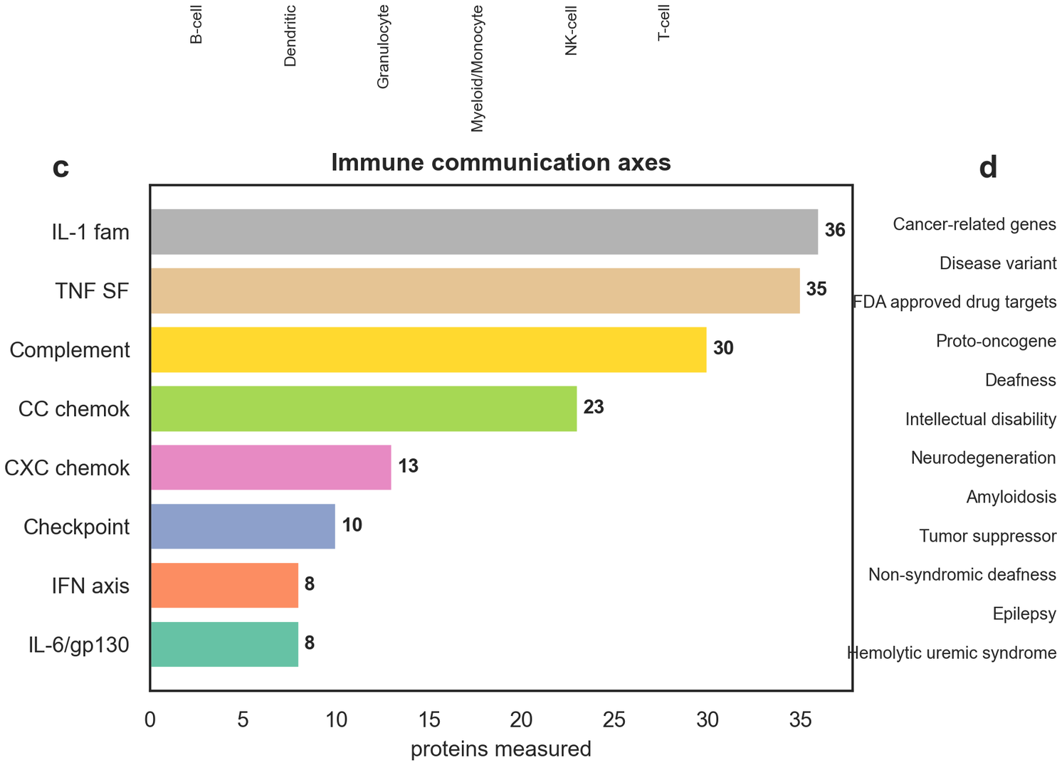
Figure S2.
E
F
G
H
A
B
C
D

Figure S2. Druggability, cellular sourcing, and molecular-layer architecture of the plasma immunome. A, Immune class by source cell, showing that immune-cell-enriched proteins dominate every lineage and most heavily the granulocyte (369) and myeloid (265) compartments. B, Druggability by immune class, expressed as the fraction of proteins that are potential drug targets, led by the interferon axis (4/8) and acute-phase (2/5) classes, with the chemokine axis contributing none (0/40). C, Immune communication axes measured on the panel, including the interleukin-1 family (36), tumor necrosis factor superfamily (35), complement (30), CC and CXC chemokines (23 and 13), checkpoints (10), and the interferon and interleukin-6/gp130 axes (8 each). D, Disease involvement of the curated proteins from HPA annotation, including approximately 120 approved drug targets. E, Immune molecular axes: for each functional axis, including the antibody (immunoglobulin, B-cell, Fc-receptor) axis, the number of proteins curated, instrumented with a cis-expression quantitative trait locus, and reaching a causal hit at a false discovery rate <0.05. F, RNA layer: blood-cell and blood-lineage RNA specificity of the instrumented immune proteins. G, Secretome and extracellular-vesicle route, showing how each instrumented protein reaches plasma, by classical secretion versus a membrane, intracellular, or vesicle route. H, Antibody-layer spotlight: immunoglobulin, B-cell, and Fc-receptor genes, whether each carries an instrument, and its strongest causal signal, led by CD79B in type 2 diabetes, FCRL5 in Alzheimer disease, and FCRL3 in rheumatoid arthritis.

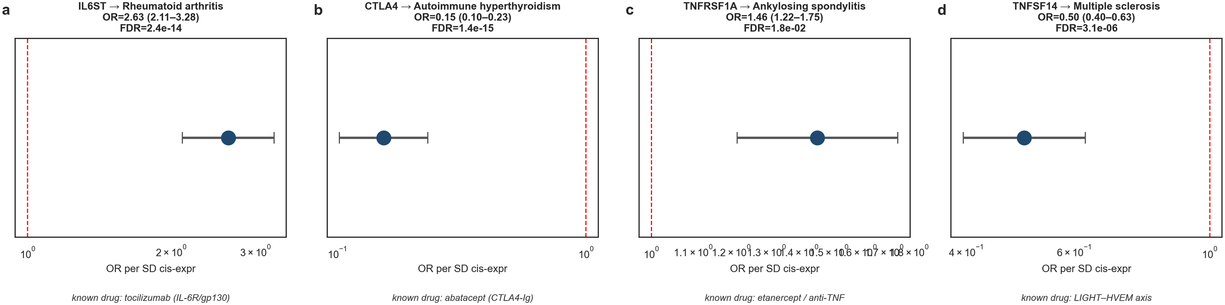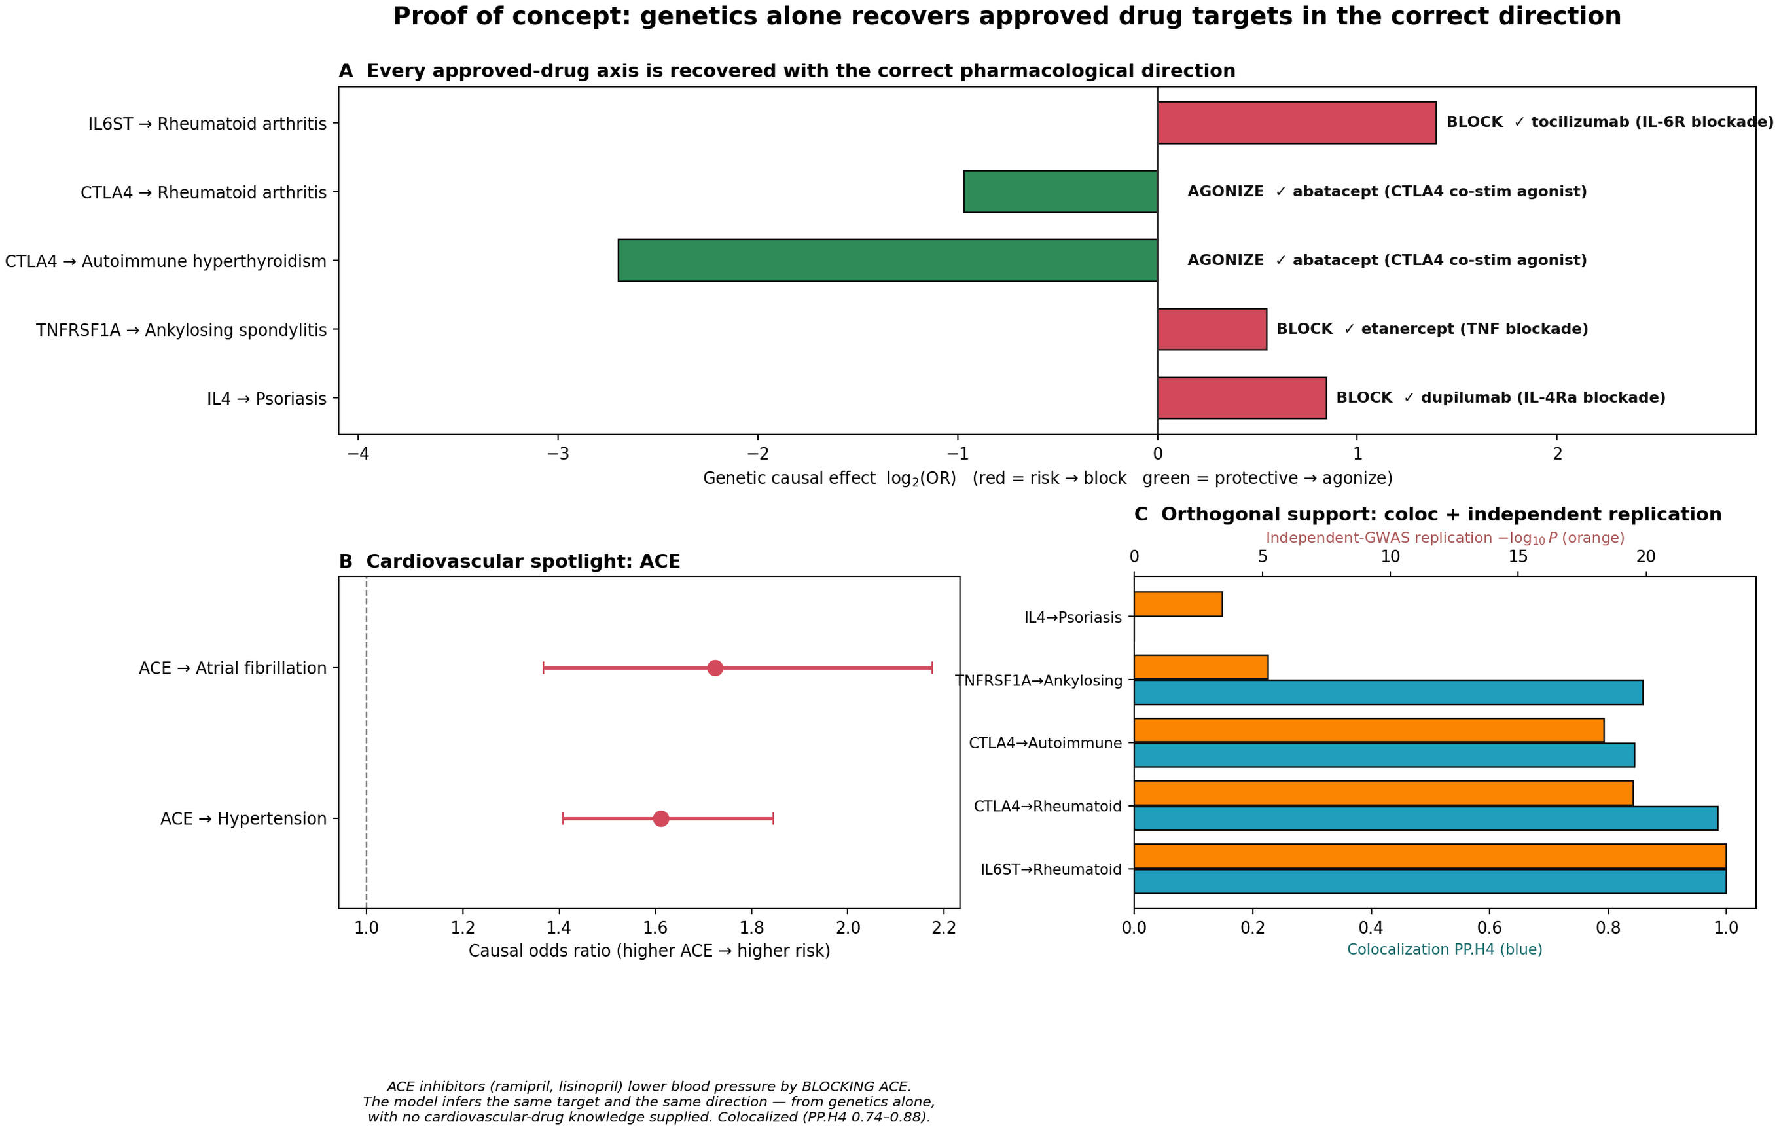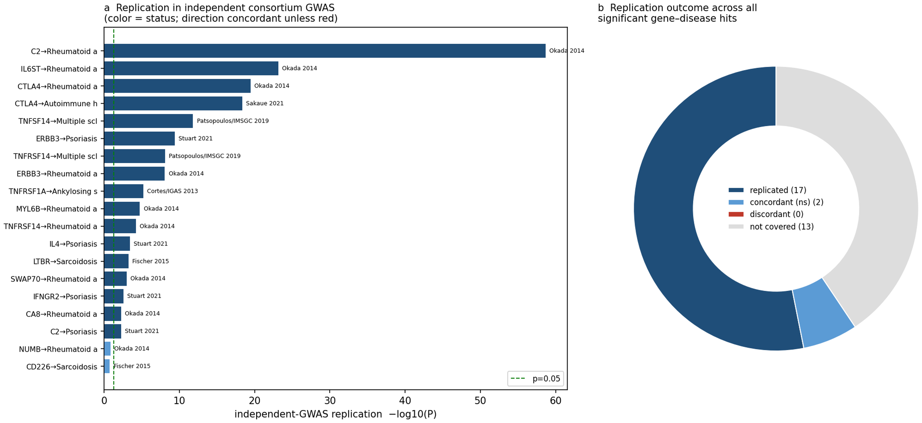
Figure S3
A
B
C
Figure S3. Instrument construction, discovery-arm Mendelian randomization, and per-disease causal yield. A, Discovery arm: (a) cis-Mendelian randomization workflow, with 812 immune cis-expression quantitative trait locus instruments constructed from eQTLGen (673 usable) and tested against 13 FinnGen autoimmune genome-wide association studies in 8,749 Wald-ratio tests yielding 32 hits at a false discovery rate (FDR) <0.05; (b) volcano plot of the 8,749-test discovery arm, with C2, IL6ST, CTLA4, and IL4 labeled; (c) causal genes per disease, led by rheumatoid arthritis (9); (d) hit enrichment by immune class, led by the complement/coagulation and tumor necrosis factor superfamily classes. B, Mirrored Manhattan plot of the 18,844 cis-Mendelian randomization tests of the 28-disease, 5-category core; points above the center line are risk increasing and points below are protective, with the dashed lines marking the FDR <0.05 band and the tallest signals spanning the drug-target axes together with cardiovascular and metabolic nominations. C, Number of causal immune proteins per disease split by direction (risk raising versus protective), with disease labels colored by category; hypertension, coronary heart disease, and type 2 diabetes carry the largest immune causal burden outside the classical autoimmune diseases. D, Evidence-source stack by disease category, decomposing each category's causal hits into Mendelian randomization only, Mendelian randomization plus colocalization, and Mendelian randomization plus colocalization plus protein quantitative trait locus support.

Figure S4
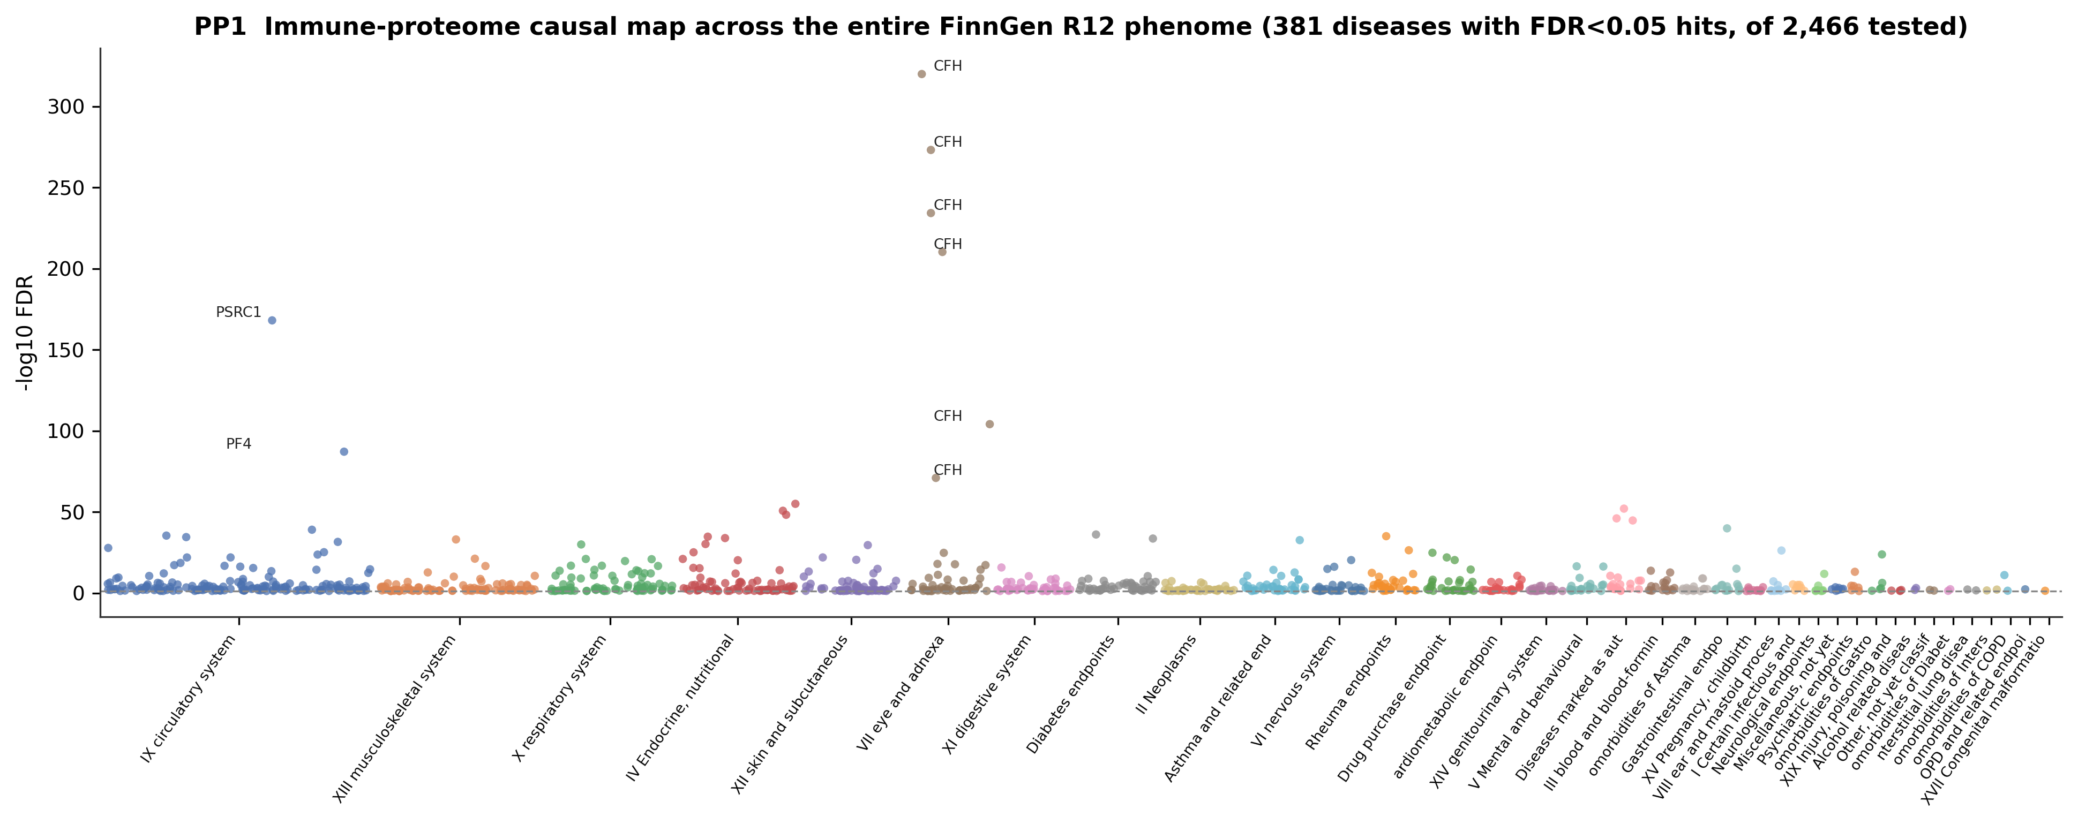
A
B
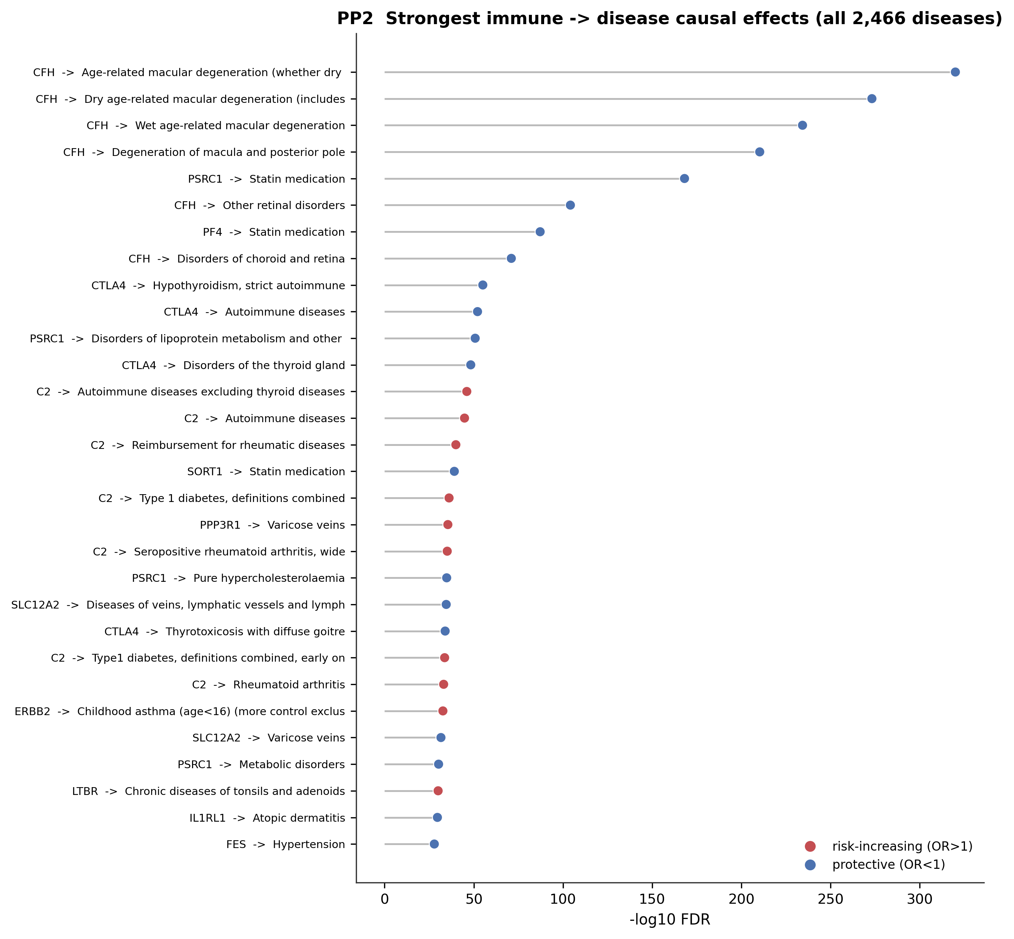
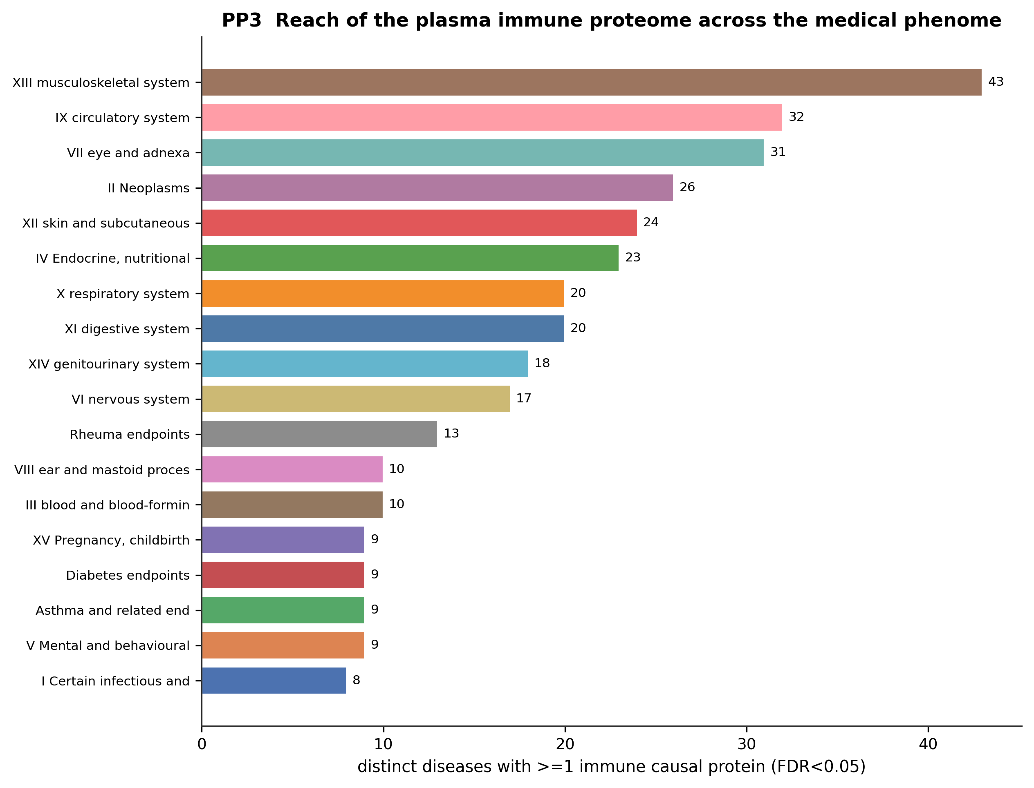
C
Figure S4. Phenome-wide causal map across all 2,469 FinnGen R12 endpoints. A, Every false discovery rate (FDR) <0.05 immune-to-disease causal effect across all 2,466 FinnGen R12 endpoints with data, grouped by International Classification of Diseases chapter (x axis) against -log10 FDR (y axis); the immune proteome reaches into essentially every organ system, with CFH to macular degeneration and PSRC1/PF4 to lipid-lowering phenotypes the extreme peaks. B, The 30 strongest immune-to-disease causal effects over the whole phenome, colored by direction (red, risk increasing; blue, protective), dominated by known complement, checkpoint, and lipid biology recovered blind. C, Reach of the plasma immune proteome across the medical phenome: number of distinct diseases with at least 1 causal immune protein (FDR <0.05) per International Classification of Diseases chapter; the musculoskeletal, circulatory, ophthalmic, neoplasm, and dermatologic chapters are the most immune connected.

Figure S5

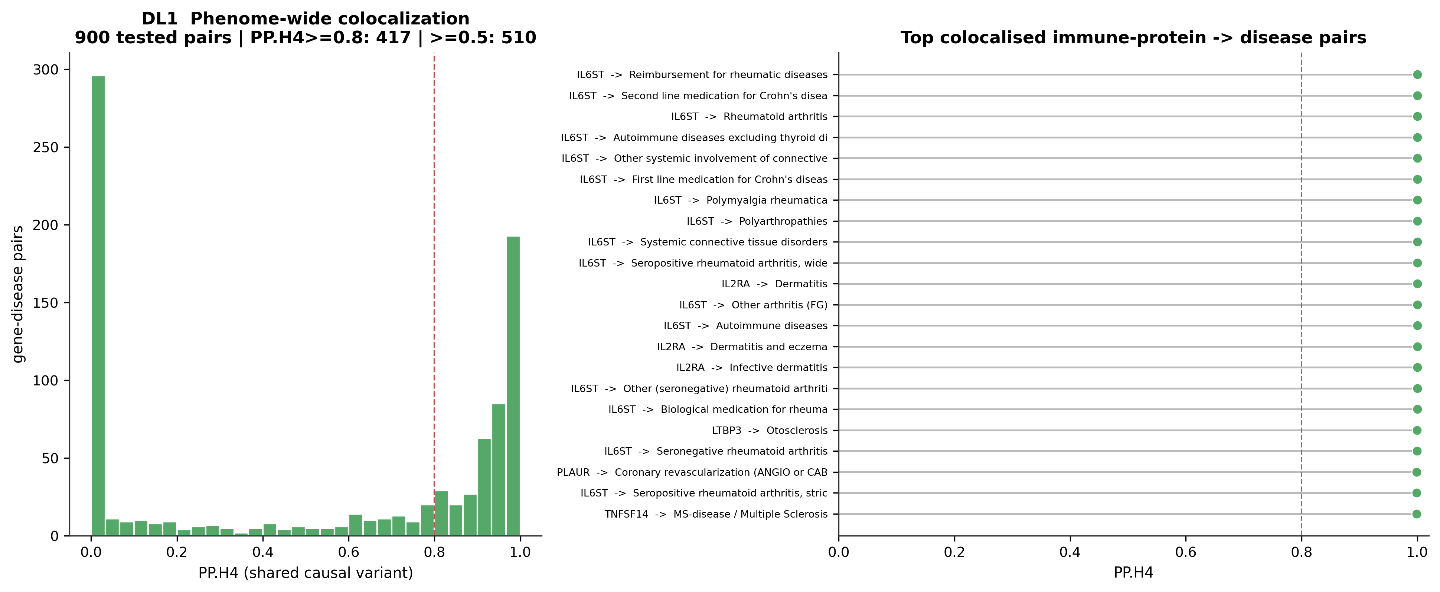
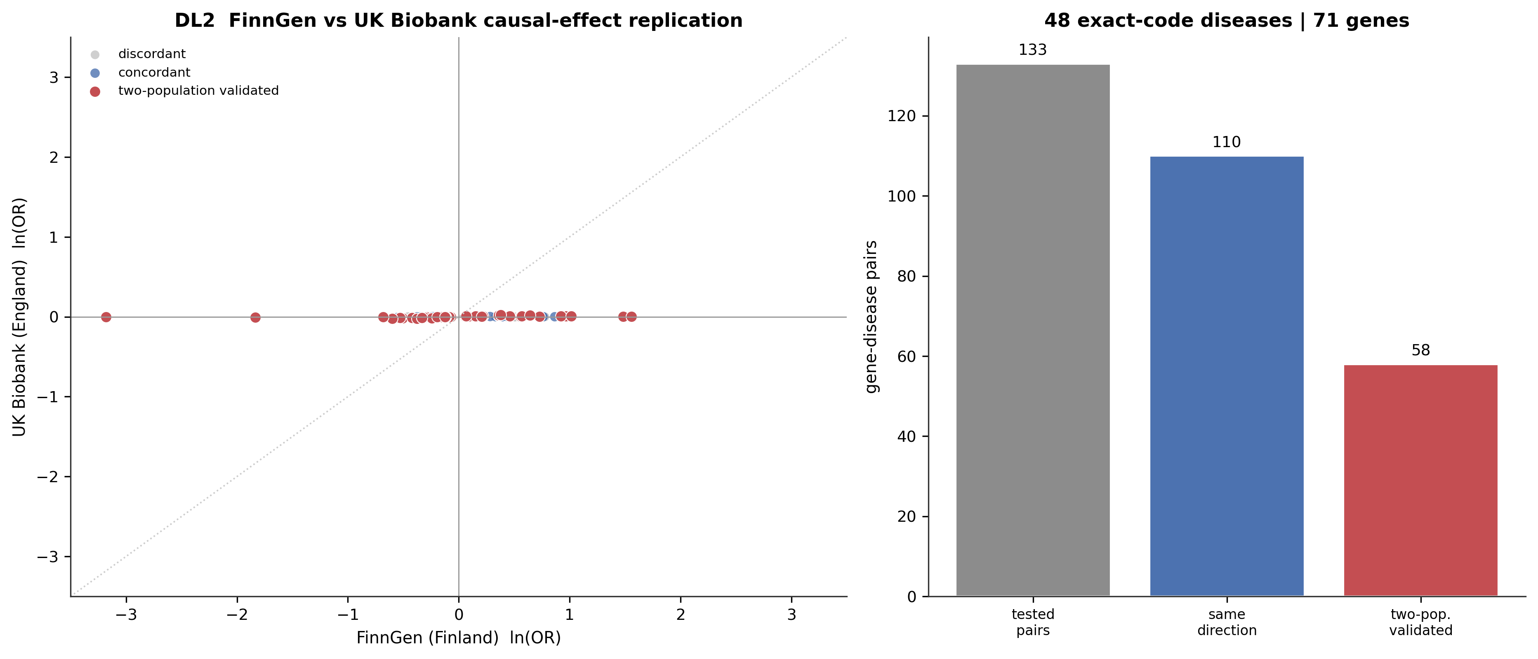
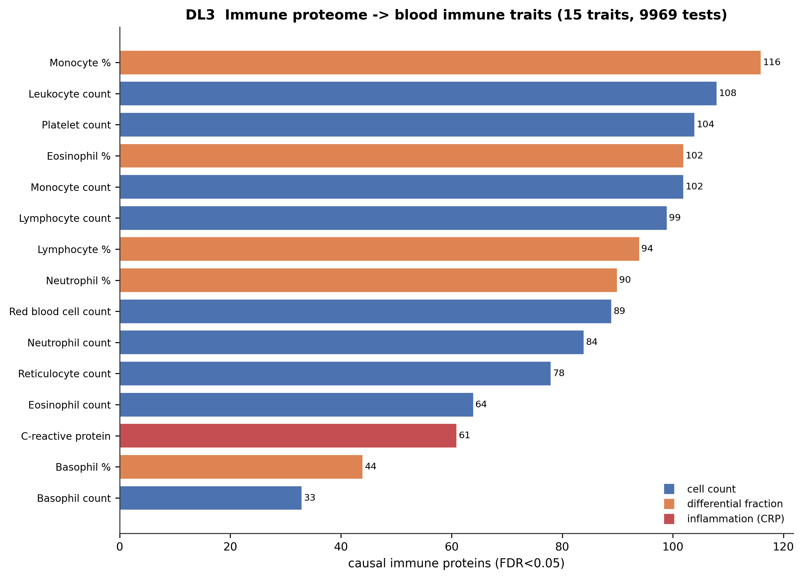
Figure S5. Deep-validation layers over the whole-phenome scan. A, Phenome-wide colocalization: distribution of the posterior probability of a shared causal variant (PP.H4) across all 900 pan-phenome Mendelian randomization hits with at least 5 shared variants (dashed line, 0.8 promotion threshold; 417 pairs above it), with the top colocalized immune-protein-to-disease pairs at right. B, FinnGen (Finland) versus UK Biobank (England) causal-effect replication: per-pair ln(odds ratio) in FinnGen (x axis) against UK Biobank (y axis); points on the same side of the origin are direction concordant, and red points are 2-population validated (same direction and UK Biobank P<0.05). The panel shown is the exact-endpoint-code arm (133 tested pairs, 110 direction concordant, 58 validated). Widening the match to conservatively normalized trait names, restricted to single-cohort UK Biobank datasets so that FinnGen-containing meta-analyses cannot make replication circular, extends this to 189 pairs across 62 diseases and 90 immune proteins, of which 162 (86%) are direction concordant and 89 are 2-population validated (Table S1). Axes are scaled independently because FinnGen log-odds and the largely linear-model UK Biobank betas are on different scales; the panel is read for sign agreement, not slope. C, Immune proteome to blood immune-trait Mendelian randomization: number of causal immune proteins (FDR <0.05) per blood trait, colored by class (cell count, differential fraction, inflammation); eosinophil and basophil counts are filled from the independent Astle et al blood-cell genome-wide association study so that no lineage is omitted.
Figure S6
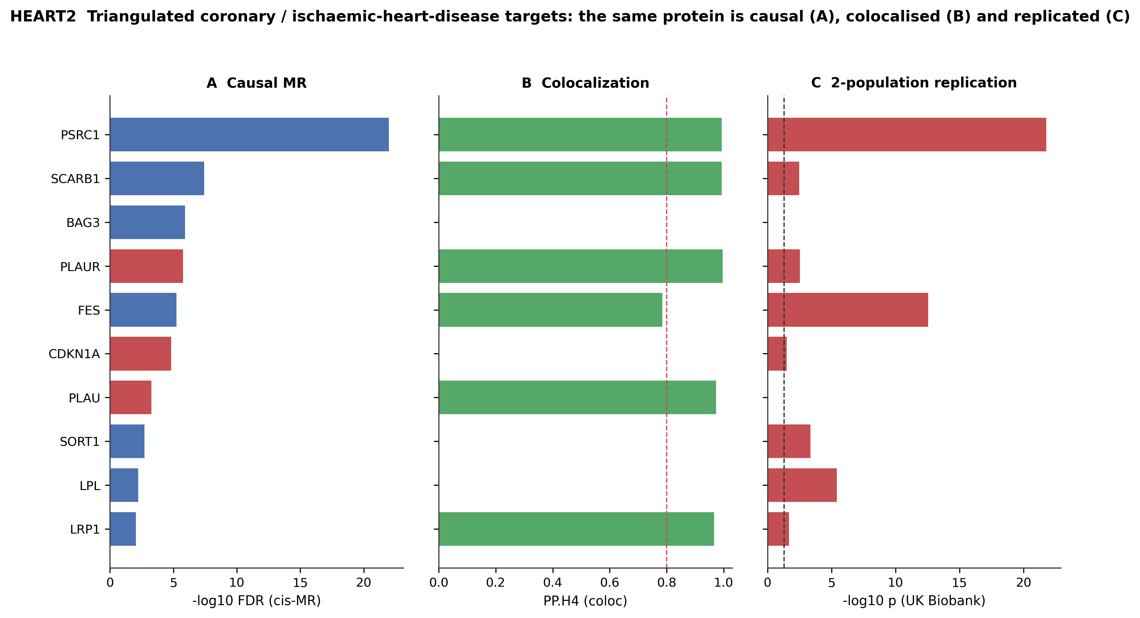
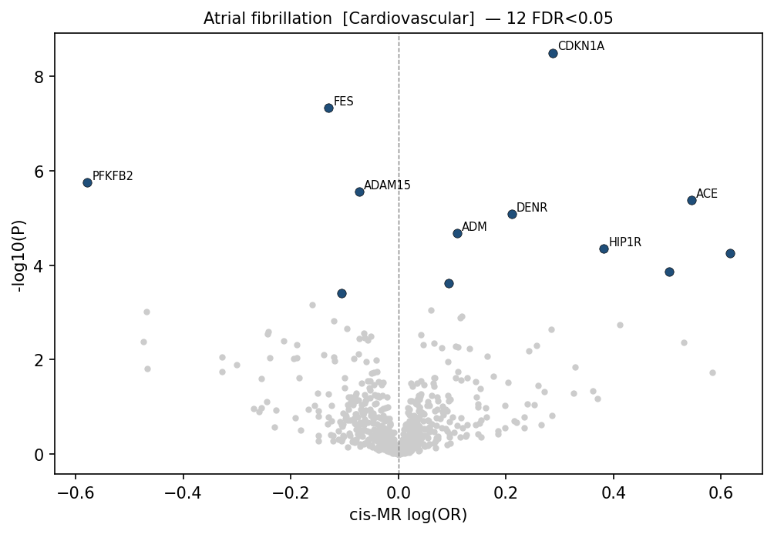
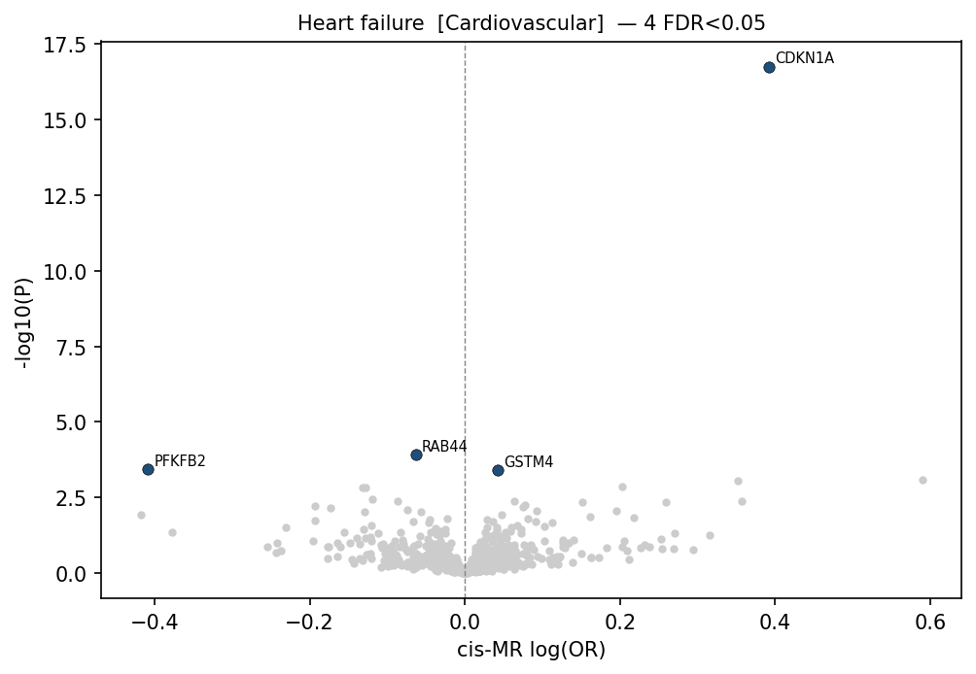
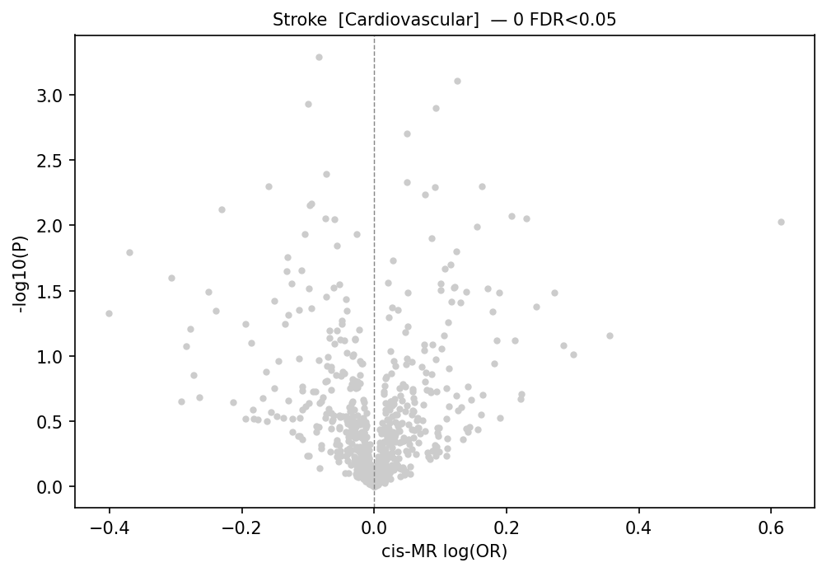
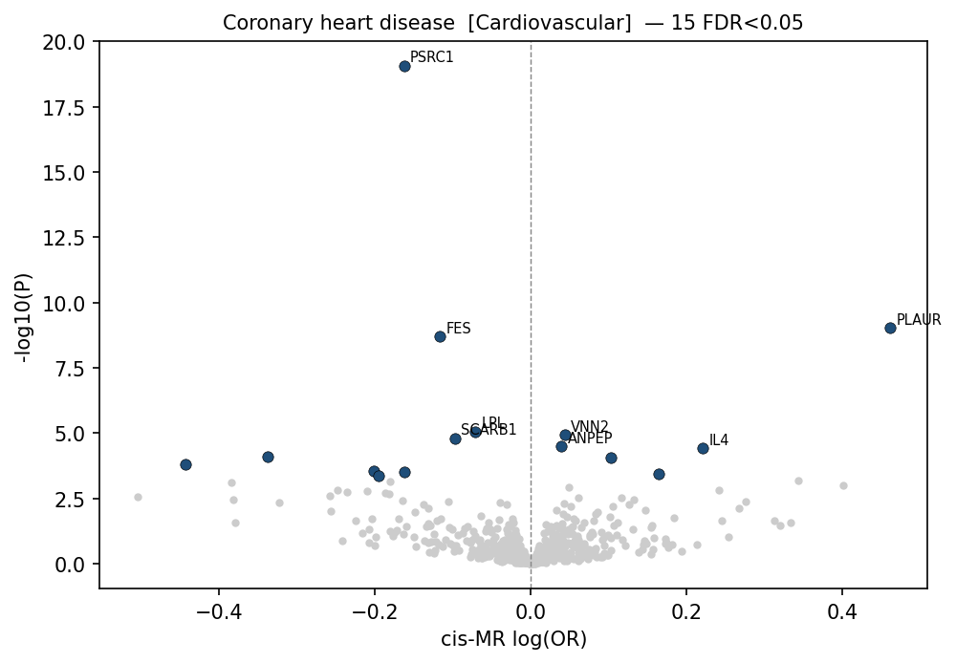
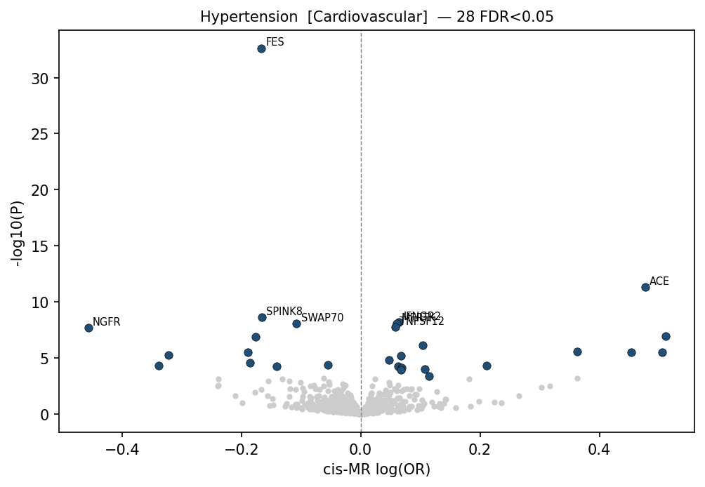
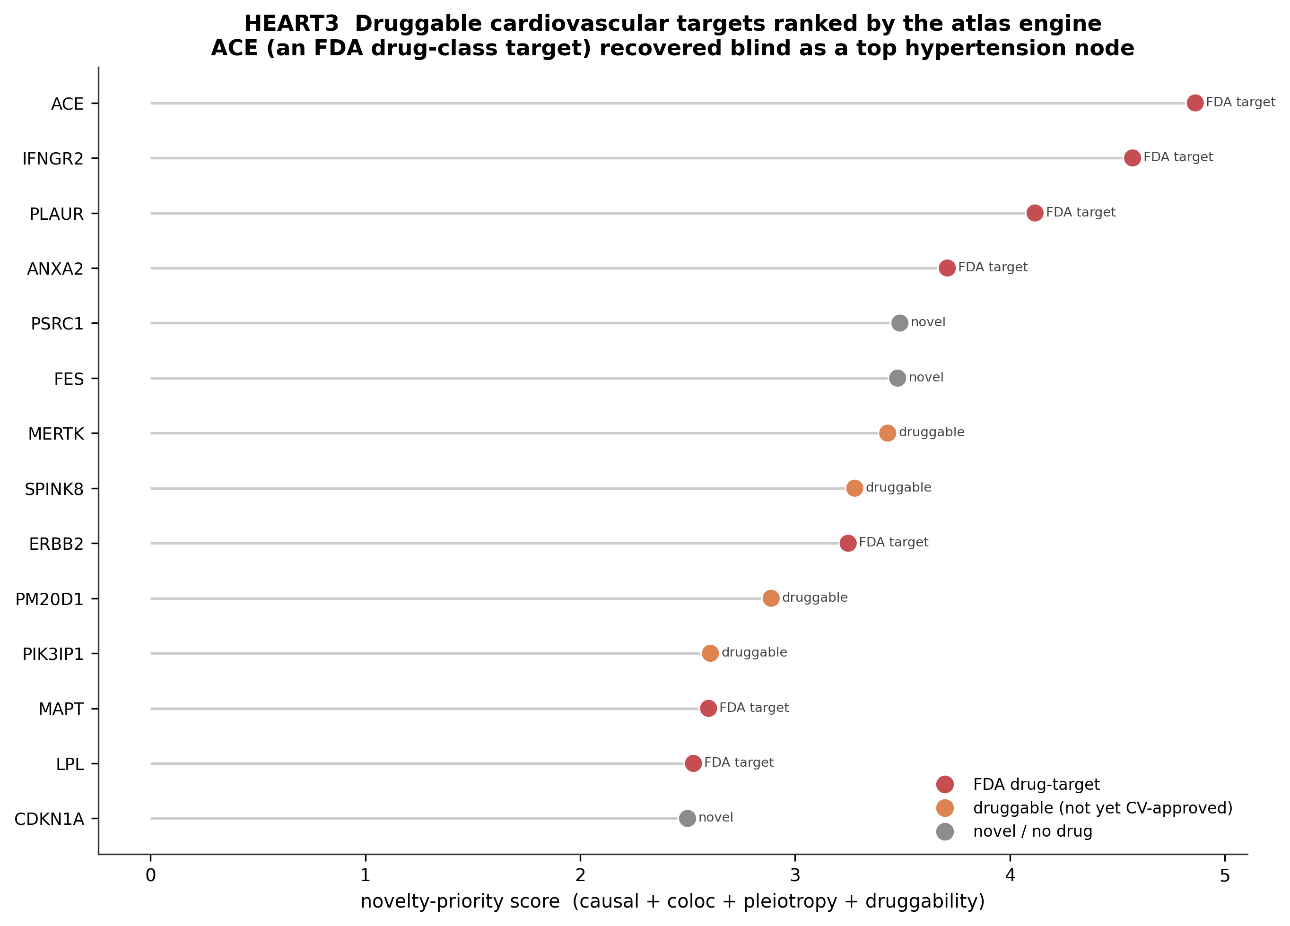
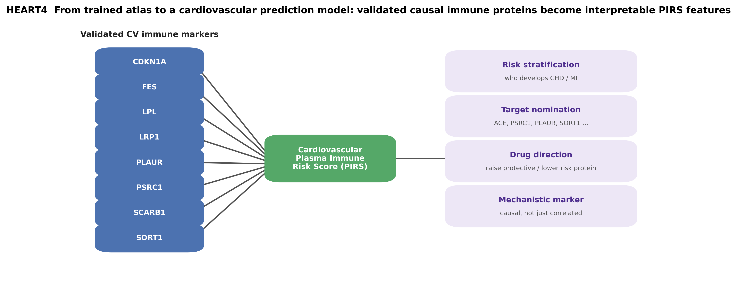
Figure S6. The cardiovascular evidence chain. A, Cardiovascular causal forest: each row is a plasma immune protein to cardiovascular endpoint effect (FinnGen R12 cis-Mendelian randomization, false discovery rate [FDR] <0.05), odds ratio per 1-SD genetically higher expression of the encoding gene (transcript-proxied) with 95% CI on a log axis (red, risk increasing/inhibition target; blue, protective/agonism target). B through F, Per-endpoint volcano plots (effect size, x axis; significance, y axis; FDR <0.05 hits highlighted): B, coronary heart disease (PSRC1, FES, SORT1, and LPL protective; PLAUR risk); C, hypertension (ACE and JMJD1C raise risk; FES, SWAP70, and MAPRE3 protective); D, atrial fibrillation/flutter (CDKN1A and ERBB2 risk; FES protective); E, heart failure (CDKN1A risk; BAG3 strongly protective); F, stroke (PSRC1 and FES protective, extending the coronary axis to cerebrovascular disease). G, Triangulation of coronary/ischemic heart disease targets across causal strength (-log10 FDR), colocalization posterior probability of a shared causal variant (dashed, 0.8), and UK Biobank replication (-log10 P; red, 2-population validated); PSRC1, FES, LPL, SORT1, PLAUR, and SCARB1 clear all 3 layers. H, Druggable cardiovascular targets ranked by the atlas engine (causal plus colocalization plus pleiotropy plus druggability; red, existing US Food and Drug Administration drug target; orange, druggable but not cardiovascular approved; gray, novel); ACE tops the hypertension nodes with no pharmacologic input, alongside the worked ACE-to-antihypertensive-medication example (odds ratio approximately 2.12; posterior probability of a shared causal variant approximately 1.00).

Figure S7
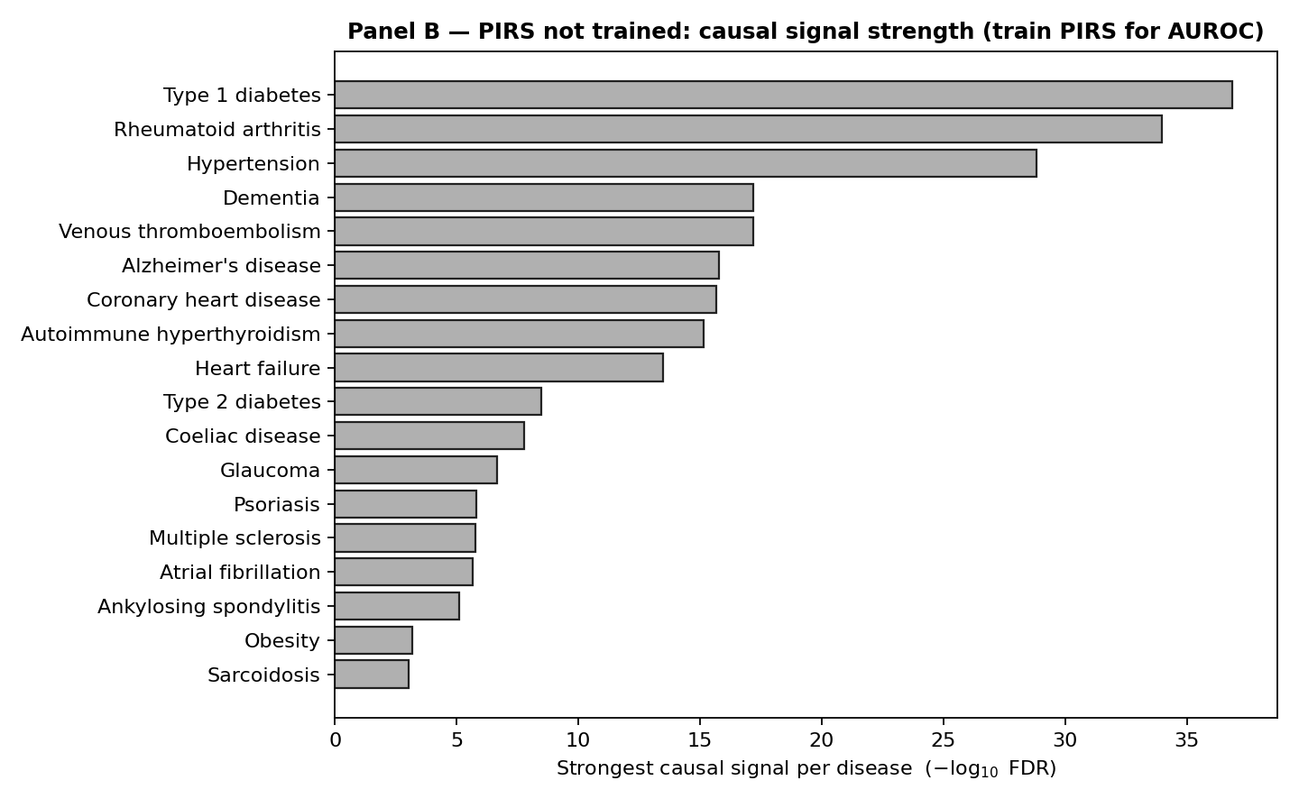

Figure S7. Design of the cardiovascular Plasma Immune Risk Score (PIRS). A, Design: 2-population-validated causal coronary proteins enter as interpretable, direction-signed features supporting risk stratification, target nomination, drug-direction assignment, and mechanistic biomarker use.

Table S1. Widened 2-Population Replication, Finland (FinnGen) Versus England (UK Biobank)
Matching route | Eligible datasets | Diseases | Pairs tested | Same direction (%) | Two-population validated
Exact endpoint code (ukb-d-<phenocode>) | Single-cohort UK Biobank | 48 | 133 | 110 (83) | 58
Normalized trait name | Single-cohort UK Biobank only (ukb-d-, ukb-b-, ukb-a-, ukb-e-); >=200 cases; European or unspecified ancestry | 14 | 56 | 52 (93) | 31
Combined (feeds novelty-priority score) | - | 62 | 189 | 162 (86) | 89
Meta-analysis datasets whose trait names match FinnGen endpoints were excluded because many silently include FinnGen (for example the Sakaue 2021 ebi-a-GCST90018* series combines Biobank Japan, UK Biobank, and FinnGen), which would make replication circular. This restriction reduced the reachable disease count from 81 to 62 and was accepted deliberately to preserve the Finland-versus-England 2-population design. The exact-code subset reproduces identically within the combined table, so widening added pairs without perturbing existing ones. Newly reachable diseases are predominantly non-autoimmune, including varicose veins, ankylosing spondylitis, hernia, and spondylopathy. Full per-pair results, including the match_method, UK Biobank trait name, and case count for every pairing, are released in uk_panphenome_concordance_ALL.tsv.
Table S2. Protein-Level (Tier 5) and Novel Protein-Confirmed Gene-Disease Pairs
Category | n | Members
Tier 5 (colocalized, protein-level pQTL concordant, specific, druggable) | 5 | IL2RA (type 1 diabetes); ANXA2 (hypertension, both endpoint definitions); PPP3R1 (varicose veins; venous/lymphatic disease)
Novel protein-confirmed (transcript colocalization plus direction-concordant protein-level pQTL Mendelian randomization) | 35 | ANXA2, CD70, CD84, CFH, CTSH, DAPK2, FCRL3, GZMB, HGF, IL2RA, LTBR, PPP3R1, PRTN3, SPINK8, SWAP70, TGFB2, TNFSF12
Protein-layer coverage after phenome-wide extension | - | 110 proteins across 219 diseases
Not reachable at protein level (no plasma aptamer) | 110 | Largely intracellular or major histocompatibility complex-region proteins, exemplified by GRK5
Tier assignment was rebuilt over all 1,016 false discovery rate-significant gene-disease pairs across 381 diseases after the INTERVAL plasma cis-protein quantitative trait locus (pQTL) layer was extended from the autoimmune arc to the whole phenome, returning 90 tier 1, 115 tier 2, 447 tier 3, 359 tier 4, and 5 tier 5 pairs. ANXA2 in hypertension is the first protein-level causal cardiovascular target in this resource. The 35 novel protein-confirmed pairs span 17 distinct proteins, each listed once in the Members column of this table.
Data S1. Precomputed Atlas Result Tables
cis_MR_ALL_finngen_results.tsv — Whole-phenome cis-Mendelian randomization results (1,656,872 tests; per-disease files under 06_genetic_causality/panphenome/).
coloc_ALL_finngen_results.tsv — Phenome-wide colocalization posteriors (900 pairs; 417 at PP.H4 >=0.8; 510 at >=0.5).
uk_panphenome_concordance.tsv — Exact-endpoint-code FinnGen-to-UK Biobank concordance (133 pairs; 110 direction concordant; 58 validated).
uk_panphenome_concordance_ALL.tsv — Widened FinnGen-to-UK Biobank concordance (189 pairs; 162 direction concordant; 89 validated). This table feeds the replication term of the novelty-priority score.
extended_cell_crp_MR_results.tsv — Extended blood immune-trait Mendelian randomization (9,969 tests; 1268 significant; 395 proteins).
Novelty-priority ranking and final evidence-tier table — Integrated ranking and tier assignment across all 1,016 causal pairs, with phenome-wide protein-level annotation.

