Hierarchical carbon-encapsulated FeCo Alloy nanoparticles bridging N-doped graphene nanoribbons for efficient bifunctional oxygen electrocatalysis and rechargeable Zn-air batteries
Chao Cheng^{1,2}, Yongqiang Ming³, Luping Liu^{2,}, Yunjian Liu^{1,},Juan Yang ^{1,}
¹ Zhejiang New Era Zhongneng Technology Co., Ltd, Shaoxing 312000, China
² School of Materials Science and Engineering, Jiangsu University, 301 Xuefu Road, Zhenjiang 212013, China
³ Changzhou Vocational Institute of Textile and Garment, 53 Gehu Middle Road, Wujin District, Changzhou 213164, China

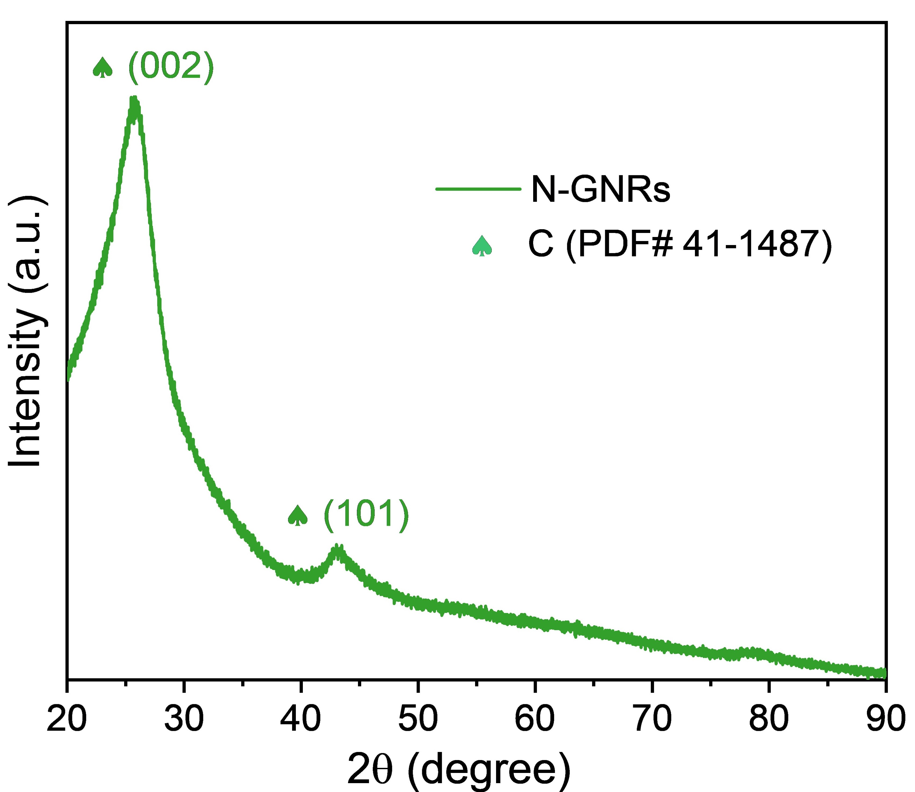
Fig. S1. The XRD pattern of N-GNRs

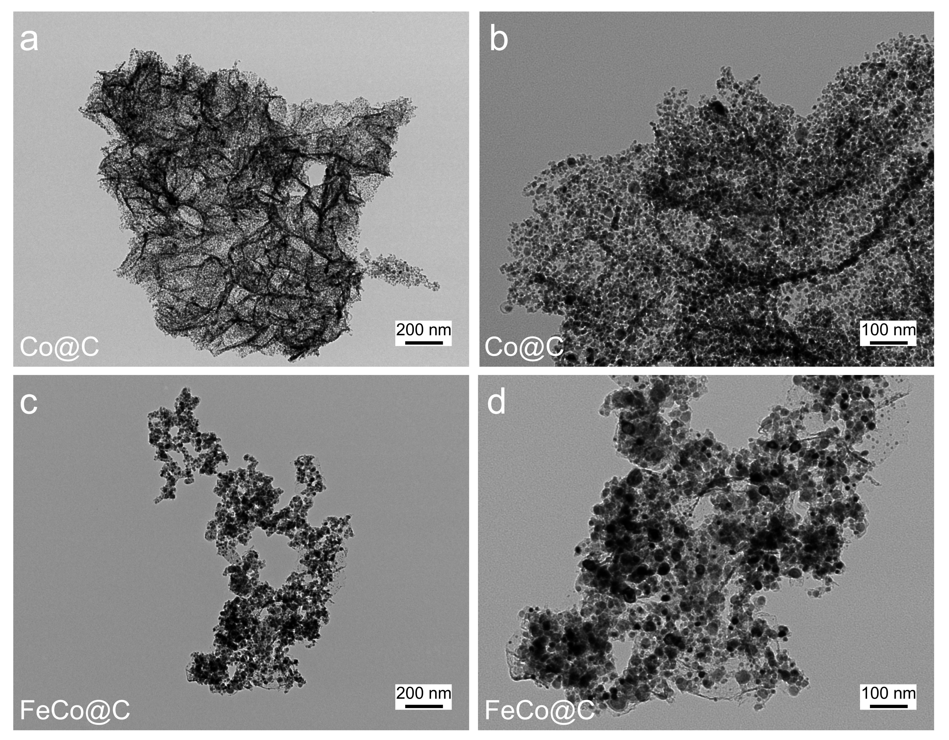
Fig. S2. TEM images for Co@C (a, b) and FeCo@C (c, d)

Fig. S3. CV curves for prepared samples (a-e) and commercial Pt/C (f)

Fig. S4. LSV curves at diverse speeds (a, c, e and g) and corresponding K–L plots (b, d, f and h)

Fig. S5. the comparison of overpotential and tafel slope for OER catalysts

Fig. S6. CV curves of all catalysts in non-faradaic region region at different scan rates

Table S1. Product parameters of liquid Zn−air battery.
Project | Parameter
Mold material | Polymethyl methacrylate
Width | 7 cm
Height | 6 cm
Distance between positive and negative poles | 1.4 cm
Sealing performance | Leakage-free
Reaction area | 1 cm²

Table S2. ORR parameters of prepared catalysts
Catalysts | E_{o} （V） | E_{1/2} （V） | J_{L} （mA cm⁻²） | Tafel slope （mV/dec） | $$\overline{n}$$
N-GNRs | 0.921 | 0.751 | -4.78 | 92.6 | 3.74
Co@C | 0.874 | 0.779 | -3.75 | 86.7 | 3.52
FeCo@C | 0.877 | 0.807 | -5.45 | 60.1 | 3.91
FeCo@C/N-GNRs | 0.922 | 0.830 | -5.34 | 83.2 | 4.00
Pt/C | 0.938 | 0.840 | -5.78 | 83.8 | 4.00

Table S3 OER parameters of prepared catalysts
Catalysts | E₁₀ （V） | Overpotential（mV） | Tafel slope （mV/dec）
N-GNRs | 1.659 | 429 | 132.8
Co@C | 1.609 | 379 | 111.1
FeCo@C | 1.575 | 345 | 94.5
FeCo@C/N-GNRs | 1.530 | 300 | 63.6
IrO₂ | 1.592 | 362 | 91.1
Table S4. Comparison of ORR and OER activity parameters for reported bifunctional catalysts.
Catalyst | E_{1/2} (V) | E₁₀ (V) | ΔE (V) | Ref.
Zn₁Co₄@NC | 0.840 | 1.567 | 0.727 | [1] Journal of Power Sources 696 (2026) 241451.
N-GNRs/CoO | 0.825 | 1.554 | 0.729 | [2] Rare Met. 43 (2024) 1524–1536
FePc-CoFe₂O₄/CNT | 0.870 | 1.690 | 0.820 | [3] ACS Appl. Mater. Interfaces 18 (2026) 1874-1884
FeCo@CNTs-60 | 0.95 | 1.810 | 0.810 | [4] Appl. Catal. B Environ. 341 (2024) 123346
FeCo-MI@TAP-900 | 0.865 | 1.615 | 0.75 | [5] Energy Storage Mater. 65 (2024) 103106
Fe/SNCFs-NH₃ | 0.89 | ~1.7 | ~0.81 | [6] Adv. Mater. 34 (2022) 2105410
SA-Fe-SNC@900 | 0.876 | 1.632 | 0.756 | [7] Adv. Mater. 35 (2023) 2209948
FeN/ZnSe/Fe-NC | 0.830 | 1.590 | 0.760 | [8] Energy Fuels 38 (2024) 12172-12181
CoPx@CNS | 0.76 | 1.54 | 0.78 | [9] Angew. Chem. Int. Ed. 59 2020 21360-21366
FeCoNiFCNFs | 0.92 | 1.64 | 0.72 | [10] Chem. Eng. J. 479 2024 147648
ES-Co/Zn-CNZIF | 0.857 | 1.692 | 0.835 | [11] J. Energy Chem. 83 2023 138-149
CoS₂/Cu₂S-NF | 0.8 | 1.53 | 0.73 | [12] Appl. Catal. B-Environ. 303 (2022) 120849
Fe NPs@PC-700 | 0.786 | 1.550 | 0.764 | [13] Small Sci. 6 (2026) e202500448
Pt/C+IrO₂ | 0.840 | 1.592 | 0.752 | This work
FeCo@C/N-GNRs | 0.830 | 1.530 | 0.700 | This work

Corresponding author. E-mail: sarsasds@163.com (L.P. Liu), lyjian122331@ujs.edu.cn(Y.J. Liu), yangjuan6347@ujs.edu.cn (J. Yang).

