Supporting Information
Injectable Hydrogel-Integrated DNA-Programmed Mitochondrial Engagers Metabolically Rewire Synovial Macrophages for Osteoarthritis Repair
Maohua Chen^{1,4}, Fengling Wang¹, Xinqiang Hu², Zhengqiang Wang¹, Hao Wei², Ming Qin¹, Rong Huang¹, Qing Luo¹, Zhong Luo³*, Jingbin Huang¹*

Supplementary Figures and Tables
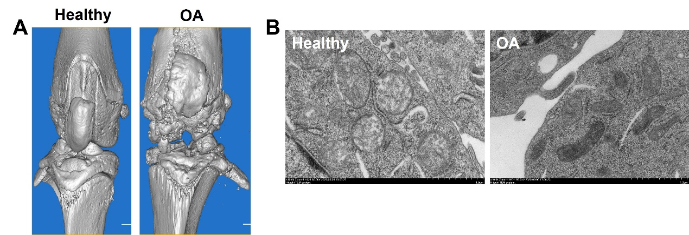
Figure S1. (A) Representative Micro-CT images of the knee joints in healthy and OA rats; (B) TEM images of macrophage healthy and OA rats.

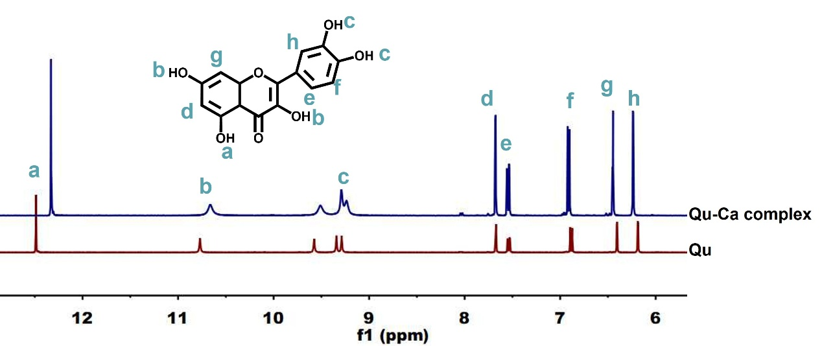
Figure S2. ¹H NMR spectra of Qu and Qu-Ca complex.

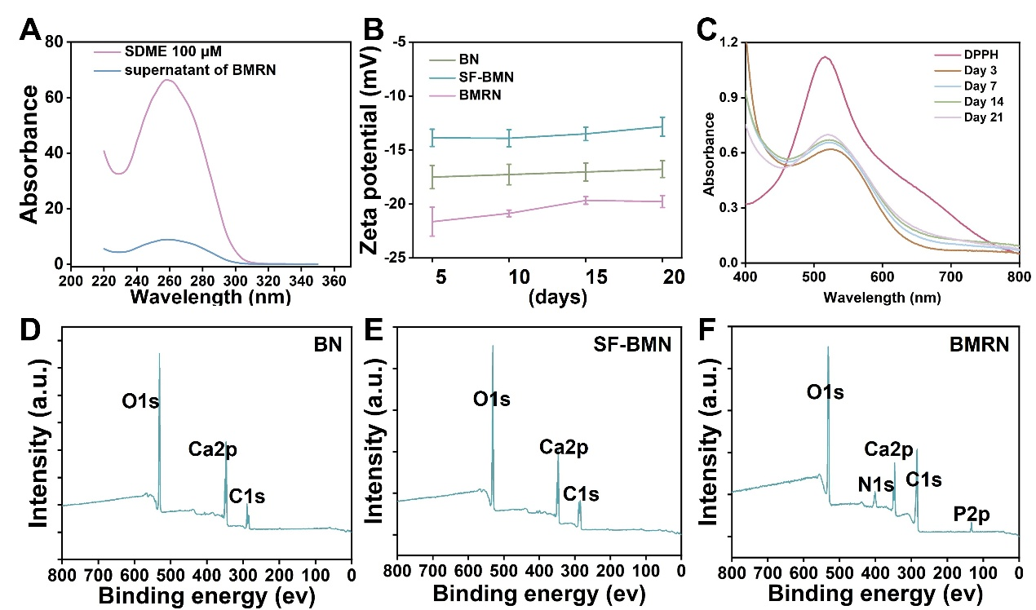
Figure S3. (A) UV-vis absorption spectra of SDME and the supernatant of SDME incubated with SF-BMN; (B) Time dependent zeta potential changes of different nanoparticles; (C) The ROS-scavenging ability of IHD at different time points; (D-F) XPS spectra of BN, SF-BMN and BMRN. Data were presented as mean ± SD for n = 3, *p < 0.05, **p < 0.01.

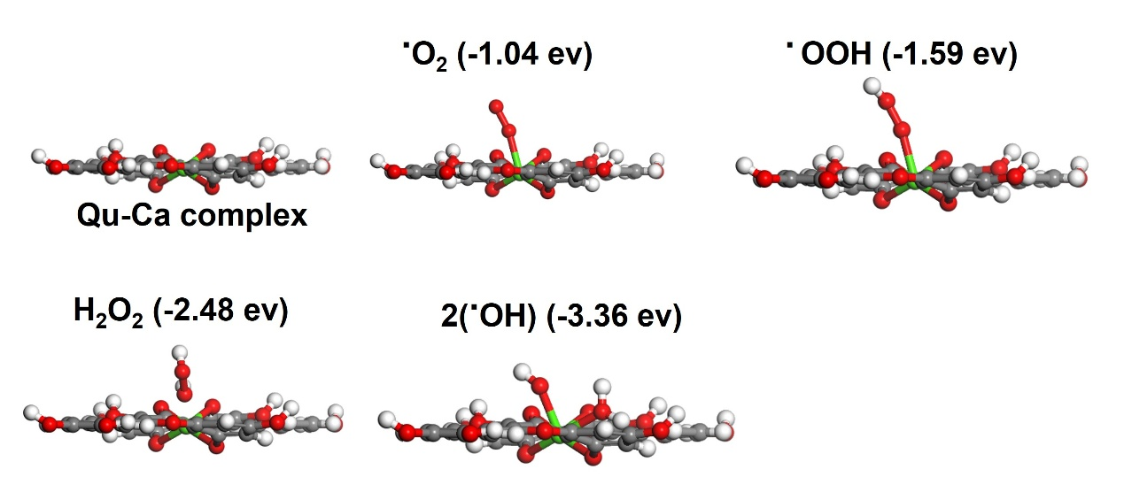
Figure S4. Side view of the optimized structures of .O₂, .OOH, H₂O₂, and .OH adsorbed on Qu-Ca complex.

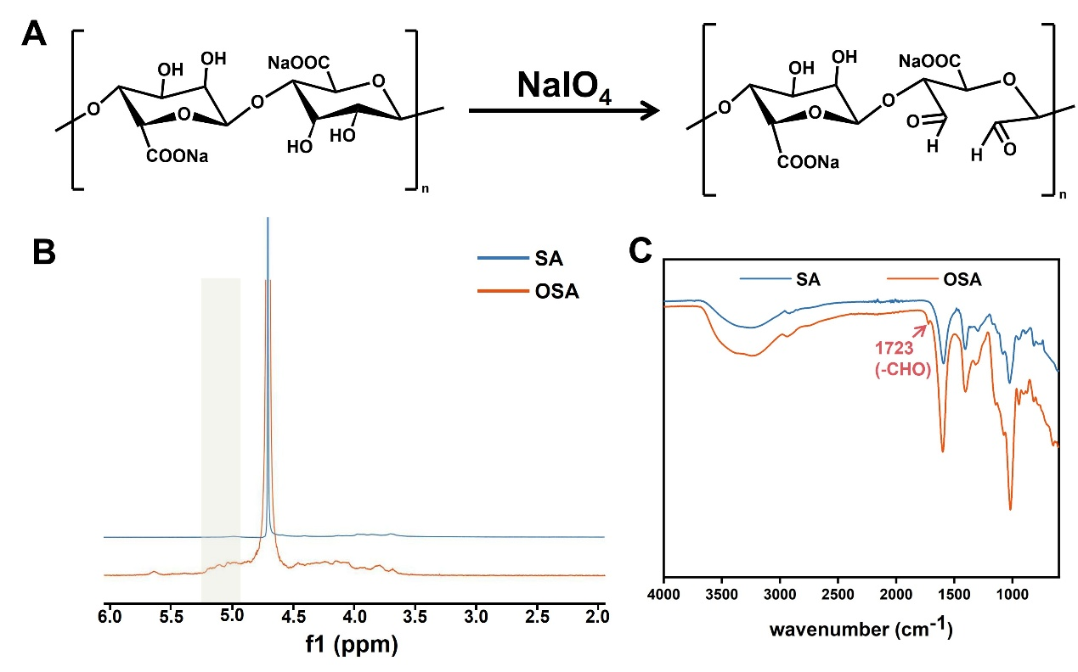
Figure S5. (A) Reaction route for the oxidation of sodium alginate; (B) 1H NMR spectra of SA and OSA; (C) FTIR spectra of SA and OSA. The enhanced absorption at 1723 cm⁻¹ confirmed the successful oxidation of SA.

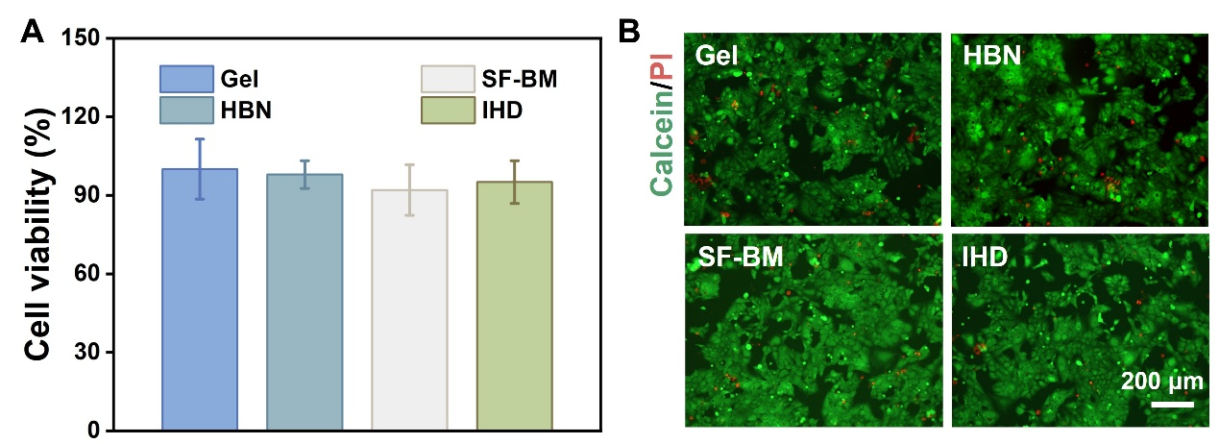
Figure S6. (A) Viability of chondrocytes cultured on different hydrogels according to cck-8 assay; (B) Live/dead staining of chondrocytes cultured on different hydrogels. Data were presented as mean ± SD for n = 3, *p < 0.05, **p < 0.01.

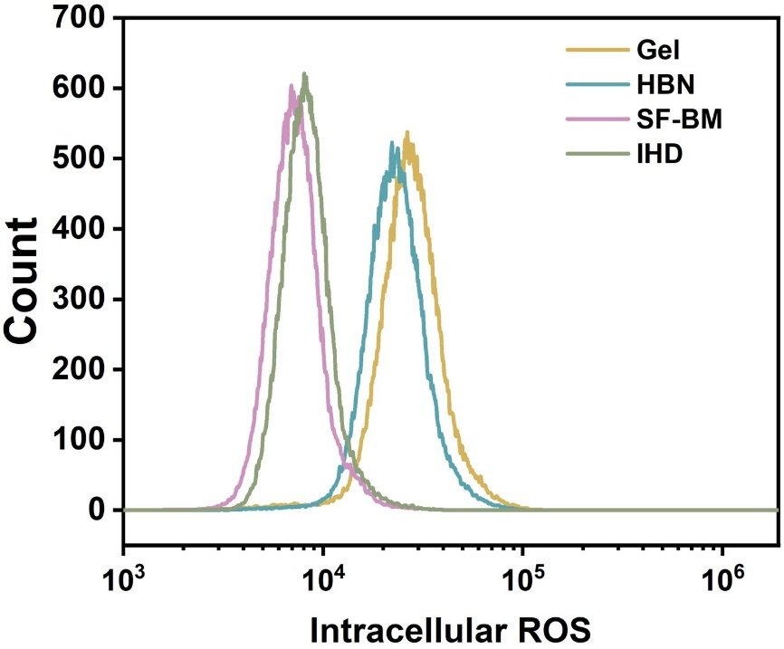
Figure S7. Intracellular ROS levels of RAW 264.7 cells according to flow cytometry analysis.

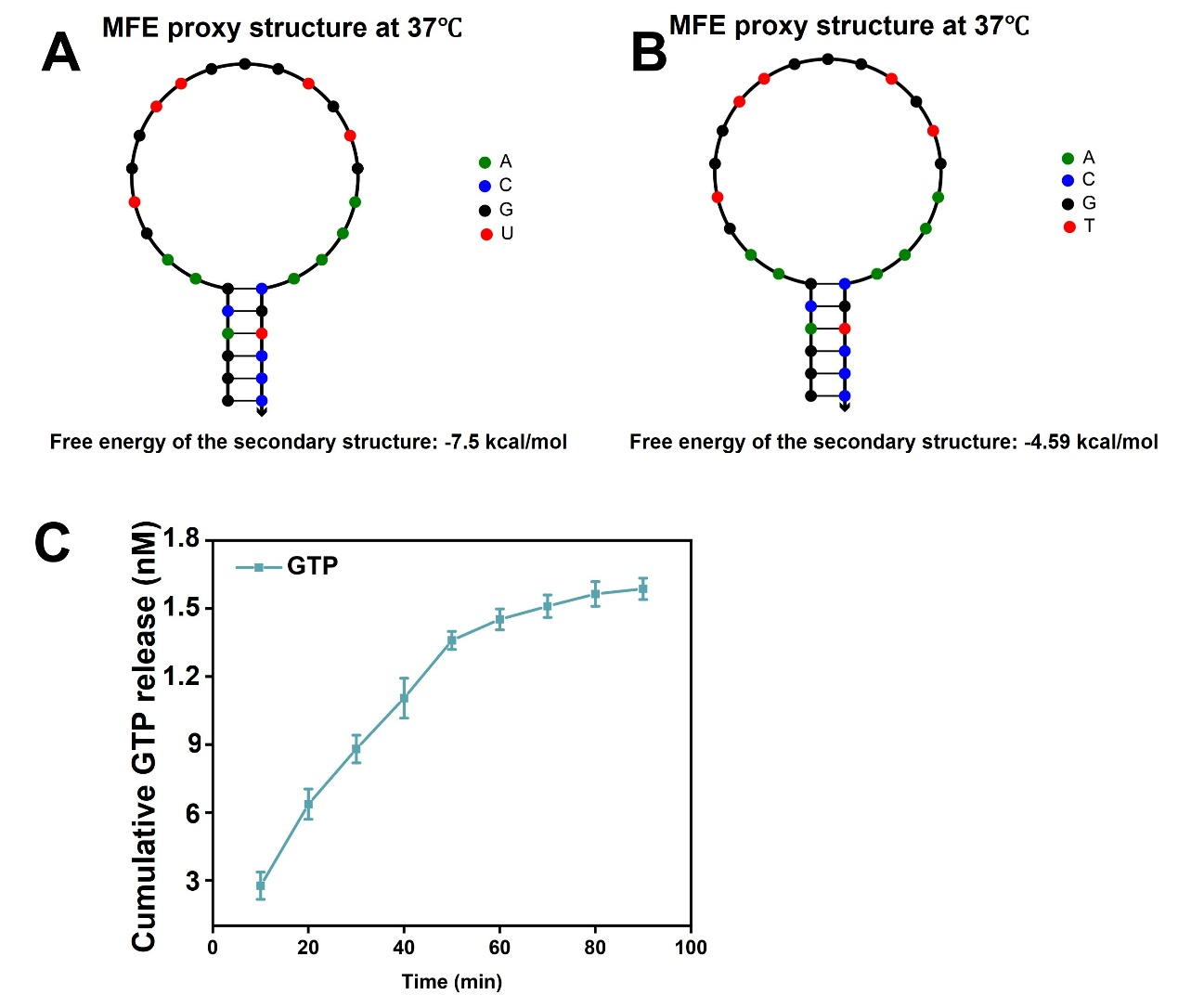
Figure S8. (A, B) The secondary structure of GTP RNA aptamer and DNA aptamer. (C) Cumulative release of GTP from SDME. Data were presented as mean ± SD for n = 3, *p < 0.05, **p < 0.01.

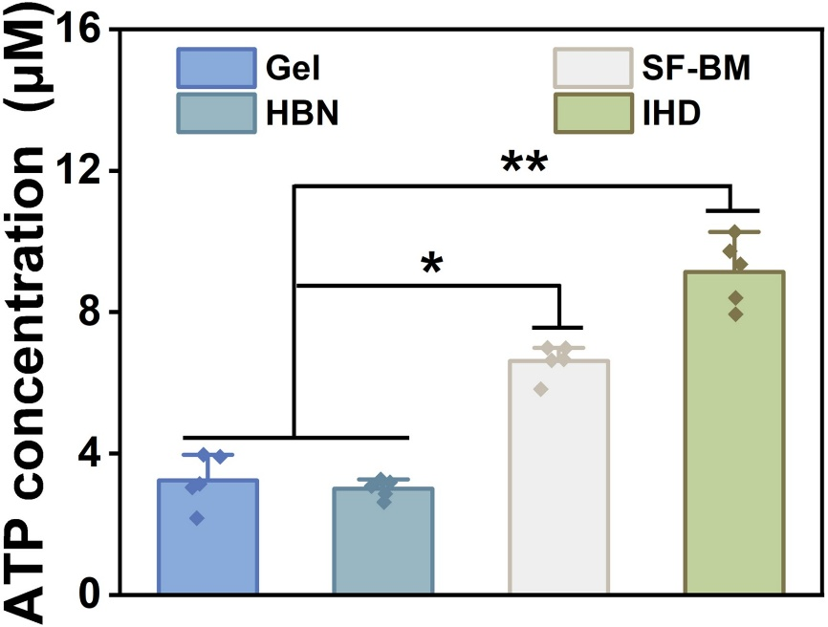
Figure S9. ATP levels in macrophage cultured on different hydrogel surfaces. Data were presented as mean ± SD for n = 5, *p < 0.05, **p < 0.01.

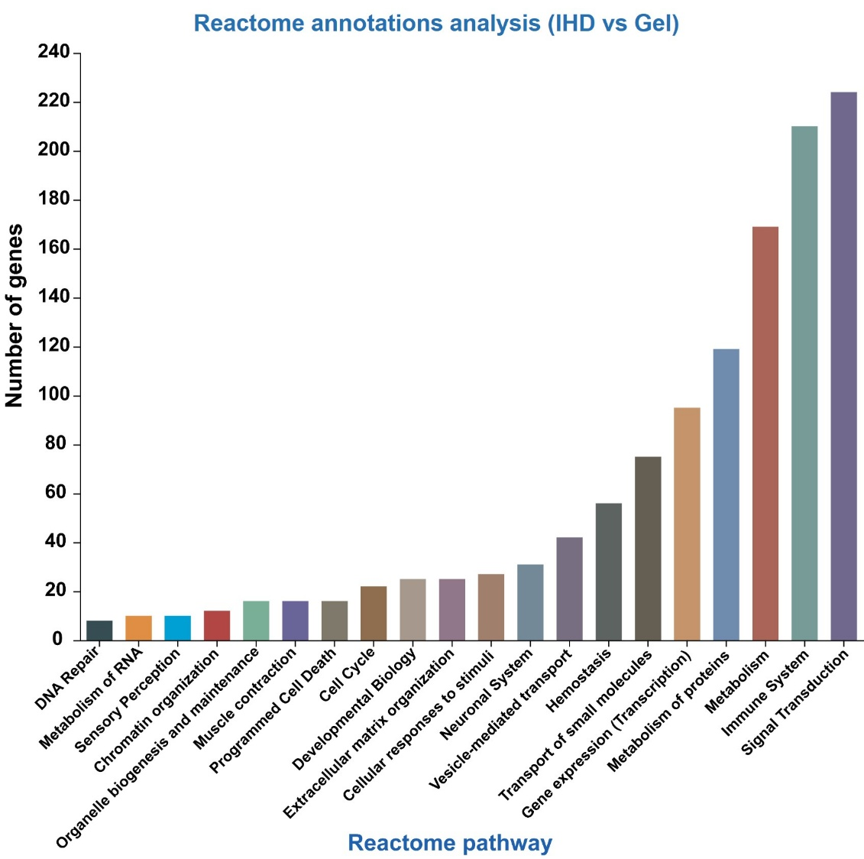
Figure S10. Reactome annotation analysis for detecting gene enriched signaling pathways.

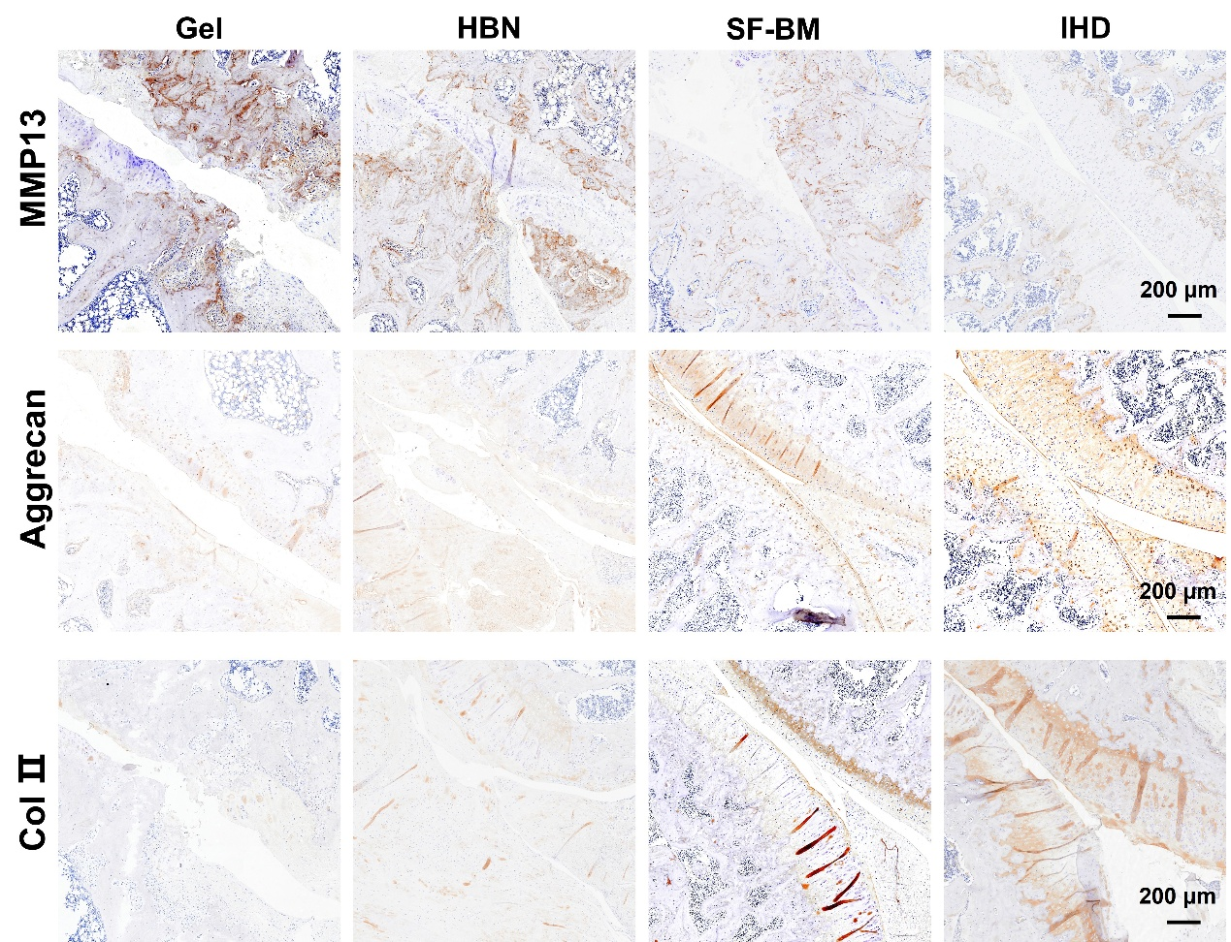
Figure S11. IHC staining of MMP 13, Aggrecan and Col Ⅱ in vivo.

