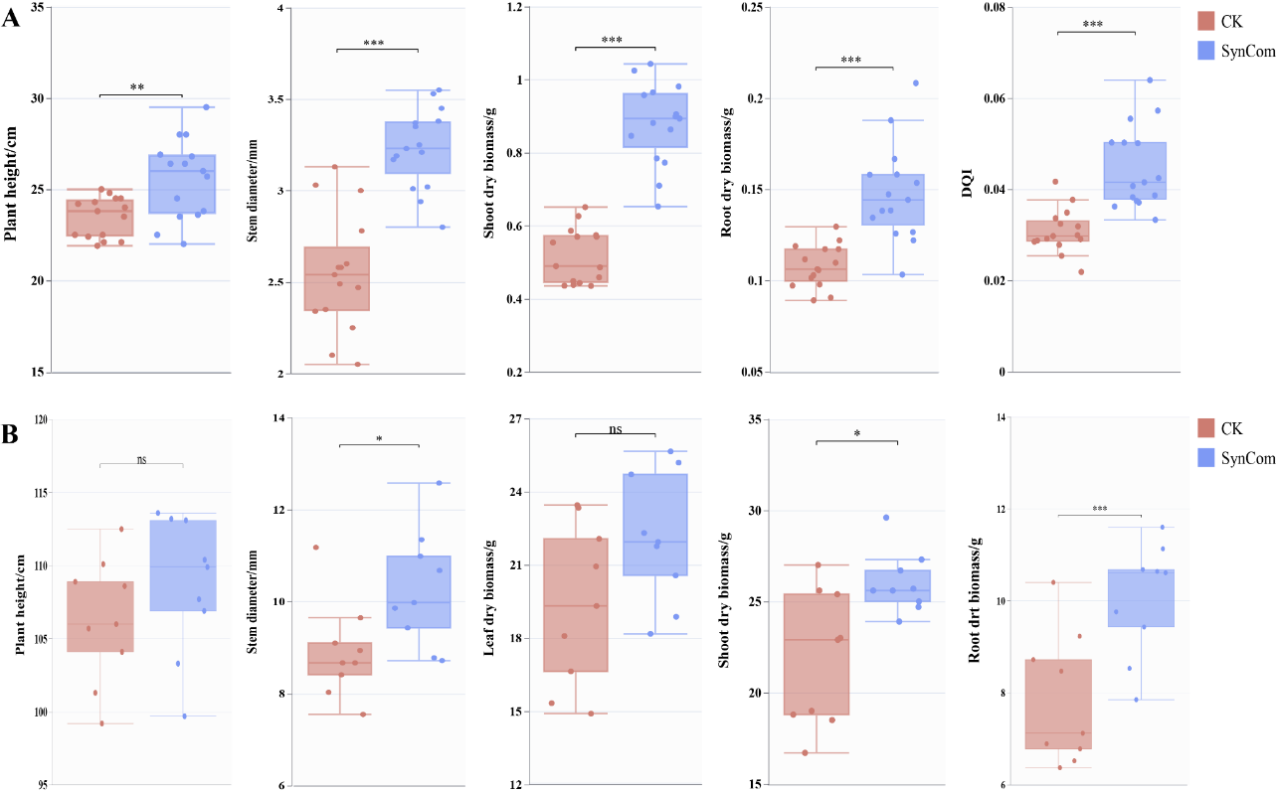
Figure S1. Effects of simplified SynCom on tomato growth indexes. CK and SynCom representing the treatments of non-inoculated and inoculated SynCom, respectively. A and B showing the morphology at the seedling and ripening stages, respectively.
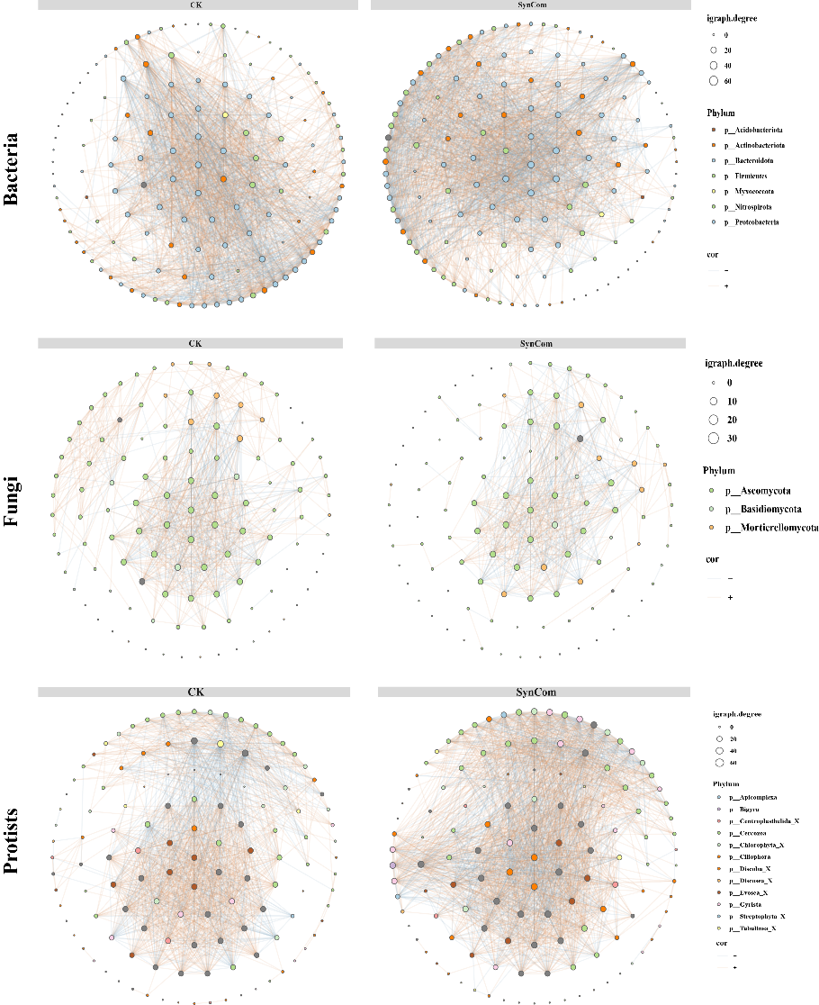
Figure S2. Co-occurrence networks of microbial communities under different treatments.
Table S1. Effects of SynCom on the yield and quality of tomato fruits
 | Yield (ton/ha) | SS (%) | SP (mg/g) | TA (%) | Ly (mg/100g) | VC (mg/g)
2CK | 50.03±2.37^{b} | 2.72±0.30^{b} | 0.11±0.01ª | 0.66±0.10ª | 45.16±8.70^{b} | 0.36±0.16^{b}
2SynCom | 59.98±5.31ª | 4.49±0.25ª | 0.12±0.01ª | 0.49±0.03^{b} | 82.06±12.56ª | 0.65±0.04ª
3CK | 56.07±4.97^{b} | 6.00±0.44^{b} | 0.21±0.06^{b} | 0.57±0.07ª | 62.91±3.45^{b} | 0.56±0.23^{b}
3SynCom | 63.35±3.29ª | 8.96±0.18ª | 0.37±0.03ª | 0.41±0.06^{b} | 88.24±3.07ª | 1.25±0.10ª
4CK | 46.62±3.21^{b} | 2.52±0.14^{b} | 0.24±0.03^{b} | 0.44±0.05ª | 62.43±9.99^{b} | 0.45±0.09^{b}
4SynCom | 53.47±2.73ª | 3.71±0.27ª | 0.32±0.04ª | 0.27±0.03^{b} | 83.08±10.37ª | 1.20±0.13ª
Note: The numbers of 2, 3 and 4 in the treatment names of non-inoculated (CK) and inoculated SynCom represent the continuous cropping of second, third and fourth respectively. SS, SP, TA, Ly and VC represent soluble sugar, soluble protein, titratable acid, lycopene and vitamin C, respectively. The small letters in uppercase indicates difference significance level of 0.05

