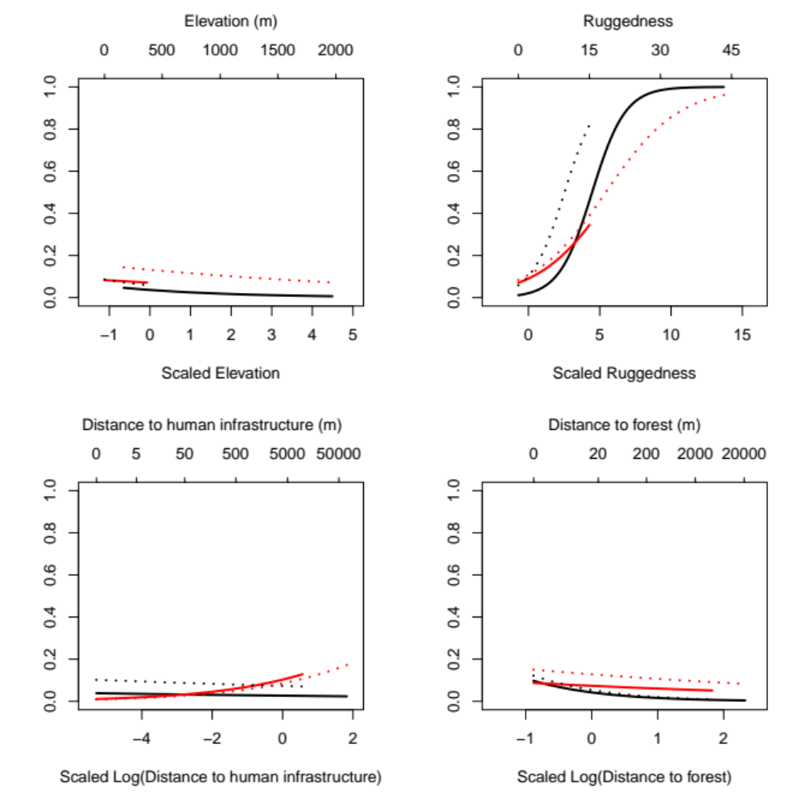
Figure A1. Predicted RSF-values on the 2nd order of selection for altitude, ruggedness, distance to forest and distance to human infrastructure one at a time while keeping the other predictors at their study area mean. The predictions are made within study area range of the environmental predictors on second order of selection. Red line: prediction for South using beta-coefficients from South. Black line: prediction for North using beta-coefficients from North. Red dotted line: prediction for North using beta-coefficient from South. Black dotted line: prediction for South using beta-coefficient from North.

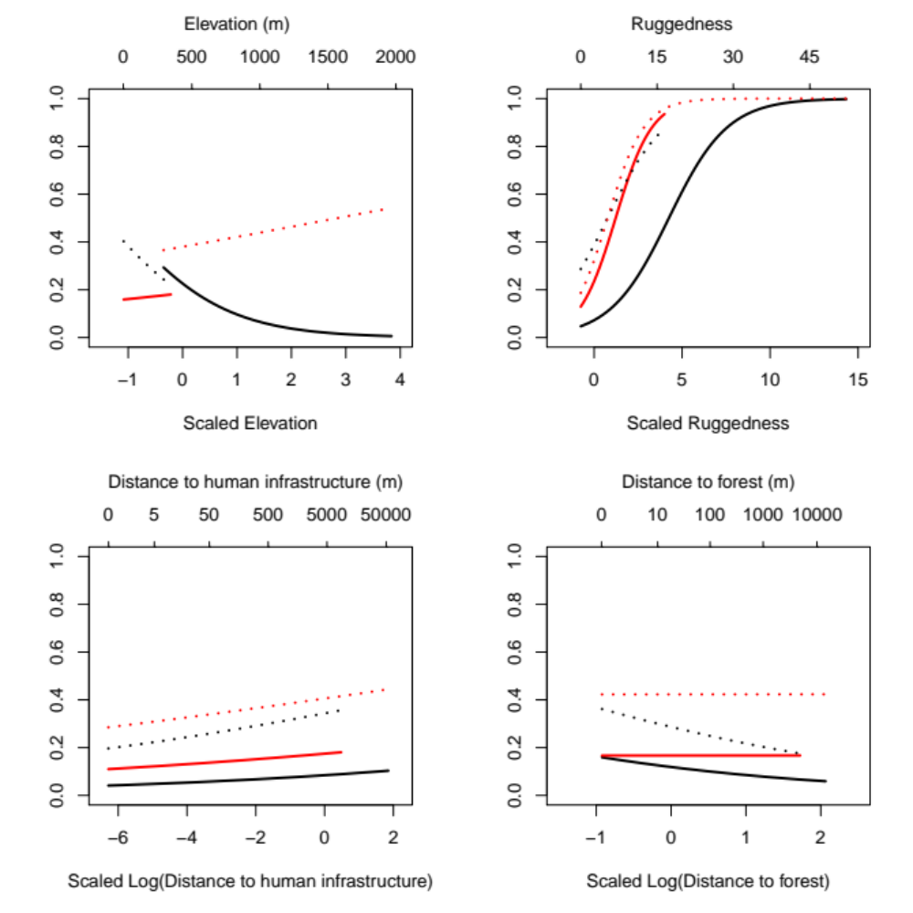
Figure A2. Predicted RSF-values on the 3rd order of selection for altitude, ruggedness, distance to forest and distance to human infrastructure one at a time while keeping the other predictors at their study area mean. The predictions are made within study area range of the environmental predictors on third order of selection. Red line: prediction for South using beta-coefficients from South. Black line: prediction for North using beta-coefficients from North. Red dotted line: prediction for North using beta-coefficient from South. Black dotted line: prediction for South using beta-coefficient from North.

Table A1. Mean, minimum and maximum (with brackets) of the scaled values (scaled independently for each order of selection) of the environmental predictors elevation, terrain ruggedness index, distance to human infrastructure (log(x+1)-transformed) and distance to forest (log(x+1)-transformed) for used and availability points of the 2nd and 3rd order selection separated by study region.
Environmental predictor | 2nd order |  | 3rd order
 | Used | Available | Used | Available
North
Elevation (m) | 0.90 (-0.27 – 3.97) | 0.94 (-0.59 – 4.53) | 0.67 (-0.35 – 3.33) | 1.02 (-0.37 – 3.81)
Terrain ruggedness index | 1.57 (-0.76 – 15.33) | 0.24 (-0.76 – 8.91) | 1.13 (-0.76 – 12.26) | 0.43 (-0.76 – 14.19)
Distance to human infrastructure (m) | 0.72 (-5.44 – 1.70) | 0.79 (-5.44 – 1.86) | 0.74 (-6.34 – 1.86) | 0.83 (-6.34 – 1.85)
Distance to forest (m) | 0.23 (-0.98 – 2.21) | 0.65 (-0.98 – 2.35) | 0.20 (-0.93 – 2.04) | 0.74 (-0.93 – 2.05)
South
Elevation (m) | -0.76 (-1.13 - -0.22) | -0.76 (-1.13 - -0.11) | -0.77 (-1.09 - -0.31) | -0.77 (-1.10 - -0.29)
Terrain ruggedness index | -0.27 (-0.76 – 4.49) | -0.40 (-0.76 – 4.50) | -0.37 (-0.76 – 3.49) | -0.45 (-0.76 – 3.96)
Distance to human infrastructure (m) | -0.46 (-5.44 – 0.45) | -0.67 (-5.44 – 0.57) | -0.62 (-6.34 – 0.42) | -0.66 (-6.34– 0.47)
Distance to forest (m) | -0.57 (-0.98 – 1.11) | -0.45 (-0.98 – 1.60) | -0.54 (-0.93 – 1.01) | -0.51 (-0.93 – 1.43)

Table A2. 2nd order selection – mean ± standard deviation and 95 % confidence limits of the coefficient for the northern and southern study region. Bold 95 % CI indicate that the range does not overlap zero.
Region | Covariate | Mean ± st.dev. | Median | 95 % CI
North | Intercept | -2.17 ± 0.27 | -2.30 | -2.44 – -1.59
 | Elevation | -0.31 ± 0.13 | -0.32 | -0.53 – 0.00
 | Terrain ruggedness index | 0.95 ± 0.05 | 0.93 | 0.88 – 1.03
 | Distance to forest | -1.00 ± 0.17 | -.98 | -1.37 – -0.61
 | Distance to human infrastructure | -0.14 ± 0.26 | -0.06 | -0.63 – 0.10
South | Intercept | -1.56 ± 0.49 | -1.61 | -2.46 – -0.58
 | Elevation | -0.28 ± 0.73 | -0.46 | -1.53 – 1.11
 | Terrain ruggedness index | 0.52 ± 0.17 | 0.56 | 0.04 – 0.73
 | Distance to forest | -0.24 ± 0.04 | -0.24 | -0.30 – -0.14
 | Distance to human infrastructure | 0.44 ± 0.09 | 0.44 | 0.31 – 0.64

Table A3. 3rd order selection – mean ± standard deviation and 95 % confidence limit of the coefficient for the northern and southern study region. Bold 95 % CI indicate that the range does not overlap zero.
Region | Covariate | Mean ± st.dev. | Median | 95 % CI
North | Intercept | -1.32 ± 0.09 | -1.34 | -1.49 – -1.11
 | Elevation | -1.00 ± 0.14 | -1.01 | -1.16 – -0.75
 | Terrain ruggedness index | 0.60 ± 0.03 | 0.60 | 0.54 – 0.65
 | Distance to forest | -0.37 ± 0.06 | -0.39 | -0.44 – -0.23
 | Distance to human infrastructure | 0.12 ± 0.15 | 0.07 | -0.21 – 0.57
South | Intercept | -1.0 ± 0.33 | -1.08 | -1.5 – -0.40
 | Elevation | 0.16 ± 0.30 | 0.20 | -0.41 – 0.62
 | Terrain ruggedness index | 0.96 ± 0.11 | 0.98 | 0.78 – 1.16
 | Distance to forest | 0.00 ± 0.02 | 0.00 | -0.05 – 0.03
 | Distance to human infrastructure | 0.09 ± 0.03 | 0.09 | 0.01 – 0.14

Table A4. 2nd order selection - covariates (raw data, log(x+1)-transformed and scaled)
Region | Mean | Standard deviation | Minimum | Maximum
Sweden
Elevation | 396 | 350 | 0.0 | 1983
Ruggedness | 2.15 | 2.82 | 0.0 | 45.43
Distance to human | 9476 | 12076 | 0.0 | 70553
Distance to forest | 696 | 2006 | 0.0 | 20945
Log(human) | 8.32 | 1.53 | 0.0 | 11.16
Log(forest) | 2.94 | 2.98 | 0.0 | 9.95
Scaled(elevation) | 0.0 | 1.0 | -1.13 | 4.53
Scaled(ruggedness) | 0.0 | 1.0 | -0.76 | 15.33
Scaled(log(human)) | 0.0 | 1.0 | -5.44 | 1.86
Scaled(log(forest)) | 0.0 | 1.0 | -0.98 | 2.35
North
Elevation | 724 | 269 | 188 | 1983
Ruggedness | 3.46 | 3.63 | 0.0 | 45.43
Distance to human (m) | 18321 | 13421 | 0.0 | 70553
Distance to forest (m) | 1497 | 2791 | 0.0 | 20945
Log(human) | 9.52 | 0.87 | 0.0 | 11.16
Log(forest) | 4.68 | 2.97 | 0.0 | 9.95
Scaled(elevation) | 0.94 | 0.77 | -0.59 | 4.53
Scaled(ruggedness) | 0.46 | 1.28 | -0.76 | 15.33
Scaled(log(human)) | 0.78 | 0.57 | -5.44 | 1.86
Scaled(log(forest)) | 0.58 | 0.99 | -0.98 | 2.35
South
Elevation | 130 | 67.7 | 0.0 | 358
Ruggedness | 1.08 | 1.09 | 0.0 | 14.84
Distance to human (m) | 2271 | 1500 | 0.0 | 9792
Distance to forest (m) | 44.1 | 124 | 0.0 | 2261
Log(human) | 7.35 | 1.23 | 0.0 | 9.20
Log(forest) | 1.52 | 2.13 | 0.0 | 7.72
Scaled(elevation) | -0.76 | 0.19 | -1.13 | -0.11
Scaled(ruggedness) | -0.38 | 0.39 | -0.76 | 4.50
Scaled(log(human)) | -0.64 | 0.81 | -5.44 | 0.57
Scaled(log(forest)) | -0.47 | 0.71 | -0.98 | 1.60

Table A5. 3rd order selection – covariates (raw data, log(x+1)-transformed and scaled)
Region | Mean | Standard deviation | Minimum | Maximum
Sweden
Elevation | 441 | 403 | 0.0 | 1975
Ruggedness | 2.66 | 3.49 | 0.0 | 52.19
Distance to human | 9256 | 10427 | 0.0 | 55698
Distance to forest | 751 | 1799 | 0.0 | 14648
Log(human) | 8.45 | 1.33 | 0.0 | 10.93
Log(forest) | 2.99 | 3.22 | 0.0 | 9.59
Scaled(elevation) | 0.0 | 1.0 | -1.10 | 3.81
Scaled(ruggedness) | 0.0 | 1.0 | -0.76 | 14.19
Scaled(log(human)) | 0.0 | 1.0 | -6.34 | 1.86
Scaled(log(forest)) | 0.0 | 1.0 | -0.93 | 2.05
North
Elevation | 829 | 301 | 295 | 1975
Ruggedness | 4.57 | 4.38 | 0.0 | 52.19
Distance to human | 17606 | 10772 | 0.0 | 55698
Distance to forest | 1653 | 2409 | 0.0 | 14648
Log(human) | 9.54 | 0.80 | 0.0 | 10.93
Log(forest) | 5.08 | 3.25 | 0.0 | 9.59
Scaled(elevation) | 0.96 | 0.75 | -0.37 | 3.81
Scaled(ruggedness) | 0.55 | 1.25 | -0.76 | 14.19
Scaled(log(human)) | 0.82 | 0.60 | -6.34 | 1.86
Scaled(log(forest)) | 0.65 | 1.01 | -0.93 | 2.05
South
Elevation | 131 | 52.89 | 0.0 | 325
Ruggedness | 1.13 | 1.14 | 0.0 | 16.47
Distance to human | 2566 | 1493 | 0.0 | 8783
Distance to forest | 27.83 | 69.26 | 0.0 | 1965
Log(human) | 7.58 | 0.99 | 0.0 | 9.08
Log(forest) | 1.33 | 1.97 | 0.0 | 7.58
Scaled(elevation) | -0.77 | 0.13 | -1.10 | -0.29
Scaled(ruggedness) | -0.44 | 0.33 | -0.76 | 3.96
Scaled(log(human)) | -0.65 | 0.74 | -6.34 | 0.47
Scaled(log(forest)) | -0.52 | 0.61 | -0.93 | 1.43

