Supporting information

Effect of rare-earth doping on the structural and optical properties
of the Ag₃AsS₃ crystals

O.V. Smitiukh ¹, O.V. Marchuk ¹∗, Y.M. Kogut ¹, V.O. Yukhymchuk ², N.V. Mazur ², G.L. Myronchuk ³, S.M. Ponedelnyk ³, O.I. Cherniushok ⁴, T.O. Parashchuk ⁴, O.Y. Khyzhun⁵, К.Т. Wojciechowski⁴, A.O. Fedorchuk ⁵
¹ Department of Chemistry and Technologies, Lesya Ukrainka Volyn National University,
Voli Ave 13, 43025 Lutsk, Ukraine
² Institute of Semiconductors Physics, National Academy of Sciences of Ukraine,
Nauky Ave 45, 03028 Kyiv, Ukraine
³ Department of Solid State Physics, Lesya Ukrainka Volyn National University,
Voli Ave 13, 43025 Lutsk, Ukraine
⁴ AGH University of Science and Technology, Faculty of Materials Science and Ceramics,
Mickiewicza Ave. 30, 30-059 Krakow, Poland
⁵ Frantsevych Institute for Problems of Materials Science, National Academy of Sciences of Ukraine, 3 Krzhyzhanivsky Street, 03142, Kyiv, Ukraine
⁶ Department of Inorganic and Organic Chemistry, Lviv National University of Veterinary Medicine and Biotechnologies, 50 Pekarska St., 79010 Lviv, Ukraine

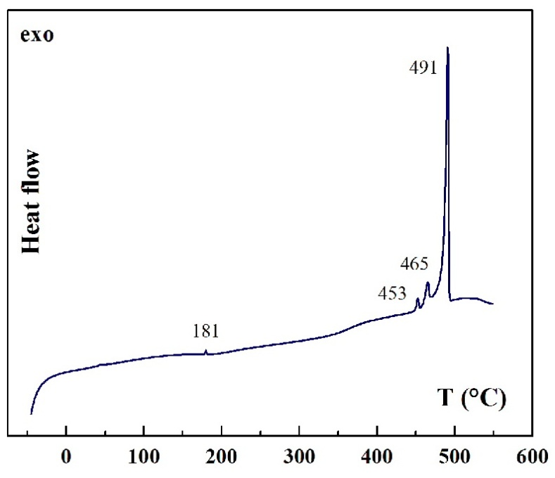
Fig. S1. DSC of sample of Ag₃AsS₃

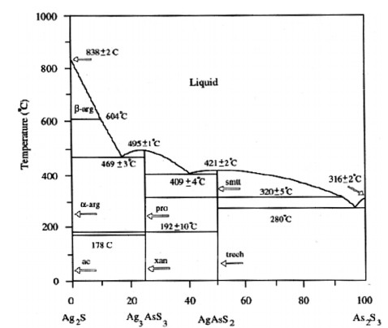

Fig. S2. Phase diagram of the Ag₂S – As₂S₃ system [1].

[1]. M. Razmara, R. Pattrick. Synthesis, characterization, stability and structure of solid solutions between α-miargyrite (AgSbS₂) – smithite (AgAsS₂) and β- miargyrite - smithite. JGeope. 24 (2011) 77-81.

∗ Corresponding author. E-mail address: Smitiukh.Oleksandr@vnu.edu.ua (Oleksandr Smitiukh)

