SUPLEMENTARY DATA

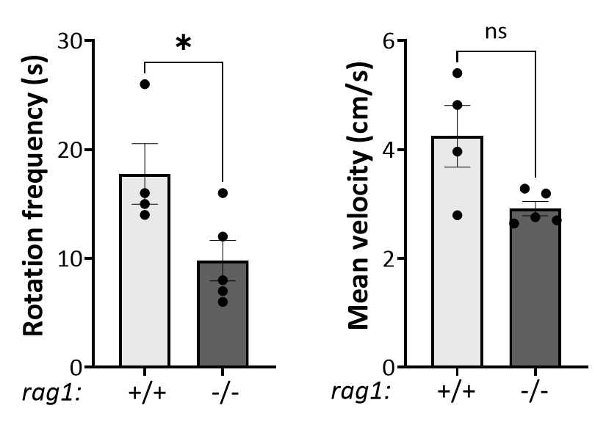
Supplementary Figure 1. Automated behavioral analysis in 8-month-old fish showing quantification of rotation frequency and mean velocity of rag1^{+/+} and rag1^{−/−} zebrafish. Each dot represents one individual and the mean ± SEM for each group is also shown. P-values were calculated using unpaired Student’s t-test or the Mann-Whitney nonparametric test, depending on the distribution of the data; * P ≤ 0.05. ns: non-significant.

Supplementary Figure 2. Dot plot showing the top KEGG pathways enriched among all differentially expressed genes in rag1 mutants WKM samples.

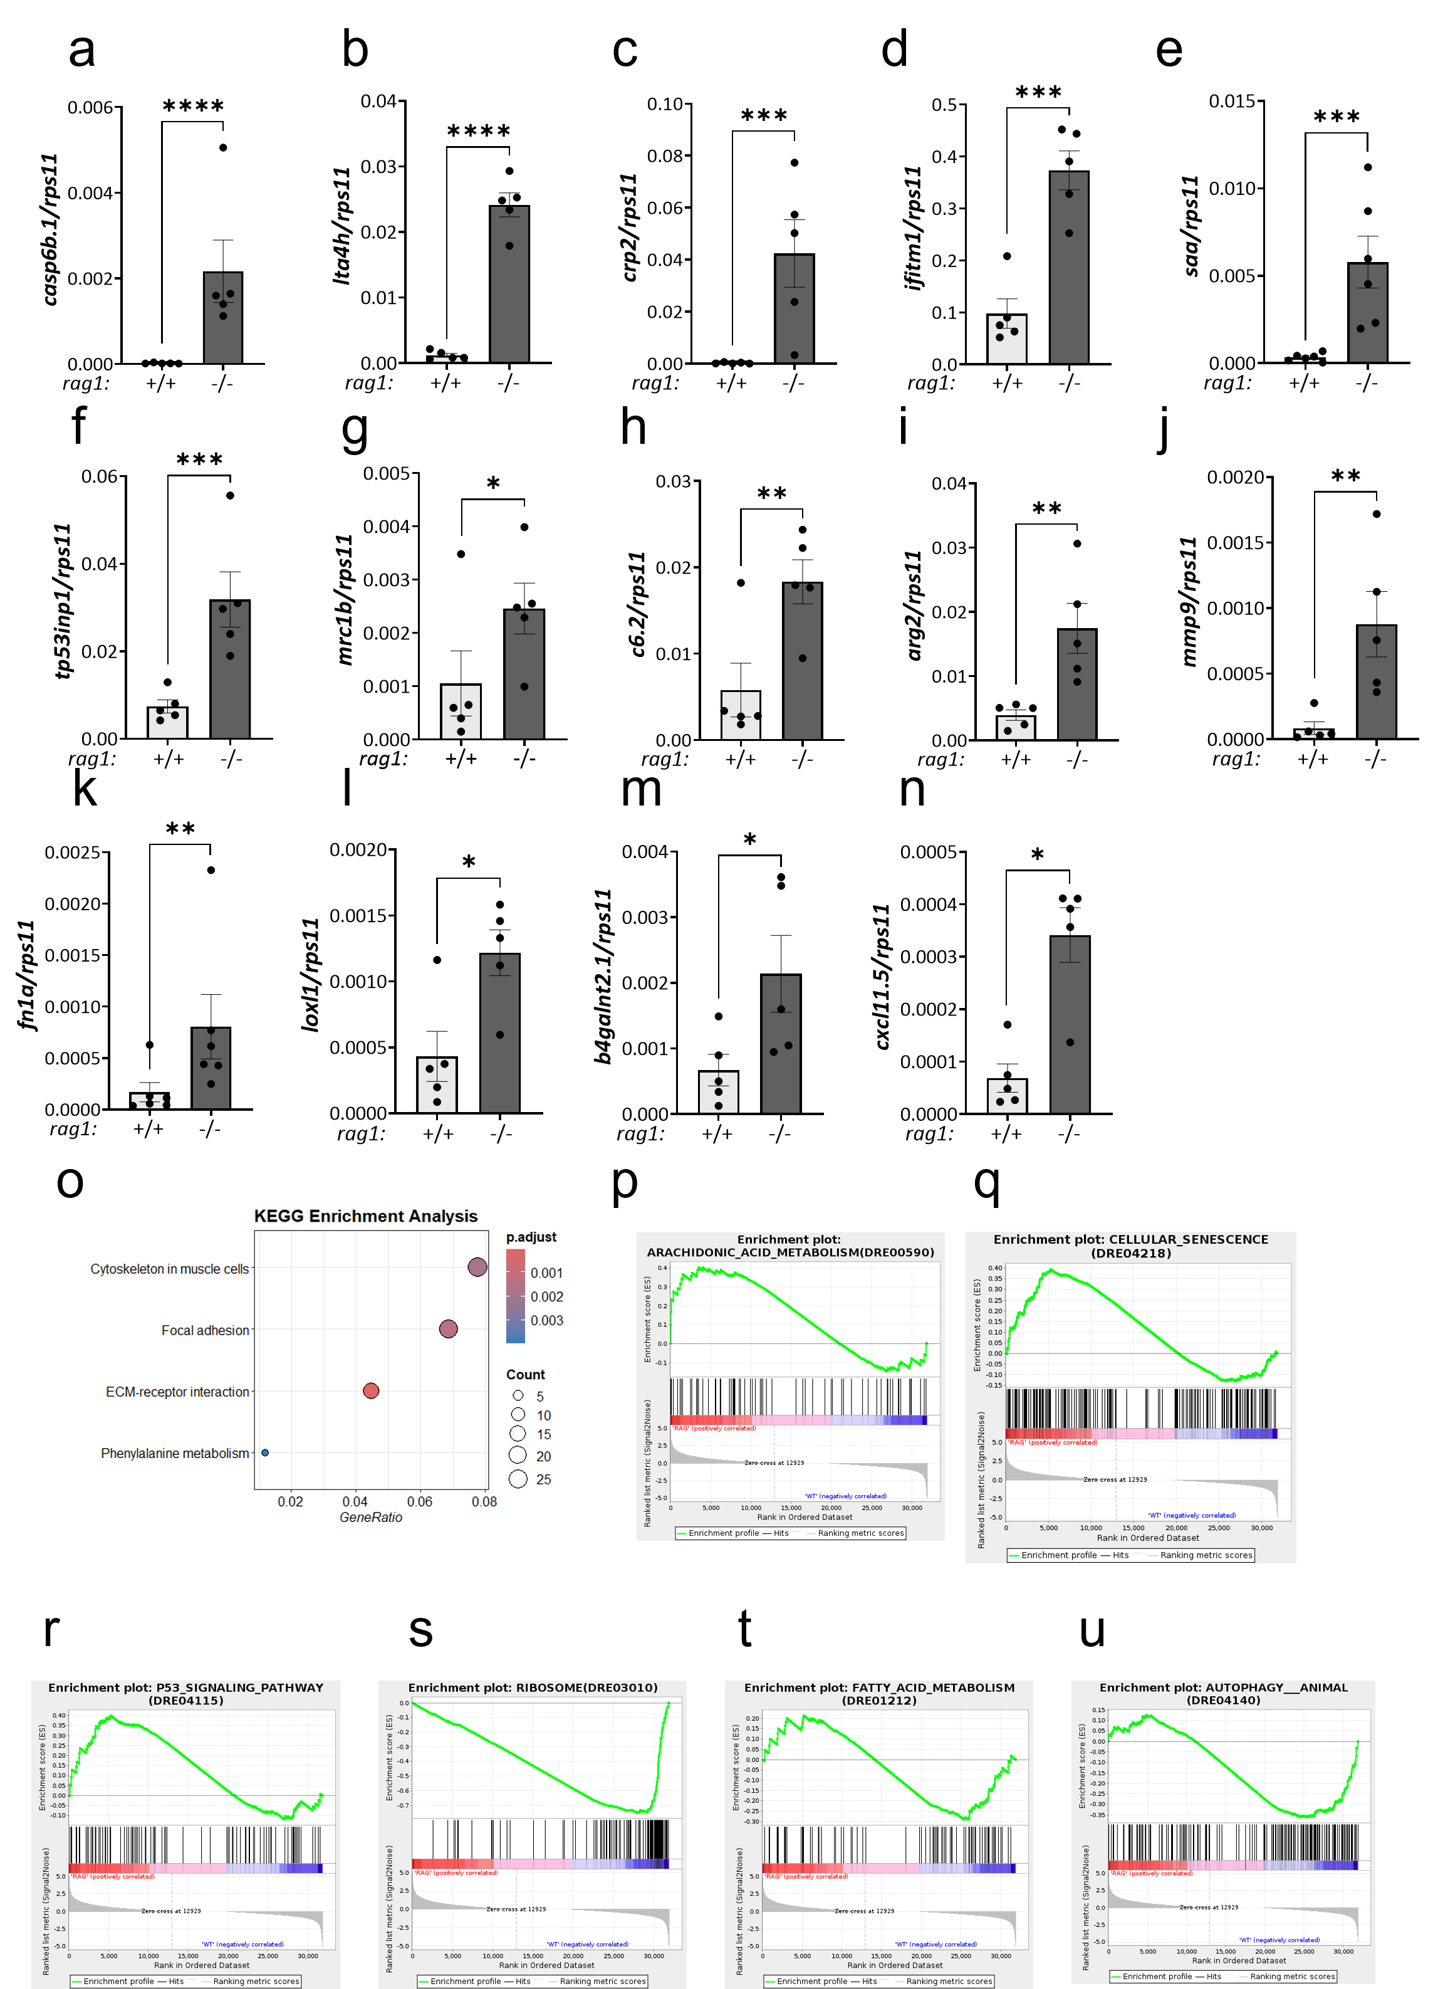
Supplementary Figure 3. (a-n) RT-qPCR validation of selected genes upregulated in rag1^{−/−} intestines. (o) Dot plot showing the top KEGG pathways enriched among all differentially expressed genes in rag1 mutants intestinal samples. (p-u) Gene set enrichment analysis of Hallmark gene sets showing pathways significantly altered in rag1^{−/−} intestines. In each enrichment plot, the green curve represents the running enrichment score as the ranked gene list is scanned from genes most induced in rag1 mutants, left, red, to genes most induced in WT controls, right, blue. Vertical black ticks indicate the position of genes belonging to each queried gene set.
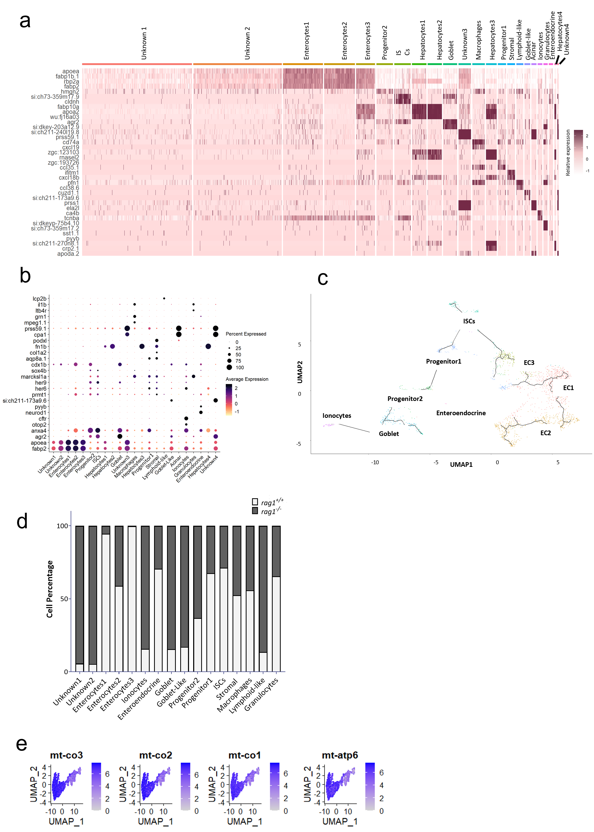
Supplementary Figure 4. (a) Heatmap of the top marker genes defining each cluster identified from sc-RNAseq intestinal data. (b) Dot plot highlighting representative markers used for cell-type annotation. (c) Uniform manifold approximation and projection (UMAP) projection of the Monocle pseudotime trajectory, highlighting progenitor and stem-cell clusters. (d) Relative abundance of each cluster expressed as percentage of total cells in WT and rag1^{-/-} samples. (e) Feature plot illustrating mitochondrial gene expression levels of mitochondrial within the Unknown1 and Unkown2 clusters.

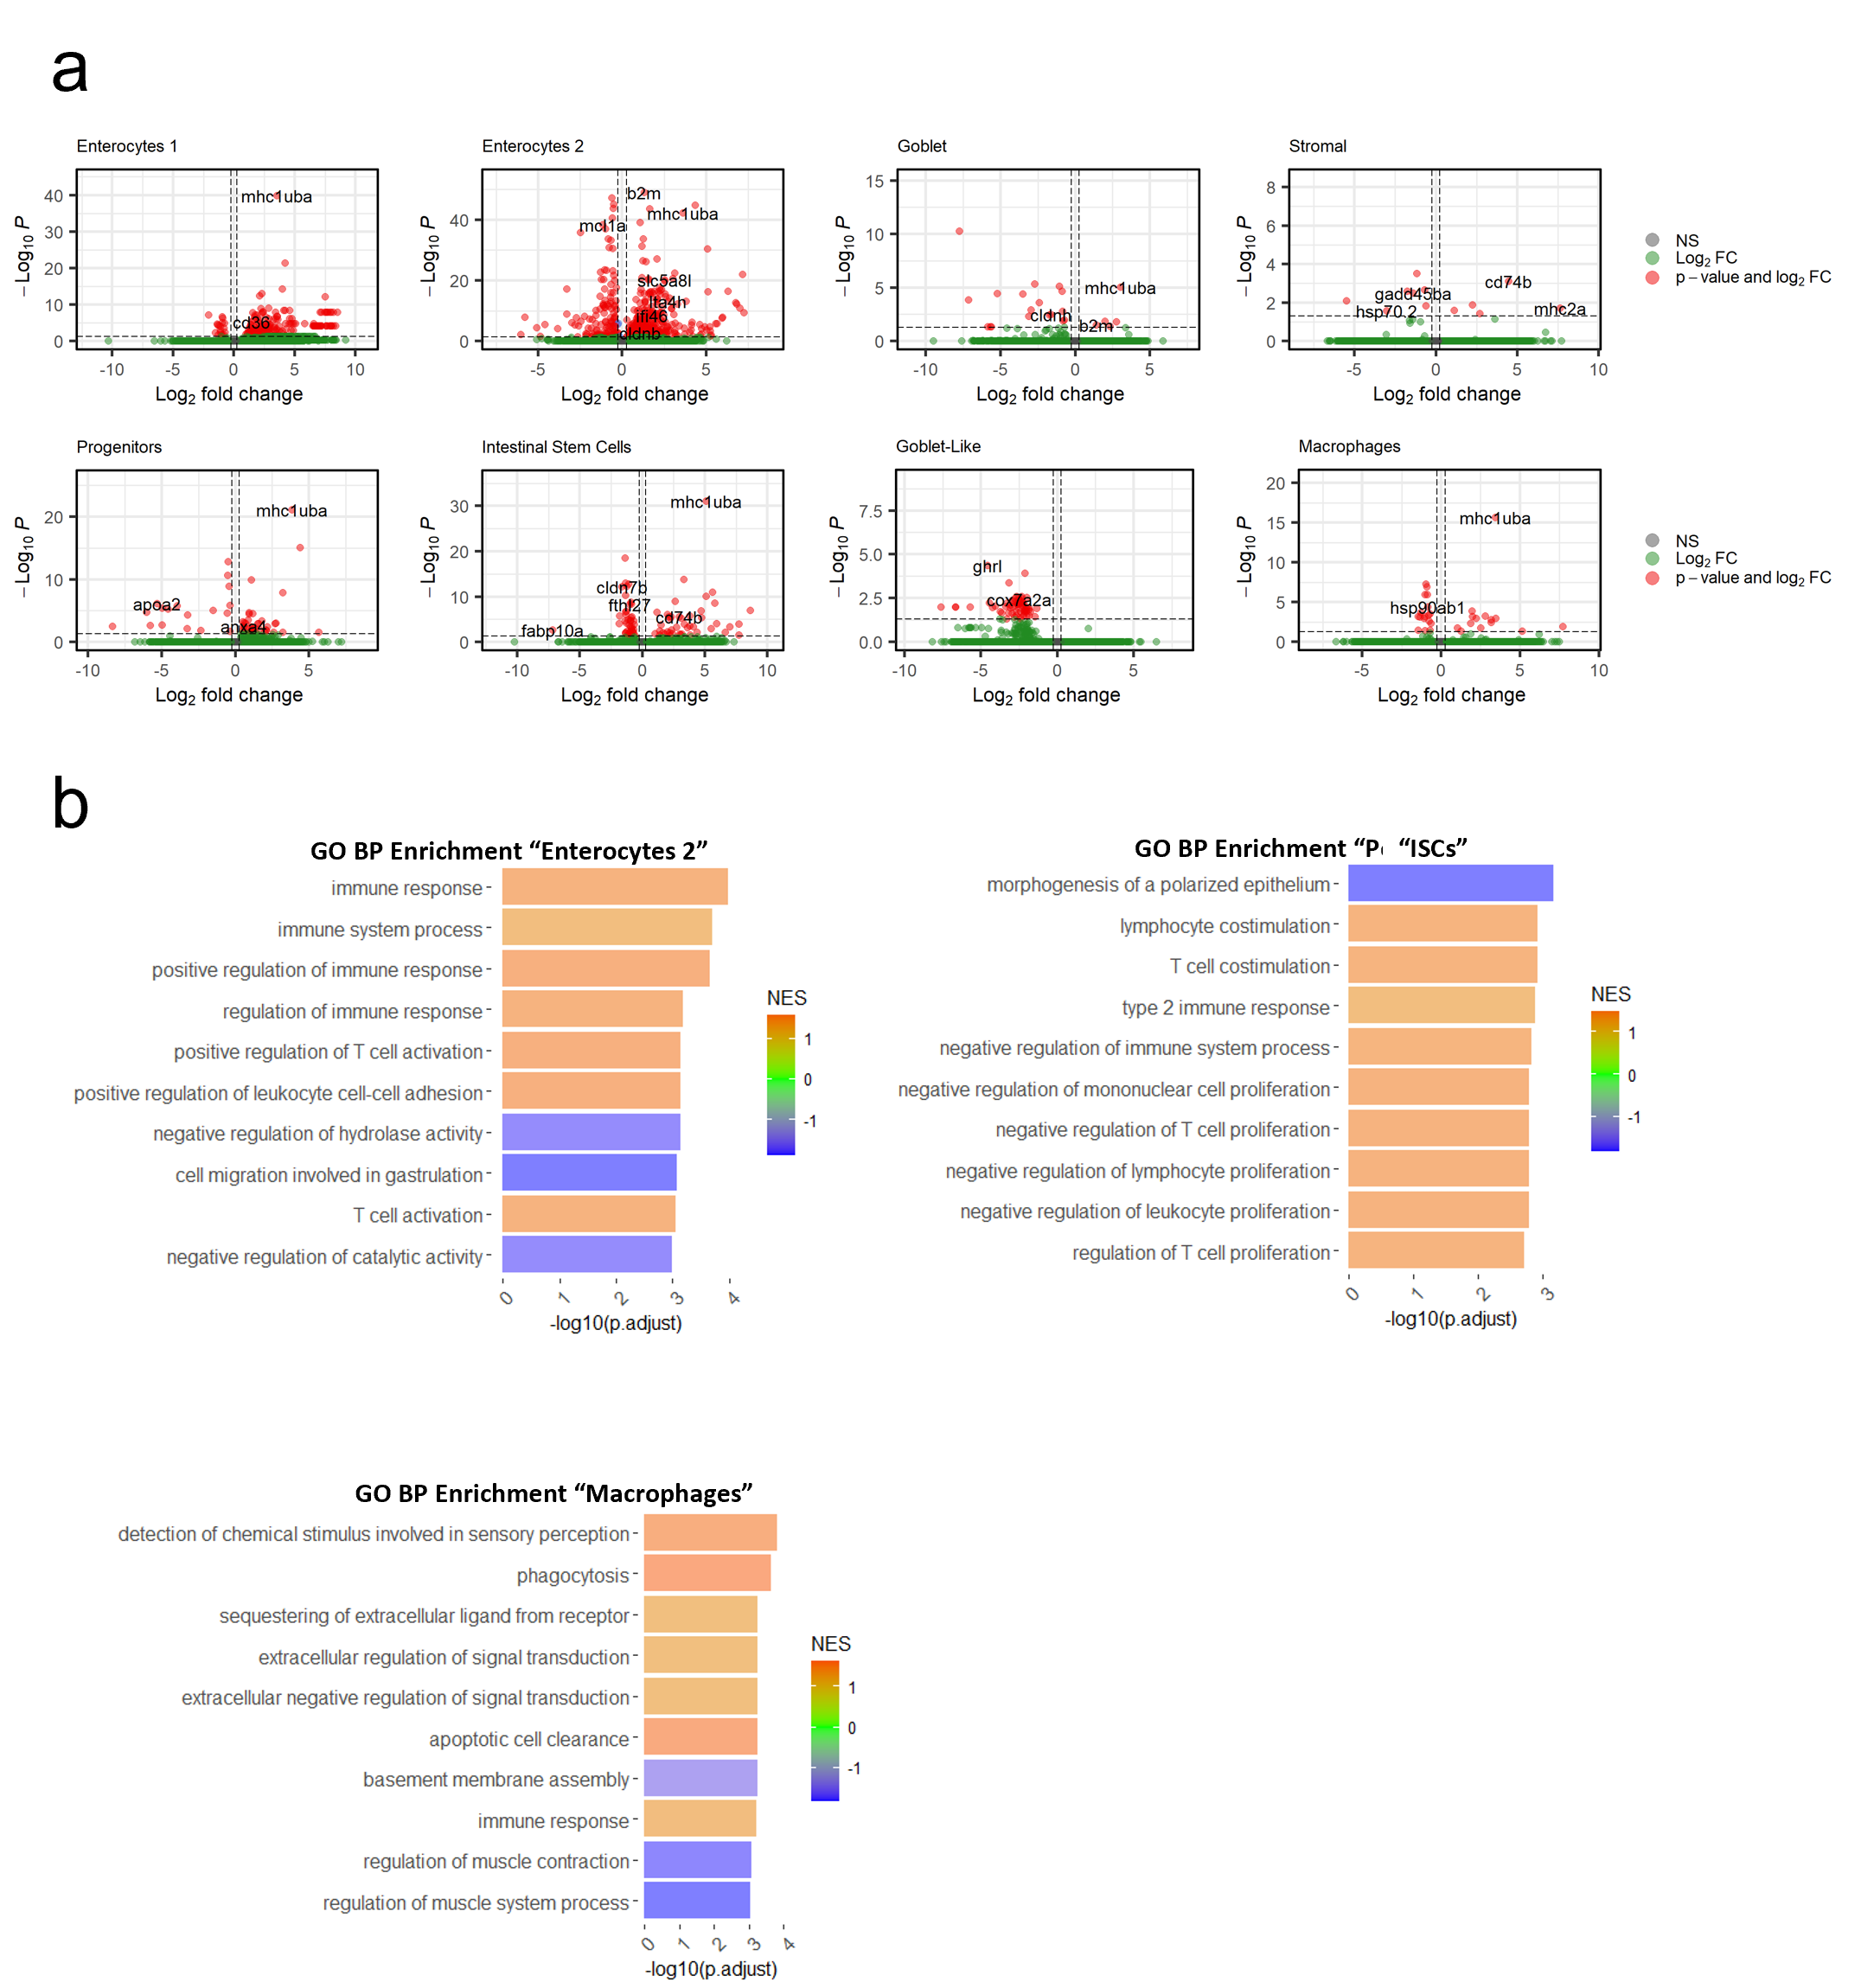
Supplementary Figure 5. (a) Volcano plots of DEGs for selected cell clusters. Genes with an adjusted P < 0.05 and |log₂FC| ≥ 0.25 are highlighted in red. (b) Top GO Biological-Process terms enriched among DEGs in the Enterocyte2, Intestinal Stem Cells (ISC) and Macrophages clusters.
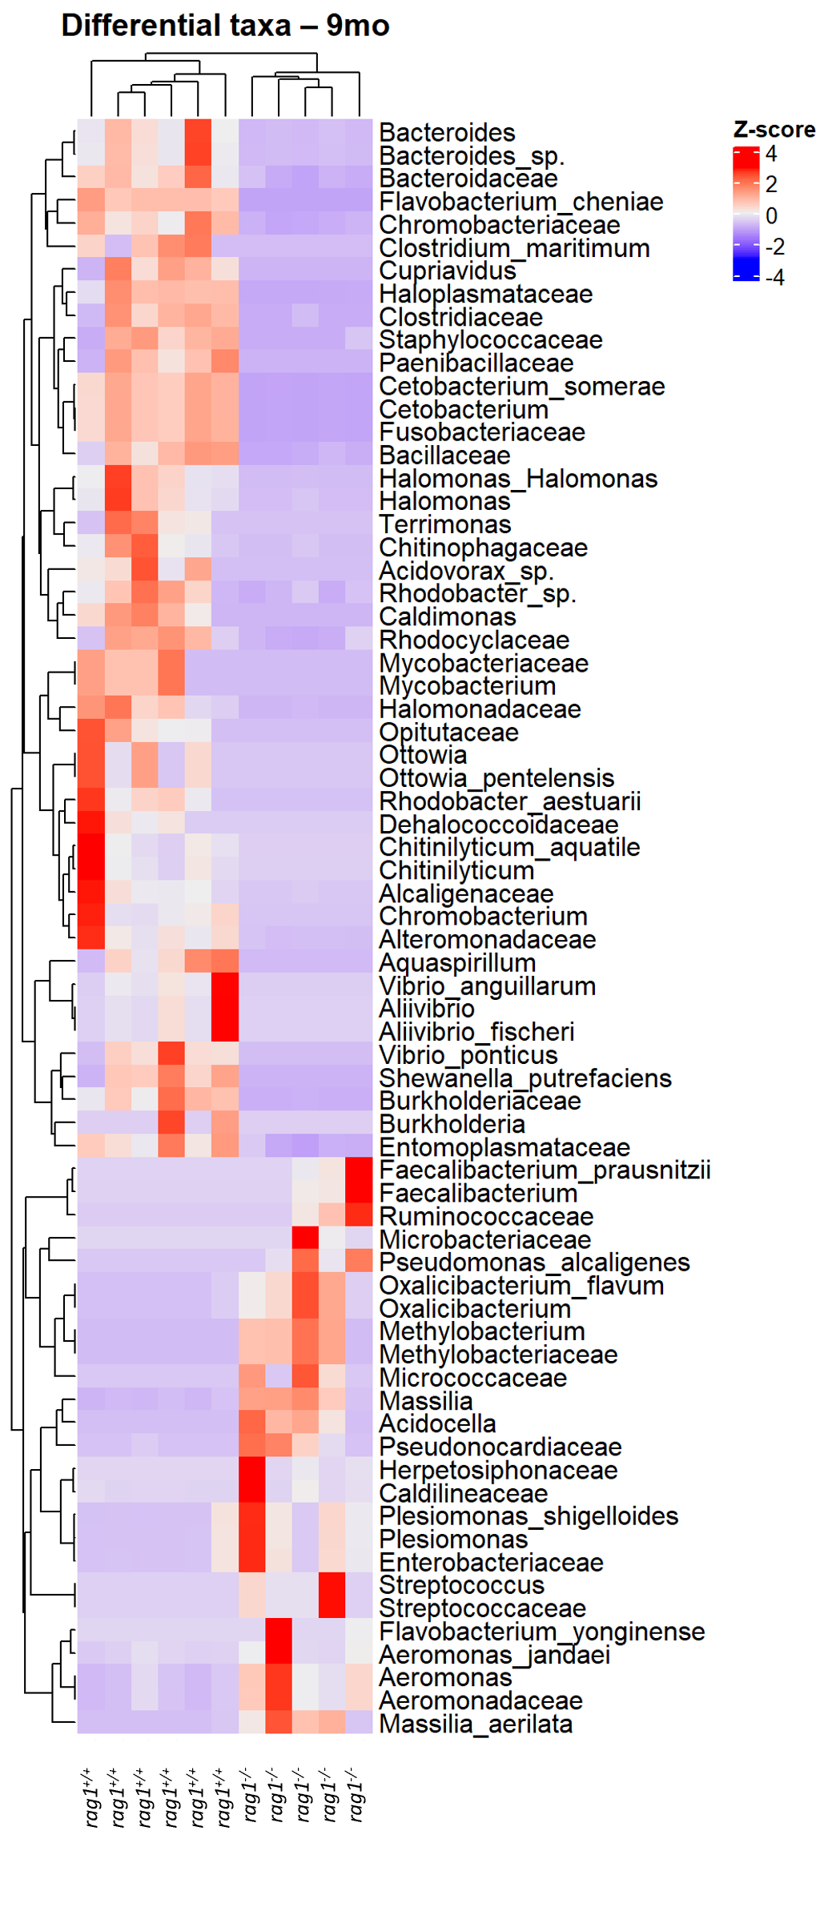
Supplementary Figure 6. Heatmap showing the top OTUs that differ significantly between rag1^{+/+} and rag1^{-/-} zebrafish at 9 months of age. OTUs enriched in the mutant group (positive Z-score) are shown in red, whereas those reduced (negative Z-score) are colored in blue. Differential abundance was assessed with DESeq2 (adjusted P ≤ 0.05).

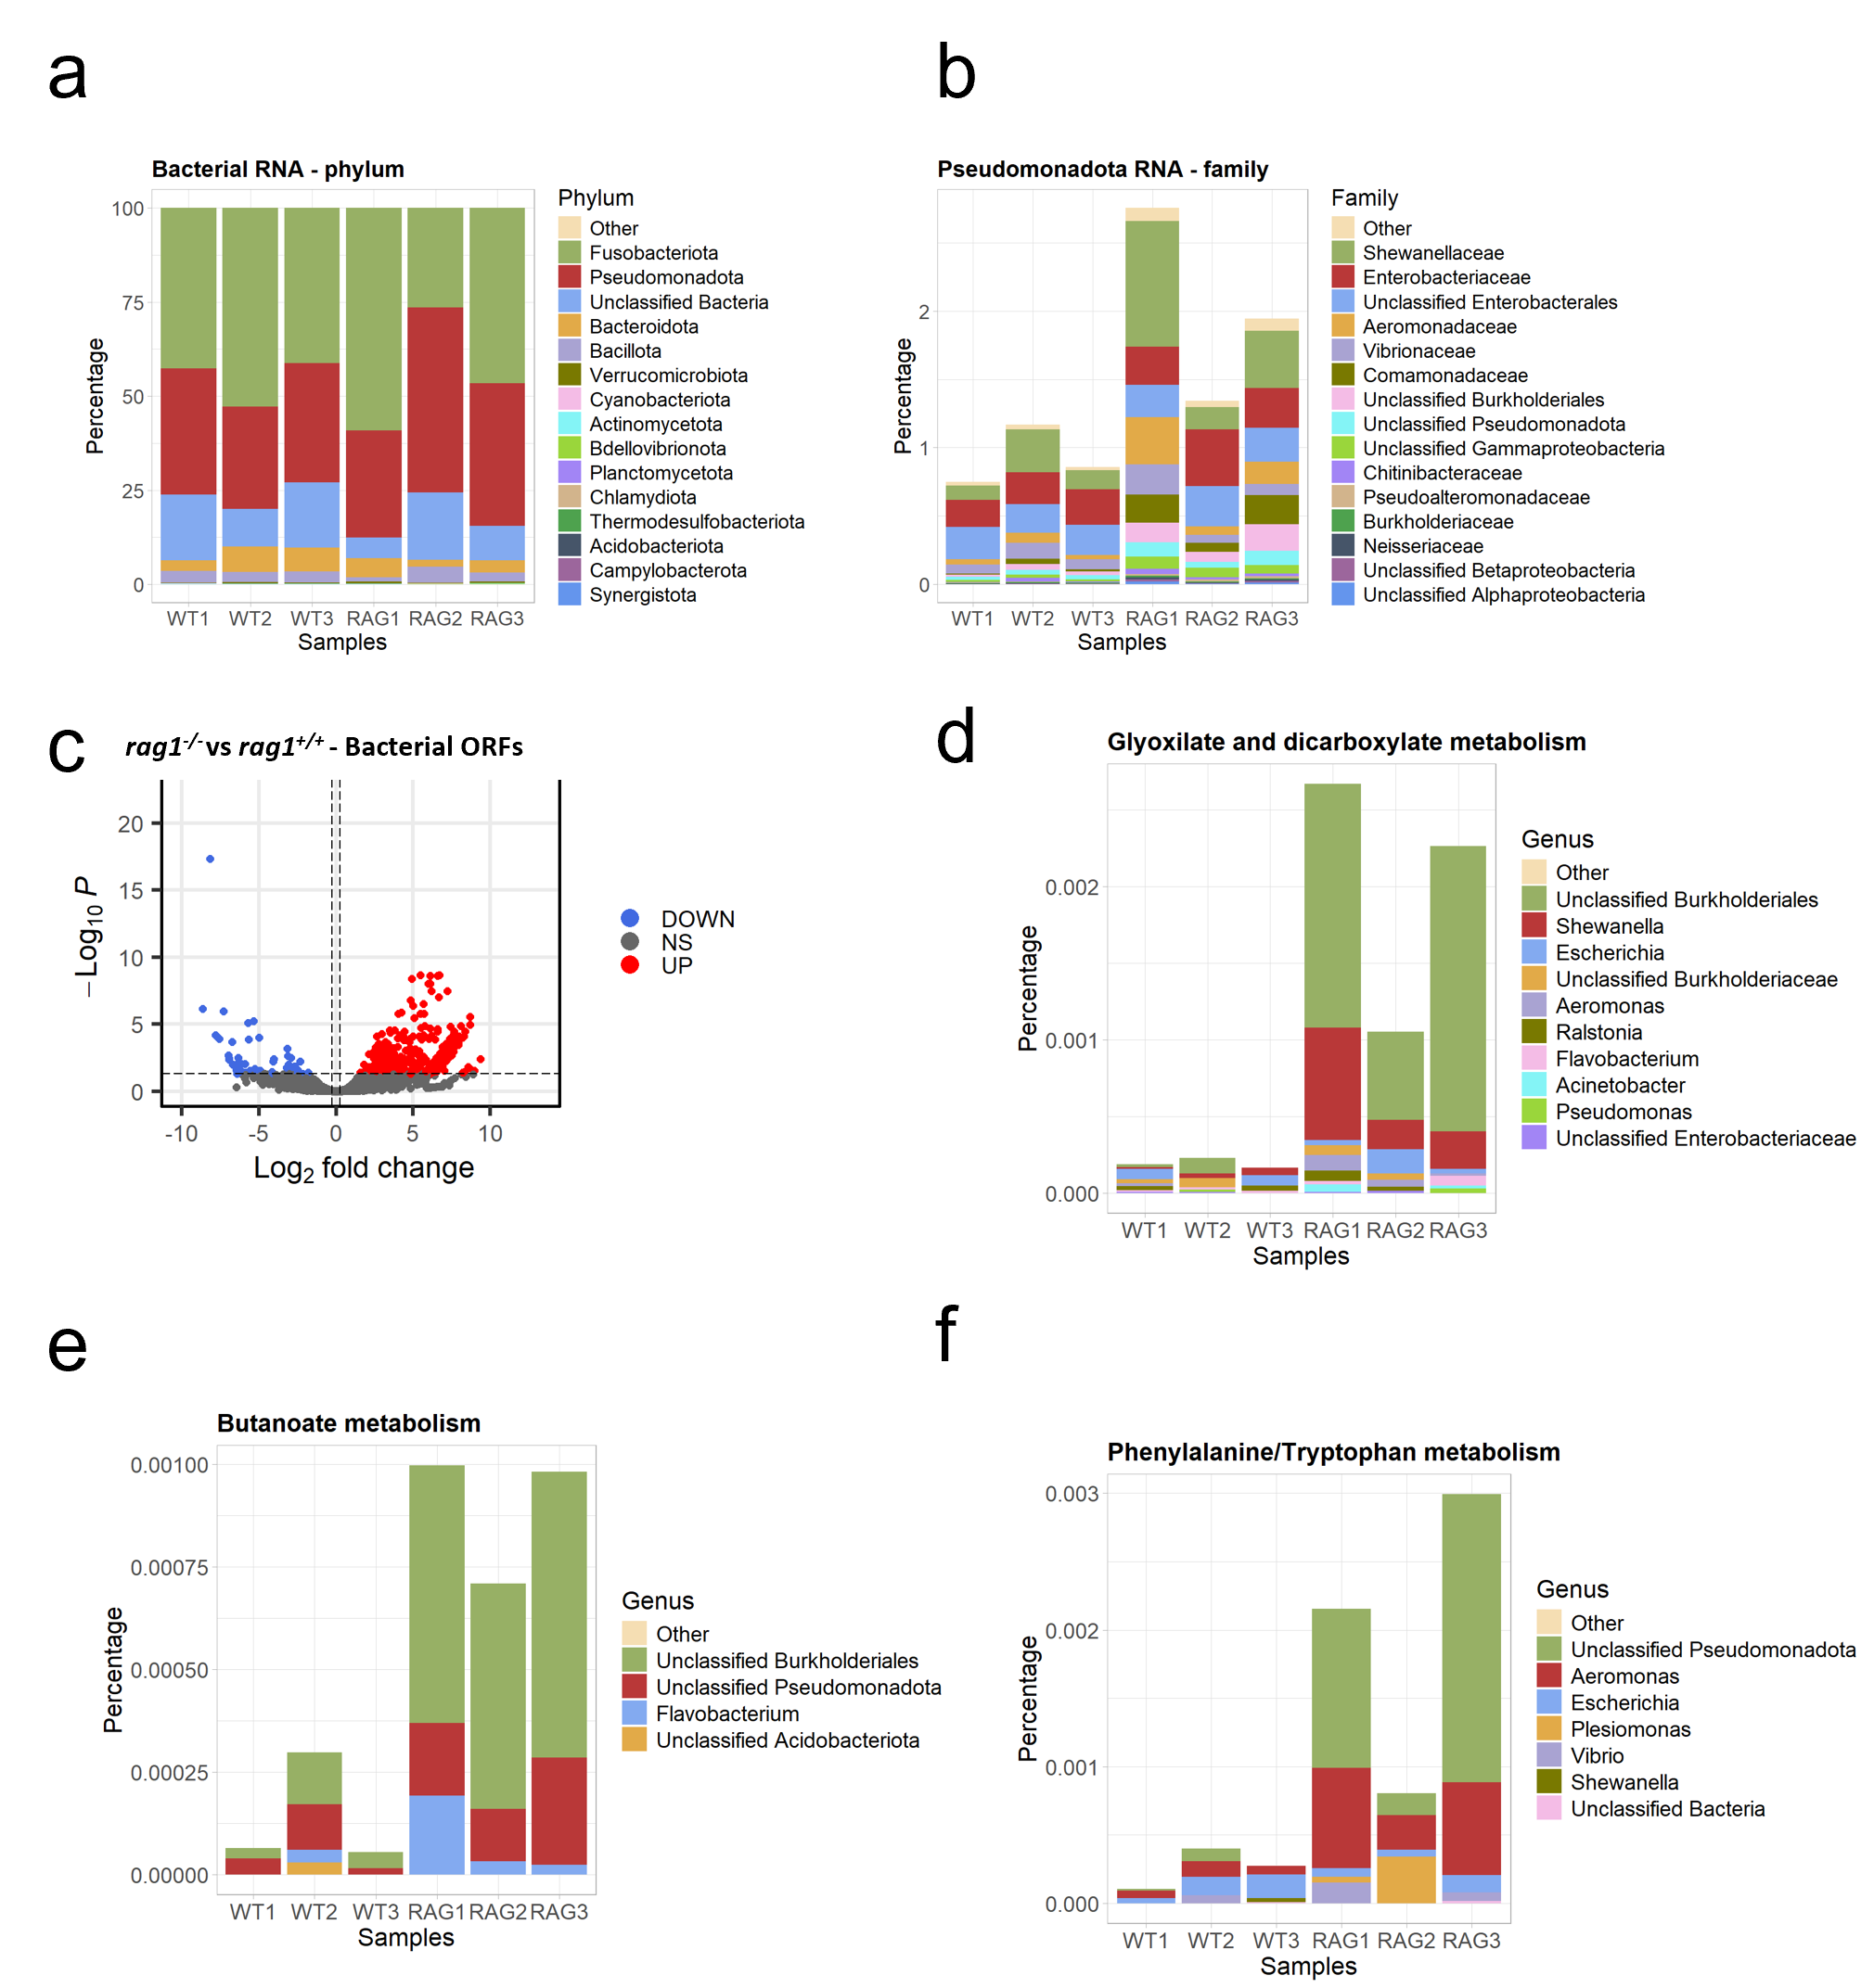
Supplementary Figure 7. (a) Taxonomy bar plot showing the relative abundance of contigs mapping to each bacterial phylum. (b) Family-level taxonomic profiles for the Pseudomonadota phylum. (c) Volcano plot representing differentially expressed bacterial ORFs identified by DESeq2. (d-f) Bar plots showing the bacterial taxonomic composition contributing to metabolism alteration in the rag1^{-/-} condition.

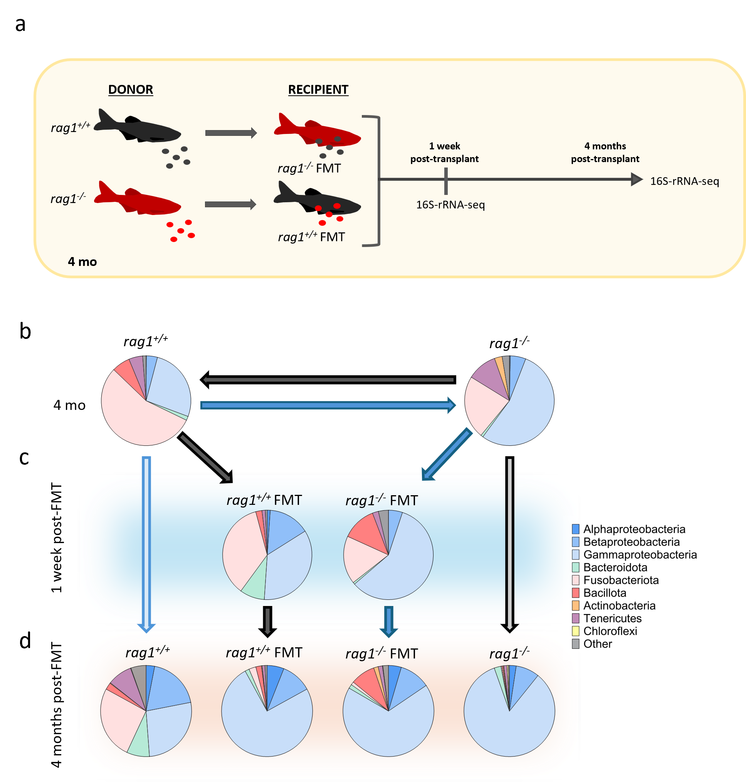
Supplementary Figure 8. (a) Experimental design. Recipient rag1^{+/+} and rag1^{-/-} zebrafish were pre-treated with a single broad-spectrum antibiotic cocktail to deplete the resident microbiota, then inoculated with a fecal microbiota from rag1^{-/-} and rag1^{+/+} donors, respectively. One week and four months after treatment, 16S rRNA-seq was performed. (b) Phylum-level fecal microbiota composition in untreated rag1^{+/+} and rag1^{-/-} controls. (c) Phylum-level composition of the three treated groups one week after intervention. (d) Phylum-level composition of all groups four months after intervention.

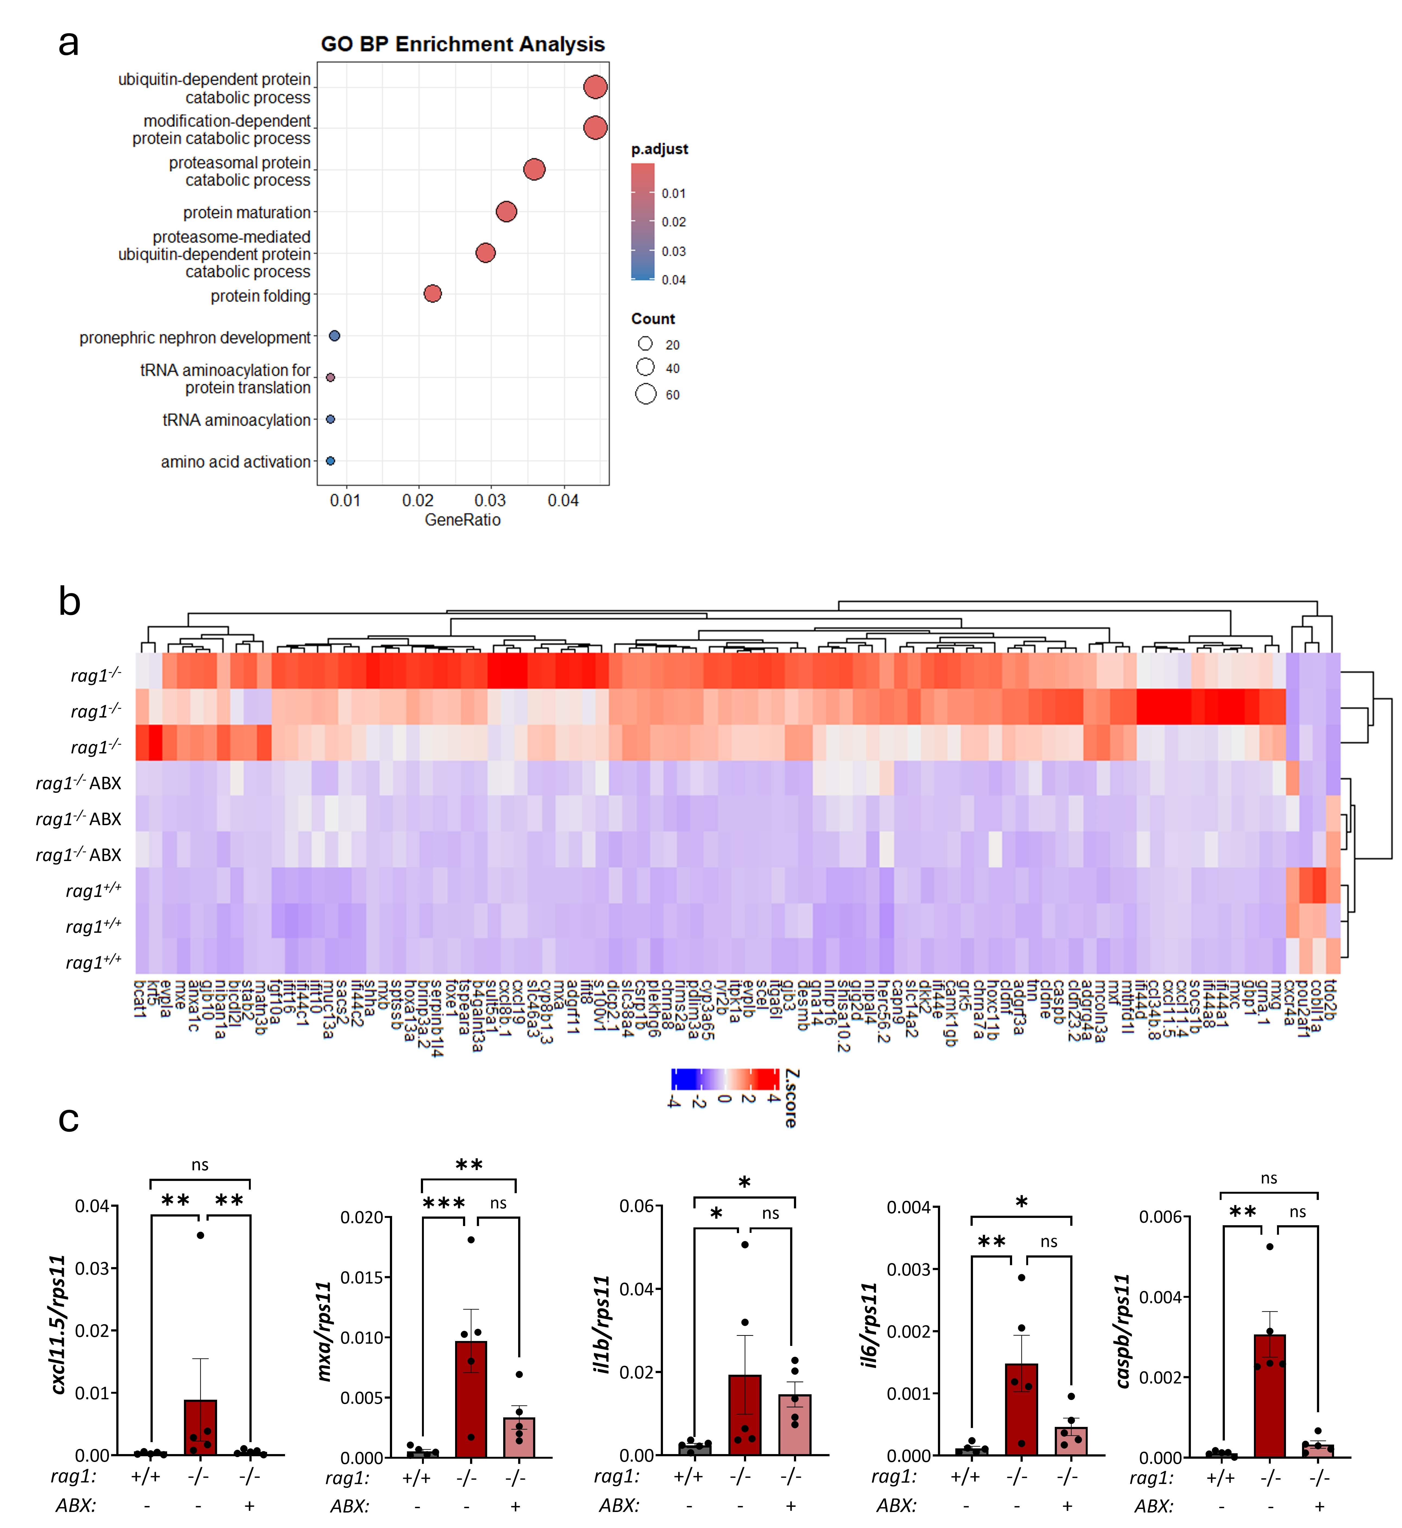
Supplementary Figure 9. (a) Dot plot representing the top enriched GO Biological Processes among all DEGs from RNA-seq data on untreated rag1 mutants, antibiotic-treated rag1 mutants and WT kidney marrow. (b) Heatmap of key DEGs that were altered in rag1^{-/-} versus WT intestines and are restored toward WT levels after antibiotic treatment; upregulated genes (positive Z-score) are shown in red, and downregulated genes (negative Z-score) in blue. (c) Representative genes found to be down-regulated between ABX and rag1 mutant control in RNA-seq and confirmed by RT-qPCR. Each dot represents one individual and the mean ± SEM for each group is also shown. P-values were calculated using unpaired Student’s t-test or the Mann-Whitney nonparametric test, depending on the distribution of the data; * P ≤ 0.05, ** P ≤ 0.01 and *** P ≤ 0.001. ns: non-significant.

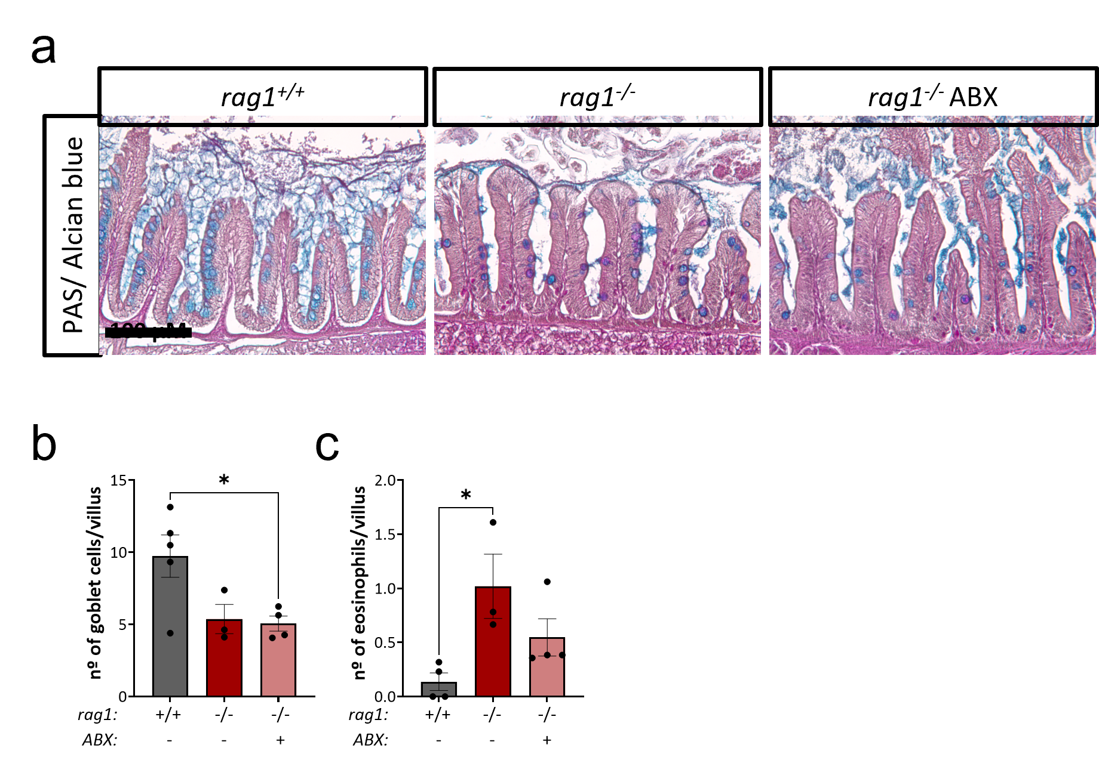
Supplementary Figure 10. (a) PAS/Alcian Blue staining of intestinal sections from 8-month-old WT, untreated rag1^{-/-} and rag1^{-/-} antibiotic-treated zebrafish (rag1^{-/-} ABX). (b) Quantification of goblet cells per villus. (c) Quantification of eosinophils per villus. P-values were calculated using one-way ANOVA or the Kruskal-Wallis nonparametric test, depending on the distribution of the data; * P ≤ 0.05. ns: non-significant.

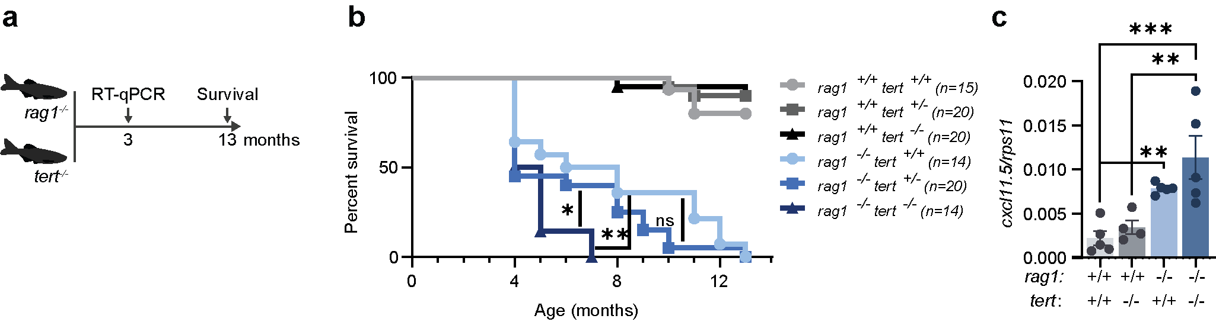
Supplementary Figure 11. (a) Experimental design. The rag1^{−/−} line was crossed with a tert^{−/−} line to generate WT, rag1^{+/+} tert^{+/+}; telomerase heterozygous, rag1^{+/+} tert^{+/−}; telomerase-null, rag1^{+/+} tert^{−/−}; and the corresponding Rag1-deficient combinations, rag1^{−/−} tert^{+/+}, rag1^{−/−} tert^{+/−} and rag1^{−/−} tert^{−/−}. Gene expression was analyzed at 3 months of age, and survival was monitored longitudinally. (b) Kaplan–Meier survival curves comparing the six genotypes. (c) Relative cxcl11.5 expression in WKM from rag1^{+/+} and rag1^{−/−} fish carrying different tert genotypes, measured by RT-qPCR at 3 months of age.

Supplementary Figure 12. Telomerase activity in WKM samples from WT, rag1^{-/-} and rag1^{-/-} drl:tert^{+/-} zebrafish. Telomerase activity is expressed as Relative Telomerase Activity (RTA) units. P-values were calculated using the Kruskal-Wallis nonparametric test; * P ≤ 0.05, ** P ≤ 0.01.

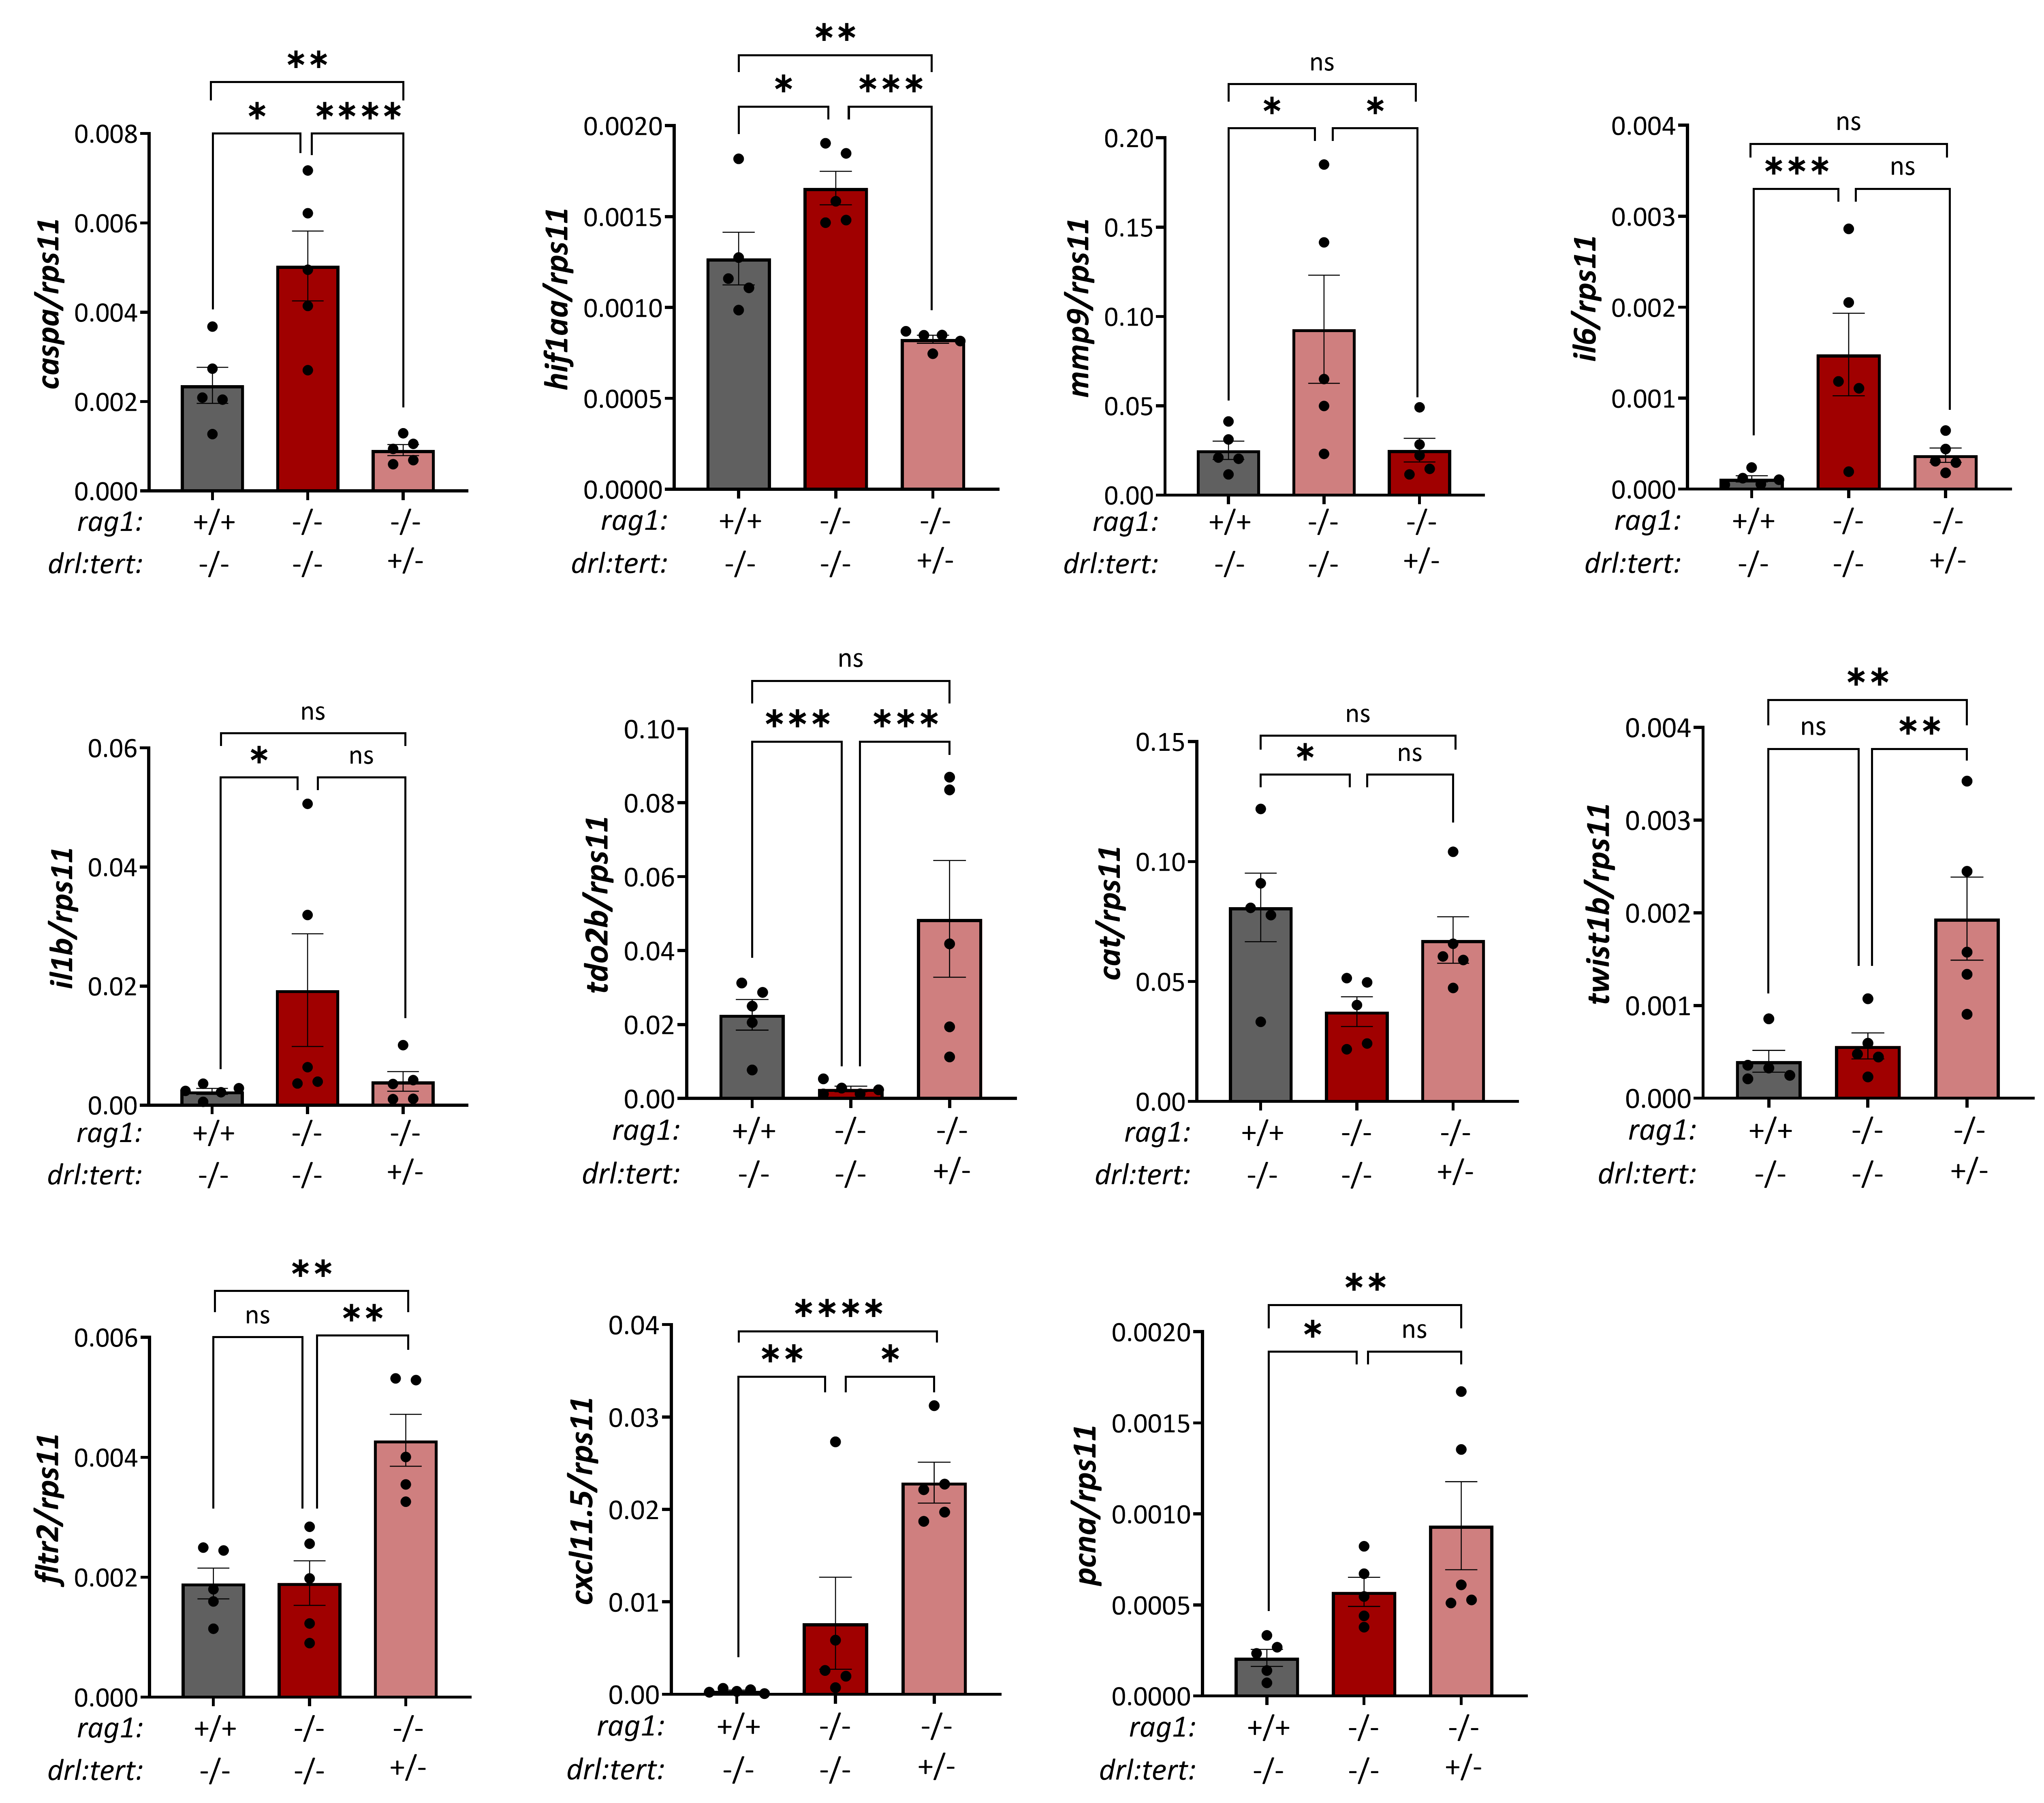
Supplementary Figure 13. Representative genes found to be diiferentially expressed between rag1^{-/-} drl:tert^{+/-} and rag1 mutant controls in WKM RNA-seq and confirmed by RT-qPCR. Each dot represents one individual and the mean ± SEM for each group is also shown. P-values were calculated using one-way ANOVA or the Kruskal-Wallis nonparametric test, depending on the distribution of the data; * P ≤ 0.05, ** P ≤ 0.01, *** P ≤ 0.001 and **** P ≤ 0.0001. ns: non-significant.

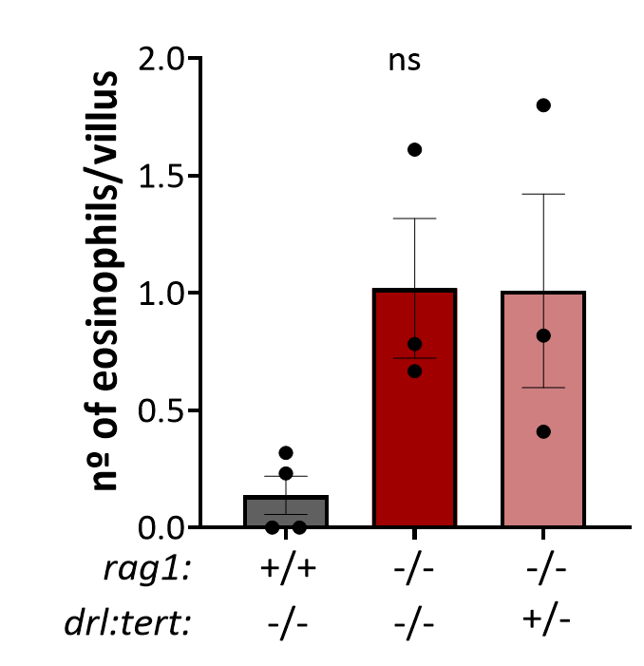
Supplementary Figure 14. Quantification of eosinophils per villus in PAS/Alcian Blue staining of intestinal sections from 8-month-old WT, rag1^{-/-} and rag1^{-/-} drl:tert^{+/-} zebrafish.

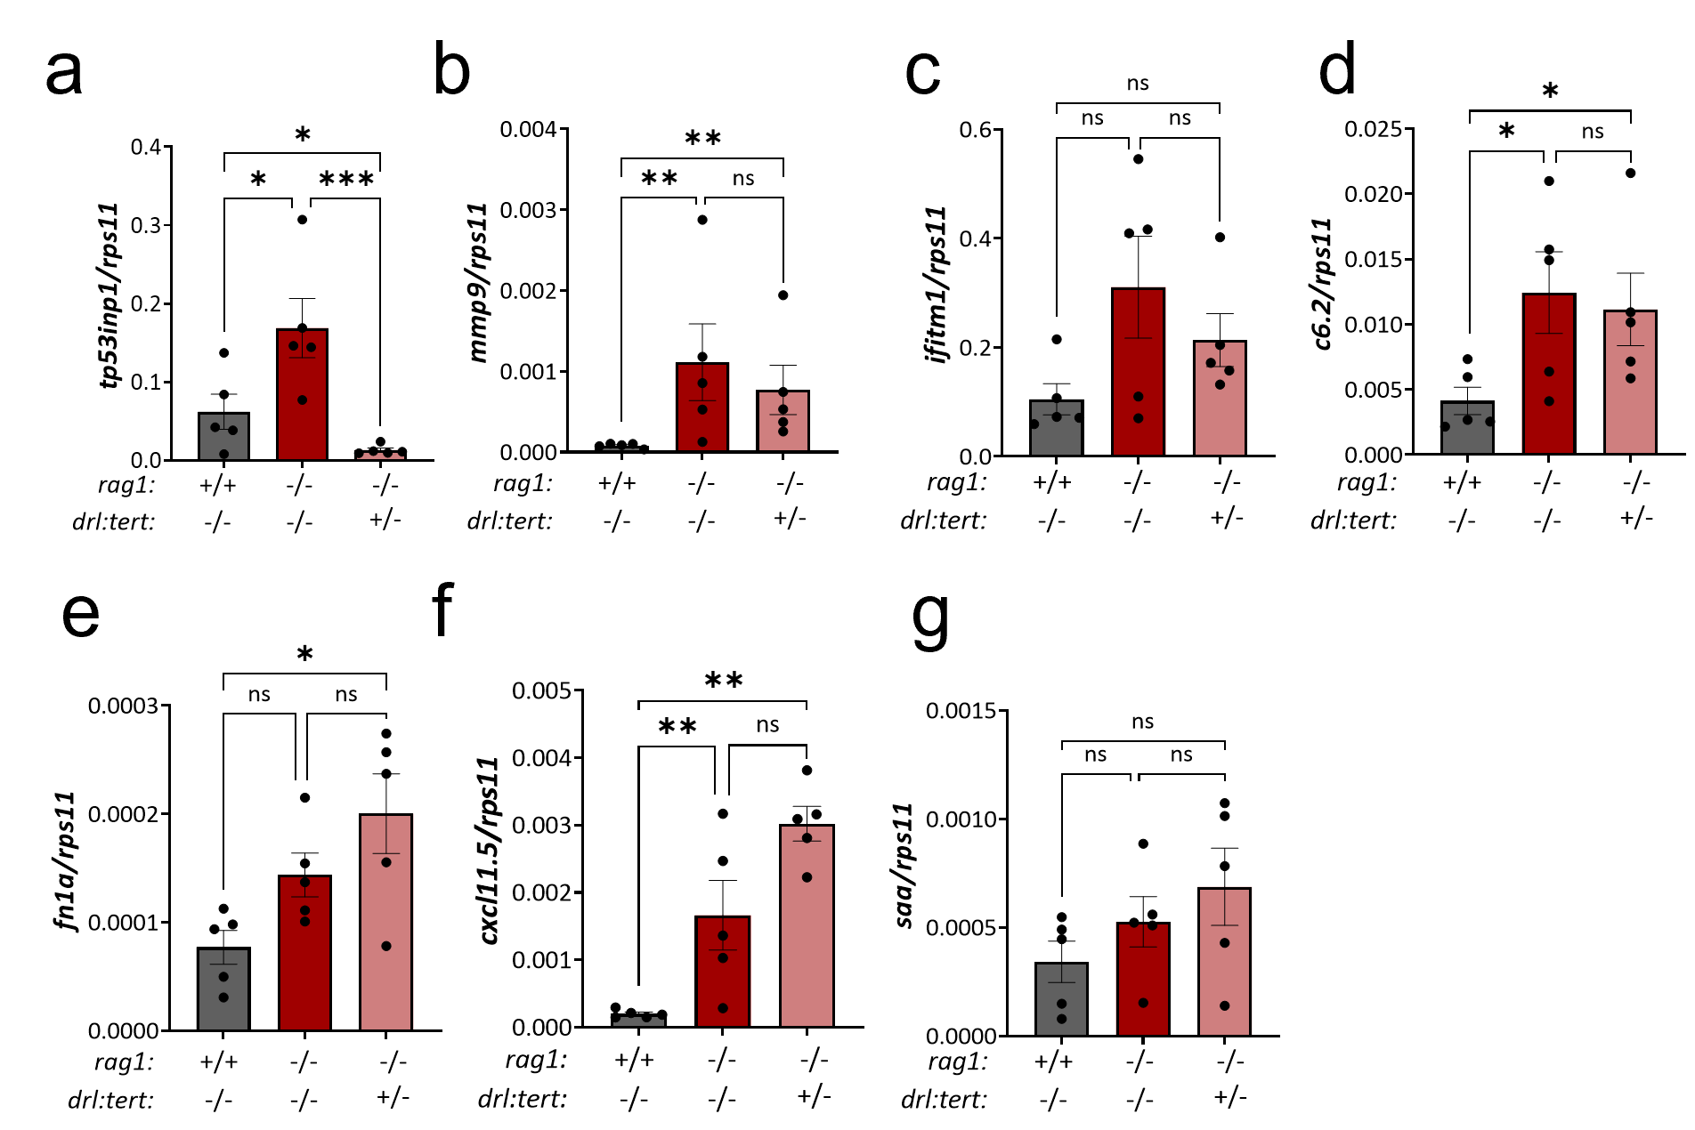
Supplementary Figure 15. (a-g) RT-q-PCR confirmation of genes previously identified as upregulated in rag1^{-/-} versus WT intestines by RNA-seq. Each dot represents one individual and the mean ± SEM for each group is also shown. P-values were calculated using one-way ANOVA or the Kruskal-Wallis nonparametric test, depending on the distribution of the data; * P ≤ 0.05 and ** P ≤ 0.01 and *** P ≤ 0.001. ns: non-significant.

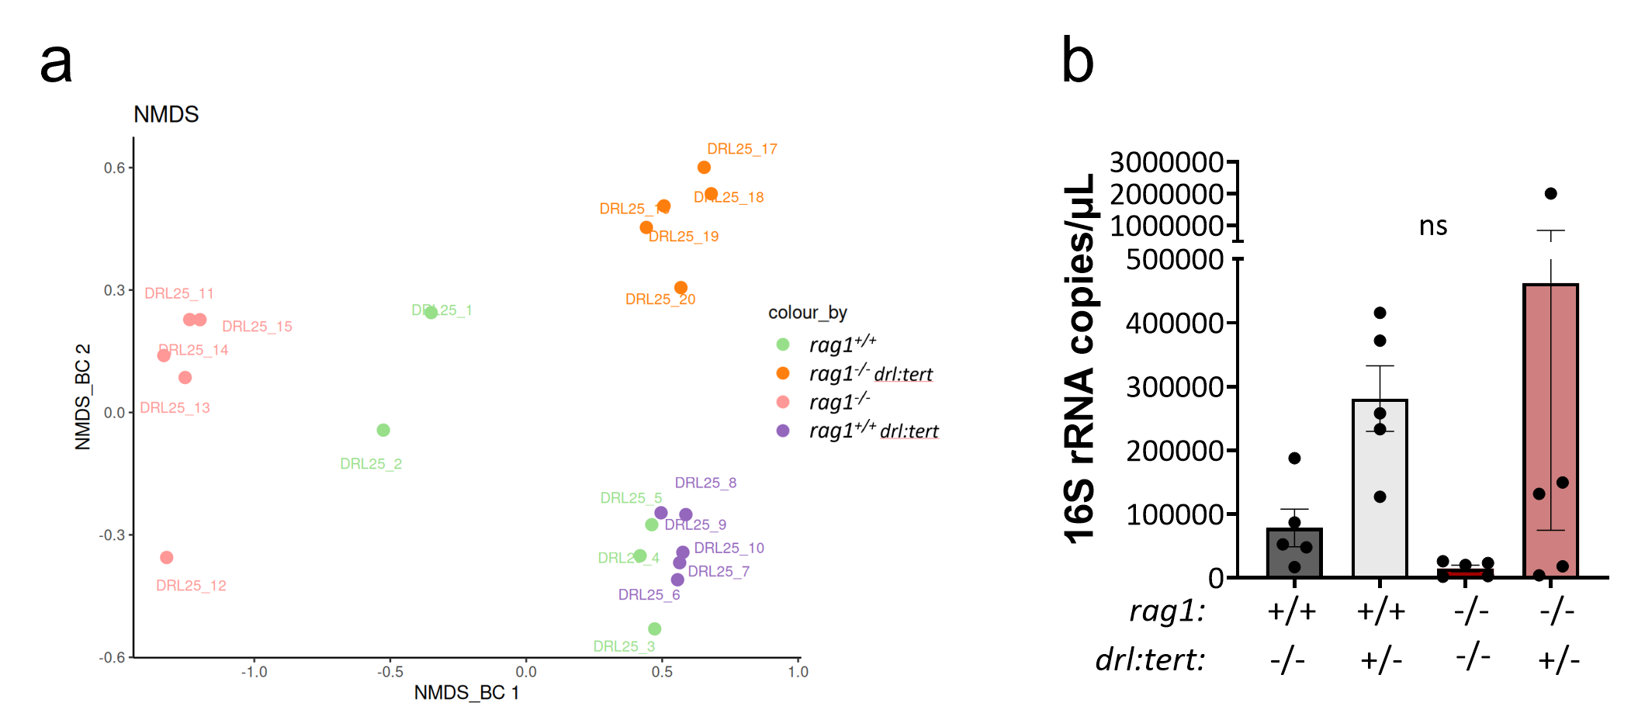
Supplementary Figure 16. (a) Non-metric multidimensional scaling (NMDS) plot of β-diversity for gut microbial communities from rag1^{+/+}, rag1^{+/+} drl:tert^{+/-}, rag1^{-/-} and rag1^{-/-} drl:tert^{+/-} fish. (b) Bacterial load quantified by 16S rRNA q-PCR and expressed as copy number per µL. Each dot represents one individual and the mean ± SEM for each group is also shown. P-values were calculated using one-way ANOVA, ** P ≤ 0.01.

Supplementary Table 1. Primers used for RT-qPCR amplification.
Target gene | Direction | Sequence (5’ à 3’)
arg2 | F | ATCTTGACTACCCTGTTCAT
arg2 | R | GCATGAAGTGCTCATCTTTT
b4galnt2.1 | F | GGGCCAGAGTGAACTTACCA
b4galnt2.1 | R | CTTCAAAAGACAAACAGGCCA
c6.2 | F | TGCACTAAAACCTGTGATTC
c6.2 | R | TACTGGACATCCCTTAAACG
casp6b.1 | F | TTACTCAACAGCTGAAGGAT
casp6b.1 | R | ATGTACCATGAGCCATTCAA
caspa | F | CGACGTCAGGGAGATAAGGC
caspa | R | TGGATACTAAGGTTTTGAACGACG
caspb | F | CAGAAATCTCAGTGGAAAAGAC
caspb | R | TTCATGTTCACGACGTTTAG
cat | F | AACTGGGATCTTACAGGAAA
cat | R | GATGAAAGACGGAAACAGAA
crp2 | F | GCTCTCTGTGACATTAGAGGCTA
crp2 | R | CTGTTGTCAGTAGCGGTCTTG
cxcl11.5 | F | CATCCAAGTCCATCTTGTGGAA
cxcl11.5 | R | AGCCCTCCTGATTAATTCCTGG
fltr2 | F | CATCTTACAAGGTGACTTGG
fltr2 | R | CAAAACATACACACAGATGC
fn1a | F | ACAGCACTGTCTTCAGTAAT
fn1a | R | GATCCCCAAACTGACATCTA
hif1aa | F | CACAGATTTGGTCTGTCTAAG
hif1aa | R | CAGGAAACTTCTGTTTGTGT
ifitm1 | F | TTTTACAACTCAGTGAAGGC
ifitm1 | R | CATAGAGGACGCCAAGAATA
il1b | F | GCCTGTGTGTTTGGGAATCT
il1b | R | TGATAAACCAACCGGGACAT
il6 | F | CGAAATATCTGGAGACGAAG
il6 | R | TGAAATCTCTCTCAAACTGC
loxl1 | F | TTCAGCCAGGAAACTACATA
loxl1 | R | CACCAAGTACTTTGGATTGAC
lta4h | F | ACTTAAAATGGCAACCGAAC
lta4h | R | ACTGTACTTGGAGAAGTTGT
mmp9 | F | ATCAAGAACATGACCAACAC
mmp9 | R | GTAACGCTTCAGATACTCATC
mrc1b | F | GTCCAACACGTGATAGTAAA
mrc1b | R | TCATTCAGCTGGTAGTAGAC
mxa | F | ATCCTCATTTCAGCAAACTC
mxa | R | TGTTAGTTTCTCTGCCAACT
pcna | F | GAACGGTCACACTTAGAATG
pcna | R | CAATTTTGTCCTCAACCACT
rps11 | F | GGCGTCAACGTGTCAGAGTA
rps11 | R | GCCTCTTCTCAAAACGGTTG
saa | F | CGCAGAGGCAATTCAGAT
saa | R | CAGGCCTTTAAGTCTGTATTTGTTG
tdo2b | F | CGGAGACTATTTACAGCTTG
tdo2b | R | GAGATGCTCATCATGGATTT
tert | F | CGGTATGACGGCCTATCACT
tert | R | TAAACGGCCTCCACAGTT
tp53inp1 | F | CCCTCTTCCTGTTTACATTAC
tp53inp1 | R | CTGAAGTGCATTAGTTACTCC
twist1b | F | TTAAATGGTCAAACCGTGAG
twist1b | R | GCACATATTTCCAACATTCG

Supplementary Table 2. Antibodies and probes used for immunohistochemistry.
Antibody target | #REF | Dilution | Antigen retrieval buffer | Antigen retrieval
Lcp1 | GTX124420 | 1:300 | EDTA 1 mM 0.05% Tween 20 pH 8.0 | 60 min
Mpx | GTX128379 | 1:100 | Tris 10mM EDTA 1mM 0.05% Tween 20 pH 9.0 | 20 min
γ-H2AX | GTX127342100 | 1:50
anti-Rabbit IgG Alexa Fluor™ 488 | A-21206 | 1:450
PNA-cy3 | F1002

Supplementary Table 3. Primers used 16S rRNA amplification prior to sequencing.
Target Region | Direction | Sequence (5’ à 3’)
V2 | F | GGCGSACGGGTGAGTAA
V2 | R | GCTGCCTCCCGTAGGAGT
V3 | F | ACTGAGACACGGTCCARACT
V3 | R | GTATTACCGCGGCTGCTG
V4 | F | CCAGCAGCCGCGGTAATA
V4 | R | GGACTACCAGGGTATCTAATCCTGT
V67 | F | ACAAGCGGHGGARCATGT
V67 | R | GACGTCATCCCCACCTTCC
V8 | F | GYTGTCGTCAGCTCGTGT
V8 | R | CGATTACTAGCGAYTCCGACTTCA
V9 | F | GTTACGACTTCACCCCAGTCA
V9 | R | GCGTCGTAGTCCGGATTGG
341 | F | CCTACGGGDGGCWGCAG, CCTAYGGGGYGCWGCAG
806 | R | GACTACNVGGGTMTCTAATCC

Supplementary Table 4. Primers used for 16S rRNA amplification by q-PCR.
Target region/gene | Name | Direction | Sequence (5’ à 3’)
16S rRNA | 341 | F | CCTACGGGNGGCWGCAG
16S rRNA | 805 | R | GACTACHVGGGTATCTAATCC
actb2 | ZfActb2-F | F | GTGCCCATCTACGAGGGTTA
actb2 | ZfActb2-R | R | TCTCAGCTGTGGTGGTGAAG

