Additional file 3. Case vignette
(English translation of the original German instrument)
(The two illustrations of the fictional patient were generated using an AI image tool and formed part of the original stimulus shown to participants.)
Case Vignette

Beatrice Müller
- Age 67, lives alone
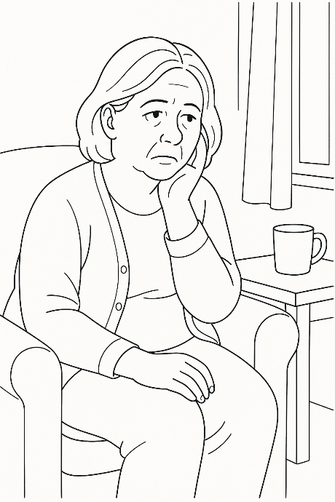
- Multiple chronic conditions:
  - Type 2 diabetes, diagnosed 2011, complications polyneuropathy with nocturnal pain in both soles of the feet, chronic kidney disease KDIGO stage 3a
  - Hypertension, diagnosed 2013; controlled with ACE inhibitor and calcium channel blocker
  - Obesity, class I
  - Musculoskeletal: spinal canal stenosis; chronic back pain; hip osteoarthritis
  - Mental health: recurrent mild depressive symptoms
- Polypharmacy: lisinopril 1 mg/day, amlodipine 5 mg/day, metfin 3x500 mg/day, semaglutide under discussion, paracetamol 3x500 mg/day (as-needed analgesics: novalgin 500 mg up to 3x/day; tramadol up to 50 mg 2x/day), escitalopram 10 mg/day
- Social isolation, no contact with family, some contact with a neighbor of similar age, meeting once or twice a week for coffee
- Feels lonely and unhappy, worries about her future

Time jump (15 years)
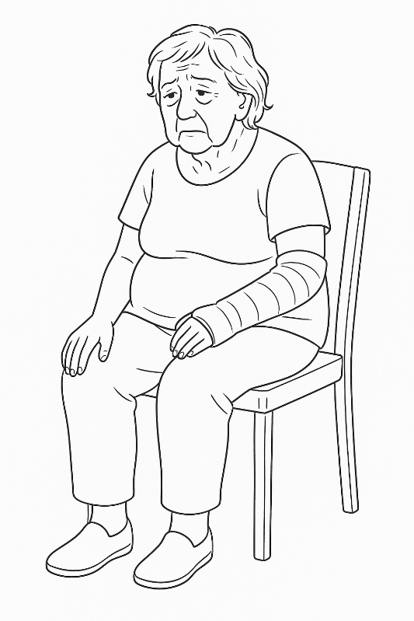
- Age 82, still lives alone and explicitly does not want to move into an institution, strong-willed
- Progression of chronic conditions:
  - Polyneuropathy has worsened, leading to sleep disturbances/daytime fatigue, and unsteady gait (reduced sensation in the feet). She has so far refused to use a cane or walker.
  - Hypertension: amlodipine increased to 10 mg/day four years ago
  - Mental health: occasionally hints during consultations that she no longer knows why she should keep living; reports no real joy in life, and escitalopram has not changed this
- Early signs of dementia; mixes up her medications
- Experiences dizziness on standing, has fallen several times; most recently sustained a fracture of the left radius (treated conservatively)

