Earth Science Informatics
Supplementary Material for
Cross-Scale Micro-CT Super-Resolution for Digital Rock Reconstruction in Heterogeneous Conglomerate Reservoirs

Contents of this file

Figures S1 to S11
Tables S1 to S2

Introduction
- Section S1: Dataset Preprocessing and REV Analysis
- Section S2: Additional Qualitative Comparisons
- Section S3: Segmentation and Physical Accuracy Assessment
- Section S4: Generalization and Transfer Learning Details

Section S1: Dataset Preprocessing and REV Analysis
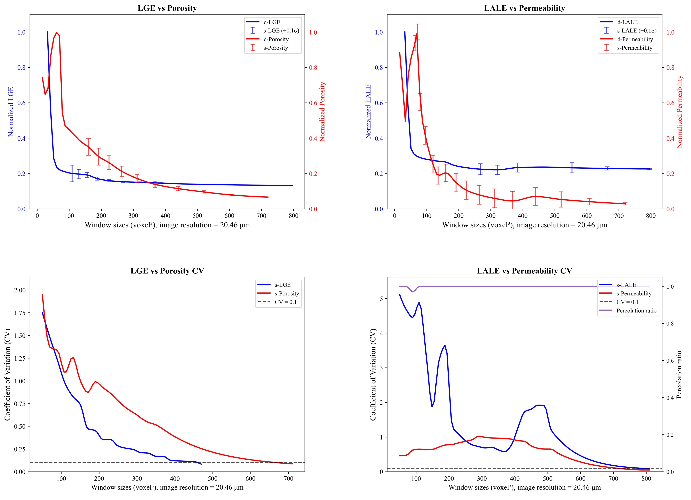
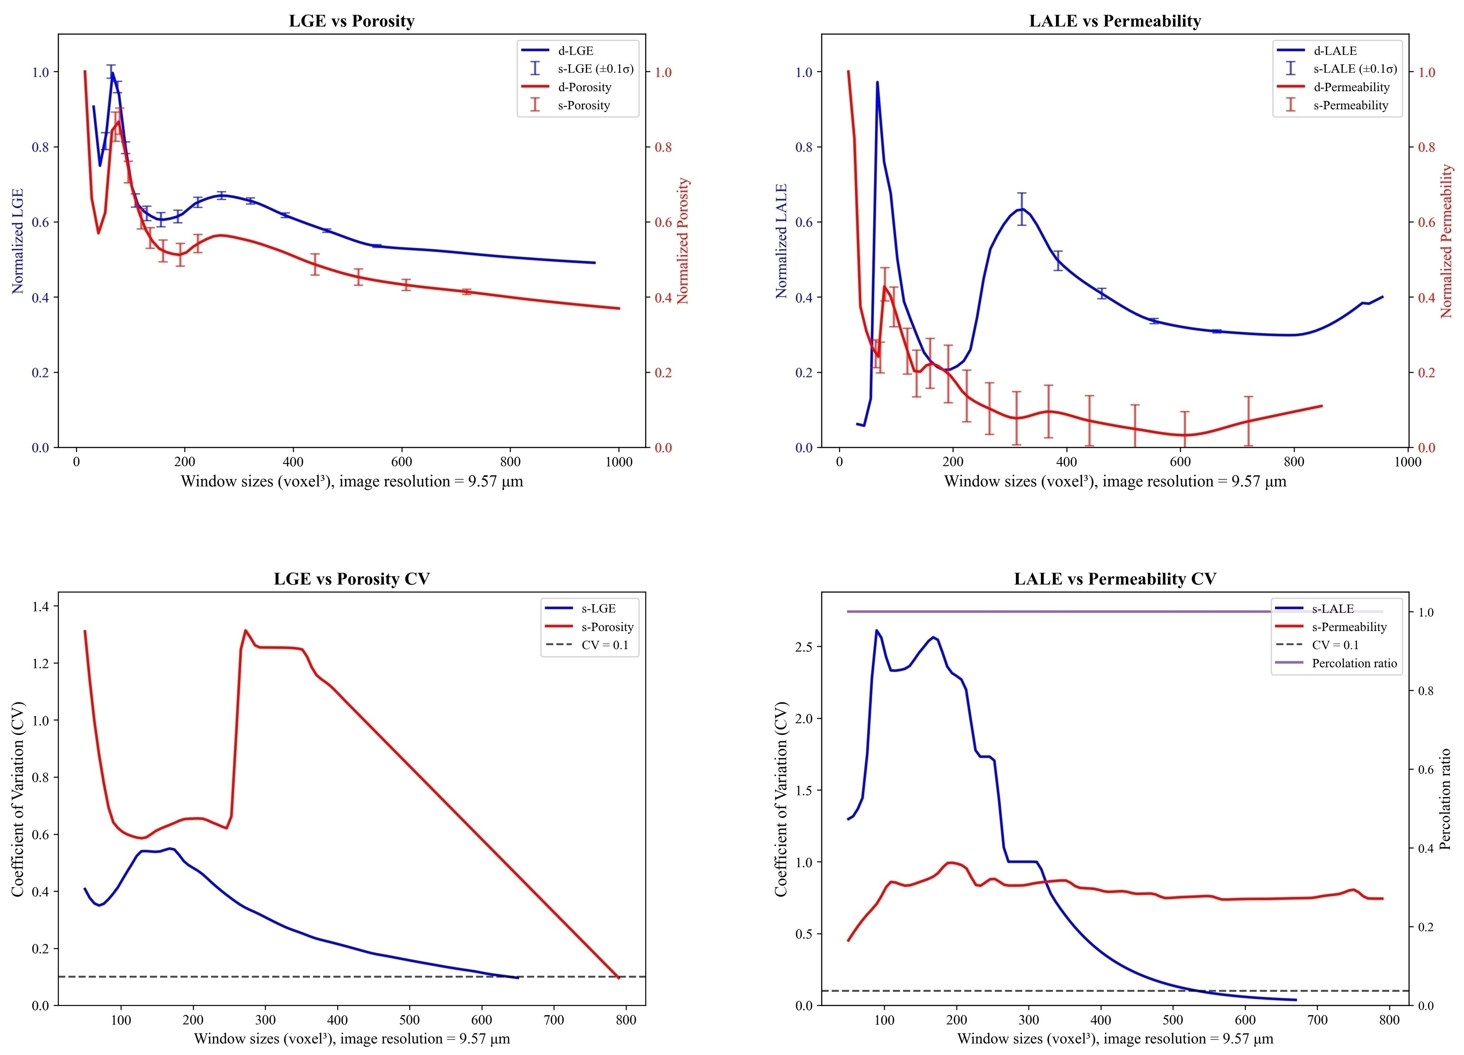

Figure S1. Determination of the Representative Elementary Volume (REV) using statistical analysis. The figure illustrates the variation of Gray-Level Size Zone Matrix (GLSZM) features—Low Gray-level Emphasis (LGE) and Large Area Low Gray-level Emphasis (LALE)—with increasing window sizes (from 0 to 800 voxels). The error bars represent the standard deviation across multiple samples. Note that both metrics converge at a window size of approximately 768³ voxels, which statistically validates that our chosen 855³ dataset is sufficient to represent the macroscopic heterogeneity of the conglomerate rock.

Section S2: Additional Qualitative Comparisons
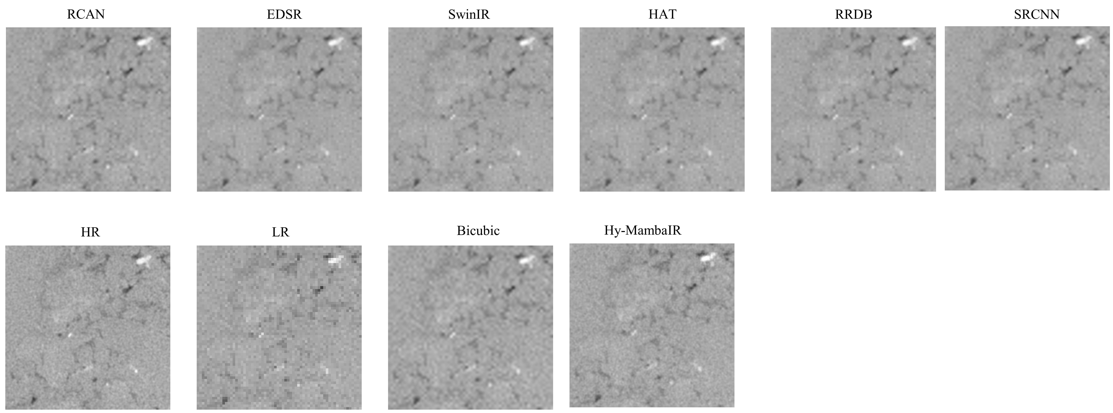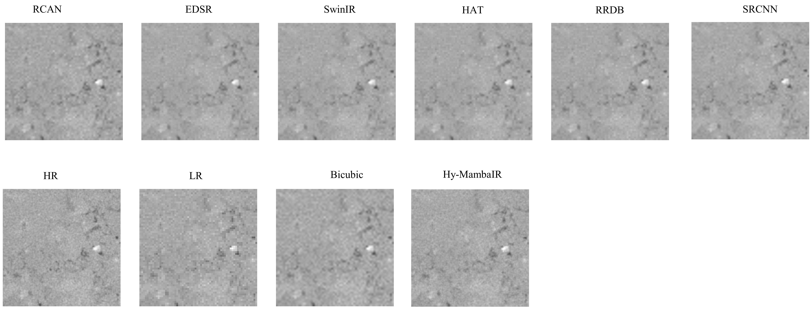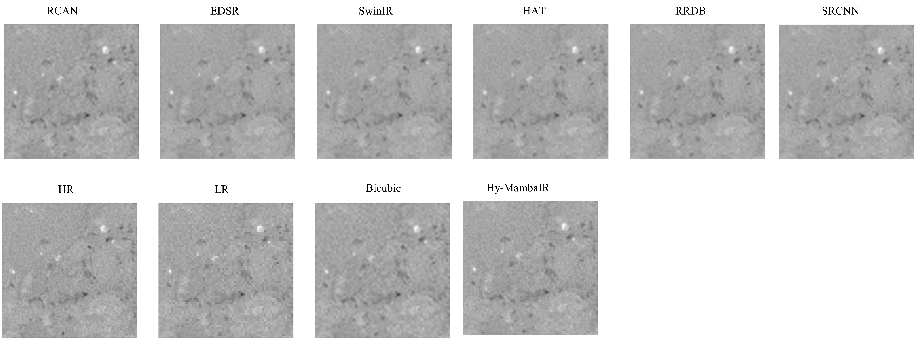

Fig. S2. Additional zoomed-in visual comparisons of reconstruction results. The figure displays representative 2D slices from different locations within the 3D volume. Compared to representative methods (top row: RCAN, EDSR, SwinIR, HAT, RRDB, SRCNN) and bicubic interpolation (bottom row), Hy-MambaIR consistently recovers sharper mineral boundaries and suppresses noise more effectively, demonstrating robustness across different viewing angles and slice positions.

Section S3: Segmentation and Physical Accuracy Assessment

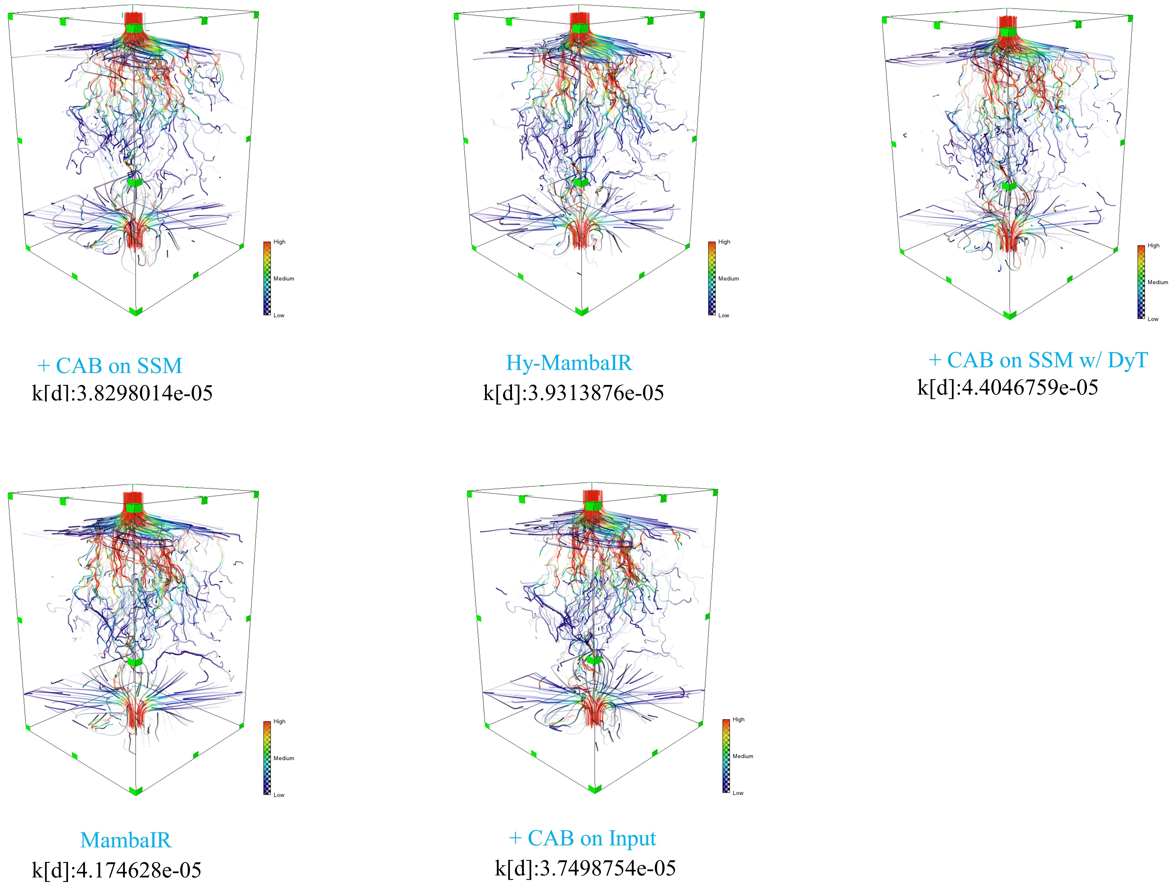

Figure S3. 3D streamline visualization for ablation study variants. The full Hy-MambaIR model (center) exhibits flow path connectivity and density most similar to the reference. Models lacking the SCAB module or with improper DyT usage show either blocked paths (underestimated flow) or non-physical shortcuts (overestimated flow), highlighting the contribution of each component to hydraulic connectivity.

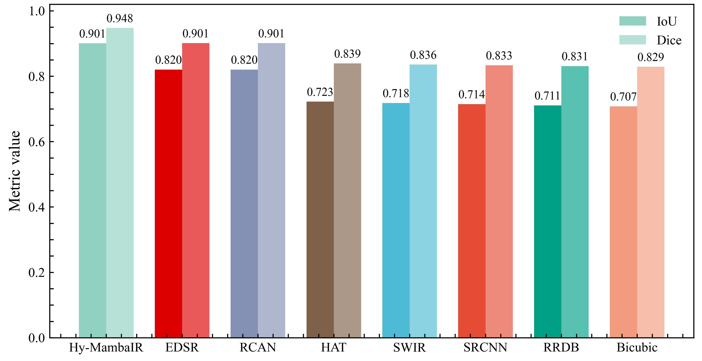

Figure S4. Quantitative comparison of segmentation accuracy. The bar chart compares the Intersection over Union (IoU) and Dice coefficient of different SR methods under a unified segmentation threshold (167). Hy-MambaIR achieves the highest scores (IoU: 0.901, Dice: 0.948), significantly outperforming Transformer-based HAT (IoU: 0.723) and CNN-based EDSR (IoU: 0.820). This indicates that our reconstruction results provide the most accurate geometric basis for subsequent pore network extraction.

Figure S5. Absolute permeability values calculated on the full-scale REV (855³ voxels; permeability values are reported in mD). Comparison of computed absolute permeability in the x, y, and z directions. Hy-MambaIR yields values closest to the HR ground truth with the lowest mean relative error. In contrast, SRCNN overestimates permeability due to artifacts, while bicubic underestimates it due to pore blockage.

Model | Permeability (mD) |  |  | MRE(k) (%)
Model | k_{x} | k_{y} | k_{z} | MRE(k) (%)
HR | 5.0691 | 6.3417 | 6.5409 | 0
Bicubic | 6.6462 | 8.6785 | 8.2722 | 31.48
Hy-MambaIR | 5.6959 | 7.4541 | 6.7805 | 11.19
EDSR | 5.6498 | 8.0857 | 6.9628 | 15.14
HAT | 5.6507 | 8.0840 | 6.9675 | 15.16
RCAN | 5.6863 | 8.1009 | 7.0131 | 15.71
RRDB | 5.7481 | 8.2429 | 7.0519 | 17.06
SRCNN | 6.0281 | 8.5370 | 7.4949 | 22.71
swinIR | 5.6235 | 8.0753 | 6.9864 | 15.03

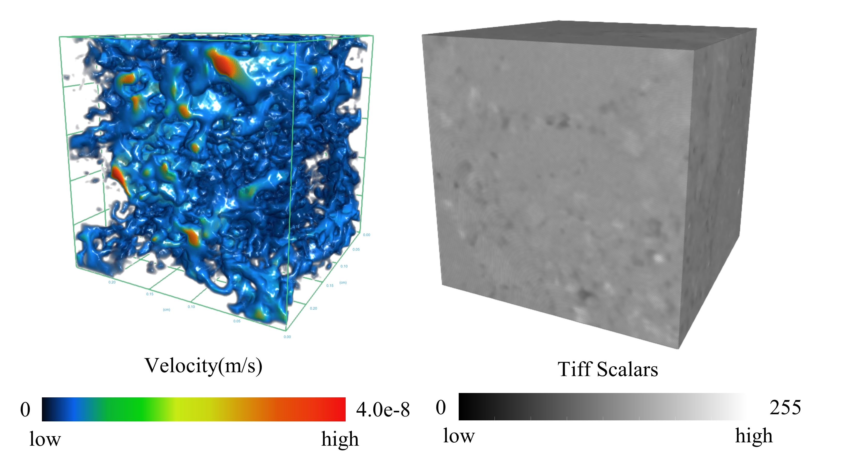

Table S1. Absolute permeability calculated on the local sub-volume (125³ voxels; permeability values are reported in mD). Quantitative comparison of three-directional absolute permeability for the local region shown in Fig. 15 of the main text. Even at this local scale, Hy-MambaIR achieves a mean relative error (MRE) of 11.19%, outperforming the compared methods (e.g., RCAN: 15.71%, HAT: 15.16%). This confirms that the model reconstructs both macroscopic trends and local pore connectivity relevant to fluid transport.

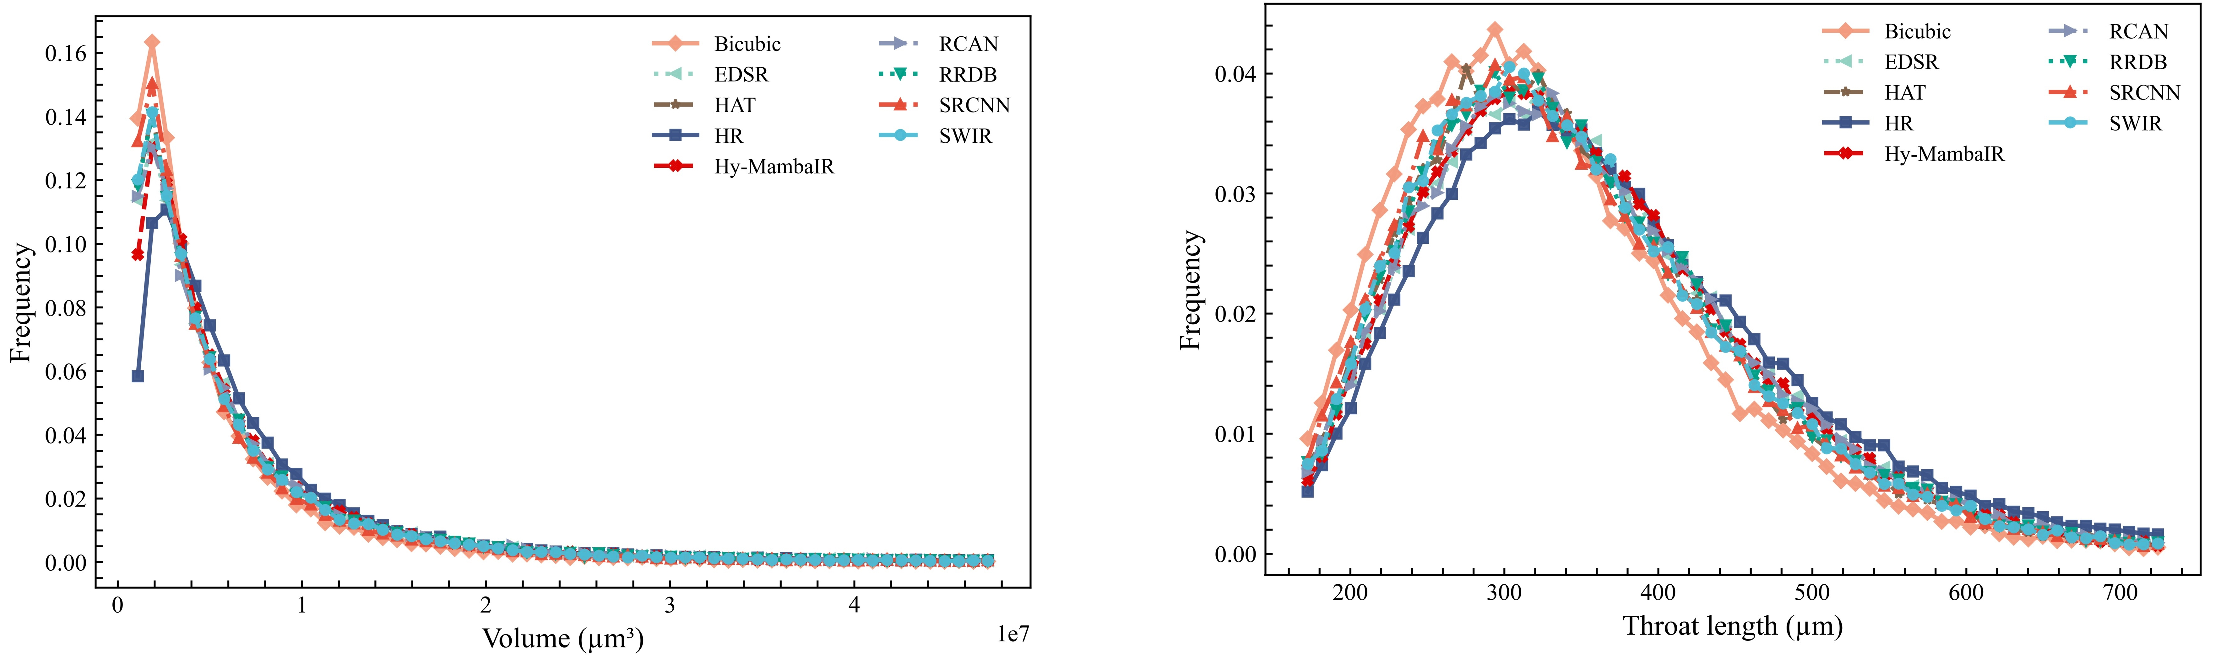

Figure S6. Distributions of pore volume (Left) and throat length (Right). Hy-MambaIR (red line) closely tracks the HR distribution (dark blue square) across the entire range, validating its ability to recover both small and large pore geometries accurately.

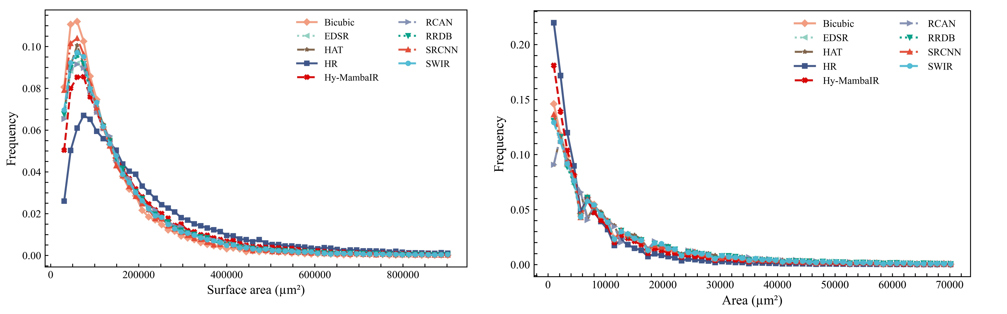

Figure S7. Distributions of pore surface area (Left) and cross-sectional area (Right). The high overlap between Hy-MambaIR and HR curves confirms the preservation of complex morphological features, which is essential for accurate fluid-solid interaction simulations.

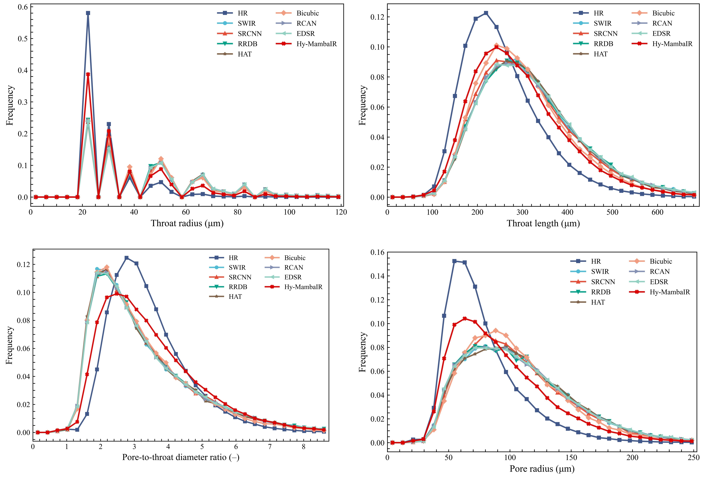

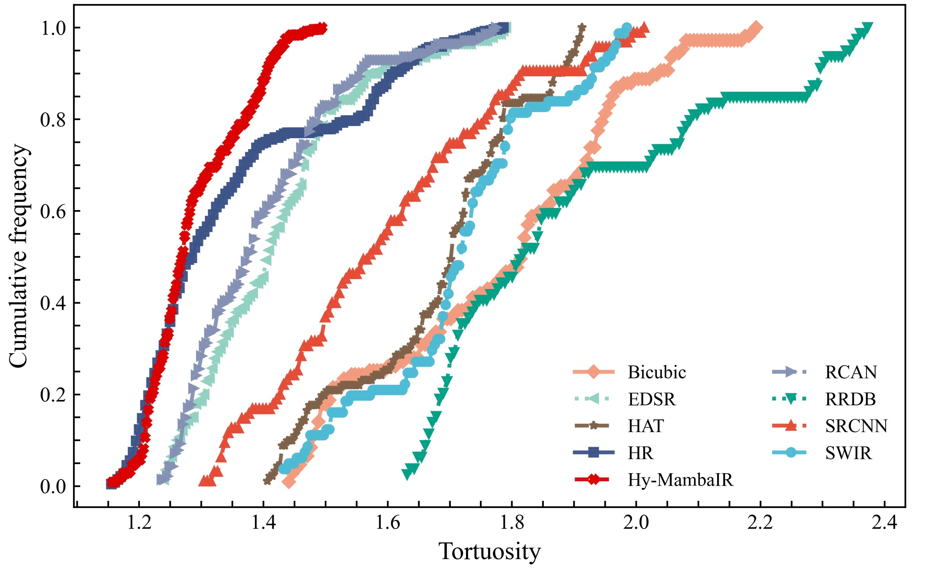

Figure S8. Pore network parameters extracted by OpenPNM. The distributions of throat radius, throat length, and tortuosity derived from Hy-MambaIR align well with the HR reference. This demonstrates the robustness of our method across different pore network extraction algorithms.

Section S4: Generalization and Transfer Learning Details
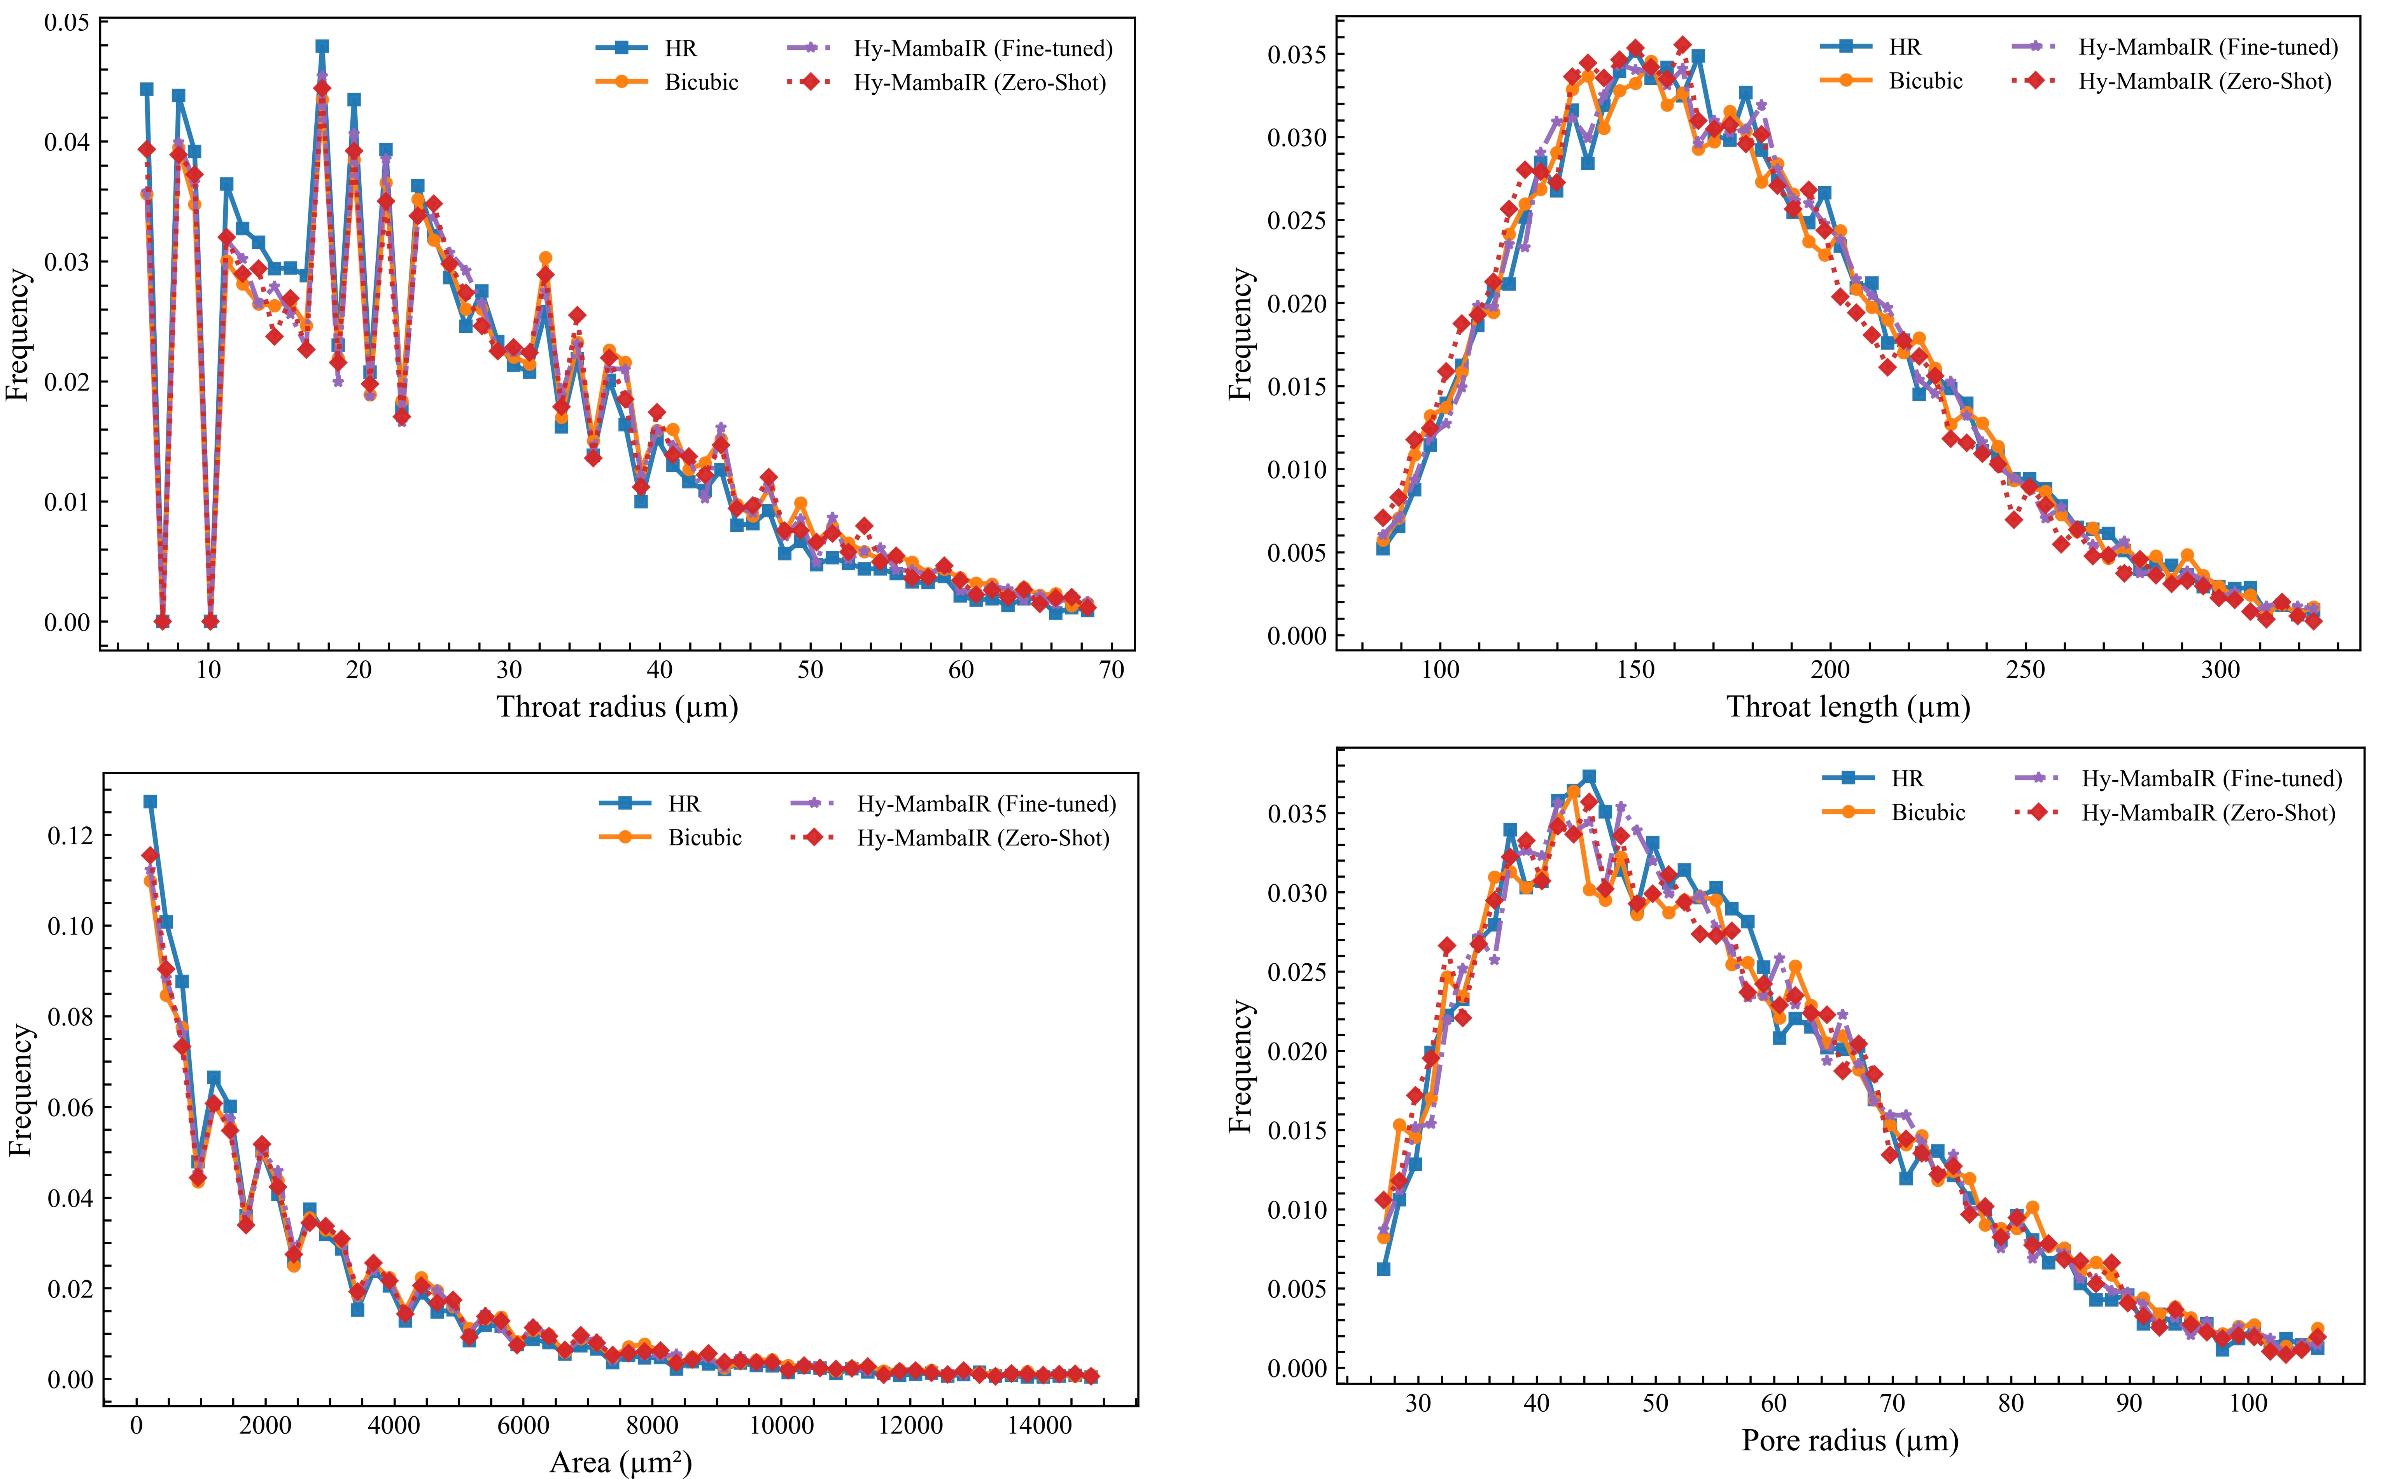

Figure S9. Physical property distributions for generalization test (Pore/Throat Size). Comparison of throat radius, throat length, and pore radius on the pebbly sandstone dataset. The Fine-tuned model (purple line) aligns much better with the Ground Truth (blue line) than the Zero-Shot baseline (red dotted line), especially in the peak regions of the distributions.

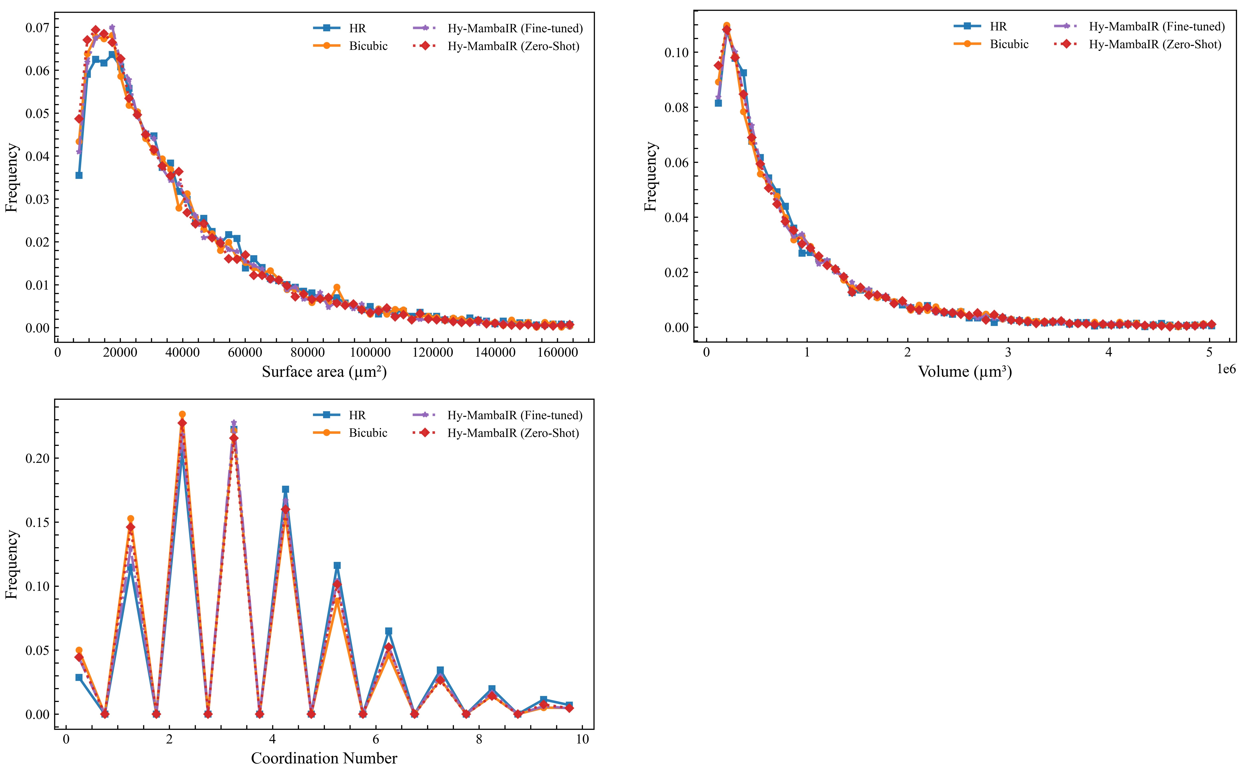

Figure S10. Physical property distributions for generalization test (Geometry). Distributions of surface area, volume, and coordination number. The results confirm that fine-tuning allows the model to adapt to the specific pore geometry of the new rock type.

Model | Porosity  (%) | χ_{v}  （× 10⁻⁶ μm⁻³） | Permeability (D) |  |  | MRE(k) (%) | Tortuosity  (Mean) | Path Count
Model | Porosity  (%) | χ_{v}  （× 10⁻⁶ μm⁻³） | k_{x} | k_{y} | k_{z} | MRE(k) (%) | Tortuosity  (Mean) | Path Count
Bicubic | 21.73 | -2.03 ×10⁻⁶ | 7.542 | 8.027 | 5.372 | 101.24 | 1.32 | 169
Hy-MambaIR (Zero-Shot) | 17.39 | -1.62 ×10⁻⁶ | 4.393 | 4.664 | 3.473 | 20.96 | 1.38 | 140
HR | 16.06 | -1.73×10⁻⁶ | 3.583 | 3.766 | 2.983 | 0 | 1.35 | 135

Table S2. Comprehensive physical parameters for generalization test (Iterative Thresholding). A comprehensive comparison of porosity, specific Euler characteristic density (χv), permeability, tortuosity, and path count for the pebbly sandstone dataset. This table highlights the baseline performance of the Hy-MambaIR (Zero-Shot) model compared to Bicubic interpolation and the Ground Truth (HR). Notably, Hy-MambaIR (Zero-Shot) maintains a reasonable path count (140) compared to HR (135), while Bicubic (169) tends to overestimate connectivity due to noise. Crucially, the significant deviations in other physical parameters observed here (when using automated iterative thresholding without fine-tuning) underscore the domain shift challenge. This contrast further highlights the accuracy of the fine-tuned model (discussed in the main text), which effectively corrects these deviations to match the HR baseline.

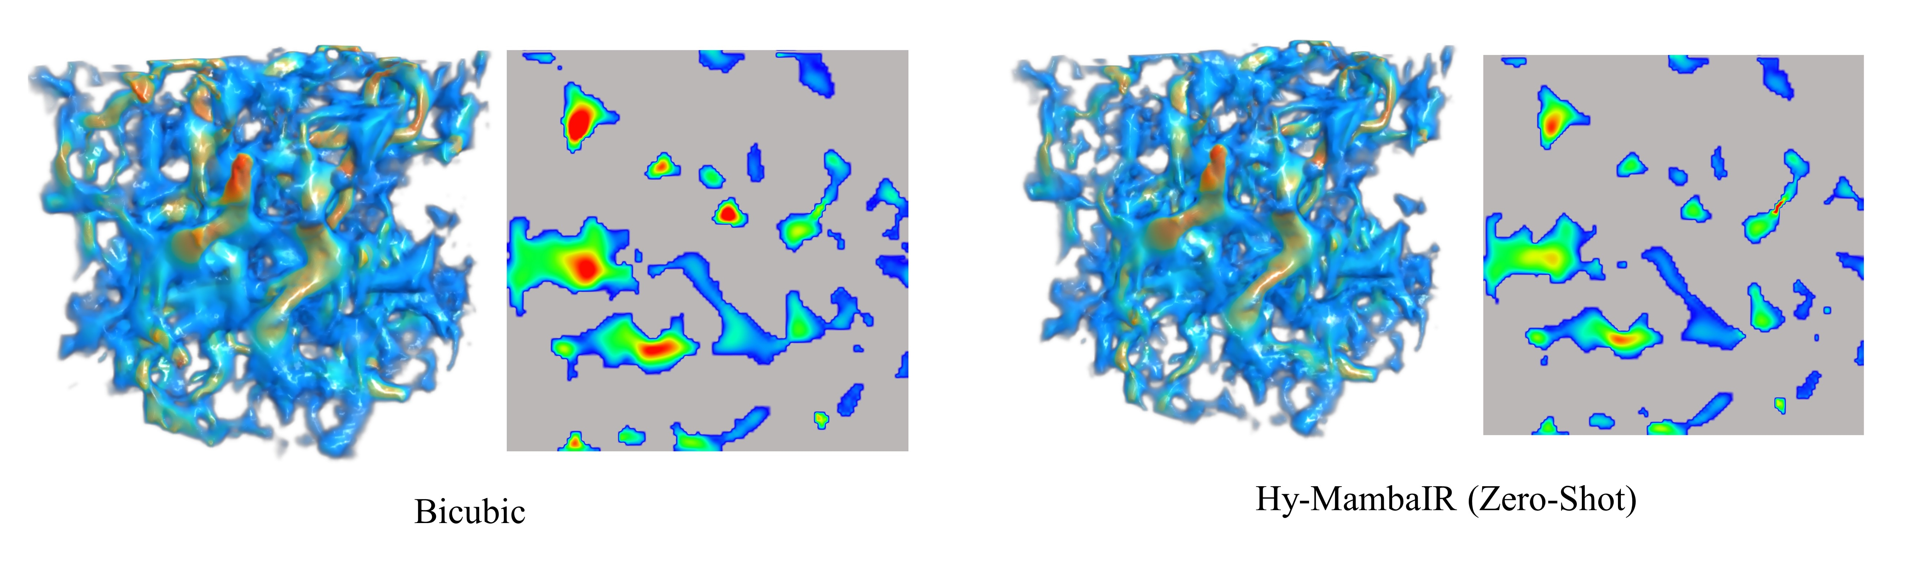 Figure S11. 3D visualization of structure and velocity field for generalization test. 3D rendering of reconstructed samples. Cross-sectional velocity fields. Consistent with the quantitative deviations observed in Table S2, the Zero-Shot and Bicubic results (derived using automatic iterative thresholding) exhibit disconnected flow paths and incorrect velocity distributions due to domain shift.

