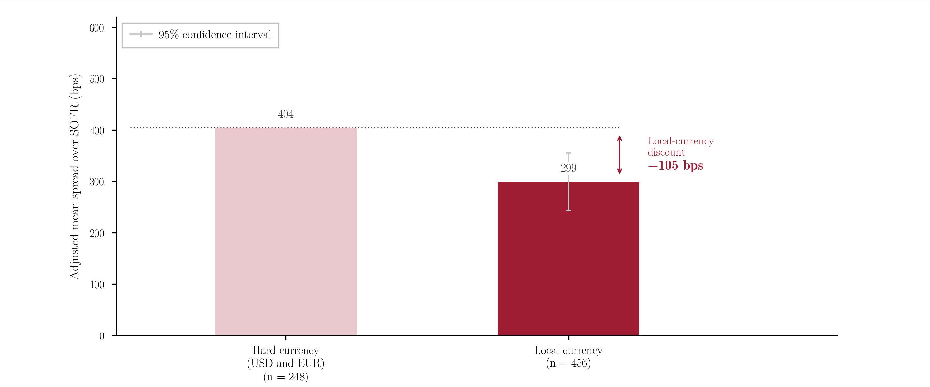

Extended Data Fig. 1 - Currency effects: Adjusted mean spread over SOFR (bps) for local-currency and hard-currency transactions, holding country, sector, year and tenor fixed, with 95% confidence intervals. Local-currency loans are converted to a USD-equivalent spread as described in Supplementary Information Section S1.

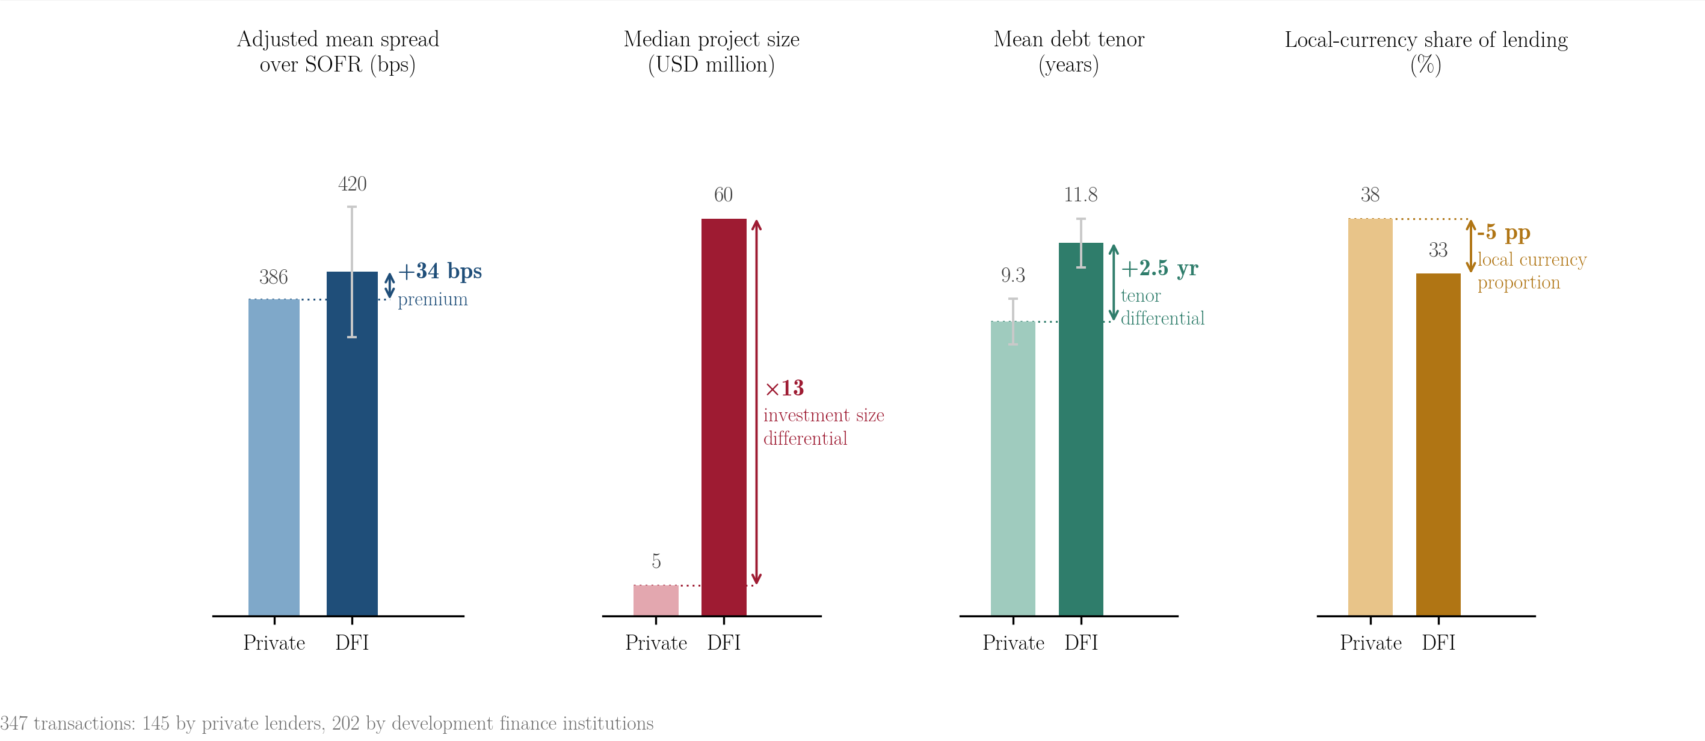

Extended Data Fig. 2 - Development finance institutions versus private investors: Adjusted mean spread, median project size and mean debt tenor for development finance institutions and private investors, estimated on the subsample that excludes national development banks lending only in their home market.

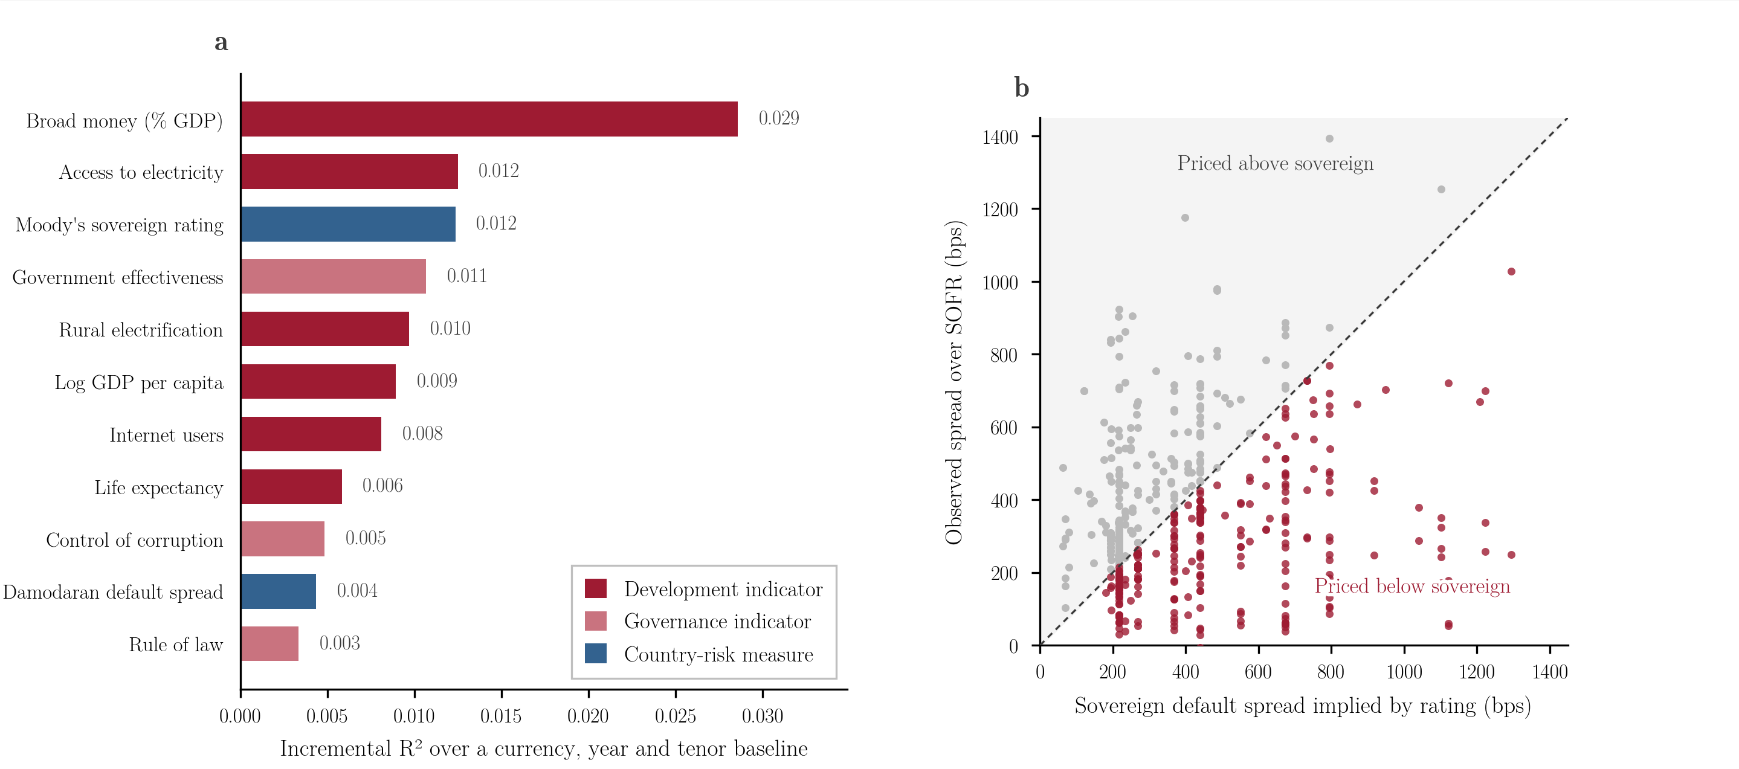

Extended Data Fig. 3 - Country-level predictors of observed spreads: Incremental R² over a currency, year and tenor baseline for each country-level indicator tested, alongside the comparison of observed spreads with the Damodaran country default spread. Values are reported in Supplementary Information Tables S6.1 and S6.2.

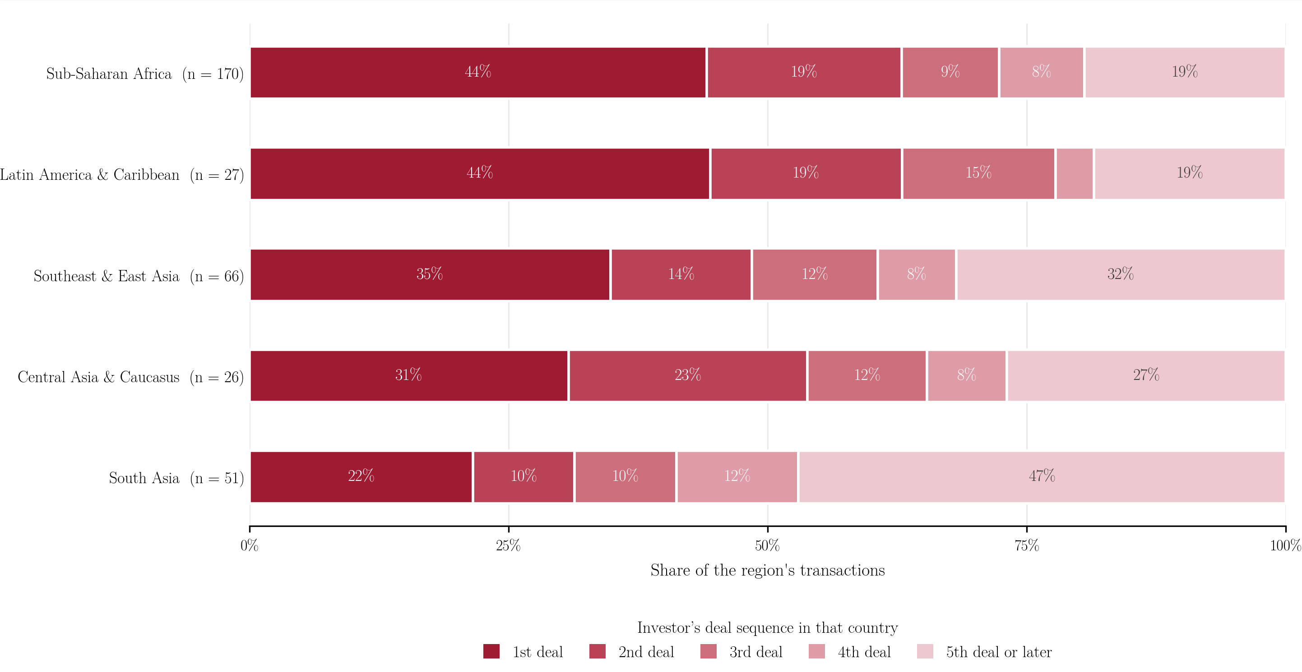

Extended Data Fig. 4 - Number of the investor’s deals in a country, by region: Share of transactions at each deal number within the investor-experience subsample. Regions with fewer than 20 transactions in that subsample are not shown.

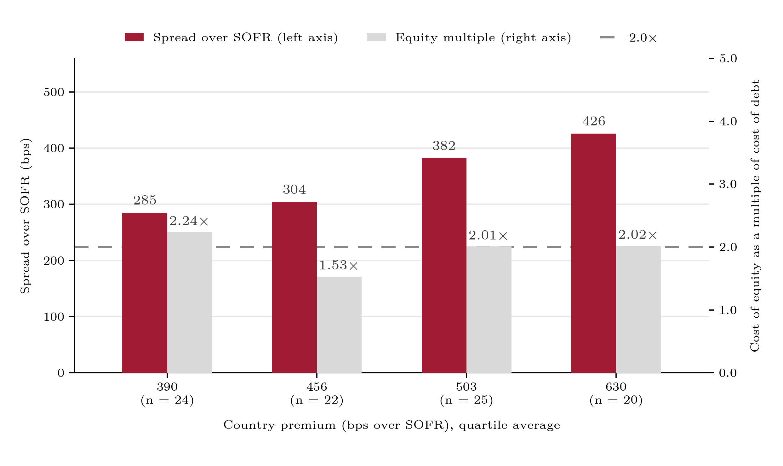
Extended Data Fig. 5 - Spread and the equity multiple by country premium: Transactions are grouped into quartiles of the country premium estimated in the base model. Bars show the mean spread over SOFR and the median ratio of the cost of equity to the cost of debt in each quartile, on the 91 transactions reporting both independently.

