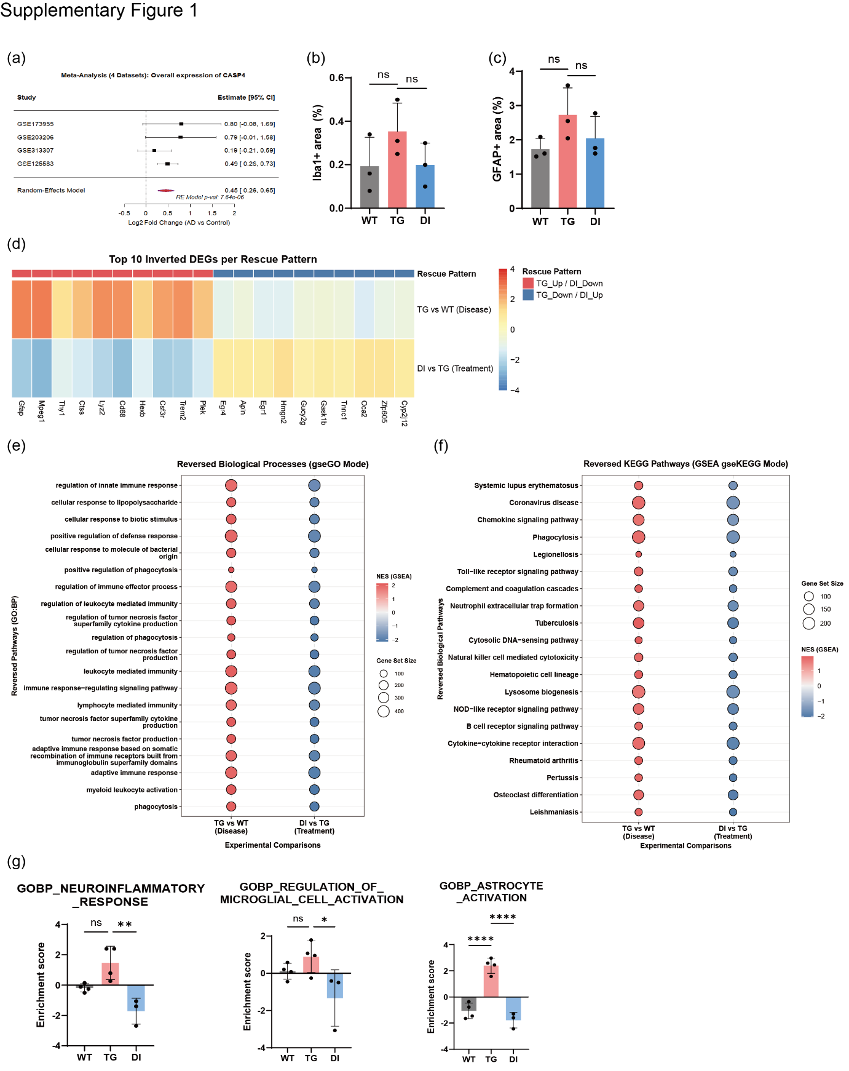
Supplementary Figure 1. Extended analyses supporting main findings. (a) Random-effects meta-analysis forest plot for CASP4 across four cohorts. (b) Quantification of total Iba1-positive area (%) in WT, TG (5xFAD), and DI (DI-treated 5xFAD) (n = 3 per group). ns, Wilcoxon test. (c) Quantification of GFAP-positive area (%) across groups. ns. (d) Heatmap of the top 10 inverted DEGs per rescue pattern (TG_Up/DI_Down and TG_Down/DI_Up), showing rescue of disease-associated transcriptional changes by DI. (e) Reversed GO Biological Process pathways (gseGO GSEA), comparing TG vs. WT and DI vs. TG contrasts. (f) Reversed KEGG pathways (gseKEGG GSEA) across the same two contrasts. (g) Three-group GSEA enrichment scores for GOBP_NEUROINFLAMMATORY_RESPONSE (TG vs. DI: **p < 0.01), GOBP_REGULATION_OF_MICROGLIAL_CELL_ACTIVATION (TG vs. DI: *p < 0.05), and GOBP_ASTROCYTE_ACTIVATION (WT vs. TG and TG vs. DI: ****p < 0.0001).

