Additional file 1
Adverse childhood experiences and medical health risk components among U.S. children: a cross-sectional study of the 2023–2024 National Survey of Children’s Health
Chenglei Qin, Yi Shi, Qian Chen, Junyu Xu, Guo Chen, Mengyu Wu, Yiwei Fu, Chen Yuan

Table S1. Sensitivity analyses of high adverse childhood experience exposure and medical health risk
Outcome | Primary 9-item, survey-weighted | 10-item ACE, survey-weighted | 9-item, unweighted | 9-item, FPL multiple-imputation expanded adjustment
More-complex CSHCN | 2.99 (2.80–3.20) | 3.38 (3.17–3.61) | 2.73 (2.65–2.82) | 2.64 (2.43–2.87)
2+ current or lifelong conditions | 2.63 (2.47–2.80) | 2.88 (2.71–3.06) | 2.43 (2.36–2.50) | 2.46 (2.28–2.66)
1+ functional difficulty | 2.23 (2.10–2.36) | 2.39 (2.25–2.52) | 2.28 (2.22–2.34) | 2.00 (1.86–2.15)
Fair or poor overall health | 3.63 (2.71–4.86) | 4.49 (3.36–6.02) | 4.16 (3.60–4.82) | 2.60 (1.85–3.67)
MHR ≥2 (overview) | 3.00 (2.81–3.20) | 3.36 (3.15–3.58) | 2.79 (2.71–2.87) | 2.66 (2.45–2.88)
Cells are adjusted prevalence ratios (95% confidence intervals). Primary models adjusted for survey year, age group, sex, and race/ethnicity. Expanded models additionally included family structure, adult education, insurance type, medical-home status, and continuous family poverty across FPL_I1–FPL_I6, with coefficients combined using Rubin’s rules. CSHCN, children with special health care needs; MHR, Medical Health Risk; FPL, federal poverty level.

Table S2. Associations per additional adverse childhood experience and medical health risk
Outcome | aPR per additional ACE (95% CI) | P value
More-complex CSHCN | 1.27 (1.26–1.29) | <0.001
2+ current or lifelong conditions | 1.24 (1.22–1.25) | <0.001
1+ functional difficulty | 1.20 (1.19–1.21) | <0.001
Fair or poor overall health | 1.34 (1.27–1.41) | <0.001
MHR ≥2 (overview) | 1.27 (1.25–1.28) | <0.001
The continuous score retained the observed nine-item count; it did not code the ≥3 category as a one-unit score. Models adjusted for survey year, age group, sex, and race/ethnicity. The log-linear per-experience specification is a sensitivity analysis. aPR, adjusted prevalence ratio; CI, confidence interval; CSHCN, children with special health care needs; MHR, Medical Health Risk.

Table S3. Internal validation of exploratory gradient-boosted tree models
Outcome | Events / eligible n | Weighted AUROC (fold range) | Weighted AUPRC | Weighted Brier | Calibration intercept | Calibration slope
More-complex CSHCN | 20387 / 104838 | 0.716 (0.706–0.723) | 0.352 | 0.124 | -0.000 | 1.036
2+ current or lifelong conditions | 23868 / 104838 | 0.724 (0.714–0.732) | 0.407 | 0.145 | -0.001 | 1.037
1+ functional difficulty | 27684 / 104697 | 0.646 (0.639–0.650) | 0.405 | 0.183 | -0.003 | 1.000
Fair or poor overall health | 1302 / 104551 | 0.754 (0.753–0.773) | 0.041 | 0.014 | 0.001 | 1.036
MHR ≥2 (overview) | 21591 / 104838 | 0.723 (0.712–0.730) | 0.382 | 0.134 | -0.003 | 1.082
Predictions came from five mutually exclusive outer test folds; early stopping used an inner validation subset drawn only from the corresponding outer training fold. Combined survey weights were used as case weights and for performance metrics. Results describe exploratory internal validation, not full design-based inference or external validation. AUROC, area under the receiver operating characteristic curve; AUPRC, area under the precision-recall curve; CSHCN, children with special health care needs; MHR, Medical Health Risk.

Figure S1. Normalized SHAP contributions by source feature and medical health risk component
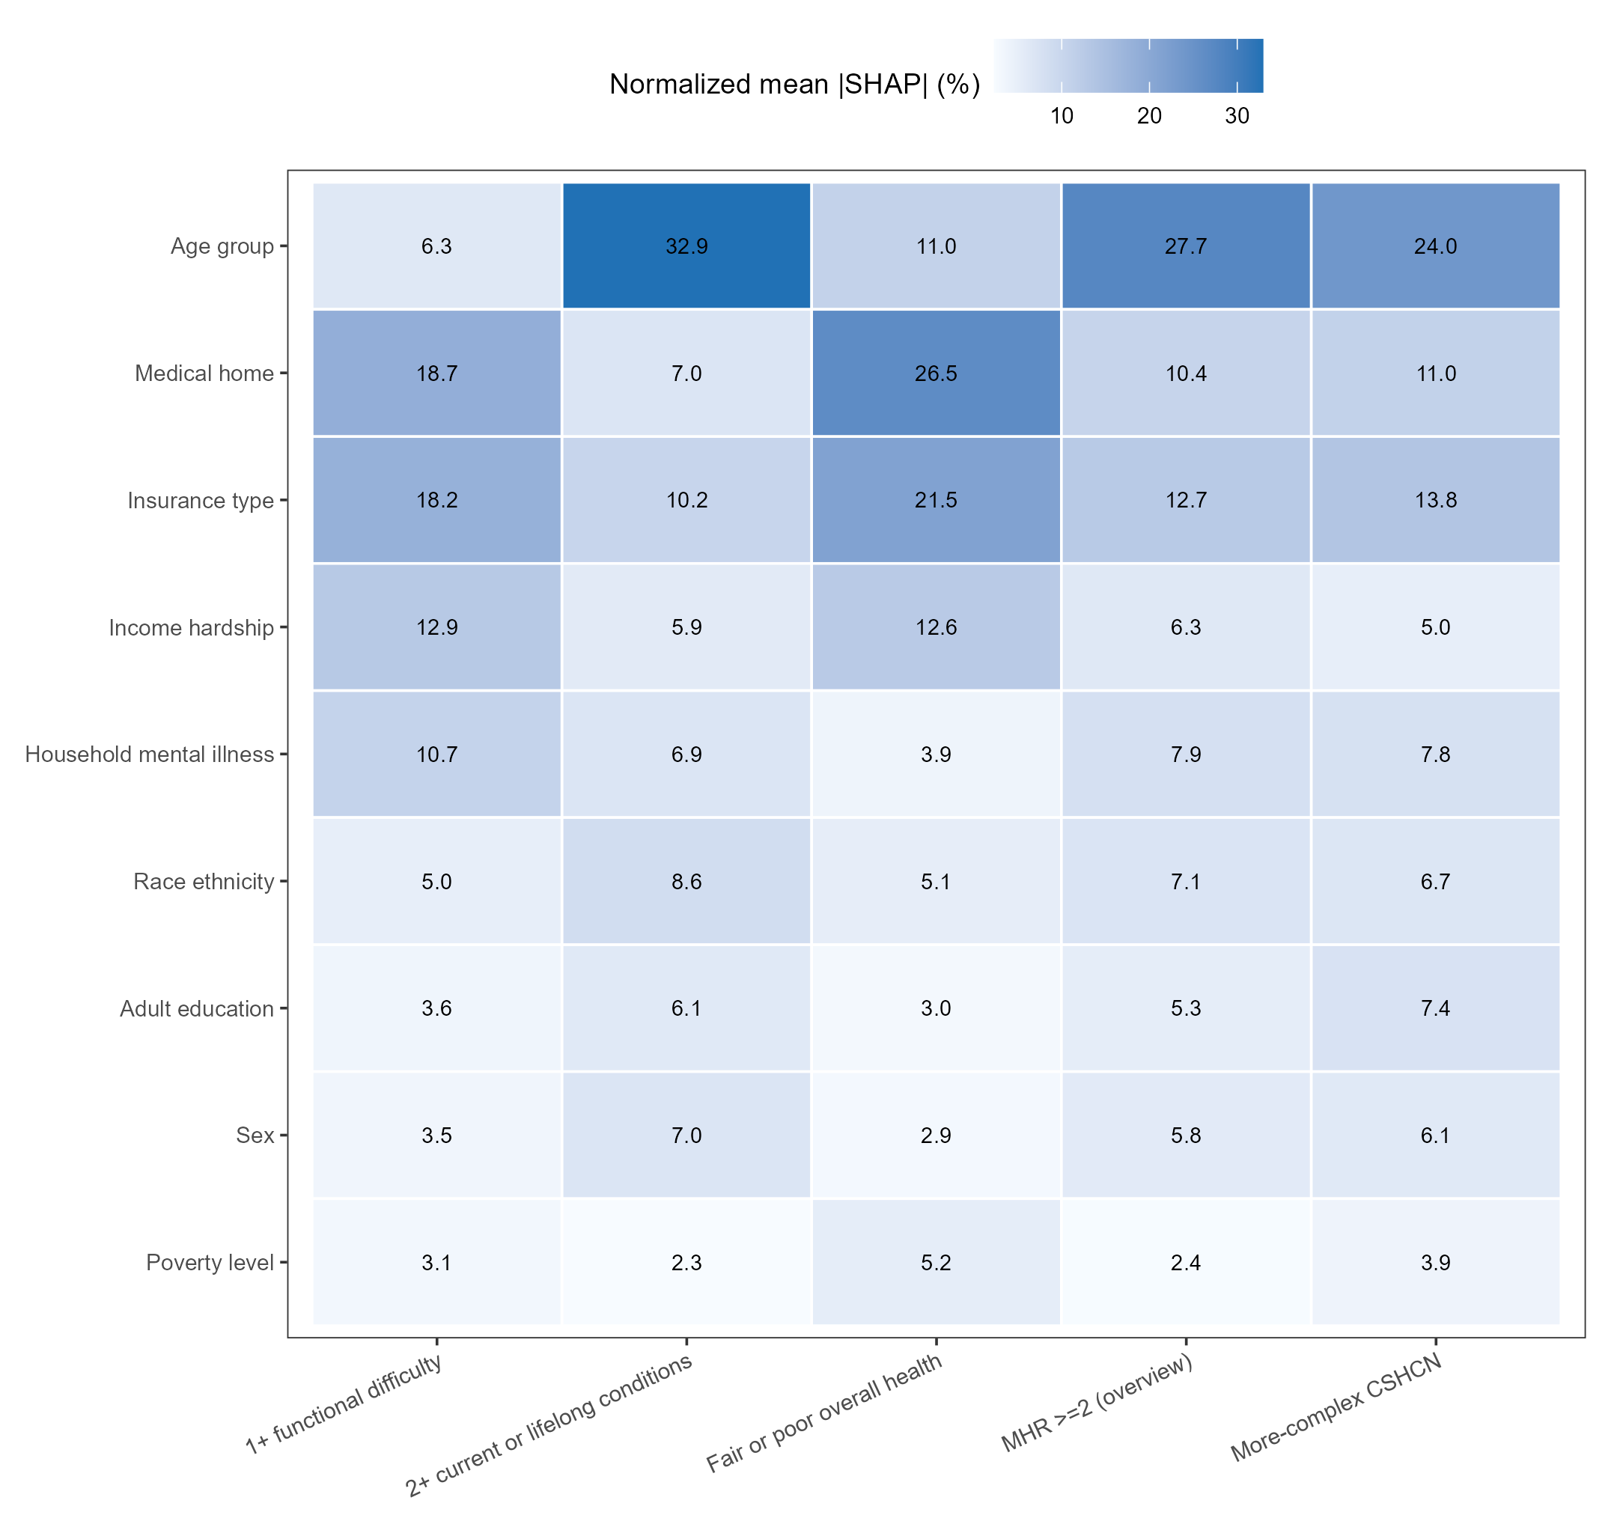
Values are each source feature’s share of total mean absolute Shapley additive explanation magnitude within an outcome after aggregation of one-hot encoded columns. Larger values indicate greater contribution to fitted predictions, not direction, causality, mediation, or intervention value.

