Supplementary Information

Precise and Scalable Synthesis of Dual-Atom Catalysts via Stepwise Microwave-Assisted Atomic Assembly

Wenrou Tian†^{1,4}, Wenxi Wang†³, Hengfang Shen³, Zhaolong Li^{1,4,5}, Nannan Ji⁶, Jin Li², Zhen Zhao³, Zean Xie³*, Wencui Li³*, Zhenfei Gao²*, Jin Zhang^{1,4}*

¹School of Materials Science and Engineering, Peking University, Beijing 100871, China
²State Key Laboratory of Heavy Oil Processing, China University of Petroleum (Beijing), Changping, China.
³Institute of Catalysis for Energy and Environment, College of Chemistry & Chemical Engineering, Shenyang Normal University, Shenyang 110034, China.
⁴Beijing Graphene Institute, Beijing 100095, China.
⁵State Key Laboratory of High-Efficiency Utilization of Coal and Green Chemical Engineering, College of Chemistry and Chemical Engineering, Ningxia University, Yinchuan 750021, China.
⁶School of Advanced Materials, Peking University, Shenzhen Graduate School, Peking University, Shenzhen, 518055, China.
†These authors contributed equally: Wenrou Tian and Wenxi Wang
Corresponding author e-mail: xiezean@126.com; wencuili1993@163.com; gaozf-cnc@pku.edu.cn; jinzhang@pku.edu.cn
Table of Contents
1. Supplementary Methods…………………………………………………………….3
2. Supplementary Figures………………………………………………………….......5
3. Supplementary Tables……………………………………………………………...36
4. Supplementary References……………………………………………………........40
1. Supplementary Methods
Chemicals
Graphene oxide (GO) was purchased from Baotailong Co., Ltd. Copper (II) chloride dihydrate (CuCl₂·2H₂O, AR), zinc chloride (ZnCl₂, AR), iron (III) chloride hexahydrate (FeCl₃·6H₂O, AR), cobalt (Ⅱ) chloride hexahydrate (CoCl₂·6H₂O, AR) and nickel (II) chloride (NiCl₂, AR) were obtained from Shanghai Macklin Biochemical Co., Ltd. Ammonium hydroxide (NH₄OH, 30%), hydrogen peroxide (H₂O₂, 30%), deuterium oxide (D₂O > 99.9%) and dimethyl sulfoxide (DMSO, AR) were supplied by Sinopharm Chemical Reagent Co., Ltd. All chemicals were of analytical grade and used as received without further purification.
Characterizations
Transmission electron microscopy (TEM, Tecnai G2 F30, 300 kV), high-resolution TEM (HRTEM) and aberration-corrected scanning transmission electron microscopy (AC-STEM, JEM-ARM300F, 300 kV) were employed to investigate the morphologies and atomic structures of the samples. High-angle annular dark-field scanning transmission electron microscopy (HAADF-STEM) images and elemental mappings were collected using a STEM equipped with energy-dispersive X-ray spectroscopy (EDS). Raman spectra were recorded on a Horiba LabRAM HR Evolution spectrometer using a 532 nm laser excitation source. Fourier transform infrared spectroscopy (FTIR) and powder X-ray diffraction (XRD, D/MAX-PC 2500, Cu Kα radiation) were performed to analyze the structural characteristics of the samples. N₂ adsorption-desorption isotherms were recorded on a Micromeritics ASAP 2460 instrument. Prior to measurement, the samples were degassed under vacuum at 120 °C for 12 h. The specific surface area was calculated using the Brunauer-Emmett-Teller (BET) method, and the pore size distribution was analyzed using the Barrett-Joyner-Halenda (BJH) method based on the adsorption branch. The surface compositions and chemical states were analyzed by X-ray photoelectron spectroscopy (XPS, Kratos Analytical Axis-Ultra spectrometer) equipped with an Al Kα X-ray source. The binding energies were calibrated using the C 1s peak at 284.5 eV. The metal contents were determined by inductively coupled plasma optical emission spectrometry (ICP-OES, Thermo ICAP PRO). Synchrotron-based X-ray absorption fine structure (XAFS) measurements were performed at the BL14W Beamline of the Shanghai Synchrotron Radiation Facility (SSRF, Shanghai, China) using Si (111) monochromators. The XAFS spectra were collected in fluorescence mode for samples and transmission mode for reference materials. Data processing, EXAFS fitting, and wavelet transform (WT) analyses were conducted using Athena and Artemis software packages¹. The temperature evolution during microwave irradiation was monitored using an infrared thermal imaging thermometer (CSASCIT T0830). Electron paramagnetic resonance (EPR) measurements were performed on a Bruker EMX X-band spectrometer (9.46 GHz). 5,5-Dimethyl-1-pyrroline-N-oxide (DMPO) was used as the spin-trapping agent for detecting reactive radical species.
In situ Diffuse Reflectance Infrared Fourier Transform (DRIFTS) spectroscopy measurement
In situ DRIFTS spectra were collected on a Bruker VERTEX 80v spectrometer equipped with an in-situ gas reaction cell in the range from 1000 to 4000 cm⁻¹ with a spectral resolution of 4 cm⁻¹. Prior to the measurements, fresh catalyst samples were pretreated at 200 °C for 1 h to remove adsorbed surface water. After cooling to room temperature, CH₄ was introduced into the reaction cell in the presence of H₂O₂ aqueous solution. The spectra were continuously recorded at 80 °C until adsorption equilibrium was achieved. Control experiments using Ar instead of CH₄ were performed to distinguish the contributions of H₂O₂ activation and CH₄ conversion toward carbon-containing intermediates.
2. Supplementary Figures

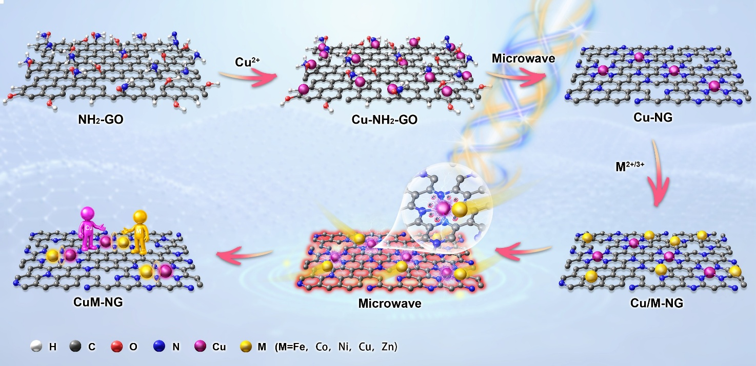
Supplementary Fig. 1 Schematic illustration of dual-atom construction on NG.

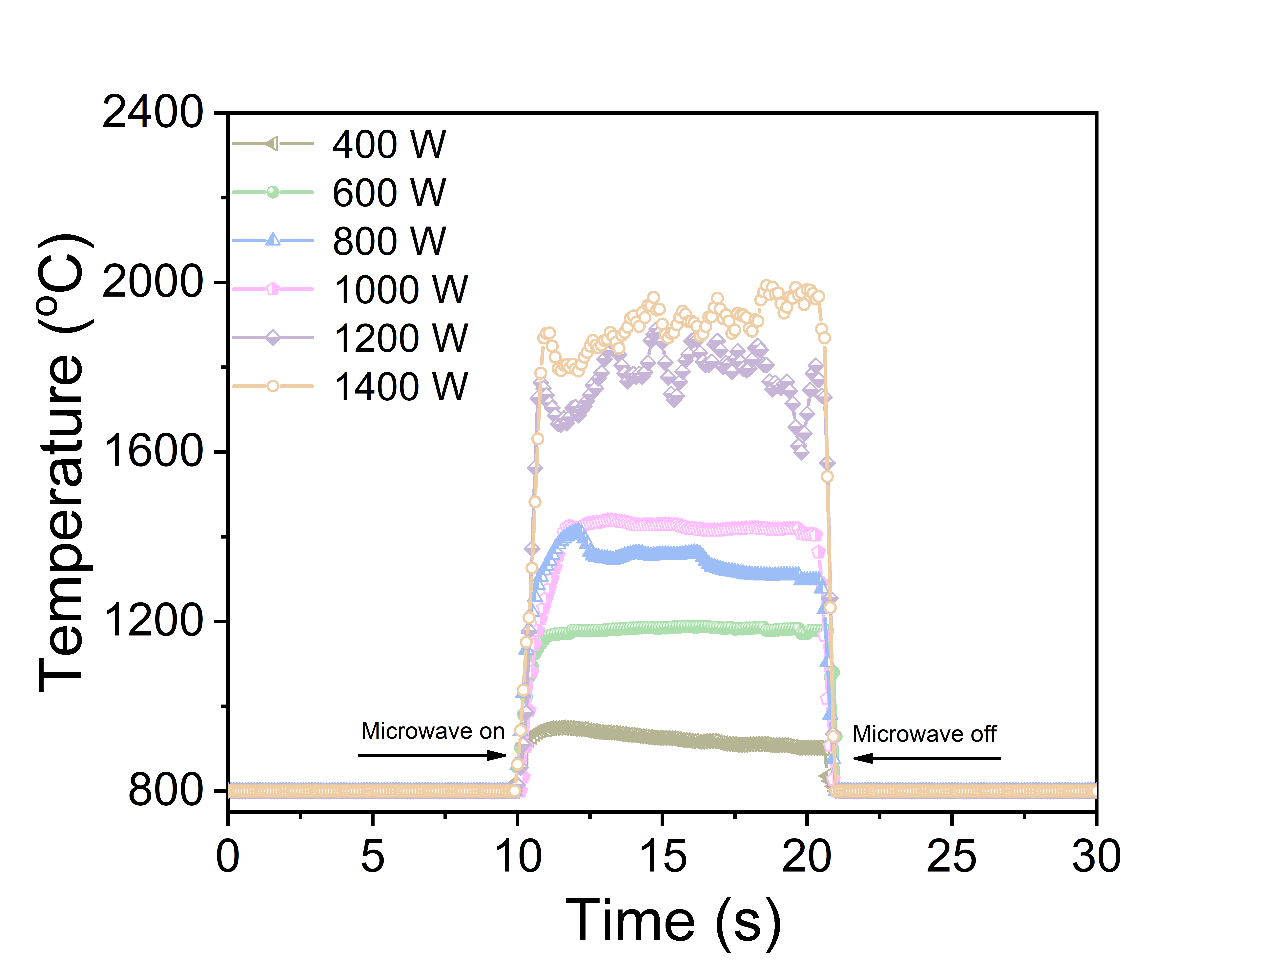
Supplementary Fig. 2 Temperature evolution of the sample under different microwave irradiation powers. The 800 °C baseline results from the detection limit of the infrared temperature measurement device.

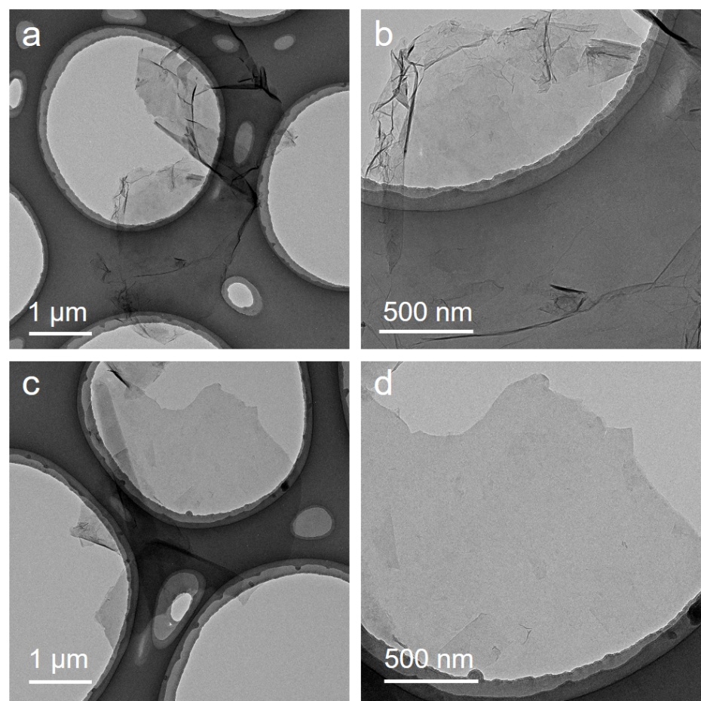
Supplementary Fig. 3 TEM images of (a-b) GO and (c-d) NH₂-GO.
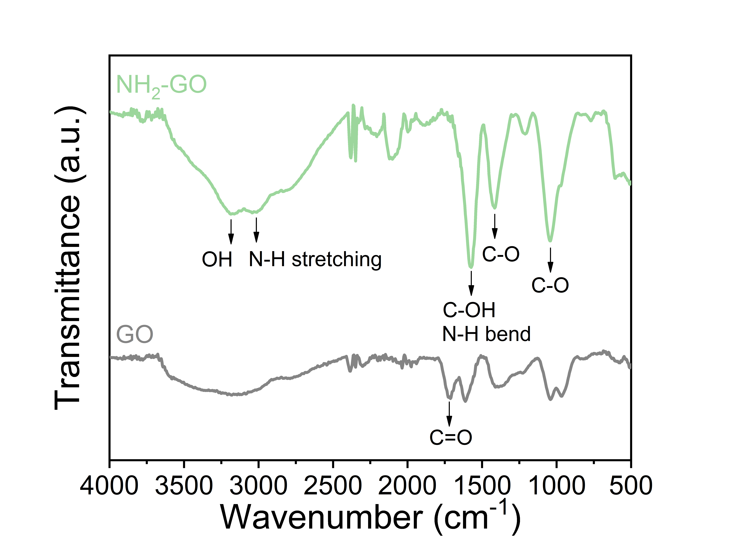
Supplementary Fig. 4 FTIR spectra of GO and NH₂-GO.
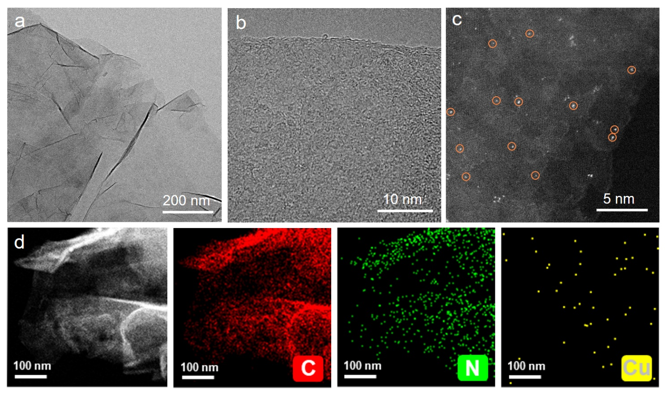
Supplementary Fig. 5 (a) TEM, (b) HRTEM, (c) AC-STEM, (d) HAADF-STEM and elemental mapping images of Cu-NG (0.3 wt%).
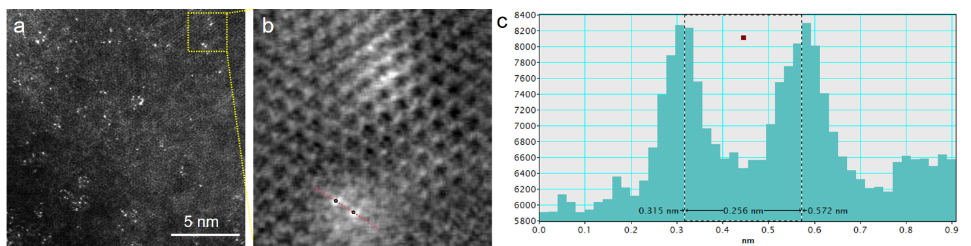
Supplementary Fig. 6 (a) AC-STEM image of CuCu-NG. (b) Inverse fast Fourier transform (IFFT) image obtained from the yellow-boxed region in (a). (c) Measurement of the interatomic distance between Cu atoms in the selected region in (b).
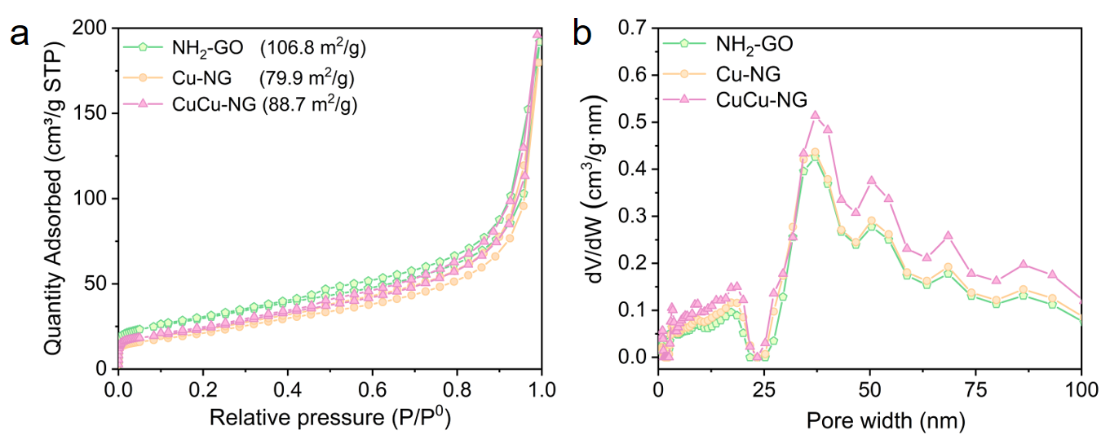
Supplementary Fig. 7 (a) N₂ adsorption-desorption isotherms and (b) pore size distributions of NH₂-GO, Cu-NG and CuCu-NG.
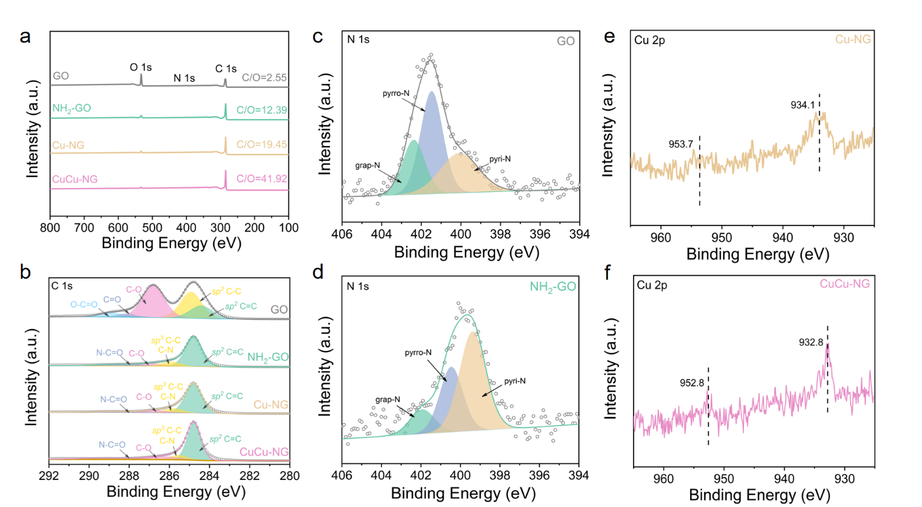
Supplementary Fig. 8 (a) XPS survey spectra and (b) C 1s spectra of GO, NH₂-GO, Cu-NG and CuCu-NG. N 1s spectra of (c) GO and (d) NH₂-GO. Cu 2p spectra of (e) Cu-NG and (f) CuCu-NG.
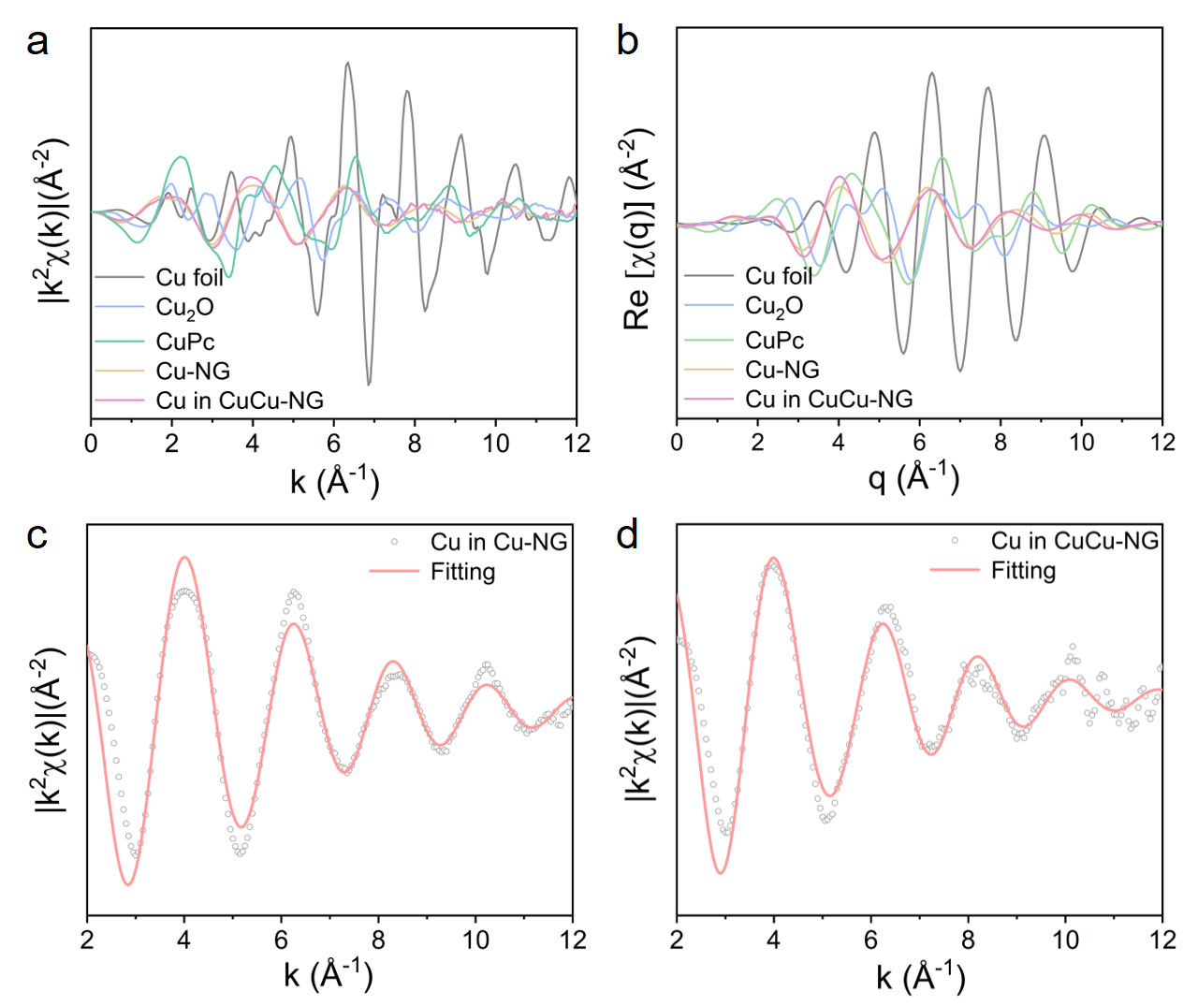
Supplementary Fig. 9 (a) k-space EXAFS spectra and (b) q-space profiles derived from WT-EXAFS analysis of Cu in Cu-NG, CuCu-NG and reference samples. k-space EXAFS fitting curves of (c) Cu-NG and (d) CuCu-NG at Cu K-edge.
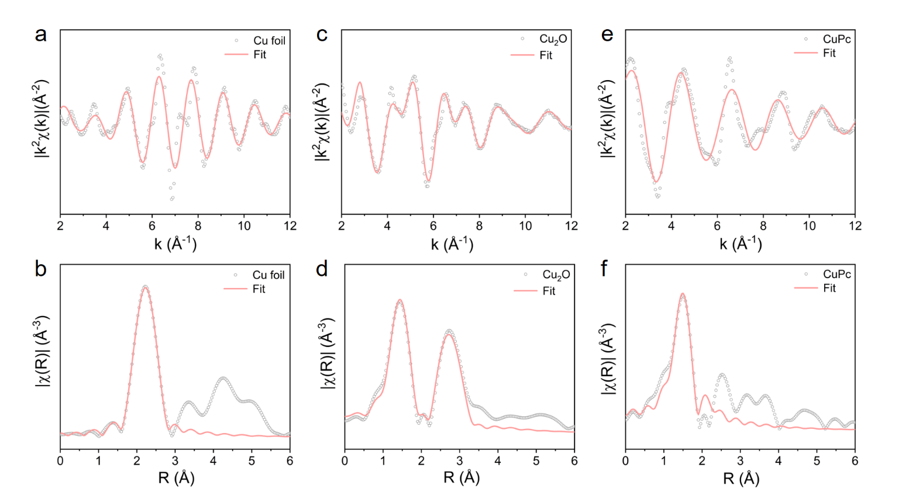
Supplementary Fig. 10 k- and R-space EXAFS fitting curves of (a-b) Cu foil, (c-d) Cu₂O and (e-f) CuPc at the Cu K-edge.
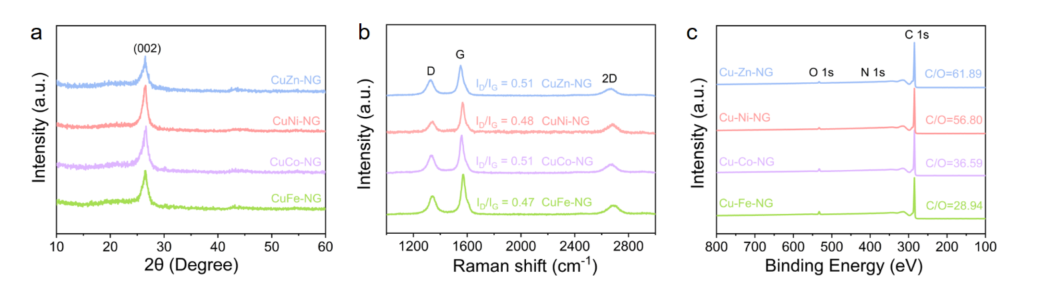
Supplementary Fig. 11 (a) XRD patterns, (b) Raman spectra and (c) XPS survey spectra of CuFe-NG, CuCo-NG, CuNi-NG and CuZn-NG.
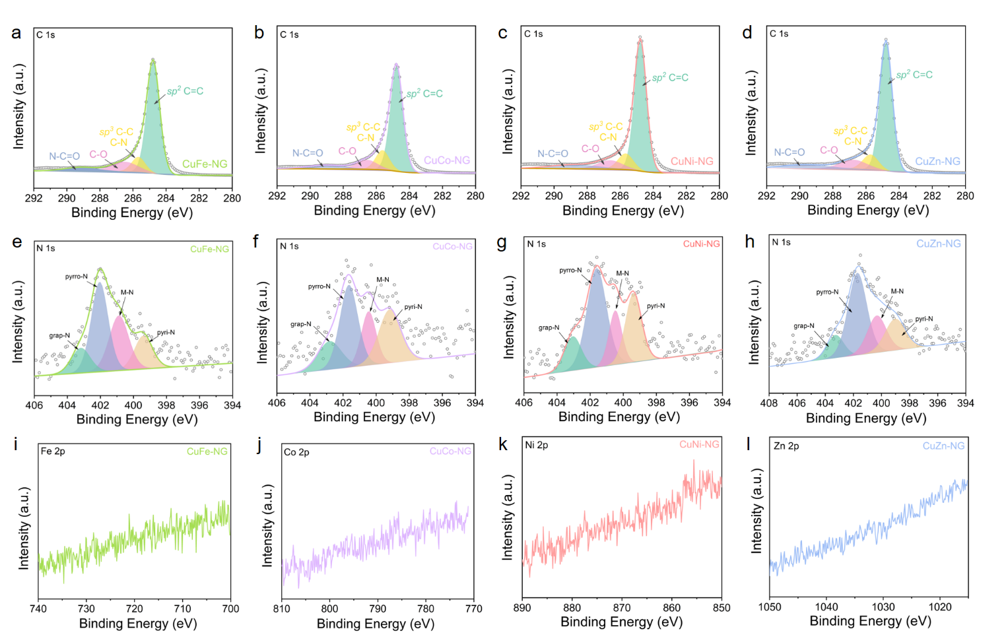
Supplementary Fig. 12 (a-d) XPS C 1s and (e-h) N 1s spectra of CuFe-, CuCo-, CuNi- and CuZn-NG. (i) Fe 2p spectra of CuFe-NG, (j) Co 2p spectra of CuCo-NG, (k) Ni 2p spectra of CuNi-NG and (l) Zn 2p spectra of CuZn-NG.
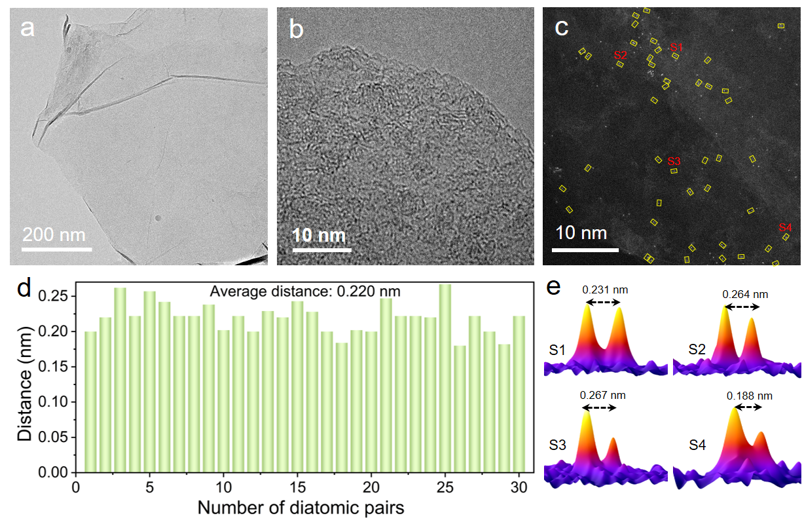
Supplementary Fig. 13 (a) TEM, (b) HRTEM, (c) AC-STEM images of CuFe-NG. (d) Statistics distribution of diatomic distance obtained from the AC-STEM images and (e) 3D intensity profiles of Cu-Fe sites in (c).
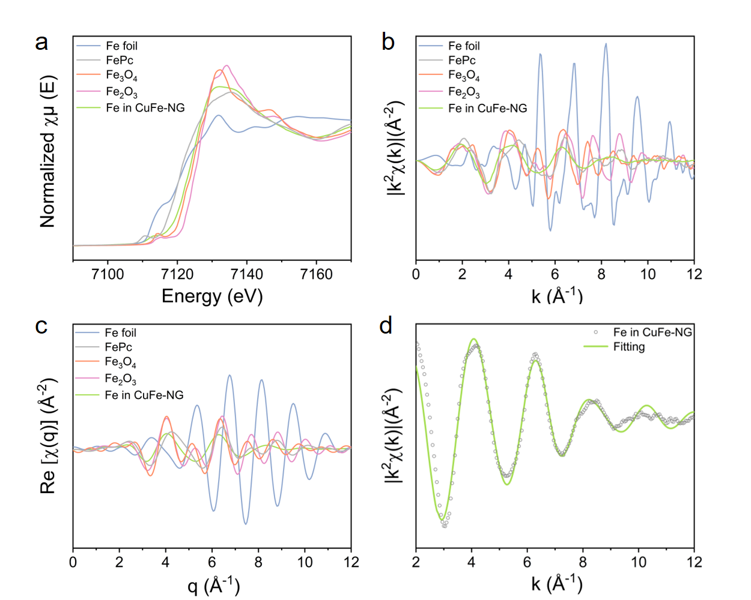
Supplementary Fig. 14 (a) Fe K-edge XANES spectra, (b) k-space EXAFS spectra, and (c) q-space profiles derived from WT-EXAFS analysis of Fe in CuFe-NG and reference samples. (d) k-space EXAFS fitting result of Fe in CuFe-NG.
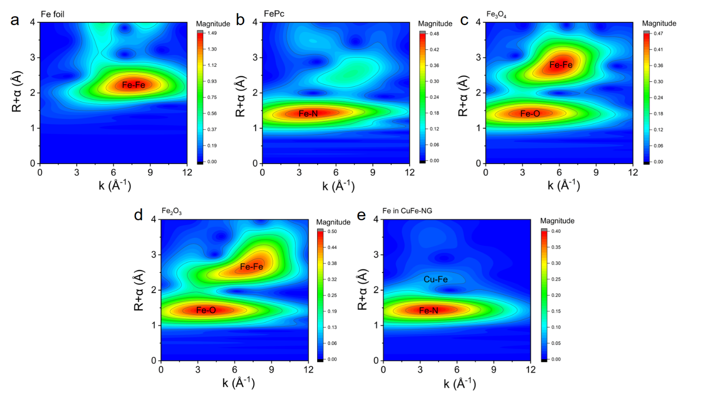
Supplementary Fig. 15 Fe K-edge WT-EXAFS spectra of (a) Fe foil, (b) FePc, (c) Fe₃O₄, (d) Fe₂O₃, and (e) CuFe-NG.

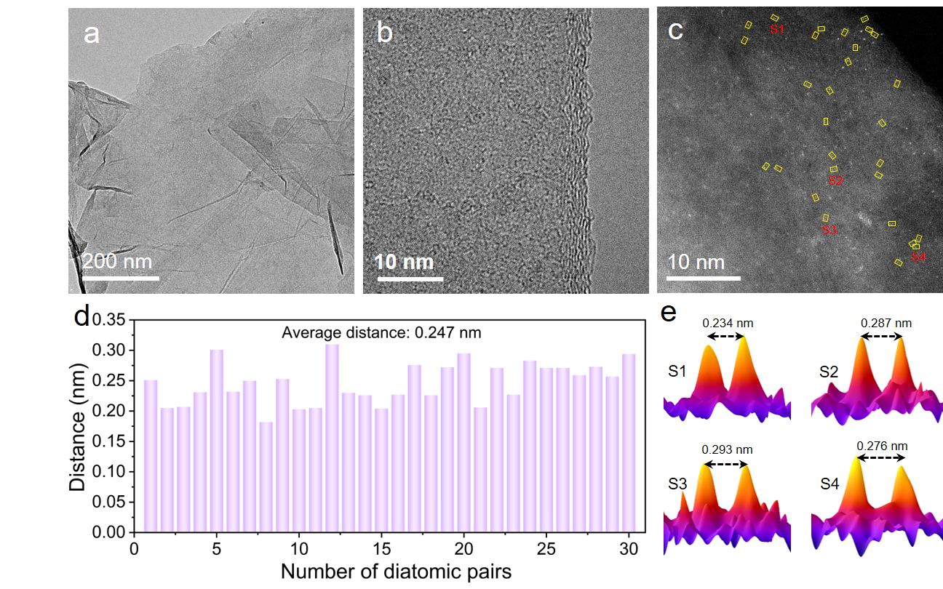
Supplementary Fig. 16 (a) TEM, (b) HRTEM, (c) AC-STEM images of CuCo-NG. (d) Statistics distribution of diatomic distance obtained from the AC-STEM images and (e) 3D intensity profiles of Cu-Co sites in (c).
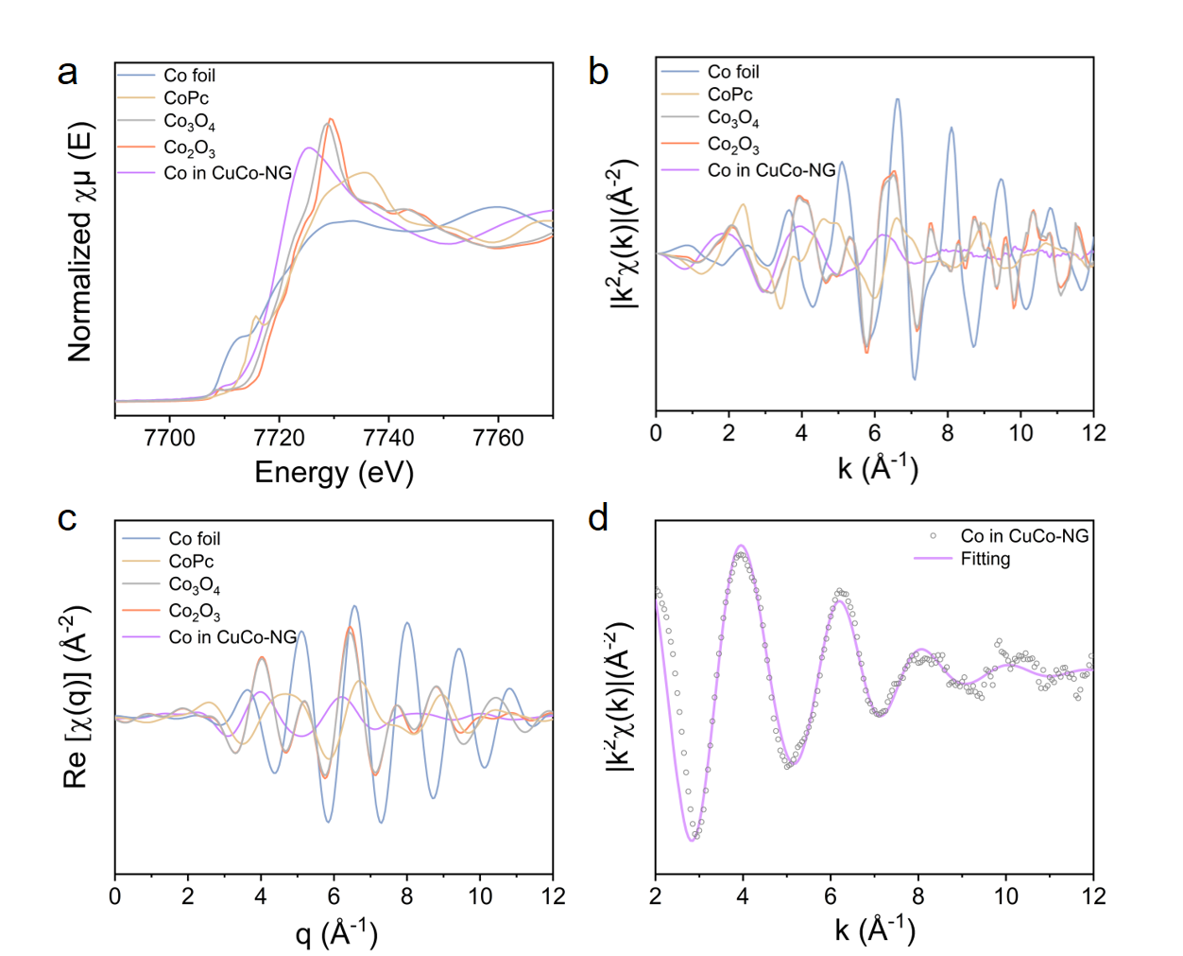
Supplementary Fig. 17 (a) Co K-edge XANES spectra, (b) k-space EXAFS spectra, and (c) q-space profiles derived from WT-EXAFS analysis of Co in CuCo-NG and reference samples. (d) k-space EXAFS fitting result of Co in CuCo-NG.
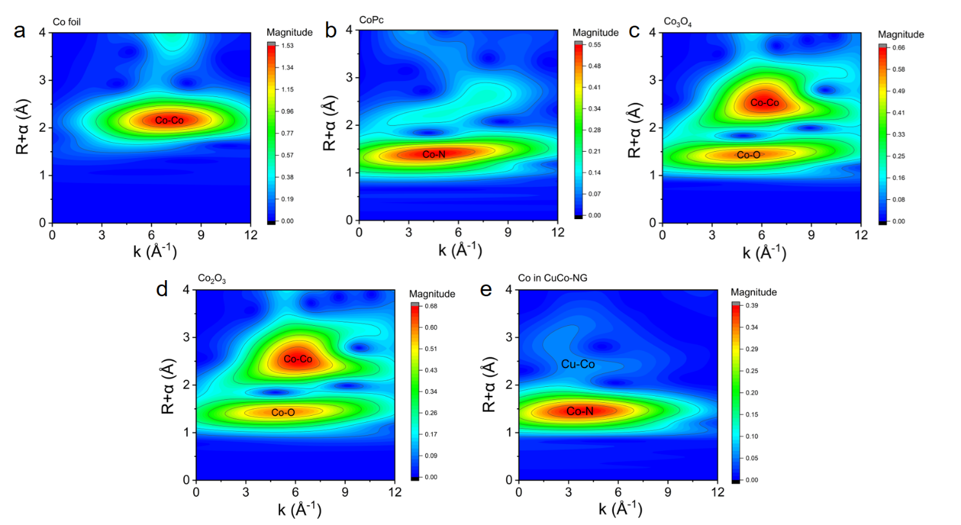
Supplementary Fig. 18 Co K-edge WT-EXAFS spectra of (a) Co foil, (b) CoPc, (c) Co₃O₄, (d) Co₂O₃, and (e) CuCo-NG.

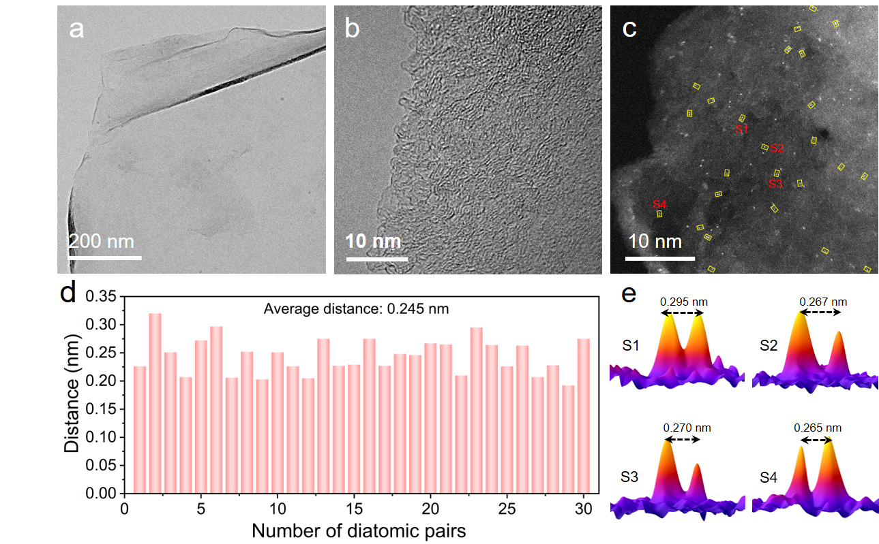
Supplementary Fig. 19 (a) TEM, (b) HRTEM, (c) AC-STEM images of CuNi-NG. (d) Statistics distribution of diatomic distance obtained from the AC-STEM images and (e) 3D intensity profiles of Cu-Ni sites in (c).
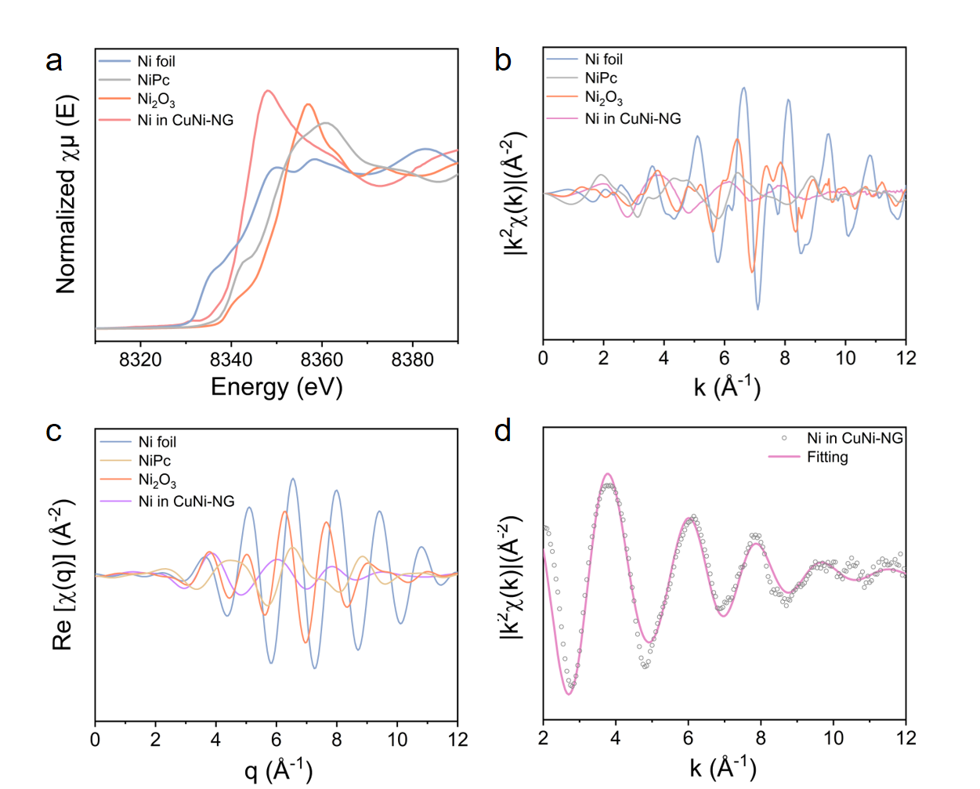
Supplementary Fig. 20 (a) Ni K-edge XANES spectra, (b) k-space EXAFS spectra, and (c) q-space profiles derived from WT-EXAFS analysis of Ni in CuNi-NG and reference samples. (d) k-space EXAFS fitting result of Ni in CuNi-NG.
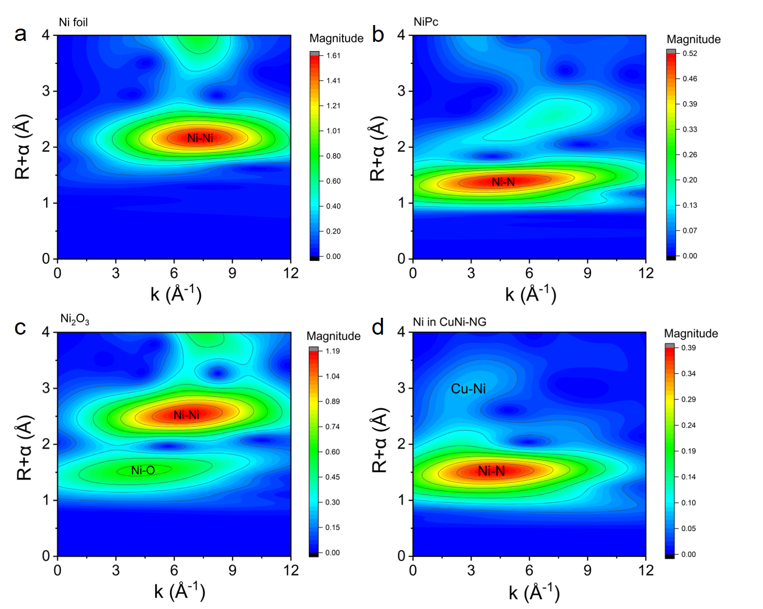
Supplementary Fig. 21 Ni K-edge WT-EXAFS spectra of (a) Ni foil, (b) NiPc, (c) Ni₂O₃, and (d) CuNi-NG.
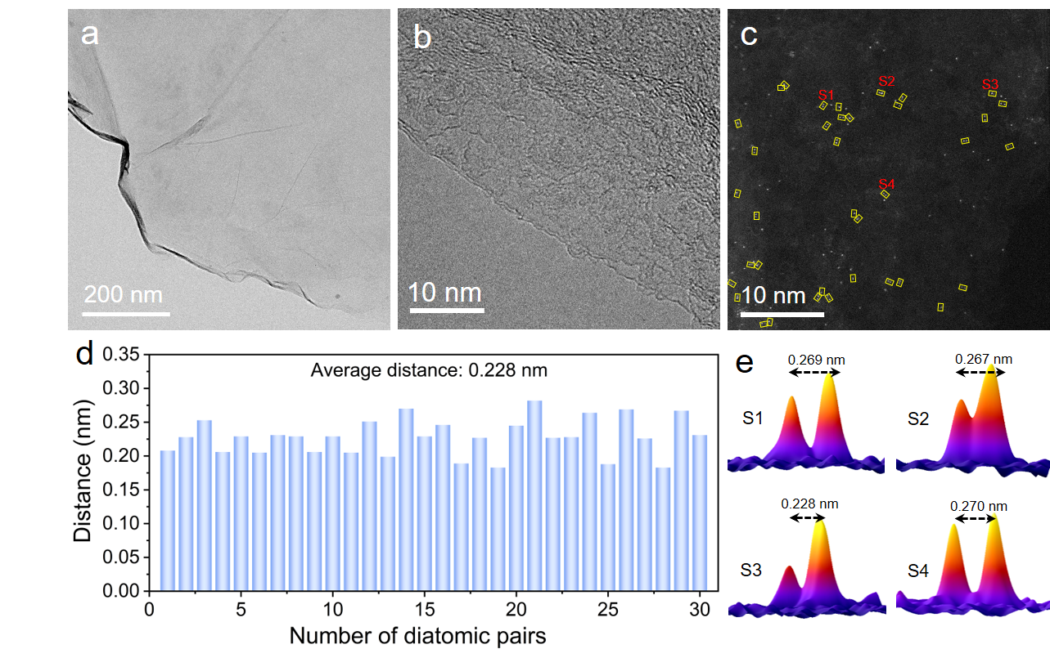
Supplementary Fig. 22 (a) TEM, (b) HRTEM, (c) AC-STEM images of CuZn-NG. (d) Statistics distribution of diatomic distance obtained from the AC-STEM images and (e) 3D intensity profiles of Cu-Zn sites in (c).
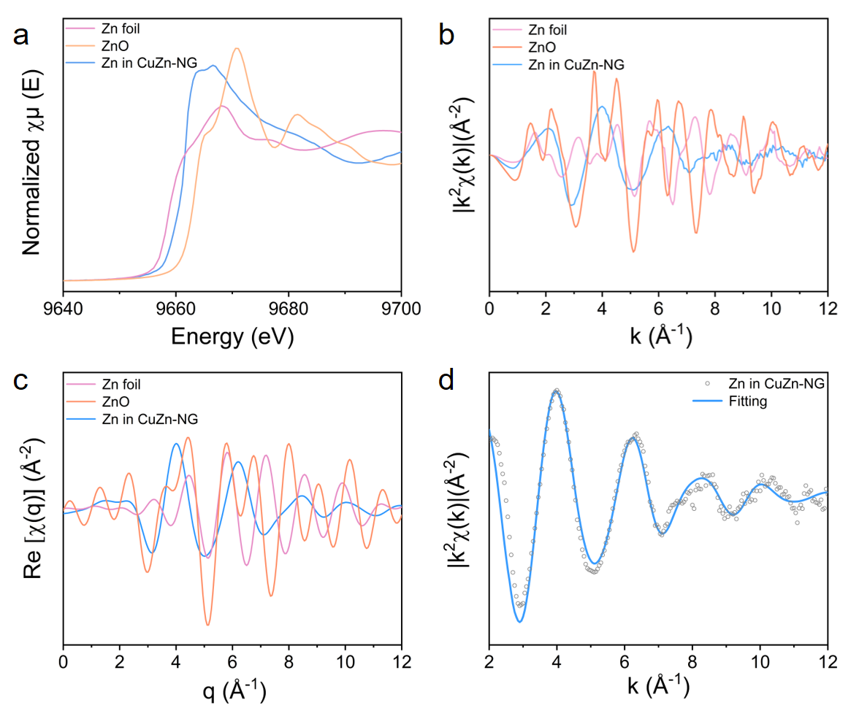
Supplementary Fig. 23 (a) Zn K-edge XANES spectra, (b) k-space EXAFS spectra, and (c) q-space profiles derived from WT-EXAFS analysis of Zn in CuZn-NG and reference samples. (d) k-space EXAFS fitting result of Zn in CuZn-NG.
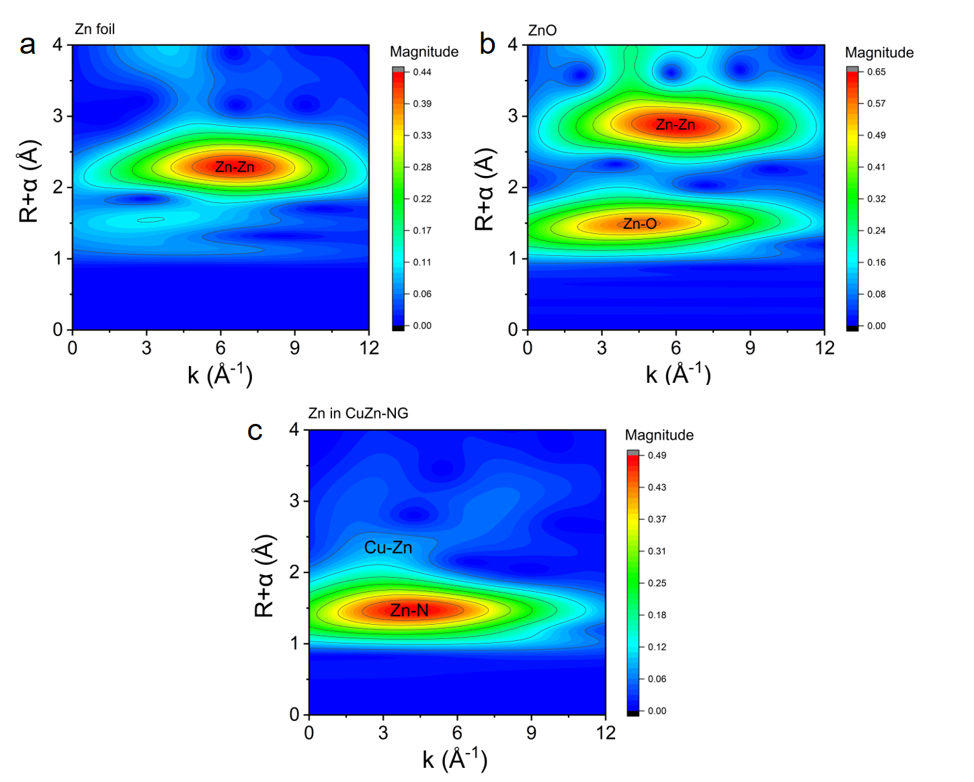
Supplementary Fig. 24 Zn K-edge WT-EXAFS spectra of (a) Zn foil, (b) ZnO and (c) CuZn-NG.
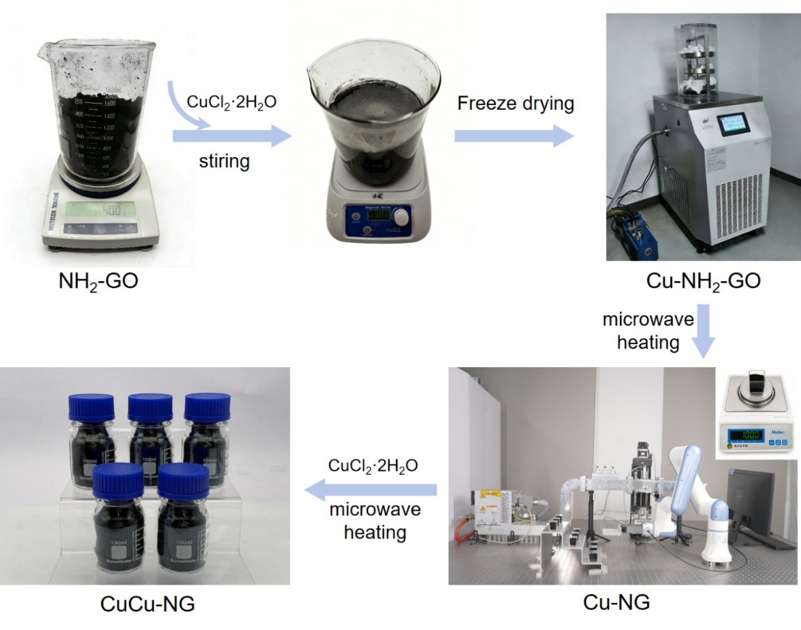
Supplementary Fig. 25 Schematic of the scale-up synthetic process of CuCu-NG DAC.

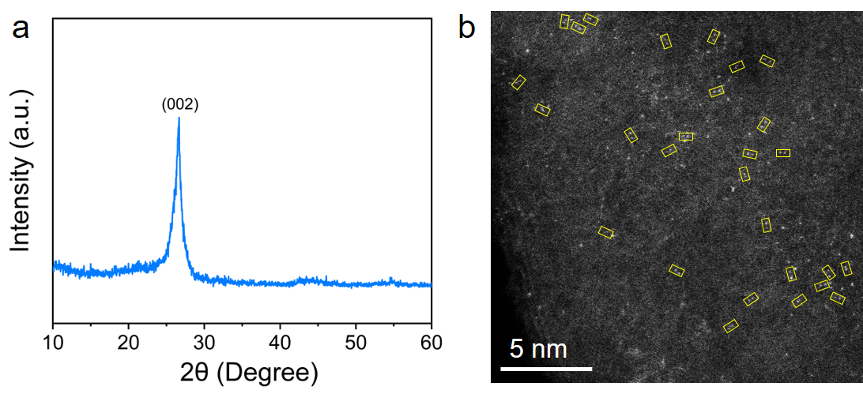
Supplementary Fig. 26 (a) XRD pattern and (b) AC-STEM image of batch-synthesized CuCu-NG DAC.
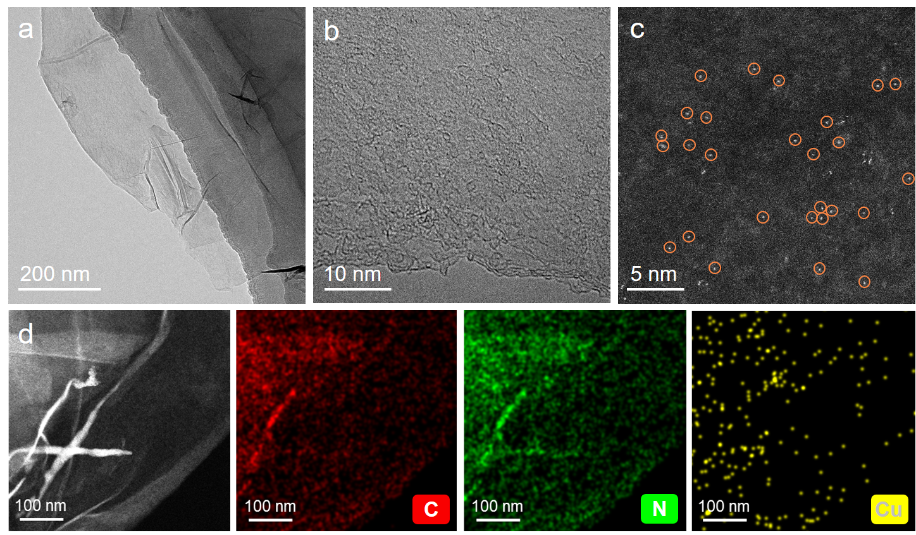
Supplementary Fig. 27 (a) TEM, (b) HRTEM, (c) AC-STEM, (d) HAADF-STEM and elemental mapping images of Cu-NG (0.6 wt%).
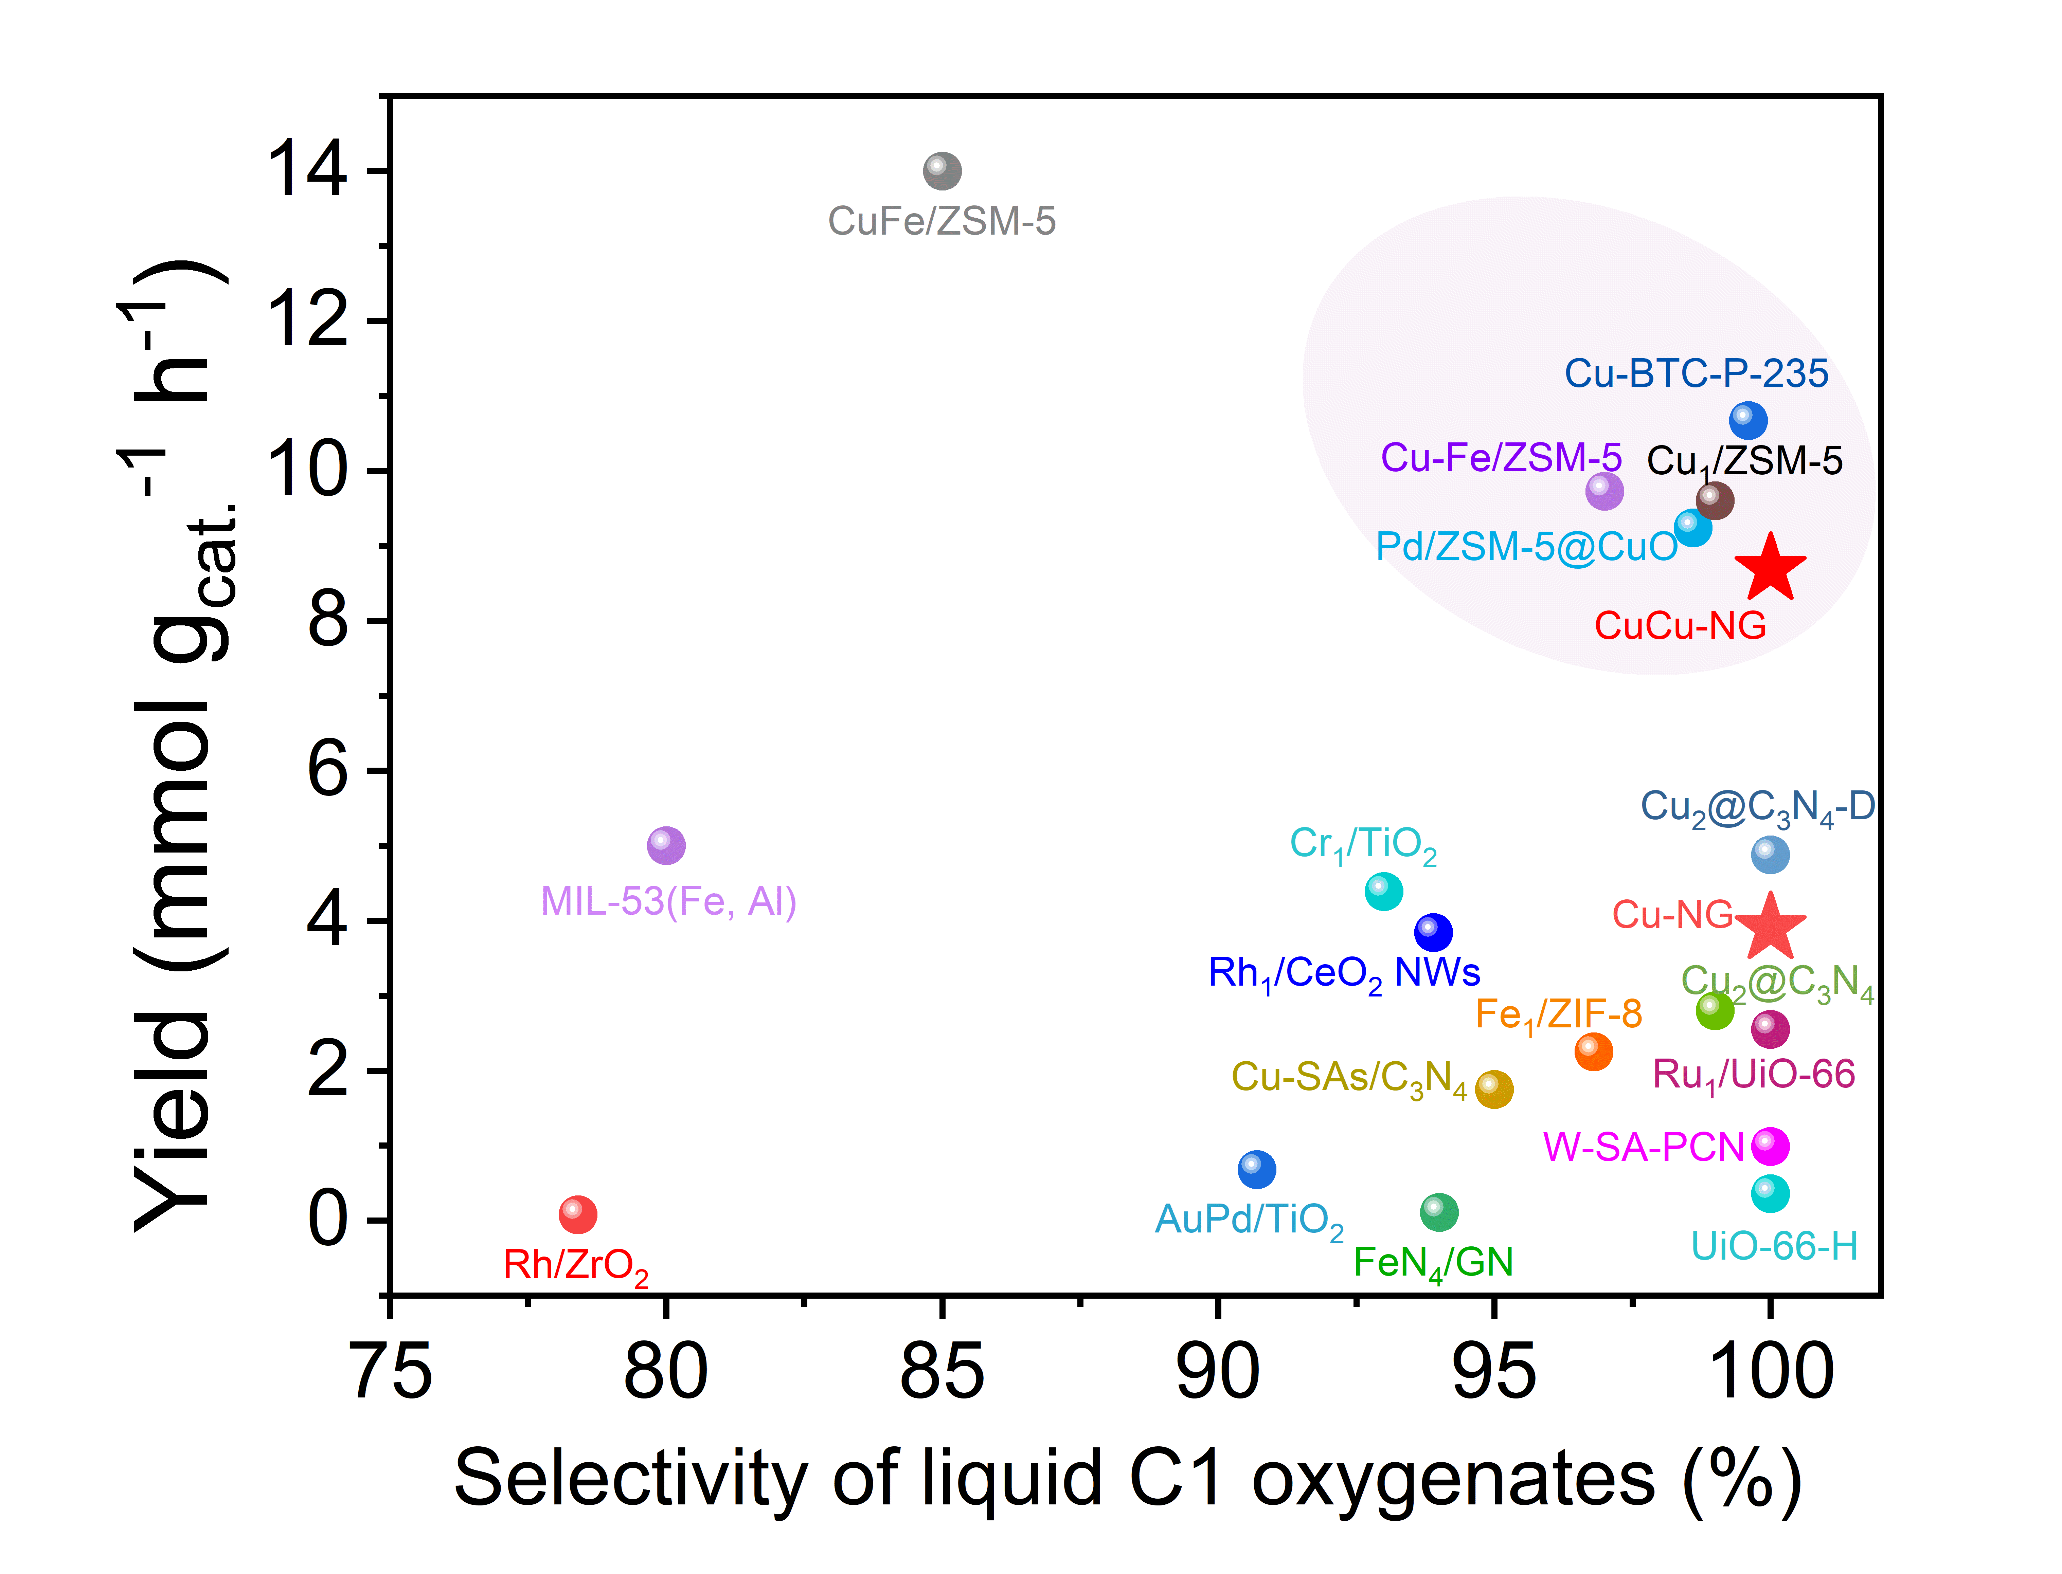
Supplementary Fig. 28 Comparison of the catalytic performance of Cu-NG, CuCu-NG, and representative catalysts previously reported for DSOM using H₂O₂.
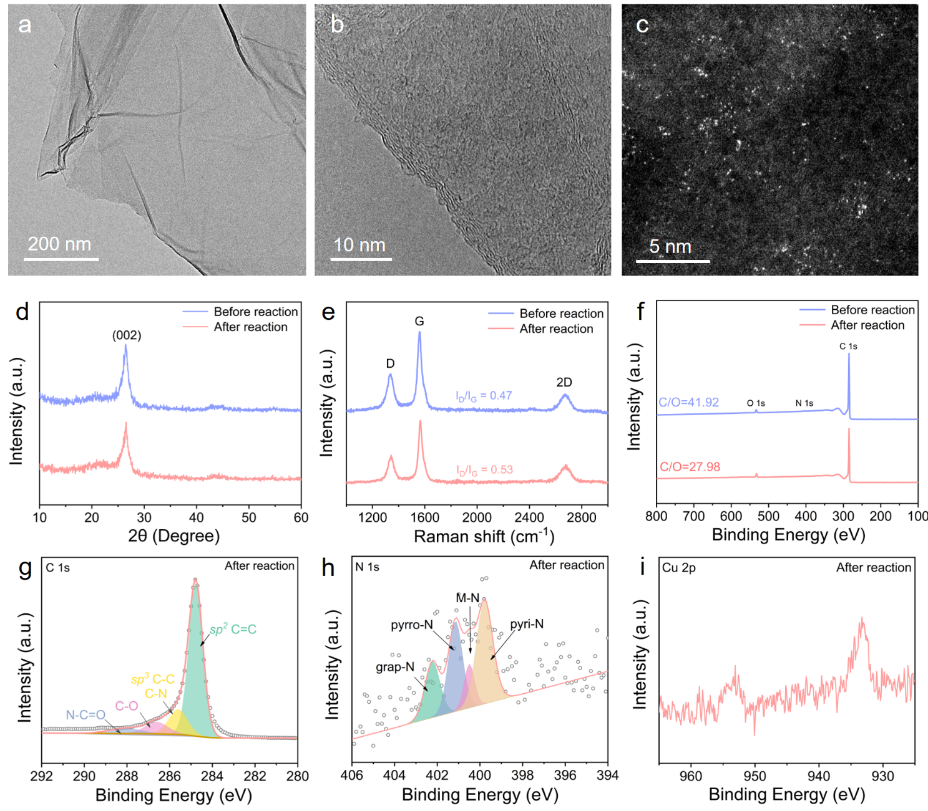
Supplementary Fig. 29 (a) TEM, (b) HRTEM, (c) AC-STEM images, (d) XRD patterns, (e) Raman spectra and (f-i) XPS spectra of recycled CuCu-NG after catalytic reaction.
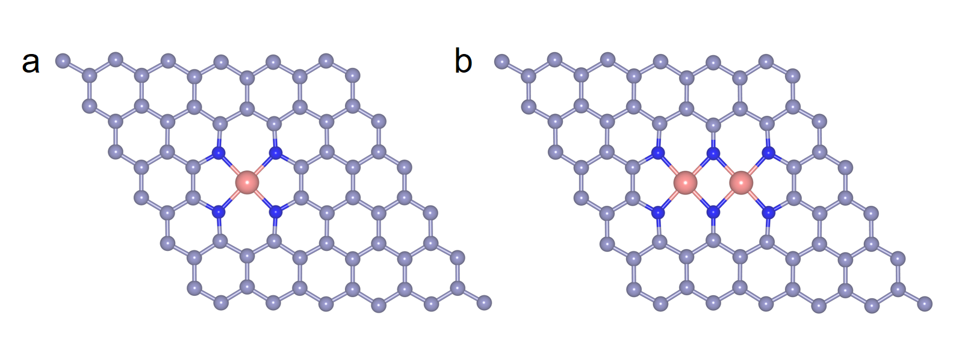
Supplementary Fig. 30 Optimized configurations of (a) Cu-NG and (b) CuCu-NG.

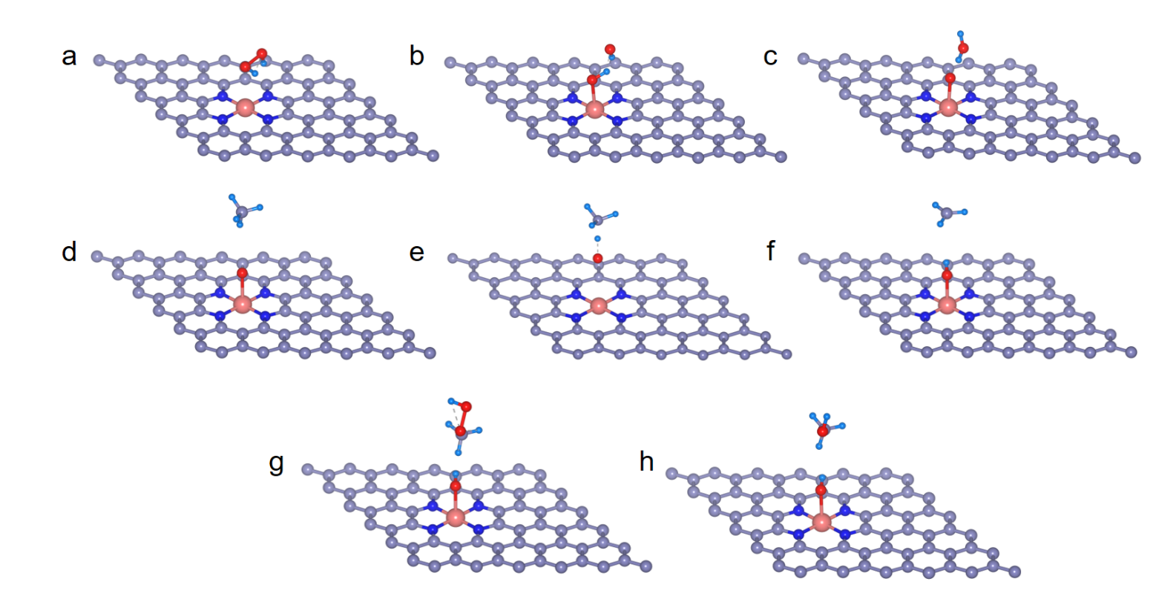
Supplementary Fig. 31 Optimized configurations of (a) H₂O₂ adsorption, (b) the first transition state (TS-1), (c) *O + H₂O, (d) CH₄ adsorption, (e) the second transition state (TS-2), (f) *CH₃, (g) CH₃OOH formation, and (h) CH₃OH formation on Cu-NG.
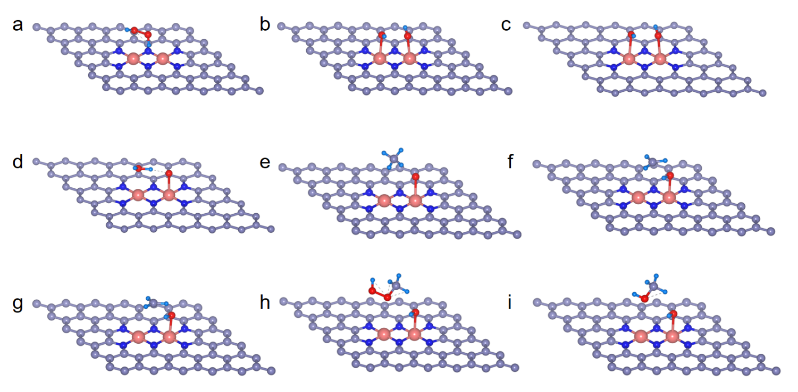
Supplementary Fig. 32 Optimized configurations of (a) H₂O₂ adsorption, (b) the first transition state (TS-1), (c) *OHOH, (d) *O + H₂O, (e) CH₄ adsorption, (f) the second transition state (TS-2), (g) *CH₃, (h) CH₃OOH formation, and (i) CH₃OH formation on CuCu-NG.

- Supplementary Tables
Supplementary Table 1. Comparison of thermal-treatment time, temperature, and dual-atom pairing ratio among different DAC synthesis methods.
Synthesis method | Thermal- treatment time(s) | Synthesis temperature  (°C) | Dual-atom ratio  (%) | Refs.
Pyrolysis | 7200 | 900 | ∼70 | ²
Pyrolysis | 11880 | 1000 | ∼60 | ³
Pyrolysis | 10800 | 900 | ∼75.1 | ⁴
Pyrolysis | 10800 | 900 | 80.7 | ⁵
Pyrolysis | 10800 | 900 | ∼60 | ⁶
Wet chemical | 10800 | 400 | - | ⁷
Wet chemical | 7200 | 300 | 59 | ⁸
Wet chemical | 72000 | 150 | - | ⁹
Ball milling | 18000 | 25 | - | ¹⁰
Ball milling | 21600 | 25 | 44 | ¹¹
Ball milling | 43200 | 25 | - | ¹²
ALD | 200 | 200 | - | ¹³
ALD | 30 | 250 | 70 | ¹⁴
ALD | 60 | 250 | - | ¹⁵
Photoinduced anchoring | 10800 | 25 | ∼76 | ¹⁶
Photoinduced anchoring | 1800 | 25 | - | ¹⁷
Photoinduced anchoring | 10800 | 25 | ∼80 | ¹⁸
Joule heating | 0.0036 | 3000 | 65.9 | ¹⁹
Joule heating | 0.2 | 1500 | - | ²⁰
Joule heating | 1.5 | 350 | - | ²¹
Joule heating | 0.5 | 1200 | - | ²²
Microwave heating | 500 | 200 | - | ²³
Microwave heating | 1800 | 900 | - | ²⁴
Microwave heating | 1800 | 170 | - | ²⁵
Microwave heating | 25 | 1420 | ∼70 | This work
Supplementary Table 2. Metal loadings of CuM-NG catalysts determined by ICP-OES.
Sample | Cu (wt%) | Fe (wt%) | Co (wt%) | Ni (wt%) | Zn (wt%)
Cu-NG (0.3 wt%) | 0.381 | - | - | - |  | -
Cu-NG (0.6 wt%) | 0.596 | - | - | - |  | -
CuFe-NG | 0.275 | 0.248 | - | - |  | -
CuCo-NG | 0.256 | - | 0.204 | - |  | -
CuNi-NG | 0.206 | - | - | 0.226 |  | -
CuCu-NG | 0.569 | - | - | - |  | -
CuZn-NG | 0.2 | - | - | - |  | 0.131

Supplementary Table 3. EXAFS fitting parameters for the metal K-edge spectra of samples.
Sample | shell | ªCN | ^{b}R(Å) | ^{c}σ² (Å²) | ^{d}ΔE₀ (eV) | ^{e}S₀² | ^{f}R factor
Cu foil | Cu-Cu | 12* | 2.55 | 0.009 | 4.5±0.8 | 0.8473  (calculated) | 0.004
Cu₂O | Cu-O | 1.5±0.2 | 1.85 | 0.002 | 7.0±1.2 | 0.8473(set) | 0.007
Cu₂O | Cu-Cu | 17.8±6.6 | 3.05 | 0.026 | 7.0±1.2 | 0.8473(set) | 0.007
CuPc | Cu-N | 4.4±1.2 | 1.93 | 0.003 | 6.1±3.6 | 0.8473(set) | 0.019
Cu-NG | Cu-N | 3.9±0.2 | 1.97 | 0.006 | -6.0±0.6 | 0.8473(set) | 0.006
CuCu-NG | Cu-N | 4.4±0.2 | 2.00 | 0.008 | -2.9±0.4 | 0.8473(set) | 0.013
CuCu-NG | Cu-Cu | 0.8±0.6 | 2.39 | 0.025 | -2.9±0.4 | 0.8473(set) | 0.013
Fe foil | Fe-Fe | 8* | 2.47 | 0.007 | 5.6±0.4 | 0.9909  (calculated) | 0.010
CuFe-NG | Fe-N | 4.7±0.1 | 2.00 | 0.010 | -4.9±0.4 | 0.9909  (set) | 0.004
CuFe-NG | Fe-Cu | 0.8±0.3 | 2.53 | 0.009 | -4.9±0.4 | 0.9909  (set) | 0.004
Co foil | Co-Co | 12* | 2.50 | 0.009 | 7.8±0.6 | 0.9859  (calculated) | 0.018
CuCo-NG | Co-N | 4.7±0.1 | 2.01 | 0.011 | -5.8±0.4 | 0.9859  (set) | 0.005
CuCo-NG | Co-Cu | 1.3±0.6 | 2.51 | 0.006 | -5.8±0.4 | 0.9859  (set) | 0.005
Ni foil | Ni-Ni | 12* | 2.49 | 0.008 | 7.1±0.5 | 0.9989  (calculated) | 0.014
CuNi-NG | Ni-N | 5.2±0.2 | 2.06 | 0.010 | -5.8±0.4 | 0.9989  (set) | 0.012
CuNi-NG | Ni-Cu | 0.9±0.3 | 2.49 | 0.020 | -5.8±0.4 | 0.9989  (set) | 0.012
Zn foil | Zn-Zn | 6* | 2.65 | 0.011 | 3.7±0.3 | 0.9935  (calculated) | 0.008
CuZn-NG | Zn-N | 4.9±0.2 | 1.99 | 0.009 | 0.1±0.5 | 0.9935(set) | 0.012
CuZn-NG | Zn-Cu | 0.8±0.3 | 2.99 | 0.014 | 0.1±0.5 | 0.9935(set) | 0.012
ªCN, coordination number; ^{b}R, distance to the neighboring atom; ^{c}σ², mean-square relative displacement (MSRD); ^{d}ΔE₀, inner potential correction. ^{e}S₀² was obtained from EXAFS fitting by fixing the coordination number (CN) to the crystallographic value of the corresponding metal foil and was kept constant during fitting. ^{f}R factor indicates the goodness of the fit. The fitting ranges were 3.0 ≤ k ≤ 11.0 Å⁻¹ and 1.0 ≤ R ≤ 3.0 Å. The Debye-Waller factors and ΔRs are based on the guessing parameters and constrained for paths.

Supplementary Table 4. Comparison of the catalytic performance of Cu-NG, CuCu-NG, and representative catalysts previously reported for DSOM using H₂O₂.
Catalyst | T (°C) | CH₄ (MPa) | H₂O₂ (M) | Oxygenates |  |  | Refs.
 |  |  |  | Yield (mmol/g_{cat.}/h) | Selectivity (%) | TOF (h⁻¹) | Refs.
0.01 wt% Pd/ZSM-5+  2 wt% 5CuO | 70 | 3 | 0.5 | 9.24 | 98.6 | 3.2 | ²⁶
0.3 wt% Rh/ZrO₂ | 70 | 3 | 0.5 | 0.08 | 78.4 | 1.3 | ²⁷
0.13 wt% AuPd/TiO₂ | 50 | 3.05 | 0.5 | 0.68 | 90.7 | 103 | ²⁸
FeN₄/GN-2.7 | 25 | 2 | 5 | 0.11 | 94 | 0.5 | ²⁹
MIL-53(Fe, Al) | 60 | 3.05 | 0.5 | 5 | 80 | 90 | ³⁰
Cu-SAs/C₃N₄ | 25 | 3 | 4 | 1.75 | 95 | 11 | ³¹
Cr₁/TiO₂ | 50 | 3 | 0.5 | 4.39 | 93 | 57.9 | ³²
Cu₁/ZSM-5 | 50 | 3 | 0.5 | 9.6 | 99 | 157 | ³³
Cu₁/ZIF-7 | 50 | 3 | 0.5 | 0.15 | 20 | 1.6 | ³⁴
Fe₁/ZIF-8 | 50 | 3 | 0.5 | 2.25 | 96.8 | 4 | ³⁵
0.38 wt% Cu₂@C₃N₄-D | 50 | 3 | 0.5 | 4.88 | ~100 | 83 | ³⁶
0.35 wt% Cu₂@C₃N₄ | 70 | 3 | 0.2 | 2.80 | 99 | 8.3 | ³⁷
0.13 wt% Ru₁/UiO-66 | 60 | 3 | 1 | 2.55 | ~100 | 185.4 | ³⁸
2.5 wt% CuFe/ZSM-5 | 50 | 3.05 | 0.5 | 14 | 85 | 31.4 | ³⁹
Cu-BTC-P-235 | 50 | 3 | 0.25 | 10.67 | 99.6 | - | ⁴⁰
Rh₁/CeO₂ NWs | 50 | 0.5 | 1 | 3.84 | 93.9 | 136 | ⁴¹
Cu-Fe(2/0.1)/ZSM-5 | 50 | 3 | 0.5 | 9.73 | 97 | 523.8 | ⁴²
W-SA-PCN-7.5 | 25 | 0.5 | - | 0.99 | ~100 | 0.387 | ⁴³
UiO-66-H | 50 | 3 | 0.25 | 0.36 | ~100 | - | ⁴⁴
Cu-NG | 80 | 3 | 1 | 3.90 | ~100 | 41.6 | This work
CuCu-NG | 80 | 3 | 1 | 8.69 | ~100 | 218 | This work

- Supplementary References
1 Funke, H., Chukalina, M. & Scheinost, A. C. A new FEFF-based wavelet for EXAFS data analysis. J. Synchrotron Radiat. 14, 426-432 (2007).
2 Zhang, Y.-X. et al. General synthesis of a diatomic catalyst library via a macrocyclic precursor-mediated approach. J. Am. Chem. Soc. 145, 4819-4827 (2023).
3 Cho, M. S. et al. Synergistic Fe-Si dual-site pathway engineering in biomass-derived carbon matrix for high-performance oxygen reduction reaction. Carbon Energy 8, e70154 (2025).
4 Wang, L. et al. Spin-regulated Fe-Cu diatomic catalytic chemistry enables significant minimization of catalyst consumption with high-efficiency Fenton-like activity. Angew. Chem. Int. Ed. 65, e25747 (2026).
5 Zhang, L. et al. High-density asymmetric iron dual-atom sites for efficient and stable electrochemical water oxidation. Nat. Commun. 15, 9440 (2024).
6 Chai, Y. et al. Dual-atom catalyst with N-colligated Zn₁Co₁ species as dominant active sites for propane dehydrogenation. J. Am. Chem. Soc. 146, 263-273 (2023).
7 Chen, T. et al. Cascade catalysis on dual-atom iridium-tungsten catalysts for enhanced ammonia selective oxidation. Nat. Commun. 16, 11179 (2025).
8 Tian, S. et al. Dual-atom Pt heterogeneous catalyst with excellent catalytic performances for the selective hydrogenation and epoxidation. Nat. Commun. 12, 3181 (2021).
9 Li, J. et al. Facilitating OH* generation on atomic Pd-Cu dual sites towards efficient glycerol electrooxidation to formate. Angew. Chem. Int. Ed. 64, e202425006 (2025).
10 Chen, Z. et al. Boosting oxygen reduction reaction with Fe and Se dual-atom sites supported by nitrogen-doped porous carbon. Appl. Catal. B Environ. 308, 121206 (2022).
11 Li, Y. et al. Ten thousand hour stable zinc air batteries via Fe and W dual atom sites. Nat. Commun. 16, 8085 (2025).
12 Zhang, Y. et al. Enhanced hydrogenation properties of Pd single-atom catalysts with atomically dispersed Ba sites as electronic promoters. ACS Catal. 12, 15091-15096 (2022).
13 Chen, S. et al. Dehydrogenation of ammonia borane by platinum-nickel dimers: Regulation of heteroatom interspace boosts bifunctional synergetic catalysis. Angew. Chem. Int. Ed. 61, e202211919 (2022).
14 Zhang, L. et al. Atomic layer deposited Pt-Ru dual-metal dimers and identifying their active sites for hydrogen evolution reaction. Nat. Commun. 10, 4936 (2019).
15 Yao, X. et al. Synergistic Ni-W dimer sites induced stable compressive strain for boosting the performance of Pt as electrocatalyst for the oxygen reduction reaction. Angew. Chem. Int. Ed. 63, e202318872 (2024).
16 Zhao, Q.-P. et al. Photo-induced synthesis of heteronuclear dual-atom catalysts. Nat. Synth. 3, 497-506 (2024).
17 Zhu, A. et al. Geminal synergy in Pt-Co dual-atom catalysts: From synthesis to photocatalytic hydrogen production. J. Am. Chem. Soc. 146, 33002-33011 (2024).
18 Pang, Y. et al. Developing dual-atom catalysts with tunable electron synergistic effect via photoinduced ligand exchange strategy. ACS Catal. 15, 1061-1072 (2025).
19 Liu, K. et al. Tailoring asymmetric RuCu dual-atom electrocatalyst toward ammonia synthesis from nitrate. Nat. Commun. 16, 2167 (2025).
20 Bai, X. et al. Asymmetric electronic modulation in bridged Cu-O₂-Ni dual-atom catalysts promoting CO₂ electroreduction. Chem. Sci. 17, 10669-10677 (2026).
21 Yuan, J. et al. Coupling electron-buffered dual single-atom pairs to unlock exceptional industrial-grade PEM water electrolysis. Joule, 10, 102425 (2026).
22 Wang, C. et al. Rigid ligand confined rapid synthesis of dual single-atomic sites on carbon black for enhanced oxygen depolarized cathodes. Nano Res. 19, 94907794 (2026).
23 Xie, Y. et al. Atomic H* production amplified by precisely tailored Ag-Pt dual-atom synergy: Crucial roles in 6PPD detoxification for water purification. Environ. Sci. Technol. 60, 9609-9622 (2026).
24 He, Z. et al. Enhanced peroxymonosulfate activation for degradation of iodinated contrast media by microwave-induced bimetallic carbon-based catalysts: Insight into the synergistic mechanism between microwaves and bimetallic sites. Chem. Eng. J. 488, 151061 (2024).
25 Yang, B. et al. Microwave synthesis of Fe-Cu diatomic active center MOF: Synergistic cyclic catalysis of persulfate for degrading norfloxacin. Environ. Sci.: Nano 10, 2778-2789 (2023).
26 Huang, W. et al. Low-temperature transformation of methane to methanol on Pd₁O₄ single sites anchored on the internal surface of microporous silicate. Angew. Chem. Int. Ed. 55, 13441-13445 (2016).
27 Kwon, Y., Kim, T. Y., Kwon, G., Yi, J. & Lee, H. Selective activation of methane on single-atom catalyst of rhodium dispersed on zirconia for direct conversion. J. Am. Chem. Soc. 139, 17694-17699 (2017).
28 Williams, C. et al. Selective oxidation of methane to methanol using supported AuPd catalysts prepared by stabilizer-free sol-immobilization. ACS Catal. 8, 2567-2576 (2018).
29 Cui, X. et al. Room-temperature methane conversion by graphene-confined single iron atoms. Chem 4, 1902-1910 (2018).
30 Osadchii, D. Y. et al. Isolated Fe sites in metal organic frameworks catalyze the direct conversion of methane to methanol. ACS Catal. 8, 5542-5548 (2018).
31 Wu, B. et al. Cu single-atoms embedded in porous carbon nitride for selective oxidation of methane to oxygenates. Chem. Commun. 56, 14677-14680 (2020).
32 Shen, Q. et al. Single chromium atoms supported on titanium dioxide nanoparticles for synergic catalytic methane conversion under mild conditions. Angew. Chem. Int. Ed. 59, 1216-1219 (2019).
33 Tang, X. et al. Direct oxidation of methane to oxygenates on supported single Cu atom catalyst. Appl. Catal. B Environ. 285, 119827 (2021).
34 Lee, H. et al. Methane partial oxidation by monomeric Cu active center confined on ZIF-7. Chem. Eng. J. 450, 138472 (2022).
35 Lin, L. et al. Selective oxidation of methane into formic acid over ZIF-8-encapsulated mononuclear Fe species under mild conditions. ChemCatChem 15, e202201234 (2022).
36 Yang, N. et al. Defective C₃N₄ frameworks coordinated diatomic copper catalyst: Towards mild oxidation of methane to C₁ oxygenates. Appl. Catal. B Environ. 299, 120682 (2021).
37 Xie, P. et al. Oxo dicopper anchored on carbon nitride for selective oxidation of methane. Nat. Commun. 13, 1375 (2022).
38 Fang, G. et al. Retrofitting Zr-oxo nodes of UiO-66 by Ru single atoms to boost methane hydroxylation with nearly total selectivity. J. Am. Chem. Soc. 145, 13169-13180 (2023).
39 Hammond, C. et al. Direct catalytic conversion of methane to methanol in an aqueous medium by using copper-promoted Fe-ZSM-5. Angew. Chem. Int. Ed. 51, 5129-5133 (2012).
40 Li, W. et al. Efficient catalysts of surface hydrophobic Cu-BTC with coordinatively unsaturated Cu(I) sites for the direct oxidation of methane. Proc. Natl. Acad. Sci. U.S.A. 120, e2206619120 (2023).
41 Bai, S. et al. High-efficiency direct methane conversion to oxygenates on a cerium dioxide nanowires supported rhodium single-atom catalyst. Nat. Commun. 11, 954 (2020).
42 Yu, T. et al. Highly selective oxidation of methane into methanol over Cu-promoted monomeric Fe/ZSM-5. ACS Catal. 11, 6684-6691 (2021).
43 Wang, Y. et al. W single-atom catalyst for CH₄ photooxidation in water vapor. Adv. Mater. 34, 2204448 (2022).
44 Fang, G. et al. Zirconium-oxo nodes of MOFs with tunable electronic properties provide effective ·OH species for enhanced methane hydroxylation. Angew. Chem. Int. Ed. 61, e202205077 (2022).

