Supporting Information
Cobalt stearate-modified Fe₃O₄: a new magnetic metal-surfactant nano-catalyst for the sustainable in-water synthesis of pyrazole derivatives
Fatemeh Tamaddon *, Bahar Zare-Banadkouki, Ehsan Ahmadi-Ahmadabadi, Amir-Abbas Jahangiri
Department of Chemistry, Yazd University, Yazd, 89195-741, Iran
E-mail: ftamaddon@yazd.ac.ir

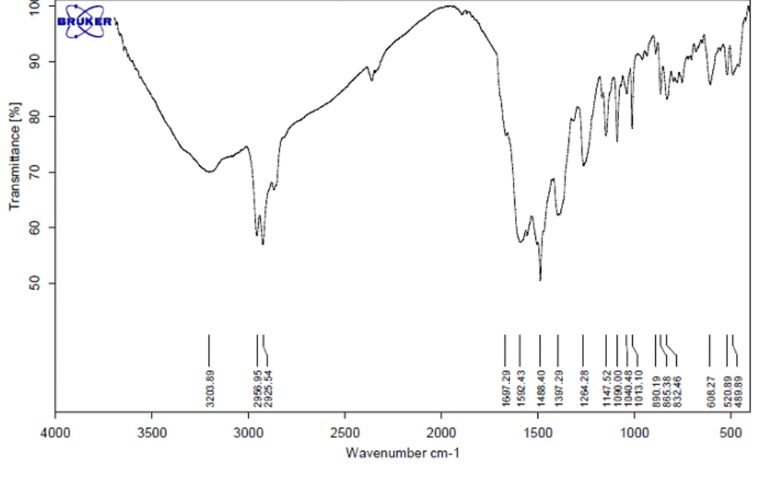
Figure S1. The FT-IR spectrum of PQ1.
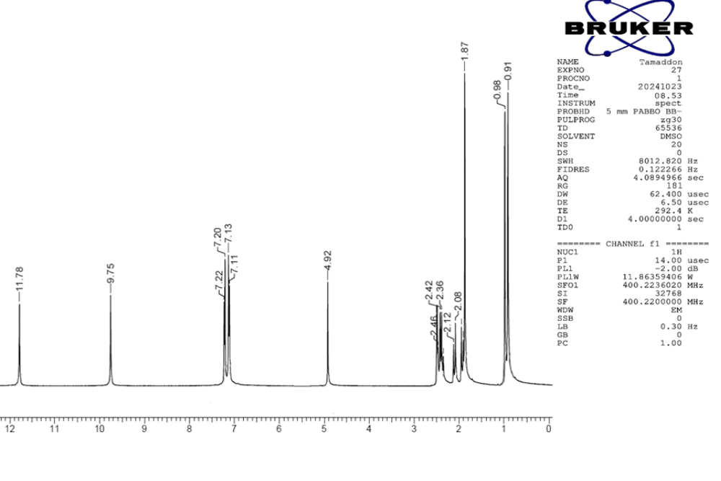
Figure 2. The ¹H NMR spectrum of PQ1.
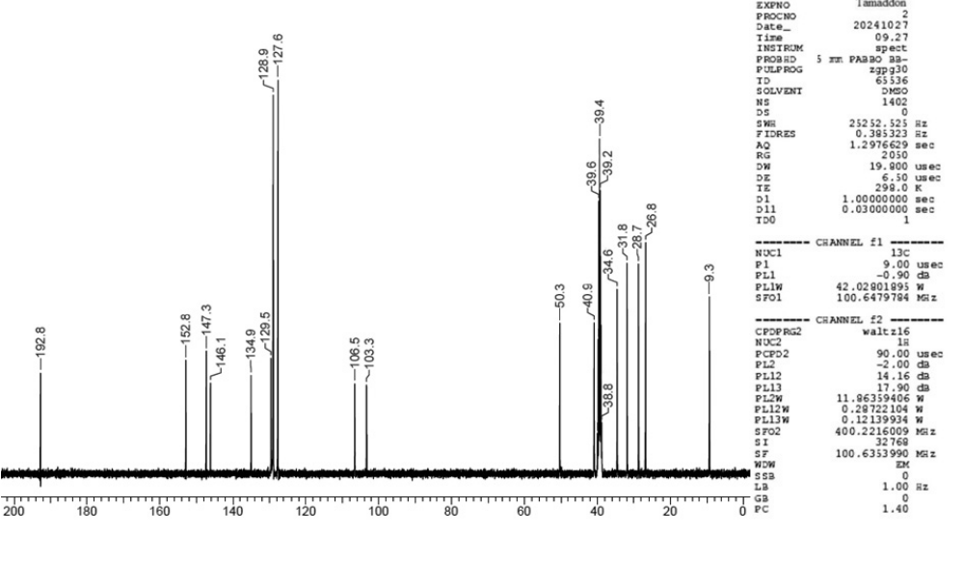
Figure S3. The ¹³C NMR spectrum of PQ1.

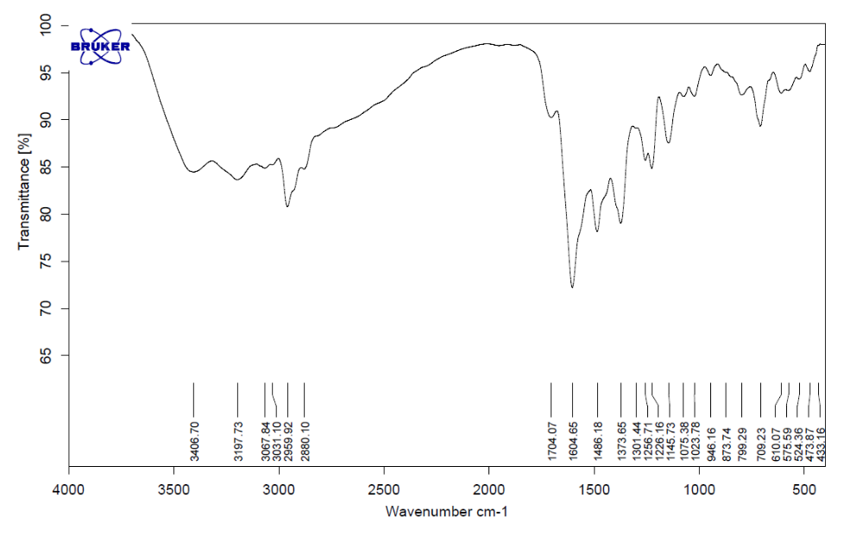
Figure S4. The FT-IR spectrum of PQ2.
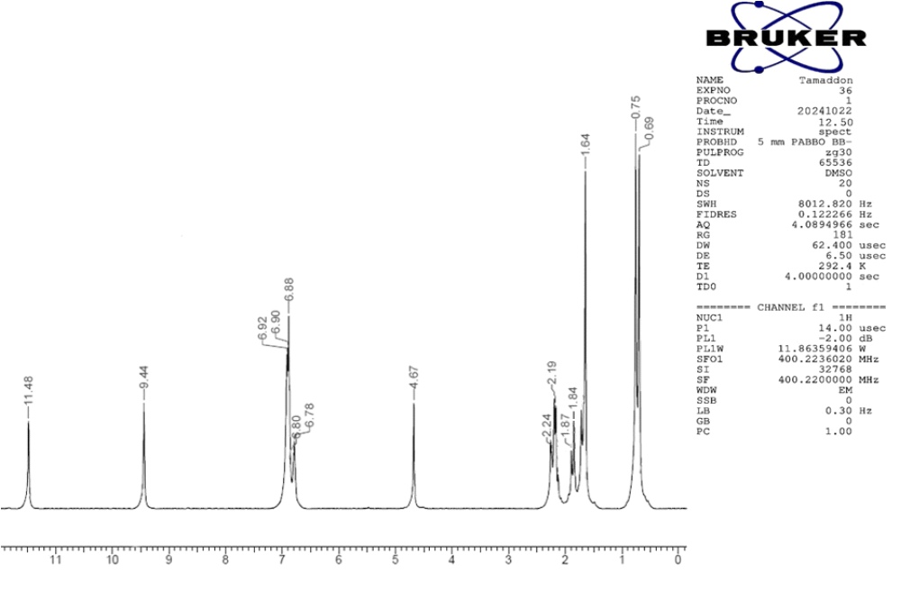
Figure S5. The ¹H NMR spectrum of PQ2.
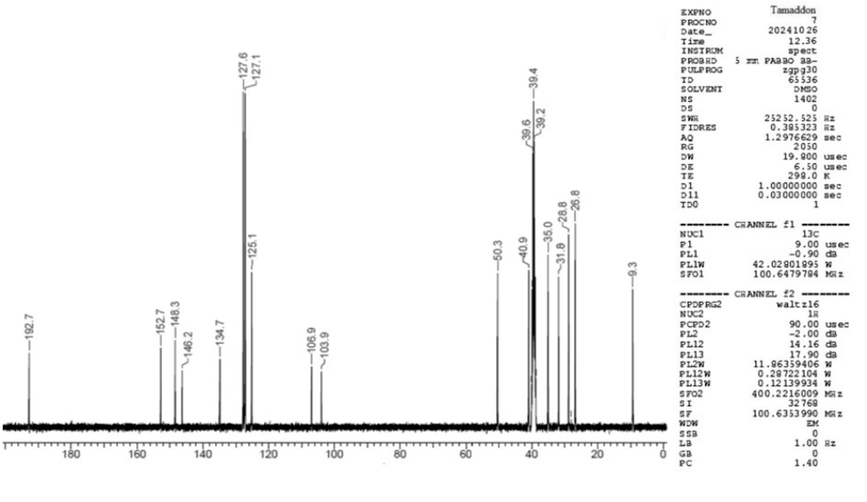
Figure S6. The ¹³C NMR spectrum of PQ2.
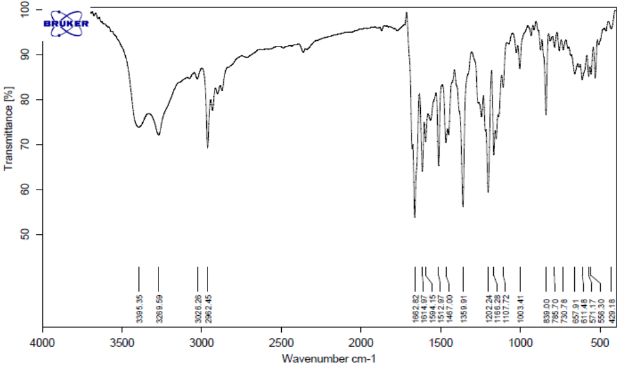
Figure S7. The FT-IR spectrum of PQ3.
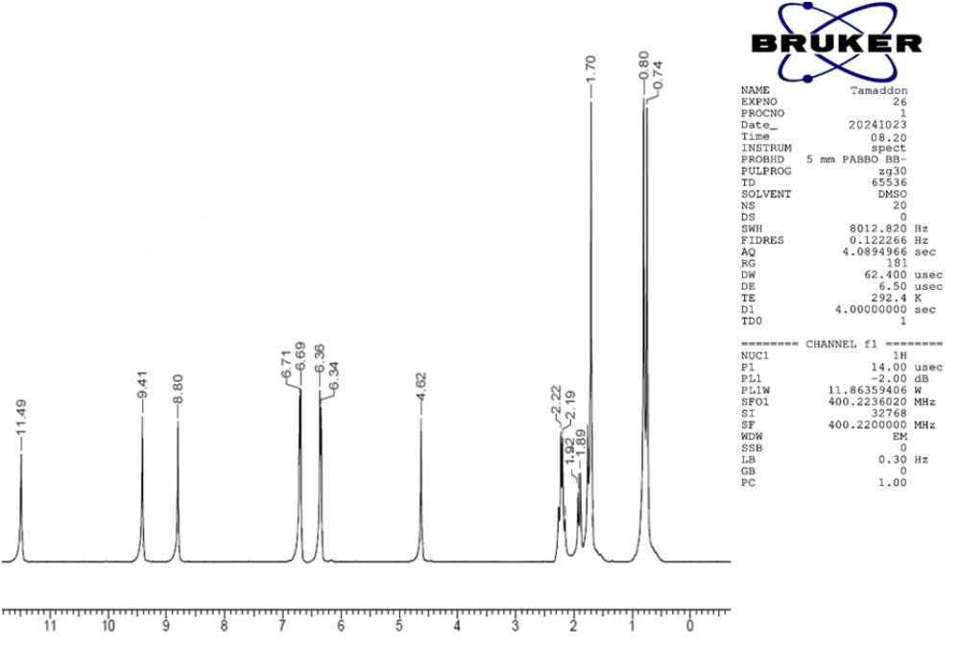
Figure 8. The ¹H NMR spectrum of PQ3.
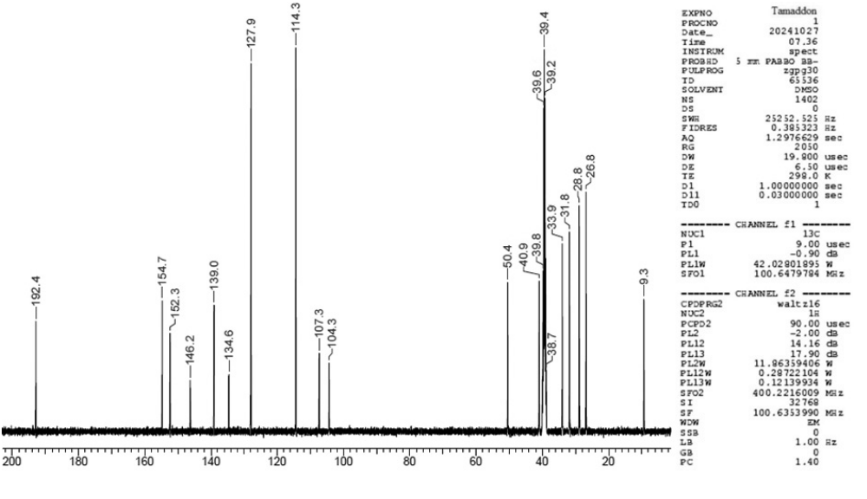
Figure S9. The ¹³C NMR spectrum of PQ3.
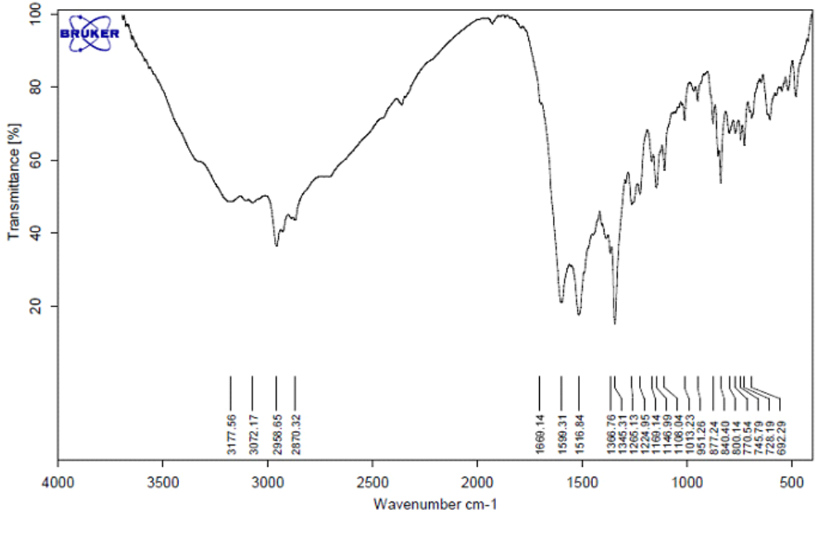
Figure S10. The FT-IR spectrum of PQ4.
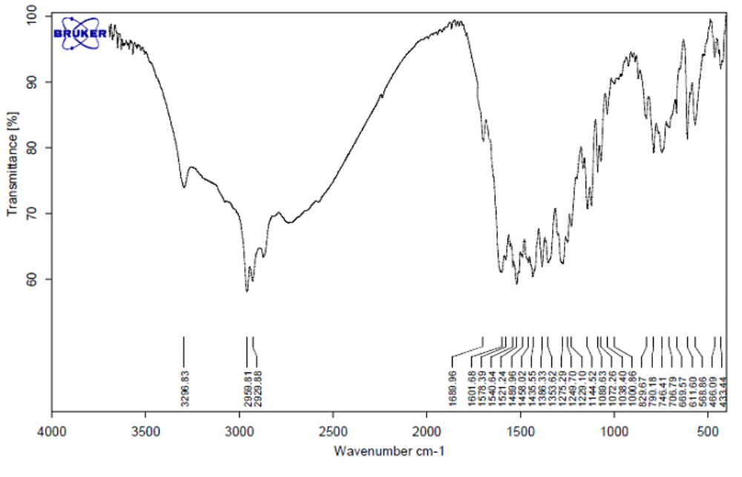
Figure S11. The FT-IR spectrum of PQ5.
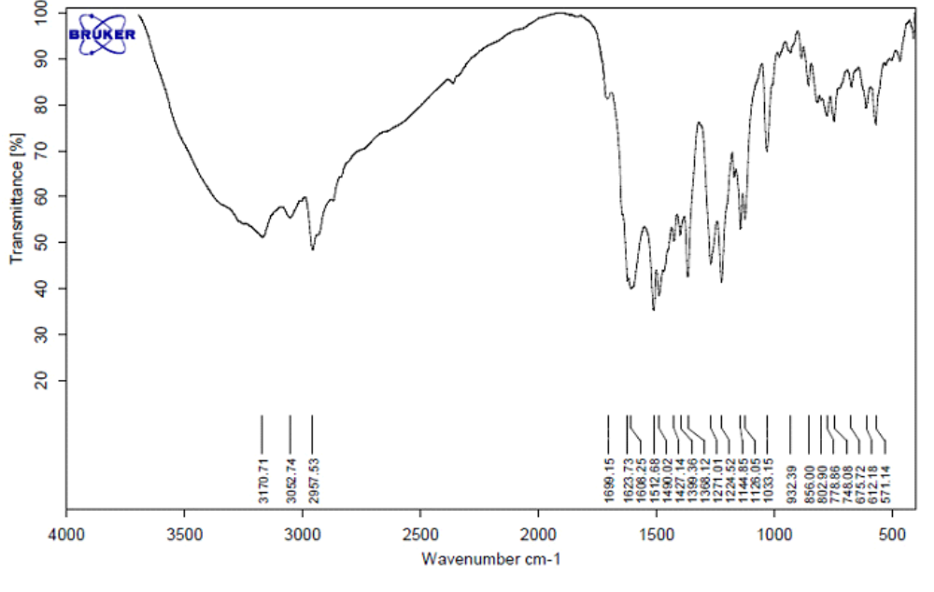
Figure S12. The FT-IR spectrum of PQ6.
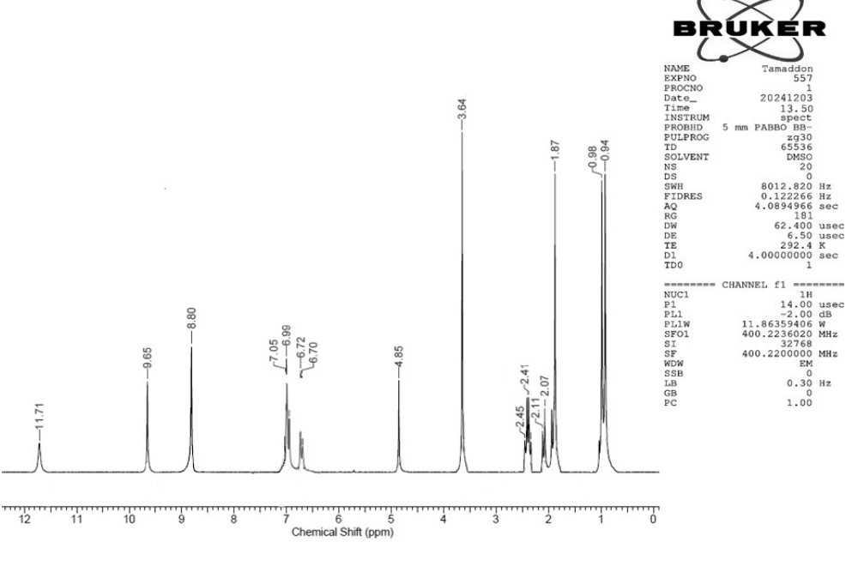
Figure 13 The ¹H NMR spectrum of PQ6.
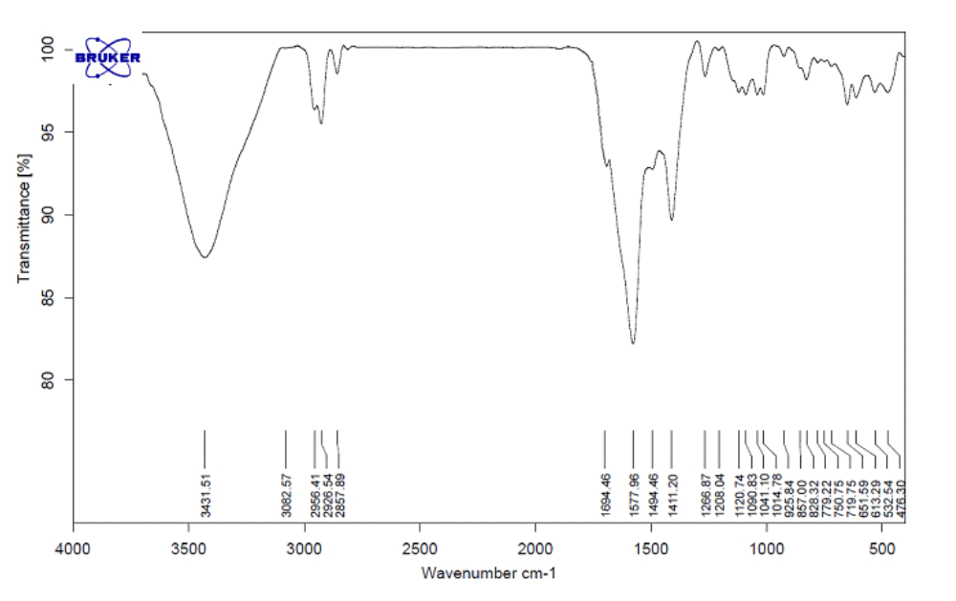
Figure S14. The FT-IR spectrum of PQ7.
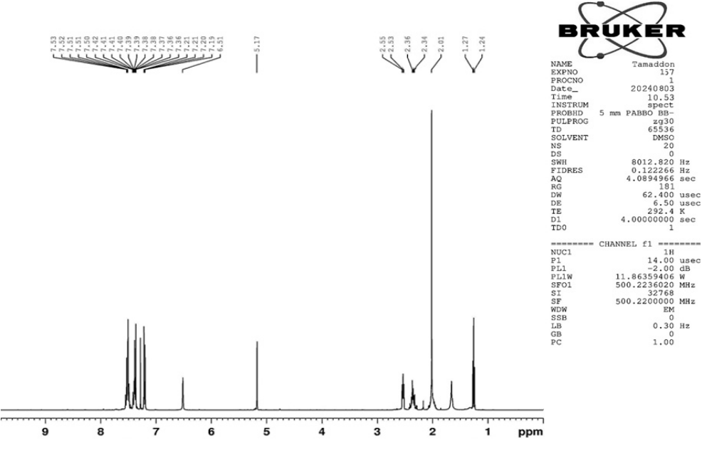
Figure S15. ¹H NMR spectrum of PQ7.
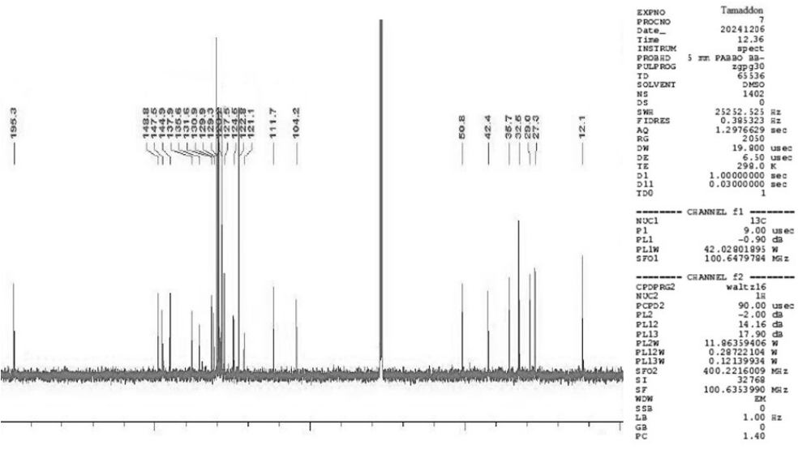
Figure S16. ¹³C NMR spectrum of PQ7
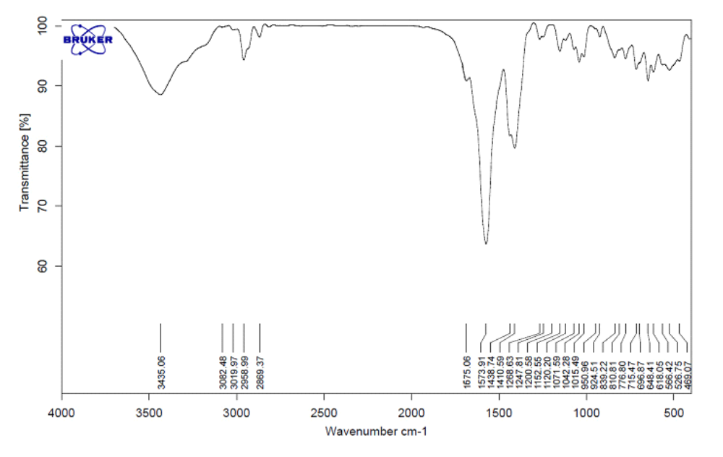
Figure S17. The FT-IR spectrum of PQ8
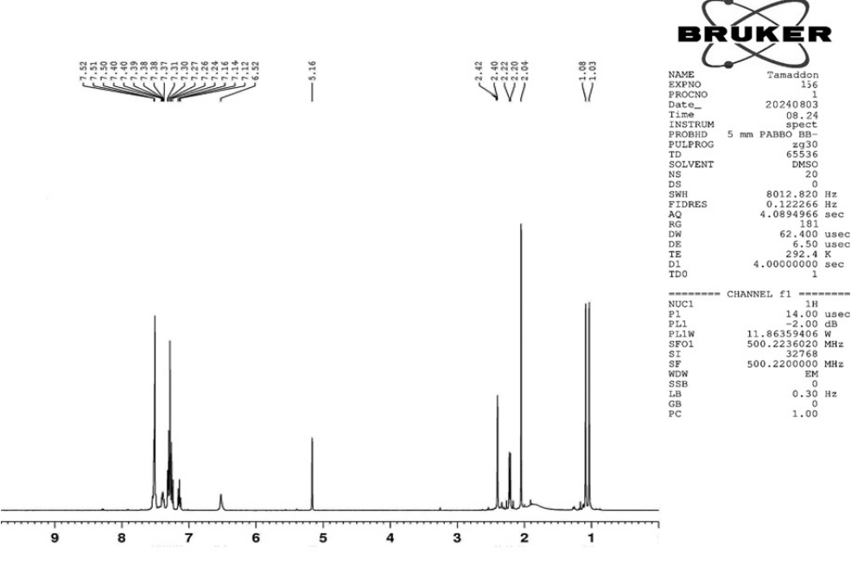
Figure S18. ¹H NMR spectrum of PQ8.
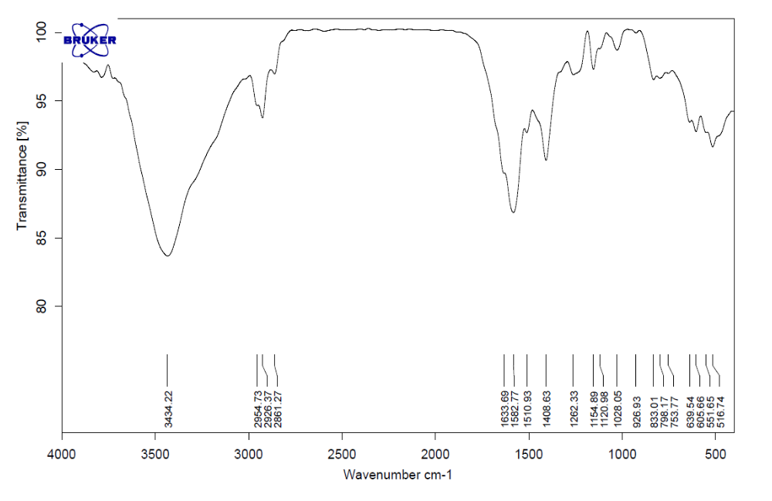
Figure S19. The FT-IR spectrum of PQ9.
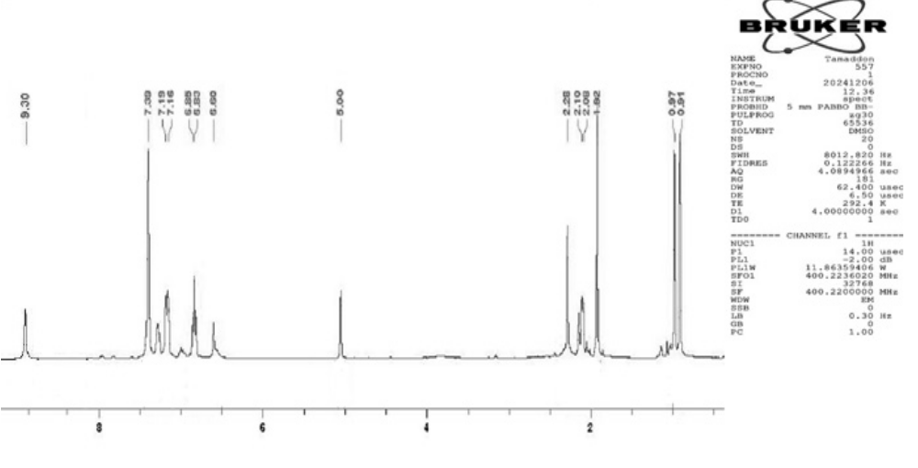
Figure S20. ¹H NMR spectrum of PQ9.
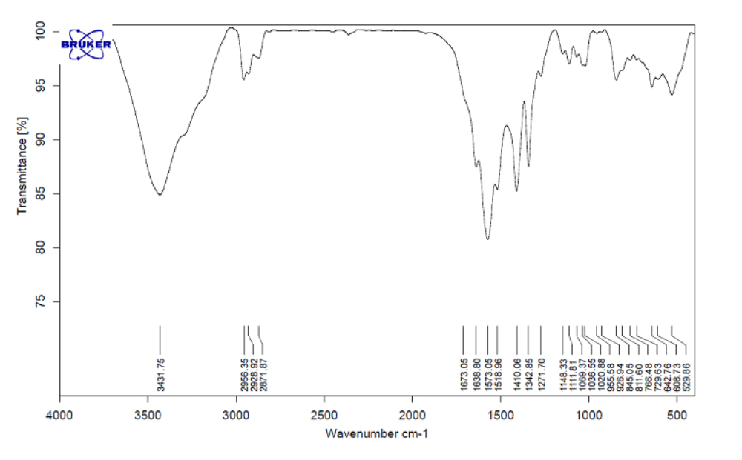
Figure S21. The FT-IR spectrum of PQ10.
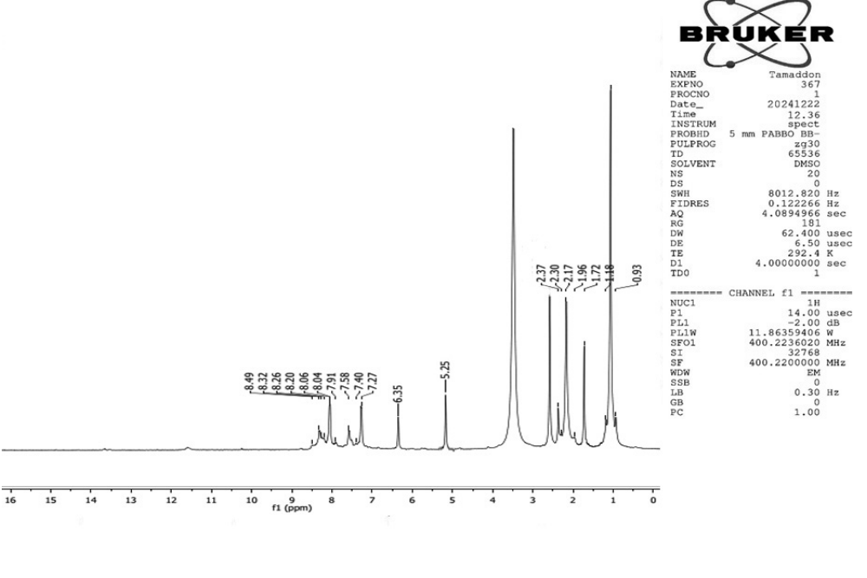
Figure S22. ¹H NMR spectrum of PQ10.
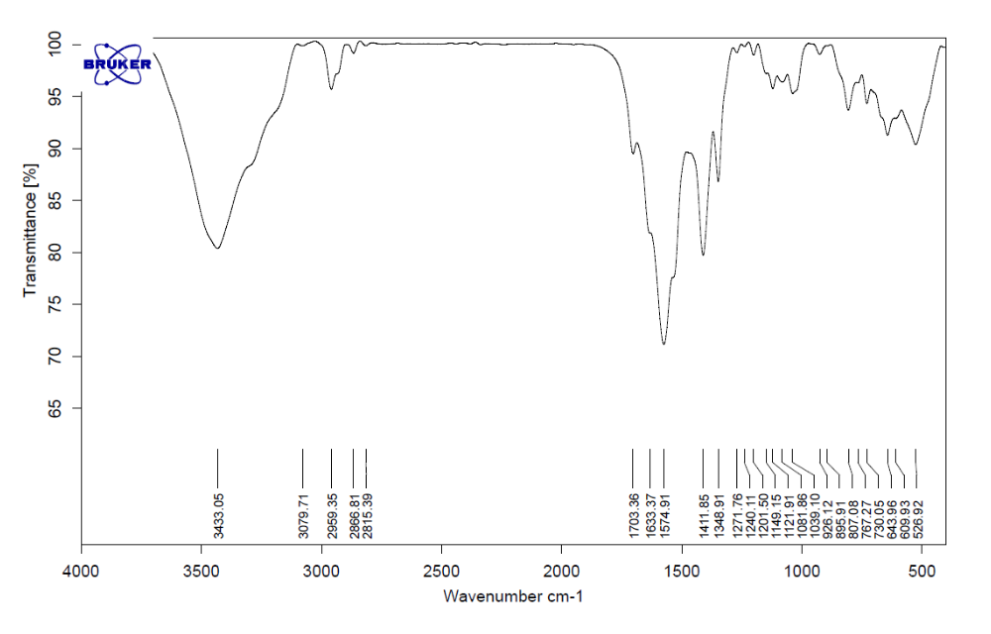
Figure S23. The FT-IR (KBr) spectrum of PQ11.
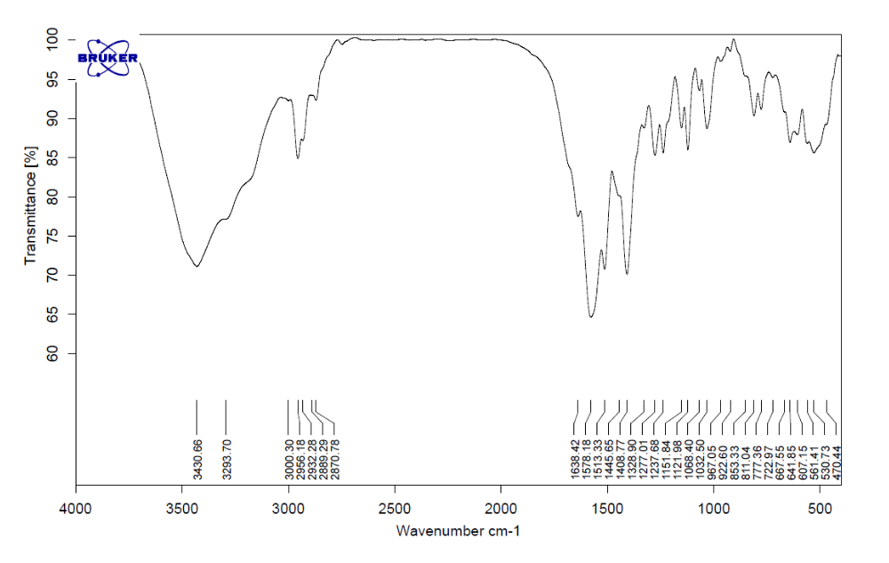
Figure S24. The FT-IR (KBr) spectrum of PQ12.
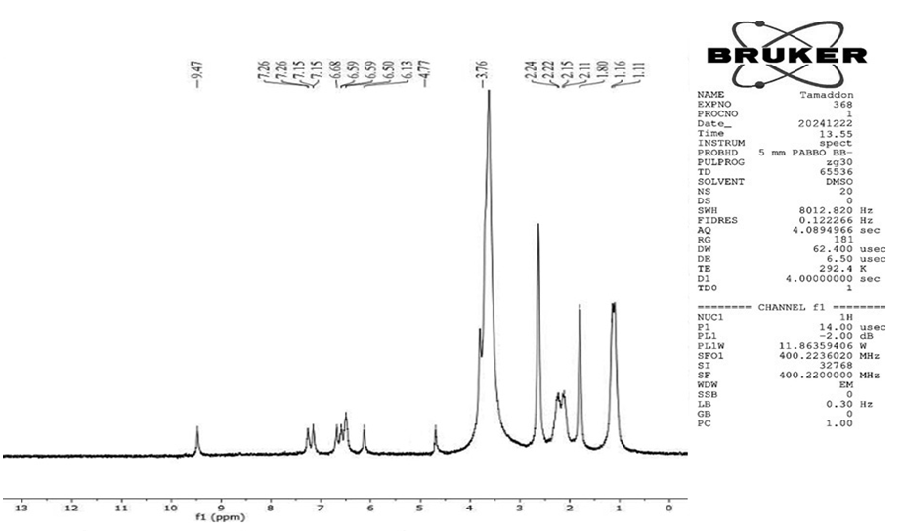
Figure S25. ¹H NMR spectrum of PQ12.
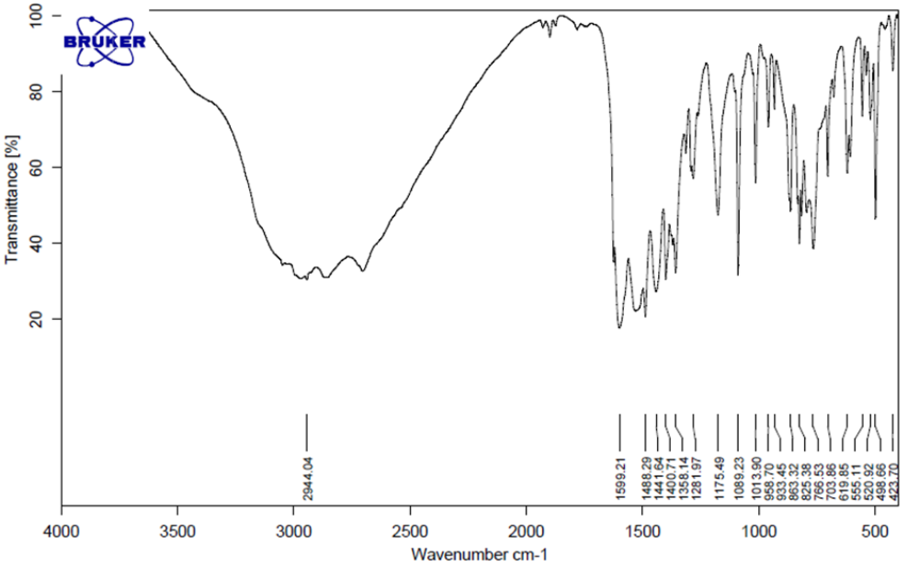
Figure S26. The FT-IR spectrum of THDPP1.
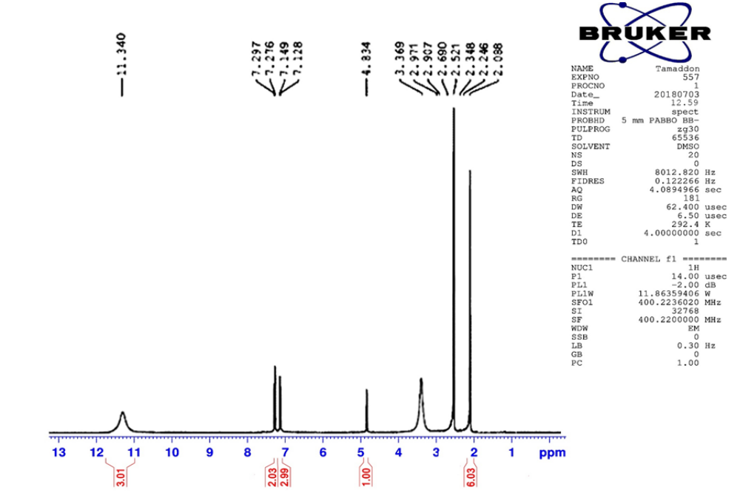
Figure S27. ¹H NMR spectrum of THDPP1.
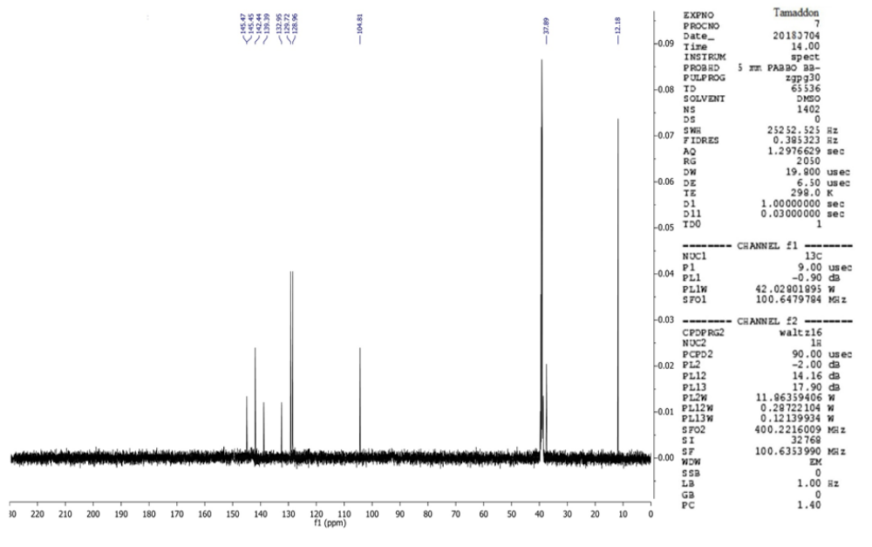
Figure S28. ¹³C NMR spectrum of THDPP1.
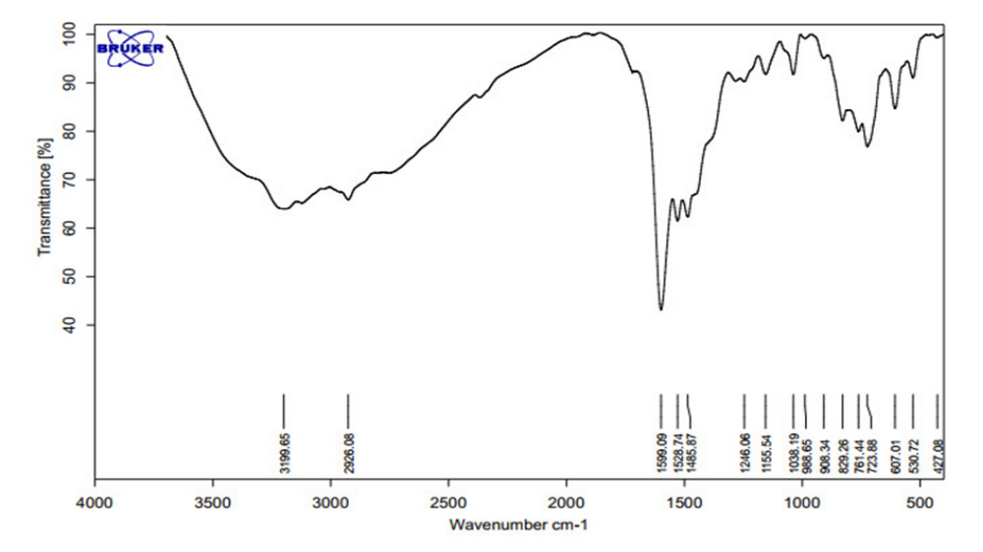
Figure S29. The FT-IR spectrum of THDPP2.

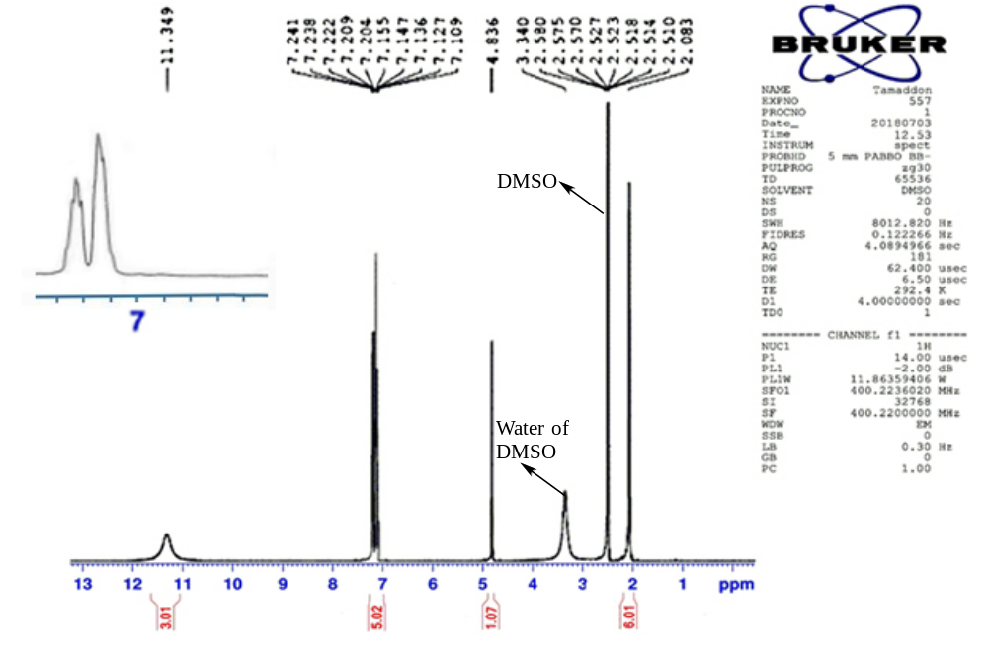
Figure S30. ¹H NMR spectrum of THDPP2
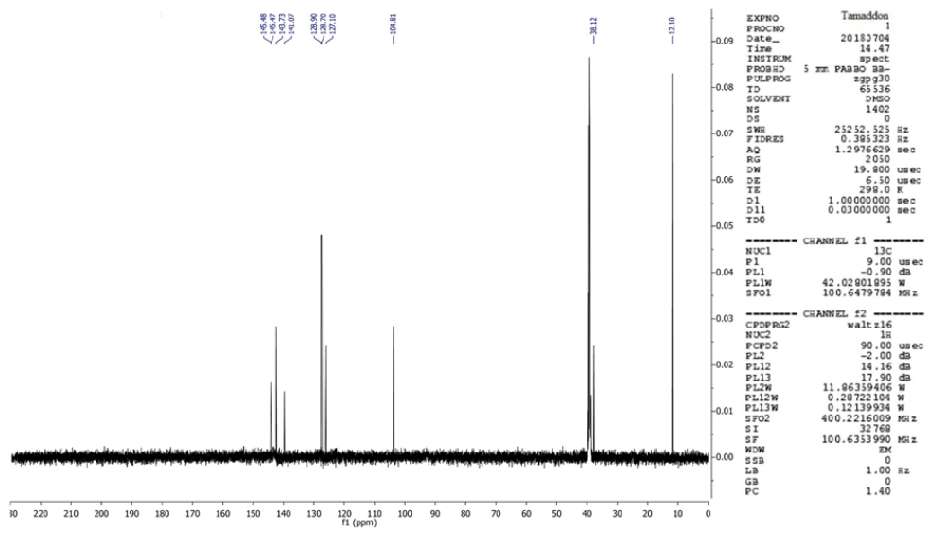
Figure 31. ¹³C NMR spectrum of THDPP2.
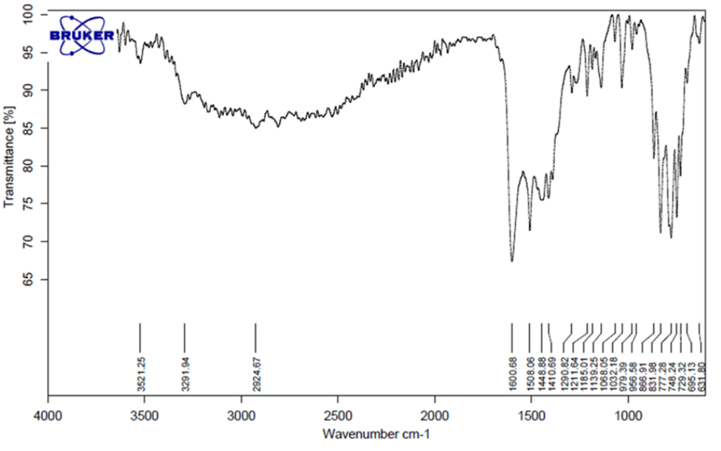
Figure S32. The FT-IR spectrum of THDPP3.
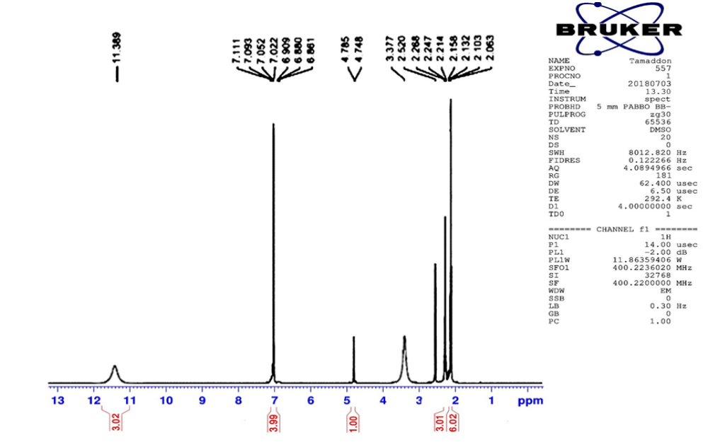
Figure S33. ¹H NMR spectrum of THDPP3
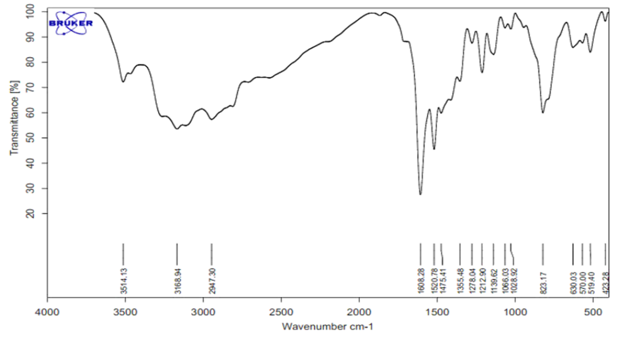
Figure S34. The FT-IR spectrum of THDPP4.
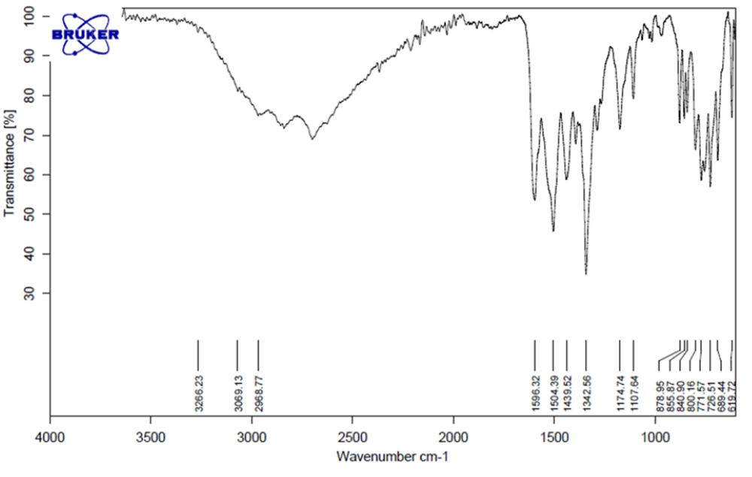
Figure S35. The FT-IR spectrum of THDPP5
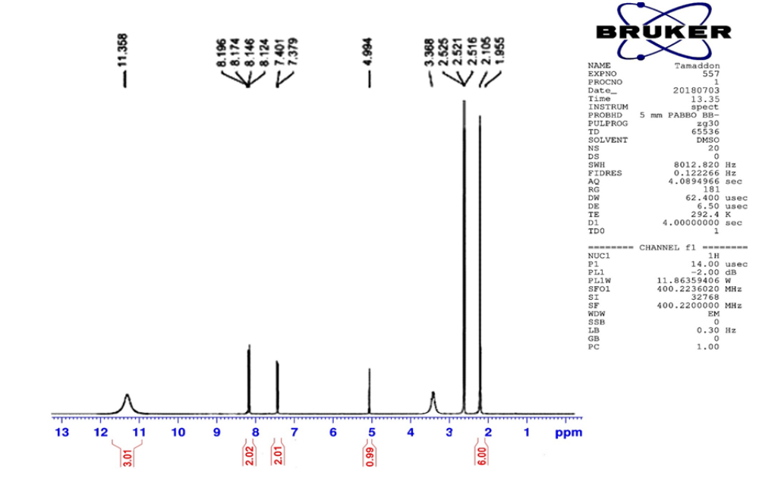
Figure S36. ¹H NMR spectrum of THDPP5.
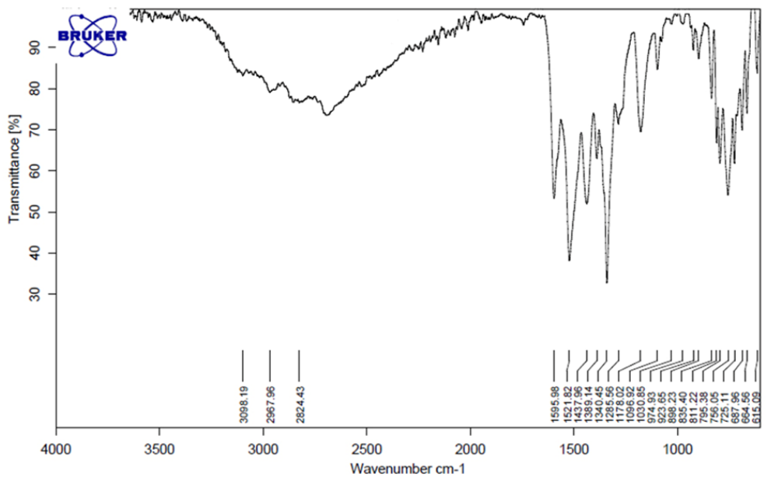
Figure S37. The FT-IR spectrum of THDPP6.
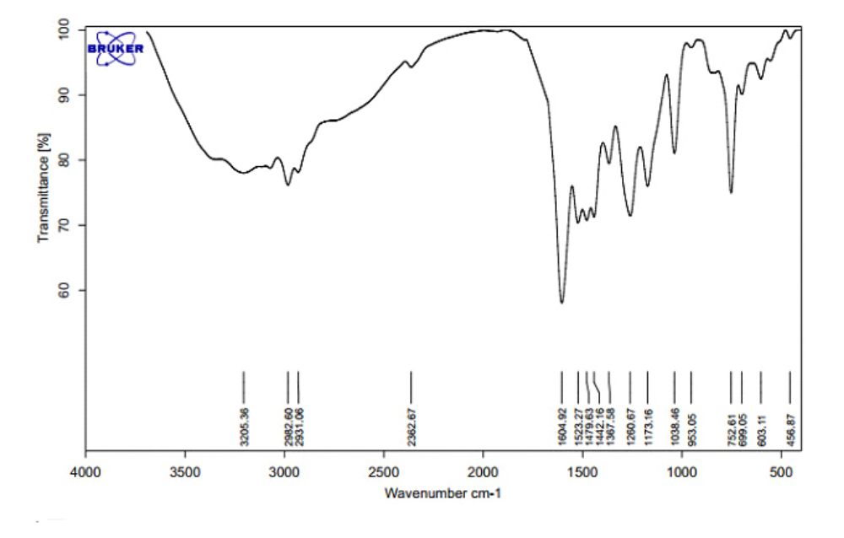
Figure S38. The FT-IR spectrum of THDPP7.
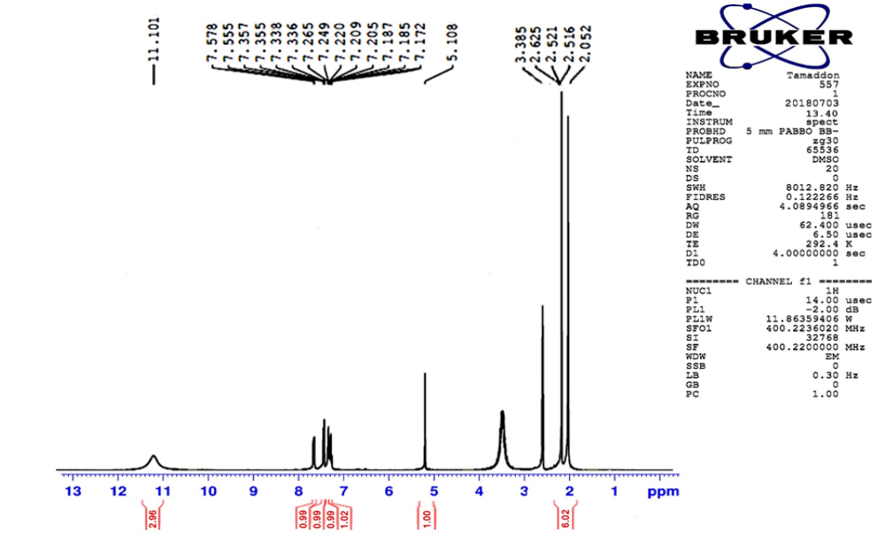
Figure S39. ¹H NMR spectrum of THDPP7.
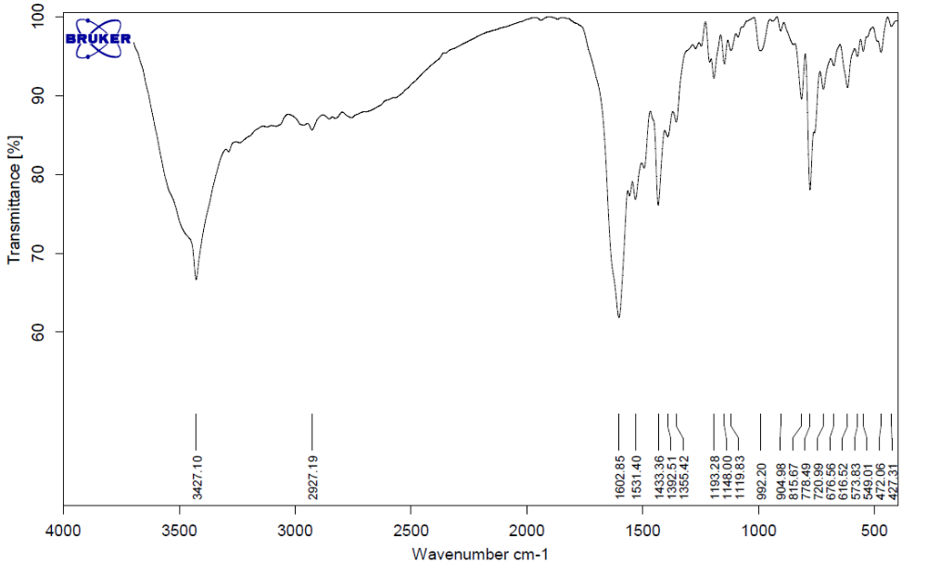
Figure S40. The FT-IR spectrum of THDPP8.
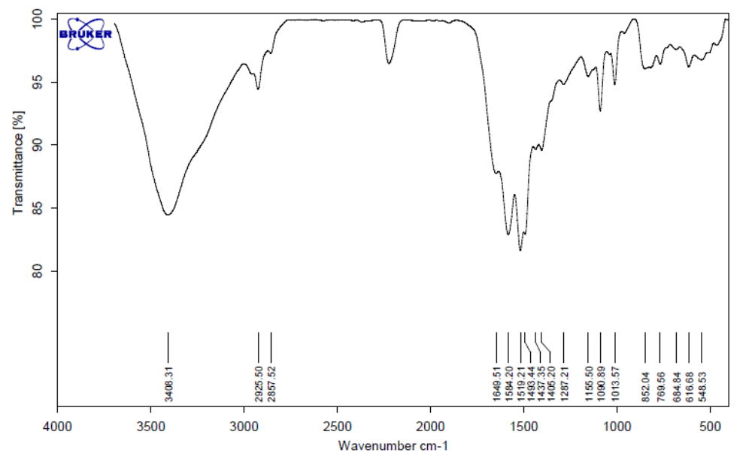
Figure S41. The FT-IR spectrum of PyPym1.

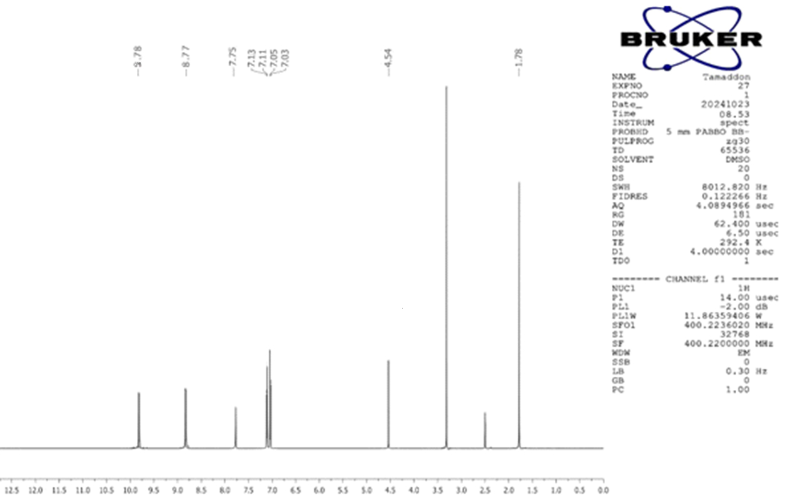
Figure S42. ¹H NMR spectrum of PyPym1.
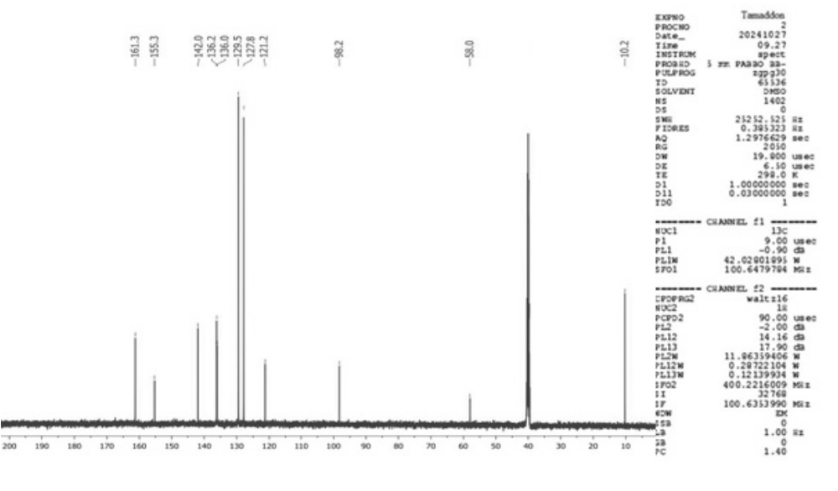
Figure S43. ¹³C NMR spectrum of PyPym1.
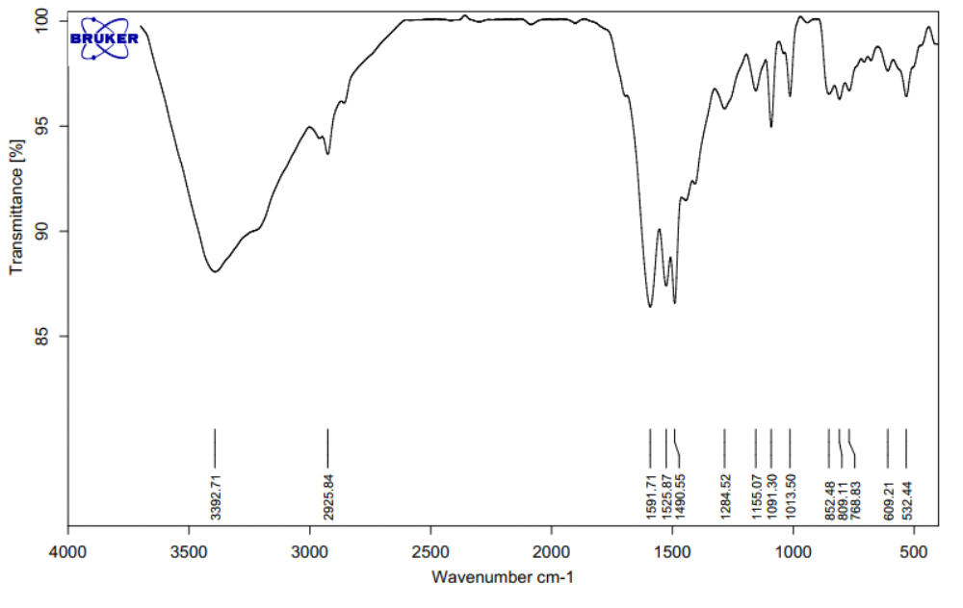
Figure S44. The FT-IR spectrum of PyPym2.

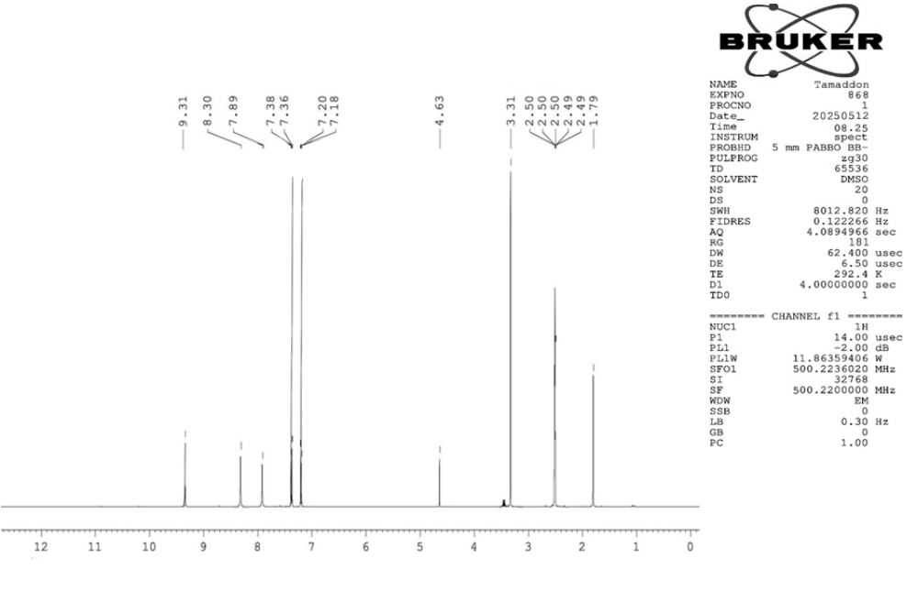
Figure S45. ¹H NMR spectrum of PyPym2.
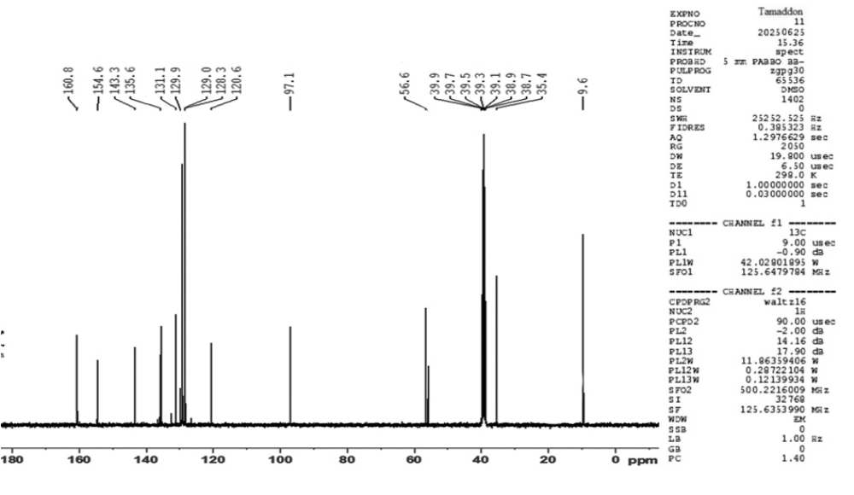
Figure S46. ¹³C NMR spectrum of PyPym2.
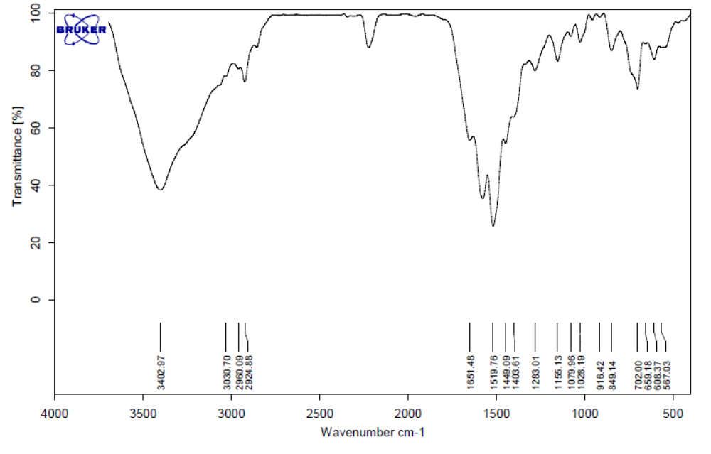
Figure S47. The FT-IR spectrum of PyPym3.
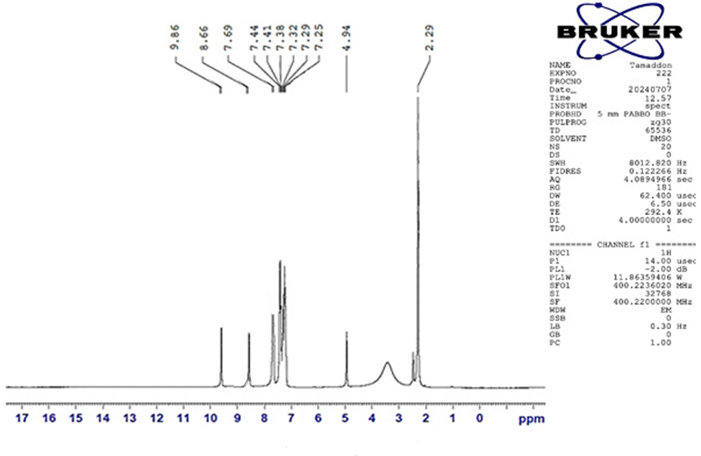
Figure 48. The ¹H NMR spectrum of PyPym3.
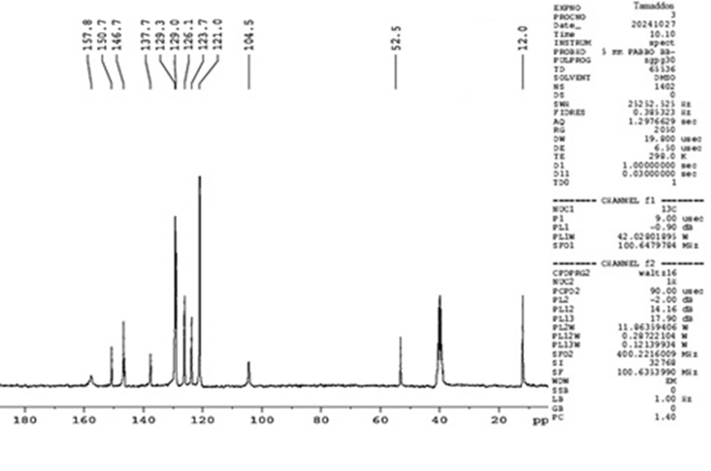
Figure S45. ¹³C NMR spectrum of PyPym3.
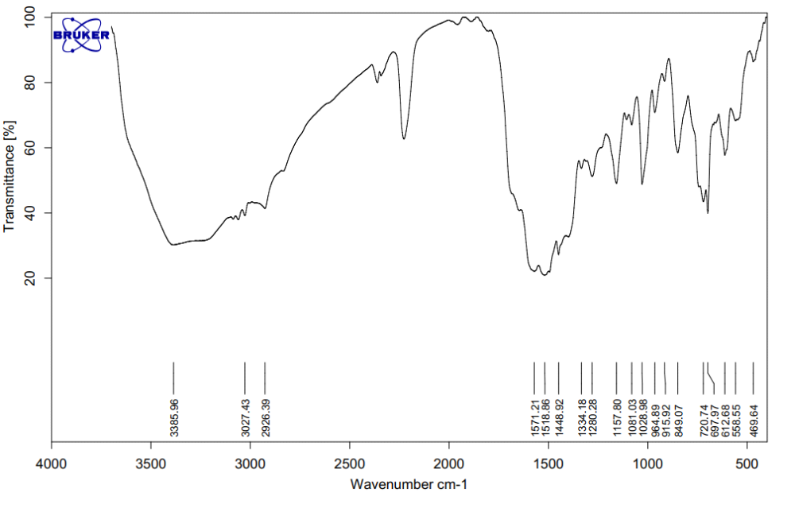
Figure S46. The FT-IR spectrum of PyPym4.
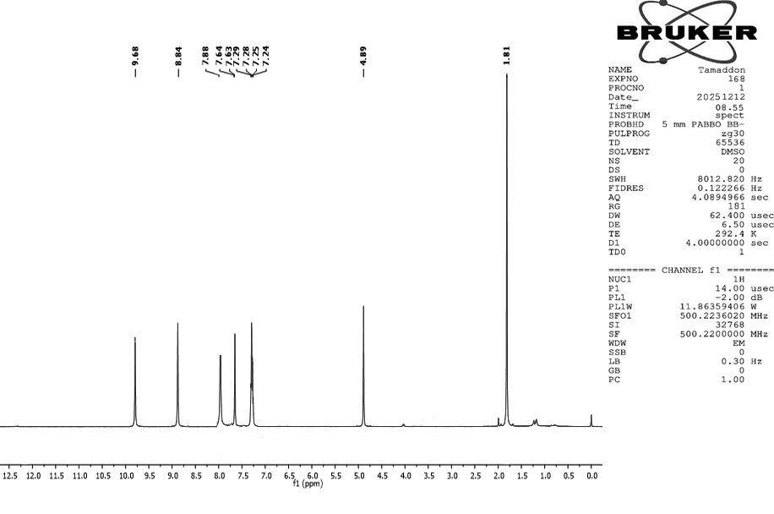
Figure 47. The ¹H NMR spectrum of PyPym4.
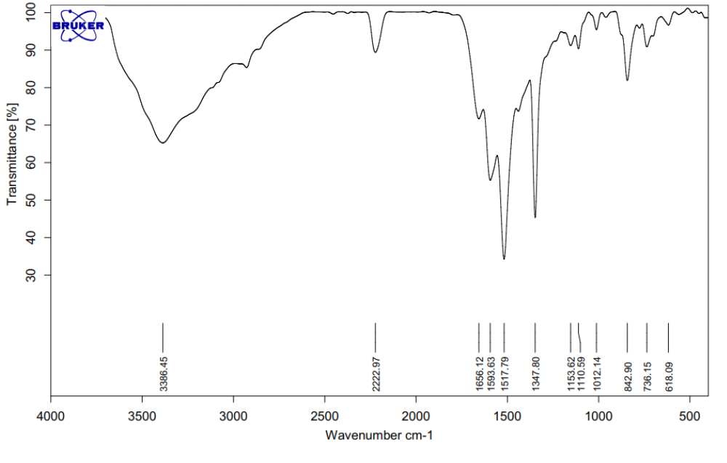
Figure S48. The FT-IR spectrum of PyPym5.
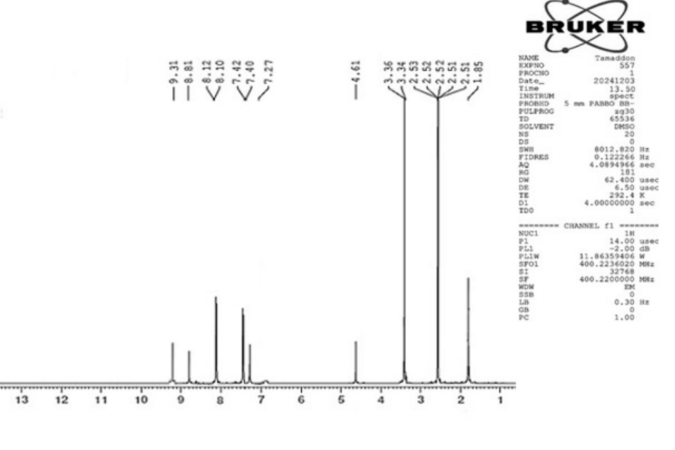
Figure 49. The ¹H NMR spectrum of PyPym5.
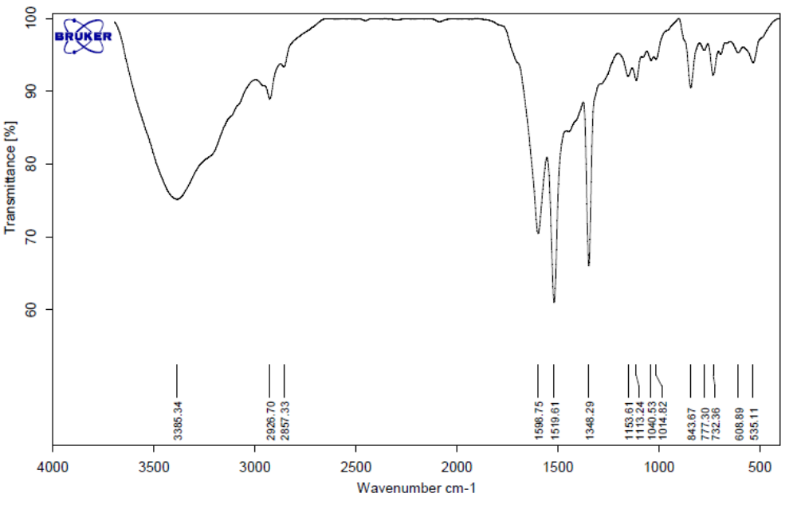
Figure S50. The FT-IR spectrum of PyPym6.
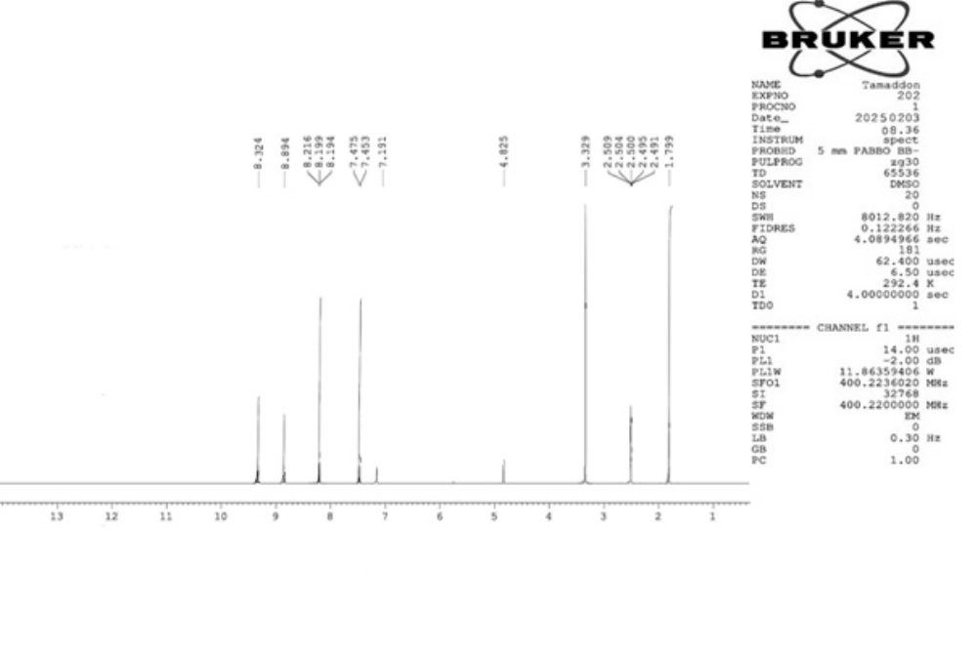
Figure 51. The ¹H NMR spectrum of PyPym6.
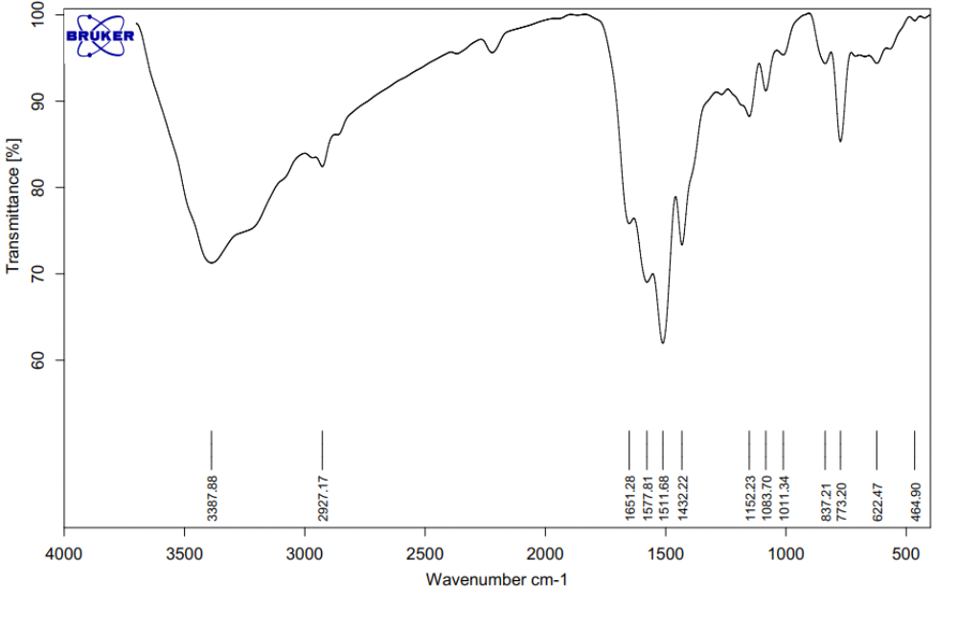
Figure S52. The FT-IR spectrum of PyPym7.
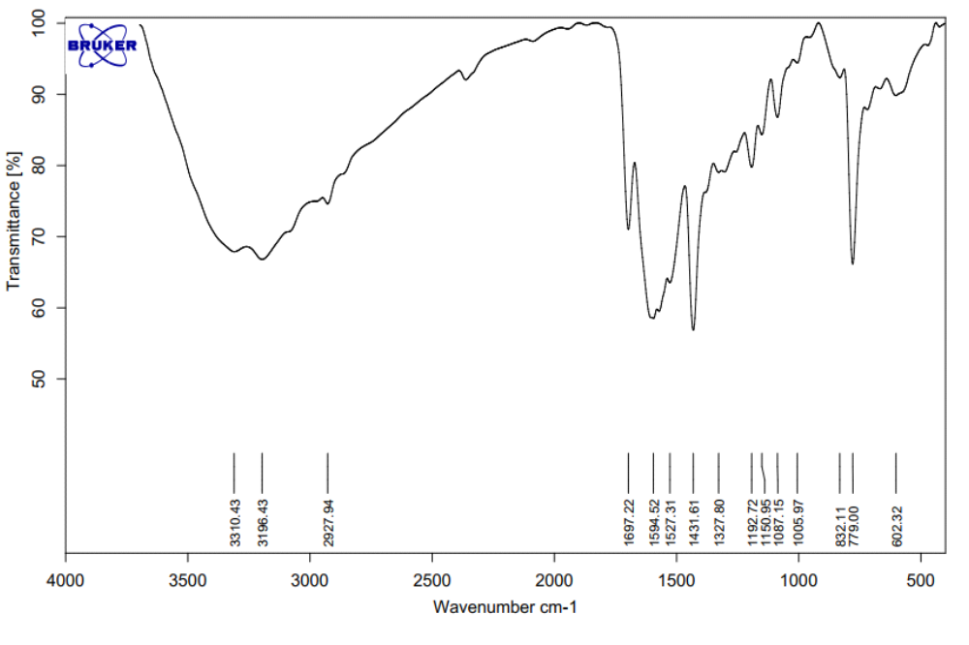
Figure S53. The FT-IR spectrum of PyPym8.
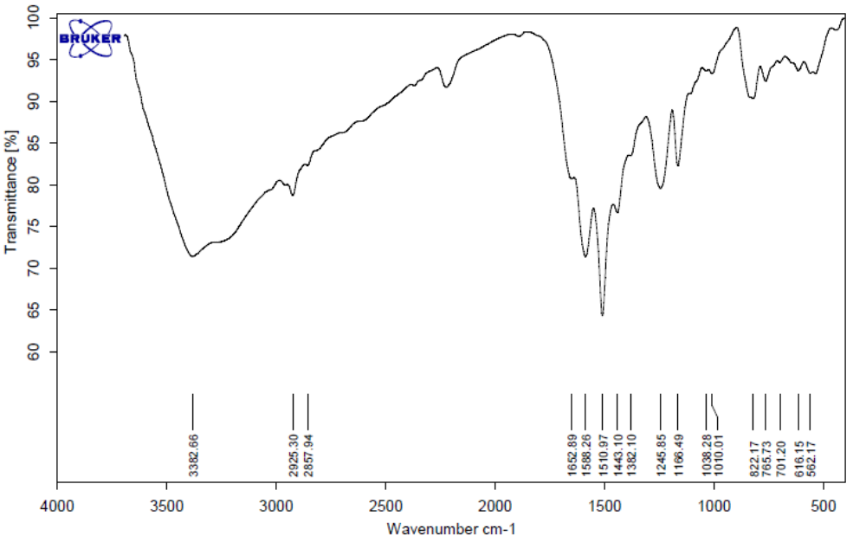
Figure S54. The FT-IR spectrum of PyPym9.
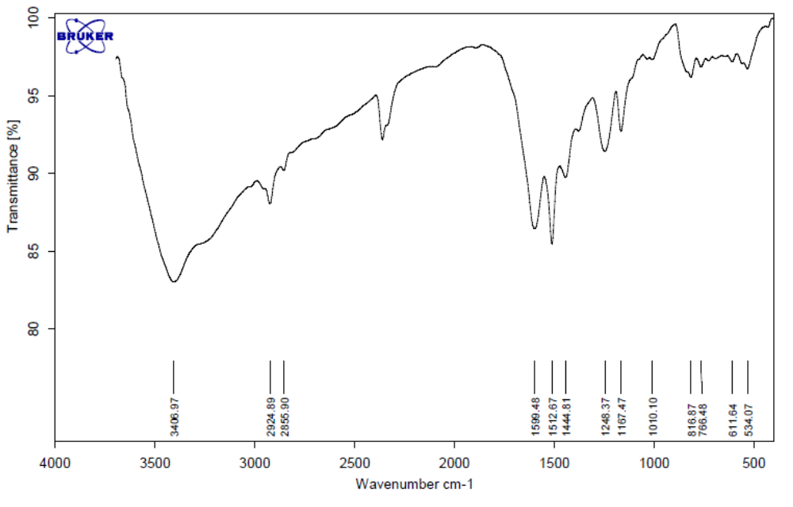
Figure S55. The FT-IR spectrum of PyPym10.

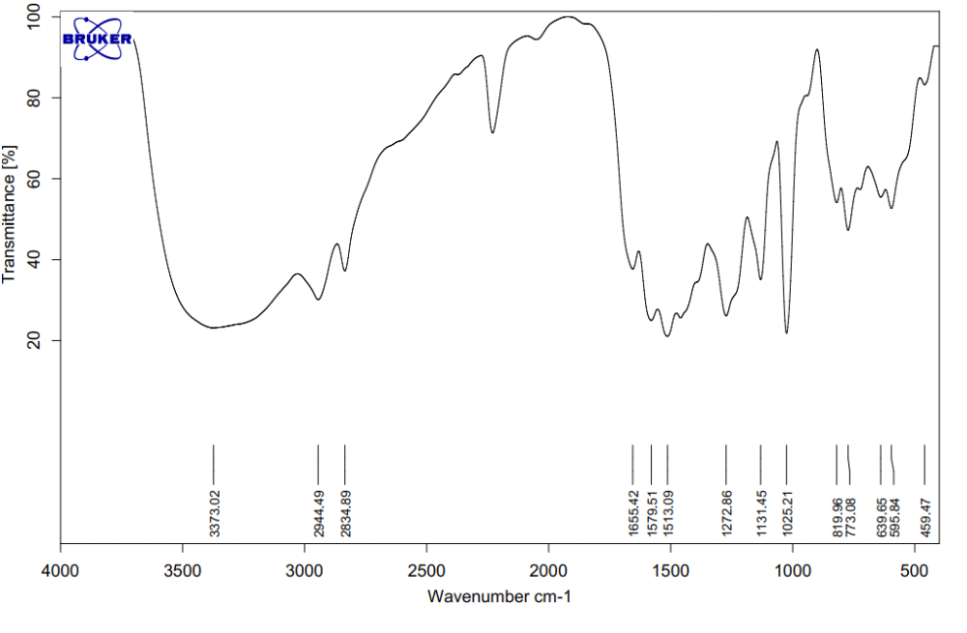
Figure S56. The FT-IR spectrum of PyPym11.

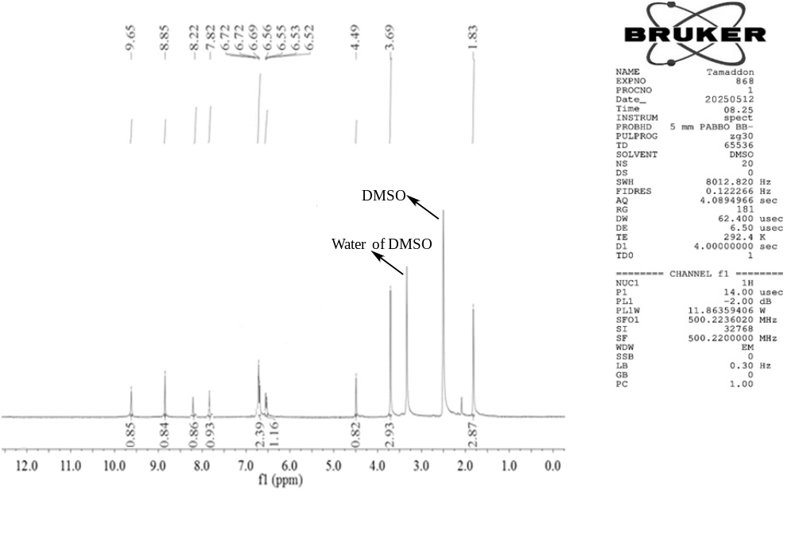
Figure 57. The ¹H NMR spectrum of PyPym11.
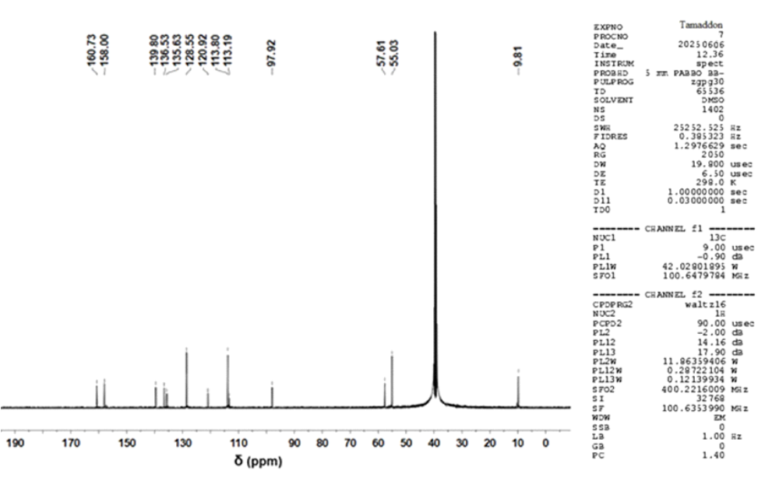
Figure 58. The ¹³C NMR spectrum of PyPym11.
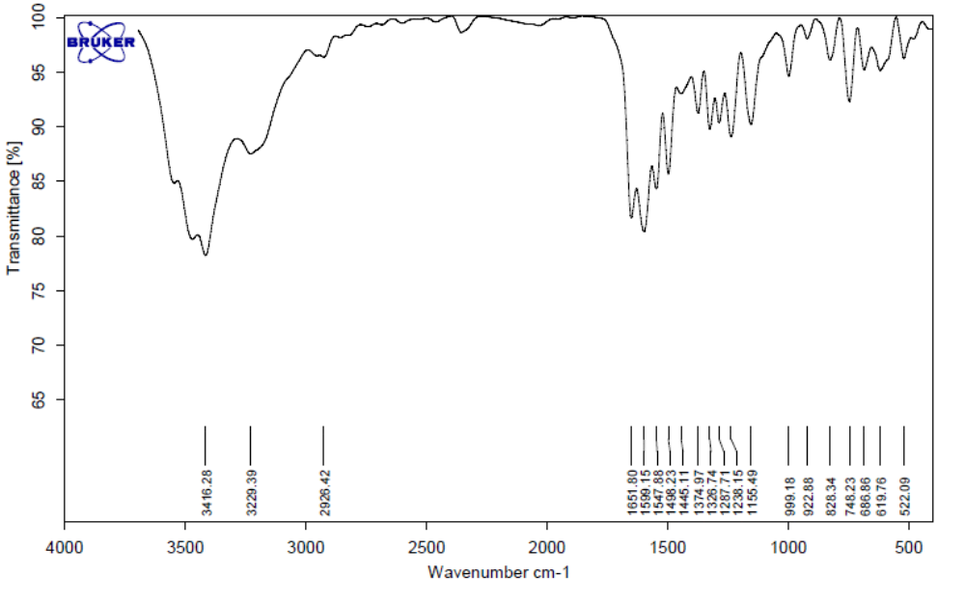
Figure S59. The FT-IR spectrum of PyPym12.

* Corresponding author. E-mail address: ftamaddon@yazd.ac.ir (F. Tamaddon).

