Supplementary Information

Dark Fermentative Biohydrogen Production from Fructose-rich Resources by the Photosynthetic Purple Bacterium Rhodospirillum rubrum
Sebastian Götz, Jonathan Beck, Kay Bretz, Hartmut Grammel*
Hochschule Biberach, Biberach University of Applied Science, Karlstraße 6-11, 88400 Biberach, Germany
*Corresponding author – grammel@hochschule-bc.de - Tel: +49 4 68 42 51 68

Supplemental Information S1: transcription analysis of hydrogen evolving enzyme by RT-PCR
As a marker gene for semiaerobic expression of nitrogenase, RT PCR was applied to detect nifH transcripts in semiaerobically dark grown cultures. The nifH gene (Rru_A1010) encodes the iron protein of the nitrogenase enzyme complex.
Briefly, R. rubrum was cultivated semiaerobically in M2SF medium containing different N-sources (NH₄, Asn, Asp, Gln, Glu, Gly) and after 3 days RNA was isolated. Semiaerobic conditions in shake-flask cultures were provided by filling 250 ml shake-flasks with 150 ml medium and low stirring at 150 rpm on a shaking incubator at 30 °C. High yields of intracytoplasmic photosynthetic membranes, determined as A₈₈₀/A₆₆₀ ratio in combination with high specific growth rates confirmed semiaerobic conditions, according to the criteria introduced in the main text.
RNA extraction was conducted with a Total RNA Purification Kit (Genaxxon bioscience, Ulm, Germany) according to the manufacturer instructions. After reverse transcription using M-MuLV Reverse Transcriptase and random hexamers, the resulting cDNA was used as template for PCR analysis of nifH transcription with the following primer pairs:
nifH_fwd ATCGGCTACAAGGGCATC
nifH_rev TACAGCGCCATCATCATCTCG
Glyceraldehyde 3-phosphate dehydrogenase (gapdh) as housekeeping gene:
fwd GATCAAGTTCGATTCCGTCC
rev AGTGGATGGTGGTCATGAAG

Since nitrogenase is subject to complex transcriptional and post-translational regulation, the detection of a transcript does not necessarily mean an active enzyme. We therefore tried to detect nitrogenase enzyme activity by purging culture samples with acetylene. After one hour of incubation in darkness or in the light, respectively, samples were analyzed by gas chromatography for the formation of ethylene (Supplemental Fig. S1B).

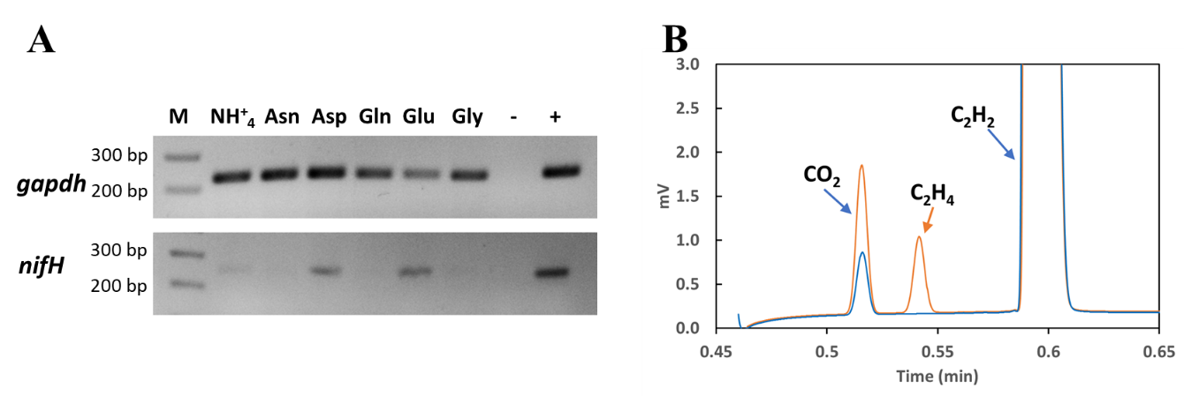
Supplemental Fig. S1 Test for nitrogenase expression and activity in semiaerobic dark cultivations of R. rubrum. A: transcript analysis of nifH and gapdh (housekeeping gene) under semiaerobic dark conditions. The cDNA PCR products (nifH: 242 bp, gapdh: 225 bp) were separated on a 2% agarose gel. M: marker. -: negative control: distilled water as template; +: positive control: genomic DNA as template. B: gas chromatography of the acetylen reduction assay for nitrogenase activity showing the separation of CO₂, actylene (C₂H₂) and ethylene (C₂H₄) on a poraplot column. Blue line: after one hour incubation in darkness of a semiaerobically grown culture. Red line: after one hour incubation with light exposure of a semiaerobically grown culture.

In the original M2SF medium of Ghosh et al. (Ghosh et al., 1994), containing ammonium succinate as source of nitrogen, a weak band at 242 bp was observed, indicating weak expression of nitrogenase (Supplemental Fig. S1A). When M2SF medium was modified with alternative N-sources, the amino acids L-aspartate and L-glutamate, provoked much stronger nifH PCR-bands. In contrast, no transcripts were found for the amino acids L-asparagine, L-glutamine and L glycine. The result is in accordance with the effect of amino acids on expression of the nifHDK operon in related purple bacteria e.g. Rhodobacter capsulatus (Pollock et al., 1988).

To detect in vivo nitrogenase enzyme activity, the same Agilent 990 Micro GC (Agilent Santa Clara, CA, USA), used for exhaust gas analysis at the bioreactor, was applied for the acetylene reduction assay. Samples were then taken from semiaerobically grown cultures and treated with 10 vol% acetylene. After one hour of incubation in darkness or under light exposure, the composition of the gas phase was analyzed by gas chromatography (supplemental Fig. S1B).
For the positive control, cultures were cultivated in glass bottles under light in a nitrogen-free nutrient medium and were purged with molecular nitrogen (N₂) as sole N-source through an airtight septum (diazotrophic growth). Diazotrophic growth under this condition is in itself a clear indication of nitrogenase activity and was used as positive control.
After 1 h incubation with acetylene, ethylene was detected in diazotrophic light-grown cultures. In semiaerobic dark-grown cultures, incubated in darkness for acetylene reduction, no ethylene could be detected. However, if semiaerobic cultures were incubated in the light, an ethylene peak occurred as shown in Supplemental Fig. S1B.
To assess the influence of light on gene expression and semiaerobic hydrogen production, two further cultivations were carried out, where semiaerobic dark cultivation was compared with semiaerobic conditions in illuminated 2 L glass bioreactors (Biostat B, Sartorius, Göttingen, Germany) (Supplemental Fig. 2) and transcription of genes encoding the hydrogen evolving enzymes nitrogenase (nifH, Rru_A1010) and formate hydrogen lyase (fhdA, Rru_A0324) were assayed by RT-PCR. The fhdA gene encodes the formate dehydrogenase component of the multi-subunit formate hydrogen lyase enzyme complex. The glyceraldehyde 3-phosphate dehydrogenase (gapdh) gene (Rru_A0222) was used as housekeeping gene.
R. rubrum was cultivated in M2SF medium supplemented with mmol L⁻¹ of L-Glu to stimulate expression of nitrogenase (Supplemental Fig. 1).
Briefly, the procedure for RT-PCR analysis was as follows: RNA isolation was performed using the Total RNA Purification Kit from Genaxxon bioscience (Genaxxon bioscience GmbH, Ulm, Germany). All steps were performed according to the manufacturer's instructions for gram-negative bacteria. The isolated RNA was then subjected to DNase digestion. The purified RNA was used for cDNA synthesis using the High-Capacity cDNA RT Kit from Thermo Fisher Scientific (Thermo Fisher Scientific, Waltham, MA USA). Quantitative RT PCR was conducted using a LightCycler 480 Instrument II (Roche Diagnostics, Mannheim, Germany) using the primer pairs:

Rru_A1010:
nifH_fwd CTACGACGACCTCGATTACG
nifH_rev CATACAGCGCCATCATCTCG
Product length : 134 bp

Rru_A0324:
fdhA_fwd AATCCATGCGCGATCTGGAA
fdhA_rev CGGTTCGATCGCCTTGTAGA
Product length : 164 bp

Rru_A0222:
gapdh_fwd AGAAGGCCAAGGTGCATC
gapdh_rev AGTGGATGGTGGTCATGAAG
Product length : 225 bp

The comparison on the gene expression level in semiaerobic phototrophic versus semiaerobic dark culture was calculated by the 2^{−ΔΔCt} method (Livak and Schmittgen, 2001). The result is shown in Supplementary Fig. 2. Depicted are the ΔCt values Ct(target gene) − Ct(reference gene).

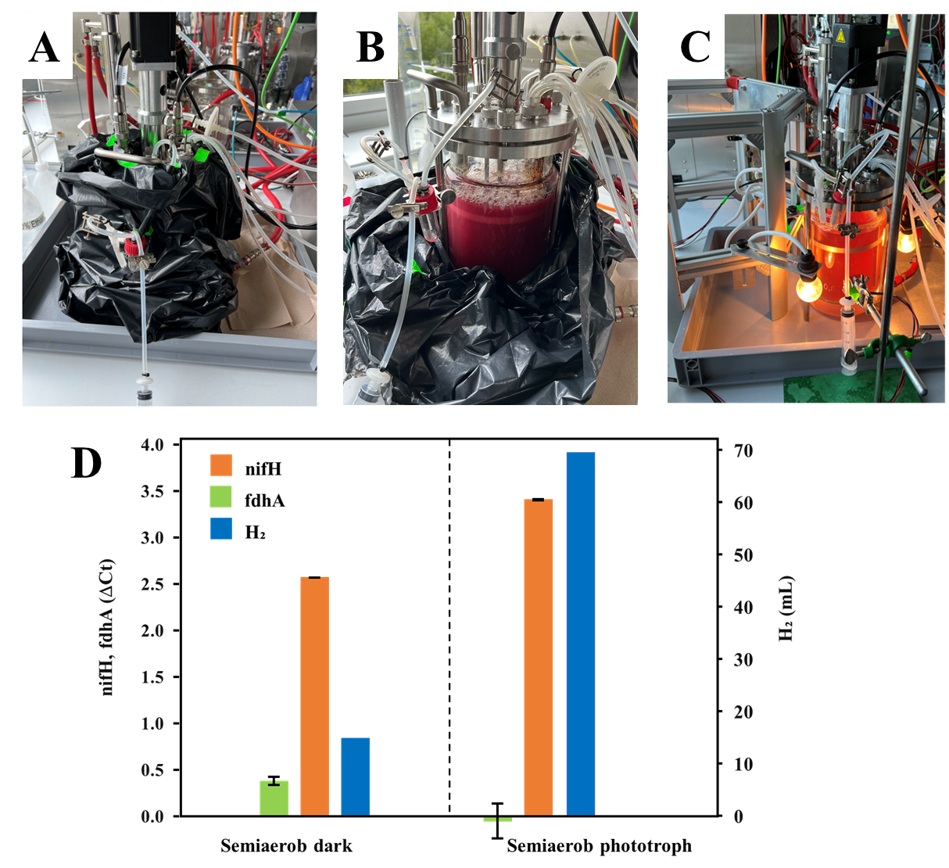
Supplemental Fig. S2 Expression analysis of nifH and fdhA in bioreactor cultivations. A: semiaerobic dark bioreactor setup; B: semiaerobic dark culture with full pigmentation (M2SF-Effekt). C: semiaerobic phototrophic bioreactor setup. D: relative expression of nifH und fdhA (Ct(target gene) − Ct(reference gene) and accumulated H₂. Error bars show standard deviation form triplicates.

While fhdA transcription was slightly lower in the light-grown culture with a fold change 2^{−ΔΔCt} = 0.742262, nifH transcription during light-based cultivation increased 1.78-fold. However, hydrogen evolution in the illuminated bioreactor rose much more sharply—specifically, 4.6-fold to the semiaerobic dark cultivation (69.61 H₂ ml produced in the semiaerobic phototrophic cultivation versus 14.97 ml H₂ produced in the semiaerobic dark cultivation). The volumetric productivity in the semiaerobic phototrophic cultivation was 0.097 mmol H₂/L/h compared to 0.05 mmol H₂/L/h in the semiaerobic dark cultivation.
Despite the lack of biological replicates, the results together provide strong evidence that nitrogenase needs light activation for full activity in accordance with a previous report (Voelskow and Schön, 1980). We therefore do not expect a significant contribution to the observed hydrogen production under dark fermentative conditions as described in the main text.

Supplemental Information S2: pressed grape pomace juice as feedstock for R. rubrum.
For the purpose of unlocking new resources for a future biorefinery application, it was tested whether R. rubrum is able to grow semiaerobically with pressed pomace juice, a side-product of wine production as substrate and to produce hydrogen thereof. After processing of the undiluted raw material as described in the main text, no growth was observed. The growth inhibition was retained when a 1:1 dilution as applied, while a 1:10 dilution allowed significant growth to occur albeit at a lower growth rate and a lower biomass yield compared to the defined M2SF medium (supplemental Fig. S3A). It was therefore assumed that inhibitory compounds are present in the complex substrate which may be less effective in diluted GPJ. The composition given in supplemental Fig. S2B suggest that the high osmolarity and high sugar concentrations contribute to the observed growth inhibition (supplemental Fig. S3B). The pH was adjusted to 6.8 in all growth experiments
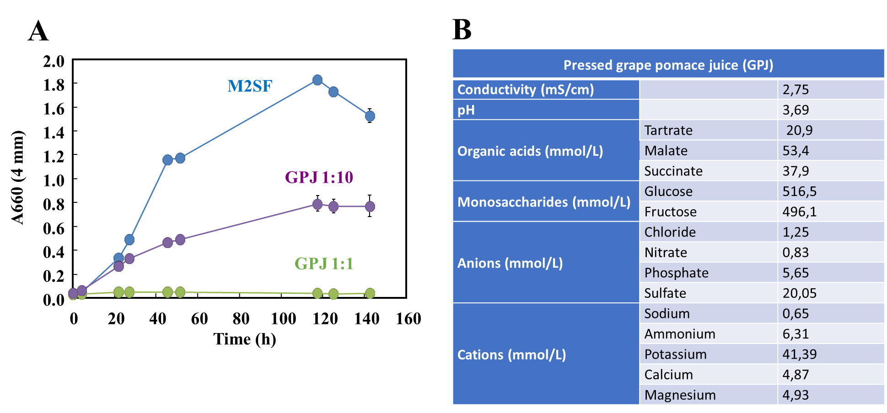
Supplemental Fig. S3. A: Growth curves of R. rubrum in semiaerobic shake-flask cultivations with M2SF medium and pressed pomace juice (GPJ) as growth substrates. B: Chemical analysis of GPJ. Organic acids and monosaccharides were determined by HPLC as described in the main text. Ion chromatography was used for determining anions and cations.

References
Ghosh, R., Hardmeyer, A., Thoenen, I., Bachofen, R., 1994. Optimization of the Sistrom Culture Medium for Large-Scale Batch Cultivation of Rhodospirillum rubrum under Semiaerobic Conditions with Maximal Yield of Photosynthetic Membranes. Applied and environmental microbiology 60 (5), 1698–1700. https://doi.org/10.1128/aem.60.5.1698-1700.1994.
Livak, K.J., Schmittgen, T.D., 2001. Analysis of Relative Gene Expression Data Using Real-Time Quantitative PCR and the 2−ΔΔCT Method. Methods 25 (4), 402–408. https://doi.org/10.1006/meth.2001.1262.
Pollock, D., Bauer, C.E., Scolnik, P.A., 1988. Transcription of the Rhodobacter capsulatus nifHDK operon is modulated by the nitrogen source. Construction of plasmid expression vectors based on the nifHDK promoter. Gene 65 (2), 269–275. https://doi.org/10.1016/0378-1119(88)90463-5.
Voelskow, H., Schn, G., 1980. H2 production of Rhodospirillum rubrum during adaptation to anaerobic dark conditions. Arch. Microbiol. 125 (3), 245–249. https://doi.org/10.1007/BF00446884.

