SUPPLEMENTARY INFORMATION
China's urban fringes are undergoing functional reorganization
Component | Contents
Supplementary Methods | Five analyses supporting spatial construction, external context, temporal extension, hindcast calibration and scenario interpretation
Supplementary Figures | Five figures (S1–S5)
Supplementary Tables | Four table groups (S1–S4; 13 sub-tables)
Companion data | Three machine-readable Excel workbooks supplied in Supplementary_Data_Excel.zip

Contents
Section | Items
Supplementary Methods | S1–S5
Supplementary Figures | Figs. S1–S5
Supplementary Tables | Tables S1–S4
Supplementary References | References 1–10

File scope. This document reports analyses and summary tables that support the blinded manuscript. The companion Excel archive contains the complete machine-readable source data for manuscript Figs. 1–5, Supplementary Figs. S1–S5 and Supplementary Tables S1–S4, including the annual VIIRS nighttime-light data used in manuscript Fig. 3 (ref. 10). Licensed raw Amap POI records are not redistributed.
Terminology. A city–grid instance is one fixed 500-m cell considered within one city-specific observation domain. Because some domains overlap, the 152,873 city–grid instances correspond to 146,118 unique spatial cells. MF denotes a low-dominance mixed state and may include low-information or all-zero POI cells; it is not evidence that multiple functions are necessarily present or coordinated.

Supplementary Methods

S1. Fixed observation domain and geometric sensitivity
The primary observation domain was fixed to the 2012 urban form so that functional change was measured at the same locations through time. The 30-m China Land Cover Dataset (CLCD) impervious class (ref. 1) was aggregated in the China Albers equal-area projection. Candidate built-up cells had an impervious fraction of at least 70% at the 500-m support. A 3 × 3 morphological closing operation was applied, after which the principal eight-neighbour-connected component containing the city-centre seed was retained; when the seed did not intersect a candidate component, the nearest principal component was used. The study domain comprised cells outside that 2012 core and within 10 km of its outer edge. The identical city-specific set of cells was then followed in all six observation years.
Geometric sensitivity was evaluated without refitting the POI-derived functional trajectories. We reconstructed the domain under all 36 combinations of three grid supports (250, 500 and 1,000 m), four impervious thresholds (50%, 60%, 70% and 80%) and three outer-buffer widths (5, 10 and 15 km). For every specification and city, fringe area was expressed relative to the primary 500-m, 70%, 10-km specification. Supplementary Fig. S1 reports the city-equal distribution of these area ratios and the 2012-to-2022 change in thresholded built-up area. The exercise quantifies observation-domain geometry; it is not a robustness refit of the state threshold, transition matrices or 2035 scenarios.

S2. ASPECT population context and sampling precision
The 2020 Age-Stratified Population Estimation from the 2020 China Census by Township (ASPECT) at 100-m resolution (refs. 2,3) was used as cross-sectional context for the functional states. Population density was sampled at a regular 10 × 10 lattice within each 500-m cell, averaged over finite samples and multiplied by 25 ha to obtain an approximate cell population. Finite estimates were available for 140,462 city–grid instances (91.88% of the full sample). Population distributions were summarized by 2020 functional state, and within-city Spearman correlations were calculated between population and impervious fraction. Distance profiles were computed within each city and normalized to its median population in the 0–2.5-km band before city-equal aggregation.
Sampling precision was checked on 15,000 cells selected across population deciles by repeating the calculation with a 20 × 20 lattice. Relative error was defined against the denser computation, with population and coverage subsets reported separately. ASPECT was not used to assign states, fit transitions or construct the 2035 scenarios. Because the ASPECT downscaling model includes POI covariates, the comparison is not an independent validation of the POI-derived classification and is interpreted only as population context.

S3. Temporal extension to 2023
A one-year temporal extension applied the final POI crosswalk, deduplication procedure, within-city rank transformation and fixed dominance threshold to 2023 snapshots. The threshold (0.415039) was obtained by the Otsu procedure (ref. 4) from the 2012–2022 analysis panel and was not re-estimated with 2023 observations; reapplying it to the stored 2022 inputs reproduced the main-analysis assignments. Complete 2023 snapshots were available for 13 cities. Guangzhou and Shenzhen were excluded rather than interpolated because their 2023 POI archives were incomplete.
We calculated the city-equal 2022–2023 origin-conditioned transition matrix, city-specific changes in state shares, annualized turnover and within-state changes in the seven relative functional scores. The 2022–2023 turnover value for each city was compared with the minimum, median and maximum annualized turnover across its historical adjacent intervals. This extension assesses whether the principal transition structure remained observable in the next available snapshot; it does not resolve cross-year changes in platform coverage or establish entity-level entries and exits.

S4. Rolling-origin hindcasts and calibration
Calibration targeted aggregate origin–destination flows rather than exact cell labels. For each historical interval, diagonal persistence was annualized and off-diagonal mass was distributed according to observed destination proportions. A Jeffreys constant of 0.5 (ref. 5) prevented unsupported structural zeros. City-specific rows were shrunk toward the 15-city matrix with weight n/(n+τ), and a common offset was applied to persistence on the logit scale. Candidate values were τ ∈ {100, 300, 1,000, 3,000} and a persistence offset from −1.5 to 1.5 in 0.25 increments, with 2.0, 2.5 and 3.0 also examined. The selected setting (τ=100; offset=−1.0) was determined from rolling-origin folds ending in 2017, 2020 and 2022 using flow and composition Jensen–Shannon divergence (ref. 6), turnover error and state-persistence error. Cell-level transition potential used scikit-learn's HistGradientBoostingClassifier (ref. 8), and target margins were restored by iterative proportional fitting (ref. 7).
Supplementary Fig. S4 pools 458,619 city–grid transitions across the three selection folds. Flow concordance is summarized by Jensen–Shannon divergence and Spearman association among off-diagonal probabilities; gross-turnover error is summarized at aggregate and city levels. The pooled-flow divergence of 0.0031 was calculated after pooling observed and hindcast counts over folds, whereas 0.01049 in Supplementary Table S4b is the weighted mean of fold-specific divergences; the two differ because Jensen–Shannon divergence is nonlinear. State-persistence intervals were obtained from 10,000 bootstrap resamples of city–fold strata. Cell-allocation metrics are reported separately against a persistence-only reference because the fitted objective was aggregate flow calibration. Consequently, lower cell-level macro-F1 than persistence for some states does not invalidate the aggregate target, but it limits interpretation of any individual 500-m allocation, consistent with recommended separation of calibration targets and validation claims in land-change modelling (ref. 9).

S5. Scenario agreement and model boundary
We compared hard-state allocations under historical continuation, ecological protection, mixed-function guidance and the development stress test. For each city–grid instance, agreement was coded as complete agreement, variation restricted to EA and MF, or variation involving another state. Under historical continuation, the margin between the two largest modeled state probabilities was divided into within-city deciles; the scenario-sensitive share was then summarized across cities with percentile intervals from 20,000 city-level bootstrap resamples. Directional changes for each scenario were calculated relative to historical continuation.
Across all 152,873 city–grid instances, 94.4% retained the same hard state under all four scenarios. Of the 8,536 scenario-sensitive instances, 97.2% varied only between EA and MF. This concentration shows that apparent scenario differences are primarily located near an uncertain boundary between eco-agricultural dominance and low dominance. Scenario contrasts are therefore conditional diagnostics of the specified model and empirical analogue rules; they are neither deterministic forecasts nor estimates of policy causality.

Supplementary Fig. S1
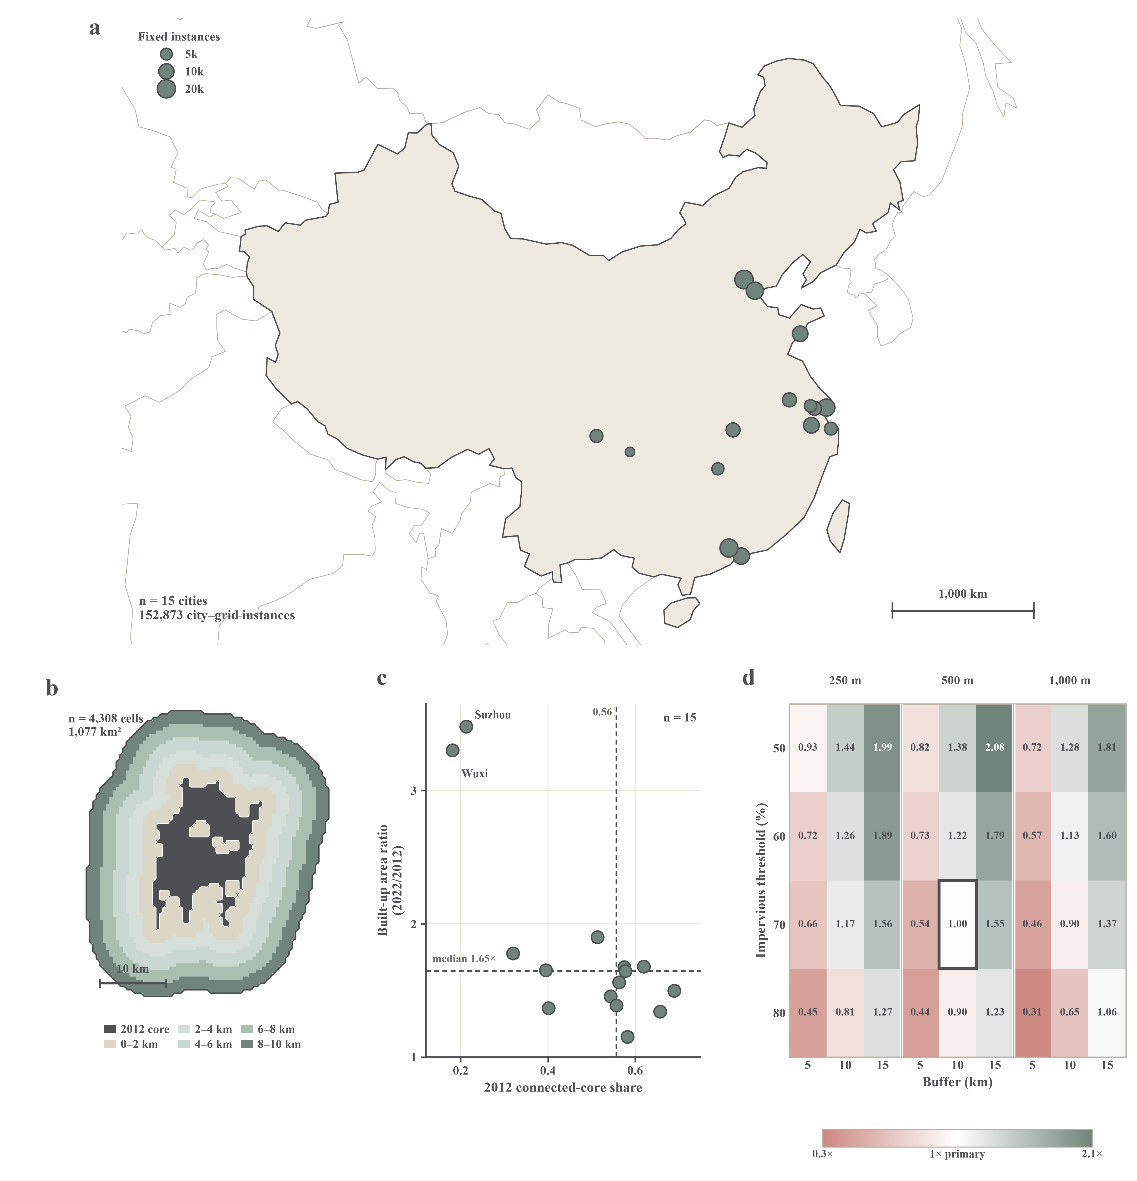
Supplementary Fig. S1 | Construction and geometric sensitivity of the fixed observation domain. a, Locations of the 15 city-specific observation domains; symbol area is proportional to the number of fixed 500-m city–grid instances. b, Chongqing example showing the 2012 built-up core and five 2-km bands extending 0–10 km beyond its fixed edge. c, Across-city variation in the 2012 connected-core share and the ratio of thresholded built-up area in 2022 to that in 2012; dashed lines indicate city medians. d, City-equal median fringe area under 36 combinations of grid resolution, impervious-surface threshold and buffer width, expressed relative to the primary specification of 500 m, 70% and 10 km. These sensitivity analyses reconstruct boundary geometry only; POI-derived functional trajectories were not refitted.

Supplementary Fig. S2
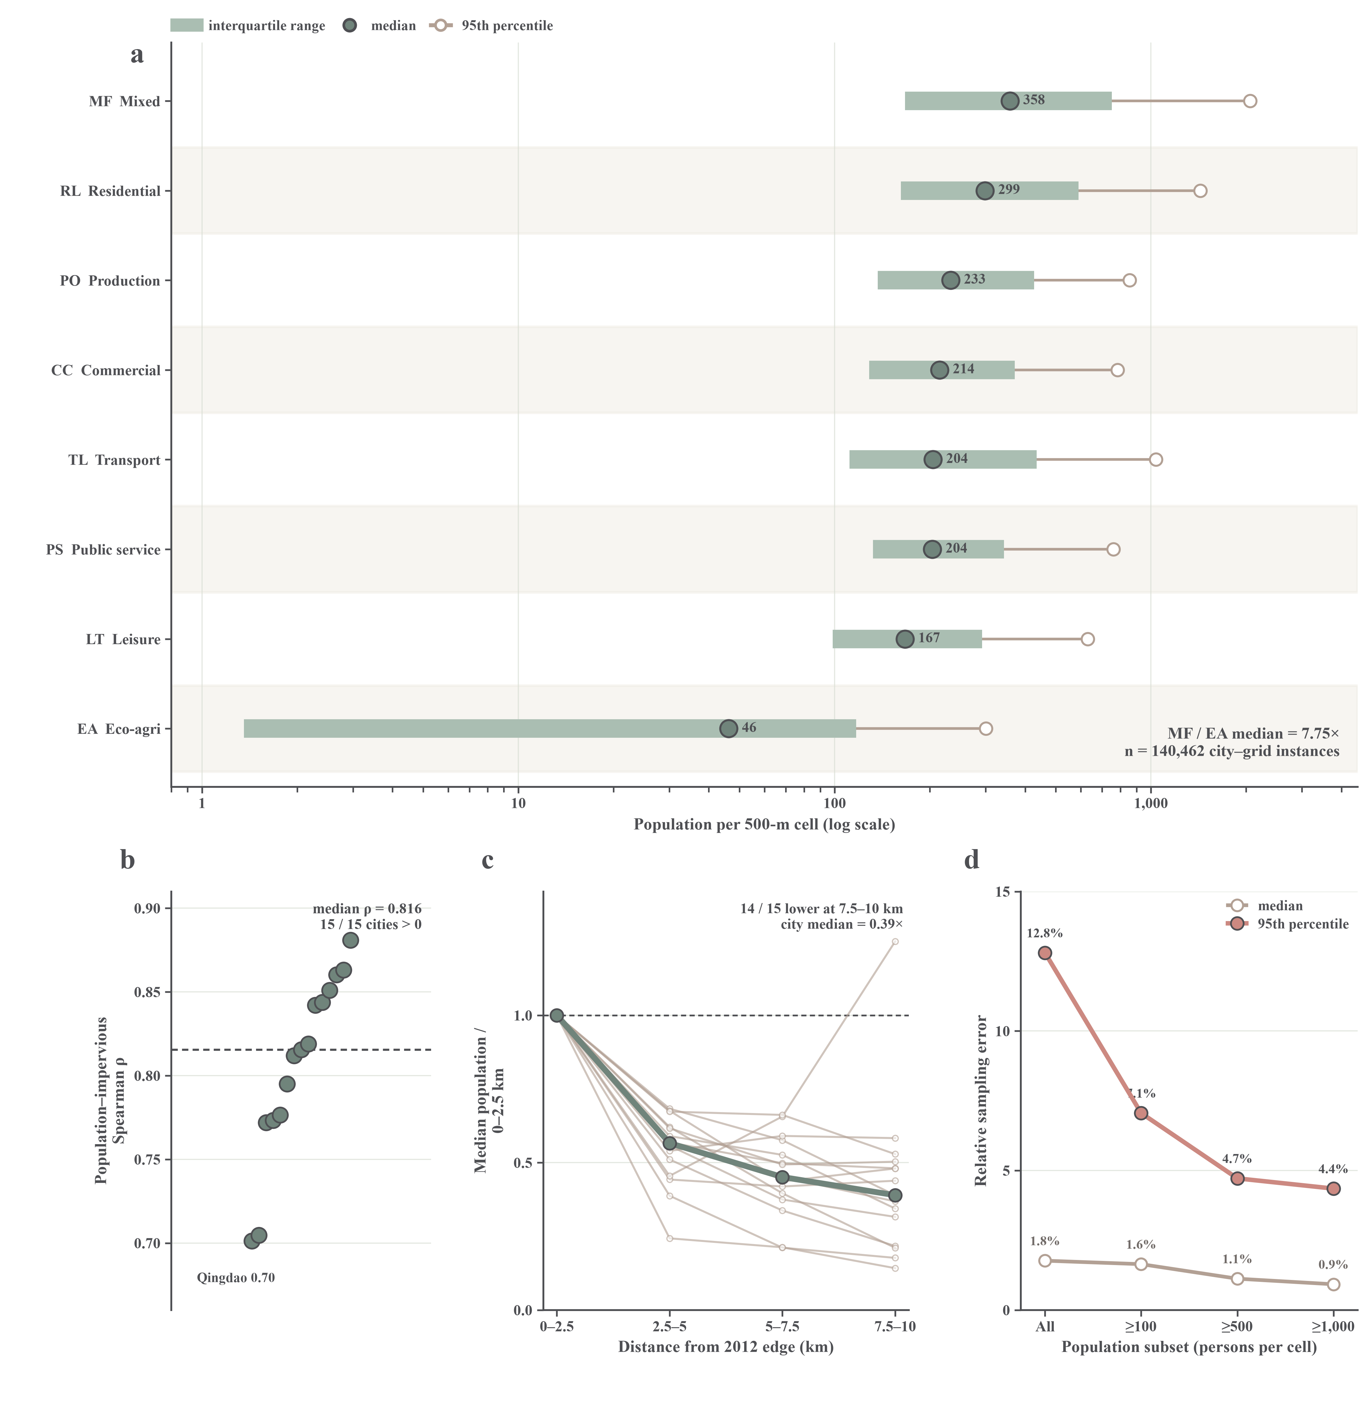
Supplementary Fig. S2 | Cross-sectional population context of the eight functional states. a, Distribution of 2020 ASPECT population across 140,462 fixed 500-m city–grid instances with finite population estimates. Thick bars show interquartile ranges, filled points medians and open points 95th percentiles. b, City-specific Spearman correlations between population and impervious fraction. c, Within-city population profiles by distance from the 2012 built-up edge, normalized to the median in the 0–2.5-km band; thin lines represent cities and the thick line the city-equal median. d, Relative error of the primary 10 × 10 sampling estimate against a 20 × 20 recomputation for 15,000 population-decile-stratified instances. ASPECT was used only as cross-sectional context and, because its downscaling model includes POI covariates, does not provide independent validation of the POI-derived states.

Supplementary Fig. S3
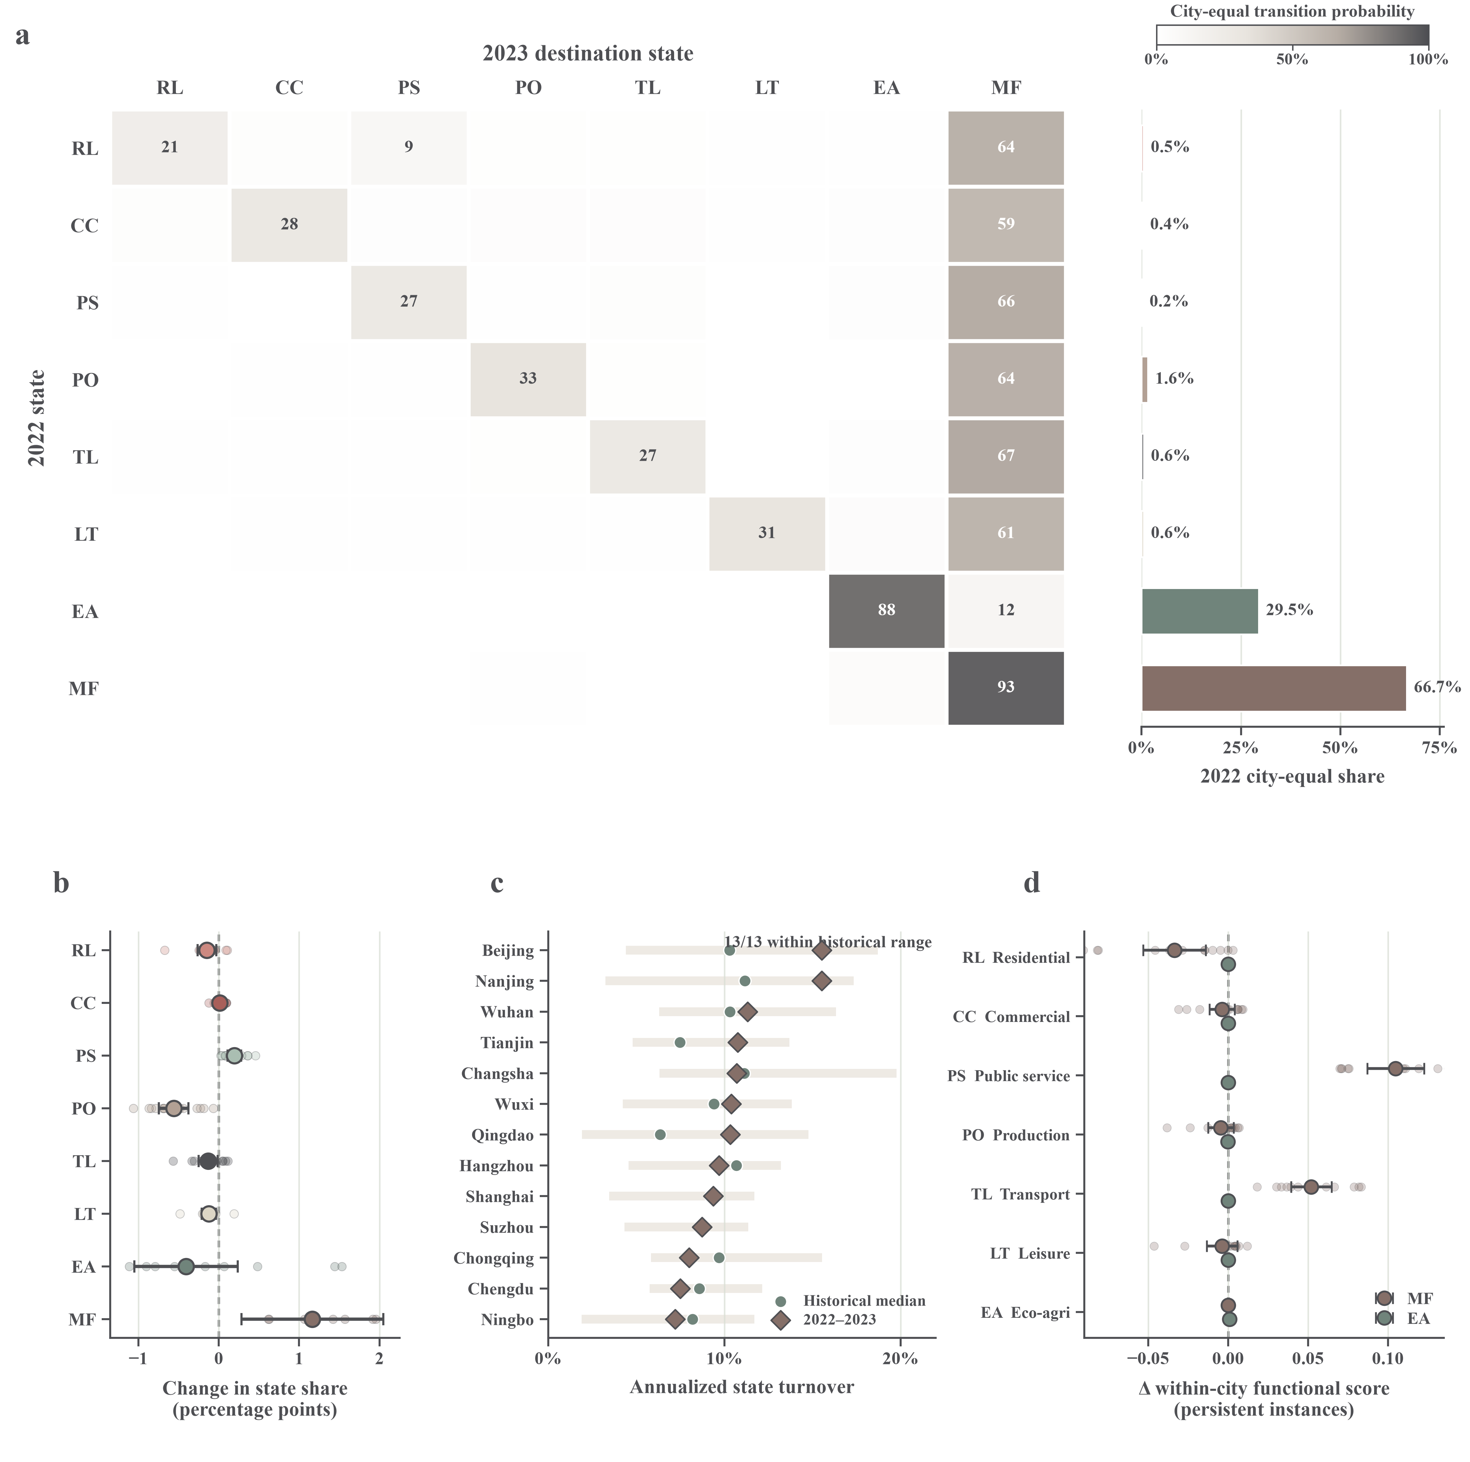
Supplementary Fig. S3 | Temporal extension of the functional-state panel to 2023. a, City-equal origin-conditioned transition probabilities between the 2022 and 2023 states for 121,353 fixed 500-m city–grid instances in 13 cities; marginal bars show city-equal 2022 state shares. b, City-specific and city-equal changes in state shares. c, Annualized 2022–2023 turnover compared with the historical minimum, median and maximum for each city; the extension estimate remained within the historical range in all 13 cities. d, Changes in the seven relative functional scores among instances retaining the low-dominance mixed state (MF) or eco-agriculture-dominant state (EA). Guangzhou and Shenzhen were excluded because complete 2023 POI snapshots were unavailable, and no interpolation was used. The threshold was estimated from 2012–2022 data and reproduced all 2022 assignments in the main analysis.

Supplementary Fig. S4
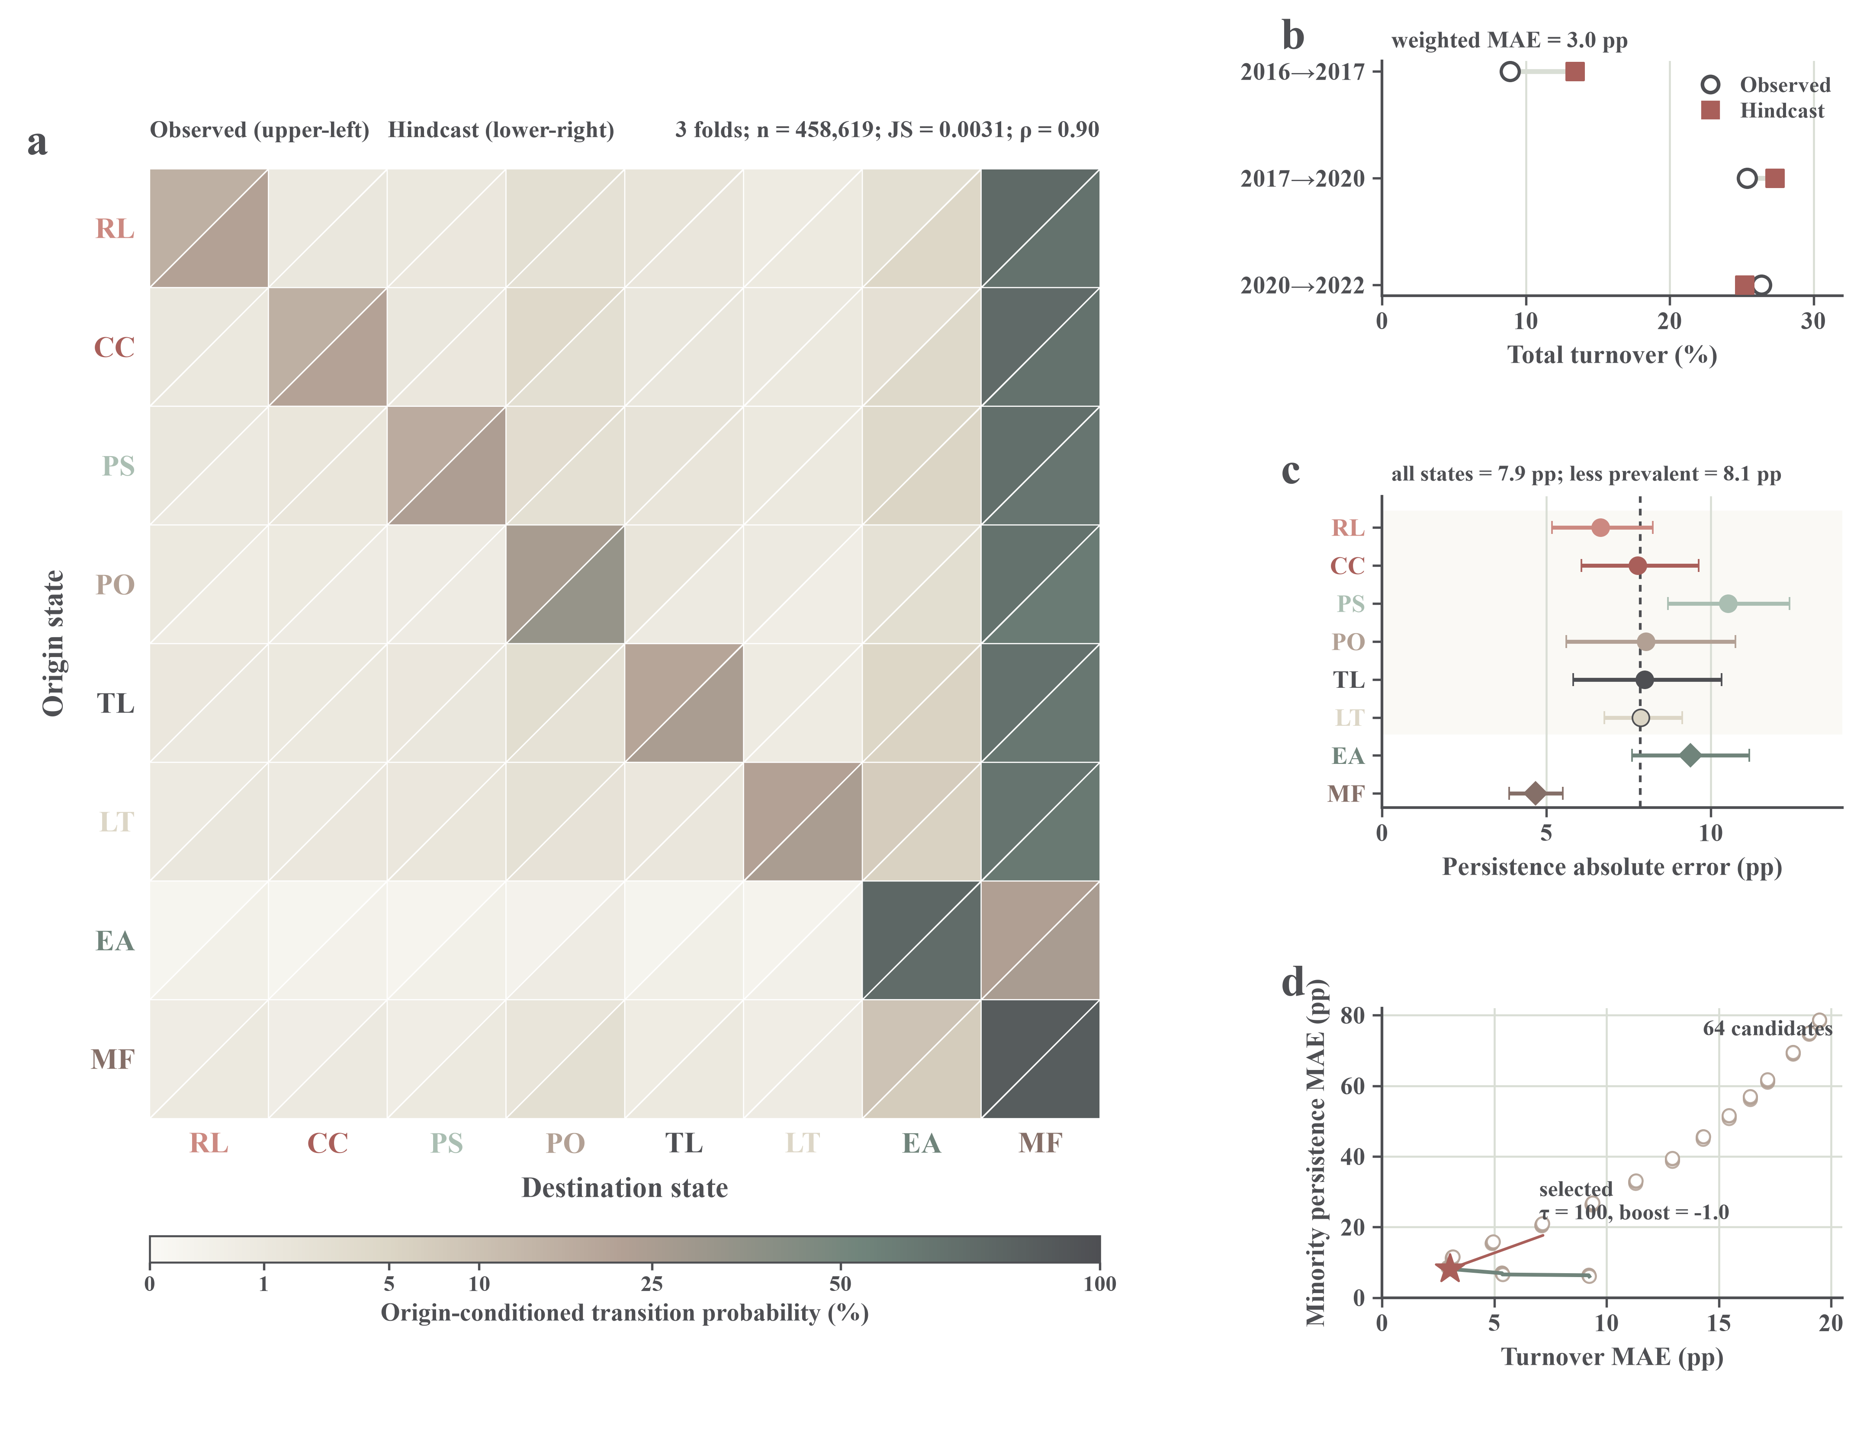
Supplementary Fig. S4 | Rolling-origin hindcasts and calibration of the 2035 conditional projection. a, Observed and hindcast origin-conditioned transition probabilities pooled across the 2016–2017, 2017–2020 and 2020–2022 held-out intervals. The comparison includes 458,619 city–grid transitions; pooled-flow Jensen–Shannon divergence was 0.0031 and Spearman’s ρ for off-diagonal probabilities was 0.90. b, Observed and hindcast gross turnover; the cell-weighted mean absolute error was 3.0 percentage points. c, Absolute error in state persistence across 45 city–fold strata per state, with 95% bootstrap intervals from 10,000 resamples. The mean error across all state-by-city-fold records was 7.9 percentage points, compared with 8.1 percentage points for the six less prevalent states. d, Calibration sensitivity across 64 parameter combinations; the star marks the selected setting of city shrinkage τ = 100 and persistence-logit adjustment = −1.0. The hindcast assesses historical calibration, not deterministic prediction of 2035 conditions.

Supplementary Fig. S5
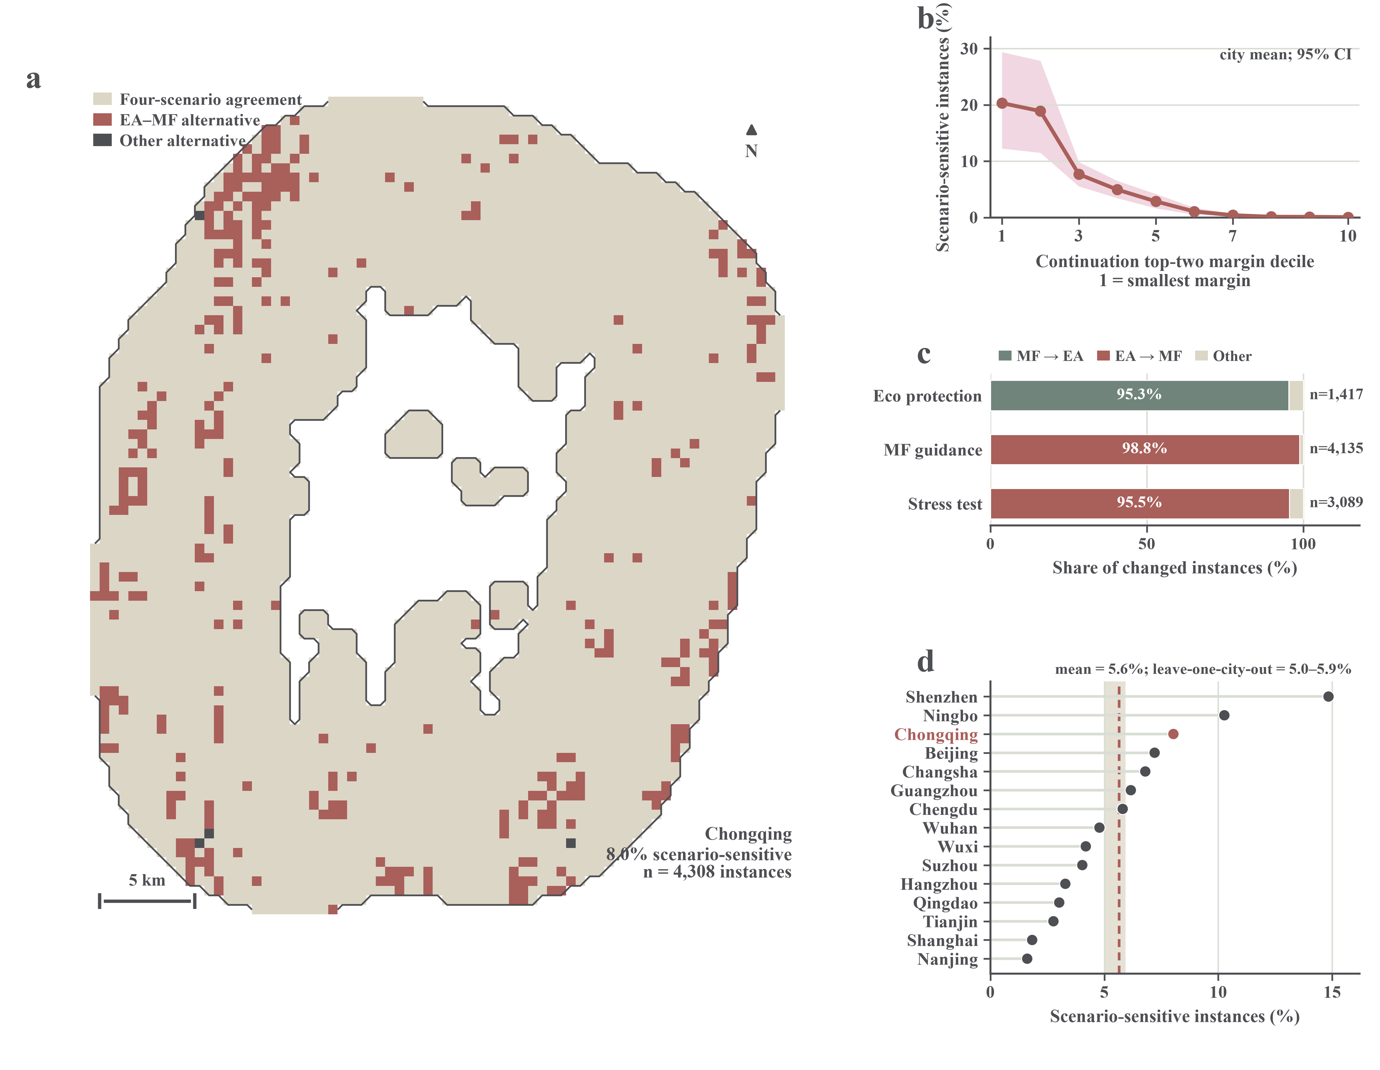
Supplementary Fig. S5 | Scenario disagreement is concentrated near uncertain EA–MF boundaries. a, Agreement among four calibrated 2035 hard-state allocations for 4,308 fixed 500-m city–grid instances in Chongqing. Pale cells retain the same state under all scenarios, coral cells vary only between the eco-agriculture-dominant state (EA) and low-dominance mixed state (MF), and charcoal cells involve another state combination. b, Scenario-sensitive share by within-city decile of the top-two probability margin under historical continuation; points show the mean across 15 cities and shading the percentile 95% interval from 20,000 city-level bootstrap replicates. c, Direction of hard-state changes under ecological protection, mixed-function guidance and the development stress test relative to historical continuation. d, Scenario-sensitive share by city; the dashed line shows the city-equal mean and the shaded band the leave-one-city-out range. Across 152,873 city–grid instances, 94.4% retained the same state under all four scenarios; 97.2% of the 8,536 scenario-sensitive instances involved only EA and MF. These comparisons diagnose conditional scenario structure and are not deterministic forecasts or estimates of policy causality.

Supplementary Tables
Supplementary Table S1 | City-specific observation domains and data coverage
City | City–grid instances | Area (km2) | POI coverage 2012 (%) | POI coverage 2014 (%) | POI coverage 2016 (%) | POI coverage 2017 (%) | POI coverage 2020 (%) | POI coverage 2022 (%) | Minimum CLCD coverage (%) | Archived relative-risk background coverage (%) | Minimum VIIRS coverage (%)
Beijing | 20,633 | 5,158.25 | 23.74 | 27.54 | 40.51 | 44.52 | 46.00 | 50.65 | 100.00 | 59.37 | 100.00
Tianjin | 15,544 | 3,886.00 | 14.80 | 18.01 | 23.40 | 26.43 | 24.88 | 30.89 | 100.00 | 98.50 | 100.00
Shanghai | 15,437 | 3,859.25 | 43.76 | 45.80 | 57.06 | 62.67 | 61.96 | 64.90 | 100.00 | 98.34 | 100.00
Chongqing | 4,308 | 1,077.00 | 38.67 | 42.90 | 53.30 | 57.75 | 61.86 | 72.38 | 100.00 | 75.37 | 100.00
Guangzhou | 18,904 | 4,726.00 | 40.79 | 42.43 | 54.37 | 59.02 | 60.64 | 69.85 | 100.00 | 97.66 | 100.00
Shenzhen | 12,616 | 3,154.00 | 34.65 | 36.51 | 45.24 | 48.23 | 51.01 | 57.39 | 100.00 | 93.12 | 100.00
Nanjing | 7,238 | 1,809.50 | 29.48 | 30.40 | 44.82 | 51.70 | 51.69 | 57.93 | 100.00 | 99.41 | 100.00
Suzhou | 7,290 | 1,822.50 | 41.34 | 43.58 | 54.91 | 58.94 | 61.23 | 64.58 | 100.00 | 99.67 | 100.00
Wuxi | 5,422 | 1,355.50 | 40.52 | 43.34 | 57.82 | 61.42 | 61.75 | 66.77 | 100.00 | 99.80 | 100.00
Hangzhou | 10,675 | 2,668.75 | 39.16 | 43.66 | 58.41 | 65.45 | 66.89 | 73.41 | 100.00 | 93.52 | 100.00
Ningbo | 5,805 | 1,451.25 | 34.26 | 34.47 | 47.39 | 52.09 | 53.57 | 58.85 | 100.00 | 93.21 | 100.00
Qingdao | 10,493 | 2,623.25 | 12.73 | 13.87 | 22.72 | 24.78 | 26.48 | 35.45 | 100.00 | 86.47 | 100.00
Wuhan | 7,375 | 1,843.75 | 25.56 | 29.82 | 39.73 | 45.69 | 47.54 | 56.49 | 100.00 | 100.00 | 100.00
Changsha | 5,208 | 1,302.00 | 26.82 | 32.09 | 41.23 | 45.93 | 53.65 | 70.31 | 100.00 | 98.58 | 100.00
Chengdu | 5,925 | 1,481.25 | 44.68 | 48.15 | 58.90 | 65.00 | 71.61 | 82.06 | 100.00 | 72.83 | 100.00
All cities | 152,873 | 38,218.25 | 31.71 | 34.40 | 45.40 | 49.91 | 51.42 | 58.23 | 100.00 | 89.85 | 100.00

Note: The 15 city-specific domains contain 152,873 city–grid instances. Their summed area (38,218.25 km²) retains cross-city overlap; 146,118 unique spatial cells correspond to 36,529.50 km². The archived relative-risk background is exploratory and is not interpreted as verified flood exposure or loss.

Supplementary Table S2 | Data harmonization and operational definitions
S2a. Amap POI crosswalk
Code | Function | Amap source-category keywords (English translations) | Cell metric
RL | Residential and daily-life services | Residential; residential compound; dormitory; daily-life services; real estate; community; commercial residence | De-duplicated POI count per 500-m cell
CC | Commercial consumption | Shopping; food and beverage; accommodation and hotels; financial and banking services; automobile and motorcycle services; commerce | De-duplicated POI count per 500-m cell
PS | Public service | Government; social organizations; healthcare and pharmacies; education and schools; science, education and culture; public facilities | De-duplicated POI count per 500-m cell
PO | Production and office | Companies and enterprises; industrial parks; business and office buildings | De-duplicated POI count per 500-m cell
TL | Transport and logistics | Transport and public transit; parking; toll stations; entrances and exits; road-related and access facilities | De-duplicated POI count per 500-m cell
LT | Leisure and tourism | Scenic sites, tourism and attractions; parks; sports and leisure; exercise and fitness; entertainment venues | De-duplicated POI count per 500-m cell

Note: Category labels are English translations of the Amap source taxonomy and define the analytical crosswalk. Counts were deduplicated within city–year snapshots and were not entity-matched across years.
S2b. CLCD class crosswalk
CLCD code | Class | Use in this study
1 | Cropland | Eco-agricultural cover
2 | Forest | Eco-agricultural cover
3 | Shrub | Eco-agricultural cover
4 | Grassland | Eco-agricultural cover
5 | Water | Eco-agricultural cover
6 | Snow/ice | Excluded from the seven functional dimensions
7 | Bare land | Excluded from the seven functional dimensions
8 | Impervious | Built-up-area delineation and land-cover diagnostics
9 | Wetland | Eco-agricultural cover

S2c. Construction of the seven relative functional scores
Code | Functional dimension | Source | Standardization | Range
RL | Residential and daily-life services | Amap POIs | Mean rank of positive counts divided by the fixed-grid cell count; zeros retained as 0 | 0–1
CC | Commercial consumption | Amap POIs | Mean rank of positive counts divided by the fixed-grid cell count; zeros retained as 0 | 0–1
PS | Public service | Amap POIs | Mean rank of positive counts divided by the fixed-grid cell count; zeros retained as 0 | 0–1
PO | Production and office | Amap POIs | Mean rank of positive counts divided by the fixed-grid cell count; zeros retained as 0 | 0–1
TL | Transport and logistics | Amap POIs | Mean rank of positive counts divided by the fixed-grid cell count; zeros retained as 0 | 0–1
LT | Leisure and tourism | Amap POIs | Mean rank of positive counts divided by the fixed-grid cell count; zeros retained as 0 | 0–1
EA | Eco-agriculture | CLCD classes 1–5 and 9 | Empirical city-year percentile of combined eco-agricultural cover | 0–1

Note: Scores are within-city, within-year empirical ranks on 0–1 scales. No equally weighted composite score was constructed.
S2d. Operational rules for the eight functional states
State | Name | Decision rule | Interpretation
RL | Residential and daily-life services | m ≥ 0.415039 and the highest-scoring dimension is RL | Dominant state
CC | Commercial consumption | m ≥ 0.415039 and the highest-scoring dimension is CC | Dominant state
PS | Public services | m ≥ 0.415039 and the highest-scoring dimension is PS | Dominant state
PO | Production and office activities | m ≥ 0.415039 and the highest-scoring dimension is PO | Dominant state
TL | Transport and logistics | m ≥ 0.415039 and the highest-scoring dimension is TL | Dominant state
LT | Leisure and tourism | m ≥ 0.415039 and the highest-scoring dimension is LT | Dominant state
EA | Eco-agriculture | m ≥ 0.415039 and the highest-scoring dimension is EA | Dominant state
MF | Low-dominance mixed state | m < 0.415039, where m = q(1) − q(2) | Low-dominance state; may include low-information or all-zero POI cells

Note: The dominance margin m is the difference between the highest and second-highest relative functional scores. MF indicates m < 0.415039; it does not require multiple nonzero functions.

Supplementary Table S3 | Observed transitions, persistence and path-conditioned functional changes
S3a. Complete 8 × 8 transition matrices for adjacent observation periods
2012–2014
Origin state | RL | CC | PS | PO | TL | LT | EA | MF
RL | 773 (66.8%) | 6 (0.5%) | 2 (0.2%) | 11 (1.0%) | 1 (0.1%) | 5 (0.4%) | 11 (1.0%) | 348 (30.1%)
CC | 6 (0.5%) | 670 (59.9%) | 5 (0.4%) | 18 (1.6%) | 4 (0.4%) | 6 (0.5%) | 19 (1.7%) | 390 (34.9%)
PS | 2 (0.1%) | 4 (0.2%) | 1,559 (74.0%) | 5 (0.2%) | 3 (0.1%) | 2 (0.1%) | 13 (0.6%) | 519 (24.6%)
PO | 7 (0.1%) | 6 (0.1%) | 4 (0.1%) | 4,898 (78.1%) | 2 (0.0%) | 5 (0.1%) | 14 (0.2%) | 1,336 (21.3%)
TL | 2 (0.4%) | 0 (0.0%) | 0 (0.0%) | 0 (0.0%) | 388 (71.3%) | 1 (0.2%) | 4 (0.7%) | 149 (27.4%)
LT | 7 (1.0%) | 4 (0.6%) | 3 (0.4%) | 1 (0.1%) | 2 (0.3%) | 487 (67.5%) | 18 (2.5%) | 200 (27.7%)
EA | 77 (0.1%) | 34 (0.0%) | 45 (0.1%) | 151 (0.2%) | 41 (0.1%) | 44 (0.1%) | 66,037 (94.2%) | 3,691 (5.3%)
MF | 380 (0.5%) | 276 (0.4%) | 333 (0.5%) | 1,107 (1.6%) | 141 (0.2%) | 175 (0.2%) | 1,965 (2.8%) | 66,456 (93.8%)

2014–2016
Origin state | RL | CC | PS | PO | TL | LT | EA | MF
RL | 316 (25.2%) | 10 (0.8%) | 5 (0.4%) | 5 (0.4%) | 14 (1.1%) | 3 (0.2%) | 8 (0.6%) | 893 (71.2%)
CC | 5 (0.5%) | 227 (22.7%) | 0 (0.0%) | 8 (0.8%) | 8 (0.8%) | 4 (0.4%) | 0 (0.0%) | 748 (74.8%)
PS | 8 (0.4%) | 29 (1.5%) | 417 (21.4%) | 27 (1.4%) | 37 (1.9%) | 18 (0.9%) | 37 (1.9%) | 1,378 (70.6%)
PO | 8 (0.1%) | 10 (0.2%) | 2 (0.0%) | 2,214 (35.8%) | 16 (0.3%) | 2 (0.0%) | 7 (0.1%) | 3,932 (63.5%)
TL | 0 (0.0%) | 3 (0.5%) | 1 (0.2%) | 0 (0.0%) | 220 (37.8%) | 0 (0.0%) | 3 (0.5%) | 355 (61.0%)
LT | 5 (0.7%) | 1 (0.1%) | 3 (0.4%) | 1 (0.1%) | 6 (0.8%) | 269 (37.1%) | 14 (1.9%) | 426 (58.8%)
EA | 44 (0.1%) | 46 (0.1%) | 70 (0.1%) | 109 (0.2%) | 166 (0.2%) | 119 (0.2%) | 56,623 (83.2%) | 10,904 (16.0%)
MF | 501 (0.7%) | 599 (0.8%) | 415 (0.6%) | 1,546 (2.1%) | 812 (1.1%) | 448 (0.6%) | 1,486 (2.0%) | 67,282 (92.1%)

2016–2017
Origin state | RL | CC | PS | PO | TL | LT | EA | MF
RL | 304 (34.3%) | 2 (0.2%) | 2 (0.2%) | 10 (1.1%) | 7 (0.8%) | 2 (0.2%) | 5 (0.6%) | 555 (62.6%)
CC | 4 (0.4%) | 315 (34.1%) | 5 (0.5%) | 12 (1.3%) | 5 (0.5%) | 5 (0.5%) | 7 (0.8%) | 572 (61.8%)
PS | 2 (0.2%) | 5 (0.5%) | 418 (45.8%) | 4 (0.4%) | 7 (0.8%) | 1 (0.1%) | 3 (0.3%) | 473 (51.8%)
PO | 8 (0.2%) | 9 (0.2%) | 3 (0.1%) | 1,666 (42.6%) | 22 (0.6%) | 4 (0.1%) | 6 (0.2%) | 2,192 (56.1%)
TL | 4 (0.3%) | 2 (0.2%) | 8 (0.6%) | 5 (0.4%) | 537 (42.0%) | 0 (0.0%) | 23 (1.8%) | 700 (54.7%)
LT | 0 (0.0%) | 4 (0.5%) | 5 (0.6%) | 1 (0.1%) | 5 (0.6%) | 411 (47.6%) | 11 (1.3%) | 426 (49.4%)
EA | 24 (0.0%) | 19 (0.0%) | 20 (0.0%) | 28 (0.0%) | 23 (0.0%) | 26 (0.0%) | 52,908 (90.9%) | 5,130 (8.8%)
MF | 319 (0.4%) | 308 (0.4%) | 403 (0.5%) | 596 (0.7%) | 298 (0.3%) | 195 (0.2%) | 1,088 (1.3%) | 82,711 (96.3%)

2017–2020
Origin state | RL | CC | PS | PO | TL | LT | EA | MF
RL | 25 (3.8%) | 9 (1.4%) | 17 (2.6%) | 19 (2.9%) | 10 (1.5%) | 3 (0.5%) | 30 (4.5%) | 552 (83.0%)
CC | 7 (1.1%) | 15 (2.3%) | 18 (2.7%) | 42 (6.3%) | 13 (2.0%) | 4 (0.6%) | 13 (2.0%) | 552 (83.1%)
PS | 11 (1.3%) | 13 (1.5%) | 39 (4.5%) | 42 (4.9%) | 16 (1.9%) | 11 (1.3%) | 47 (5.4%) | 685 (79.3%)
PO | 26 (1.1%) | 26 (1.1%) | 38 (1.6%) | 291 (12.5%) | 54 (2.3%) | 19 (0.8%) | 73 (3.1%) | 1,795 (77.3%)
TL | 6 (0.7%) | 12 (1.3%) | 23 (2.5%) | 41 (4.5%) | 51 (5.6%) | 8 (0.9%) | 51 (5.6%) | 712 (78.8%)
LT | 9 (1.4%) | 7 (1.1%) | 15 (2.3%) | 26 (4.0%) | 10 (1.6%) | 14 (2.2%) | 53 (8.2%) | 510 (79.2%)
EA | 51 (0.1%) | 46 (0.1%) | 71 (0.1%) | 143 (0.3%) | 75 (0.1%) | 91 (0.2%) | 40,995 (75.8%) | 12,579 (23.3%)
MF | 554 (0.6%) | 424 (0.5%) | 707 (0.8%) | 1,800 (1.9%) | 701 (0.8%) | 392 (0.4%) | 15,536 (16.7%) | 72,645 (78.3%)

2020–2022
Origin state | RL | CC | PS | PO | TL | LT | EA | MF
RL | 23 (3.3%) | 10 (1.5%) | 4 (0.6%) | 31 (4.5%) | 20 (2.9%) | 11 (1.6%) | 26 (3.8%) | 564 (81.9%)
CC | 14 (2.5%) | 9 (1.6%) | 3 (0.5%) | 32 (5.8%) | 7 (1.3%) | 10 (1.8%) | 30 (5.4%) | 447 (81.0%)
PS | 19 (2.0%) | 19 (2.0%) | 11 (1.2%) | 41 (4.4%) | 27 (2.9%) | 14 (1.5%) | 64 (6.9%) | 733 (79.0%)
PO | 51 (2.1%) | 37 (1.5%) | 16 (0.7%) | 274 (11.4%) | 60 (2.5%) | 42 (1.7%) | 113 (4.7%) | 1,811 (75.3%)
TL | 26 (2.8%) | 16 (1.7%) | 3 (0.3%) | 47 (5.1%) | 37 (4.0%) | 15 (1.6%) | 71 (7.6%) | 715 (76.9%)
LT | 7 (1.3%) | 5 (0.9%) | 3 (0.6%) | 19 (3.5%) | 8 (1.5%) | 16 (3.0%) | 82 (15.1%) | 402 (74.2%)
EA | 31 (0.1%) | 26 (0.0%) | 26 (0.0%) | 84 (0.1%) | 52 (0.1%) | 80 (0.1%) | 35,853 (63.1%) | 20,646 (36.3%)
MF | 636 (0.7%) | 492 (0.5%) | 258 (0.3%) | 1,851 (2.1%) | 670 (0.7%) | 724 (0.8%) | 9,089 (10.1%) | 76,310 (84.8%)

Note: Each cell reports count (origin-row percentage). Diagonal entries are persistence; off-diagonal entries retain transition direction.

S3b. Pooled persistence and leading off-diagonal destination
Origin state | Name | Persistence (%) | Dominant exit | Leading destination (% of all origin instances)
RL | Residential and daily-life services | 30.98 | MF | 62.60
CC | Commercial consumption | 29.02 | MF | 63.61
PS | Public services | 36.14 | MF | 56.01
PO | Production and office activities | 44.28 | MF | 52.45
TL | Transport and logistics | 29.09 | MF | 62.07
LT | Leisure and tourism | 34.24 | MF | 56.18
EA | Eco-agriculture | 82.16 | MF | 17.23
MF | Low-dominance mixed state | 88.56 | EA | 7.07

Note: The leading-destination percentage uses all instances in the corresponding origin state as the denominator, not only exiting instances.
S3c. Path-conditioned changes in the seven relative functional scores
Path | n | RL | CC | PS | PO | TL | LT | EA
EA → MF | 27421 | 0.255 [0.234, 0.276] | 0.288 [0.273, 0.303] | 0.130 [0.120, 0.141] | 0.358 [0.340, 0.375] | 0.240 [0.215, 0.265] | 0.250 [0.223, 0.277] | -0.048 [-0.065, -0.031]
MF → EA | 3286 | -0.037 [-0.049, -0.025] | -0.042 [-0.052, -0.031] | -0.085 [-0.111, -0.058] | -0.147 [-0.187, -0.107] | -0.019 [-0.026, -0.013] | -0.069 [-0.093, -0.044] | 0.069 [0.048, 0.089]
PO → MF | 5590 | 0.446 [0.410, 0.482] | 0.542 [0.513, 0.570] | 0.242 [0.211, 0.274] | -0.143 [-0.177, -0.109] | 0.446 [0.409, 0.483] | 0.179 [0.143, 0.215] | 0.010 [0.003, 0.016]
EA → EA | 41850 | 0.000 [0.000, 0.000] | 0.001 [-0.001, 0.004] | 0.000 [0.000, 0.000] | 0.002 [-0.002, 0.007] | 0.000 [0.000, 0.000] | 0.000 [0.000, 0.000] | 0.017 [0.010, 0.024]
MF → MF | 63546 | 0.226 [0.192, 0.261] | 0.191 [0.161, 0.222] | 0.040 [0.017, 0.062] | 0.146 [0.113, 0.180] | 0.297 [0.253, 0.340] | 0.154 [0.125, 0.183] | 0.009 [0.004, 0.014]

Note: Entries are equal-city mean endpoint-minus-starting-point changes [descriptive 95% t intervals across 15 cities]. n is the raw number of city–grid instances on each path and is not the inferential sample size.

Supplementary Table S4 | 2035 calibration, hindcasts and conditional scenario outputs
S4a. Final model, calibration and allocation parameters
Component | Parameter | Candidate range or rule | Final setting | Role | Selection status
Flow calibration | City-shrinkage parameter τ | 100; 300; 1,000; 3,000 | 100 | Partial pooling of city-specific transition rows toward the 15-city matrix | Selected by rolling hindcast
Flow calibration | Persistence-logit adjustment b | −1.5 to 1.5 in 0.25 steps; 2.0, 2.5 and 3.0 also tested | −1.0 | Common adjustment of diagonal persistence probabilities | Selected by rolling hindcast
Flow calibration | Jeffreys smoothing | Fixed | 0.5 | Avoid structural zeros for rare origin states | Fixed analytical rule
Flow calibration | Projection horizon | Fixed | 13 years | Raise the calibrated annual transition matrix to the 13th power | Fixed by study design
Transition potential | Classifier | Separate model for each origin state | HistGradientBoostingClassifier | Estimate conditional destination-state potential | Fixed model class
Transition potential | Learning rate | Fixed | 0.08 | Gradient-boosting step size | Fixed algorithm setting
Transition potential | Maximum iterations | Fixed | 120 | Number of boosting iterations | Fixed algorithm setting
Transition potential | Maximum leaf nodes | Fixed | 15 | Tree complexity | Fixed algorithm setting
Transition potential | Minimum samples per leaf | Fixed | 80 | Regularize sparse origin states | Fixed algorithm setting
Transition potential | L2 regularization | Fixed | 1.0 | Regularize fitted transition potentials | Fixed algorithm setting
Transition potential | Fallback | <80 records or one destination class | Empirical destination classes | Avoid unsupported classifier fits | Fixed rule
Transition potential | Random seed | Fixed | 20260817 | Reproducibility | Fixed
Cell allocation | Neighbourhood beta | Checked historically | 1.0 | Weight for 500-m neighbourhood support in hindcast allocation | Fixed allocation constant
Cell allocation | State inertia | Checked historically | 0.25 | Preference for retaining the current state in hindcast allocation | Fixed allocation constant
Cell allocation | Neighbourhood-support coefficient | Fixed | 0.85 | Eight-neighbour support in final 2035 constrained allocation | Fixed; not selected by flow hindcast
Cell allocation | Functional-suitability coefficient | Fixed | 0.55 | Within-city rank of 2022 functional suitability | Fixed; not selected by flow hindcast
Scenario construction | Minimum empirical-stratum records | Fixed | 500 | City × 2-km band × archived-background quartile | Fixed support rule
Scenario construction | Scenario-stratum selection | Fixed | 20%; ≥3 strata per class | Select empirical analogue strata | Fixed scenario rule
Scenario construction | Cell-level log probability-ratio truncation | Fixed | ±ln(25) | Bound scenario reweighting relative to historical continuation | Fixed scenario rule

S4b. Aggregate-flow rolling hindcasts
Hindcast interval | Flow JS | Composition JS | Observed turnover | Hindcast turnover | Aggregate turnover absolute error | Cell-weighted mean city-level absolute turnover error | Eight-state persistence MAE | Six-less-prevalent-state persistence MAE
2016—2017 | 0.007443 | 0.002746 | 0.088982 | 0.134165 | 0.045183 | 0.045183 | 0.106281 | 0.123833
2017—2020 | 0.017281 | 0.010611 | 0.253792 | 0.272948 | 0.019155 | 0.029129 | 0.053988 | 0.039332
2020—2022 | 0.006747 | 0.003908 | 0.263879 | 0.252065 | 0.011815 | 0.016189 | 0.075529 | 0.080987
Three-fold weighted summary | 0.010490 | 0.005755 | 0.202218 | 0.219726 |  | 0.030167 | 0.078599 | 0.081384

Note: The aggregate turnover error is |observed − hindcast| for each held-out interval. The adjacent column is the cell-weighted mean of city-level absolute errors and is the quantity summarized as 3.0 percentage points in Supplementary Fig. S4. The weighted mean of fold-specific flow divergences (0.01049) differs from the pooled-count divergence in Fig. S4 (0.0031) because Jensen–Shannon divergence is nonlinear.
S4c. Cell-allocation hindcast metrics and persistence-only reference
Start year | End year | Horizon (years) | Method | Accuracy | Balanced accuracy | Macro F1 | Macro recall | Observed changed share | Predicted changed share | Change figure of merit | State-share MAE
2016 | 2017 | 1 | Persistence-only | 0.9110 | 0.6544 | 0.5874 | 0.6544 | 0.0890 | 0.0000 | 0.0000 | 0.0112
2016 | 2017 | 1 | Calibrated turnover model | 0.8370 | 0.4287 | 0.3790 | 0.4287 | 0.0890 | 0.1341 | 0.1693 | 0.0070
2016 | 2020 | 4 | Persistence-only | 0.7304 | 0.2318 | 0.2249 | 0.2318 | 0.2696 | 0.0000 | 0.0000 | 0.0067
2016 | 2020 | 4 | Calibrated turnover model | 0.7205 | 0.2141 | 0.2089 | 0.2141 | 0.2696 | 0.3230 | 0.4263 | 0.0257
2017 | 2020 | 3 | Persistence-only | 0.7462 | 0.2295 | 0.2303 | 0.2295 | 0.2538 | 0.0000 | 0.0000 | 0.0048
2017 | 2020 | 3 | Calibrated turnover model | 0.7365 | 0.2156 | 0.2127 | 0.2156 | 0.2538 | 0.2729 | 0.3979 | 0.0276
2020 | 2022 | 2 | Persistence-only | 0.7361 | 0.2242 | 0.2175 | 0.2242 | 0.2639 | 0.0000 | 0.0000 | 0.0199
2020 | 2022 | 2 | Calibrated turnover model | 0.7503 | 0.2156 | 0.2095 | 0.2156 | 0.2639 | 0.2520 | 0.3947 | 0.0127

Note: The 2016–2020 interval is a supplementary audit. Parameter selection used 2016–2017, 2017–2020 and 2020–2022. These cell-level metrics are diagnostic because calibration targeted aggregate flows, composition and persistence.
S4d. State-level diagnostics for the three selection folds
State | Name | City-folds | Persistence MAE | 95% CI | Calibrated recall | Calibrated F1 | Persistence-baseline recall | Persistence-baseline F1
RL | Residential and daily-life services | 45 | 0.066 | [0.052, 0.082] | 0.086 | 0.062 | 0.174 | 0.153
CC | Commercial consumption | 45 | 0.078 | [0.061, 0.096] | 0.079 | 0.057 | 0.172 | 0.146
PS | Public services | 45 | 0.105 | [0.087, 0.124] | 0.110 | 0.090 | 0.187 | 0.177
PO | Production and office activities | 45 | 0.080 | [0.056, 0.107] | 0.206 | 0.149 | 0.318 | 0.257
TL | Transport and logistics | 45 | 0.080 | [0.058, 0.103] | 0.121 | 0.090 | 0.230 | 0.196
LT | Leisure and tourism | 45 | 0.079 | [0.068, 0.091] | 0.114 | 0.089 | 0.227 | 0.197
EA | Eco-agriculture | 45 | 0.094 | [0.076, 0.112] | 0.738 | 0.763 | 0.831 | 0.795
MF | Low-dominance mixed state | 45 | 0.047 | [0.039, 0.055] | 0.839 | 0.835 | 0.816 | 0.839

Note: Intervals summarize 45 city–fold strata per state. They are internal rolling-hindcast diagnostics, not external validation.

S4e. City-specific hard-state constrained allocations under four 2035 scenarios
Historical continuation
City | n | RL (%) | CC (%) | PS (%) | PO (%) | TL (%) | LT (%) | EA (%) | MF (%) | Changed from continuation (%)
Beijing | 20,633 | 1.22 | 1.44 | 1.69 | 4.39 | 1.56 | 1.75 | 30.33 | 57.63 | 0.00
Tianjin | 15,544 | 1.22 | 0.83 | 1.03 | 3.65 | 1.01 | 0.56 | 35.16 | 56.54 | 0.00
Shanghai | 15,437 | 0.82 | 0.37 | 0.60 | 2.14 | 0.56 | 0.47 | 23.71 | 71.34 | 0.00
Chongqing | 4,308 | 1.32 | 0.63 | 0.51 | 2.02 | 0.79 | 0.63 | 23.65 | 70.45 | 0.00
Guangzhou | 18,904 | 0.38 | 0.45 | 0.49 | 1.59 | 0.51 | 0.41 | 19.64 | 76.52 | 0.00
Shenzhen | 12,616 | 0.23 | 0.21 | 0.20 | 0.71 | 0.35 | 0.35 | 20.18 | 77.77 | 0.00
Nanjing | 7,238 | 1.24 | 1.04 | 0.98 | 3.03 | 1.84 | 0.84 | 27.70 | 63.33 | 0.00
Suzhou | 7,290 | 0.80 | 0.45 | 0.43 | 2.28 | 0.77 | 0.62 | 26.95 | 67.71 | 0.00
Wuxi | 5,422 | 0.63 | 0.77 | 0.52 | 3.60 | 0.70 | 0.74 | 24.20 | 68.85 | 0.00
Hangzhou | 10,675 | 0.76 | 0.66 | 0.72 | 2.15 | 0.69 | 0.64 | 19.83 | 74.56 | 0.00
Ningbo | 5,805 | 0.24 | 0.33 | 0.34 | 1.48 | 0.33 | 0.29 | 19.78 | 77.21 | 0.00
Qingdao | 10,493 | 0.61 | 1.03 | 0.97 | 3.28 | 1.23 | 0.51 | 29.88 | 62.49 | 0.00
Wuhan | 7,375 | 1.48 | 0.94 | 1.45 | 3.32 | 1.33 | 0.69 | 29.90 | 60.89 | 0.00
Changsha | 5,208 | 1.27 | 1.42 | 1.27 | 2.84 | 1.21 | 0.98 | 26.36 | 64.65 | 0.00
Chengdu | 5,925 | 0.88 | 0.41 | 0.39 | 1.45 | 0.49 | 0.35 | 17.65 | 78.38 | 0.00

Ecological protection
City | n | RL (%) | CC (%) | PS (%) | PO (%) | TL (%) | LT (%) | EA (%) | MF (%) | Changed from continuation (%)
Beijing | 20,633 | 1.23 | 1.43 | 1.69 | 4.39 | 1.56 | 1.74 | 31.37 | 56.59 | 1.06
Tianjin | 15,544 | 1.22 | 0.82 | 1.01 | 3.62 | 1.01 | 0.55 | 37.74 | 54.04 | 2.57
Shanghai | 15,437 | 0.80 | 0.38 | 0.60 | 2.12 | 0.57 | 0.48 | 24.59 | 70.47 | 0.91
Chongqing | 4,308 | 1.32 | 0.65 | 0.53 | 2.02 | 0.79 | 0.63 | 24.09 | 69.96 | 0.49
Guangzhou | 18,904 | 0.38 | 0.46 | 0.49 | 1.59 | 0.51 | 0.41 | 19.71 | 76.45 | 0.08
Shenzhen | 12,616 | 0.23 | 0.21 | 0.20 | 0.71 | 0.35 | 0.36 | 20.84 | 77.11 | 0.67
Nanjing | 7,238 | 1.24 | 1.02 | 0.98 | 3.00 | 1.87 | 0.86 | 27.70 | 63.33 | 0.04
Suzhou | 7,290 | 0.80 | 0.45 | 0.44 | 2.28 | 0.77 | 0.62 | 28.52 | 66.13 | 1.58
Wuxi | 5,422 | 0.63 | 0.76 | 0.53 | 3.58 | 0.70 | 0.74 | 24.55 | 68.52 | 0.37
Hangzhou | 10,675 | 0.75 | 0.67 | 0.73 | 2.14 | 0.69 | 0.65 | 19.92 | 74.46 | 0.11
Ningbo | 5,805 | 0.24 | 0.33 | 0.34 | 1.48 | 0.34 | 0.29 | 20.62 | 76.35 | 0.86
Qingdao | 10,493 | 0.62 | 1.01 | 0.96 | 3.27 | 1.21 | 0.51 | 31.80 | 60.62 | 1.93
Wuhan | 7,375 | 1.46 | 0.94 | 1.44 | 3.31 | 1.33 | 0.72 | 31.47 | 59.34 | 1.60
Changsha | 5,208 | 1.29 | 1.40 | 1.29 | 2.80 | 1.25 | 1.00 | 26.57 | 64.40 | 0.31
Chengdu | 5,925 | 0.88 | 0.41 | 0.39 | 1.47 | 0.47 | 0.35 | 17.64 | 78.40 | 0.03

Mixed-function guidance
City | n | RL (%) | CC (%) | PS (%) | PO (%) | TL (%) | LT (%) | EA (%) | MF (%) | Changed from continuation (%)
Beijing | 20,633 | 1.23 | 1.44 | 1.69 | 4.39 | 1.57 | 1.74 | 30.33 | 57.62 | 0.01
Tianjin | 15,544 | 1.22 | 0.82 | 1.02 | 3.64 | 1.02 | 0.57 | 35.01 | 56.70 | 0.17
Shanghai | 15,437 | 0.80 | 0.38 | 0.60 | 2.12 | 0.57 | 0.48 | 23.72 | 71.34 | 0.03
Chongqing | 4,308 | 1.32 | 0.63 | 0.53 | 2.02 | 0.79 | 0.63 | 21.36 | 72.73 | 2.30
Guangzhou | 18,904 | 0.38 | 0.45 | 0.49 | 1.57 | 0.51 | 0.41 | 13.59 | 82.60 | 6.08
Shenzhen | 12,616 | 0.23 | 0.21 | 0.19 | 0.70 | 0.34 | 0.35 | 6.06 | 91.93 | 14.16
Nanjing | 7,238 | 1.24 | 1.02 | 0.98 | 3.00 | 1.87 | 0.86 | 27.70 | 63.33 | 0.04
Suzhou | 7,290 | 0.80 | 0.45 | 0.44 | 2.26 | 0.77 | 0.62 | 26.24 | 68.42 | 0.73
Wuxi | 5,422 | 0.63 | 0.76 | 0.53 | 3.58 | 0.70 | 0.74 | 24.01 | 69.05 | 0.22
Hangzhou | 10,675 | 0.75 | 0.67 | 0.73 | 2.13 | 0.69 | 0.65 | 18.62 | 75.77 | 1.24
Ningbo | 5,805 | 0.22 | 0.33 | 0.34 | 1.46 | 0.33 | 0.29 | 10.58 | 86.44 | 9.23
Qingdao | 10,493 | 0.62 | 1.02 | 0.97 | 3.28 | 1.22 | 0.51 | 29.82 | 62.56 | 0.08
Wuhan | 7,375 | 1.46 | 0.95 | 1.44 | 3.31 | 1.33 | 0.72 | 29.90 | 60.89 | 0.04
Changsha | 5,208 | 1.29 | 1.40 | 1.29 | 2.80 | 1.25 | 1.00 | 26.34 | 64.63 | 0.10
Chengdu | 5,925 | 0.88 | 0.41 | 0.39 | 1.47 | 0.47 | 0.35 | 12.37 | 83.66 | 5.30

Development stress test
City | n | RL (%) | CC (%) | PS (%) | PO (%) | TL (%) | LT (%) | EA (%) | MF (%) | Changed from continuation (%)
Beijing | 20,633 | 1.19 | 1.37 | 1.65 | 4.25 | 1.51 | 1.69 | 24.56 | 63.77 | 6.15
Tianjin | 15,544 | 1.22 | 0.82 | 1.02 | 3.64 | 1.02 | 0.57 | 35.16 | 56.55 | 0.03
Shanghai | 15,437 | 0.80 | 0.38 | 0.60 | 2.10 | 0.56 | 0.47 | 22.87 | 72.22 | 0.89
Chongqing | 4,308 | 1.32 | 0.63 | 0.53 | 2.00 | 0.79 | 0.63 | 18.08 | 76.02 | 5.59
Guangzhou | 18,904 | 0.38 | 0.46 | 0.49 | 1.58 | 0.51 | 0.41 | 19.64 | 76.52 | 0.01
Shenzhen | 12,616 | 0.23 | 0.21 | 0.20 | 0.71 | 0.35 | 0.36 | 20.16 | 77.77 | 0.02
Nanjing | 7,238 | 1.24 | 1.02 | 0.98 | 2.98 | 1.85 | 0.86 | 26.18 | 64.88 | 1.58
Suzhou | 7,290 | 0.78 | 0.45 | 0.44 | 2.26 | 0.77 | 0.62 | 25.24 | 69.44 | 1.74
Wuxi | 5,422 | 0.63 | 0.76 | 0.53 | 3.52 | 0.70 | 0.74 | 20.68 | 72.45 | 3.61
Hangzhou | 10,675 | 0.74 | 0.67 | 0.72 | 2.12 | 0.69 | 0.65 | 17.80 | 76.62 | 2.08
Ningbo | 5,805 | 0.24 | 0.33 | 0.34 | 1.48 | 0.34 | 0.29 | 19.26 | 77.71 | 0.52
Qingdao | 10,493 | 0.62 | 1.01 | 0.97 | 3.25 | 1.22 | 0.51 | 28.92 | 63.49 | 1.01
Wuhan | 7,375 | 1.45 | 0.94 | 1.42 | 3.27 | 1.33 | 0.72 | 26.85 | 64.03 | 3.16
Changsha | 5,208 | 1.27 | 1.38 | 1.27 | 2.76 | 1.23 | 1.00 | 20.05 | 71.04 | 6.43
Chengdu | 5,925 | 0.88 | 0.41 | 0.39 | 1.47 | 0.47 | 0.35 | 16.47 | 79.56 | 1.20

Note: These are hard-state constrained allocations. Main Fig. 5c instead reports expected-probability contrasts; the two quantities are supplied in separate worksheets in the companion Excel archive. Percentages may differ from 100 by rounding.

Supplementary References
1. Yang, J. & Huang, X. The 30 m annual land cover dataset and its dynamics in China from 1990 to 2019. Earth Syst. Sci. Data 13, 3907–3925 (2021).
2. Ju, Y. et al. 100-m resolution Age-Stratified Population Estimation from the 2020 China Census by Township (ASPECT). Sci. Data 12, 1058 (2025). https://doi.org/10.1038/s41597-025-05401-1
3. Ju, Y. et al. ASPECT data record. Figshare (2024). https://doi.org/10.6084/m9.figshare.27323106.v1
4. Otsu, N. A threshold selection method from gray-level histograms. IEEE Trans. Syst. Man Cybern. 9, 62–66 (1979).
5. Jeffreys, H. An invariant form for the prior probability in estimation problems. Proc. R. Soc. Lond. A 186, 453–461 (1946).
6. Lin, J. Divergence measures based on the Shannon entropy. IEEE Trans. Inf. Theory 37, 145–151 (1991).
7. Deming, W. E. & Stephan, F. F. On a least squares adjustment of a sampled frequency table when the expected marginal totals are known. Ann. Math. Stat. 11, 427–444 (1940).
8. Pedregosa, F. et al. Scikit-learn: machine learning in Python. J. Mach. Learn. Res. 12, 2825–2830 (2011).
9. van Vliet, J. et al. A review of current calibration and validation practices in land-change modeling. Environ. Model. Softw. 82, 174–182 (2016).
10. Román, M. O. et al. NASA's Black Marble nighttime lights product suite. Remote Sens. Environ. 210, 113–143 (2018).
Double-anonymized review statement. This supplementary file contains no author names, affiliations, funding information, acknowledgements or contributor statements. Those items should be supplied separately in the journal submission system.

