Table S1. List of ICMs in tumor cells examined by DNA microarray
Gene name | Alternative name
CD274  PDCD1LG2  ICOSLG  CD276  VTCN1  TNFRSF14  CD48  CD70  CD80  CD86  NECTIN1  NECTIN2  TNFSF9  PVR  CD200  FGL-1  LGALS3  LGALS9  CLEC4G  SELPLG  SIRPA  THBS1  MICA  MICB | PD-L1  PD-L2  B7RP1  B7-H3  B7-H4  HVEM  BLAST-1  TNFSF7  B7-1  B7-2  CD111  CD112  CD137L  CD155  OX-2  HFREP-1  Galectin-3 (Gal-3)  Galectin-9 (Gal-9)  LSECTIN  PSGL1  CD172a  TSP1  MHC class I polypeptide-related sequence A  MHC class I polypeptide-related sequence B

Table S2. Fold change of ICMs by TKI exposure
Gene name | TKI Avg  (log2) | DMSO Avg  (log2) | Fold  change | Group
VTCN1  LGALS3  CD47  LGALS9  TNFRSF14  PDCD1LG2  CD200  CLEC4G  CD48  TNFSF9  CD70  SELPLG  CD80  ICOSLG  CD86  MICA  SIRPA  ICOSLG  CD200; RP11  THBS1  FGL1  CD276  MICB  PVR  CD274 | 9.45  16.05  12.62  6.23  5.18  3.91  3.23  5.5  3.46  6.4  2.79  4.12  3.41  4.19  3.11  7.85  6.06  3.93  2.93  10.11  3.45  5.57  9.42  9.07  6.51 | 4.37  14.06  10.86  4.58  4.57  3.48  2.95  5.3  3.3  6.28  2.68  4.01  3.3  4.11  3.05  7.81  6.2  4.08  3.13  10.32  3.76  5.93  9.85  10.56  8.21 | 33.65  3.97  3.37  3.14  1.52  1.35  1.21  1.15  1.11  1.09  1.08  1.08  1.08  1.06  1.04  1.03  -1.1  -1.11  -1.15  -1.16  -1.24  -1.29  -1.35  -2.81  -3.26 | Multiple Complex  Multiple Complex  Multiple Complex  Multiple Complex  Multiple Complex  Multiple Complex  Multiple Complex  Multiple Complex  Multiple Complex  Multiple Complex  Multiple Complex  Coding  Multiple Complex  Multiple Complex  Multiple Complex  Coding  Coding  Coding  Non-Coding  Multiple Complex  Multiple Complex  Multiple Complex  Multiple Complex  Multiple Complex  Multiple Complex

Table S3. List of primers used in the present study
Target | Forward primer | Reverse primer
Human  PD-L1  PD-L2  B7-H3  B7-H4  CD80  Gal-3  Gal-9  IRF-1 | AAACAATTAGACCTGGCTG  GTCTTGGGAGCCAGGGTGAC  ACAGGAAGATGCTTCGAGGA  TATTAGCAGCCGCTCTGTGC  GCAGGGAACATCACCATCCA  GGCCACTGATTGTGCCTTAT  CTTTCATCACCACCATTCTG  CCAAGAGGAAGTCATGTG | TCTTACCACTCAGGACTTG  TGAAAAGTGCAAATGGCAAGC  GAGACCTGGACTTCCACAGC  TCAGGATTCCATCCTCCCCA  AGGTGAGGCTCTGGAAAACC  TCTTTCTTCCCTTCCCCAGT  ATGTGGAACCTCTGAGCACTG  TAGCCTGGAACTGTGTAG
Mouse  Gal-9 | GCAGGAGGGACTTCAGGTGA | GCCCCCACTGTCCGTTCT

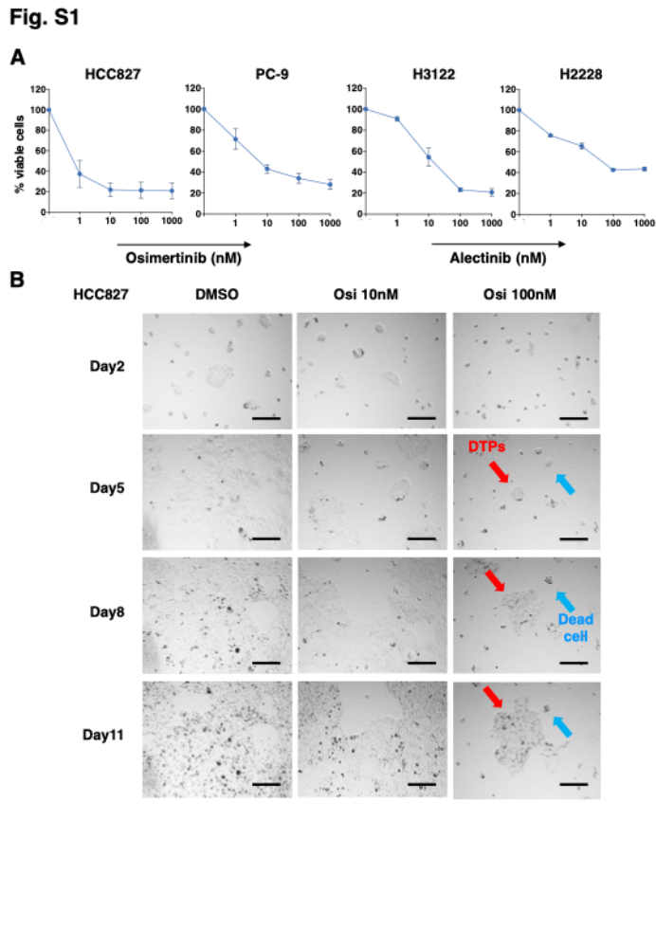
Fig. S1 DTPs in driver-positive NSCLC cells exposed to selective TKIs. A, Antiproliferative effect of osimertinib and alectinib against EGFR mutation-positive, HCC827 and PC-9 cells, and ALK fusion-positive, H3122 and H2228 dells, respectively. The relative numbers of viable cells were quantified using CCK-8 assay. Points, mean % viable cells; bars, SEM of at least three independent experiments performed in triplicate. B, Phase contrast images of time course analysis of the proliferation of HCC827 cells which were exposed to DMSO, 10 nM and 100 nM of osimertinib. Red and blue arrows indicate DTPs and dead cells, respectively. Scale bar, 200 μm.

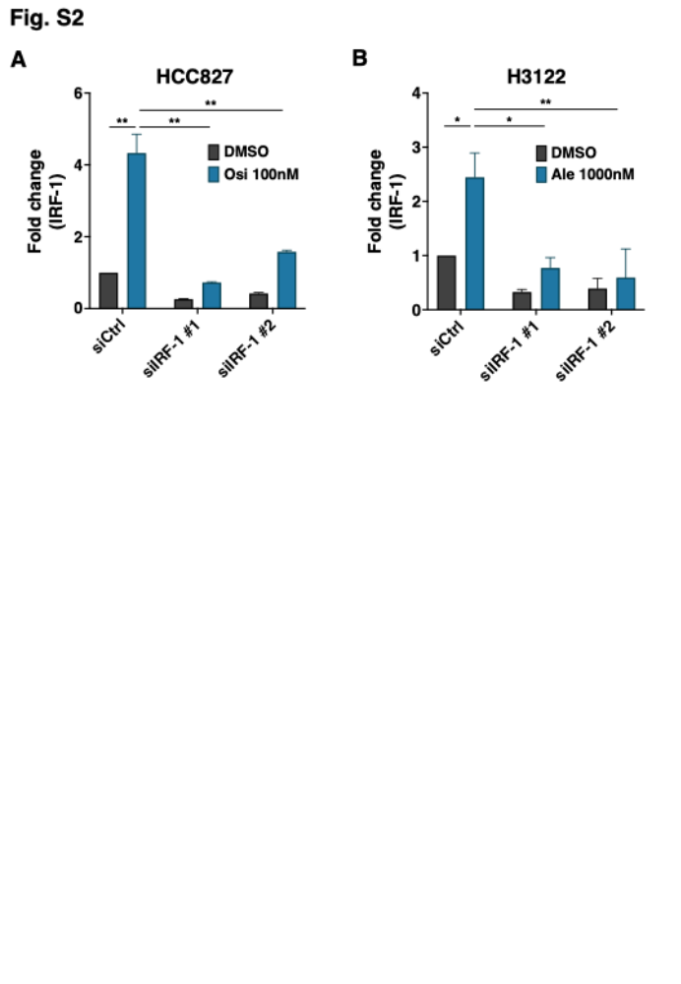Fig. S2 Induction of IRF-1 in driver-positive NSCLC cells by specific TKI stimulation which was suppressed by siRNA. A, siRNA targeting IRF-1 significantly inhibited the osimertinib-induced upregulation of IRF-1 in HCC827 cells. B, siRNA targeting IRF-1 successfully inhibited the alectinib-induced upregulation of IRF-1 in H3122 cells. Results in represent mean ± SEM of at least three independent experiments performed in triplicates. * P < 0.05 and ** P < 0.01.
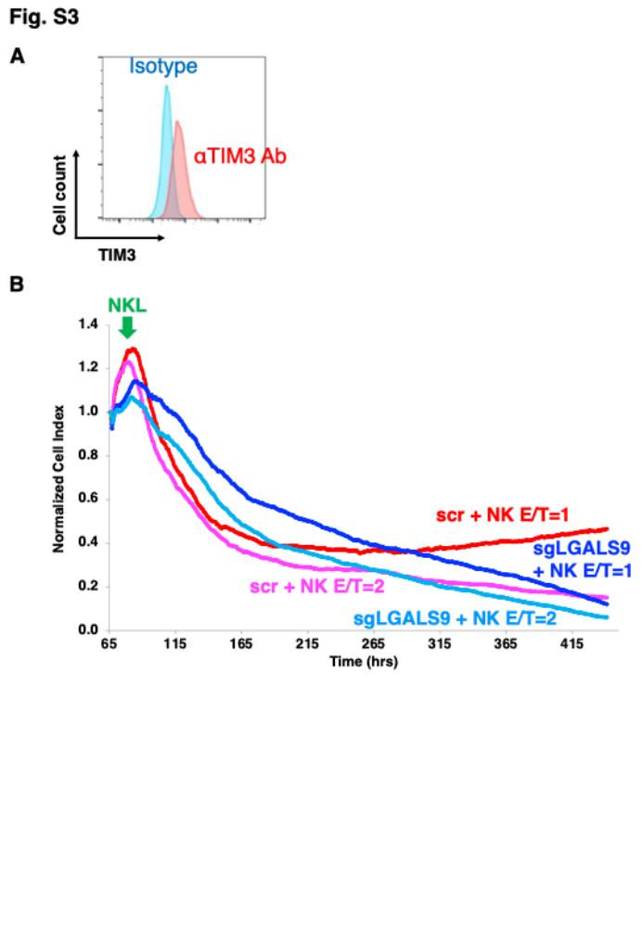
Fig. S3 Impaired cytotoxicity of NK cells against DTPs in HCC827 cells. A, Cell surface TIM-3, one of Gal-9 receptors, expression on NKL cells was evaluated by flowctytometry. Experiments were performed twice with similar results., B, NKL-mediated cytotoxicity against DTPs in HCC827-scr and HCC827-sgLGALS9 cells was measured by long-term xCELLigence analysis.
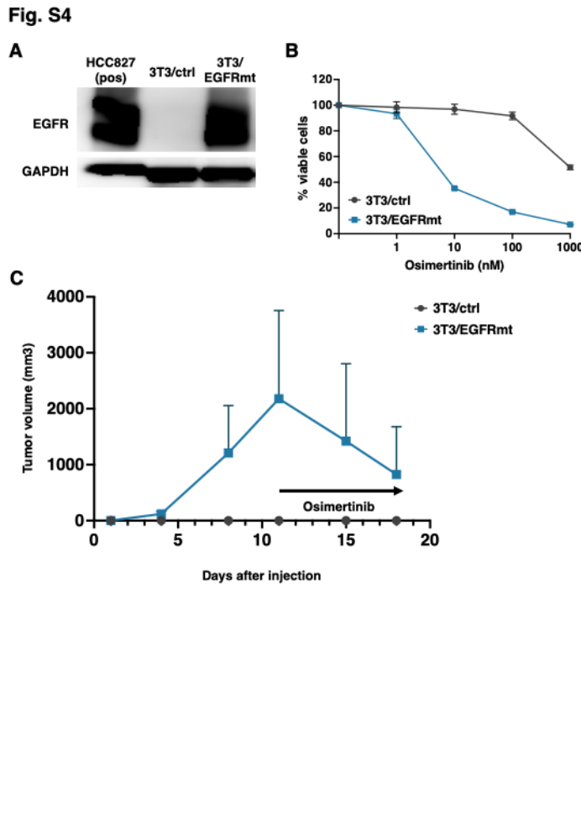
Fig. S4 Establishment of 3T3/EGFRmt cells for the allograft experiments. A, Immunoblotting analysis for the expression of human EGFR in control or human EGFRmt lentiviral-vector transfected 3T3 cells. Experiments were performed thrice with similar resuts. Pos, positive control. B, Antiproliferative effect of osimertinib against 3T3/ctrl cells and 3T3/EGFRmt cells. The relative numbers of viable cells were quantified using CCK-8 assay. Points, mean % viable cells; bars, SEM of at least three independent experiments performed in triplicate. C, The tumor volume curve of 3T3/ctrl and 3T3/EGFRmt subcutaneous allografts in nude mice (n = 3 each) to confirm malignant transformation. After confirming that subcutaneously inoculated 3T3/EGFRmt allografts grew in nude mice, 3mg/kg of osimertinib was orally administered to verify the sensitivity to osimertinib. Each plot point, the mean tumor volume of each group; Bars, SD.
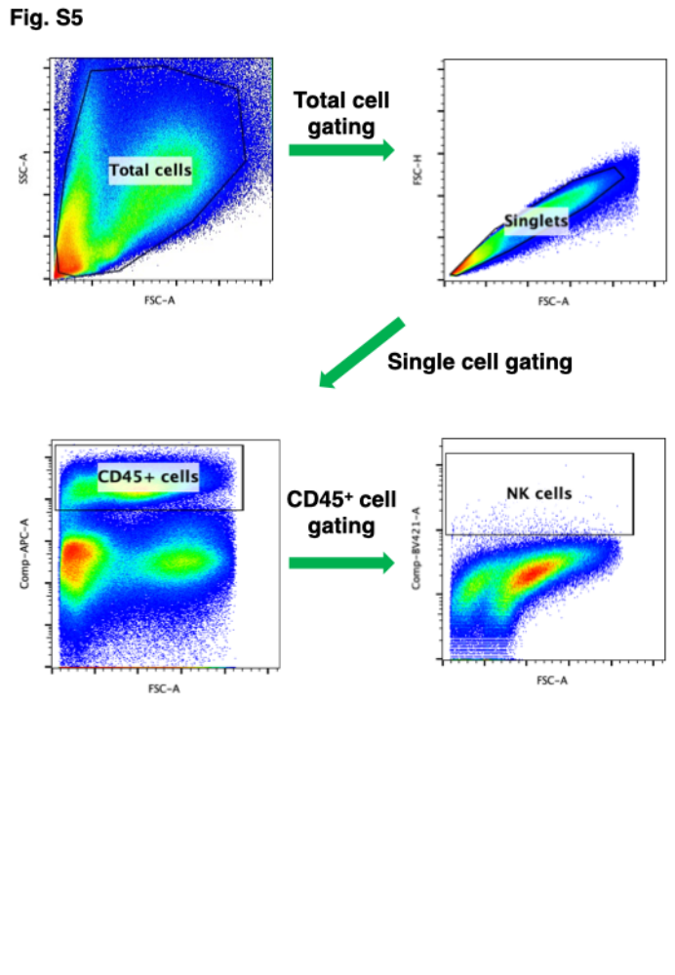
Fig. S5 Gating strategy for flow cytometry analysis of tumor-infiltrating NK cells in allografts. NK cells were identified as CD45⁺NKp46⁺ cells in singlets.
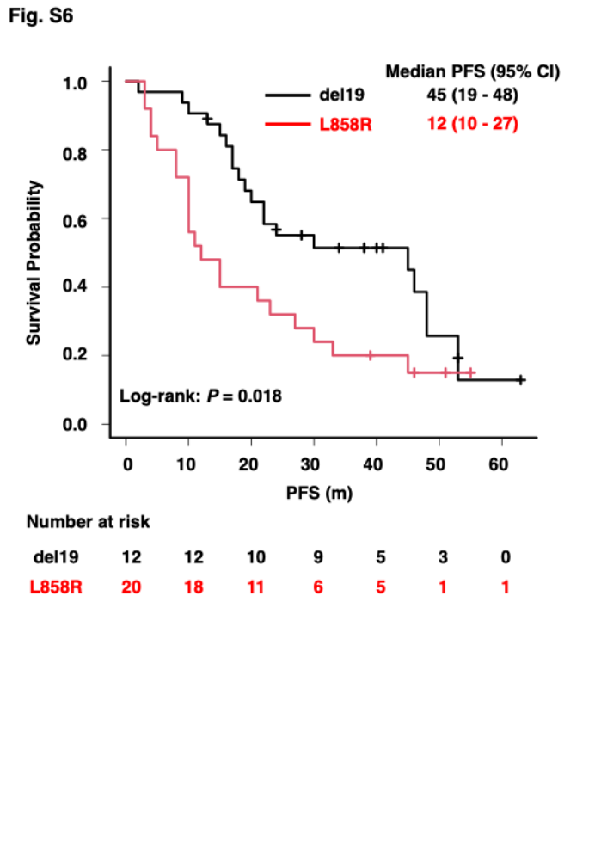
Fig. S6 Kaplan-Meier curve according to the EGFR mutation status (del19 or L858R) in patients with EGFR mutation-positive NSCLC who received osimertinib monotherapy. Log-rank test was used to quantify the differences between del19 group and L858R group.

