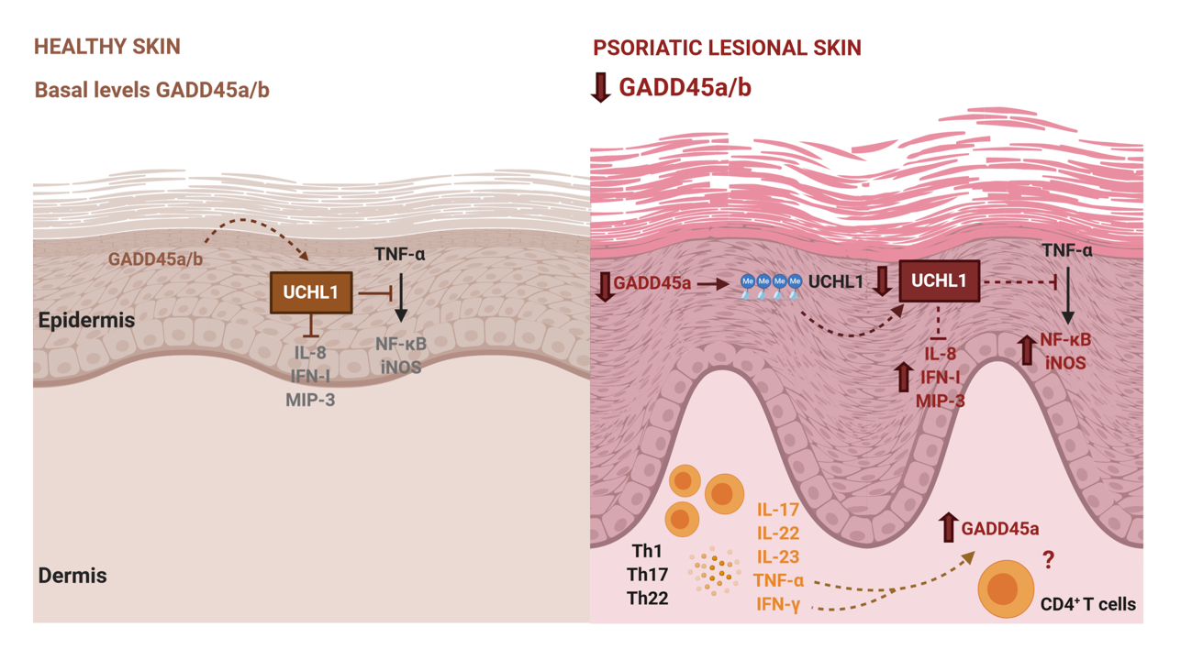

A complex regulation of GADD45 proteins in psoriasis. Under non-pathological conditions, basal levels of GADD45a/b in the epidermis allow sustained levels of UCHL1 that suppress pro-inflammatory cytokines such as IL-8, and TNF-α dependent induction of NF-κB and iNOS. Here we propose that the reduction of GADD45a in the epidermis of psoriatic lesional skin is involved in the hypermethylation of UCHL1 promoter, then reducing the expression of this protein. This reduction in the levels of UCHL1 is related with an increase of the pro-inflammatory molecules, repressed under physiological conditions. This process may contribute to the inflammation in psoriatic skin. Furthermore, psoriasis is characterized by an infiltration of effector T cells in the dermis (Th1, Th17, Th22) that release pro-inflammatory cytokines, including TNF-α and IFN-Ɣ, that could induce the upregulation of GADD45a in the inflammatory infiltrate. Whether the upregulation of GADD45a in T cells from psoriasis patients is involved in the inflammatory process characteristic of this disease, remains unknown. Altogether, GADD45 proteins participate in the inflammatory response in psoriasis, although further studies will be needed to fully understand the mechanisms involved in this complex regulation.

