Supplementary Fig. 1 Typical scans classified as atypical by the sensitive cut-off in the training dataset.
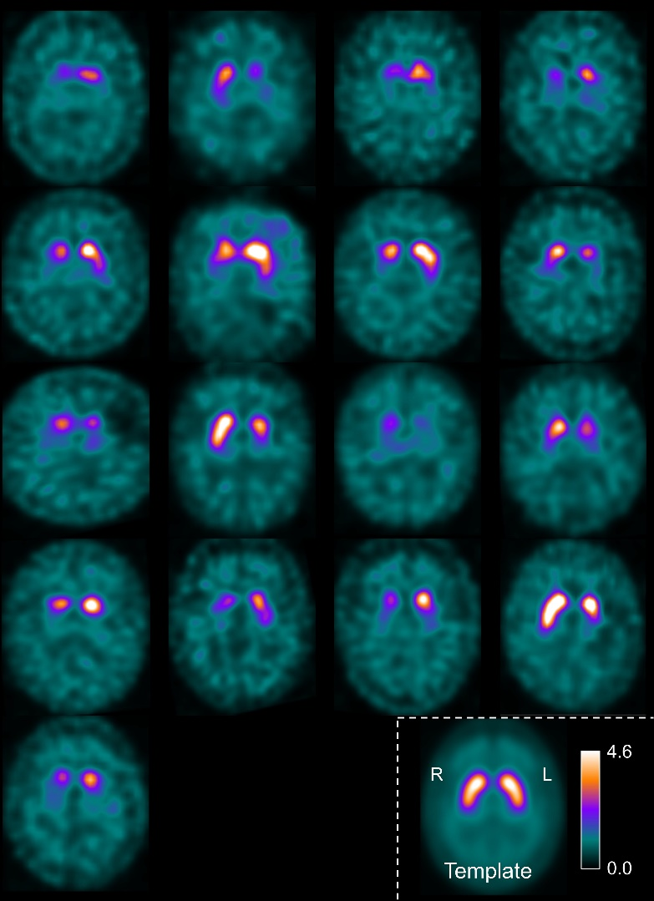
Legend to Supplementary Fig. 1: Binding ratio slab (12 mm thick) from all 17 cases in the training dataset misclassified as atypical by the sensitive threshold on the asymmetry of the caudate binding ratio.

