Supporting Information

Solvothermal Engineering: A Universal Route to High-Performance Free-standing PEDOT:PSS Thick Films

Jiawei Wu,ª Wanying Zhang,^{a,b} Zhen Su,*ª Tao Chen,ª Wentao Wang,*^{b} Jiayi Zeng,ª Yingzhi Jin,ª Jiaxing Song,ª Lin Hu,ª Xinxing Yin,ª Erjun Zhou,ª Zaifang Li*ª

The following files including:

Table S1 The polarity, boiling point, and Hansen solubility parameters of MeOH, DMF, and DMSO
Table S2 The reaction time and pressure of sample treated with MeOH
Table S3 The reaction time and pressure of sample treated with DMF
Table S4 The reaction time and pressure of sample treated with DMSO
Table S5 The thickness, sheet resistance, and conductivity of MeOH-30, MeOH-50, MeOH-60, and MeOH-80
Table S6 The thickness, sheet resistance, and conductivity of DMF-80, DMF-100, DMF-120, and DMF-140
Table S7 The thickness, sheet resistance, and conductivity of DMSO-80, DMSO-100, DMSO-120, and DMSO-140
Figure S1 The correlation plot of pressure vs. conductivity
Figure S2 Cross-sectional images of (a) untreated PEDOT:PSS films, (b) MeOH-80, (c) DMF-100, and (d) DMSO-100
Figure S3 AFM images of PH1000, MeOH-80, DMF-100, and DMSO-100
Figure S4 Specific capacitances at different scan rates of our electrodes compared with previously reported PEDOT:PSS electrodes.

Table S1 The polarity, boiling point, and Hansen solubility parameters of MeOH, DMF, and DMSO.
Materials | Boiling Point | Polarity | Hansen solubility parameters | Matching Degree (with PEDOT:PSS)
MeOH | 64.7 | 32.6 | δ_{d}=15.1 | Poor
MeOH | 64.7 | 32.6 | δ_{p}=12.3 | Poor
MeOH | 64.7 | 32.6 | δ_{h}=22.3 | Poor
DMF | 153 | 38.3 | δ_{d}=17.4 | Good
DMF | 153 | 38.3 | δ_{p}=13.7 | Good
DMF | 153 | 38.3 | δ_{h}=11.3 | Good
DMSO | 189 | 46.7 | δ_{d}=18.4 | Excellent
DMSO | 189 | 46.7 | δ_{p}=16.4 | Excellent
DMSO | 189 | 46.7 | δ_{h}=10.2 | Excellent
PEDOT:PSS | / | 10-15 | δ_{d}=18.0 | /
PEDOT:PSS | / | 10-15 | δ_{p}=16.0 | /
PEDOT:PSS | / | 10-15 | δ_{h}=10.0 | /

Table S2 The reaction time and pressure of sample treated with MeOH.
Sample | MeOH-30 | MeOH-50 | MeOH-60 | MeOH-80
Time (h) | 6 | 6 | 6 | 6
Pressure (MPa) | 0.020 | 0.025 | 0.03 | 0.04

Table S3 The reaction time and pressure of sample treated with DMF.
Sample | DMF-80 | DMF-100 | DMF-120 | DMF-140
Time (h) | 6 | 6 | 6 | 6
Pressure (MPa) | 0.020 | 0.025 | 0.040 | 0.065

Table S4 The reaction time and pressure of sample treated with DMSO.
Sample | DMSO-80 | DMSO-100 | DMSO-120 | DMSO-140
Time (h) | 6 | 6 | 6 | 6
Pressure (MPa) | 0.020 | 0.023 | 0.025 | 0.026

Table S5 The thickness, sheet resistance, and conductivity of MeOH-30, MeOH-50, MeOH-60, and MeOH-80.
Sample | Thickness (μm) | R_{sq} (Ω sq⁻¹) | Conductivity  (S cm⁻¹)
MeOH-30 | 3.60±0.03 | 1.18±0.10 | 2352±5
MeOH-50 | 3.641±0.03 | 1.09±0.11 | 2635±110
MeOH-60 | 3.691±0.04 | 1.12±0.13 | 2570±149
MeOH-80 | 3.637±0.06 | 1.02±0.09 | 2698±260

Table S6 The thickness, sheet resistance, and conductivity of DMF-80, DMF-100, DMF-120, and DMF-140.
Sample | Thickness (μm) | R_{sq} (Ω sq⁻¹) | Conductivity  (S cm⁻¹)
DMF-80 | 3.715±0.04 | 1.40±0.02 | 1850±48
DMF-100 | 3.770±0.02 | 1.30±0.03 | 2150±350
DMF-120 | 3.708±0.05 | 1.60±0.05 | 1580±13
DMF-140 | 3.705±0.02 | 1.68±0.02 | 1558±31

Table S7 The thickness, sheet resistance, and conductivity of DMSO-80, DMSO-100, DMSO-120, and DMSO-140.
Sample | Thickness (μm) | R_{sq} (Ω sq⁻¹) | Conductivity  (S cm⁻¹)
DMSO-80 | 3.959±0.04 | 1.17±0.02 | 2188±29
DMSO-100 | 3.523±0.02 | 1.27±0.11 | 2294±144
DMSO-120 | 3.681±0.04 | 1.51±0.07 | 1805±88
DMSO-140 | 3.741±0.03 | 45.67±7.77 | 56±3

Figure S1 The correlation plot of pressure vs. conductivity.
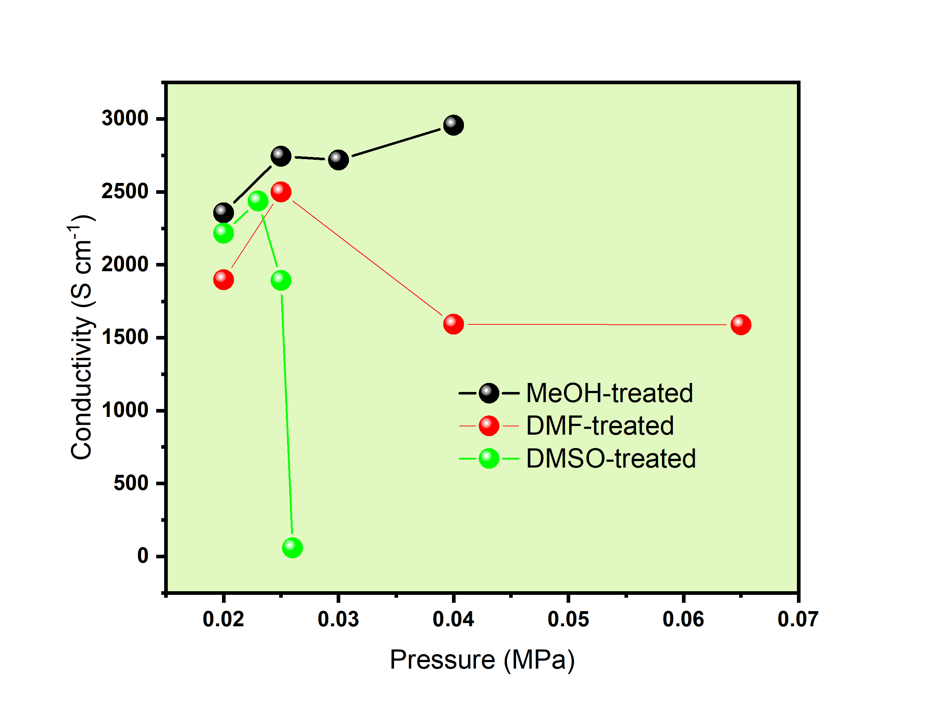

Figure S2 Cross-sectional images of (a) untreated PEDOT:PSS films, (b) MeOH-80, (c) DMF-100, and (d) DMSO-100.

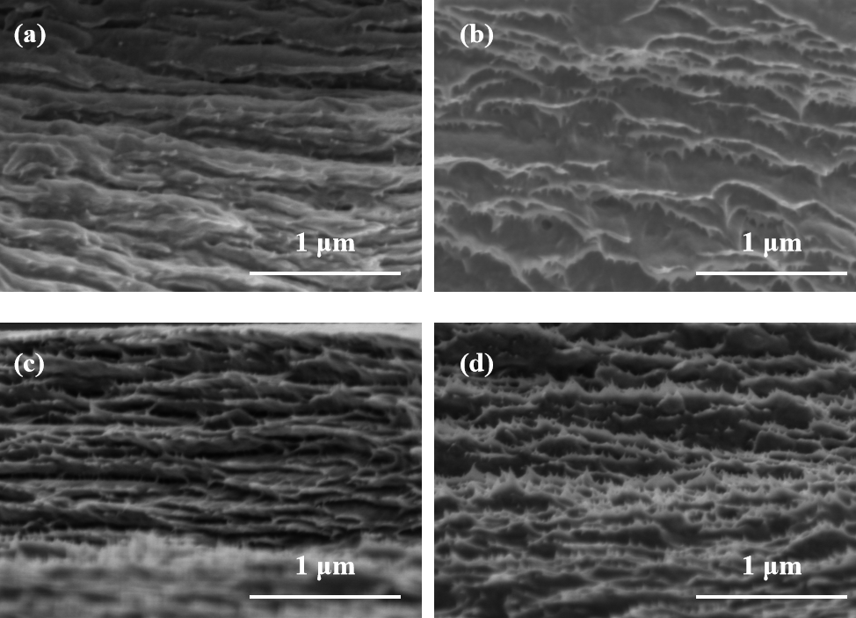

Figure S3 AFM images of PH1000, MeOH-80, DMF-100, and DMSO-100.
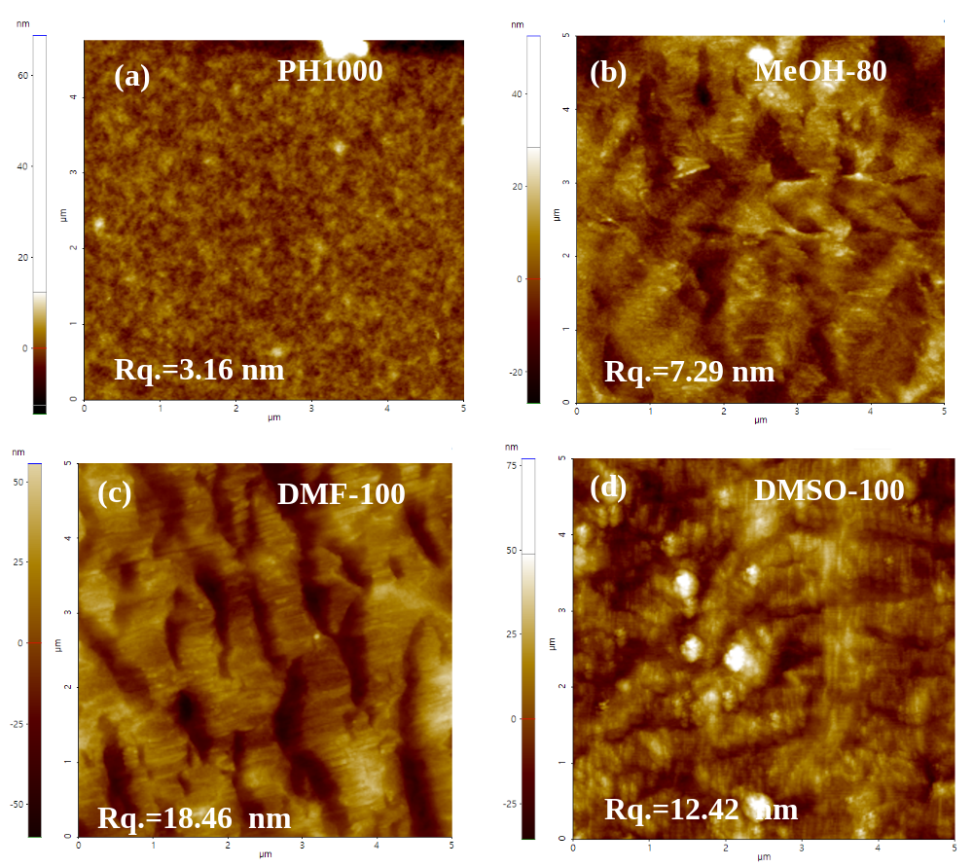

Figure S4 Specific capacitances at different scan rates of DMSO-treated samples compared with previous reported PEDOT:PSS electrodes.
